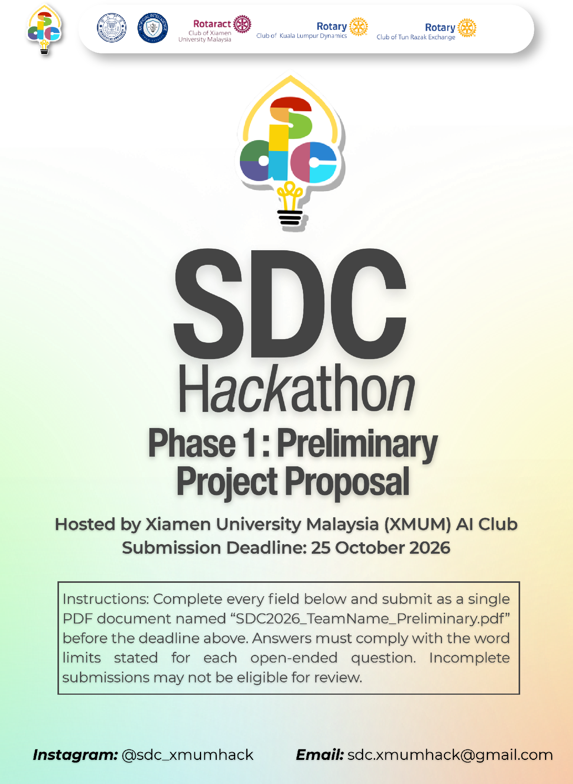
SDC HACKATHON 2026
Phase 1: Preliminary Project Proposal
Hosted by Xiamen University Malaysia (XMUM) AI Club
Submission Deadline: 25 October 2026
Instructions: Complete every field below and submit as a single PDF document named “SDC2026_TeamName_Preliminary.pdf” before the deadline above. Answers must comply with the word limits stated for each open-ended question. Incomplete submissions may not be eligible for review.

1. Team & Project Overview
Team Name | Kita Akan Lawan

Selected Domain | Domain 2 - Orbyte Smart SME Challenge:  Less Busywork, Better Business

Selected SDG Track (1–17) | SDG 8 and SDG 9

Project / Solution Name | StockNow

Name (Leader) | Alfred Jason Gustono

Email & Phone (Leader) | alfredgustono0926@gmail.com / [leader phone number]

University Affiliation(s) | Xiamen University Malaysia

Number of Team Members | 5 Members

2. Executive Summary & Problem Statement

2.1 The Problem Context
Describe the specific, real-world challenge your team is tackling. Who is affected by this problem, and why does it matter? Highlight the critical social, environmental, or economic issues involved.
[Maximum 250 words]
Current Small and Medium Enterprises (SMEs) retailers must keep sufficient stock to serve customers without tying up limited cash in products that sell slowly. When sales records, stock counts, and purchasing decisions are managed separately, owners and staff must repeatedly reconcile quantities, identify low-stock items, and calculate replenishment orders. Missing or inconsistent records make it difficult to see which product needs attention, who changed its stock, and whether a proposed purchase fits the available budget.
StockNow serves small Malaysian clothing retailers and similar inventory-based SMEs, its existing core codebase can be extended and its algorithms modified to support other product-based businesses if required in the future. Owners require visibility into cash flow and purchasing, managers need practical replenishment tools, and staff need a consistent method for recording stock movements and counts. These operational needs are significant: DOSM (Department of Statistics Malaysia) reports that MSMEs (Micro, Small and Medium Enterprises) contributed 39.5% of Malaysia’s GDP and 48.7% of total employment in 2024 [1]. While these figures highlight the sector’s importance, they do not reflect inventory inefficiency.
The challenge is to reduce repetitive stock management tasks while ensuring decisions remain traceable and under human oversight. Improved stock visibility may help prevent unnecessary purchases and reduce unsold goods, although StockNow has not yet measured reductions in waste or emissions. The current problem framing is a design hypothesis grounded in workflow needs that the prototype addresses. Retailer interviews and a timed comparison will validate its scale during Phase 2.

2.2 The Proposed AI Solution
Provide a high-level overview of your proposed application. How does it apply artificial intelligence to solve the problem stated above? Briefly mention the tools or technical skills gained from the SDC Phase 1 workshops (e.g., GenAI APIs, database architecture, cloud hosting) that you intend to leverage.
[Maximum 300 words]
StockNow is an inventory and restock-planning web app for small clothing shops, designed to plug into the Orbyte business hub. Staff record stock in and out; stock levels, sales value, suppliers and a monthly purchase budget sit in one place, with Owner, Manager and Staff roles.
The AI Restock planner answers the owner's hardest question: what to buy this month, and how much, within the budget. For each product it forecasts next month's demand from six months of sales (a weighted moving average blended with a linear trend), adds safety stock, subtracts stock on hand and already on order, and checks the profit margin. It then ranks items by urgency and profit and fills the budget, giving a buy-or-skip decision with plain reasons, expected profit, return on investment and a confidence score. Every number opens in a “Show calculation” view, and an “Accuracy check” tests the forecast against the latest real month, showing when to trust it.
AI suggests; people decide. Staff send the plan for approval, and the Owner or Manager approves or rejects each item. Approved items become one supplier order per supplier with a ready-to-send WhatsApp message, and deliveries are received in StockNow, with every action logged. The system also acts on its own: a stock out that leaves under a week of stock raises an alert, a plan is drafted on a fixed day each month, and late deliveries are flagged daily.
Workshop skills applied: GenAI API – Google Gemini writes the plan summary and supplier messages from figures the engine has already computed, never the numbers themselves; Database – Supabase PostgreSQL stores products, stock movements, plans, orders and the activity log; Cloud deployment – the app is deployed on Replit. Orbyte modules (Directory, eLeave, notifications, Payment) are integration points, not features we rebuild.

3. Technical Architecture & Implementation Plan

3.1 Conceptual Tech Stack
List the technologies, frameworks, APIs, and databases you plan to use to build a functional, deployed prototype. Describe (or attach as an appendix) a simple system block diagram showing how the workshop elements connect into one architecture.
Did your project utilize any official SDC sponsor-provided GenAI API or Cloud Platform? If yes, specify which one and how it is used.
Frontend: Next.js 15 (React 19, JavaScript) with plain CSS and lucide-react icons; responsive for phone and desktop.
Backend & AI engine: Next.js server routes containing the restock engine (demand forecast, safety stock, budget-limited allocation, profit/ROI, confidence and backtest), written by the team in JavaScript so every result is deterministic and testable (25 automated tests).
Database: Supabase (PostgreSQL) with tables for products, categories, suppliers, stock_transactions, purchase_requests, request_items, purchase_orders, settings (monthly budget) and activity_logs. The demo has no login page; a demo account switcher shows the Owner, Manager and Staff views. Supabase Auth or Orbyte sign-in will be added before real use.
GenAI: Google Gemini API turns computed results into a short plan summary and WhatsApp supplier messages; fixed templates are used if the API is unavailable.
Cloud deployment: Replit hosts and deploys the app; API keys are kept as server-side secrets.
How it connects: Browser → Next.js app on Replit → restock engine (+ Gemini for wording) → Supabase PostgreSQL; supplier messages open in WhatsApp through click-to-chat links. See Appendix A for the system block diagram.
Sponsor resources: Yes. Replit (SDC sponsor cloud platform) is used to host and deploy the prototype. The Gemini API is used on the team's own free-tier account, not a sponsor-provided API.

3.2 Design-Thinking & Deployment Strategy
Explain how your team applied design-thinking methodology to ensure this solution is technically viable, user-friendly, and ready for real deployment by Phase 2.
[Maximum 200 words]
Empathise: we mapped a small clothing shop's routine (counting stock, deciding what to reorder, checking cash, messaging suppliers) and found the hardest steps are choosing what to buy within a budget and following the order through to delivery.
Define: owners need a clear, explainable answer to “what should I buy this month?” without losing control of the decision.
Ideate: we chose “AI suggests, people decide”: a transparent forecast and budget planner with per-item approval, instead of an opaque chatbot.
Prototype: we built a clickable prototype and revised it through seven feedback rounds, removing features that added noise (a chatbot, extra dashboard cards) and fixing budget, sales and returns logic to match how a shop really works.
Test: automated browser tests cover every flow on desktop and mobile, and the forecast is backtested on six demand scenarios (rising, falling, festive, viral, overstock, mixed).
Deployment readiness: the app runs on Replit with Supabase, uses synthetic data only, and includes an outage plan (offline stock entry and backup export). In Phase 2 we will run timed tasks with real retailers and tune the forecast on their sales data.

4. Preliminary Environmental & SDG Impact Framework
To align with SDC’s focus on meaningful global sustainability, establish your project’s impact baseline before building the prototype. Use estimated data, published research, or public benchmarks where exact figures are unavailable. Provide the citation of any sources used.
The target, baseline, and KPI you provide here will be used by judges during shortlisting to assess Innovation and Creativity as well as Feasibility of build. Vague or unsupported projections may weaken your case for advancing to Phase 2.

Metric Category | Your Response
Target SDG Sub-Target(s)  Identify the exact UN SDG sub-target your project addresses  e.g., Target 11.6 “Reduce the adverse per-capita environmental impact of cities, focusing on air quality and waste management.” | SDG Target 8.2: achieve higher levels of economic productivity through diversification, technological upgrading and innovation [2].  SDG Target 9.3: increase the access of small-scale enterprises to financial services and their integration into value chains and markets [3].
Current Problem Baseline  What is the starting condition of the problem, expressed as a number?  e.g., “The target infrastructure currently experiences 35% energy inefficiency due to unoptimized scheduling.” | Tested on the prototype's 6 synthetic demand scenarios (8 products, 144 monthly test points), a common manual rule – reorder the average of the last 3 months – misses actual monthly demand by 18.6% on average (MAPE); “same as last month” misses by 11.8%.  Building a budget-checked restock order by hand takes about 6 separate tasks (check stock per item, review sales, estimate demand, compare with budget, message suppliers, track delivery); time per order will be measured with retailers in Phase 2.
Core Measurable KPI  The specific unit you will track  e.g., % reduction in power consumption, processing-latency improvement, or kg of resource waste avoided. | 1. Forecast error (MAPE, %) of monthly demand vs actual sales.  2. Minutes needed to produce an approved, budget-checked restock order.  3. % of AI-planned purchase value within the owner's monthly budget.
Phase 2 Impact Target  Your realistic, percentage-based target by the final prototype presentation  e.g., “20% improvement in computational resource use.” | 1. ≥30% lower forecast error than the 3-month-average rule on real retailer sales (prototype: 41% lower on synthetic data, 11.0% vs 18.6%).  2. ≥50% less time to produce a budget-checked restock order in timed tasks with at least 3 retailers.  3. 100% of AI-planned purchases within budget (enforced by the planner).

5. Eligibility & Readiness Checklist
Tick all boxes that apply before submitting.
All team members have completed the mandatory GenAI, Database, and Cloud Deployment upskilling workshops.

 | The project concept addresses a verified real-world problem mapped directly to one or more UN SDGs.
  ✓

 | The proposed solution targets a functional, deployed application rather than a theoretical business case study.
  ✓

 | All fields in this template have been completed within the word limits stated.
  ✓

6. IP & Originality Declaration
6.1 Pre-Existing / Prior-Owned Work
Does this submission include any code, design, research, or other work that any team member created or owned before the start of this hackathon?
☐ Yes ☒ No
If yes, briefly describe what was pre-existing and which team member(s) owned it:

6.2 Third-Party Code, Datasets, or Models
Does your project use any third-party code libraries, open-source frameworks, public/private datasets, or pre-trained AI models that your team did not create?
☒ Yes ☐ No
If yes, list them below (open-source use is permitted provided it is declared and properly licensed/attributed):
Name | Type (code/dataset/model) | License
Next.js | Code (web framework) | MIT
React | Code (UI library) | MIT
lucide-react | Code (icon library) | ISC
@supabase/supabase-js | Code (database client) | MIT
Inter typeface (Google Fonts) | Code (font) | SIL Open Font License 1.1
Google Gemini API | Model (pre-trained, via API) | Google APIs Terms of Service & Gemini API Additional Terms
DOSM MSMEs Performance 2024 statistics [1] | Dataset (public, cited only) | DOSM terms of use

6.3 Employment-Related IP Conflicts
Is any team member currently bound by an employment, internship, or consulting agreement under which their employer could claim ownership of work they create during this hackathon?
☐ Yes ☒ No
If yes, please describe the nature of the agreement and which member it concerns:

7. Declaration
By submitting this proposal, the team leader confirms that the information provided is accurate to the best of the team’s knowledge and that the project will be original work created during the SDC 2026 hackathon period.

[Signature]

[Date]
Saturday, 24 October 2026
REFERENCES
[1] Department of Statistics Malaysia (DOSM). Micro, Small & Medium Enterprises (MSMEs) Performance 2024. Released 31 July 2025. Reports MSME GDP contribution of 39.5% and employment contribution of 48.7% for 2024. https://www.dosm.gov.my/portal-main/release-content/micro-small--medium-enterprises-msmes-performance-2024

[2] United Nations, Department of Economic and Social Affairs. Goal 8, Target 8.2: productivity through diversification, technological upgrading and innovation. https://sdgs.un.org/goals/goal8

[3] United Nations, Department of Economic and Social Affairs. Goal 9, Target 9.3: access to financial services and integration of small enterprises into value chains and markets. https://sdgs.un.org/goals/goal9

APPENDIX A – SYSTEM BLOCK DIAGRAM
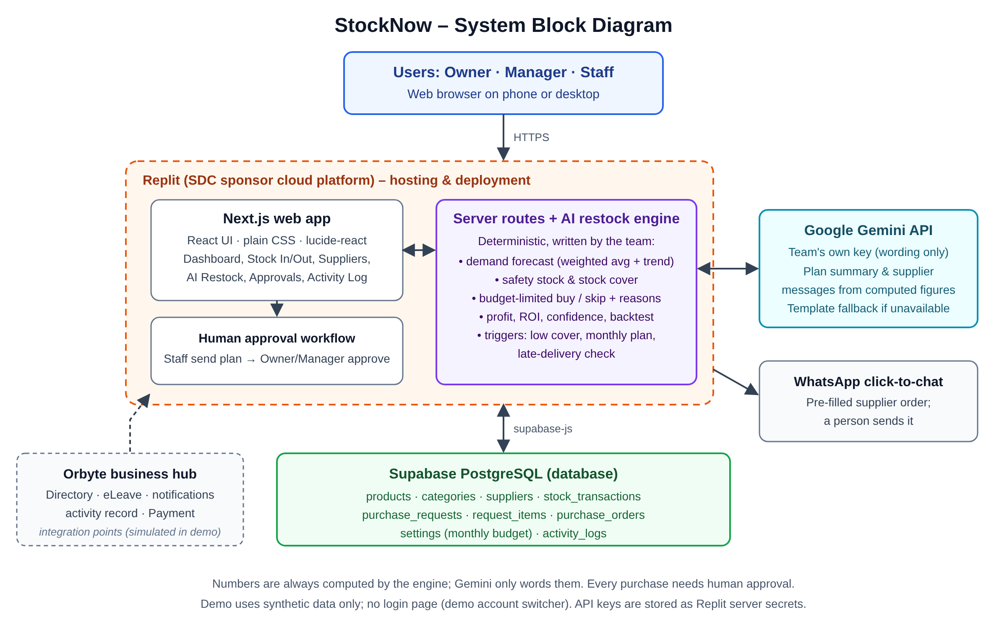
Figure A1. StockNow architecture: browser, Next.js app and AI restock engine on Replit, Gemini API for wording, Supabase PostgreSQL, WhatsApp and Orbyte integration points.

