Project1 - **Deploy Static Website on AWS**

Udacity ID – [mukul.kumar@natwest.com](mailto:mukul.kumar@natwest.com)

*Project URLs*:

* CloudFront Distribution domain name: https://d24ygk3svamcxm.cloudfront.net/
* S3 object URL: https://mk-proj1-bucket.s3.amazonaws.com/index.html
* Bucket website endpoint: <http://mk-proj1-bucket.s3-website-us-east-1.amazonaws.com/>

1. Bucket created in S3

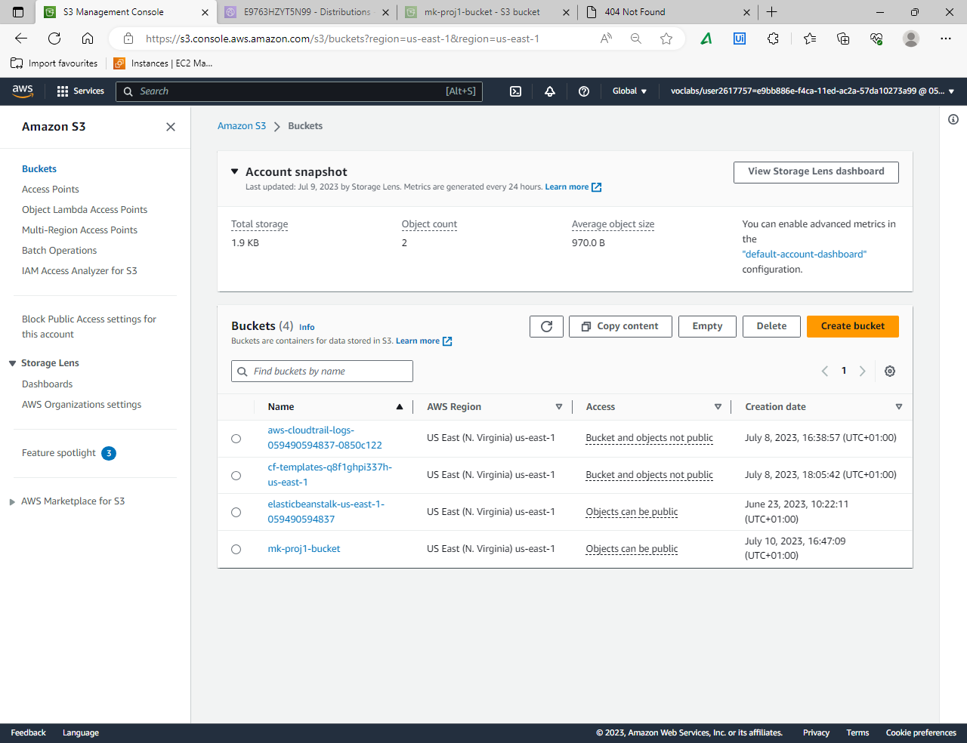

1. Files and folders uploaded in bucket

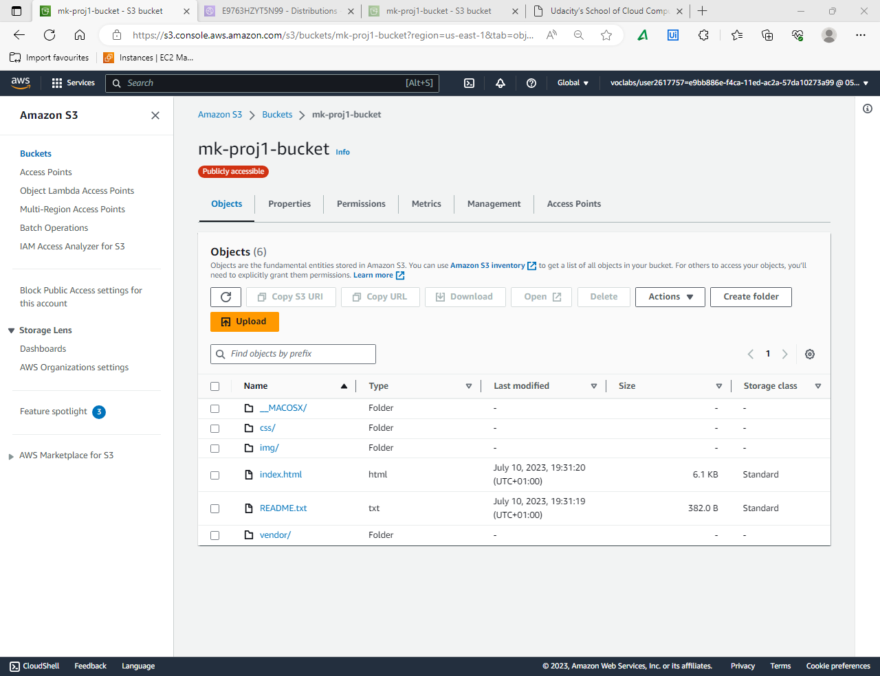

1. Bucket general properties configured  
   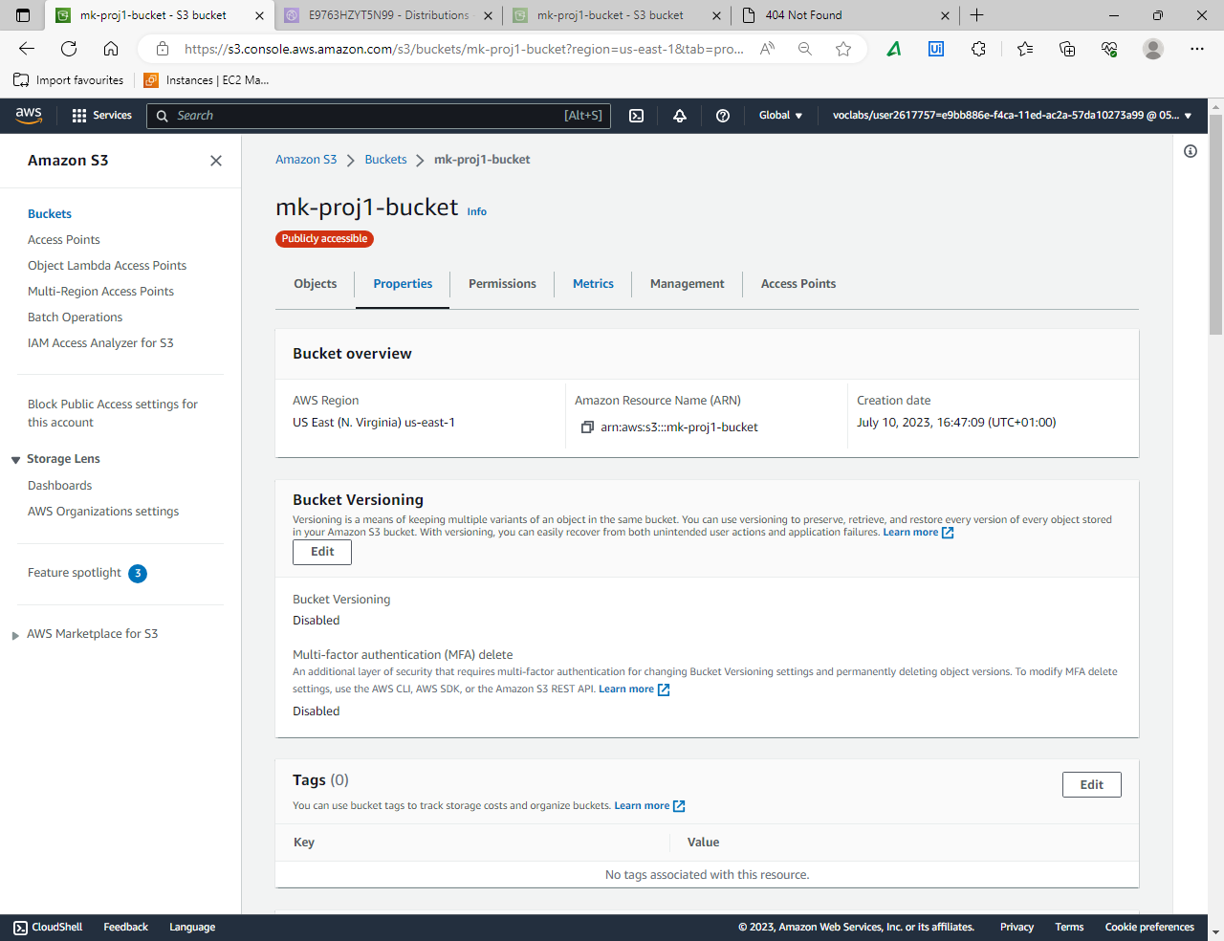
2. Static Website hosting configured in bucket  
   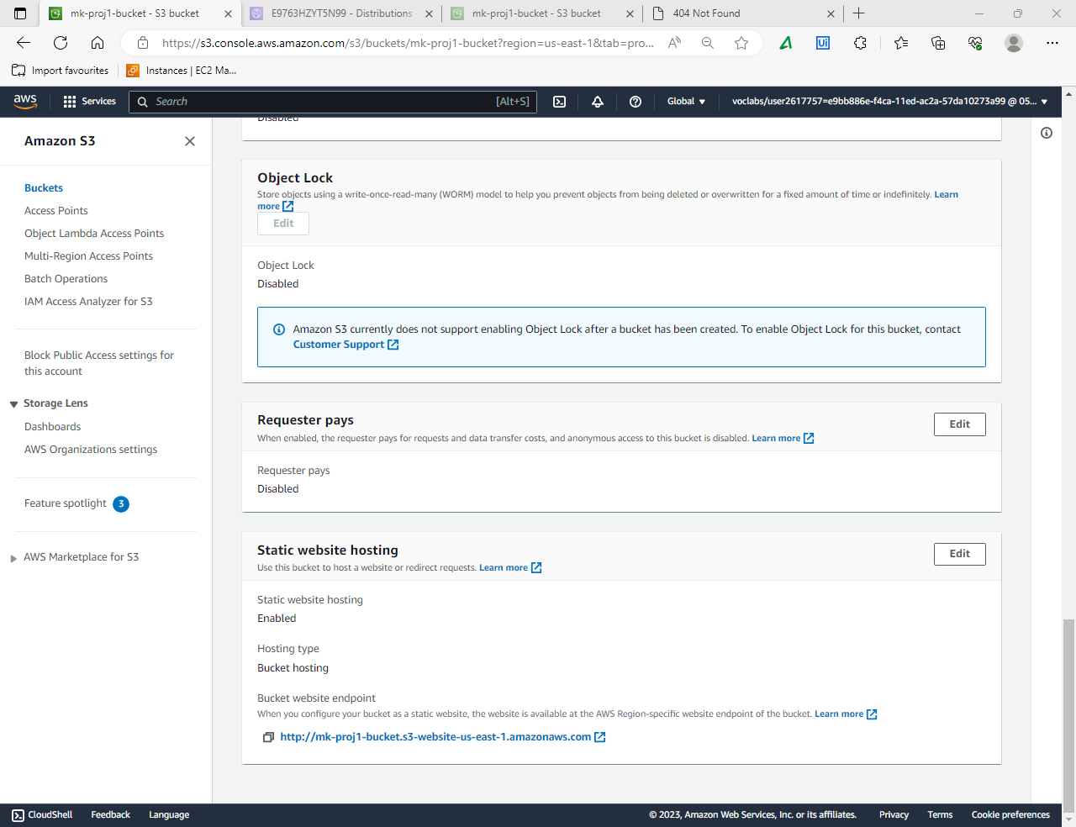
3. Public access granted to everyone on bucket  
   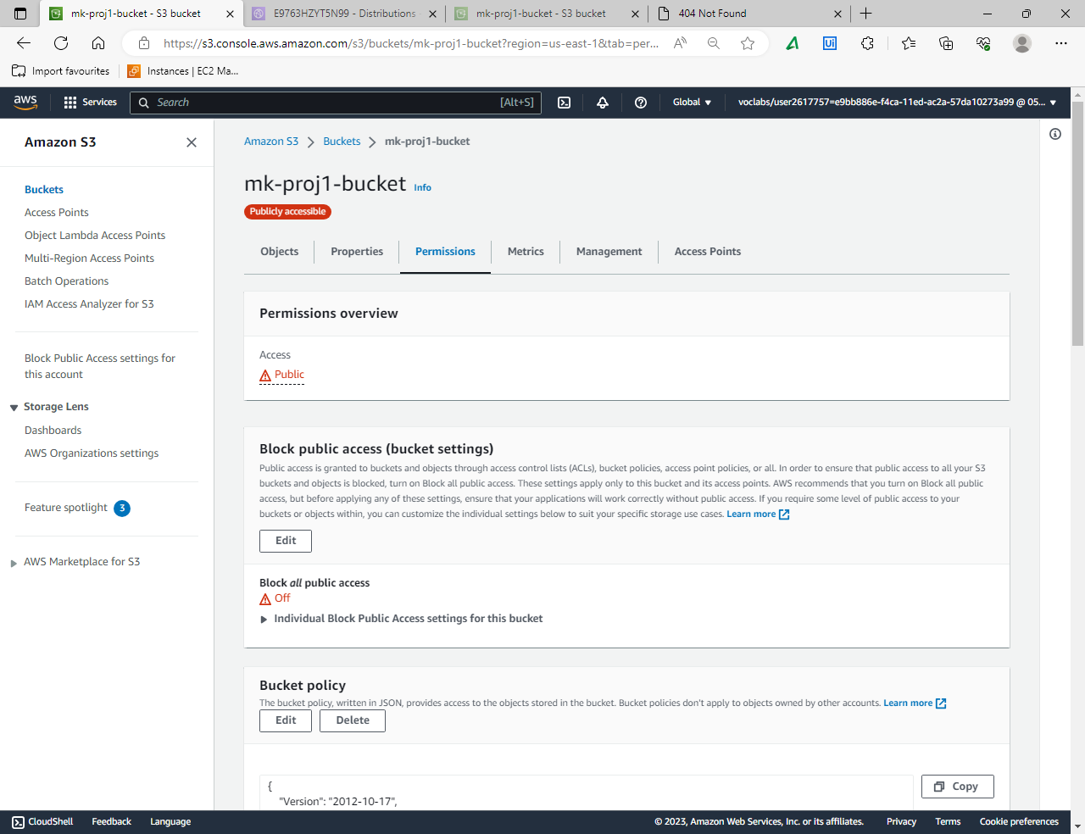
4. Bucket policy defined  
   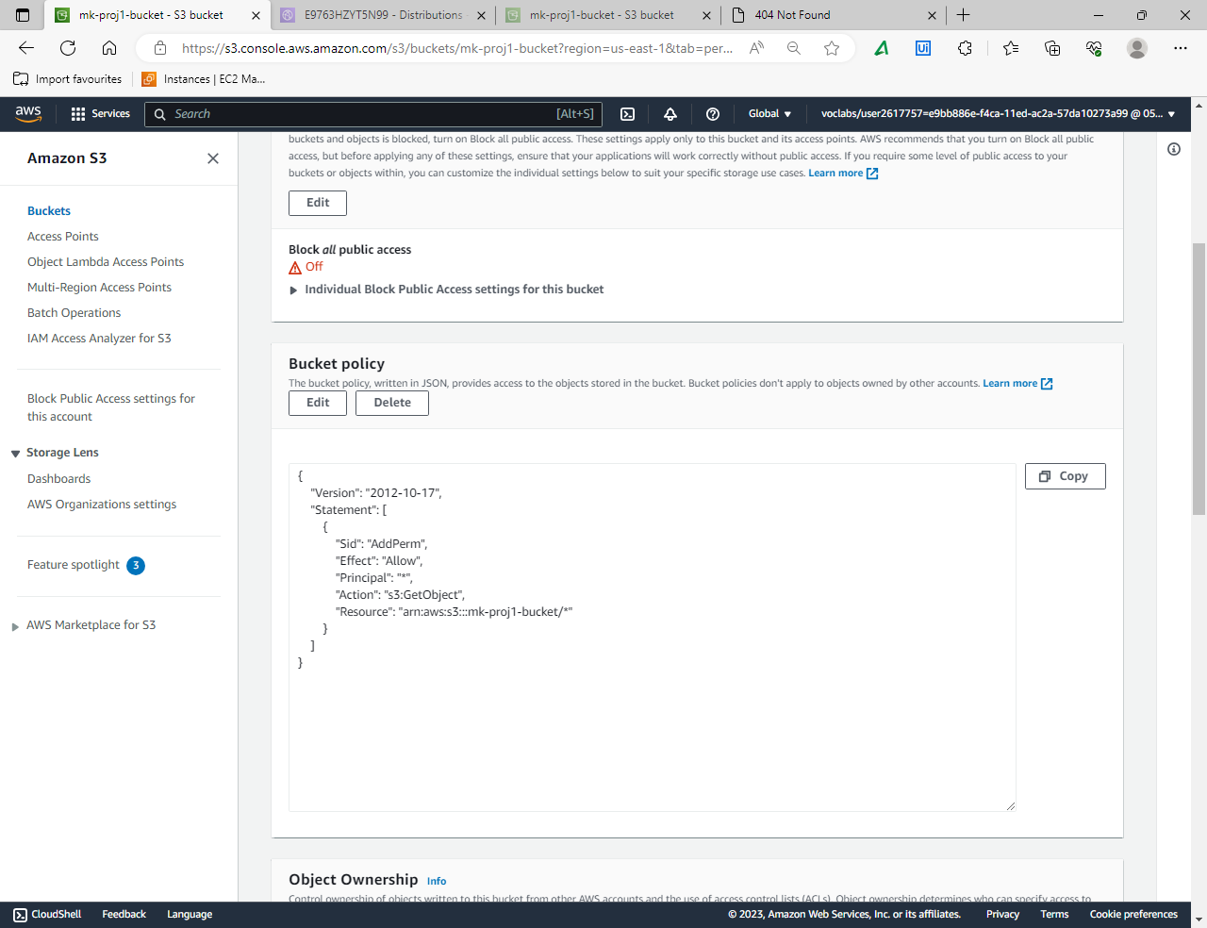  
     
   7. CloudFront distribution created   
   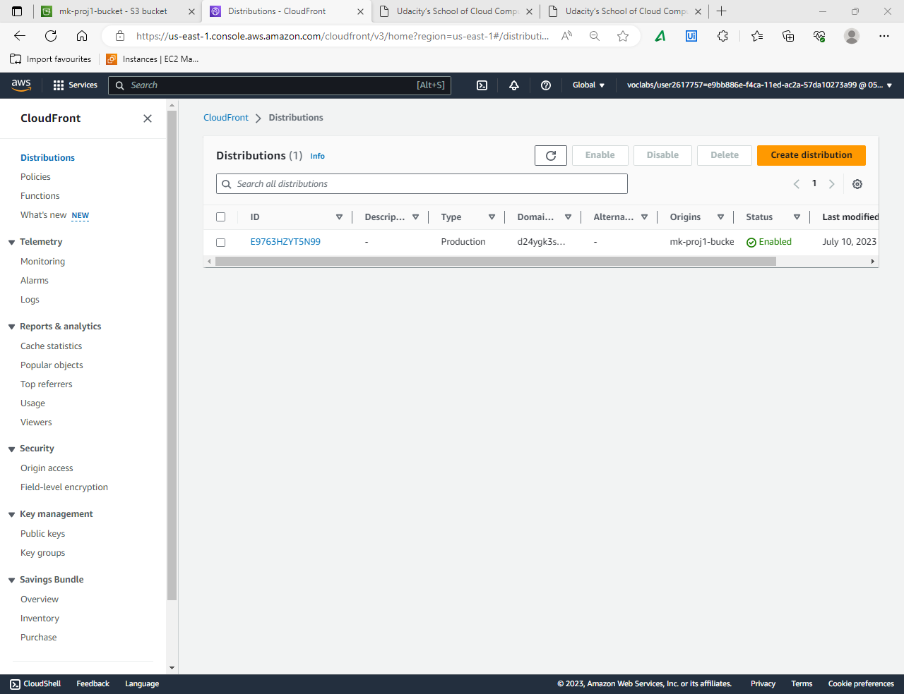

8. CloudFront distribution general properties configured.  
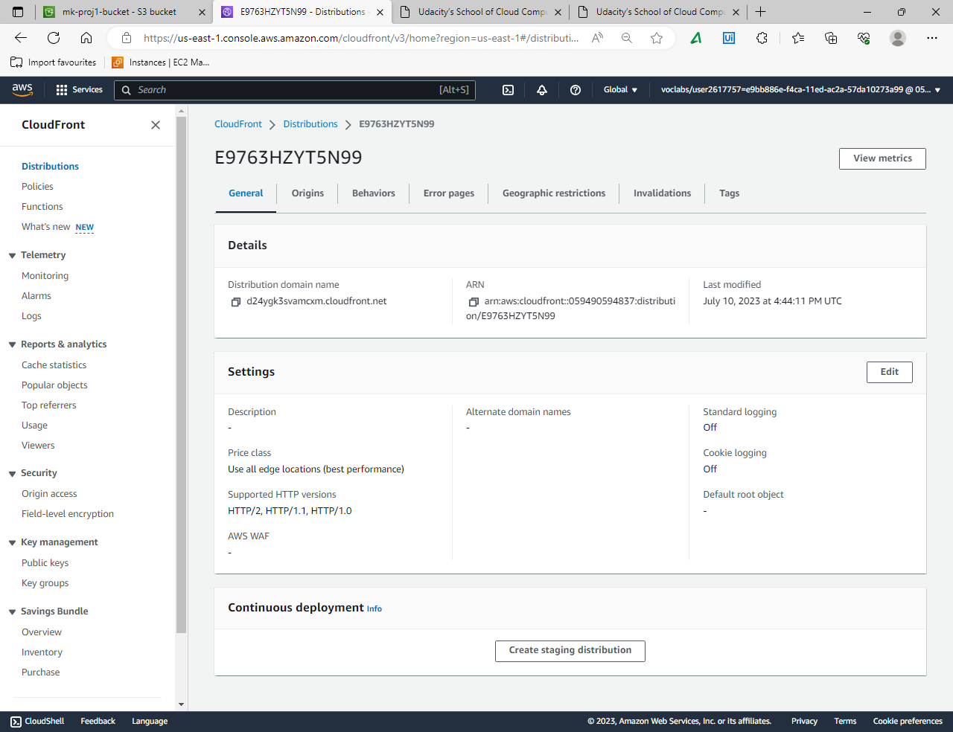

9. CloudFront distribution origin configured  
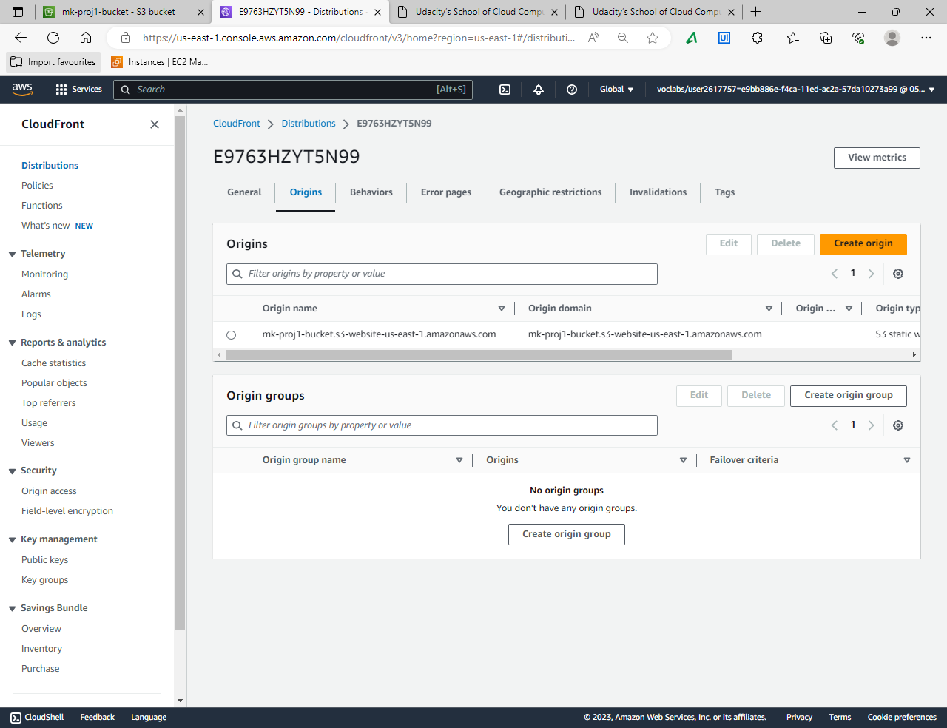

10. S3 static website URL up   
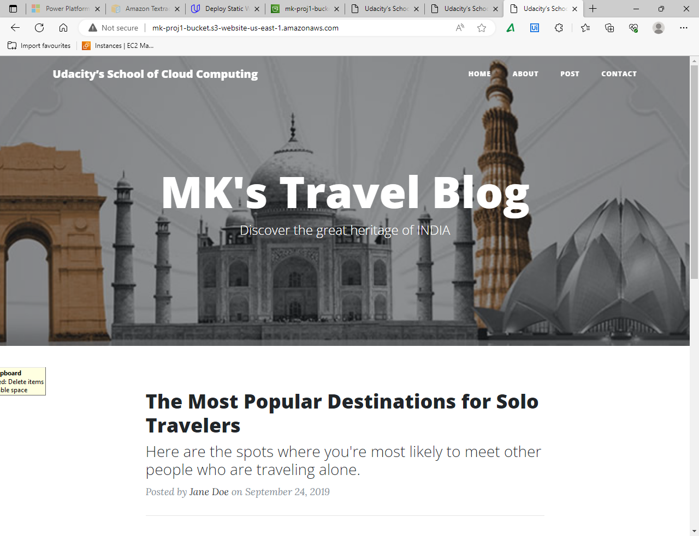

11. index.html page via S3 object URL up  
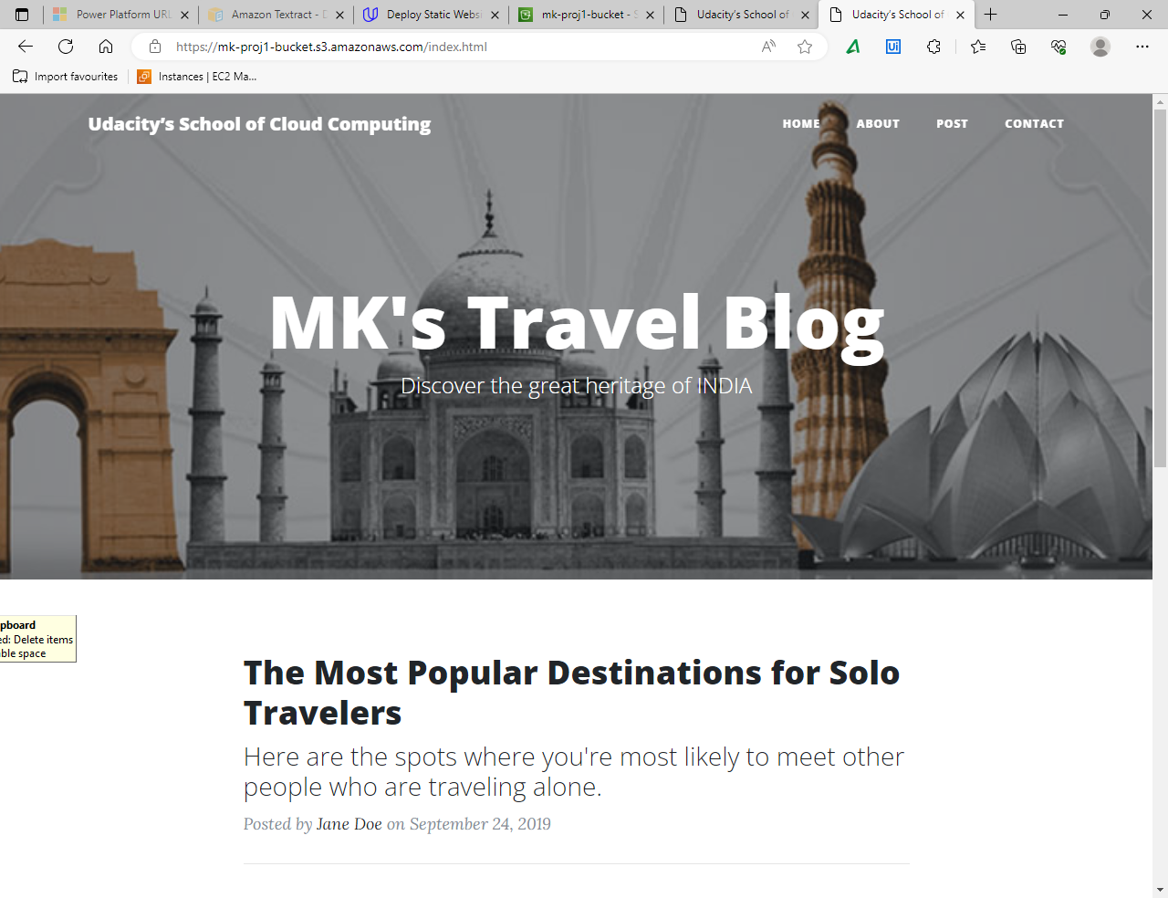  
  
12. Website via CloudFront Distribution domain name up 