Installing SPHinXsys

Install Cmake.

<https://cmake.org/>

Cmake is cross-plateform project manager.

It generates files for a project.

## Three dependences:

1. Simbody,

Downloading from <https://github.com/simbody/simbody/releases>

Choose version 3.5.4

Unpack and move it to C:/simbody-source

Create a folder C:/simbody-build

Comply use Cmake.

Configure with option Visual Studioi 2017 x64 and then Generate the solution file for VS2017

(Note that install prefix should be a file folder not in system folder. For example : C:/Simbody)

Install simbody by following instruction in windows or linux.

In Visual Studio, open the solution file generated by Cmake

Choose RelWithDebinfo and X64 mode.

Right-clicking ALL_BUILD and selecting build

Right-clicking INSTALL and selecting build

Set system environment variable SIMBODY_HOME to the simbody directory.

And the simbody\bin path to environmental variable: System variables.

In Windows system, The system environment variables and PATH can be set like the following pic:

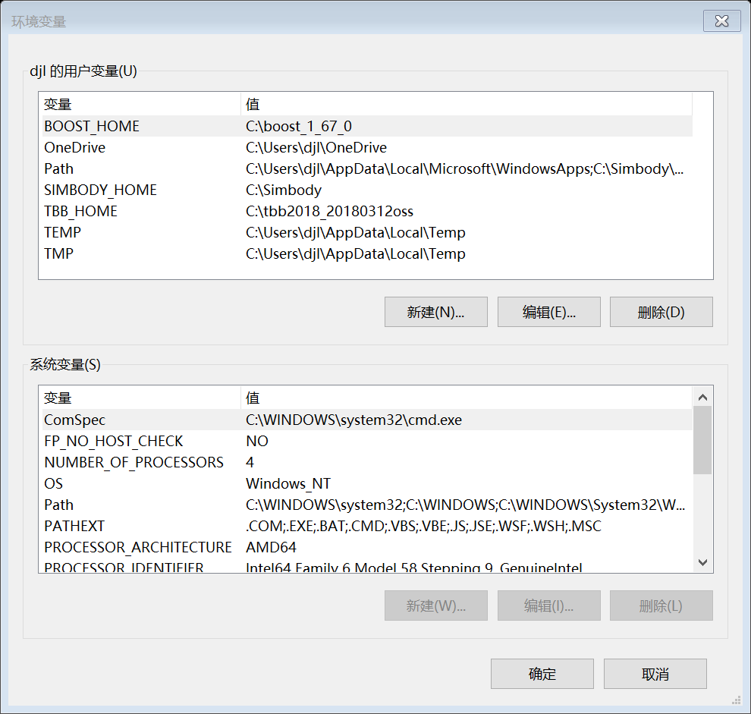

Fig1. How to set system environment variables and PATH in Windows System

1. TBB

Install TBB, actually extract the file to the assigned folder , e.g. C:/ tbb_version

set environment variable: TBB_HOME to the tbb directory

Set the path bin\intel64\vc14 to environmental variable: System variables.

See Fig. 1

1. Boost

Install boost, , actually extract the file to the assigned folder, e,g, C:/boost_version

set environment: BOOST_HOME to its directory

See Fig. 1

## Buidling SPHinXsys project

Clone SPHinXsys source files to local computer using SmartGit

Use Cmake to build project file. As follows,

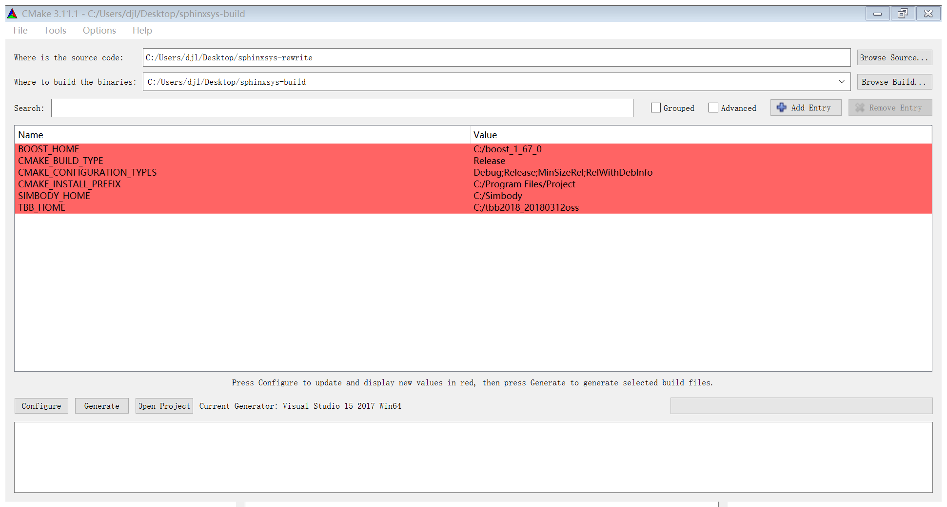

Fig. How to Cmake the SPHinXsys

Configure x64 build and Generate

Remember to creat a new directory outside of the git directory to avoid upload the project files to the git- lab.

After configuration, one can choose debug or relaese mode of the project file.

The directory CMAKE_INSTALL_PREFIX C:/Program Files/Project is the place will be the place that lib files be produced.

In the SPHinXsys project.

Run INSTALL will produce .h, .lib and .dll liberies for external use.

Source folders

Base: simple mathematical varaible and functions and basic data structures

Kernel: kernel functions

Material: equation of state

PreProcessing:

Equation: dynamics or the right-hand-side of dynmaic equation

Base-equation: single body dynamics

Interaction-equation:

ReduceEquation: global data to single data

FluidMechanics: combination of several type equation

SolidMechanics: combination of several type equation

SPHsystem: data manuplation, mathemaical operators

Porcess for contructure an example (a case)

Build a system with a domain, a kernel and dynamical components

Creat particles

Define current neighbor search method

Finish the system with consider dynamics interactions

Define dyanmics

Computing