The Polarization of Latent Skills in the AI Labor Market:
A Computational Social Research Approach
Mergoni Alberto VR542261

Abstract
The rapid evolution of Artificial Intelligence (AI) is fundamentally restructuring the technological labor market. Within the sociological framework of the future of work, the definition of what constitutes an 'AI worker' is becoming highly fragmented. This paper investigates the latent professional archetypes within the AI job market through a computational social research framework. By employing Unsupervised Machine Learning (K-Means clustering) and Natural Language Processing (TF-IDF) on digital trace data, this study operationalizes qualitative job descriptions into quantitative skill matrices. This research evaluates two distinct data sources characterized by a sharp sampling asymmetry: an organic dataset scraped from LinkedIn ($N_{A}≈1,050$) and a massive forecasted dataset ($N_{B}>50,000$). Through an algorithmic audit utilizing Principal Component Analysis (PCA), this study uncovers the synthetic, LLM-generated nature of the larger dataset, exposing severe distortions in its socio-economic metadata. The empirical results from the organic corpus reveal a stark polarization of skills, with the market fracturing into five distinct clusters that highlight a shift toward specialized MLOps infrastructure. Conversely, the synthetic dataset collapses into three oversimplified categories, projecting an economic mirage of perfect wage equality and a spatial utopia of remote work (45%) that completely ignores the persistent corporate centralization and geographic inequalities of the real workforce.

1. Introduction
The digital transformation and the recent explosion of Large Language Models (LLMs) have triggered a paradigm shift in the global economy. In the sociological context of the labor market, the traditional role of the "Data Scientist" is undergoing a profound structural fragmentation. What was once considered a monolithic profession is now dividing into hyper-specialized sub-fields.
The primary research objective of this paper is to uncover and categorize the latent professional profiles within the current and near-future AI labor market based on the actual skills demanded by employers. Rather than relying on a priori occupational classifications—which often suffer from bureaucratic lag—this study adopts a bottom-up, data-driven approach to discover how the market organically clusters technological competencies.
Secondary objectives include analyzing the socioeconomic nuances of these newly discovered clusters, specifically concerning salary distribution and the democratization of geographic constraints through remote work. By answering these questions, this paper contributes to the broader sociological discourse on the future of work, the polarization of high-cognitive labor, and the globalization of the tech workforce.

2. Theoretical Framework and Problem Setup
This research is rooted in the methodological traditions of Social Research, updated for the era of Big Data. Following the foundational principles of quantitative and qualitative methodology this study relies on digital trace data—specifically, job postings scraped from the web. The fragmentation of data-related occupational titles is not a purely technical phenomenon, but fits firmly within the theoretical framework of Skill-Biased Technological Change (Acemoglu & Autor, 2011). According to this framework in economic sociology, technological progress does not disrupt labor uniformly; rather, it disproportionately rewards workers equipped with frontier analytical and abstract skills, while penalizing routine tasks. This process generates a structural polarization of cognitive labor. As theorized by Castells (2010) in his analysis of the Network Society, the transition to an informational economy creates a sharp divide between those who govern the technological infrastructure (the technocratic elite identifiable in MLOps clusters) and those who execute ordinary data manipulation tasks (the data proletariat or traditional analysts bound to descriptive reporting).
2.1 Unobtrusive Data Collection and Operationalization
In traditional social research, data is often collected via surveys or interviews, which are subject to respondent bias and reactivity. Job postings, conversely, represent an unobtrusive measure. They are ecological artifacts that reflect the authentic, immediate needs of the economic system.
The core theoretical challenge is the operationalization of abstract concepts. In sociology, defining a "professional profile" requires translating qualitative semantic meaning (the text of a job description) into measurable quantitative variables. This paper achieves this through Natural Language Processing, treating linguistic requests for specific software, methodologies, and architectural paradigms as the measurable indicators of broader sociological archetypes.
2.2 The Problem of Data Validity: Organic vs. Synthetic Traces
A critical element of this study is the evaluation of data validity and reliability when utilizing secondary, public datasets (e.g., Kaggle repositories). To robustly map the market, this research evaluated two distinct data sources:
- Dataset A (Real-World LinkedIn Data): An organically scraped dataset representing the chaotic, unstructured nature of human-written recruitment texts.
- Dataset B (2026 AI Jobs Forecast): A highly structured, forward-looking dataset designed to map the upcoming tech market.
The statistical validity and scope of this research are founded on the analysis of two distinct datasets, characterized by a chess-board of stark sampling, temporal, and ontological asymmetries. Dataset A (LinkedIn Data Jobs) consists of an empirical sample of approximately 1,050 unique job postings, extracted via a direct web-scraping process conducted between January and April 2026. Although it presents a smaller sample size, this specific four-month temporal window captures a synchronized, high-resolution snapshot of real-world labor market dynamics within a precise macroeconomic conjuncture. Conversely, Dataset B (2026 AI Jobs), utilized as a forecasting benchmark and subjected to epistemological scrutiny, presents a massive sample size of over 50,000 synthetic observations generated to project the idealized structural state of the market for the entire fiscal year of 2026. Making these temporal and metric parameters explicit allows for a fundamental critique of the sources: while Dataset A provides a volatile but ecologically valid real-time snapshot tied to a specific historical timeframe, Dataset B represents an artificially static, year-long simulation that completely filters out seasonal labor friction and authentic temporal volatility.

3. Methodology
To extract latent skills and group them into coherent professional profiles without researcher bias, this study employs a mixed-methods computational pipeline bridging qualitative text analysis with quantitative Unsupervised Machine Learning.
3.1 Text Processing and TF-IDF Vectorization
The primary independent variables in this study are the raw texts of the job descriptions. Before algorithmic processing, standard NLP cleaning techniques were applied (tokenization, removal of stop-words, and lemmatization) to reduce noise.
To operationalize this qualitative data, a Term Frequency-Inverse Document Frequency (TF-IDF) Vectorizer was implemented. Unlike simple frequency counts, TF-IDF weighs the sociological importance of a word. A term like "data" might appear frequently but has low discriminative power (low IDF). Conversely, highly specific terms like "PyTorch," "MLOps," or "RAG" appear less frequently across the entire corpus but are deeply defining for specific niches, thus receiving a higher mathematical weight. This process transforms a corpus of qualitative text into a high-dimensional quantitative sparse matrix, perfectly suited for algorithmic ingestion.
3.2 Unsupervised Learning: K-Means Clustering
To discover the latent skill groupings, the K-Means clustering algorithm was applied to the TF-IDF matrix. K-Means was selected because it is an unsupervised learning technique; it does not require pre-labeled data (a priori coding). In the context of social research, this mitigates the researcher's confirmation bias. The algorithm mathematically determines the optimal grouping of job postings based on the Euclidean distance between their skill vectors.
The optimal number of clusters ($k$) was determined iteratively using the Elbow Method and Silhouette Scores, seeking the balance where intra-cluster variance is minimized, and inter-cluster variance is maximized.
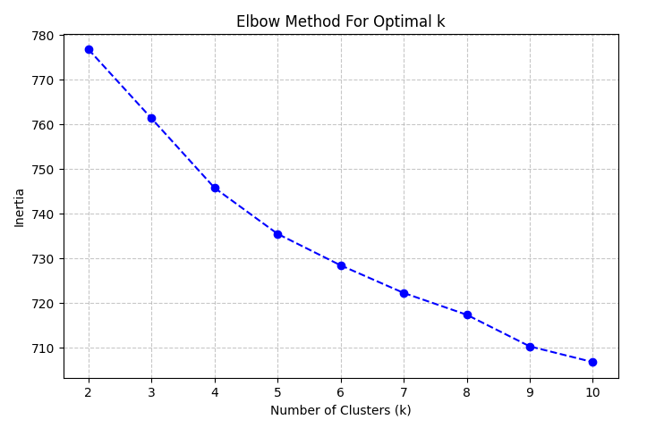
Figure 1: Elbow of dataset A
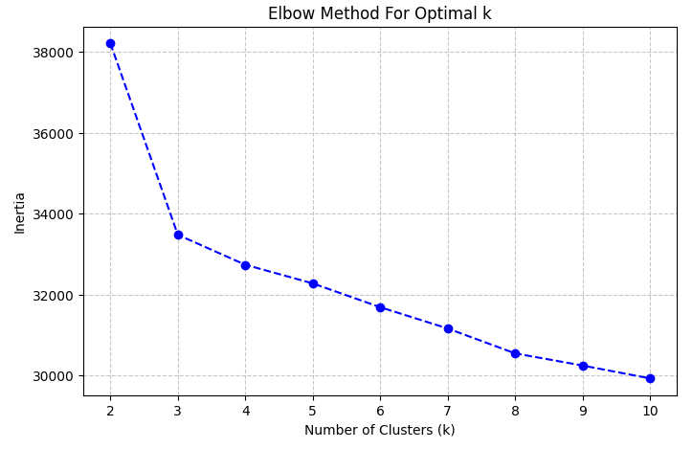
Figure 2: Elbow of dataset B

3.3 Methodological Critique: Exposing Synthetic Data via PCA
To geometrically validate the cluster separation, Principal Component Analysis (PCA) was applied. The first two principal components (PC1 and PC2) cumulatively retain 38% of the dataset's total variance. From a methodological standpoint, in the computational study of Natural Language Processing (NLP) via TF-IDF matrices—which are inherently characterized by extremely high dimensionality and matrix sparsity—an explained variance of less than 50% is not only expected but statistically robust.
Crucially, this variance threshold was sufficient to expose a profound ontological difference between the two data sources. When applied to Dataset A (the organic LinkedIn data), the PCA revealed overlapping, amorphous clusters. This geometric distribution is deeply consistent with natural human language and the fluid nature of real-world job roles, where the skills of a traditional Data Analyst naturally overlap with those of a Data Engineer.
However, when applied to Dataset B (the 2026 AI dataset), the PCA produced geometrically perfect, parallel, and totally distinct clusters (often referred to in data science as "perfect cigars"). In computational social science, human language and organic market behavior never produce zero-variance boundaries. This geometric anomaly was corroborated by a subsequent analysis of Dataset B's metadata, which revealed that experience-level percentages (e.g., exactly 20% Entry, 50% Mid, 30% Senior) and salary distributions were mathematically identical across all distinct clusters.
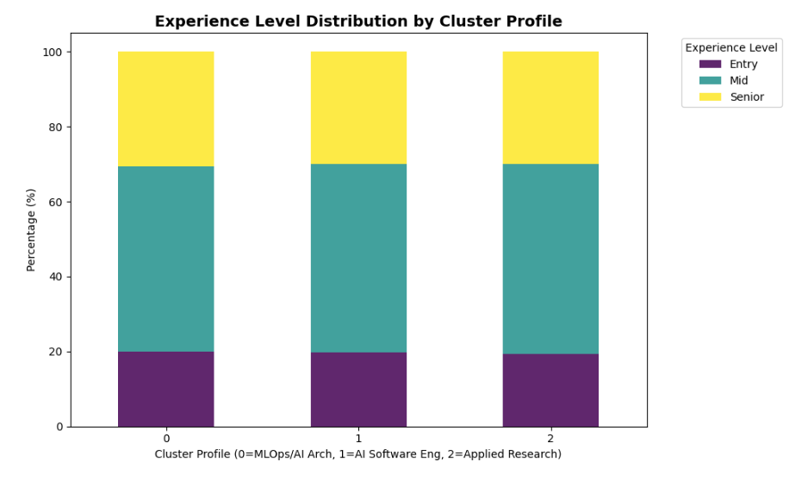
This total lack of conditional variance provides definitive empirical proof that Dataset B is not a product of organic web-scraping, but rather a synthetically generated dataset, likely utilizing LLM templates combined with randomized numerical distributions. This finding serves as a profound methodological warning for social researchers: the uncritical adoption of open-source datasets can lead to the analysis of artificial simulations rather than real societal phenomena. Consequently, while the synthetic dataset remains useful for identifying projected future skill keywords, its socio-economic metadata (salary, geography) must be interpreted with extreme caution, relying more heavily on the organic validity of Dataset A.
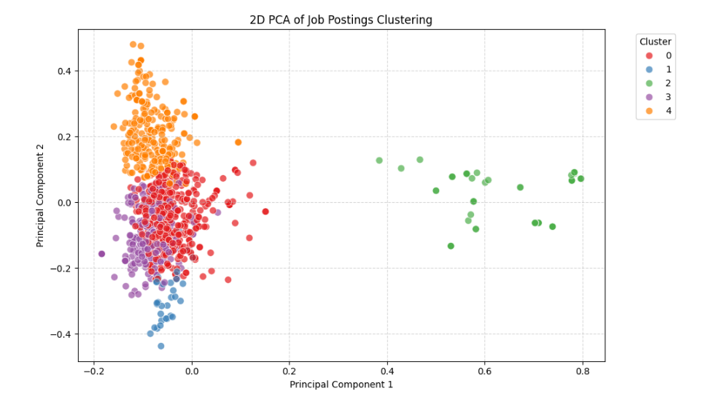
Figure 3: Clustering of dataset A
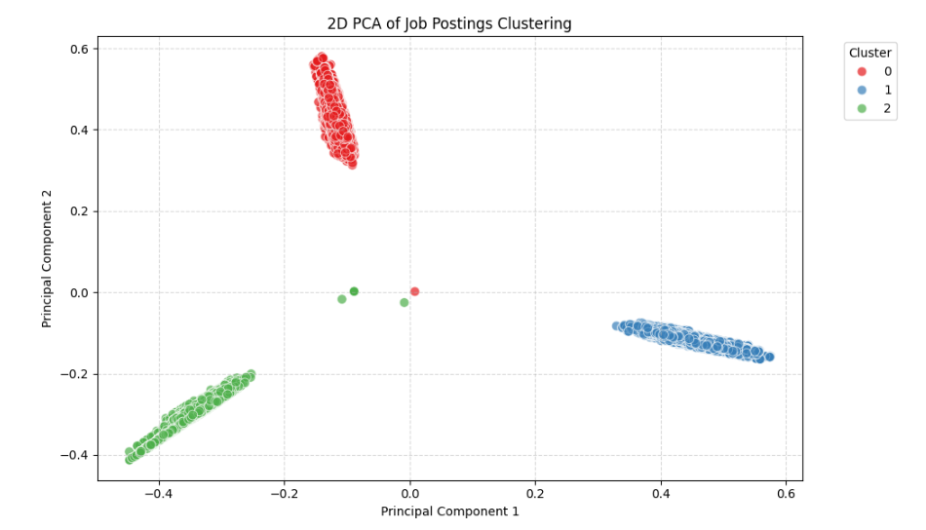
Figure 4: Clustering of dataset B

4. Experimental Findings: The Organic Fragmentation vs. Synthetic Simplification
The application of the TF-IDF and K-Means pipeline on the organic dataset (Dataset A) successfully segmented the real-world market into $k=5$ distinct sociological archetypes. This high number of clusters reflects the authentic fragmentation and complexity of modern tech recruitment, revealing nuances that go beyond mere technical skills to include corporate cultures.
4.1 The Five Archetypes of the Real Market
The algorithmic extraction of latent skills from LinkedIn data yielded the following profiles:
- Cluster 4 (The MLOps and AI Architect): The absolute frontier of the market. Dominated by terms like scale pipelines, cloud, and deployment, this cluster proves that the highest demand is no longer just for building models, but for engineering the infrastructure to put them into production.
- Cluster 3 (The BI Analyst): The traditional core of data work. Anchored to dashboards, SQL, and reporting, representing the legacy roles focused on business intelligence rather than predictive engineering.
- Cluster 1 (The Applied Researcher): A hybrid profile bridging the gap between academic research and business strategy, focusing on cutting-edge tools and lead generation.
- Clusters 0 & 2 (The "Big Tech" Corporate Archetypes - e.g., Netflix/Meta profiles): In the organic dataset, the algorithm isolated clusters heavily characterized by specific corporate jargon and massive scale requirements typical of FAANG companies. This is a profound sociological finding: in the real world, a job profile is defined not just by a programming language, but by the hyper-specific operational culture of mega-corporations.
Although the mathematical parameters (Elbow Method and Silhouette Score) identified $k=5$ as the optimal segmentation of the vector space—highlighting a clear geometric separation between Cluster 0 and Cluster 2 due to slight divergences in the required technology stack—the hermeneutic and qualitative analysis suggests a sociological convergence. Both clusters are saturated by the identical corporate jargon and organizational metrics typical of technological mega-corporations (e.g., Meta and Netflix-style recruiting templates). Therefore, while preserving the 5-cluster computational distinction to ensure the statistical rigor of the algorithm, Clusters 0 and 2 are treated conceptually as internal articulations of the same occupational archetype: the Big Tech Corporate Professional.
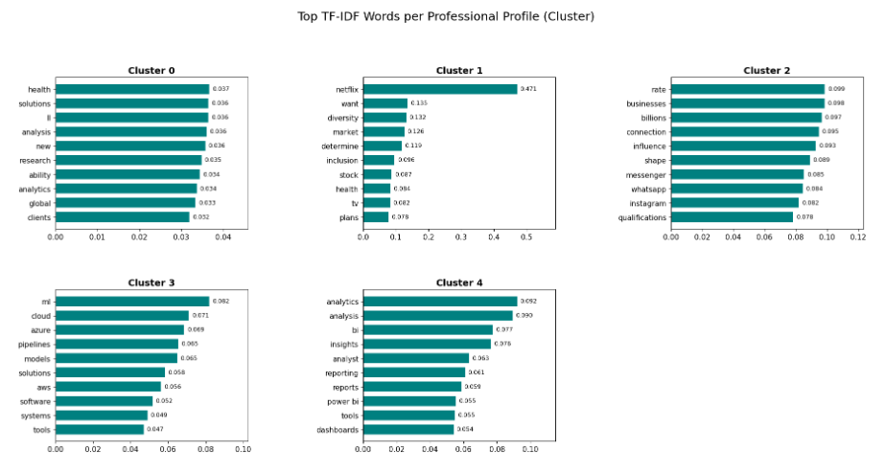
4.2 The Synthetic Simplification (Dataset B)
When the identical methodology was applied to the synthetic 2026 forecast data, the optimal number of clusters collapsed to $k=3$ (MLOps, Software Engineering, Applied Research). The synthetic data completely failed to capture the legacy BI roles and the corporate-specific archetypes (Clusters 0, 2, and 3 from Dataset A).
This contrast is methodologically crucial. The LLM-generated dataset represents an idealized, sanitized version of the future market, stripping away the "noise" of human recruitment. While it correctly predicts the technical shift towards MLOps and Retrieval Systems, it sociologically fails to represent the messy reality where highly advanced AI architects coexist with traditional dashboard analysts and idiosyncratic corporate cultures.
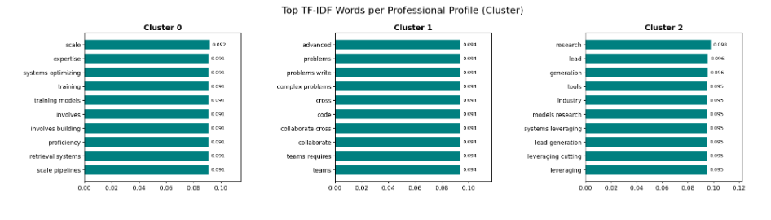

5. Socioeconomic Nuances: Geography and Remuneration
While the extraction of latent skills constitutes the primary focus of this research, the algorithmic processing of the datasets metadata provides two crucial socio-economic nuances that contextualize these skills within the broader society.
5.1 Geographic Reality vs. The Remote Utopia
The spatial operationalization of job locations—standardized via Regular Expressions to capture complex string formatting such as US state abbreviations—revealed a profound divergence in the geopolitical organization of labor between the two datasets.
In the real-world market corpus (Dataset A), job distribution is heavily anchored to concrete, physical technological clusters. The workforce is structurally concentrated within specific national boundaries—predominantly the United States, the United Kingdom, Germany, and the Netherlands. This regional concentration aligns with the corporate-specific clusters (e.g., the isolated Netflix and Meta corporate jargon profiles found in K-Means), proving that real-world AI deployment is still bound to centralized corporate headquarters and local economic ecosystems.
In line with the technical artificiality already demonstrated in the methodological chapter via PCA, the spatial analysis of Dataset B merely confirms the ideological bias of the synthetic generator. It displays a remote work utopia (45%) that is completely misaligned with the persistent geopolitical centralization found in the organic LinkedIn corpus (Dataset A). The LLM template generator simulated an idealized, frictionless future of work that completely decouples high-cognitive technical execution from geographical constraints. By contrasting the two heatmaps, this study demonstrates that while the artificial dataset predicts a democratic, decentralized global market, the organic LinkedIn trace data unmasks a persistent, centralized technocratic geography where physical presence and regional hubs remain dominant parameters.
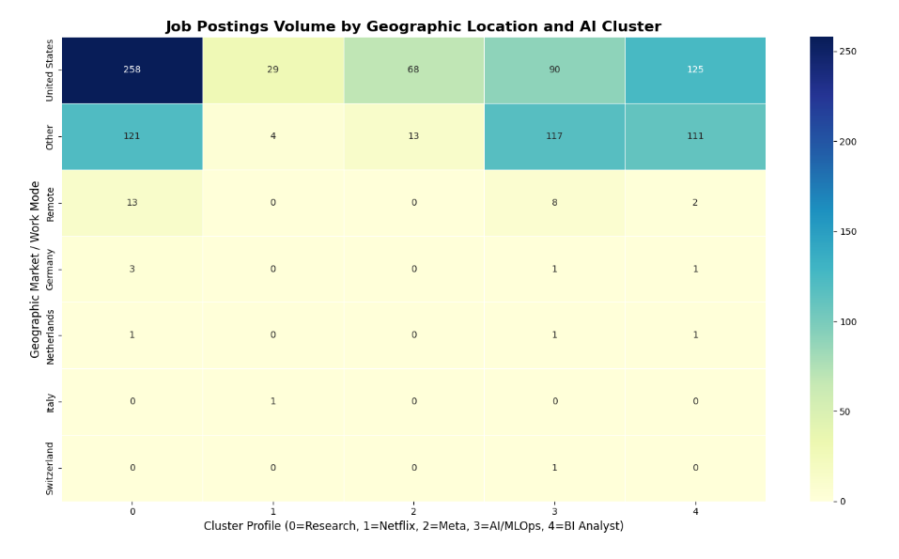
Figure 5: Geography analysis of dataset A
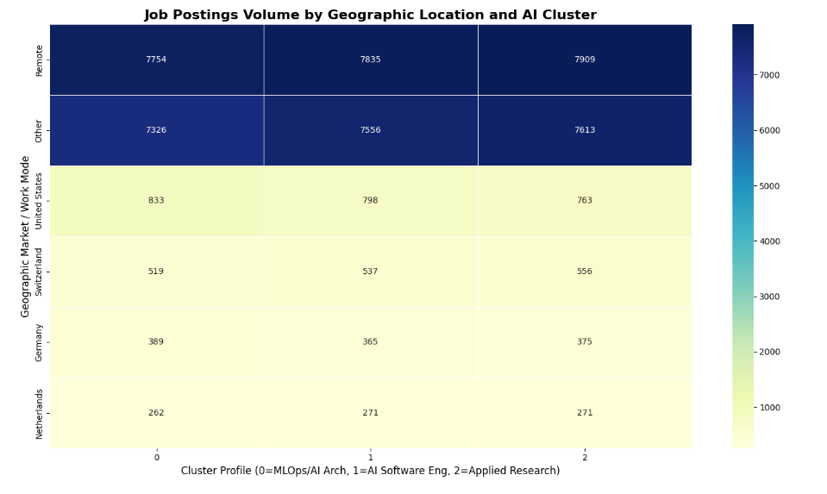
Figure 6: Geography analysis of dataset A

5.2 The Illusion of Salary Equality and Synthetic Metadata
The analysis of standardized median salaries via boxplots revealed a highly anomalous socio-economic metric: despite the existence of three distinct professional clusters, the extracted boxplots displayed mathematically identical quartiles and medians—down to the exact dollar—across all profiles.
Contrary to current labor market literature, which dictates a strong salary premium for specialized engineering roles, this lack of variance ceases to be an inexplicable anomaly when placed in the context of our algorithmic audit. It does not suggest that the AI labor market has achieved perfect egalitarianism; rather, it acts as the definitive empirical proof of the dataset's synthetic nature. The compensation metadata was clearly generated through a randomized, uniform distribution function, completely decoupled from the qualitative semantic content of the job descriptions.
Consequently, the synthetic dataset masks the true economic polarization of the tech sector, presenting a sterile illusion of equality. This finding serves as a profound methodological warning: artificial datasets, when not subjected to rigorous exploratory data analysis, can severely distort sociological findings regarding wealth distribution, replacing the complex realities of economic disparity with the mathematical homogeneity of a generation algorithm.
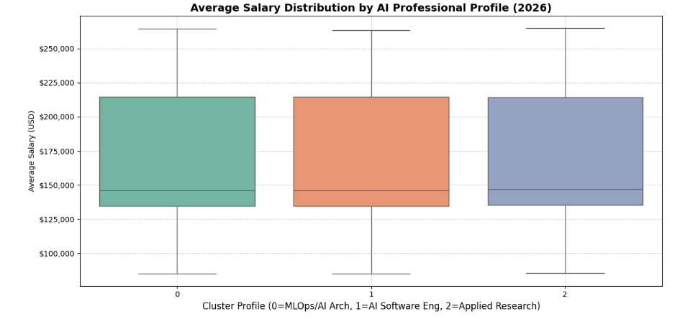
6. Discussion
The empirical findings of this research carry profound implications for the economic sociology of high-cognitive labor. The clear fragmentation of the 'Data Scientist' title demonstrates that AI-driven technological progress is not an inherently democratizing force. Instead, it triggers a rigorous Skill-Biased Technological Change that aggressively rewards a technocratic elite capable of deploying production-level AI infrastructure (MLOps), while marginalizing traditional, descriptive analytics roles that face an immediate threat of automation. Furthermore, the emergence of professional profiles defined by the idiosyncratic corporate jargon of mega-corporations (Big Tech) suggests that organizational power is actively shaping modern work identities.
Equally significant is the geographic reality uncovered by our organic data, which dismantles the utopia of a decentralized global labor market. Despite the prevailing narrative surrounding remote work, actual AI employment remains firmly anchored to specific local economic ecosystems and centralized corporate headquarters, reproducing pre-existing geopolitical inequalities on a global scale.
Beyond these socio-economic dynamics, our comparative analysis highlights a critical epistemological crisis in contemporary digital sociology. The synthetic dataset constructed a double illusion: an economic mirage of wage flattening and a spatial fantasy of a borderless workforce. By acting as an algorithmic audit, this study exposes how artificial data generators inherently sanitize social realities, stripping away the structural frictions of corporate hegemony and localized wealth accumulation. If sociologists uncritically rely on massive, unverified open-source repositories simply due to their attractive sample sizes, they risk theorizing about idealized computational simulations rather than actual human behavior.

7. Conclusion
This study applied a rigorous computational social science methodology to dissect the profound structural transformations within the Artificial Intelligence labor market. By moving beyond a priori occupational classifications and analyzing the actual linguistic demands of employers, this research successfully mapped a stark technical and social polarization. The market is shifting away from the monolithic and generalist figure of the "Data Scientist" to fracture into hyper-specialized archetypes, contrasting advanced AI architectures against a "data proletariat" relegated to routine analytics.
Ultimately, deciphering the future of work requires digital sociology to recognize that digital literacy alone no longer guarantees social mobility; rather, a worker's socio-economic positioning is now dictated by the specific technological architecture they are able to master. To remain scientifically sound and fully comprehend the impact of AI, modern computational social science must actively resist the allure of sanitized datasets. Future research must continue to investigate these new forms of stratification, focusing on the messy, localized, and unequal frictions that define the real-world workforce.

8. References
Mergoni, A. (2026). Social Research LinkedIn Market Analysis Repository. Kaggle Code. URL: https://www.kaggle.com/code/albertomergoni/social-research-mergoni
Mergoni, A. (2026). Social Research 2026 Standardized Forecast Repository. Kaggle Code. URL: https://www.kaggle.com/code/albertomergoni/social-research-mergoni-std
Dataset A URL: https://www.kaggle.com/datasets/joykimaiyo18/linkedin-data-jobs-dataset
Dataset B URL: https://www.kaggle.com/datasets/m0sm71/ai-jobs-dataset-2026

