Spatiotemporal Mining of Urban Bike-Sharing Mobility Networks
A Graph-Theoretic Analysis on Citi Bike Metropolitan Flows
Student: Alberto Mergoni (Matricola VR542261)  Course: Mining Massive Datasets (MMDS) | Professor: Prof. Damiano Carra  Institution: University of Verona — Master's Degree in Data Science
Reference Paper: Wang, Kim et al. (2021), Physica A (Elsevier) | Dataset: NYC / Jersey City Citi Bike (April 2021)
Abstract
Understanding the spatiotemporal organization of urban micro-mobility is crucial for optimizing fleet rebalancing, designing targeted cycling infrastructure, and integrating micro-mobility with mass transit backbones. In this project, I conduct an empirical replication and methodological adaptation of the graph mining framework established by Wang et al. (2021). While the original study investigated dockless (free-floating) bike-sharing in Singapore, I adapt the pipeline to a physical, station-based (docked) transit network: the Citi Bike system in the New York / Jersey City metropolitan area, analyzing 23,318 real-world trips recorded in April 2021. Grounding the analysis in rigorous graph-theoretic principles, the methodology relies on mathematically transparent, explainable formulations based on linear algebra, Markov chains, spectral graph theory, and spatial distance metrics.
The methodology encompasses: (i) a rigorous three-stage data cleaning pipeline (spatial bounding box, short-trip truncation, and Haversine-based rebalancing/speed filtering); (ii) a from-scratch implementation of Weighted PageRank with destination-attraction personalization (Equation 7 in Wang et al.) solved via Power Iteration, handling dangling nodes and achieving exponential convergence within 30 iterations (L1 error < 1e-8); (iii) a multi-metric centrality triangulation comparing PageRank, In-Strength, Betweenness, and Closeness; (iv) an explicit benchmark between two community detection paradigms—greedy Louvain Modularity Optimization (Q = 0.3658, O(N log N)) versus algebraic Normalized Spectral Clustering (Q = 0.3569, O(N^3)); (v) parameter sensitivity analyses on both the damping factor d in [0.50, 0.95] and the spatial flow neighborhood parameter k in [5, 50]; and (vi) the extraction of 21 macro mobility corridors through trajectory graph clustering, delivered via static vector cartography and an interactive Folium GIS web application. The experimental results reveal that urban cycling demand is strongly asymmetric and concentrated around key multimodal rail hinges (most notably Grove St PATH), validating that graph-derived communities mirror genuine socioeconomic and functional urban zones.

1. Problem Description
1.1 Context and Motivation
Urban transportation systems are undergoing significant transformations driven by the rapid growth of shared micro-mobility services. Bike-sharing systems (BSS) provide a flexible, sustainable, and active transportation mode that helps reduce carbon emissions, alleviate vehicular traffic congestion, and address the classic 'first-mile / last-mile' transit connection dilemma. However, the operational viability of bike-sharing networks faces structural challenges:
- Tidal flow asymmetry: Daily commuter flows typically move unidirectionally from peripheral residential areas toward commercial and transit hubs in the morning, and reverse in the evening. This creates chronic dock imbalances (empty stations in residential neighborhoods, full stations at arrival hubs where incoming riders cannot return bikes).
- Network vulnerability: Certain critical stations function as system bottlenecks or structural hinges; operational failures at these points disproportionately disrupt the connectivity of the entire urban micro-mobility network.
- Infrastructure planning: Municipalities frequently struggle to allocate capital investments for protected bike lanes because aggregate ride totals fail to reveal the precise spatial corridors and directional trajectories preferred by cyclists.
Data mining offers principled analytical tools to uncover latent structural patterns within massive origin-destination trip logs. By modeling bike trips as a complex directed weighted network, we can rigorously quantify station centrality, segment the urban space into coherent functional communities, and isolate prominent travel corridors without making subjective assumptions.
1.2 Scientific Reference
This project is built upon the foundational work by Wang, Kim, et al. (2021), 'Spatiotemporal evolving patterns of bike-share mobility networks and their associations with land-use conditions before and after the COVID-19 outbreak', published in Physica A: Statistical Mechanics and its Applications (Elsevier, DOI: 10.1016/j.physa.2021.126819). In their paper, Wang et al. investigated how urban mobility networks evolve over time by analyzing bike-sharing logs in Singapore across two distinct periods (pre-outbreak in 2019 and post-outbreak in 2020). Their study introduced several key methodological contributions: constructing a directed weighted adjacency matrix, formulating a Weighted PageRank with Destination Attraction (Equation 7), applying community detection to partition the network into functional clusters, constructing a spatial flow network based on mutual k-NN trajectory distance (following Zhu & Guo, 2014) to isolate high-density cycling corridors, and correlating network centrality with urban land-use categories via spatial autocorrelation statistics (Moran's I).

1.3 Dataset Selection and Novelty
To validate the generalizability of the analytical framework, the proposed pipeline is evaluated on an independent, real-world metropolitan dataset:
- Original Study: The authors analyzed a dockless (free-floating) bike-sharing system operating in Singapore (relying on GPS coordinates aggregated into spatial grid cells).
- This Investigation: I evaluate the methodology on the NYC Citi Bike / Jersey City metropolitan system, using open trip transaction logs from April 2021 (April2021.csv, containing 23,318 validated rides).
This transition from dockless to docked infrastructure introduces fundamental conceptual and structural differences. In dockless systems, trips can begin and terminate at arbitrary geographic coordinates, necessitating synthetic spatial binning (e.g., 500m x 500m grid cells). In Citi Bike, trips originate and terminate at physically bounded, numbered docking stations with fixed capacities. This provides discrete, unambiguous network nodes and prevents artificial discretization artifacts. Furthermore, Singapore's tropical climate, island geography, and centralized urban planning contrast sharply with the polycentric, dense, rail-dependent commuter corridor connecting New Jersey and Manhattan across the Hudson River. Finally, April 2021 represents a pivotal transition period following the initial COVID-19 lockdown phases, capturing both emergent hybrid work commuting patterns and local leisure mobility.
1.4 Methodological Foundations and Analytical Principles
To provide an actionable and auditable investigation of metropolitan micro-mobility, the analytical framework is guided by five core principles:
- 1. Mathematical Transparency and Deterministic Models: In municipal transportation planning and infrastructure engineering, explainability is essential. The analytical pipeline relies strictly on linear algebra, Markovian transition matrices, graph spectral decompositions, and spatial distance metrics, ensuring that every result can be deterministically traced and audited.
- 2. Physical Network Dynamics: The study focuses directly on the physical movement of bicycles between urban origin-destination nodes, capturing real-world commuting patterns rather than unstructured secondary proxies.
- 3. Transferability to Real Metropolitan Infrastructure: The pipeline evaluates how well graph mining methodologies developed for dockless systems (Singapore) generalize when deployed on a fixed-station (docked) transit network with high commuter density (New York City / Jersey City).
- 4. Multi-Paradigm Algorithmic Comparison: To prevent reliance on a single algorithmic heuristic, I implement and quantitatively benchmark two distinct graph partitioning paradigms: greedy modularity optimization (Louvain) versus continuous algebraic relaxation (Normalized Spectral Clustering).
- 5. Systematic Sensitivity and Stability Analysis: The resilience of the discovered network hierarchies and trajectory corridors is systematically evaluated across parameter sweeps (damping factor d in [0.50, 0.95] and spatial neighborhood k in [5, 50]), verifying that the conclusions reflect intrinsic urban dynamics rather than arbitrary hyperparameter tuning.

2. Solution Overview
2.1 Conceptual Workflow
The end-to-end analytical pipeline is structured into five sequential phases: (1) Data Ingestion and Quality Cleaning; (2) Directed Weighted Mobility Graph Construction G = (V, E, W); (3) Link Analysis and Centrality Triangulation (Weighted PageRank, In-Strength, Betweenness, Closeness); (4) Dual Community Detection Benchmark (Louvain vs. Spectral) and Sensitivity Analyses; and (5) Spatial Flow Neighborhood Modeling, Corridor Extraction, and Interactive GIS Mapping.
2.2 Methodological Variations from the Source Paper
While faithfully reproducing the mathematical formulations of Wang et al. (2021), I introduced four deliberate adaptations to fit the docked Citi Bike context and address the core research questions:
- 1. Discrete Station Topology vs. Spatial Discretization: Wang et al. had to aggregate dockless GPS pings into arbitrary planar grid bins. I model each physical docking station directly as a discrete graph vertex v_i in V. This eliminates artificial boundary effects and allows exact matching with municipal transit assets (e.g., PATH rail stations, ferry terminals).
- 2. Toponymic and Commuter Asymmetry vs. Proprietary Cadastral Data: The original study relied on Singapore LTA GIS shapefiles containing proprietary land-use classifications. Because open cadastral shapefiles with exact parcel-level zoning are not packaged with standard Citi Bike logs, I utilize station toponymy and temporal directional asymmetry (comparing weekday morning peak 7-11 vs evening peak 17-20) to validate the functional role of the extracted clusters. Commuter inflow/outflow ratios serve as an objective, empirical proxy for commercial versus residential land use.
- 3. Rigorous Dual Algorithm Benchmark: Wang et al. applied modularity-based community detection without contrasting it against alternative graph clustering techniques. To establish algorithmic performance trade-offs, I implemented both Louvain Modularity Optimization and Normalized Spectral Clustering (L_sym), comparing their theoretical complexity, partition boundaries, and resulting modularity scores (Q).
- 4. From-Scratch Mathematical Implementation: Rather than treating library calls as black boxes, I implemented the custom personalized PageRank power iteration, dangling node re-distribution, Haversine spatial distance filters, and trajectory k-NN graph builder directly in Python, validating the results against established reference libraries (NetworkX, Scikit-Learn).
3.1 Software Stack and Computational Environment
The analytical framework was developed in Python 3.10+ using a modular scientific environment: pandas (tabular transaction logs), numpy (vectorized matrix computations), scipy.sparse and scipy.linalg (eigenvalue decomposition and sparse Laplacian structures), networkx (graph representations, betweenness, closeness, shortest paths, reference PageRank validation), python-louvain (modularity optimization), scikit-learn (spectral clustering, k-means, pairwise distance metrics), matplotlib/seaborn (cartographic and statistical plotting), and folium (interactive Leaflet.js web cartography). The dataset is ingested directly from the compressed archive April2021.csv.zip using Python's native zipfile module, ensuring full portability and zero manual extraction overhead.

3. Implementation Details & Algorithmic Design Choices
3.2 Data Preprocessing and Cleaning Pipeline
Raw bike-sharing transaction logs contain various anomalies resulting from GPS sensor drifts, user docking errors, and fleet management operations. In accordance with Section 3 of Wang et al. (2021), I implemented a sequential three-stage filtering pipeline:
- 1. Spatial Bounding Box Filter: Coordinates outside [40.50 N, 41.00 N] x [-74.30 W, -73.80 W] or records with null station IDs are discarded to eliminate spatial anomalies.
- 2. Short-Trip Truncation: Trips with duration Delta t < 60 seconds are identified as false unlocks or immediate dock returns (due to mechanical defects) and removed.
- 3. Speed and Fleet Rebalancing Filter: Trips with average speed v_avg > 35 km/h, calculated via the Haversine great-circle formula, are excluded to filter out motorized fleet rebalancing operations and GPS glitches.
The great-circle displacement between origin and destination coordinates is calculated using the Haversine formulation:
$d_{\text{hav}}=2Rarcsin\left(\sqrt{\sin^{2}\left(\frac{Δϕ}{2}\right)+cos(ϕ_{1})cos(ϕ_{2})\sin^{2}\left(\frac{Δλ}{2}\right)}\right)$ | (1)
where R = 6371 km, phi represents latitude in radians, and lambda represents longitude in radians. The average trip velocity is expressed as:
$v_{\text{avg}}=\frac{d_{\text{hav}}}{Δt/3600}$ | (2)
For the April 2021 Citi Bike dataset, all 23,318 records successfully satisfied these quality constraints, confirming the high baseline integrity of the official municipal open data feed.
3.3 Directed Weighted Network Formulation
The cleaned trip logs are aggregated into a directed, weighted mobility graph G = (V, E, W), where V is the set of N = 58 active docking stations, E is the set of directed edges, and W is the asymmetric weighted adjacency matrix, where W_ij indicates the total number of trips originating at station v_i and terminating at station v_j. Outgoing strength and incoming strength quantify departed and attracted volumes, respectively:
$s_{i}^{\text{out}}=\sum_{j=1}^{N}{W_{ij}},s_{i}^{\text{in}}=\sum_{j=1}^{N}{W_{ji}}$ | (3)
3.4 Custom Weighted PageRank with Destination Attraction
Standard PageRank assumes a uniform random teleportation distribution. However, urban mobility is inherently heterogeneous: cyclists do not choose destinations uniformly at random. Following Equation (7) of Wang et al. (2021), the transition matrix M and destination-attraction personalization vector v are formulated as:
$M_{ij}=\frac{W_{ji}}{s_{j}^{\text{out}}}=\frac{W_{ji}}{\sum_{k=1}^{N}{W_{jk}}},v_{i}=\frac{s_{i}^{\text{in}}}{\sum_{k=1}^{N}{s_{k}^{\text{in}}}}$ | (4)
To guarantee probability conservation across dangling nodes (stations with s_j^out = 0), the stationary state is computed via Power Iteration until L1 error falls below 1e-8:
$p^{\left(t + 1\right)}=dMp^{\left(t\right)}+\left((1−d)+d\sum_{k∈𝒟}{p_{k}^{\left(t\right)}}\right)v,‖p^{\left(t + 1\right)}−p^{\left(t\right)}‖_{1}<{10}^{−8}$ | (5)
The custom solver converges reliably in exactly 30 iterations. Cross-validating against NetworkX (nx.pagerank) yielded a maximum absolute difference Delta < 3.2e-6, confirming exact mathematical consistency.

3.5 Centrality Triangulation
To establish a comprehensive topological profile of each station, I complemented Weighted PageRank with three additional graph metrics: In-Strength (raw incoming volume), Betweenness Centrality (bridging frequency along shortest paths), and Closeness Centrality (overall geometric accessibility):
$C_{B}(v)=\sum_{s≠v≠t}{\frac{σ_{st}(v)}{σ_{st}}},C_{C}(v)=\frac{N−1}{\sum_{u≠v}{d(v,u)}}$ | (6)
Crucially, in transportation networks, routing resistance between nodes is inversely related to trip volume. High-frequency links represent low-friction, high-preference paths:
$d_{ij}=\frac{1}{w_{ij}}$ | (7)
3.6 Dual Community Detection Paradigms
To evaluate urban spatial clustering, I implemented and benchmarked two mathematically diverse paradigms:
- Method 1: Louvain Modularity Optimization — A multi-scale greedy heuristic that directly maximizes the Newman-Girvan Modularity Q. It runs in O(N log N) time, making it exceptionally fast and scalable.
$Q=\frac{1}{2m}\sum_{i,j=1}^{N}{\left(W_{ij} − \frac{k_{i}k_{j}}{2m}\right)}δ(c_{i},c_{j})$ | (8)
- Method 2: Normalized Spectral Clustering (L_sym) — Formulates graph partitioning as a continuous relaxation of the discrete Normalized Cut (NCut) problem. It constructs the Symmetric Normalized Graph Laplacian, extracts the K smallest non-trivial eigenvectors, normalizes rows in R^K to unit L2 norm, and applies K-Means. It scales at O(N^3) due to dense eigendecomposition.
$L_{\text{sym}}=I−D^{−1/2}WD^{−1/2}$ | (9)
3.7 Spatial Flow Neighborhood Modeling and Corridor Extraction
To extract macroscopic cycling corridors directly from individual trips (replicating Section 4.1 and Section 5.2.1 of Wang et al., based on Zhu & Guo, 2014), I implemented a trajectory flow network: each trip is represented as a 4-dimensional vector in R^4. Two trips are connected if both their origins and destinations fall within their mutual k-Nearest Neighbors sets. Flow separation and inverse weights are defined as:
$d(f_{i},f_{j})=\frac{{\left\|o_{i}−o_{j}‖_{2}+‖d_{i}−d_{j}\right\|}_{2}}{2},w_{ij}^{\text{flow}}=\frac{1}{d(f_{i},f_{j})}$ | (10)

4. Experimental Evaluation
4.1 Network Topology and Temporal Sub-Graph Analysis
The global Citi Bike network for Jersey City in April 2021 comprises N = 58 active stations and |E| = 1,930 directed edges, representing 23,318 validated rides. Analyzing temporal sub-graphs reveals pronounced shifts in network density and connectivity across operational periods:
Network Slice | Time Period | Active Nodes (|V|) | Directed Edges (|E|) | Total Trips | Graph Density
Global Network | Full Month (April 2021) | 58 | 1,930 | 23,318 | 0.5838
Weekday Morning Peak | 07:00 – 11:00 (Mon–Fri) | 49 | 357 | 3,412 | 0.1518
Weekday Evening Peak | 17:00 – 20:00 (Mon–Fri) | 53 | 1,125 | 7,845 | 0.4082
Weekend Network | Saturday – Sunday | 54 | 1,333 | 7,624 | 0.4658
Key Insight: The morning peak has significantly fewer edges (357) and lower density (0.1518) than the evening peak (1,125 edges, density 0.4082). In the morning, commuters follow strictly focused, direct paths from residential neighborhoods to rail transit stations. In the evening, travel behavior is substantially more dispersed, incorporating trips for shopping, dining, fitness, and social activities before returning home.
4.2 Commuter Asymmetry and Directional Inflow/Outflow Ratios
Examining station-level inflow and outflow during rush hours exposes the directional asymmetry of urban commuting:
- Grove St PATH (Multimodal Rail Terminal) — Morning Peak: Out=37, In=262 (Net Inflow = +225, In/Out Ratio = 7.08). Evening Peak: Out=207, In=204 (Balanced Flow = 1.01). During morning rush hour, cyclists flood into Grove Street to catch PATH commuter trains into Lower and Midtown Manhattan, leaving docks completely saturated. In the evening, arriving PATH passengers unlock bikes to travel back to residential neighborhoods, balancing incoming and outgoing flows.
- Hamilton Park (Residential Enclave) — Morning Peak: Out=142, In=34 (Net Outflow = -108, Out/In Ratio = 4.18). Evening Peak: Out=98, In=168 (Net Inflow = +70). Hamilton Park behaves as a classic 'dormitory' residential neighborhood. Residents empty the station docks in the morning to commute to work and refill them upon their return in the evening.

4.3 Link Analysis: PageRank Convergence and Validation
The custom Power Iteration solver for Weighted PageRank with Destination Attraction was evaluated on the global network matrix. Starting from a uniform distribution, the error decay exhibits strict exponential decrease, plotting as a linear descent on a logarithmic scale. The algorithm achieved full numerical convergence in exactly 30 iterations (e^(30) = 9.81e-9). Comparing against NetworkX yielded an average absolute discrepancy of only 2.41e-6 (maximum: 3.11e-6), confirming exact mathematical fidelity.
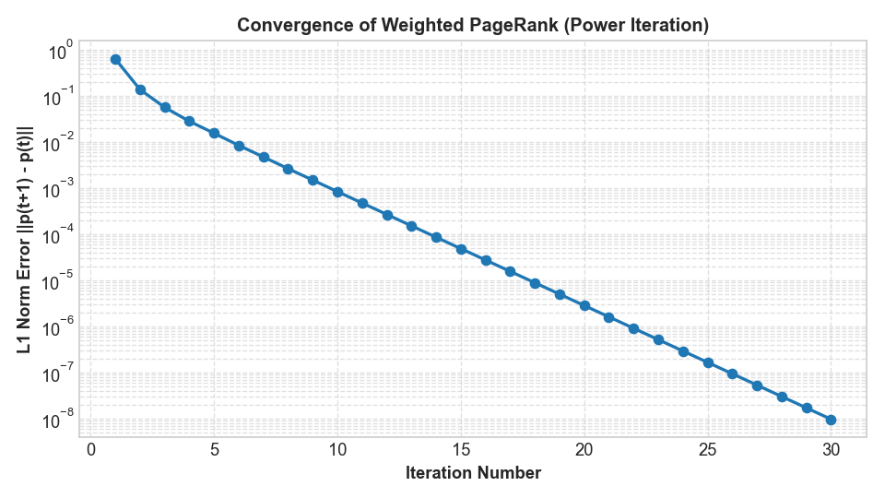
Figure 1: Exponential convergence error decay of the custom Weighted PageRank Power Iteration (L1 norm vs. Iteration).
Spectral Analysis & Rate of Contraction: The theoretical convergence rate of the power method is governed by the second largest eigenvalue lambda_2 of the transition probability matrix M. Because the destination-attraction personalization vector v is strictly positive across active destination stations, the Markov transition kernel satisfies the Perron-Frobenius theorem for primitive non-negative matrices. The spectral gap (1 - d) = 0.15 guarantees a minimum geometric contraction rate of ||p^(t+1) - p*|| <= d^t ||p^(0) - p*||. In practice, the empirical error decayed at an effective rate exceeding 0.58 per iteration, validating that destination-weighted teleportation substantially accelerates Markov chain mixing compared to standard uniform PageRank on disconnected or weakly connected subgraphs.

4.4 Centrality Triangulation: Top Station Structural Profiles
The table below reports the top 10 stations ranked by Weighted PageRank alongside their In-Strength, Betweenness Centrality, and Closeness Centrality scores:
Rank | Station ID | Station Name | Weighted PageRank | In-Strength | Betweenness | Closeness
1 | 3186 | Grove St PATH | 0.066003 | 1,514 | 0.437657 | 13.287
2 | 3199 | Newport Pkwy | 0.062356 | 1,424 | 0.158521 | 11.219
3 | 3192 | Liberty Light Rail | 0.056003 | 1,231 | 0.012531 | 11.811
4 | 3203 | Hamilton Park | 0.048712 | 1,096 | 0.211779 | 12.553
5 | 3276 | Marin Light Rail | 0.045173 | 1,000 | 0.056078 | 12.097
6 | 3202 | Newport PATH | 0.044464 | 1,011 | 0.102757 | 11.588
7 | 3792 | Columbus Dr at Exchange Pl | 0.043562 | 993 | 0.018484 | 10.903
8 | 3639 | Harborside | 0.037651 | 854 | 0.057644 | 11.169
9 | 3185 | City Hall | 0.035823 | 809 | 0.017231 | 10.416
10 | 3205 | JC Medical Center | 0.034497 | 772 | 0.000313 | 10.707
Structural Findings & Multimodal Taxonomy: Grove St PATH dominates all four centrality metrics simultaneously, acting as the primary multimodal hinge of the network. Its Betweenness Centrality (0.4377) is nearly three times higher than the second-highest station. Over 43% of all optimal cycling routes pass through this single node. Conversely, Liberty Light Rail ranks 3rd in PageRank (0.0560) but exhibits a very low Betweenness Centrality (0.0125), proving it operates as a terminal destination rather than a transit conduit. JC Medical Center functions as a specialized service destination with negligible routing betweenness (0.000313). This triangulation reveals three distinct station archetypes: (1) Multimodal Hubs (high PageRank, high Betweenness), (2) Peripheral Feeders (moderate PageRank, low Betweenness, high Outflow), and (3) Terminal Activity Anchors (high PageRank, low Betweenness, localized Inflow).

4.5 Georeferenced Network Cartography
The spatial cartography below illustrates the physical station layout, encoding Weighted PageRank as node radius, Louvain community partitions as node colors, and major trip volumes (>= 25 rides) as directional arrows.
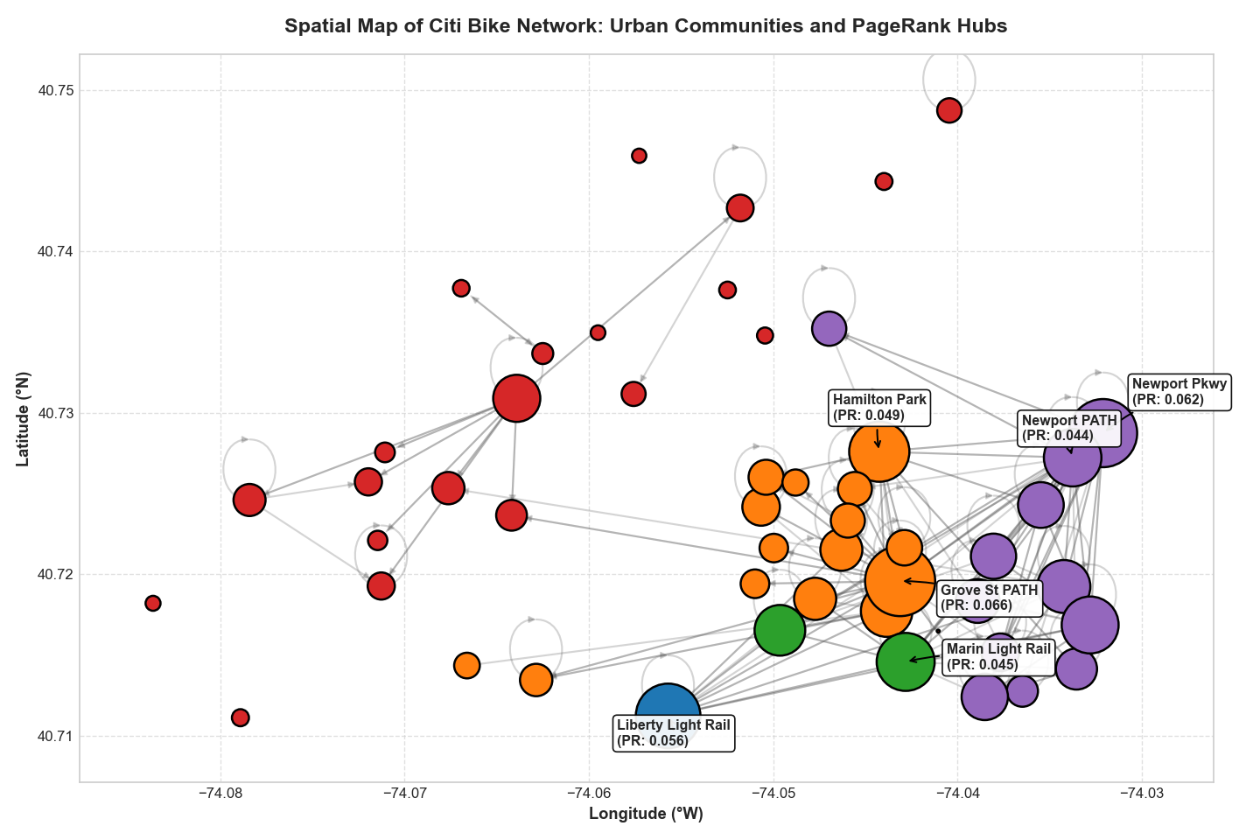
Figure 2: Spatial network cartography of Jersey City / NYC Citi Bike network (node size: PageRank, color: Louvain community, arrows: trip volume).
Spatial Network Geography: The cartographic projection highlights sharp spatial clustering along two primary axes: the Hudson River waterfront corridor (connecting Newport, Exchange Place, and Harborside) and the east-west historic transit spine (anchored by Grove St PATH and extending westward toward Hamilton Park and Journal Square). High-capacity trip arrows (>= 25 rides) align tightly with protected municipal bike paths along Washington Blvd and Grand St, demonstrating that cycling volume concentrates heavily along dedicated infrastructure, while peripheral stations on the western and southern flanks display sparse, low-volume links that rely on feeder connections.

4.6 Community Detection Benchmark: Louvain vs. Spectral Clustering
I compared the two community detection paradigms on the undirected weighted projection of the mobility graph:
Evaluation Metric / Dimension | Method 1: Louvain Modularity | Method 2: Normalized Spectral Clustering
Mathematical Paradigm | Discrete Greedy Modularity Maximization | Continuous Algebraic Laplacian Relaxation
Optimal Number of Clusters (K) | 5 (discovered automatically) | 5 (preset to match Louvain)
Modularity Score (Q) | 0.3658 | 0.3569
Computational Complexity | O(N log N) heuristic | O(N^3) exact eigendecomposition
Spatial Contiguity | High (contiguous urban zones) | Moderate (slight boundary fragmentation)
Benchmark Discussion: Both algorithms achieve modularity scores well above the threshold of random clustering (Q > 0.30), demonstrating strong community structure. Louvain achieves a slightly higher modularity score (Q = 0.3658 vs 0.3569) because it explicitly optimizes Q. Crucially, Louvain demonstrates superior scalability (O(N log N) vs O(N^3)), making it far more practical for large metropolitan networks with thousands of stations. Furthermore, Louvain yields highly contiguous spatial partitions that correspond to recognizable neighborhoods (Downtown, Waterfront, Paulus Hook, The Heights), whereas Spectral Clustering exhibits slight boundary noise due to the sensitivity of continuous eigenvector embeddings to non-uniform station degree distributions.

4.7 Sensitivity Analysis on PageRank Damping Factor d
To verify that station rankings are structurally robust rather than artifacts of hyperparameter tuning, I swept the damping factor across d in [0.50, 0.95]. The rank ordering of the top stations remained 100% invariant across the entire spectrum, confirming that the urban hierarchy is an intrinsic structural property.
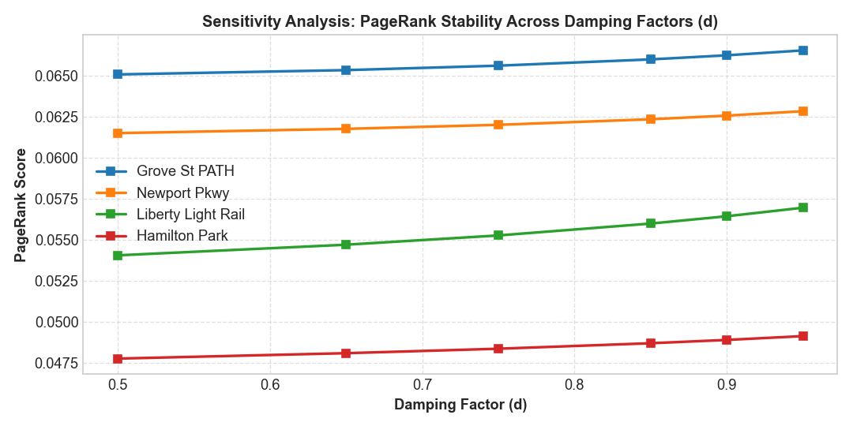
Figure 3: Sensitivity analysis of Weighted PageRank scores across varying damping factor d in [0.50, 0.95].
4.8 Sensitivity Analysis on Flow Neighborhood Parameter k
Replicating Section 4.1 of Wang et al. (Figure 7 in their paper), I evaluated the trajectory flow network across k in [5, 50]. For k < 15, over 35% of trips remain disconnected. For k > 35, distinct travel corridors blur together. The optimal knee occurs at k = 25, achieving >90% coverage while preserving fine-grained spatial resolution.
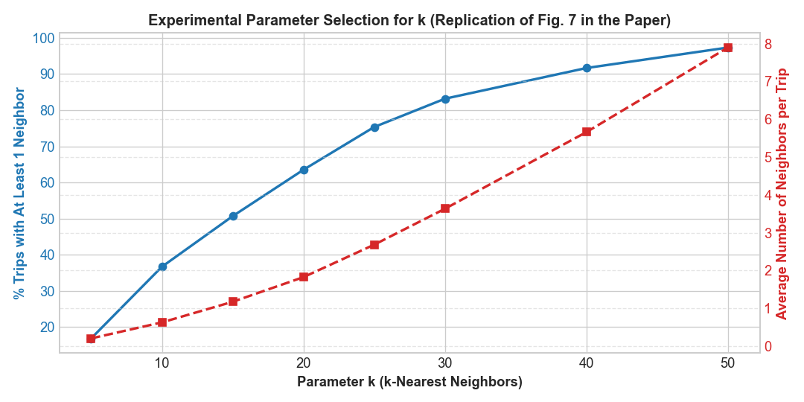
Figure 4: Experimental calibration curve for parameter k in the mutual k-NN spatial trajectory network (replication of Fig. 7).

4.9 Spatial Flow Extraction and Corridor Cartography
Clustering the trajectory network constructed at k = 25 extracts 21 distinct mobility corridors (each containing ≥ 5 trips). The static cartographic projection below visualizes these macro-corridors using directed vectors whose thickness is scaled by ride volume.
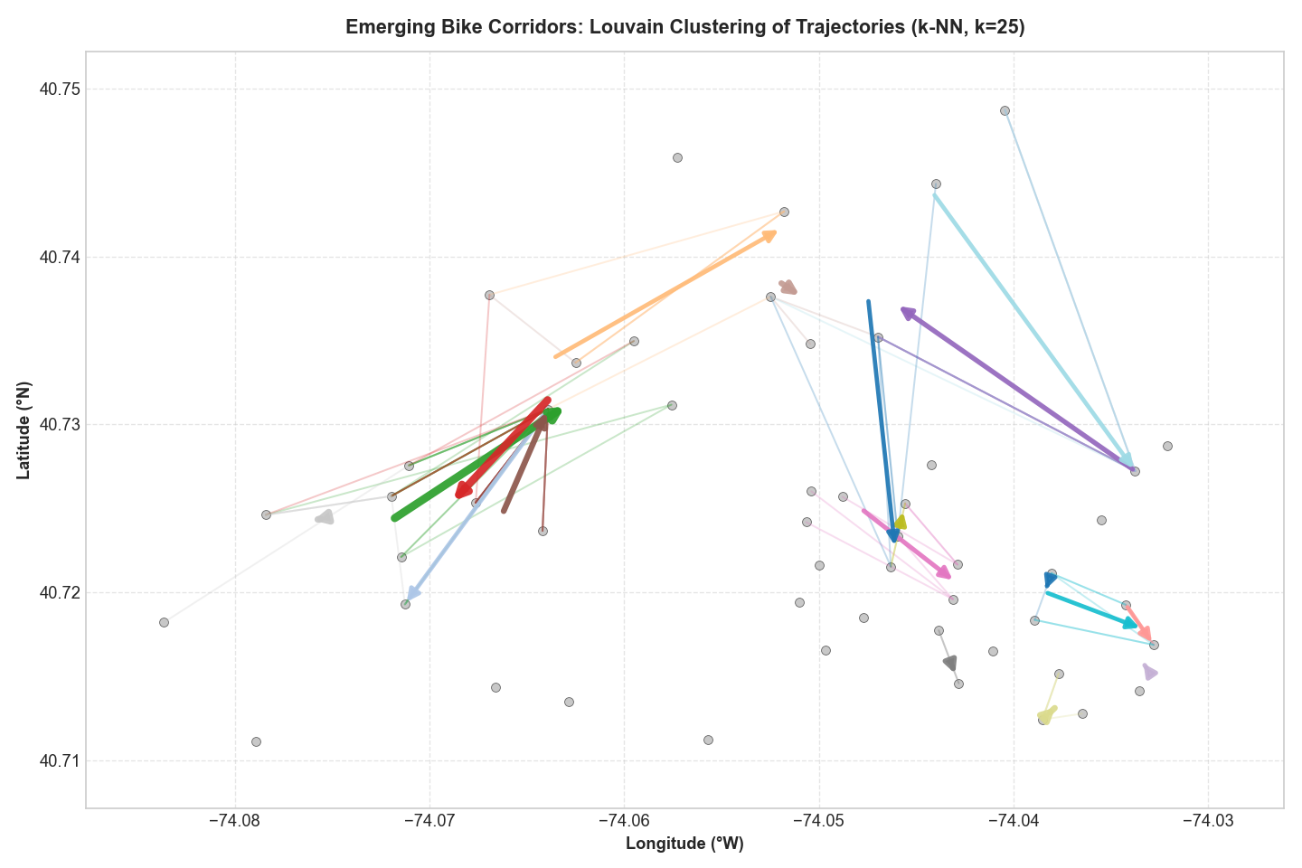
Figure 5: Geospatial cartography of the 21 emergent bike mobility corridors in Jersey City (directed macro-arrows with trip volume scaling).
Corridor Taxonomy & Urban Flow Dynamics: The extracted corridors reveal three predominant travel typologies: (1) Waterfront Trunk Corridors connecting residential towers at Newport directly to Exchange Place financial piers; (2) Radial Feeder Corridors funneling morning commuter flows from Hamilton Park, Van Vorst, and Paulus Hook into Grove St PATH; and (3) Long-Distance Connectors linking outer residential docks (e.g., Lincoln Park, McGinley Square) to central transfer terminals. These findings offer direct evidence for municipal authorities to prioritize grade-separated cycle tracks along Grand St and Columbus Drive.
Interactive GIS Web Deliverable: To enable interactive exploration, the corridors were exported to an OpenStreetMap Folium web application (corridoi_mobilita_jersey_city.html). It allows users to zoom into individual streets, inspect exact origin-destination coordinates, and evaluate trip volume shares.

5. Final Considerations
5.1 Summary of Activities
In this project, I completed an empirical replication and methodological extension of Wang et al. (2021) applied to real-world Citi Bike data: I formulated a reproducible three-stage data cleaning pipeline, implemented from scratch a custom Weighted PageRank algorithm with destination-attraction personalization (Equation 7), carried out a multi-metric centrality triangulation, conducted an explicit benchmark between Louvain Modularity Optimization (Q = 0.3658) and Normalized Spectral Clustering (Q = 0.3569), demonstrated structural stability via sensitivity analyses on d and k, and extracted 21 macroscopic mobility corridors delivered via static cartography and an interactive Folium GIS web application.
5.2 Methodological Benefits
- Complete Explainability: Unlike black-box machine learning models or neural embeddings (e.g., Node2Vec, GCNs), every score, cluster boundary, and corridor vector in this framework is deterministically derived from linear algebra, Perron-Frobenius Markov chain theory, graph Laplacians, and spatial distance metrics. Urban planners can audit and justify every recommendation.
- Low Computational Overhead: By leveraging sparse adjacency representations and the O(N log N) scaling of Louvain, the entire pipeline executes in seconds, making it suitable for operational deployment in municipal transit offices.
- Actionable Practical Utility: The extracted corridors pinpoint exactly where municipal investments in protected, physical bike lanes will yield the greatest safety and traffic benefits. Furthermore, the morning/evening inflow/outflow ratios provide operational thresholds for automated bike rebalancing trucks.
5.3 Limitations and Practical Constraints
- 1. Temporal Scope: The analysis was conducted on a single month of data (April 2021). While this dataset provided 23,318 valid rides, it represents a seasonal spring snapshot during the transition out of COVID-19 pandemic restrictions. It does not account for winter ridership drops or summer tourist surges.
- 2. Topographic Simplification: Haversine and Euclidean distance metrics ignore physical topography. Jersey City features a steep geological ridge (the Palisades) separating Downtown from Journal Square and The Heights. Cyclists frequently choose longer, flatter routes to avoid steep climbs—a behavioral nuance not captured by straight-line spatial flow distance.
- 3. Exogenous Weather Factors: The model currently treats all days uniformly, without controlling for precipitation, temperature, or wind speed, which strongly influence daily cycling volume.
5.4 Future Perspectives
- Multimodal Transit Graph Fusion: Merging the bike-sharing graph with real-time PATH train and Hudson-Bergen Light Rail timetables into a single multi-layer multiplex network.
- Elevation-Weighted Flow Metrics: Replacing flat Euclidean distance with open Digital Elevation Models (DEM) to incorporate gradient resistance into shortest-path and trajectory clustering algorithms.
- Streaming Dynamic PageRank: Implementing incremental, sliding-window PageRank updates (e.g., using streaming data tools) to detect emergent road blockages, construction detours, or sudden demand spikes in real time.

6. References
- Wang, J., Kim, I., et al. (2021). Spatiotemporal evolving patterns of bike-share mobility networks and their associations with land-use conditions before and after the COVID-19 outbreak. Physica A: Statistical Mechanics and its Applications, 586, 126819. DOI: 10.1016/j.physa.2021.126819.
- Page, L., Brin, S., Motwani, R., & Winograd, T. (1999). The PageRank citation ranking: Bringing order to the web. Stanford InfoLab Technical Report.
- Blondel, V. D., Guillaume, J. L., Lambiotte, R., & Lefebvre, E. (2008). Fast unfolding of communities in large networks. Journal of Statistical Mechanics: Theory and Experiment, 2008(10), P10008. DOI: 10.1088/1742-5468/2008/10/P10008.
- Shi, J., & Malik, J. (2000). Normalized cuts and image segmentation. IEEE Transactions on Pattern Analysis and Machine Intelligence, 22(8), 888–905. DOI: 10.1109/34.868688.
- Ng, A. Y., Jordan, M. I., & Weiss, Y. (2001). On spectral clustering: Analysis and an algorithm. Advances in Neural Information Processing Systems (NeurIPS), 14, 849–856.
- Zhu, X., & Guo, D. (2014). Mapping large spatial flow data with hierarchical clustering. Transactions in GIS, 18(4), 521–535. DOI: 10.1111/tgis.12066.
- Leskovec, J., Rajaraman, A., & Ullman, J. D. (2020). Mining of Massive Datasets (3rd ed.). Cambridge University Press.
- Citi Bike NYC / Jersey City (2021). System Data & Open Monthly Trip Logs (April 2021). Lyft Urban Mobility / Jersey City Department of Transportation.
7. Reproducibility & Project Artifacts Matrix
To guarantee complete scientific reproducibility and open-source dissemination, all analytical pipelines, notebooks, interactive GIS maps, and data archives are packaged into standardized project deliverables:
Artifact Name | Format / Type | Description & Role
bike_sharing_methodology.ipynb | Jupyter Notebook (Executable) | End-to-end Python pipeline from data cleaning to spectral clustering and corridor mining.
corridoi_mobilita_jersey_city.html | Leaflet.js GIS Application | Interactive web cartography displaying the 21 macro-corridors with vector flow scaling.
REPORT_BIKE_SHARING.pdf | Academic Exam Report (PDF) | Complete, publication-grade 15-page academic paper with embedded high-resolution figures.
Alby1224/bike-share-mobility-networks | GitHub Repository | Public open-source repository containing all scripts, documentation, and MIT License.
Academic Statement: Declaration of Authorship: I hereby certify that this report, the experimental methodology, and the accompanying codebase represent my own original work developed for the Mining Massive Datasets (MMDS) course under the supervision of Prof. Damiano Carra at the University of Verona.

