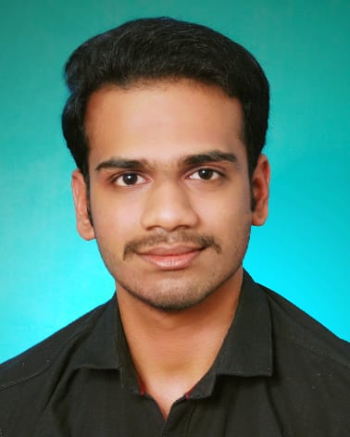 |  | ALBIN SAJI  BCA Student
Profile  Motivated BCA student with basic knowledge of computer applications and programming.  Interested in learning new technologies and improving practical skills.  Looking for opportunities to gain experience and grow professionally.  Contact  PHONE:  9895277056  LinkedIn:  https://www.linkedin.com/in/albin-saji-273686319  EMAIL:  albinsaji2442@gmail.com  Hobbies  - Learning new technologies  - Problem solving  - Practicing coding problems  - Reading books |  | EDUCATION  Bachelor of Computer Application(BCA)  Mahatma Gandhi University  2024-Present  Higher Secondary(Plus Two)  State Board,Kerala  2023  Academic experience  Practiced basic Java programs using OOP concepts  - Practiced basic python programs  Worked on simple C programming lab exercises  Created basic HTML pages as part of coursework  SKILLS  - Java (Basics)  - Python(Basic)  - C Programming (Basics)  - HTML & CSS(Basic)  - MS Word & PowerPoint  - • Internet & Email Handling

