Lab 4

Problem 1 (Turn in SAS CODE)

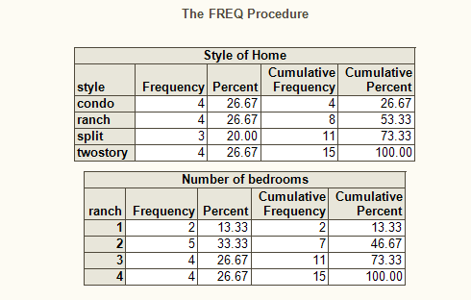
- Using following data, reproduce output above

Style bedroom
condo 1
condo 1
condo 2
condo 2
ranch 2
ranch 2
ranch 2
ranch 3
split 3
split 3
split 3
twostory 4
twostory 4
twostory 4
twostory 4

Problem 2 (Turn in SAS Code)

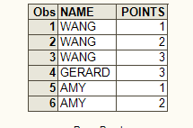

Using following data, reproduce the output above
AMY 2
AMY 1
GERARD 3
WANG 3
WANG 1
WANG 2

Problem 3 (Turn in CODE)

Create a permanent SAS data and Read in VITAM.SAS7BDAT, DEMOG.SAS7BDAT, and FAT.TXT into this data set. (Remember FAT.TXT was defined in assignment # 2.)

Problem 2 (Turn in CODE for a-h)

- Read the contents of the permanent data set into a temporary data set (i.e, Data three;) Label the variable MARITAL with the following text:

'1=never, 2=married, 3= widow, 4=divorce'

- Create a new variable called UNSAT that is the sum of monounsaturated fat(TOTMFA) and polyunsaturated fat(TOTPFA).
- Use the variable EDUC to create a new two-category variable for years of education, EDUC2.

EDUC2 1= some college or less years, 2 = college grad or more years

Label EDUC2 with the descriptive statement given in italics.

- Conduct a group-specific analysis to determine mean UNSAT for the two
categories of EDUC2 using a CLASS statement.

e) Determine the number of subjects in each of the following sub-groups

- never-smokers
- never-smokers AND never married
- never-smoker AND never married AND college grad or more years

g) Redo d)-f) after excluding ID 40001

