Team name: ____________________ | Group number: __________

Bias audits with missing group data
How reliable are fairness audits when demographic information is incomplete?
Team members: Dev Gupta and Tabassum Nadavinmani
Interdisciplinary Elective — AI, Power & Responsibility: Governing Intelligence
Initial research proposal • Project 21 • 2 November 2026
We propose a controlled study of how missing demographic labels affect fairness audits of income classifiers. All numerical exhibits in Appendix A use illustrative dummy data. The main experiment is planned; no empirical findings are claimed.

1 Target journal and reference publication
Target: Machine Learning (Springer Nature). Anchor: Dai et al. (2025), “Assessing the risk of discriminatory bias in classification datasets,” 114, Article 204. DOI: 10.1007/s10994-025-06843-9 [1]. Journal fit is provisional: a reproducible comparison alone may not meet its contribution threshold. Journal scope, author guidance and publication route will be rechecked after evidence is complete.

2 Background problem and research gap
Fairness audits compare outcomes or model decisions across groups. When demographic labels are unavailable for some records, an audit can look precise while describing only the observed subset. This is a governance problem because institutions may rely on that partial evidence when deciding whether to investigate unequal outcomes. Dataset-risk assessment [1,4] and empirical audit-accountability work [7] motivate reporting data completeness alongside disparities.
Recent research examines group-conditionally missing demographics [2], inequitable effects of missing features [3], fairness-aware classification on incomplete data [5], and uncertainty in inferred sensitive attributes [6]. Zaccour et al. [8] study how restricted data access affects quantitative audits. Sample-size-aware methods [9] and prespecified audit testing [10] further establish the need to report statistical uncertainty. These studies motivate a focused comparison of audit estimation error when model predictions are held fixed and only demographic label availability changes.
We will compare three missingness mechanisms across two classifiers, two states and two fairness metrics, using the complete-label audit of each held-out sample as a reference. Our intended contribution is a reproducible account of which audit conclusions remain stable, which become misleading, and how uncertainty changes as labels disappear. This is a controlled empirical extension of [1,2,8]. We will compare the full experimental designs of closely related studies before making a final novelty claim.

3 Research questions
RQ1. How does the proportion of missing group labels affect the error of disparity estimates relative to a complete-label audit?
RQ2. How do random, group-dependent and outcome-dependent missingness differ in their effects on audit reliability?
RQ3. Under what conditions do incomplete-label audits understate, overstate or reverse complete-label disparities?
RQ4. How do these effects differ between demographic parity and equal opportunity for logistic regression and random forest?
RQ5. How consistent are the patterns across California and Texas, and how does uncertainty change as observed group support falls?

4 Public datasets and access
2018 American Community Survey (ACS), one-year Public Use Microdata Sample, person records for California and Texas. These public ZIP archives are downloadable without registration. The existing local downloads establish access feasibility; the raw files are not redistributed in this submission. The main analysis will record SHA-256 hashes, ZIP member names, row counts and software versions at execution.
California: https://www2.census.gov/programs-surveys/acs/data/pums/2018/1-Year/csv_pca.zip
Texas: https://www2.census.gov/programs-surveys/acs/data/pums/2018/1-Year/csv_ptx.zip
2018 data dictionary: https://www2.census.gov/programs-surveys/acs/tech_docs/pums/data_dict/PUMS_Data_Dictionary_2018.pdf
ACSIncome benchmark and datasheet: https://github.com/socialfoundations/folktables
Reuse: Census public-use data are separate from Folktables’ MIT-licensed code. Consult the Folktables datasheet and linked Census terms; attribute the original source, avoid reidentification and do not imply government endorsement. This secondary-data project does not recruit participants. Confirm institutional requirements before any later human research.
Item | Prespecified definition
Sampling frame | CA/TX, ACS 2018 person records; AGEP>16, PINCP>100, WKHP>0.
Outcome | y=1 if released PINCP exceeds $50,000; no cross-year or inflation comparison.
Audit group | Recorded SEX: 1=male, 2=female. This does not represent gender identity.
Predictors | AGEP, WKHP; categorical COW, SCHL, MAR, OCCP, POBP, RELP.
Exclusions | Invalid audit labels/identifiers; duplicate record IDs cause failure; earlier pilot households excluded.
Identifiers | Household=ST:SERIALNO; person=ST:SERIALNO:SPORDER. No identifier is a predictor.

5 Methodology and experimental design
- Use all eligible, valid records from each state after excluding earlier exploratory pilot households, and report the inclusion flow. The earlier pilot informs feasibility; its findings are excluded from the planned main analysis.
- Split households approximately 60% training, 20% validation and 20% testing; no household may cross splits. Fit median/mode imputation, scaling and one-hot encoding on training only.
- Fit logistic regression (C=1) and random forest (200 trees; minimum leaf size 20). Use fixed threshold 0.5. Exclude SEX, RAC1P, income and identifiers from predictors; report validation/test accuracy and AUROC.
- Freeze test predictions and compute complete-label references. Mask only the audit attribute at expected rates 0%, 10%, 30%, 50% and 70%; keep outcomes and predictions unchanged.
- Compare random, group-dependent and outcome-dependent masking. Calibrate logistic missingness probabilities to each target rate; odds ratio=2 for female records or positive outcomes respectively. Run 100 paired masks per condition; record realized rates.
- Estimate gaps using records with observed group labels. Pair masks across models. Compare errors with the same complete-label test reference; never use test results to select features, threshold or model.

6 Evaluation uncertainty and failure cases
Measure | Definition / interpretation
Demographic parity (DP) | P(pred=1 | male) − P(pred=1 | female).
Equal opportunity (EO) | P(pred=1 | y=1,male) − P(pred=1 | y=1,female).
Primary outcome | Absolute error in DP gap: |masked estimate − complete-label reference|.
Secondary outcomes | Signed DP/EO errors; EO absolute error; income prevalence gap; magnitude change; sign reversals.
Reversal / magnitude | Reversal only if |reference gap|≥1 percentage point. Under/overstatement compares absolute gap magnitudes.
Uncertainty | Between-mask SD and Monte Carlo mean error; conditional 95% household-bootstrap intervals for replicate 0.
Support / undefined cells | Flag group n<100 or positive n<30. Undefined estimates remain NaN, never zero.
- Use the full eligible analytical sample in each state. Precision depends on the smaller observed group and its positive-outcome count, so report both denominators at every missingness rate. With 100 masks, the worst-case Monte Carlo standard error of a binary event rate is 5 percentage points; rare-event estimates will therefore remain exploratory.
- Use 500 household-bootstrap draws for the prespecified first mask in each condition and the complete-label case. These intervals condition on a fitted model and do not incorporate model training uncertainty, all missingness realizations, or the ACS survey design. Report mask variability separately; interval inclusion of a sample reference is not population coverage.
- Compare states and models descriptively using paired masks. Prespecify all primary comparisons before execution. Follow-up sensitivities will vary missingness odds ratios (1, 3 and 5), decision thresholds (0.4 and 0.6), household split seeds, and survey-weighted descriptive comparisons; these extensions require additional implementation.
- Stop or flag convergence failures, empty classes, zero denominators, inadequate support, input year/state mismatches and leakage. Require at least 95% valid bootstrap draws for an interval. Do not suppress failed runs.
- Group-only random loss within each group need not systematically bias group-specific rates, though precision can fall. Outcome-only masking need not bias TPR because TPR conditions on the outcome. Null effects are informative and will be reported.

7 Expected results and limitations
We expect to produce an audit-reliability map that distinguishes estimation error, sign stability and loss of precision across the experimental conditions. The direction and size of effects remain empirical questions. Appendix A presents four planned figures or tables per research question, for 20 exhibits in total. Every value is illustrative dummy data used solely to demonstrate the reporting format.
The study can establish sensitivity of selected sample audits under the specified artificial mechanisms. It cannot establish causal discrimination, legal compliance, realistic missingness prevalence, population-wide fairness, or generality beyond two states in 2018. Binary recorded sex excludes other identities; income prediction is a benchmark rather than an observed deployment. Complete labels give a sample reference, not ethical ground truth. No claim that excluding protected predictors eliminates bias is made.

8 Reproducibility and research checkpoints
We will preserve input hashes, split identifiers, software versions, frozen predictions, audit runs and summary outputs in a reproducible workflow. The initial implementation will remain unexecuted for this submission. Before the main run, we will review and lock the primary analysis; completed results, uncertainty checks, independent reproduction, updated literature overlap, author contributions and journal readiness will be evaluated at later checkpoints.

References
The following ten publications from 2025–2026 inform the proposed design. The literature search focuses on missing demographics, incomplete-data fairness, quantitative audits and statistical uncertainty. The 2018 ACS release provides a stable benchmark; its vintage limits claims about current population conditions.
[1] Dai, K., Kim, J., Džeroski, S., Wicker, J., Dobbie, G., & Dost, K. (2025). Assessing the risk of discriminatory bias in classification datasets. Machine Learning, 114, Article 204.
https://doi.org/10.1007/s10994-025-06843-9
[2] Jiang, K., Fan, W., Li, M., & Zhang, X. (2025). Fairness Risks for Group-Conditionally Missing Demographics. Proceedings of AISTATS, PMLR 258, 3520–3528.
https://proceedings.mlr.press/v258/jiang25b.html
[3] Min, S., Asif, H., & Vaidya, J. (2025). Exploring the Inequitable Impact of Data Missingness on Fairness in Machine Learning. IEEE Intelligent Systems, 40(3), 28–38.
https://doi.org/10.1109/MIS.2025.3549484
[4] Gallese, C., Scantamburlo, T., Manzoni, L., Giannerini, S., & Nobile, M. S. (2025). FanFAIR: sensitive data sets semi-automatic fairness assessment. BMC Medical Informatics and Decision Making, 25, 329.
https://doi.org/10.1186/s12911-025-03184-4
[5] Miao, X., Qiang, L., Huang, G., Wu, Y., & Yin, J. (2025). Fairness-Aware Classification over Incomplete Data. Proceedings of SIGIR, 549–558.
https://doi.org/10.1145/3726302.3729975
[6] Wang, Y., & Singh, L. (2025). Impact on bias mitigation algorithms to variations in inferred sensitive attribute uncertainty. Frontiers in Artificial Intelligence, 8, 1520330.
https://doi.org/10.3389/frai.2025.1520330
[7] Gerchick, M. K., Encarnación, R., Tanigawa-Lau, C., Armstrong, L., Gutiérrez, A., & Metaxa, D. (2025). Auditing the Audits: Lessons for Algorithmic Accountability from Local Law 144’s Bias Audits. Proceedings of FAccT, 29–44.
https://doi.org/10.1145/3715275.3732004
[8] Zaccour, J., Binns, R., & Rocher, L. (2025). Access Denied: Meaningful Data Access for Quantitative Algorithm Audits. Proceedings of CHI, Article 388, 1–31.
https://doi.org/10.1145/3706598.3713963
[9] Ferrara, A., Cozzi, F., Perotti, A., Panisson, A., & Bonchi, F. (2025). Size-adaptive Hypothesis Testing for Fairness. Advances in Neural Information Processing Systems, 38.
https://proceedings.neurips.cc/paper_files/paper/2025/hash/8cdc8e07038dcd423d382048b7063d07-Abstract-Conference.html
[10] Anaya-Quesada, M., & Kountouris, M. (2026). Sequential Hypothesis Testing for Black-Box Fairness Audits. Proceedings of the Fifth European Conference on Algorithmic Fairness, PMLR 350, 51–66.
https://proceedings.mlr.press/v350/anaya-quesada26a.html

Appendix A1 Planned outputs for RQ1
How does the proportion of missing group labels affect the error of disparity estimates relative to a complete-label audit?
DUMMY DATA — ILLUSTRATIVE ONLY. No experiment generated these values. pp = percentage points. Each exhibit demonstrates a planned output, not an expected numerical finding.
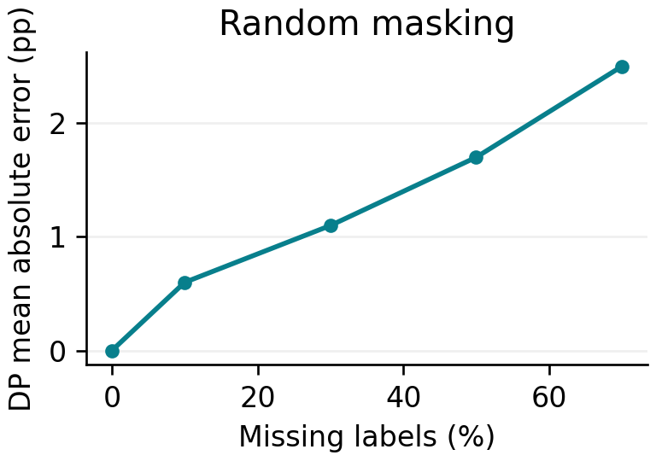  Figure 1. Random masking. Dummy values; all rates use the same illustrative test set. | 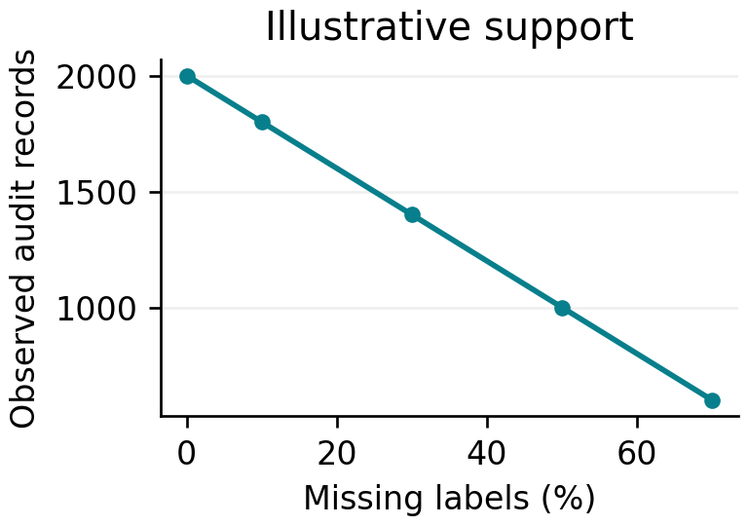  Figure 2. Illustrative support. Dummy values; all rates use the same illustrative test set.
Table 1. Error summary by missingness rate. DUMMY DATA.
Missing (%) | Signed error (pp) | MAE (pp)
0 | 0.0 | 0.0
10 | 0.1 | 0.6
30 | 0.1 | 1.1
50 | 0.2 | 1.7
70 | 0.3 | 2.5
Table 2. Support and conditional interval width. DUMMY DATA.
Missing (%) | Observed n | CI width (pp)
0 | 2000 | 5.0
30 | 1400 | 6.0
70 | 600 | 9.1
Planned interpretation: quantify error and precision loss separately. Zero missingness must reproduce the reference exactly.

Appendix A2 Planned outputs for RQ2
How do random, group-dependent and outcome-dependent missingness differ in their effects on audit reliability?
DUMMY DATA — ILLUSTRATIVE ONLY. No experiment generated these values. pp = percentage points. Each exhibit demonstrates a planned output, not an expected numerical finding.
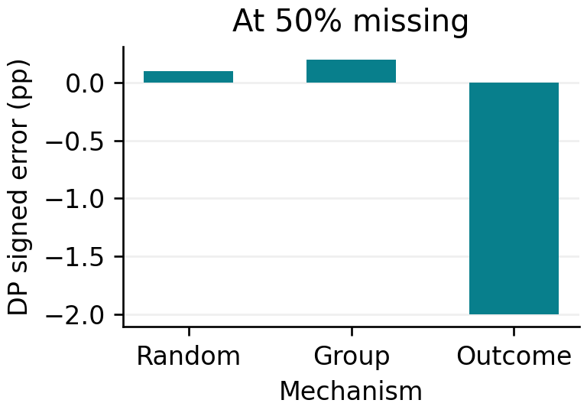  Figure 3. At 50% missing. Dummy values; scenario shown for layout only. | 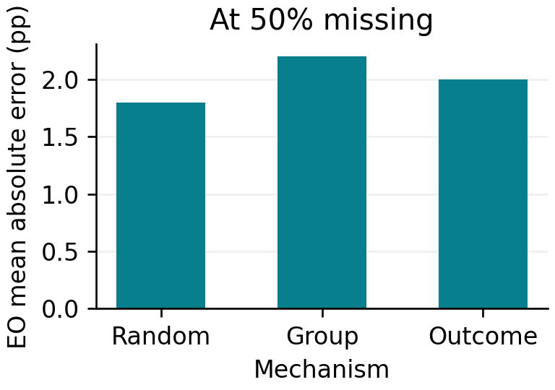  Figure 4. At 50% missing. Dummy values; scenario shown for layout only.
Table 3. DP errors by masking mechanism. DUMMY DATA.
Mechanism | Missing (%) | DP error (pp) | DP MAE (pp)
Random | 50 | 0.1 | 1.7
Group | 50 | 0.2 | 1.9
Outcome | 50 | −2.0 | 2.6
Table 4. Illustrative calibrated missingness probabilities for an equal risk-group mixture. DUMMY DATA.
Mechanism | Low-risk P(miss) | High-risk P(miss)
Random | 0.50 | 0.50
Group | 0.41 | 0.59
Outcome | 0.41 | 0.59
Planned interpretation: compare mechanisms without assuming each must produce bias. Group-only loss can affect precision more than mean rates.

Appendix A3 Planned outputs for RQ3
Under what conditions do incomplete-label audits understate, overstate or reverse complete-label disparities?
DUMMY DATA — ILLUSTRATIVE ONLY. No experiment generated these values. pp = percentage points. Each exhibit demonstrates a planned output, not an expected numerical finding.
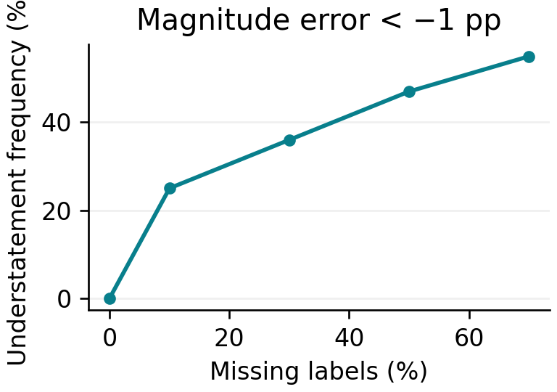  Figure 5. Magnitude error < −1 pp. Dummy values; scenario shown for layout only. | 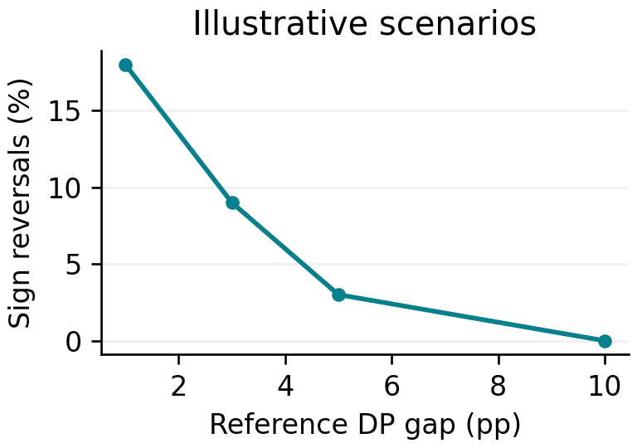  Figure 6. Illustrative scenarios. Dummy values; scenario shown for layout only.
Table 5. Magnitude classification with a 1 pp tolerance. DUMMY DATA.
Missing (%) | Under (%) | Over (%) | Within ±1 pp (%)
10 | 25 | 24 | 51
30 | 36 | 22 | 42
50 | 47 | 20 | 33
70 | 55 | 18 | 27
Table 6. Sign stability at 50% missingness. DUMMY DATA.
Reference (pp) | Reversed (%) | Same sign (%)
1 | 18 | 82
3 | 9 | 91
5 | 3 | 97
10 | 0 | 100
Planned interpretation: report magnitude and sign separately. Near-zero reference gaps can make sign reversals unstable; exclude references below 1 pp from reversal summaries.

Appendix A4 Planned outputs for RQ4
How do these effects differ between demographic parity and equal opportunity for logistic regression and random forest?
DUMMY DATA — ILLUSTRATIVE ONLY. No experiment generated these values. pp = percentage points. Each exhibit demonstrates a planned output, not an expected numerical finding.
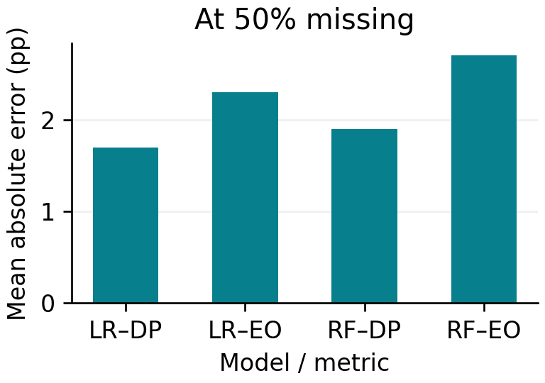  Figure 7. At 50% missing. Dummy values; scenario shown for layout only. | 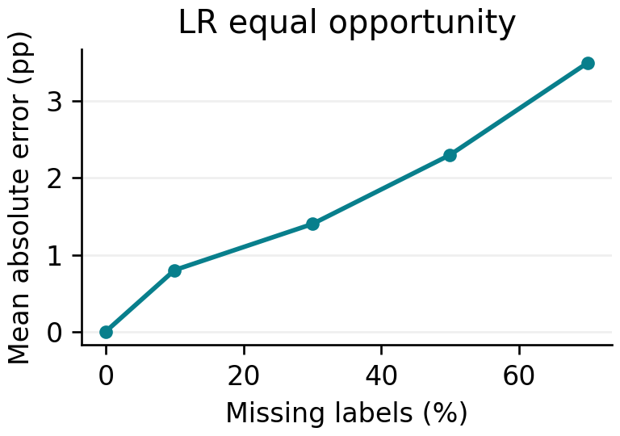  Figure 8. LR equal opportunity. Dummy values; scenario shown for layout only.
Table 7. Metric comparison at 50% missing labels. DUMMY DATA.
Model | DP MAE (pp) | EO MAE (pp)
LR | 1.7 | 2.3
RF | 1.9 | 2.7
Table 8. Predictive performance reported separately from audit quality. DUMMY DATA.
Model | Accuracy | AUROC
LR | 0.80 | 0.87
RF | 0.81 | 0.88
Planned interpretation: distinguish model accuracy from audit reliability. Similar predictive performance does not imply equally stable disparity estimates.

Appendix A5 Planned outputs for RQ5
How consistent are the patterns across California and Texas, and how does uncertainty change as observed group support falls?
DUMMY DATA — ILLUSTRATIVE ONLY. No experiment generated these values. pp = percentage points. Each exhibit demonstrates a planned output, not an expected numerical finding.
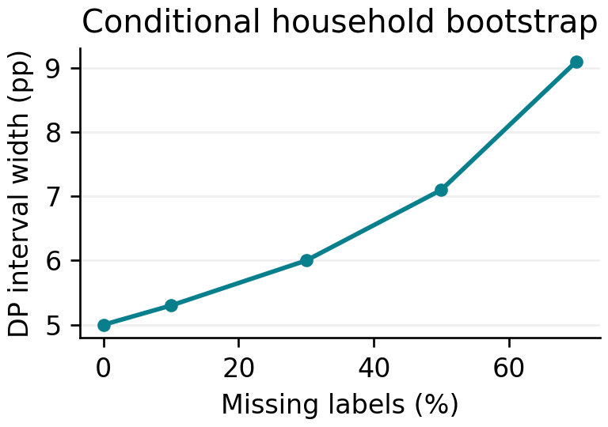  Figure 9. Conditional household bootstrap. Dummy values; scenario shown for layout only. | 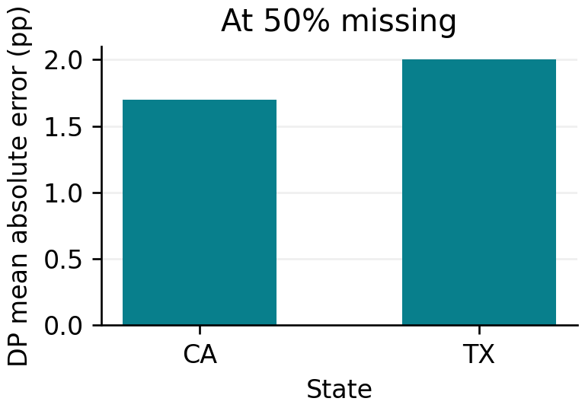  Figure 10. At 50% missing. Dummy values; scenario shown for layout only.
Table 9. State comparison at 50% missing labels. DUMMY DATA.
State | DP MAE (pp) | CI width (pp)
CA | 1.7 | 7.1
TX | 2.0 | 7.8
Table 10. Support and low-support flags across illustrative masks. DUMMY DATA.
Missing (%) | Smaller-group n | Flagged masks (%)
0 | 1000 | 0
30 | 700 | 0
50 | 500 | 2
70 | 300 | 12
Planned interpretation: compare states with their observed denominators. Bootstrap interval widths and variation across masks quantify different uncertainty sources.

