A simple model for thermal laser processing

# **Introduction**

This is a simple model based on photothermal ablation for predicting and visualizing the behavior of different materials under pulsed laser irradiation. The main parameters under investigation are the beam’s parameters, and scanning speed. This way we can calculate the ablation depth and create complex structures with higher precision. Laser induced damage threshold (LIDT) and beam focus area are some quantities that will be addressed later.

# **Basic quantities**

## Scanning speed

Scanning velocity of the laser is assumed constant. Scanning speed is the main factor to manipulate the effective pulse number, as we will show later.

## Scanning repetitions

Scanning reps refers to the number of repetitions of the total laser design/path. Repetition is a twofold parameter as it allows us to use higher speeds in combination with repeated scanning, thus avoid extreme or extended heat diffusion and damage.

## Energy Pulse

Energy of a pulse Ep is calculated by dividing the mean intensity (P) of the beam by the repetition rate of the pulses (f).

**Ep = P / f**

## Beam Fluence

The pulse energy is not enough to characterize the experiment, as the focus of the beam and the surface covered by each pulse also play an important role. Thus, the energy fluence (energy per area) is needed, and given by the following formula:

$$F\left(r\right)=F_{0}e^{-2{\left(\frac{r}{w_{0}}\right)}^{2}}$$

Where F0 is the peak fluence, r is the distance measured from the center of the beam (max fluence) to the undamaged material (min fluence/threshold), and w0 is the beam waist.

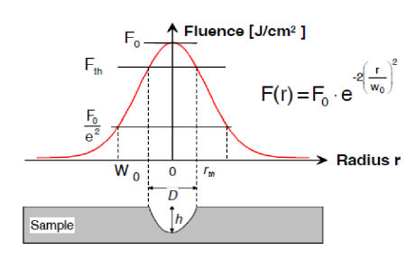

Fig 2. Fluence to radius diagram.

## Beam waist

For a specific wavelength (λ), beam waist (w0) defines the shape and size of the beam. It is the point of focus where the beam width is the smallest and it can be calculated with multiple ways. Usually, it is defined at the distance where intensity is 1/e2 (13.5%) or 1/e (37%) of the maximum. In order to determine the most accurate model, we must account for the material’s damage threshold. If the used intensity In<0.4I0 is below the threshold, no damage is done to the material, the 1/e method could offer better results.

## Laser Induced Damage threshold

LIDT is the limit at which a material will be damaged by a laser given the fluence (energy per area), intensity (power per area), and wavelength. Thermal breakdown is the studied mechanism.

## Ablation depth

Ablation depth indicates the amount of extracted material due to thermal or chemical effects, depending on the laser characteristics. Only thermal effects are studied here.

## Line width (If using Cura)

Line width (LW) as set by the Cura program is a parameter that Cura needs in order to calculate the steps a stepper motor has to do in order to complete a specific design’s width. LW is actually calculated by the effective radius of the beam.

E.g. for LW = 0.01 mm = 10 um to fill a 100 um (=0.1 mm) width the system will do 10 steps.

# **Modelling**

The pulse radius can be calculated using the Gaussian distribution and by measuring the diameter of the structure created by a single pulse. From these two quantities we can calculate the energy density of the pulse.

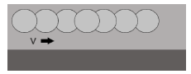

Fig 3. Material’s line scanning.

In the scanning of a line or area with a laser, we use the total number of pulses per length or per unit area. One way of calculating is through the waist diameter 2w0. For “line scanning” at a constant speed v (mm/s) and at a pulse repetition rate f (Hz), **the actual number of pulses Neff, 1Dline** can be set as:

**Neff, 1Dline = 2 · w0 · f / v**

(Meaning: number of laser pulses falling, during linear scanning, to length interval equal to the diameter 2w0.)

**For “area scanning”** and distance D (step) between the scan lines, we define:

Neff,2D = π · Neff, 1Dline · Neff,1Dstep / 4 = π · w02 · f / (v·δ)

where Neff, 1Dstep = 2w0 /D

(Meaning: number of laser pulses falling, during 2D scanning, to

an area equal to 2w0.)

Another way to calculate this is the **pulse overlap factor (Of)** that is defined as:

$$O_{f}=\left(1-\frac{v}{{2w}_{0}*f}\right)*100\%$$

In order to calculate the ablation characteristics:

**Max Ablation Depth: $A_{d}=\frac{1}{α} ln⁡(\frac{F_{p}}{F_{th}})$** , where α= absorptivity, $F_{p}$ = peak fluence, $F_{th}$ = threshold fluence

**Ablation Width: $A_{w}=w_{0}\sqrt{2αA_{d}}$**

# **PLA modelling example**

In this example a nanosecond pulsed ytterbium fiber laser @(1064nm, 5 ns) is used.

For our experiment, we will connect ablation depth with the depth of focus, as IR lasers in transparent materials are subject to non-linear effects, so nothing really happens far from beam focus.

Depth of focus (b) is equal to 2zR (Rayleigh range) or b = 2 * π n w0/λ, where n is the refractive index of the medium (for air nair=1).

For w0 = 0.035 mm (measured with profile meter), f=2000Hz and v=100mm/s:

Neff, 1Dline = 2 * 0.035 * 2000 / 100 = 1.4 pulse per length unit (length unit is considered the pulse width).

Of = (1 – 100/0.07 * 2000) * 100% = ~30% overlapping.

Thus, at this example, small pulse overlapping is expected. The algorithm confirmed these results, and from the code visualization anisotropic processing is expected. The beam spots (fig E1, top) are calculated on 1/e2 of intensity.

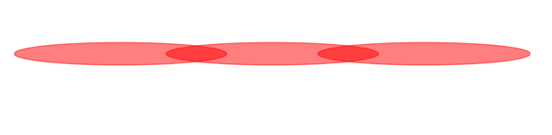

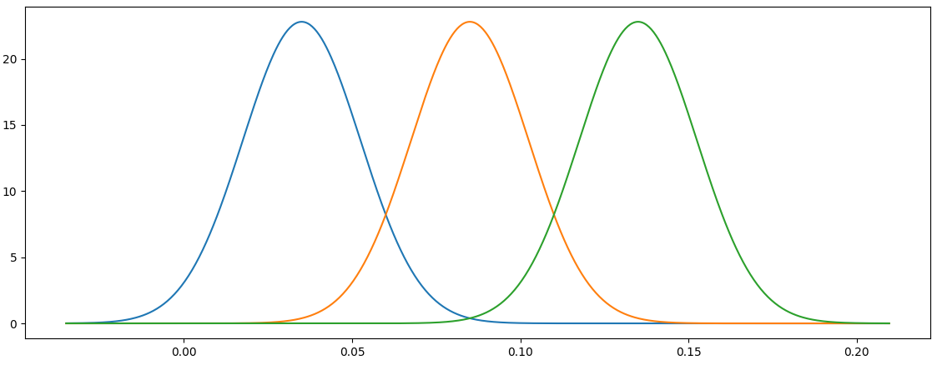

Fig E1. Visual representation (top) and graph (bottom) of 3 consecutive pulses in a scanning line patern.

The algorithm expectation values are in accordance to the experimental results, and are presented below (fig E2).

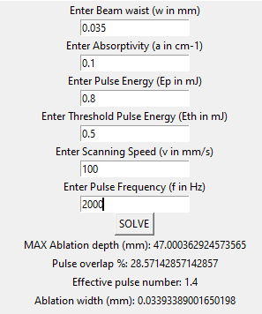

Fig E2. Theoretical results from modelling algorithm.

# **References**

[1] <https://en.wikipedia.org/wiki/Laser_damage_threshold>

[2] <https://www.edmundoptics.com/knowledge-center/application-notes/lasers/gaussian-beam-propagation/>

[3] Effect of Laser Pulse Overlap and Scanning Line Overlap on Femtosecond Laser-Structured Ti6Al4V Surfaces

[4] Influence of ambient conditions on the evolution of wettability properties of an IR-, ns-laser textured aluminium alloy

[5] Applying Ultrashort Pulsed Direct Laser Interference Patterning for Functional Surfaces

[6] Prediction of femtosecond laser ablation profile on human teeth