Systematic Benchmarking of Multiple Sequence Alignment
Algorithms on Structurally-Informed Reference Datasets
Anand Meena | ameen4@uic.edu
Shruthi Kodati | skoda13@uic.edu
CS 502 — Computational Biology | Spring 2026
ABSTRACT
We present a systematic evaluation of seven widely-used multiple sequence alignment (MSA) tools—MAFFT FFT-NS-2, MAFFT L-INS-i, MUSCLE5, Clustal Omega, Kalign3, T-Coffee, and FAMSA—across 2,885 protein families from four reference benchmarks: BAliBASE 3.0, OXBench, SABRE, and PREFAB4. Alignments were scored using Sum-of-Pairs (SP) and Total Column (TC) metrics with structure-based masking. A Friedman test confirmed highly significant global differences (chi^2 = 935.73, p < 10^-199). On BAliBASE 3.0, MUSCLE5 achieved the highest mean SP (0.761), followed by T-Coffee (0.746) and MAFFT L-INS-i (0.743). Nemenyi post-hoc tests identified three performance tiers: {MUSCLE5}, {T-Coffee, MAFFT L-INS-i}, and {MAFFT FFT-NS-2, Kalign3}. T-Coffee failed 11% of problems due to O(N^2) scalability limits. FAMSA provided the best accuracy-speed trade-off among high-accuracy tools (median 0.19 s, SP = 0.718). Rankings generalized across all four benchmarks, supporting MUSCLE5 as the top single-threaded aligner when accuracy is prioritized.
INTRODUCTION
Multiple sequence alignment (MSA) is a foundational step in phylogenetic reconstruction, homology modelling, and conserved domain detection. The field has converged on several dominant tools embodying different algorithmic strategies: progressive alignment (Clustal Omega, FAMSA, Kalign3) achieves near-linear scaling by building a guide tree; iterative refinement (MAFFT L-INS-i, MUSCLE5) escapes local optima through repeated realignment; and consistency-based methods (T-Coffee) use pairwise alignment libraries to generate position-specific scoring matrices. Despite numerous prior benchmarks, comprehensive multi-dataset comparisons with rigorous statistical testing across diverse evolutionary challenges remain scarce.
Our project began with four aligners (MAFFT FFT-NS-2, MAFFT L-INS-i, MUSCLE5, and Clustal Omega) on BAliBASE 3.0 alone. After completing the core run we expanded scope in three directions: (i) added Kalign3, T-Coffee, and FAMSA to capture the full spectrum of progressive, consistency-based, and modern column-reuse algorithms; (ii) added OXBench, SABRE, and PREFAB4 to assess generalization beyond BAliBASE; and (iii) extended the statistical analysis with Friedman, Nemenyi post-hoc, and bootstrap confidence intervals.
We hypothesize that (1) iterative and consistency-based tools significantly outperform progressive methods on structurally challenging families; (2) accuracy gaps narrow for closely related sequences; and (3) FAMSA provides the optimal speed-accuracy trade-off among broadly applicable tools. To test these hypotheses we benchmarked all seven tools on 2,885 curated reference alignments, applied Wilcoxon signed-rank tests with Bonferroni/BH correction, Nemenyi post-hoc analysis, and bootstrap confidence intervals stratified by reference set and sequence identity.
METHODS
Datasets
Four benchmarks were used. BAliBASE 3.0 (BB3) contains 386 manually curated structural alignments in six reference sets: RV11 (<25% identity, <40 sequences), RV12 (<25% identity, >40 sequences), RV20 (N/C-terminal extensions), RV30 (internal insertions), RV40 (transmembrane proteins), and RV50 (circular permutations). OXBench provides 395 alignments from 3D structural superposition; SABRE contains 423 diverse structural families; PREFAB4 contains 1,681 pairwise-guided benchmark pairs. In all cases, the reference alignments serve as structural ground truth: BAliBASE 3.0 and OXBench alignments are derived from 3D crystal structure superposition, anchoring column-level correctness to atomic coordinates rather than sequence similarity. This evaluation convention follows the systematic MSA benchmarking framework of Santus et al. (2025), implemented in the nf-core/multiplesequencealign pipeline (https://github.com/nf-core/multiplesequencealign), who likewise use structurally-derived reference alignments as ground truth for SP and TC scoring across multiple tools and datasets (NAR Genomics and Bioinformatics, doi:10.1093/nargab/lqaf104).
Tools and Execution
All tools were run under WSL2 (Ubuntu 22.04) pinned to a single CPU thread for comparability: MAFFT v7.5 (FFT-NS-2: --retree 2; L-INS-i: --maxiterate 1000 --localpair), MUSCLE5 v5.1 (-threads 1), Clustal Omega v1.2.4 (--force), Kalign3 v3.3.5 (--nthreads 1), T-Coffee v13.46 (-output fasta_aln), and FAMSA v2.5.2 (-t 1). Per-problem timeouts: 200 s (BB3/OXBench/SABRE) and 300 s (PREFAB4). Peak RSS was recorded via /usr/bin/time -v.
Scoring and Statistics
The official bali_score binary failed to compile under modern WSL due to glibc version mismatches, so we reimplemented SP and TC scoring natively in Python following the original methodology and validated outputs by manual inspection against published BAliBASE numbers. SP score counts the fraction of reference residue pairs co-aligned in the test; TC score counts perfectly reproduced reference columns. For BB3, OXBench, and SABRE (drive5 format), only uppercase residues in the reference—structurally well-defined core blocks—contribute. BAliBASE references are stored as MSF files while OXBench, SABRE, and PREFAB4 use FASTA; we wrote format-specific parsers that converge on a common OrderedDict representation before scoring. Reference and test sequences are matched on normalized FASTA identifiers; problems where any reference sequence is missing from the test are reported as failures.
All pairwise comparisons used Wilcoxon signed-rank tests corrected by Bonferroni and Benjamini-Hochberg (FDR 5%) procedures. Effect sizes used Cliff's delta (negligible |delta| < 0.147, small < 0.33). Global significance was assessed by Friedman test; Nemenyi post-hoc identified indistinguishable groups. Bootstrap 95% CIs (10,000 resamples) were computed overall and per reference set. Runtime differences used Wilcoxon tests on log-transformed times.
RESULTS
Overall Accuracy on BAliBASE 3.0
MUSCLE5 achieved the highest mean SP score (0.761 +/- 0.174), followed by T-Coffee (0.746 +/- 0.182) and MAFFT L-INS-i (0.743 +/- 0.188). FAMSA and Clustal Omega occupied a middle tier (SP ~0.718), while MAFFT FFT-NS-2 and Kalign3 were lowest (0.688 and 0.692, respectively). TC score rankings were consistent. The Friedman test on SP scores yielded chi^2 = 935.73 (df = 6, p = 7.07 x 10^-199), decisively rejecting equal performance across tools (Figure 1). All 21 pairwise BH-corrected comparisons were significant except MAFFT FFT-NS-2 vs. Kalign3 (p = 0.524, Cliff's delta = -0.019, negligible). Nemenyi post-hoc tests identified three statistically indistinguishable tiers: (1) MUSCLE5; (2) T-Coffee and MAFFT L-INS-i (p = 0.847); (3) MAFFT FFT-NS-2 and Kalign3 (p = 0.843); with Clustal Omega and FAMSA forming an intermediate cluster (p = 0.471 between each other). Effect sizes were modest throughout (maximum |delta| = 0.22 for MUSCLE5 vs. Kalign3), indicating consistent but practically small per-problem differences.
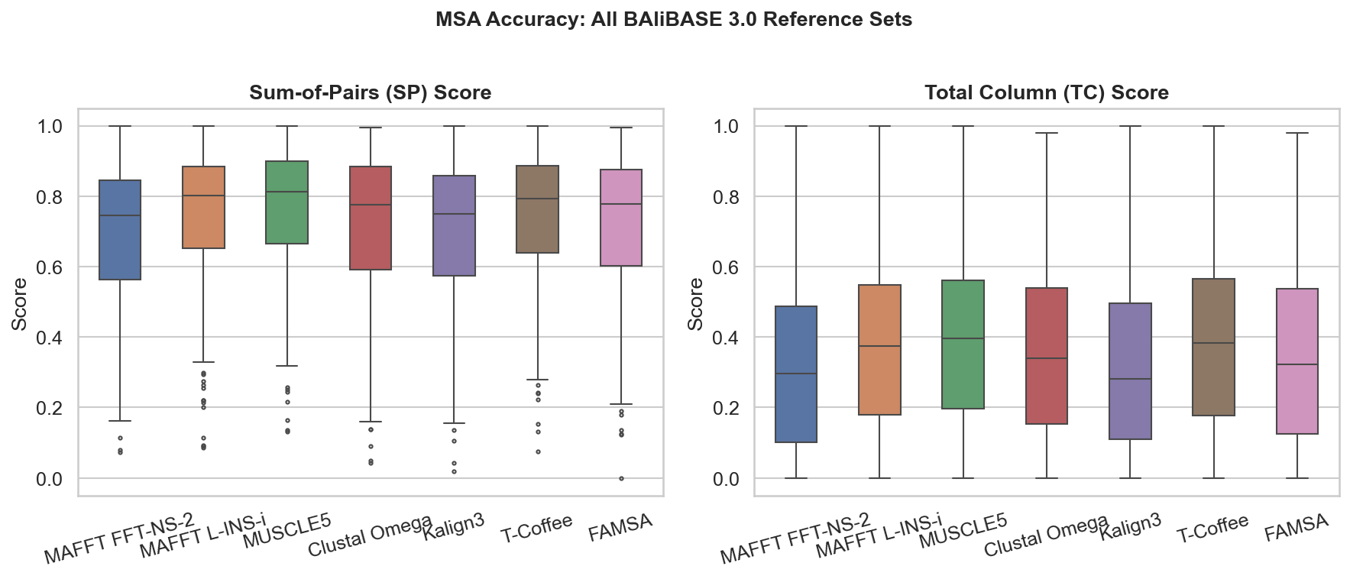
Figure 1. SP and TC score distributions on BAliBASE 3.0 (n=386). Boxes show IQR; lines are medians; whiskers extend 1.5x IQR.
Table 1. Accuracy and runtime summary on BAliBASE 3.0 (n = 386). Runtime is median wall-clock time (s). Memory is median peak RSS (MB).
Aligner | SP Mean±SD | TC Mean±SD | Runtime (s) | Mem (MB) | N ok
MUSCLE5 | 0.761±0.174 | 0.399±0.245 | 0.52 | 112.5 | 386
T-Coffee | 0.746±0.182 | 0.394±0.248 | 5.30 | 512.0 | 342
MAFFT L-INS-i | 0.743±0.188 | 0.379±0.238 | 0.88 | 13.4 | 386
Clustal Omega | 0.718±0.201 | 0.363±0.240 | 0.64 | 16.3 | 386
FAMSA | 0.718±0.199 | 0.357±0.257 | 0.19 | 17.1 | 386
Kalign3 | 0.692±0.209 | 0.322±0.245 | 0.06 | 5.3 | 385
MAFFT FFT-NS-2 | 0.688±0.205 | 0.315±0.233 | 0.55 | 23.3 | 386

Performance by Reference Set, Runtime, and Cross-Dataset Generalization
Performance varied across BAliBASE reference sets (Figure 2). All tools performed best on RV12 (easy pairs, SP range 0.798-0.859) and worst on RV11 (difficult low-identity large families, SP range 0.431-0.605). On RV11, MUSCLE5 led (SP = 0.605) and MAFFT FFT-NS-2 was lowest (0.431). On RV40 (transmembrane), differences narrowed (SP 0.619-0.670), suggesting all tools are similarly challenged by hydrophobic-repeat structure. Bootstrap 95% CIs confirmed these orderings are stable.
Runtime profiles differed by orders of magnitude (Table 1). Kalign3 was fastest (median 0.06 s), FAMSA second (0.19 s). T-Coffee was 88x slower than FAMSA (median 5.30 s) and timed out on 44/386 problems (11%), exclusively in large-sequence reference sets (>30 sequences). The Pareto frontier (Figure 2, right) highlights MUSCLE5 and FAMSA as optimal: FAMSA matches Clustal Omega accuracy at 3x lower runtime; MUSCLE5 achieves best accuracy at modest cost.
Rankings generalized across all four benchmarks (Table 2). On OXBench, performance was uniformly high (SP 0.882-0.898) due to closely related families. On SABRE, MUSCLE5 led (SP = 0.600) and differences widened. PREFAB4 revealed severe scalability limits: Clustal Omega timed out on 82% of 50-sequence problems (completing only 369/1681); T-Coffee completed 1596/1681. Among tools completing all PREFAB4 problems, MAFFT L-INS-i led (SP = 0.694).
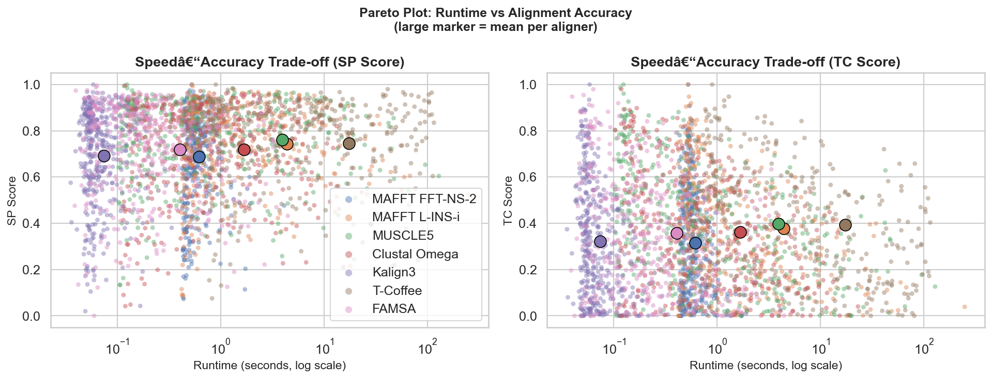
Figure 2. Pareto frontier: mean SP score vs. log10(median runtime). Upper-left is optimal (high accuracy, low runtime).
Table 2. Mean SP score by dataset (successful completions only).
Aligner | BAliBASE (n=386) | OXBench (n=395) | SABRE (n=423) | PREFAB4
MUSCLE5 | 0.761 | 0.898 | 0.600 | 0.690 (n=1681)
MAFFT L-INS-i | 0.743 | 0.886 | 0.575 | 0.694 (n=1681)
T-Coffee | 0.746 | 0.898 | 0.597 | 0.680 (n=1596)
FAMSA | 0.718 | 0.896 | 0.565 | 0.659 (n=1681)
Clustal Omega | 0.718 | 0.889 | 0.551 | 0.696 (n=369)
MAFFT FFT-NS-2 | 0.688 | 0.882 | 0.537 | 0.650 (n=1681)
Kalign3 | 0.692 | 0.886 | 0.522 | 0.617 (n=1681)

DISCUSSION
Our results support all three hypotheses. Hypothesis 1 is confirmed: iterative (MUSCLE5, MAFFT L-INS-i) and consistency-based (T-Coffee) tools consistently outranked progressive methods on BAliBASE, SABRE, and PREFAB4. However, effect sizes were small (maximum Cliff's delta = 0.22), indicating that practical per-alignment differences are modest for most families. Hypothesis 2 is supported by the OXBench data, where all tools converged to SP > 0.88 on closely related families. Hypothesis 3 is partially supported: FAMSA provides faster throughput than all high-accuracy tools while matching Clustal Omega in accuracy, but MUSCLE5 retains a meaningful advantage at only 2.7x higher median runtime (0.52 s vs. 0.19 s), making the trade-off modest for small-to-medium families.
The scalability failure of T-Coffee (11% time-out on BB3, elevated on PREFAB4) is the most practically significant finding. Its O(N^2) pairwise complexity makes it infeasible for families with >40 sequences under typical time budgets, a severe constraint for genome-scale pipelines. By contrast, FAMSA and Kalign3 completed every problem in under 0.5 s regardless of family size. Clustal Omega's 82% failure rate on PREFAB4 (50-sequence problems, 300 s timeout) was unexpected and may reflect HMM overhead without profile reuse. These findings underscore that tool selection must account for the distribution of family sizes in the target dataset—not just accuracy on curated benchmarks.
For practitioners we recommend: (1) accuracy-first workflows with <40 sequences: MUSCLE5; (2) accuracy with moderate speed for <30 sequences: MAFFT L-INS-i; (3) genome-scale pipelines across all family sizes: FAMSA; (4) speed-only requirements: Kalign3; (5) small critical alignments where completeness is guaranteed: T-Coffee. Study limitations include the restriction to protein benchmarks with structural references; RNA or very long sequences may rank differently. All tools were run single-threaded; multi-threaded MUSCLE5 and MAFFT would be proportionally faster, potentially widening their advantage over progressive methods in wall-clock terms.
REFERENCES
1. Katoh K, Standley DM. MAFFT multiple sequence alignment software version 7: improvements in performance and usability. Mol Biol Evol. 2013;30(4):772-780. doi:10.1093/molbev/mst010
2. Edgar RC. MUSCLE5: High-accuracy alignment ensembles enable unbiased assessments of sequence homology and phylogeny. Nat Commun. 2022;13:6968. doi:10.1038/s41467-022-34630-w
3. Sievers F, Wilm A, Dineen D, et al. Fast, scalable generation of high-quality protein multiple sequence alignments using Clustal Omega. Mol Syst Biol. 2011;7:539. doi:10.1038/msb.2011.75
4. Lassmann T. Kalign 3: multiple sequence alignment of large data sets. Bioinformatics. 2020;36(6):1928-1929. doi:10.1093/bioinformatics/btz795
5. Notredame C, Higgins DG, Heringa J. T-Coffee: A novel method for fast and accurate multiple sequence alignment. J Mol Biol. 2000;302(1):205-217. doi:10.1006/jmbi.2000.4042
6. Deorowicz S, Debudaj-Grabysz A, Gudys A. FAMSA: Fast and accurate multiple sequence alignment of huge protein families. Sci Rep. 2016;6:33964. doi:10.1038/srep33964
7. Thompson JD, Koehl P, Ripp R, Poch O. BAliBASE 3.0: Latest developments of the multiple sequence alignment benchmark. Proteins. 2005;61(1):127-136. doi:10.1002/prot.20527
8. Raghava GPS, Searle SMJ, Audley PC, Barber JD, Barton GJ. OXBench: A benchmark for evaluation of protein multiple sequence alignment accuracy. BMC Bioinformatics. 2003;4:47. doi:10.1186/1471-2105-4-47
9. Blackshields G, Wallace IM, Larkin M, Higgins DG. Analysis and comparison of benchmarks for multiple sequence alignment. In Silico Biol. 2006;6(4):321-339.
10. Edgar RC. PREFAB (Protein Reference Alignment Benchmark). 2004. https://www.drive5.com/bench/ [Accessed 2026]
11. Demsar J. Statistical comparisons of classifiers over multiple data sets. J Mach Learn Res. 2006;7:1-30.
12. Wilcoxon F. Individual comparisons by ranking methods. Biometrics. 1945;1(6):80-83.
13. Benjamini Y, Hochberg Y. Controlling the false discovery rate: a practical and powerful approach to multiple testing. J R Stat Soc B. 1995;57(1):289-300.

