### ALGORITHM-1 INIT_MODE-1 SIZE-20 MAX_DIGIT-99999999 OPTIMIZATION-O2

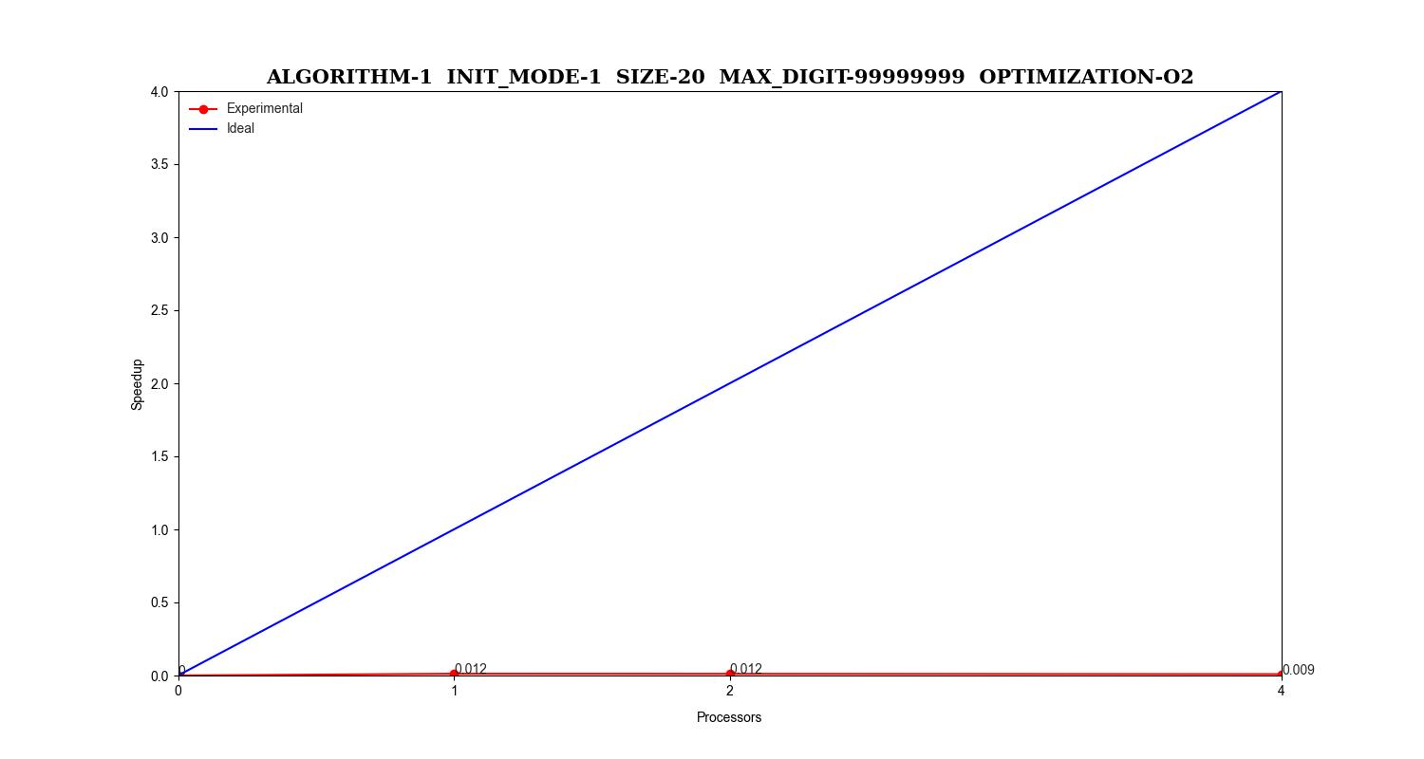

|  |  |  |  |  |  |  |  |  |
| --- | --- | --- | --- | --- | --- | --- | --- | --- |
| Version | Processes | Init | Real_Func | User | Sys | Elapsed | Speedup | Efficiency |
| Serial | 1 | 4e-05 | 0.0 | 0.001 | 0.001 | 0.00393877 | 1.0 | 1.0 |
| Parallel | 1 | 0.02788696 | 1.00000000 | 0.19160000 | 0.07858823 | 0.32336734 | 0.01218049 | 0.01218049 |
| Parallel | 2 | 0.02791585 | 0.00034333 | 0.30791176 | 0.11737142 | 0.34124999 | 0.01154219 | 0.00577109 |
| Parallel | 4 | 0.03601268 | 0.00083270 | 0.63297435 | 0.20967741 | 0.42467567 | 0.00927478 | 0.00231869 |

### ALGORITHM-1 INIT_MODE-1 SIZE-200 MAX_DIGIT-99999999 OPTIMIZATION-O2

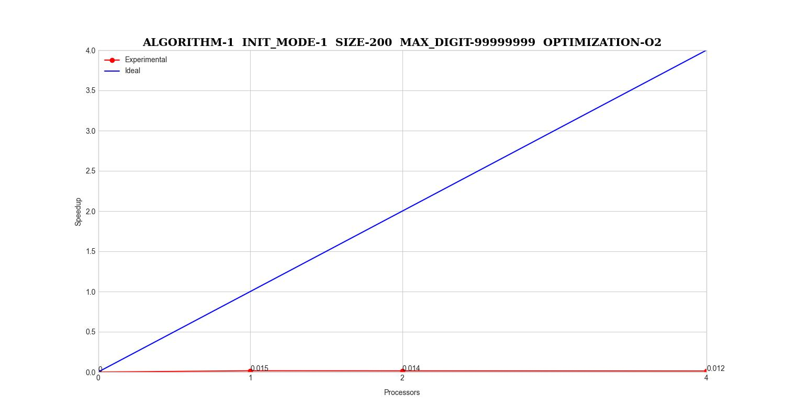

|  |  |  |  |  |  |  |  |  |
| --- | --- | --- | --- | --- | --- | --- | --- | --- |
| Version | Processes | Init | Real_Func | User | Sys | Elapsed | Speedup | Efficiency |
| Serial | 1 | 5.175e-05 | 2.16666666 | 0.001 | 0.00200000 | 0.005 | 1.0 | 1.0 |
| Parallel | 1 | 0.02813294 | 2.73469387 | 0.19507894 | 0.08173684 | 0.32928571 | 0.01518438 | 0.01518438 |
| Parallel | 2 | 0.03032857 | 0.00036102 | 0.32517647 | 0.12720588 | 0.35708108 | 0.01400242 | 0.00700121 |
| Parallel | 4 | 0.04006285 | 0.00087227 | 0.66111764 | 0.21645714 | 0.41261111 | 0.01211794 | 0.00302948 |

### ALGORITHM-1 INIT_MODE-1 SIZE-2 MAX_DIGIT-99999999 OPTIMIZATION-O2

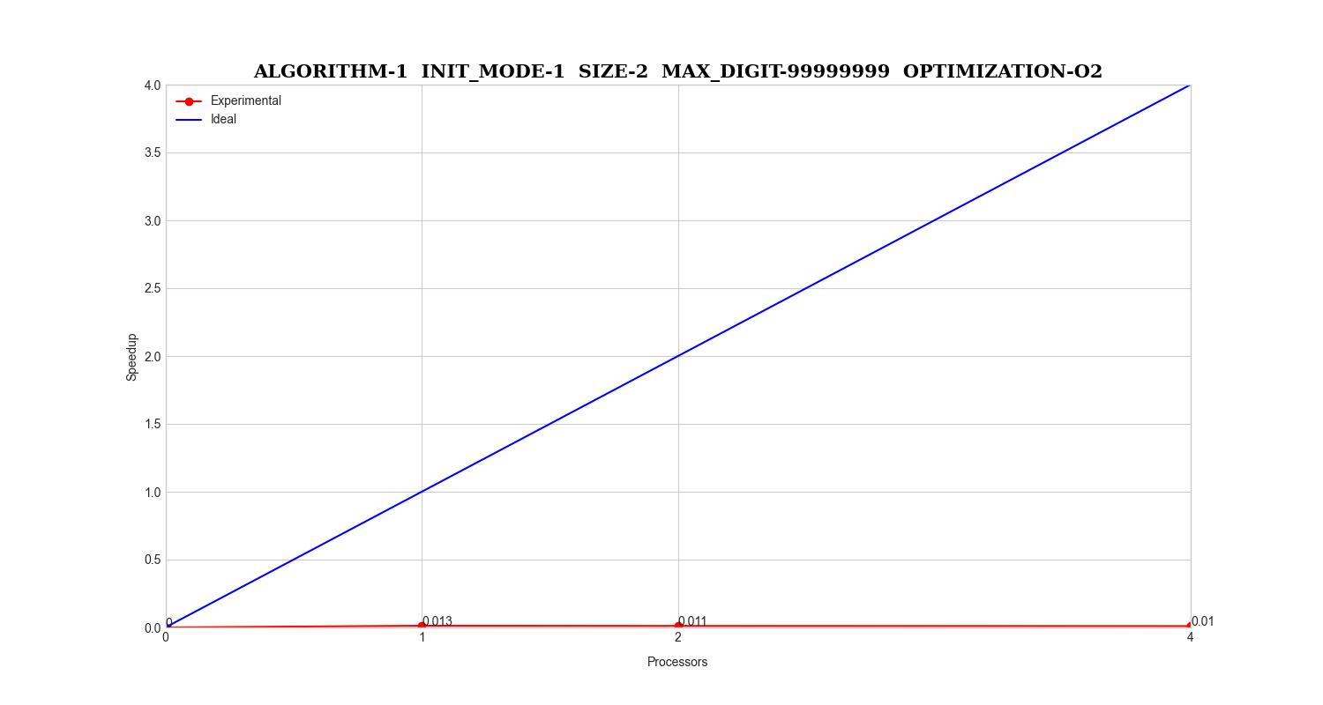

|  |  |  |  |  |  |  |  |  |
| --- | --- | --- | --- | --- | --- | --- | --- | --- |
| Version | Processes | Init | Real_Func | User | Sys | Elapsed | Speedup | Efficiency |
| Serial | 1 | 4.99999999 | 0.0 | 0.001 | 0.0015 | 0.00450000 | 1.0 | 1.0 |
| Parallel | 1 | 0.028065 | 1e-05 | 0.20400000 | 0.0895 | 0.356 | 0.01264044 | 0.01264044 |
| Parallel | 2 | 0.03659 | 0.00041 | 0.346 | 0.1355 | 0.396 | 0.01136363 | 0.00568181 |
| Parallel | 4 | 0.03379 | 0.00088 | 0.679 | 0.236 | 0.443 | 0.01015801 | 0.00253950 |

### ALGORITHM-1 INIT_MODE-1 SIZE-20000000 MAX_DIGIT-99999999 OPTIMIZATION-O2

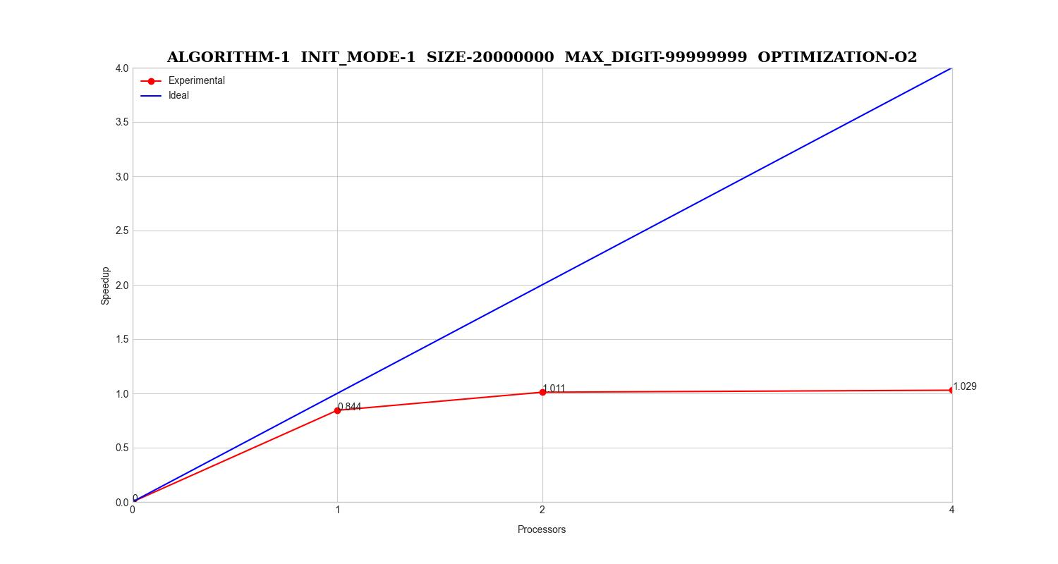

|  |  |  |  |  |  |  |  |  |
| --- | --- | --- | --- | --- | --- | --- | --- | --- |
| Version | Processes | Init | Real_Func | User | Sys | Elapsed | Speedup | Efficiency |
| Serial | 1 | 0.04116666 | 1.55256333 | 1.51766666 | 0.106 | 1.71666666 | 1.0 | 1.0 |
| Parallel | 1 | 0.0687485 | 1.65119422 | 1.73727777 | 0.20800000 | 2.03417021 | 0.84391495 | 0.84391495 |
| Parallel | 2 | 0.05915918 | 1.32246812 | 1.99463829 | 0.29994444 | 1.69810869 | 1.01092861 | 0.50546430 |
| Parallel | 4 | 0.05234723 | 1.25672382 | 2.70797500 | 0.50263157 | 1.66785106 | 1.02926856 | 0.25731714 |

### ALGORITHM-0 INIT_MODE-0 SIZE-200 MAX_DIGIT-99999999 OPTIMIZATION-O2

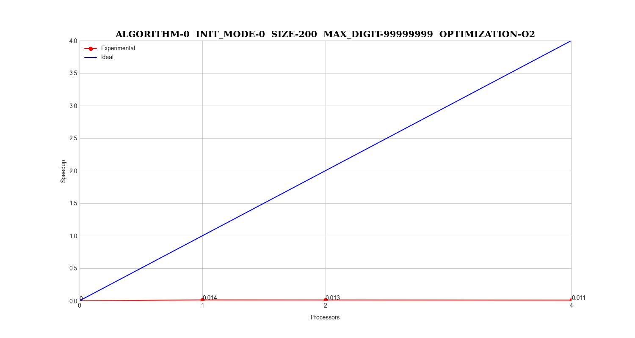

|  |  |  |  |  |  |  |  |  |
| --- | --- | --- | --- | --- | --- | --- | --- | --- |
| Version | Processes | Init | Real_Func | User | Sys | Elapsed | Speedup | Efficiency |
| Serial | 1 | 3.68181818 | 2.11111111 | 0.001 | 0.001 | 0.00410204 | 1.0 | 1.0 |
| Parallel | 1 | 5.18181818 | 5.67441860 | 0.16807692 | 0.07606451 | 0.29193478 | 0.01405122 | 0.01405122 |
| Parallel | 2 | 4.88636363 | 0.00021078 | 0.26638095 | 0.11439473 | 0.31424444 | 0.01305366 | 0.00652683 |
| Parallel | 4 | 5.25e-05 | 0.00034837 | 0.51560000 | 0.19590000 | 0.38472727 | 0.01066220 | 0.00266555 |

### ALGORITHM-0 INIT_MODE-0 SIZE-2 MAX_DIGIT-99999999 OPTIMIZATION-O2

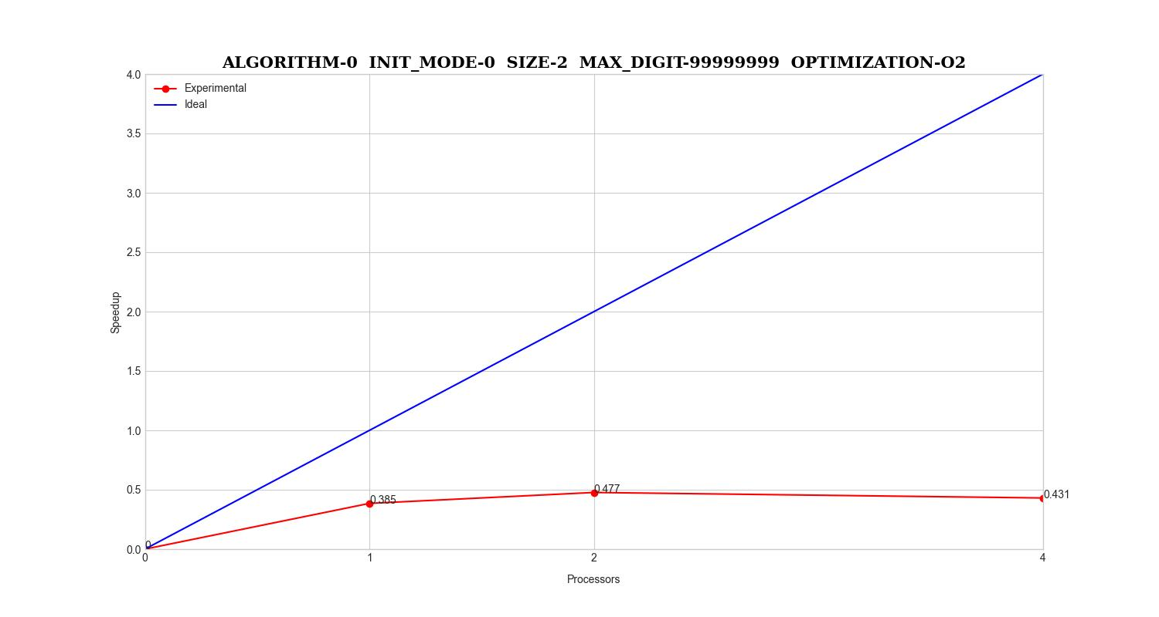

|  |  |  |  |  |  |  |  |  |
| --- | --- | --- | --- | --- | --- | --- | --- | --- |
| Version | Processes | Init | Real_Func | User | Sys | Elapsed | Speedup | Efficiency |
| Serial | 1 | 9e-05 | 0.0 | 0.001 | 0.0015 | 0.182 | 1.0 | 1.0 |
| Parallel | 1 | 8.99999999 | 0.0001 | 0.1785 | 0.0935 | 0.4725 | 0.38518518 | 0.38518518 |
| Parallel | 2 | 6e-05 | 0.00035999 | 0.27 | 0.1365 | 0.3815 | 0.47706422 | 0.23853211 |
| Parallel | 4 | 4.5e-05 | 0.000995 | 0.532 | 0.2155 | 0.4225 | 0.43076923 | 0.10769230 |

### ALGORITHM-0 INIT_MODE-0 SIZE-20000000 MAX_DIGIT-99999999 OPTIMIZATION-O2

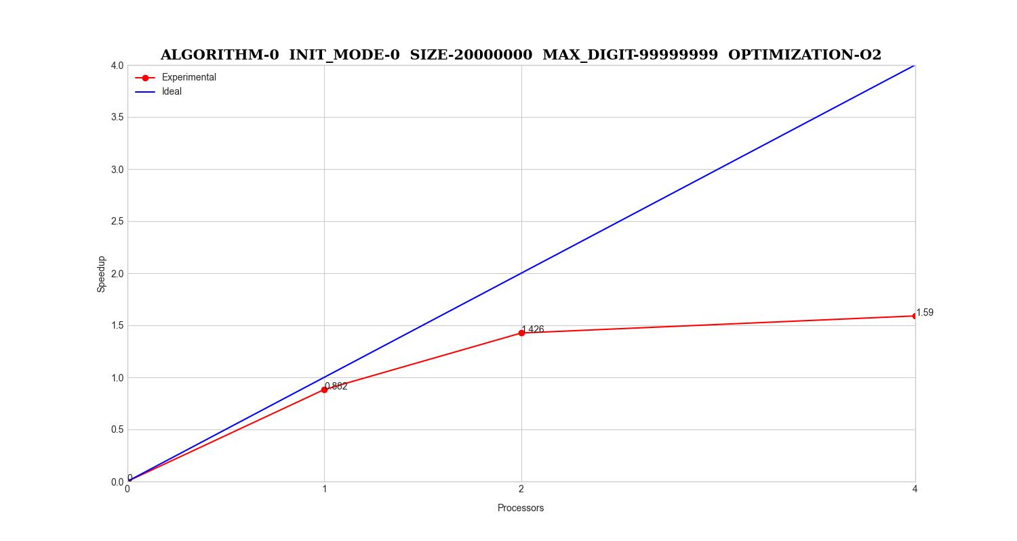

|  |  |  |  |  |  |  |  |  |
| --- | --- | --- | --- | --- | --- | --- | --- | --- |
| Version | Processes | Init | Real_Func | User | Sys | Elapsed | Speedup | Efficiency |
| Serial | 1 | 0.03775230 | 2.05378 | 1.99178571 | 0.11508333 | 2.14794444 | 1.0 | 1.0 |
| Parallel | 1 | 0.04116714 | 2.09036200 | 2.16533333 | 0.18764285 | 2.43394736 | 0.88249420 | 0.88249420 |
| Parallel | 2 | 0.04102928 | 1.20186277 | 2.48753333 | 0.23475000 | 1.50644444 | 1.42583714 | 0.71291857 |
| Parallel | 4 | 0.04383642 | 0.99917176 | 3.37382352 | 0.406 | 1.35106250 | 1.58981871 | 0.39745467 |

### ALGORITHM-0 INIT_MODE-1 SIZE-20000000 MAX_DIGIT-99999999 OPTIMIZATION-O2

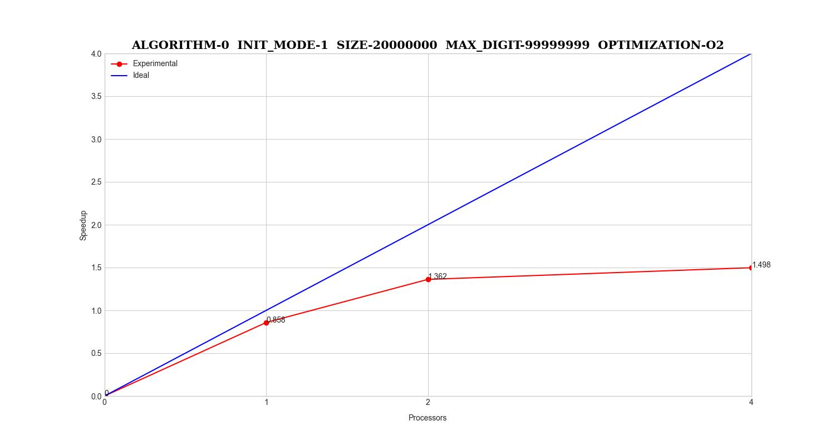

|  |  |  |  |  |  |  |  |  |
| --- | --- | --- | --- | --- | --- | --- | --- | --- |
| Version | Processes | Init | Real_Func | User | Sys | Elapsed | Speedup | Efficiency |
| Serial | 1 | 0.03799266 | 2.05399285 | 1.99638461 | 0.11406250 | 2.14255555 | 1.0 | 1.0 |
| Parallel | 1 | 0.11168642 | 2.07334111 | 2.20705882 | 0.21125 | 2.49594117 | 0.85841588 | 0.85841588 |
| Parallel | 2 | 0.10630684 | 1.17515866 | 2.57415384 | 0.2786 | 1.57316666 | 1.36193805 | 0.68096902 |
| Parallel | 4 | 0.11304812 | 1.01250999 | 3.62164285 | 0.46516666 | 1.43021428 | 1.49806611 | 0.37451652 |