**Introduction**

In this project, I complete the mandatory part with the help of built-in database in Qt. I load the data into the database and then perform operations like insert and search. It is fast to manipulate the data on the database.

To make the program more methodical, I divide it into four parts. “mainwindow.cpp” connects three tools on the toolbar. “dataBase.cpp” works on loading the contents into the database and executing functions of “Filter”. “dataPlot.cpp” works on plotting charts on the basis of the dataset. Additionally, I show the data in many ways including histogram、pie chart and interpolated line to make it diverse. “comparePlot.cpp” works on displaying the difference of two users or POIs.

**Implementation Details**



“Ui Designer”: I collect three pictures and use them as the icon of the tools. The input is in the form of line edit and buttons are used to run code.

“mainwindow.cpp”: I create a variable whose type is “database”. I emit the signal of the file’s name to “myWork”. And I also transmit the input sent by the “lineEdit” to execute filtering fuctions. The advantage is that I could make full use of “dataBase”.

“dataBase.cpp”: In the header file, I set the “checkIn” and “db” as public variable. Because I need to transmit the data to “myPlot” created in the lambda expression and transmit the database to “compare” created after the database was built. This works well in solving data transmission problem.

“dataPlot.cpp”: In function “topTen1”, I create an array “rank” and maintain the order during input. It avoids sort and improves the efficiency. In function “getNum1”, I choose month as the unit and plot the histogram. In function “getNum2”, I use “QSplineSeries” to plot interpolated line.

“compare.cpp”: I interpret DAU as the user who is repeated most often of the day. And I only count the day when both POIs have at least one record.

**Results**

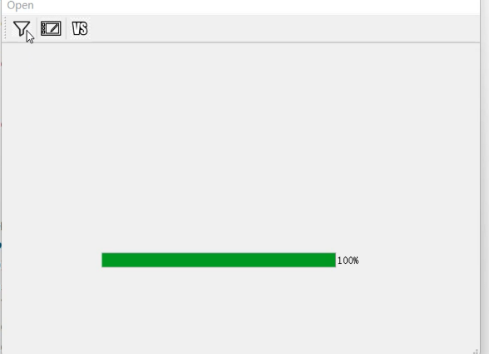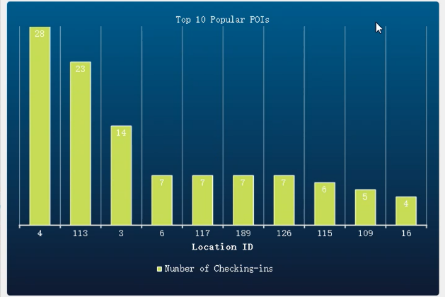

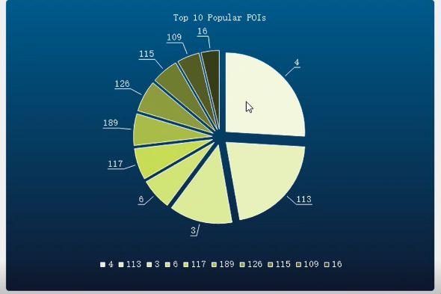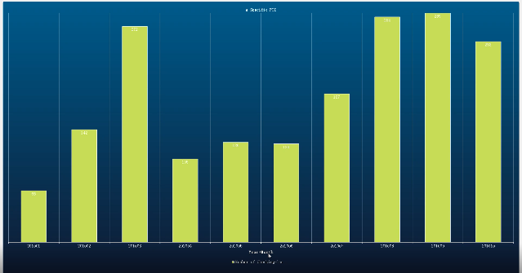

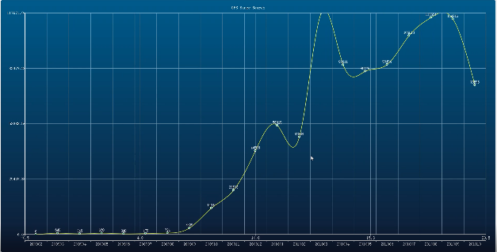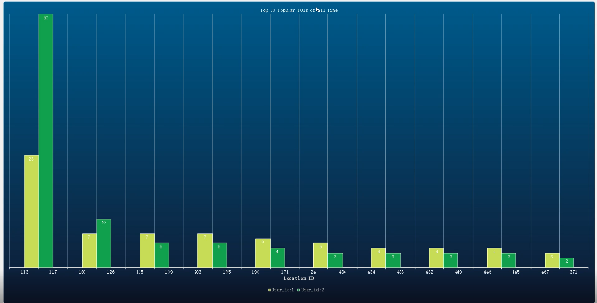

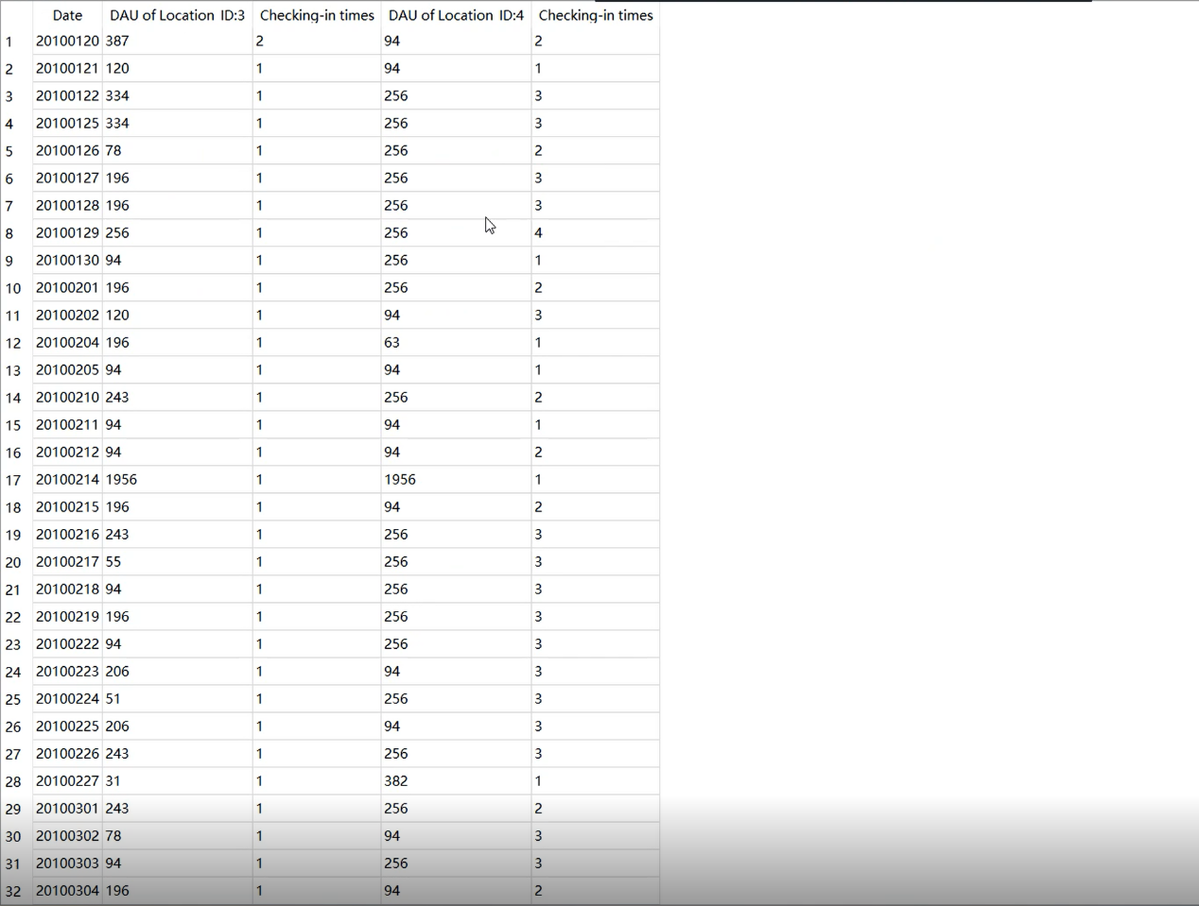

**Discussions**

I haven’t used multithreading to upload the file so that some poor performance computers will get stuck during this process. Actually, at the beginning, I tried a lot of times cutting the csv file into many parts and allocating them to some threads, but I failed. Then I searched online and found out that Qt has its built-in database. And operations on the database will be efficient. As expected, filtration and plot are really fast. The last function “DAU of Two POIs” is not satisfactory. The scale of the cycle is so large that the program will get stuck for about 50 seconds. If I have enough time after exam week, I would like to improve the procedure. All in all, I learn a lot from this homework and thank teachers and assistants.