**09-27作业1**

2.

CREATE TABLESPACE my2016220203031_Job

DATAFILE 'C:\exampleDB\2016220203031_Job_data.dbf'

SIZE 100M

AUTOEXTEND on

NEXT 20M MAXSIZE unlimited

EXTENT MANAGEMENT local;

CREATE TEMPORARY TABLESPACE my2016220203031_Job_temp

tempfile 'C:\exampleDB\2016220203031_Job_temp.dbf'

SIZE 50M

AUTOEXTEND on

NEXT 10M MAXSIZE unlimited

EXTENT MANAGEMENT local;

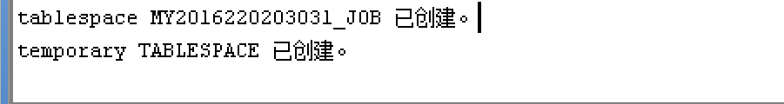

3.CREATE user user_2016220203031

IDENTIFIED BY 2016220203031

DEFAULT TABLESPACE my2016220203031_Job

TEMPORARY TABLESPACE my2016220203031_Job_temp

ACCOUNT unlock;

GRANT DBA to user_2016220203031;

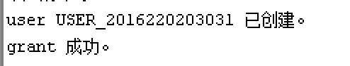

4.

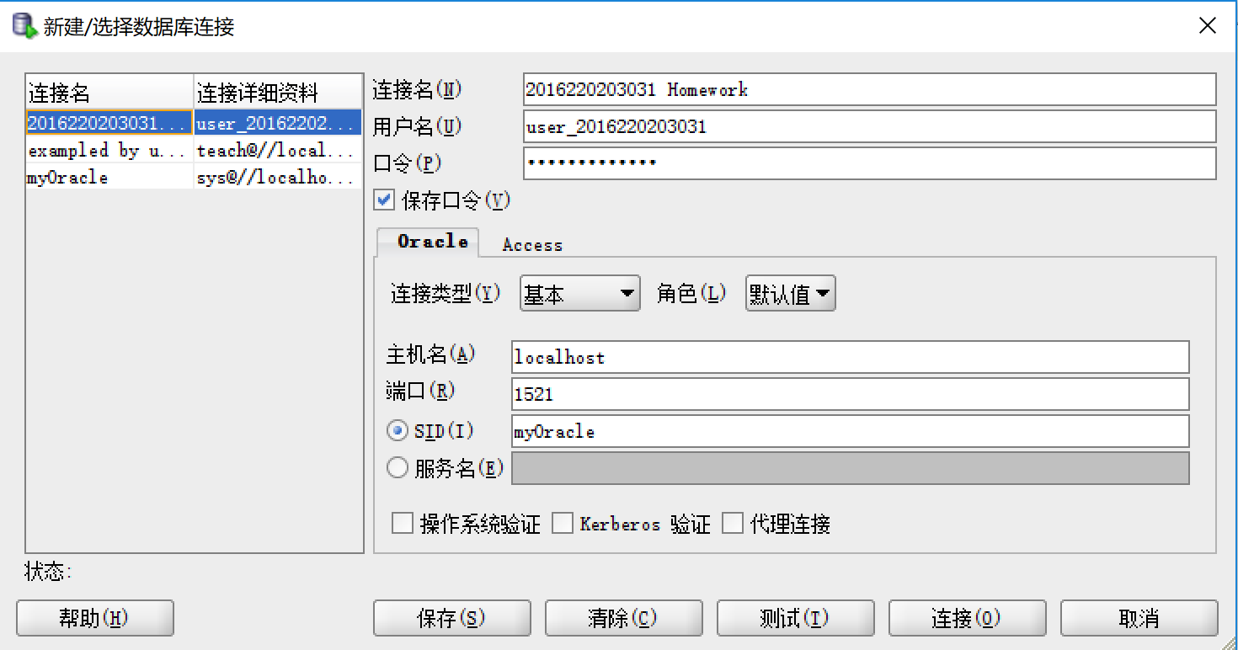

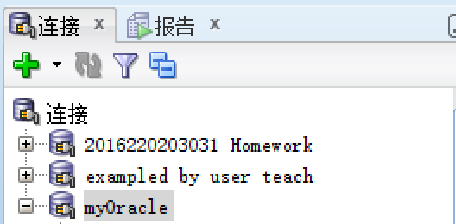

5.(1).

CREATE TABLESPACE HR

DATAFILE 'C:\exampleDB\HR.dbf'

SIZE 100M

AUTOEXTEND on

NEXT 20M MAXSIZE unlimited

EXTENT MANAGEMENT local;

CREATE TABLE Department(

DeptID char(3) not null,

DeptName char(30) not null,

DeptTel char(20) null,

DeptManager char(10) null,

constraint DeptID_PK primary key(DeptID)

)TABLESPACE HR;

CREATE TABLE Employee(

EmpID char(5) not null,

EmpName char(10) not null,

Gender char(2) null,

Title char(6) null,

DeptID char(3) not null,

Phone char(11) not null,

constraint EmpID_PK primary key(EmpID)

);

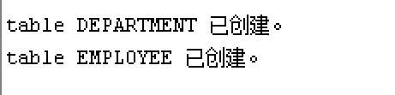

(2).

INSERT INTO Department

VALUES ('001','研发部','18280007528','大彪');

INSERT INTO Employee

VALUES ('001','大彪','女','员工','001','18280007528');

UPDATE Department

SET DeptTel='110'

WHERE DeptID='001';

SELECT * from Department;

INSERT INTO Employee

VALUES ('002','小彪','女','员工','001','18280007529');

DELETE FROM Employee WHERE EmpName='小彪';

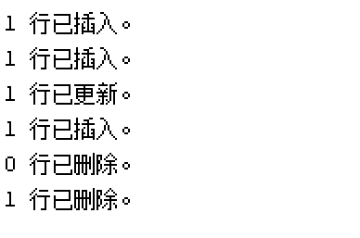

6.(1).

CREATE TABLESPACE EstateDB

DATAFILE 'C:\exampleDB\EstateDB.dbf'

SIZE 100M

AUTOEXTEND on

NEXT 20M MAXSIZE unlimited

EXTENT MANAGEMENT local;

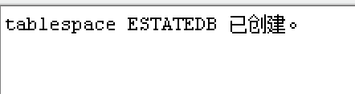

(2).

CREATE TABLE OWNER(

PersonID Char(18) NOT NULL PRIMARY KEY,

Name Varchar(20) NOT NULL,

Gender Char(2) NOT NULL,

Occupation Varchar(20) NOT NULL,

Addr Varchar(50) NOT NULL,

Tel Varchar(11) NOT NULL

)TABLESPACE EstateDB;

CREATE TABLE ESTATE (

EstateID Char(15) NOT NULL PRIMARY KEY,

EstateName VarChar(50) NOT NULL,

EstateBuildName Varchar(50) NOT NULL,

EstateAddr Varchar(60) NOT NULL,

EstateCity Varchar(60) NOT NULL,

EstateType Char(4) NOT NULL CHECK(EstateType IN('住宅','商铺','车位','别墅')),

PropertyArea Numeric(5,2) NOT NULL,

UsableArea Numeric(5,2) NOT NULL,

CompletedDate Date NOT NULL,

YearLength Int DEFAULT '70' NOT NULL,

Remark Varchar(100) NULL

)TABLESPACE EstateDB;

CREATE TABLE Registration(

RegisterID Int NOT NULL PRIMARY KEY,

PersonID Char(18) NOT NULL REFERENCES Owner(PersonID),

EstateID Char(15) NOT NULL REFERENCES Estate(EstateID),

Price Int NOT NULL,

PurchasedDate Date NOT NULL,

DeliverDate Date NOT NULL

)TABLESPACE EstateDB;

../images/9-27%206（2）1.PNG

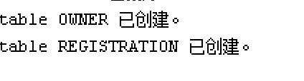

../images/9-27%206（2）3.PNG

(3).

INSERT INTO Estate

VALUES('001','商铺1','楼盘1','成华区','成都','商铺','50','40',to_date('2015-01-01','yyyy-mm-dd'),10,'无');

INSERT INTO Estate

VALUES('002','住宅1','楼盘1','成华区','成都','住宅','100','80',to_date('2015-01-01','yyyy-mm-dd'),10,'无');

INSERT INTO Estate

VALUES('003','住宅2','楼盘2','成华区','成都','住宅','90','70',to_date('2015-01-01','yyyy-mm-dd'),10,'无');

INSERT INTO Owner

VALUES('0001','土豪','男','老师','成都','13112341234');

INSERT INTO Owner

VALUES('0002','穷人','男','老师','成都','13143214321');

INSERT INTO Registration

VALUES('1','0001','002',50000,to_date('2015-01-01','yyyy-mm-dd'),to_date('2015-02-01','yyyy-mm-dd'));

INSERT INTO Registration

VALUES('2','0001','003',100000,to_date('2015-01-01','yyyy-mm-dd'),to_date('2015-02-01','yyyy-mm-dd'));

INSERT INTO Registration

VALUES('3','0002','001',5000,to_date('2015-01-01','yyyy-mm-dd'),to_date('2015-02-01','yyyy-mm-dd'));



(4).

SELECT * FROM Estate

WHERE EstateType='商铺';

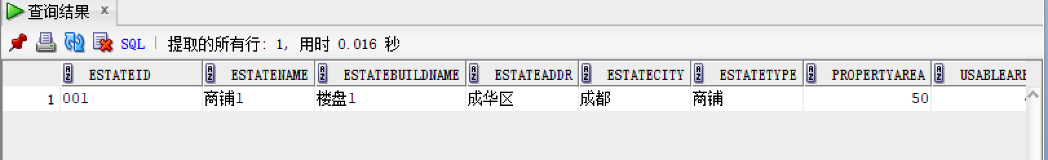

(5).

SELECT * FROM Estate

WHERE CompletedDate>=to_date('2015-01-01','yyyy-mm-dd') AND PropertyArea>= 90 AND EstateType='住宅';

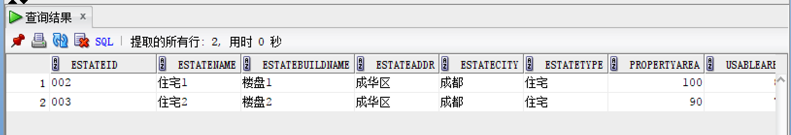

(6).

SELECT * FROM Owner

WHERE PersonID IN (SELECT R.PersonID

FROM ESTATE E, Registration R

WHERE E.EstateID=R.EstateID AND E.EstateType='住宅'

GROUP BY R.PersonID

HAVING COUNT(*) >=2

);

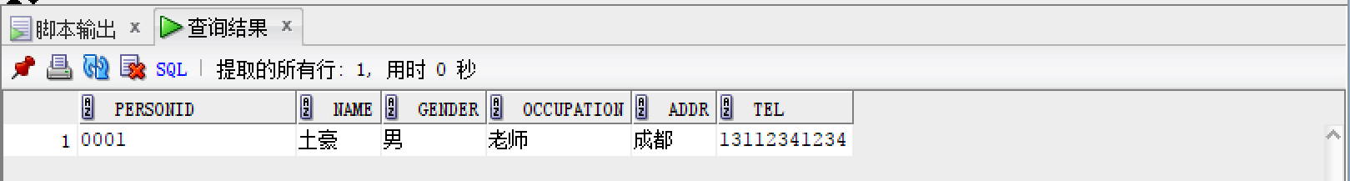

(7).

SELECT * FROM Owner

WHERE PersonID IN (SELECT R.PersonID

FROM ESTATE E, Registration R

WHERE E.EstateID=R.EstateID AND E.EstateType='住宅' AND E.EstateCity='成都'

GROUP BY R.PersonID

HAVING COUNT(*) >=2

);

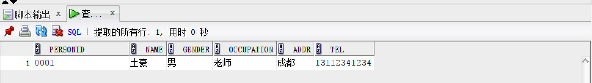

(8).

SELECT E.EstateType, SUM(E.PropertyArea) FROM Registration R, Estate E

WHERE E.EstateID=R.EstateID AND R.PurchasedDate>=to_date('2015-01-01','yyyy-mm-dd')

GROUP BY E.EstateType;

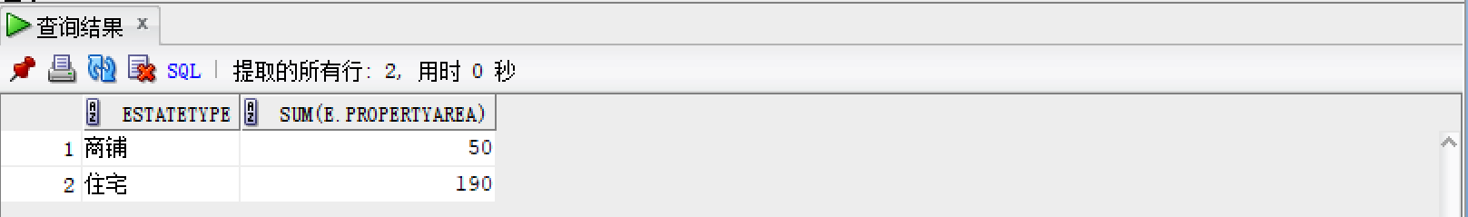

(9).

SELECT E.EstateType, SUM(R.Price) FROM Registration R, Estate E

WHERE E.EstateID=R.EstateID AND R.PurchasedDate>=to_date('2015-01-01','yyyy-mm-dd')

GROUP BY E.EstateType;

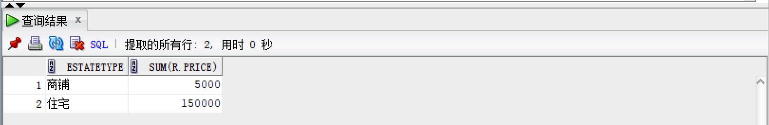

(10).

CREATE VIEW Owner_001 AS

SELECT R.RegisterID AS 登记编号,

E.EstateName AS 房产名称,

E.EstateType AS 房产类型,

E.PropertyArea AS 产权面积,

R.Price AS 购买金额,

R.PurchasedDate AS 购买日期,

E.EstateBuildName AS 房产楼盘,

E.EstateCity AS 房产城市

FROM Estate E,Registration R

WHERE R.PersonID='0001' AND R.EstateID=E.EstateID

ORDER BY R.PurchasedDate DESC;

SELECT * FROM Owner_001;

SELECT E.EstateType, SUM(R.Price) FROM Registration R, Estate E

WHERE E.EstateID=R.EstateID AND R.PurchasedDate>=to_date('2015-01-01','yyyy-mm-dd')

GROUP BY E.EstateType;

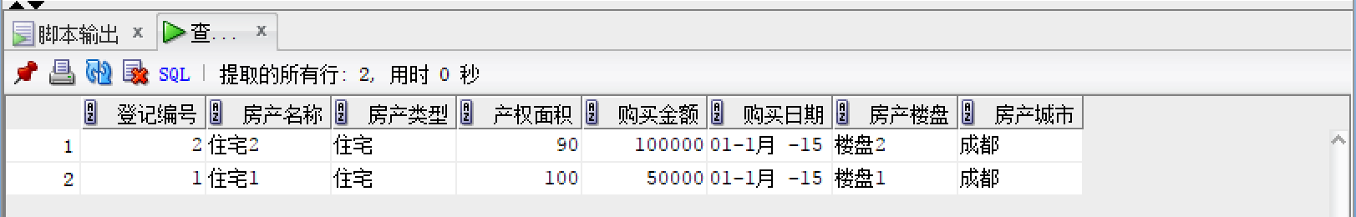

(11).

CREATE VIEW CitySale AS

SELECT COUNT(R.RegisterID) AS 销售套数,

SUM(R.Price) AS 总销售金额

FROM Registration R, Estate E

GROUP BY E.EstateCity;

SELECT * FROM CitySale;

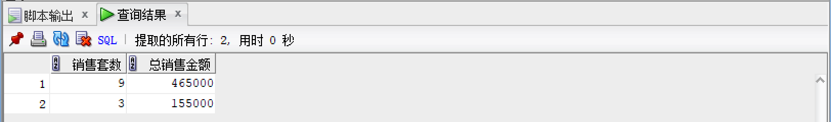

**第2讲PPT作业2**



6.

（1）

CREATE TABLESPACE BORROW

DATAFILE 'C:\exampleDB\borrow.dbf'

SIZE 100M

AUTOEXTEND on

NEXT 20M MAXSIZE unlimited

EXTENT MANAGEMENT local;

CREATE TEMPORARY TABLESPACE BORROW_TEMP

TEMPFILE'C:\exampleDB\borrow_temp.dbf'

size 50M

AUTOEXTEND on

NEXT 10M MAXSIZE unlimited

EXTENT MANAGEMENT local;

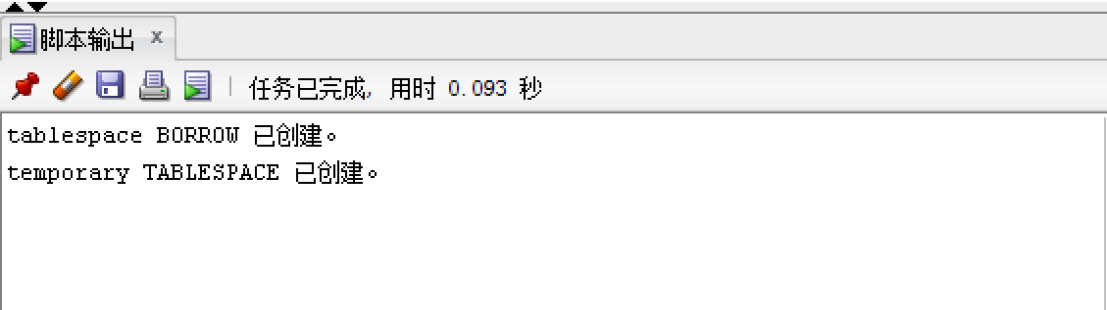

（2）

CREATE TABLE DEPARTMENT (

DeptID char(3) NOT NULL PRIMARY KEY,

DeptName char(30) NULL,

DeptTel char(20) NULL,

DeptManager char(10) NULL

);

CREATE TABLE READER (

ReaderID char(5) NOT NULL PRIMARY KEY,

ReaderName char(30） NULL,

Gender char(2) NULL,

Birthday date NULL,

DeptID char(3) NULL,

Phone char(11) NULL,

CONSTRAINT DeptID_PK FOREIGN KEY(DeptID)

REFERENCES DEPARTMENT(DeptID)

);

CREATE TABLE BOOK (

ISBN char(16) NOT NULL PRIMARY KEY,

BookName char(30) NOT NULL,

BookIntr char(255) NULL,

BookType char(30) NULL,

Authors char(30) NULL,

Price int NULL,

Publisher char(30) NULL,

PublishDate date NULL

);

CREATE TABLE LOAN (

RecordID int NOT NULL,

ReaderID char(5) NOT NULL REFERENCES READER(ReaderID),

ISBN CHAR(16) NOT NULL REFERENCES BOOK(ISBN),

OperType char(4) Not NULL,

OperDate date NULL,

Note char(100) NULL

);

CREATE SEQUENCE Seq_Loan_ReacordID INCREMENT BY 1 START WITH 1;

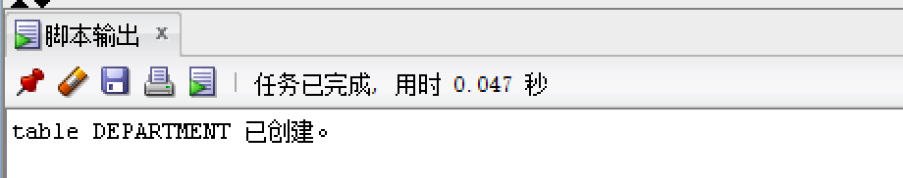



（3）

ALTER TABLE LOAN

ADD CONSTRAINTS ReaderID_FK FOREIGN KEY(ReaderID)

REFERENCES READER(ReaderID)

ON DELETE CASECADE;

ALTER TABLE LOAN

ADD CONSTRAINTS ISBN FOREIGN KEY(ISBN)

REFERENCES BOOK(ISBN)

ON DELETE CASECADE;



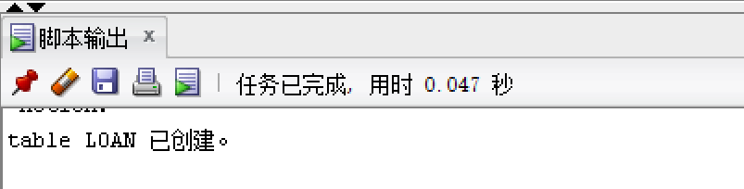

(4)

INSERT INTO READER (ReaderID,ReaderName, Gender)

VALUES ('00001','大彪','女'）;

SELECT * FROM READER;

INSERT INTO BOOK (ISBN,BookName)

VALUES ('001','小王子');

SELECT * FROM BOOK;

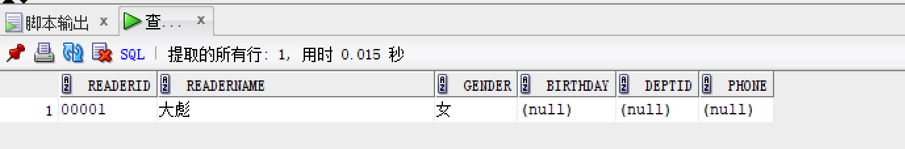

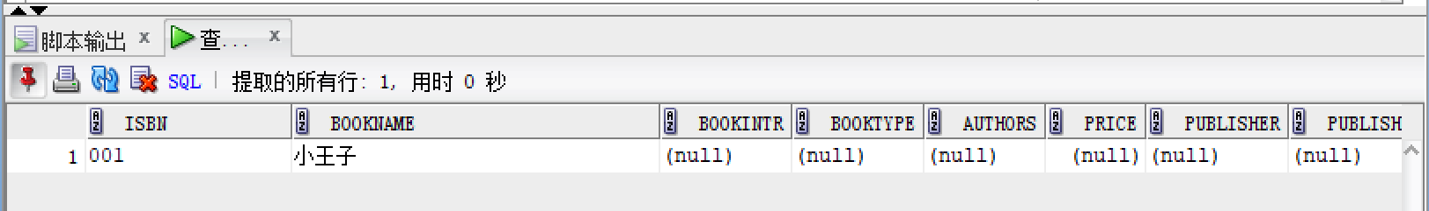

**11-30作业3**

5． (1).

CDM

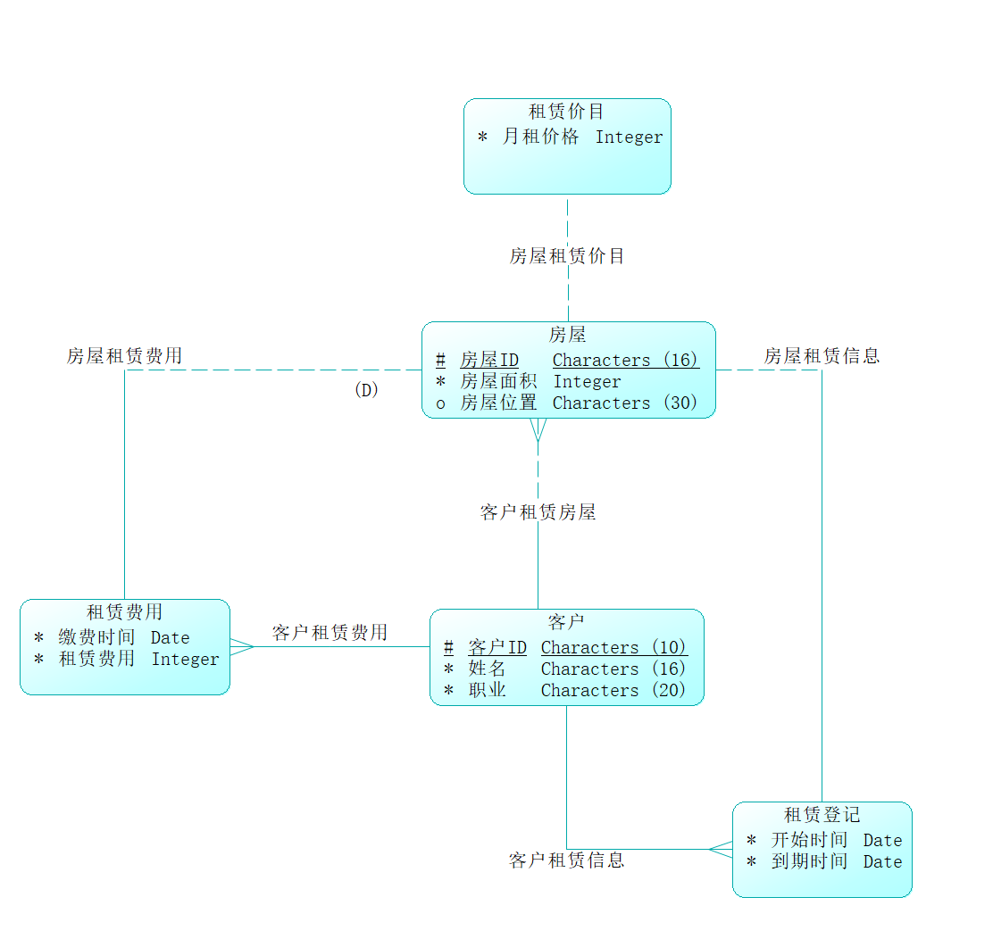

LDM

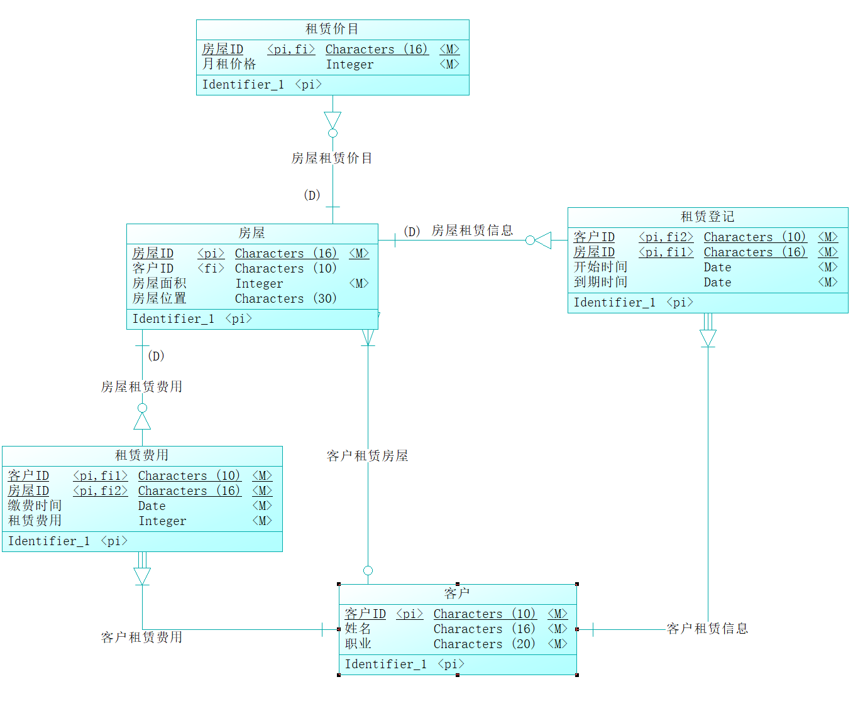

PDM

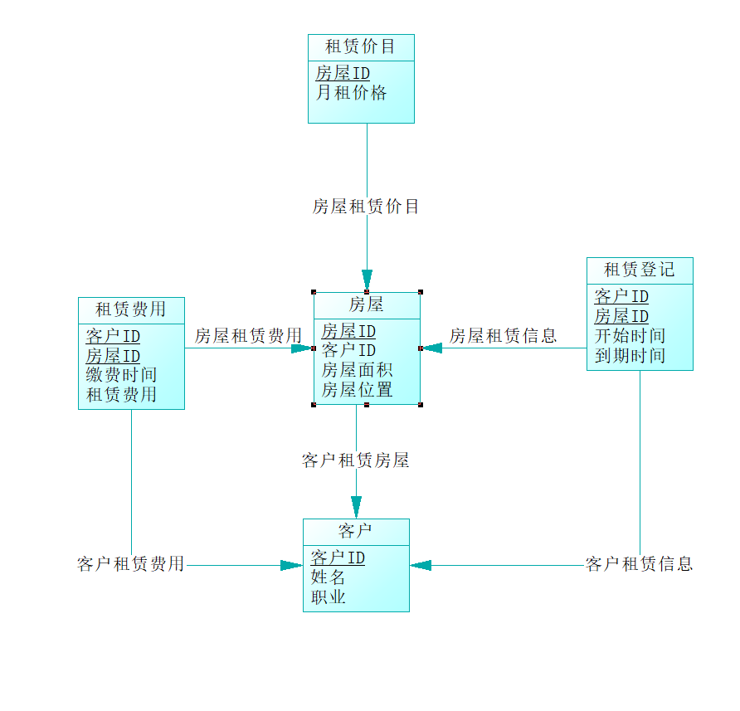

1.

alter table House

drop constraint FK_HOUSE_CLIENTREN_CLIENT;

alter table RentFee

drop constraint FK_RENTFEE_CLIENTREN_CLIENT;

alter table RentFee

drop constraint FK_RENTFEE_HOUSERENT_HOUSE;

alter table RentPrice

drop constraint FK_RENTPRIC_HOUSERENT_HOUSE;

alter table RentReg

drop constraint FK_RENTREG_CLIENTREN_CLIENT;

alter table RentReg

drop constraint FK_RENTREG_HOUSERENT_HOUSE;

drop index ClientRentHouse_FK;

drop table House cascade constraints;

drop index HouseRentFee_FK;

drop index ClientRentFee_FK;

drop table RentFee cascade constraints;

drop table RentPrice cascade constraints;

drop index ClientRentMsg_FK;

drop table RentReg cascade constraints;

drop table client cascade constraints;

/*==============================================================*/

/* Table: House */

/*==============================================================*/

create table House

(

HouseID CHAR(16) not null,

ClientID CHAR(10),

HouseArea INTEGER not null,

HouseState CHAR(30),

constraint PK_HOUSE primary key (HouseID)

);

/*==============================================================*/

/* Index: ClientRentHouse_FK */

/*==============================================================*/

create index ClientRentHouse_FK on House (

ClientID ASC

);

/*==============================================================*/

/* Table: RentFee */

/*==============================================================*/

create table RentFee

(

ClientID CHAR(10) not null,

HouseID CHAR(16) not null,

PayTime DATE not null,

Fee INTEGER not null,

constraint PK_RENTFEE primary key (ClientID, HouseID)

);

/*==============================================================*/

/* Index: ClientRentFee_FK */

/*==============================================================*/

create index ClientRentFee_FK on RentFee (

ClientID ASC

);

/*==============================================================*/

/* Index: HouseRentFee_FK */

/*==============================================================*/

create index HouseRentFee_FK on RentFee (

HouseID ASC

);

/*==============================================================*/

/* Table: RentPrice */

/*==============================================================*/

create table RentPrice

(

HouseID CHAR(16) not null,

MonthPrice INTEGER not null,

constraint PK_RENTPRICE primary key (HouseID)

);

/*==============================================================*/

/* Table: RentReg */

/*==============================================================*/

create table RentReg

(

ClientID CHAR(10) not null,

HouseID CHAR(16) not null,

BeginTime DATE not null,

EndTime DATE not null,

constraint PK_RENTREG primary key (ClientID, HouseID)

);

/*==============================================================*/

/* Index: ClientRentMsg_FK */

/*==============================================================*/

create index ClientRentMsg_FK on RentReg (

ClientID ASC

);

/*==============================================================*/

/* Table: client */

/*==============================================================*/

create table client

(

ClientID CHAR(10) not null,

ClientName CHAR(16) not null,

ClientJob CHAR(20) not null,

constraint PK_CLIENT primary key (ClientID)

);

alter table House

add constraint FK_HOUSE_CLIENTREN_CLIENT foreign key (ClientID)

references client (ClientID);

alter table RentFee

add constraint FK_RENTFEE_CLIENTREN_CLIENT foreign key (ClientID)

references client (ClientID);

alter table RentFee

add constraint FK_RENTFEE_HOUSERENT_HOUSE foreign key (HouseID)

references House (HouseID);

alter table RentPrice

add constraint FK_RENTPRIC_HOUSERENT_HOUSE foreign key (HouseID)

references House (HouseID);

alter table RentReg

add constraint FK_RENTREG_CLIENTREN_CLIENT foreign key (ClientID)

references client (ClientID);

alter table RentReg

add constraint FK_RENTREG_HOUSERENT_HOUSE foreign key (HouseID)

references House (HouseID);

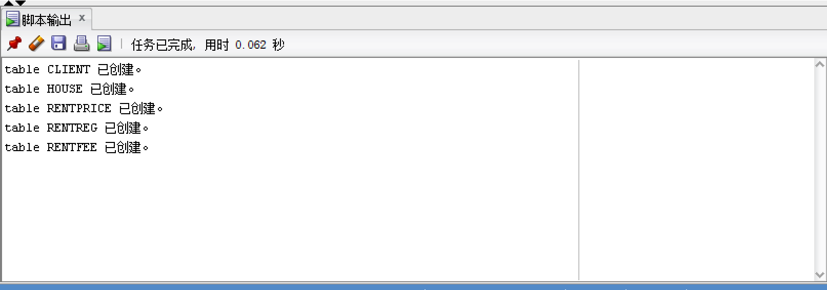

5. (2).

CDM

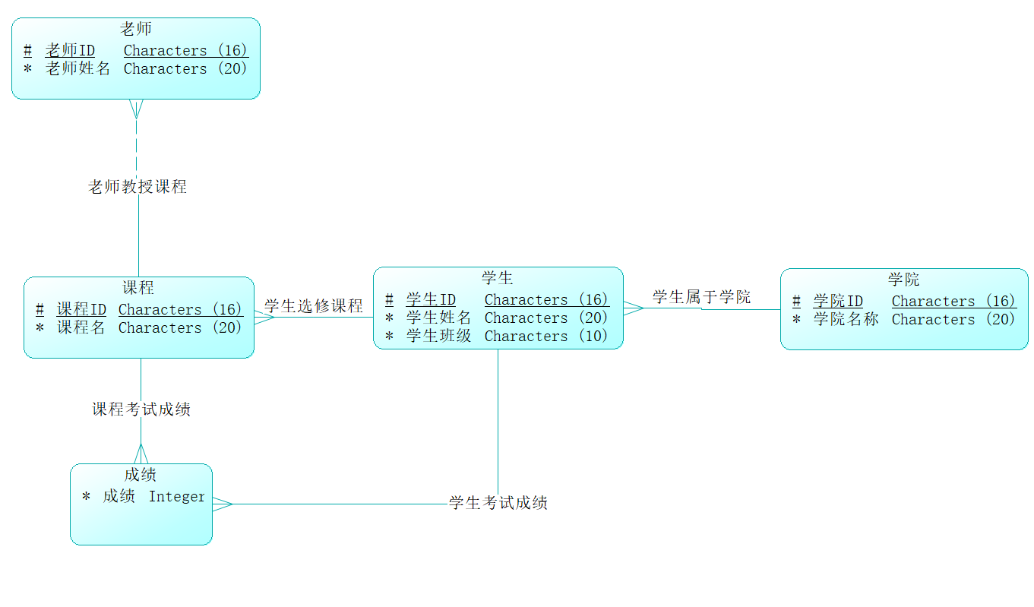

LDM

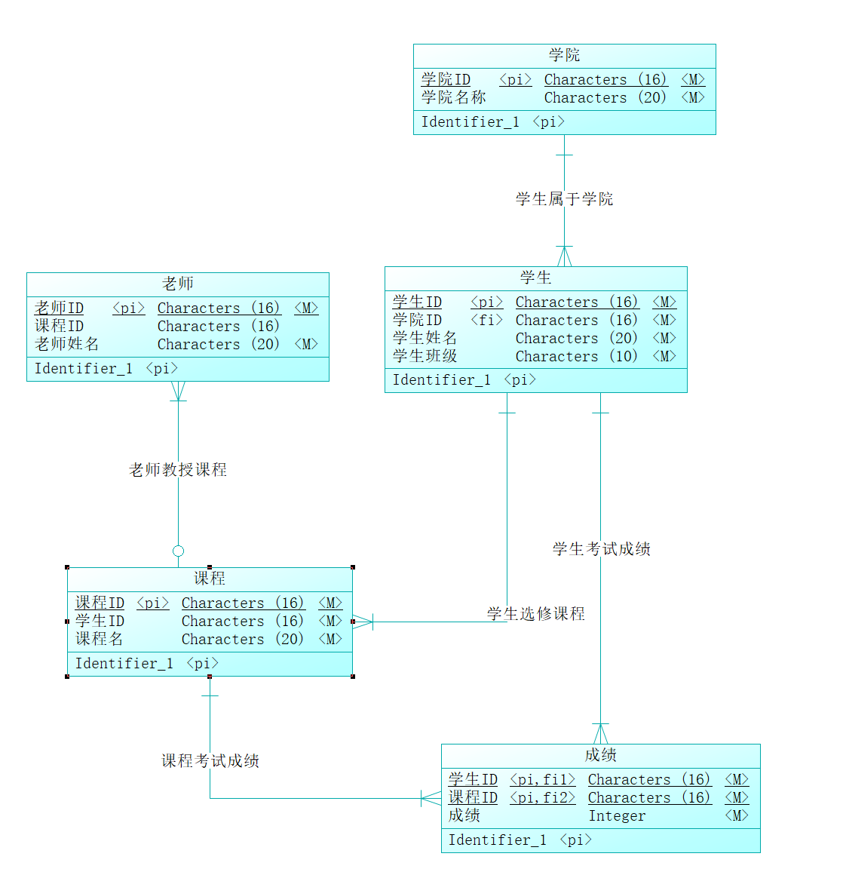

PDM

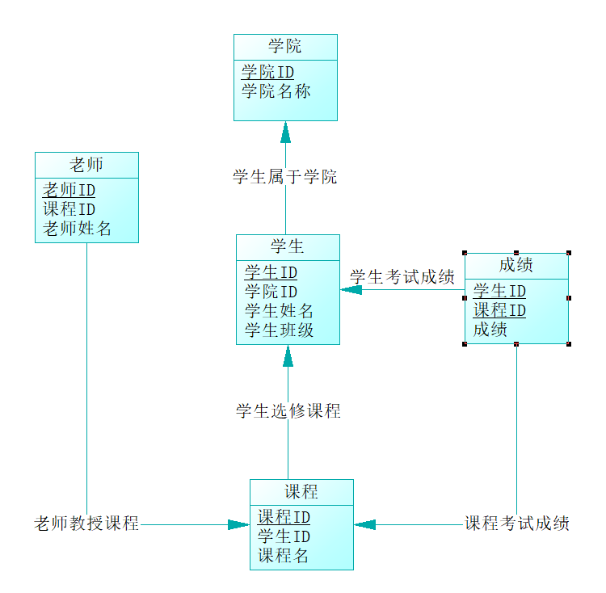

2.

alter table Course

drop constraint FK_COURSE_STUDENTCH_STUDENT;

alter table Grade

drop constraint FK_GRADE_COURSEGRA_COURSE;

alter table Grade

drop constraint FK_GRADE_STUDENTGR_STUDENT;

alter table Student

drop constraint FK_STUDENT_STUDENTIN_ACADEMY;

alter table Teacher

drop constraint FK_TEACHER_TEACHERTE_COURSE;

drop table Academy cascade constraints;

drop table Course cascade constraints;

drop index 课程考试成绩_FK;

drop index 学生考试成绩_FK;

drop table Grade cascade constraints;

drop index 学生属于学院_FK;

drop table Student cascade constraints;

drop table Teacher cascade constraints;

/*==============================================================*/

/* Table: Academy */

/*==============================================================*/

create table Academy

(

AcademyID CHAR(16) not null,

AcademyName CHAR(20) not null,

constraint PK_ACADEMY primary key (AcademyID)

);

/*==============================================================*/

/* Table: Course */

/*==============================================================*/

create table Course

(

CourseID CHAR(16) not null,

StudentID CHAR(16) not null,

CourseName CHAR(20) not null,

constraint PK_COURSE primary key (CourseID)

);

/*==============================================================*/

/* Table: Grade */

/*==============================================================*/

create table Grade

(

StudentID CHAR(16) not null,

CourseID CHAR(16) not null,

Grade INTEGER not null,

constraint PK_GRADE primary key (StudentID, CourseID)

);

/*==============================================================*/

/* Index: 学生考试成绩_FK */

/*==============================================================*/

create index 学生考试成绩_FK on Grade (

StudentID ASC

);

/*==============================================================*/

/* Index: 课程考试成绩_FK */

/*==============================================================*/

create index 课程考试成绩_FK on Grade (

CourseID ASC

);

/*==============================================================*/

/* Table: Student */

/*==============================================================*/

create table Student

(

StudentID CHAR(16) not null,

AcademyID CHAR(16) not null,

StudentName CHAR(20) not null,

StudentClass CHAR(10) not null,

constraint PK_STUDENT primary key (StudentID)

);

/*==============================================================*/

/* Index: 学生属于学院_FK */

/*==============================================================*/

create index 学生属于学院_FK on Student (

AcademyID ASC

);

/*==============================================================*/

/* Table: Teacher */

/*==============================================================*/

create table Teacher

(

TeacherID CHAR(16) not null,

CourseID CHAR(16),

TeacherName CHAR(20) not null,

constraint PK_TEACHER primary key (TeacherID)

);

alter table Course

add constraint FK_COURSE_STUDENTCH_STUDENT foreign key ()

references Student (StudentID);

alter table Grade

add constraint FK_GRADE_COURSEGRA_COURSE foreign key (CourseID)

references Course (CourseID);

alter table Grade

add constraint FK_GRADE_STUDENTGR_STUDENT foreign key (StudentID)

references Student (StudentID);

alter table Student

add constraint FK_STUDENT_STUDENTIN_ACADEMY foreign key (AcademyID)

references Academy (AcademyID);

alter table Teacher

add constraint FK_TEACHER_TEACHERTE_COURSE foreign key ()

references Course (CourseID);

