**WEEK-3**

**Spring Core and Maven**

**Exercise 1: Configuring a Basic Spring Application**

**Scenario:**

**Your company is developing a web application for managing a library. You need to use the Spring Framework to handle the backend operations.**

**Steps:**

1. **Set Up a Spring Project:**
   * **Create a Maven project named LibraryManagement.**
   * **Add Spring Core dependencies in the pom.xml file.**
2. **Configure the Application Context:**
   * **Create an XML configuration file named applicationContext.xml in the src/main/resources directory.**
   * **Define beans for BookService and BookRepository in the XML file.**
3. **Define Service and Repository Classes:**
   * **Create a package com.library.service and add a class BookService.**
   * **Create a package com.library.repository and add a class BookRepository.**
4. **Run the Application:**
   * **Create a main class to load the Spring context and test the configuration.**

**CODE:**

pom.xml

<project xmlns="http://maven.apache.org/POM/4.0.0"

xmlns:xsi="http://www.w3.org/2001/XMLSchema-instance"

xsi:schemaLocation="http://maven.apache.org/POM/4.0.0

http://maven.apache.org/xsd/maven-4.0.0.xsd">

<modelVersion>4.0.0</modelVersion>

<groupId>com.library</groupId>

<artifactId>LibraryManagement</artifactId>

<version>1.0-SNAPSHOT</version>

<dependencies>

<!-- Spring Core -->

<dependency>

<groupId>org.springframework</groupId>

<artifactId>spring-context</artifactId>

<version>5.3.31</version>

</dependency>

</dependencies>

</project>

applicationContext.xml

<?xml version="1.0" encoding="UTF-8"?>

<beans xmlns="http://www.springframework.org/schema/beans"

xmlns:xsi="http://www.w3.org/2001/XMLSchema-instance"

xsi:schemaLocation="http://www.springframework.org/schema/beans

http://www.springframework.org/schema/beans/spring-beans.xsd">

<bean id="bookRepository" class="com.library.repository.BookRepository"/>

<bean id="bookService" class="com.library.service.BookService">

<property name="bookRepository" ref="bookRepository"/>

</bean>

</beans>

BookRepository.java

package com.library.repository;

public class BookRepository {

public String getBookDetails() {

return "Book: Spring in Action by Craig Walls";

}

}

BookService.java

package com.library.service;

import com.library.repository.BookRepository;

public class BookService {

private BookRepository bookRepository;

// Setter for dependency injection

public void setBookRepository(BookRepository bookRepository) {

this.bookRepository = bookRepository;

}

public void displayBook() {

System.out.println(bookRepository.getBookDetails());

}

}

MainApp.java

package com.library;

import org.springframework.context.ApplicationContext;

import org.springframework.context.support.ClassPathXmlApplicationContext;

import com.library.service.BookService;

public class MainApp {

public static void main(String[] args) {

ApplicationContext context = new ClassPathXmlApplicationContext("applicationContext.xml");

BookService bookService = (BookService) context.getBean("bookService");

bookService.displayBook();

}

}

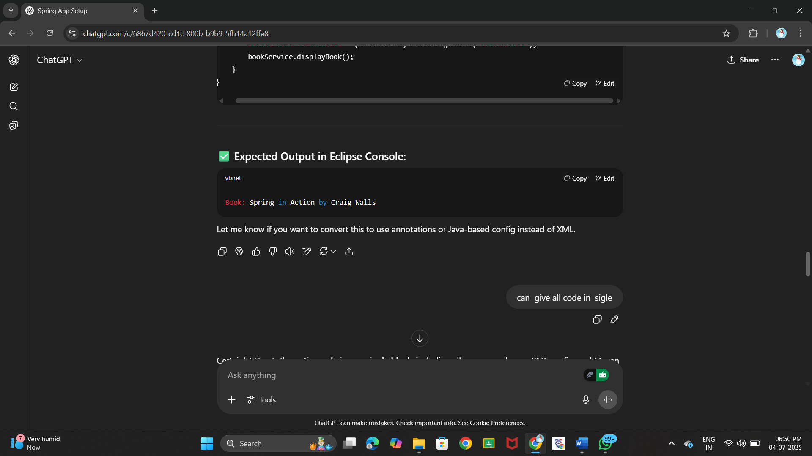**OUTPUT:**

**Exercise 2: Implementing Dependency Injection**

**Scenario:**

**In the library management application, you need to manage the dependencies between the BookService and BookRepository classes using Spring's IoC and DI.**

**Steps:**

1. **Modify the XML Configuration:**
   * **Update applicationContext.xml to wire BookRepository into BookService.**
2. **Update the BookService Class:**
   * **Ensure that BookService class has a setter method for BookRepository.**
3. **Test the Configuration:**
   * **Run the LibraryManagementApplication main class to verify the dependency injection.**

**CODE:**

pom.xml

<project xmlns="http://maven.apache.org/POM/4.0.0"

xmlns:xsi="http://www.w3.org/2001/XMLSchema-instance"

xsi:schemaLocation="http://maven.apache.org/POM/4.0.0

http://maven.apache.org/xsd/maven-4.0.0.xsd">

<modelVersion>4.0.0</modelVersion>

<groupId>com.library</groupId>

<artifactId>LibraryManagement</artifactId>

<version>1.0-SNAPSHOT</version>

<dependencies>

<!-- Spring Core Dependency -->

<dependency>

<groupId>org.springframework</groupId>

<artifactId>spring-context</artifactId>

<version>5.3.31</version>

</dependency>

</dependencies>

</project>

applicationContext.xml

<?xml version="1.0" encoding="UTF-8"?>

<beans xmlns="http://www.springframework.org/schema/beans"

xmlns:xsi="http://www.w3.org/2001/XMLSchema-instance"

xsi:schemaLocation="http://www.springframework.org/schema/beans

http://www.springframework.org/schema/beans/spring-beans.xsd">

<!-- BookRepository Bean -->

<bean id="bookRepository" class="com.library.repository.BookRepository"/>

<!-- BookService Bean with Setter Injection -->

<bean id="bookService" class="com.library.service.BookService">

<property name="bookRepository" ref="bookRepository"/>

</bean>

</beans>

BookRepository.java

package com.library.repository;

public class BookRepository {

public String getBookDetails() {

return "Book: Spring in Action by Craig Walls";

}

}

BookService.java

package com.library.service;

import com.library.repository.BookRepository;

public class BookService {

private BookRepository bookRepository;

// Setter method for Dependency Injection

public void setBookRepository(BookRepository bookRepository) {

this.bookRepository = bookRepository;

}

public void displayBook() {

System.out.println(bookRepository.getBookDetails());

}

}

LibraryManagementApplication.java

package com.library;

import org.springframework.context.ApplicationContext;

import org.springframework.context.support.ClassPathXmlApplicationContext;

import com.library.service.BookService;

public class LibraryManagementApplication {

public static void main(String[] args) {

ApplicationContext context = new ClassPathXmlApplicationContext("applicationContext.xml");

BookService bookService = (BookService) context.getBean("bookService");

bookService.displayBook();

}

}

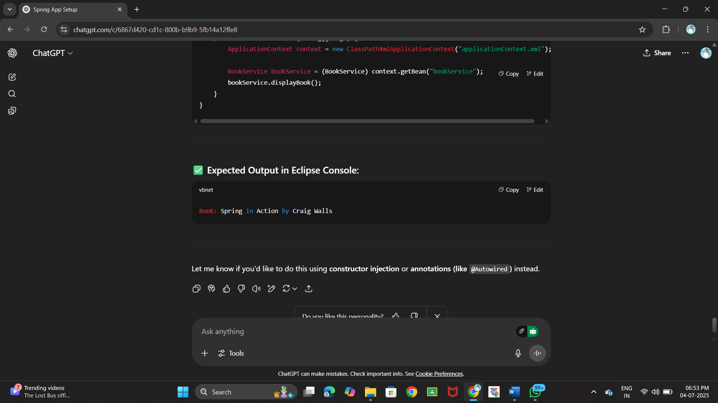**OUTPUT:**

**Exercise 4: Creating and Configuring a Maven Project**

**Scenario:**

**You need to set up a new Maven project for the library management application and add Spring dependencies.**

**Steps:**

1. **Create a New Maven Project:**
   * **Create a new Maven project named LibraryManagement.**
2. **Add Spring Dependencies in pom.xml:**
   * **Include dependencies for Spring Context, Spring AOP, and Spring WebMVC.**
3. **Configure Maven Plugins:**
   * **Configure the Maven Compiler Plugin for Java version 1.8 in the pom.xml file.**

**CODE:**

pom.xml

<project xmlns="http://maven.apache.org/POM/4.0.0"

xmlns:xsi="http://www.w3.org/2001/XMLSchema-instance"

xsi:schemaLocation="http://maven.apache.org/POM/4.0.0

http://maven.apache.org/xsd/maven-4.0.0.xsd">

<modelVersion>4.0.0</modelVersion>

<groupId>com.library</groupId>

<artifactId>LibraryManagement</artifactId>

<version>1.0-SNAPSHOT</version>

<properties>

<maven.compiler.source>1.8</maven.compiler.source>

<maven.compiler.target>1.8</maven.compiler.target>

</properties>

<dependencies>

<!-- Spring Context -->

<dependency>

<groupId>org.springframework</groupId>

<artifactId>spring-context</artifactId>

<version>5.3.31</version>

</dependency>

<!-- Spring AOP -->

<dependency>

<groupId>org.springframework</groupId>

<artifactId>spring-aop</artifactId>

<version>5.3.31</version>

</dependency>

<!-- Spring Web MVC -->

<dependency>

<groupId>org.springframework</groupId>

<artifactId>spring-webmvc</artifactId>

<version>5.3.31</version>

</dependency>

<!-- Servlet API (required for Spring MVC only at compile time) -->

<dependency>

<groupId>javax.servlet</groupId>

<artifactId>javax.servlet-api</artifactId>

<version>4.0.1</version>

<scope>provided</scope>

</dependency>

</dependencies>

<build>

<plugins>

<!-- Compiler Plugin for Java 8 -->

<plugin>

<groupId>org.apache.maven.plugins</groupId>

<artifactId>maven-compiler-plugin</artifactId>

<version>3.8.1</version>

<configuration>

<source>1.8</source>

<target>1.8</target>

</configuration>

</plugin>

</plugins>

</build>

</project>

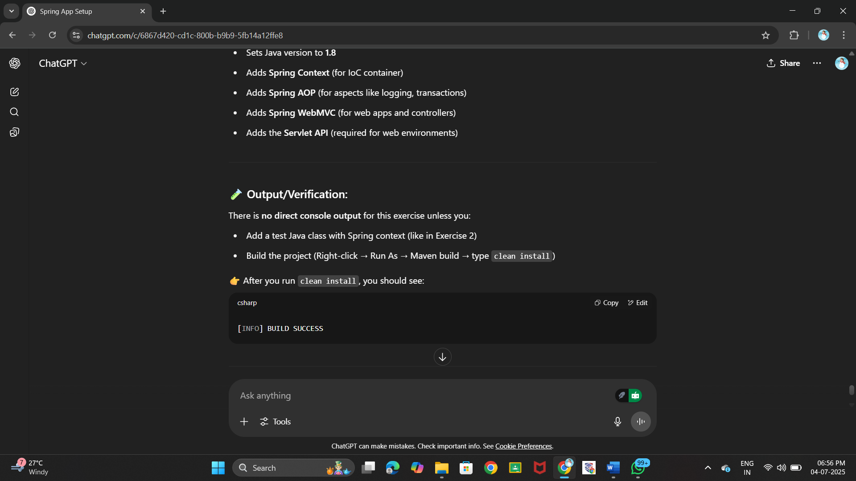**OUTPUT:**

**Spring Data JPA with Spring Boot, Hibernate**

**Hands on 1**

**Spring Data JPA - Quick Example   
  
Software Pre-requisites**

* MySQL Server 8.0
* MySQL Workbench 8
* Eclipse IDE for Enterprise Java Developers 2019-03 R
* Maven 3.6.2

**Create a Eclipse Project using Spring Initializr**

* Go to <https://start.spring.io/>
* Change Group as “com.cognizant”
* Change Artifact Id as “orm-learn”
* In Options > Description enter "Demo project for Spring Data JPA and Hibernate"
* Click on menu and select "Spring Boot DevTools", "Spring Data JPA" and "MySQL Driver"
* Click Generate and download the project as zip
* Extract the zip in root folder to Eclipse Workspace
* Import the project in Eclipse "File > Import > Maven > Existing Maven Projects > Click Browse and select extracted folder > Finish"
* Create a new schema "ormlearn" in MySQL database. Execute the following commands to open MySQL client and create schema.

> mysql -u root -p

**mysql> create schema ormlearn;**

* In orm-learn Eclipse project, open src/main/resources/application.properties and include the below database and log configuration.

# Spring Framework and application log

logging.level.org.springframework=info

logging.level.com.cognizant=debug

# Hibernate logs for displaying executed SQL, input and output

logging.level.org.hibernate.SQL=trace

logging.level.org.hibernate.type.descriptor.sql=trace

# Log pattern

logging.pattern.console=%d{dd-MM-yy} %d{HH:mm:ss.SSS} %-20.20thread %5p %-25.25logger{25} %25M %4L %m%n

# Database configuration

spring.datasource.driver-class-name=com.mysql.cj.jdbc.Driver

spring.datasource.url=jdbc:mysql://localhost:3306/ormlearn

spring.datasource.username=root

spring.datasource.password=root

# Hibernate configuration

spring.jpa.hibernate.ddl-auto=validate

spring.jpa.properties.hibernate.dialect=org.hibernate.dialect.MySQL5Dialect

* Build the project using ‘mvn clean package -Dhttp.proxyHost=proxy.cognizant.com -Dhttp.proxyPort=6050 -Dhttps.proxyHost=proxy.cognizant.com -Dhttps.proxyPort=6050 -Dhttp.proxyUser=123456’ command in command line
* Include logs for verifying if main() method is called.

import org.slf4j.Logger;

import org.slf4j.LoggerFactory;

private static final Logger LOGGER = LoggerFactory.getLogger(OrmLearnApplication.class);

public static void main(String[] args) {

SpringApplication.run(OrmLearnApplication.class, args);

  LOGGER.info("Inside main");

}

* Execute the OrmLearnApplication and check in log if main method is called.

**SME to walk through the following aspects related to the project created:**

1. src/main/java - Folder with application code
2. src/main/resources - Folder for application configuration
3. src/test/java - Folder with code for testing the application
4. OrmLearnApplication.java - Walkthrough the main() method.
5. Purpose of @SpringBootApplication annotation
6. pom.xml
   1. Walkthrough all the configuration defined in XML file
   2. Open 'Dependency Hierarchy' and show the dependency tree.

Country table creation

* Create a new table country with columns for code and name. For sample, let us insert one country with values 'IN' and 'India' in this table.

create table country(co_code varchar(2) primary key, co_name varchar(50));

* Insert couple of records into the table

insert into country values ('IN', 'India');

insert into country values ('US', 'United States of America');

Persistence Class - com.cognizant.orm-learn.model.Country

* Open Eclipse with orm-learn project
* Create new package com.cognizant.orm-learn.model
* Create Country.java, then generate getters, setters and toString() methods.
* Include @Entity and @Table at class level
* Include @Column annotations in each getter method specifying the column name.

import javax.persistence.Column;

import javax.persistence.Entity;

import javax.persistence.Id;

import javax.persistence.Table;

@Entity

@Table(name="country")

public class Country {

  @Id

    @Column(name="code")

    private String code;

    @Column(name="name")

    private String name;

// getters and setters

  // toString()

}

**Notes:**

* @Entity is an indicator to Spring Data JPA that it is an entity class for the application
* @Table helps in defining the mapping database table
* @Id helps is defining the primary key
* @Column helps in defining the mapping table column

Repository Class - com.cognizant.orm-learn.CountryRepository

* Create new package com.cognizant.orm-learn.repository
* Create new interface named CountryRepository that extends JpaRepository<Country, String>
* Define @Repository annotation at class level

import org.springframework.data.jpa.repository.JpaRepository;

import org.springframework.stereotype.Repository;

import com.cognizant.ormlearn.model.Country;

@Repository

public interface CountryRepository extends JpaRepository<Country, String> {

}

Service Class - com.cognizant.orm-learn.service.CountryService

* Create new package com.cognizant.orm-learn.service
* Create new class CountryService
* Include @Service annotation at class level
* Autowire CountryRepository in CountryService
* Include new method getAllCountries() method that returns a list of countries.
* Include @Transactional annotation for this method
* In getAllCountries() method invoke countryRepository.findAll() method and return the result

Testing in OrmLearnApplication.java

* Include a static reference to CountryService in OrmLearnApplication class

private static CountryService countryService;

* Define a test method to get all countries from service.

    private static void testGetAllCountries() {

        LOGGER.info("Start");

        List<Country> countries = countryService.getAllCountries();

        LOGGER.debug("countries={}", countries);

        LOGGER.info("End");

    }

* Modify SpringApplication.run() invocation to set the application context and the CountryService reference from the application context.

        ApplicationContext context = SpringApplication.run(OrmLearnApplication.class, args);

        countryService = context.getBean(CountryService.class);

        testGetAllCountries();

* Execute main method to check if data from ormlearn database is retrieved.

**CODE:**

**Country.java**

package com.cognizant.ormlearn.model;

import javax.persistence.*;

@Entity

@Table(name = "country")

public class Country {

@Id

@Column(name = "co_code")

private String code;

@Column(name = "co_name")

private String name;

public String getCode() { return code; }

public void setCode(String code) { this.code = code; }

public String getName() { return name; }

public void setName(String name) { this.name = name; }

@Override

public String toString() {

return "Country [code=" + code + ", name=" + name + "]";

}

}

**CountryRepository.java**

package com.cognizant.ormlearn.repository;

import org.springframework.data.jpa.repository.JpaRepository;

import org.springframework.stereotype.Repository;

import com.cognizant.ormlearn.model.Country;

@Repository

public interface CountryRepository extends JpaRepository<Country, String> {}

**CountryService.java**

package com.cognizant.ormlearn.service;

import java.util.List;

import javax.transaction.Transactional;

import org.springframework.beans.factory.annotation.Autowired;

import org.springframework.stereotype.Service;

import com.cognizant.ormlearn.model.Country;

import com.cognizant.ormlearn.repository.CountryRepository;

@Service

public class CountryService {

@Autowired

private CountryRepository countryRepository;

@Transactional

public List<Country> getAllCountries() {

return countryRepository.findAll();

}

}

**OrmLearnApplication.java**

package com.cognizant.ormlearn;

import java.util.List;

import com.cognizant.ormlearn.model.Country;

import com.cognizant.ormlearn.service.CountryService;

import org.slf4j.Logger;

import org.slf4j.LoggerFactory;

import org.springframework.boot.SpringApplication;

import org.springframework.boot.autoconfigure.SpringBootApplication;

import org.springframework.context.ApplicationContext;

@SpringBootApplication

public class OrmLearnApplication {

private static final Logger LOGGER = LoggerFactory.getLogger(OrmLearnApplication.class);

private static CountryService countryService;

public static void main(String[] args) {

ApplicationContext context = SpringApplication.run(OrmLearnApplication.class, args);

LOGGER.info("Inside main");

countryService = context.getBean(CountryService.class);

testGetAllCountries();

}

private static void testGetAllCountries() {

LOGGER.info("Start");

List<Country> countries = countryService.getAllCountries();

LOGGER.debug("countries={}", countries);

LOGGER.info("End");

}

}

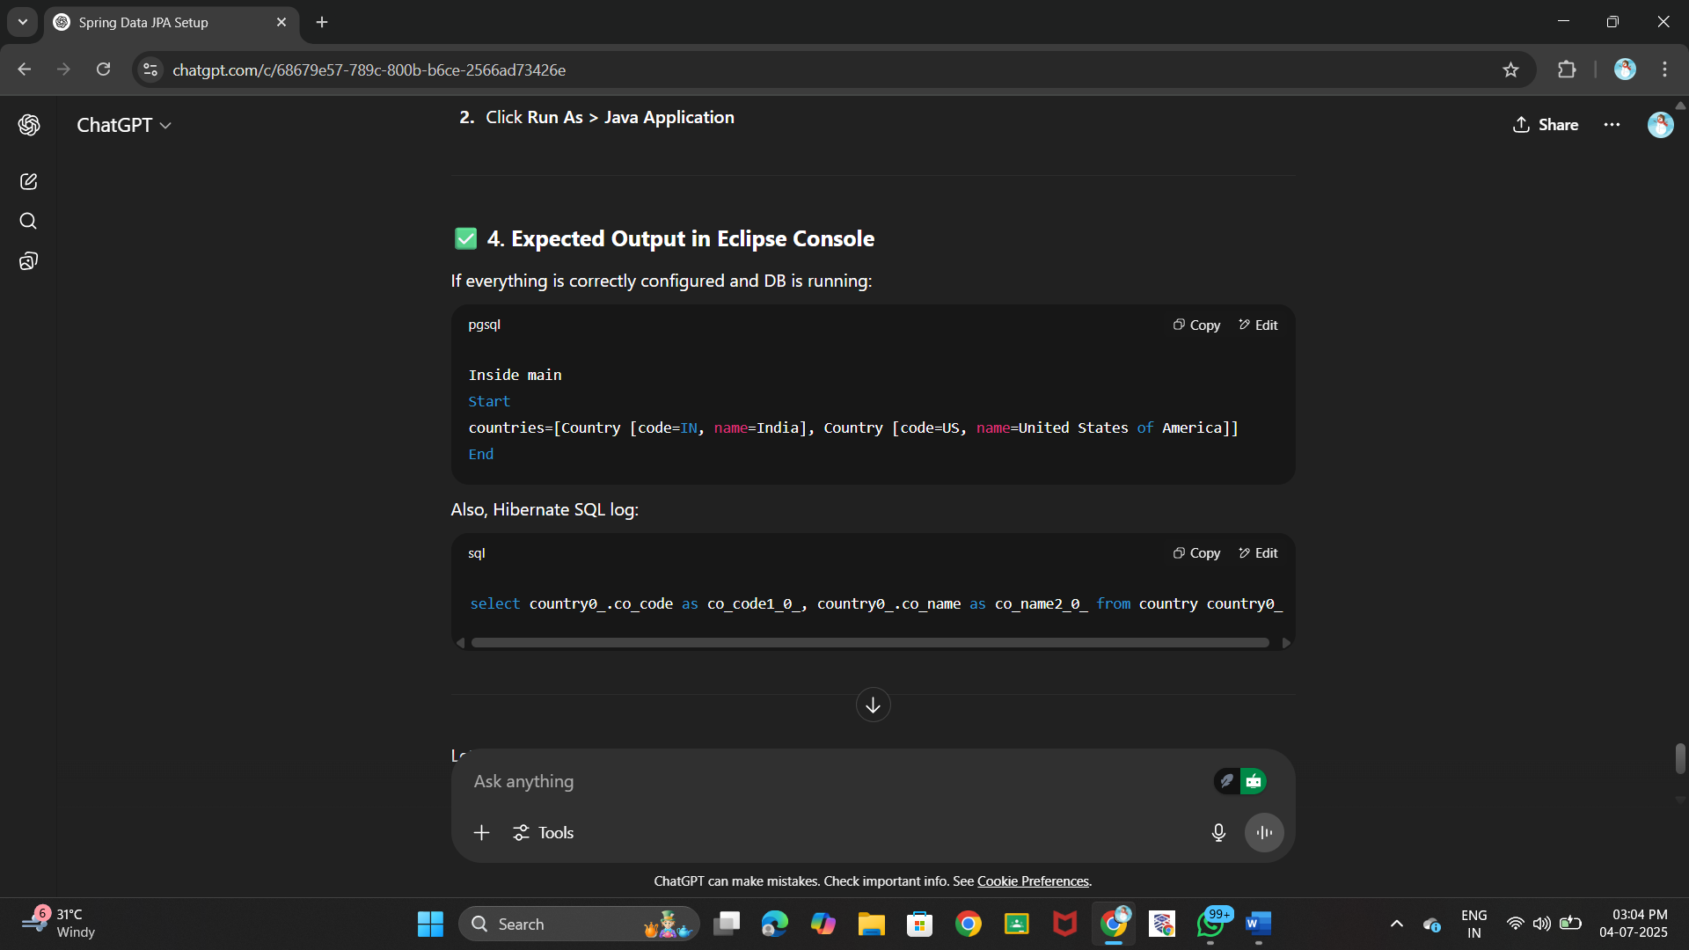**OUTPUT:**



**Hands on 4**

**Difference between JPA, Hibernate and Spring Data JPA   
  
Java Persistence API (JPA)**

* JSR 338 Specification for persisting, reading and managing data from Java objects
* Does not contain concrete implementation of the specification
* Hibernate is one of the implementation of JPA

**Hibernate**

* ORM Tool that implements JPA

**Spring Data JPA**

* Does not have JPA implementation, but reduces boiler plate code
* This is another level of abstraction over JPA implementation provider like Hibernate
* Manages transactions

Refer code snippets below on how the code compares between Hibernate and Spring Data JPA  
Hibernate

   /* Method to CREATE an employee in the database */

   public Integer addEmployee(Employee employee){

      Session session = factory.openSession();

      Transaction tx = null;

      Integer employeeID = null;

      try {

         tx = session.beginTransaction();

         employeeID = (Integer) session.save(employee);

         tx.commit();

      } catch (HibernateException e) {

         if (tx != null) tx.rollback();

         e.printStackTrace();

      } finally {

         session.close();

      }

      return employeeID;

   }

Spring Data JPA  
EmployeeRespository.java

public interface EmployeeRepository extends JpaRepository<Employee, Integer> {

}

EmployeeService.java

@Autowire

  private EmployeeRepository employeeRepository;

@Transactional

public void addEmployee(Employee employee) {

  employeeRepository.save(employee);

  }

**​​​​​​​ CODE:**

**Employee.java**

package com.example.springdemo.model;

import javax.persistence.*;

@Entity

@Table(name = "employee")

public class Employee {

@Id

private int id;

private String name;

private double salary;

public int getId() { return id; }

public void setId(int id) { this.id = id; }

public String getName() { return name; }

public void setName(String name) { this.name = name; }

public double getSalary() { return salary; }

public void setSalary(double salary) { this.salary = salary; }

@Override

public String toString() {

return "Employee [id=" + id + ", name=" + name + ", salary=" + salary + "]";

}

}

**EmployeeRepository.java**

package com.example.springdemo.repository;

import org.springframework.data.jpa.repository.JpaRepository;

import com.example.springdemo.model.Employee;

public interface EmployeeRepository extends JpaRepository<Employee, Integer> {}

**EmployeeService.java**

package com.example.springdemo.service;

import java.util.List;

import org.springframework.beans.factory.annotation.Autowired;

import org.springframework.stereotype.Service;

import com.example.springdemo.model.Employee;

import com.example.springdemo.repository.EmployeeRepository;

@Service

public class EmployeeService

@Autowired

private EmployeeRepository employeeRepository;

public void addEmployee(Employee employee) {

employeeRepository.save(employee);

}

public List<Employee> getAllEmployees() {

return employeeRepository.findAll();

}

}

**SpringdemoApplication.java**

package com.example.springdemo;

import java.util.List;

import com.example.springdemo.model.Employee;

import com.example.springdemo.service.EmployeeService;

import org.springframework.beans.factory.annotation.Autowired;

import org.springframework.boot.SpringApplication;

import org.springframework.boot.autoconfigure.SpringBootApplication;

import org.springframework.context.ApplicationContext;

@SpringBootApplication

public class SpringdemoApplication {

private static EmployeeService employeeService;

public static void main(String[] args) {

ApplicationContext context = SpringApplication.run(SpringdemoApplication.class, args);

employeeService = context.getBean(EmployeeService.class);

Employee e = new Employee();

e.setId(3);

e.setName("Anjali");

e.setSalary(70000);

employeeService.addEmployee(e);

List<Employee> all = employeeService.getAllEmployees();

all.forEach(System.out::println);

}}

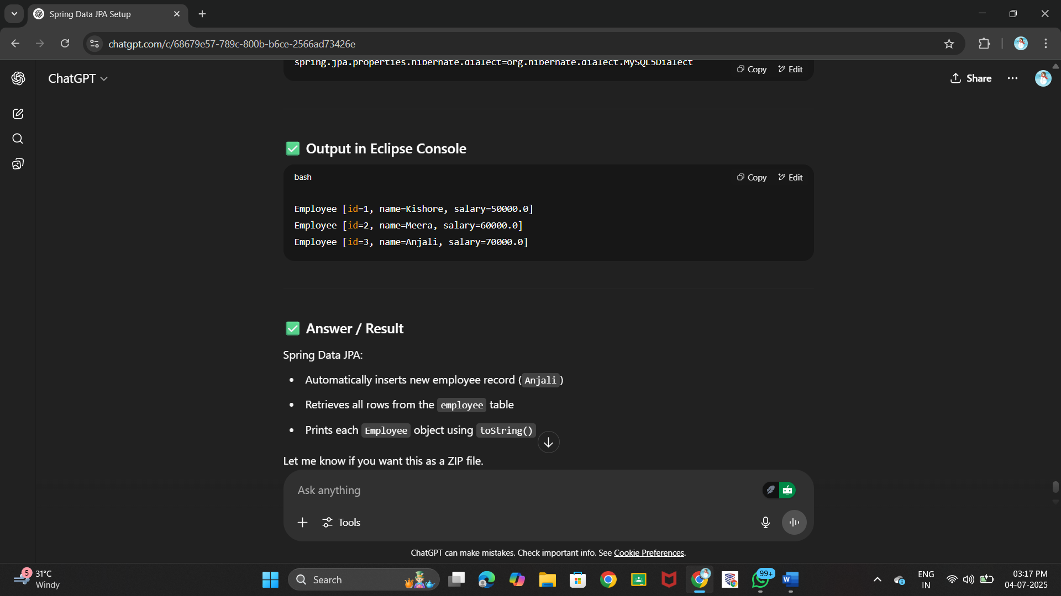**OUTPUT:**