Lab 3: Model Creation
put the date, 2017

Names:

What each person contributed to the lab:
Please make sure to show all R code and output after each question so that I can see your work. Write a sentence for each numerical value produced describing its meaning in context with the proper units.

Consider the data, pollution.csv, which measured air pollution in 41 U.S. cities. The type of air pollution under study is the annual mean concentration of sulfur dioxide (SO2). The values of six potential explanatory variables were recorded in order to examine the variation in the sulfur dioxide concentrations
SO2 = the annual mean concentration of sulfur dioxide (micrograms per cubic meter)
Temp = the average annual temperature in ?F
Comp = number of manufacturing enterprises with 20 or more workers
Pop = population size in last census (thousands)
Wind = average annual wind speed (mph)
Precip = average annual precipitation (inches) Pdays = average number of day with precipitation per year
We want to develop a model relating sulfur dioxide to the six possible explanatory variables to determine which are able to predict air pollution levels within the cities. Please provide plots or R output to justify your assessments. Provide detailed description of what each plot or output displays or calculates.
Your goal is to determine the best model. To do so, be sure to provide the following information

Part 1: Exploratory Data Analysis

1.a.
Define each variable (response/explanatory, quantitative/categorical)
In this study we have the annual mean concentration of sulfur dioxide being our response variable, which is measured as micrograms per cubic meter and is therefore a quantitative variable. The other variables in our dataset could be considered as explanatory variables, except for the "City" variable, since this is only a column to identify where the data was collected. For our explanatory variables we can observe that they are all quantitative variables. Our first being temperature, which is the average annual temperature in Farenheits, has a range of 43.5 degrees to 75.50 degrees, a mean of 55.76 degrees and a standard deviation equal to 7.2277 degrees. Another explanatory variable "Comp", is the number of manufacturing enterprises with 20 or more workers, it has a mean of 463.1 and a standard deviation of 563.47. We also have the variable "Pop", which is population size in last census in thousands, that has a mean of 608.6 thousand and a standard deviation of 579.113 thousand. The next explanatory variable is "Wind", which is the average annual wind speed in miles per hour, that has a mean of 9.444 mph and a standard deviation of 1.428644 mph. We also have "Precip", which is the average annual precipitation measured in inches, that has a mean of 36.77 inches and a standard deviation of 11.77 inches. Finally, we have the variable "Pdays", which is the average number of days with precipitation per year, it has a mean of 113.9 days and a standard deviation of 26.506 days.

1.b.
Check for Linear Relationships (Tip: if any extreme outliers, try removing them to see how things look.) Is there any evidence that higher-order terms should be included?
#Provide R code and output/graphs
library(readr)
library(mosaic)
## Loading required package: dplyr
##
## Attaching package: 'dplyr'
## The following objects are masked from 'package:stats':
##
## filter, lag
## The following objects are masked from 'package:base':
##
## intersect, setdiff, setequal, union
## Loading required package: lattice
## Loading required package: ggformula
## Loading required package: ggplot2
##
## New to ggformula? Try the tutorials:
## learnr::run_tutorial("introduction", package = "ggformula")
## learnr::run_tutorial("refining", package = "ggformula")
## Loading required package: mosaicData
## Loading required package: Matrix
##
## The 'mosaic' package masks several functions from core packages in order to add
## additional features. The original behavior of these functions should not be affected by this.
##
## Note: If you use the Matrix package, be sure to load it BEFORE loading mosaic.
##
## Attaching package: 'mosaic'
## The following object is masked from 'package:Matrix':
##
## mean
## The following objects are masked from 'package:dplyr':
##
## count, do, tally
## The following objects are masked from 'package:stats':
##
## binom.test, cor, cor.test, cov, fivenum, IQR, median,
## prop.test, quantile, sd, t.test, var
## The following objects are masked from 'package:base':
##
## max, mean, min, prod, range, sample, sum
pollution <- read_csv("~/Desktop/ucsc/pollution.csv")
## Warning: Missing column names filled in: 'X9' [9]
## Parsed with column specification:
## cols(
## City = col_integer(),
## SO2 = col_double(),
## Temp = col_double(),
## Comp = col_integer(),
## Pop = col_integer(),
## Wind = col_double(),
## Precip = col_double(),
## Pdays = col_integer(),
## X9 = col_character()
## )
View(pollution)
attach(pollution)
summary(pollution)
## City SO2 Temp Comp
## Min. : 1 Min. :2.079 Min. :43.50 Min. : 35.0
## 1st Qu.:11 1st Qu.:2.565 1st Qu.:50.60 1st Qu.: 181.0
## Median :21 Median :3.258 Median :54.60 Median : 347.0
## Mean :21 Mean :3.153 Mean :55.76 Mean : 463.1
## 3rd Qu.:31 3rd Qu.:3.555 3rd Qu.:59.30 3rd Qu.: 462.0
## Max. :41 Max. :4.700 Max. :75.50 Max. :3344.0
## Pop Wind Precip Pdays
## Min. : 71.0 Min. : 6.000 Min. : 7.05 Min. : 36.0
## 1st Qu.: 299.0 1st Qu.: 8.700 1st Qu.:30.96 1st Qu.:103.0
## Median : 515.0 Median : 9.300 Median :38.74 Median :115.0
## Mean : 608.6 Mean : 9.444 Mean :36.77 Mean :113.9
## 3rd Qu.: 717.0 3rd Qu.:10.600 3rd Qu.:43.11 3rd Qu.:128.0
## Max. :3369.0 Max. :12.700 Max. :59.80 Max. :166.0
## X9
## Length:41
## Class :character
## Mode :character
##
##
##
names(pollution)
## [1] "City" "SO2" "Temp" "Comp" "Pop" "Wind" "Precip" "Pdays"
## [9] "X9"
sd(City)
## [1] 11.97915
sd(SO2)
## [1] 0.7023011
sd(Temp)
## [1] 7.227716
sd(Comp)
## [1] 563.4739
sd(Pop)
## [1] 579.113
sd(Wind)
## [1] 1.428644
sd(Precip)
## [1] 11.77155
sd(Pdays)
## [1] 26.50642
plot(Temp, SO2)
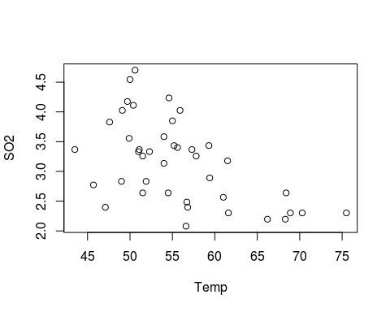
plot(Comp, SO2)
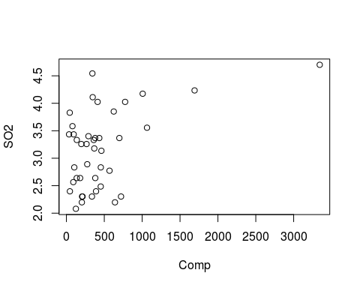
plot(Pop, SO2)
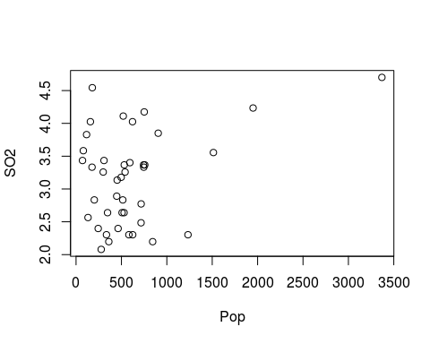
plot(Wind, SO2)
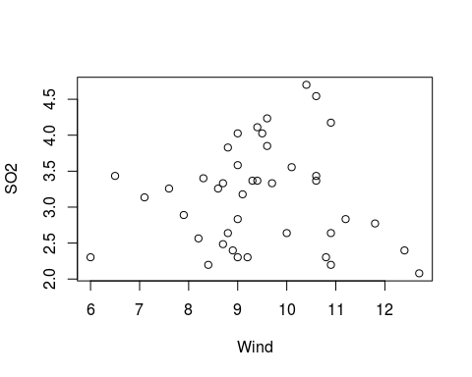
plot(Precip, SO2)
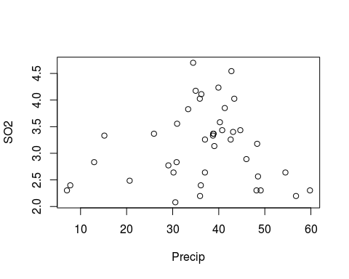
plot(Pdays, SO2)
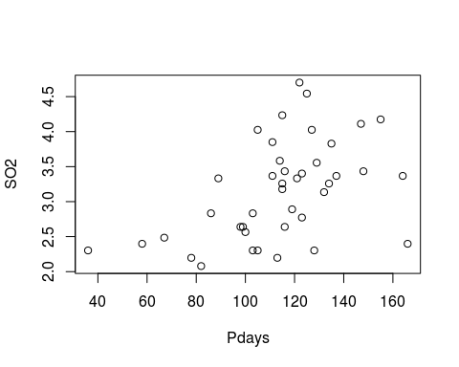
#Here is a hint on how to remove one row from a data set, say row 2
#when we use [] brackets, we can reference certain rows and columns of the data
#so this code says to remove row 11 (rows are before the comma) but keep all columns (Columns are after the comma)
#pollution[-11,]
Insert Answer Here

1.c.
Check of collinearity (remember to check your 3b notes - how do you procede in the presence of collinearity?)
#Provide R code and output/graphs
Insert Answer Here

Part 2: Use two variable selection methods
(One out of R2 and Cp, and one out of Forward and Backward):

2.a.
Choose one: Adjusted R2 or Mallow's Cp to select a subset of 2 best models
#Provide R code and output/graphs
Intert Answer Here

2.b.
Choose one: Forward Selection or Backward Elimination
#Provide R code and output/graphs
Insert Answer Here
#Provide R code and output/graphs
Insert Answer Here

2.c.
Compare and contrast the final model options between the two methods you used
Insert Answer Here

Part 3: Detailed description of the model formulation
Why did you choose the models you chose - provide statistical and practical evidence. Provide necessary code and output to support your decisions.

3.a.
Detailed description of assessment of model assumptions
#Provide R code and output/graphs
Insert Answer Here

3.b.
Detailed description of assessment of significance tests
#Provide R code and output/graphs
Insert Answer Here

3.c.
Detailed description of final model including interpretation of the parameter values in the context of the problem.
#Provide R code and output/graphs
Insert Answer Here

3.d.
General conclusion based on the model - what factors seem to contribute to SO2 output. To what population/situations can we apply our findings?
Insert Answer Here

