Effect of Adding Worm Castings and Pea Plants
Fertilizer On Spinach Yield

Luis Sanchez, Daniel Meza, Nick Schmoll, Adolfo Huerta

Abstract
The research objective is to investigate the effect of adding worm castings and pea plants to a spinach crop on the sellable spinach yield and to understand the effects of the new fertilizer on the spinach independent of the yield. There were sixty six spinach plots split into four columns. Two columns in Group 1 (control) received the normal liquid kelp fertilizer and fabric row covers to help fight disease. Two columns in Group 2 (treatment) received the same as control and an added fertilizer of meal worm castings and pea plants. Data on the plot density, yellowing, spotting, and pest presence was collected over three weeks and the total yield of sellable spinach was collected on the third week. We used statistical analysis in order to determine the efficacy of the altered fertilizer.

Introduction
An important question that environmental scientist have, when working closely with farmers, is what they can do to help improve the yield of the farmers crop. In the case of a spinach crop, it is commonly believed and practiced that adding liquid kelp fertilizer and fabric covers helps to fight disease. However, there are many other additives and methods used to grow spinach that people believe will improve their crop yield and most importantly their sellable product. One well known idea is adding worm castings to the soil, since they are packed with minerals that are essential for plant growth, such as concentrated nitrates, phosphorus, magnesium, potassium and calcium. Unlike animal manure and artificial fertilizers, worm castings are absorbed easily and immediately by plants. Apart from stimulating growth, they also enhance the soil’s ability to retain water, due to its texture, and it even inhibits root diseases such as root rot (tastefulgarden, 2017).

Another additive that is believed to help with growth of the crop is pea plants, since they are known to contain symbiotic bacteria called Rhizobia within root nodules of their root systems. These bacteria have the special ability of fixing nitrogen from atmospheric, molecular nitrogen (N2) into ammonia (NH3). Ammonia is then converted to ammonium, which is used by some plants through another reaction with hydrogen. This means that the root nodules are sources of nitrogen, making them rich in plant proteins. All proteins contain nitrogenous amino acids. Nitrogen is therefore a necessary ingredient in the production of proteins. Hence, peas and many legumes are among the best sources of plant protein. One example given is that when a pea plant dies in the field, following the harvest, all of its remaining nitrogen, incorporated into amino acids inside the remaining plant parts, is released back into the soil. In the soil, the amino acids are converted to nitrate (NO3−), making the nitrogen available to other plants, thereby serving as fertilizer for future crops (University of Edinburgh, 2017).

Our research objective is to investigate the effect of adding worm castings and pea plant fertilizer to a spinach crop on its proportion of yellowing, spotting, pest presence and whether these changes impact the actual amount of sellable spinach. We analyze the data that is based on an experimental study conducted by Environmental Science major for their Capstone Project. We hypothesize that the combined additives of worm castings and pea plant fertilizer will have a positive effect of sellable spinach and a negative effect on yellowing, spotting and pest by reducing the amount of spinach with these diseases. In our data analysis, we provide statistical evidence for the hypothesis.

Methods
Environmental students treated four rows of spinach and split them into two groups, a treatment and a control group. For the control group, the students used liquid kelp fertilizer and fabric covers to fight disease. For the treatment group, the students used both liquid kelp fertilizer and fabric covers but also added worm castings fertilizer and pea plants fertilizer in hope of better results. Data was collected over three weeks, with the researcher taking measure of different metrics after every week. The researcher measured the density, which is scientifically defined as the mass per unit volume. The other measures were three variables of the spinach having defects, which were the number of spinach plants that had yellowing, spots or pests present in each plot.

For our first analysis, we used a fitted linear mixed effect (LMER) model to track the progress of the spinach for three weeks. This is due to the fact that we are working with longitudinal data, so we want for each identification of each plot to be treated as its own unique data and the three observations for each week to be related to that plot identification. In our models we included an interaction term to test if the control and treatment groups had different slopes in the spotting, yellowing and pest presence of the spinach. To perform the hypothesis testing, we let the β1 be the partial slope of the control group and let β1+β3 be the partial slope for the treatment group. We then tested for the null hypothesis H0: β1 - (β1+β3) = 0 versus the alternative hypothesis H1: β1 - (β1+β3) < 0 at the significance level ∝ = 0.05 (probability of Type I error).

In the second analysis, we used simple linear regression(SLR) to model the average total grams of sellable spinach by category. We separated the spinach weight data into two categories that were made up of combining the weights of spinach for the treatment and combining the weights of spinach for the control groups. We now had a category with all of the spinach weight for the control and another category for all of the spinach in the treatment groups. We used R studio to analyse the data and generate plots compared the slopes of each group for each parameter of interest. To perform the hypothesis testing in this analysis, we let μ1 be the mean spinach yield for the control group and we let μ2 be the mean spinach yield for the treatment group. We then tested for the null hypothesis H0: μ2 - μ1 = 0 versus the alternative hypothesis H1: μ2 - μ1 > 0 at the significance level ∝ = 0.05 (probability of Type I error).

Results
The addition of the mealworm castings and pea plants fertilizer to the kelp fertilizer and fabric covers had the intended positive impact on yellowing for the spinach. However, based on our results this treatment had a negative effect on the spotting for the spinach. We also did not have any evidence to conclude that difference in pesticide between the control group and the treatment group was significant.
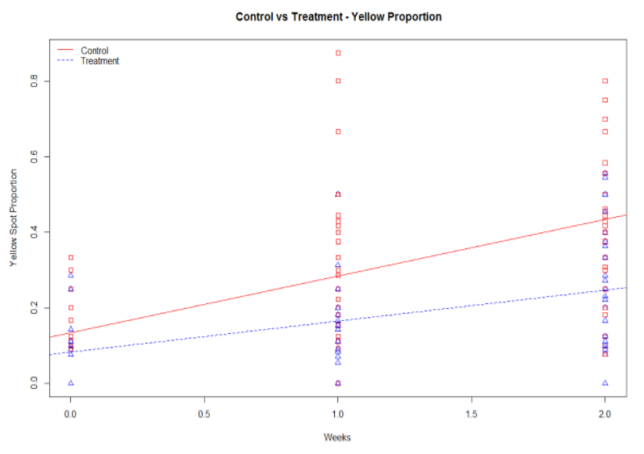
Figure 1: Linear Model for Groups by Weeks

In analysis two, we wanted to determine if the control or the treatment group produced the most sellable spinach after the three weeks of the experiment. In order for the spinach to be sold, it cannot have any yellowing on the leaves. Sellable spinach could contain spots. Using the simple linear model our results indicated that the control group had a higher total weight of sellable spinach of 206.09 grams. The treatment group had an average total of sellable spinach of 156.78 grams. Our categorical variable group, which was one if in the treatment group, was significant with a p-value less than the significance level of .05.

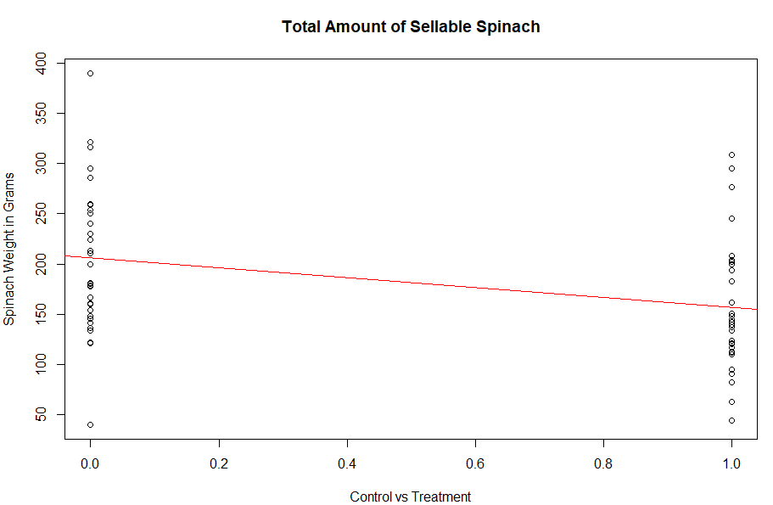
Figure 2: Linear Model by Group

Discussion
There were quite a few experimental issues that we could not control and could have had a significant impact on our results; the biggest being the layout of the control and treatment columns of spinach. Since the spinach was split into large block getting the treatment or not, any given row could have been on better land or received more water. A control group with better growing conditions (being on a better area of land) could potentially negate or outweigh the benefits of the altered fertilizer in a comparative analysis. Another experimental error was that the fourth row (one of the treatment groups) was planted 4 days later than the others which means those spinach had less time to grow and very likely impacted our final analysis which suggested a lack of benefit to total yield in the control group. Had the designers of the experiment alternated control and treatment plots and planted everything at the same time, we may have seen different results. Since there were a variety of these errors we would suggest more analysis with the above precautions to give a more accurate estimate of the effect of the treatment fertilizer.

References

“Biological Sciences.” The University of Edinburgh, 25 Oct. 2017, www.ed.ac.uk/biology.

“Need Help?” Worm Castings, www.tastefulgarden.com/Worm-Castings-d114.htm.

Appendix
Analysis 1: control vs treatment (yellowing)
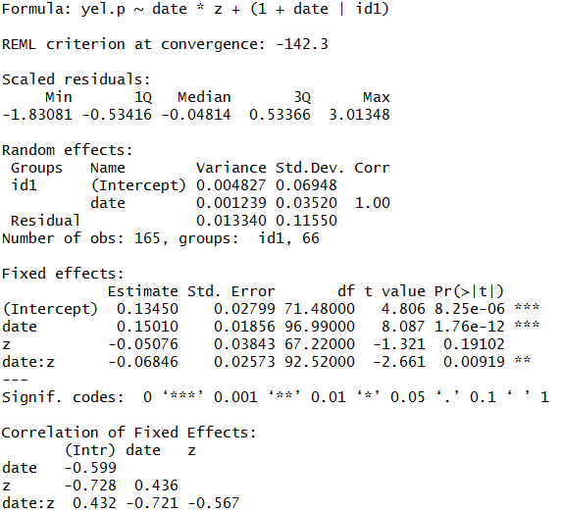
Analysis 1: control vs treatment (Spotting)
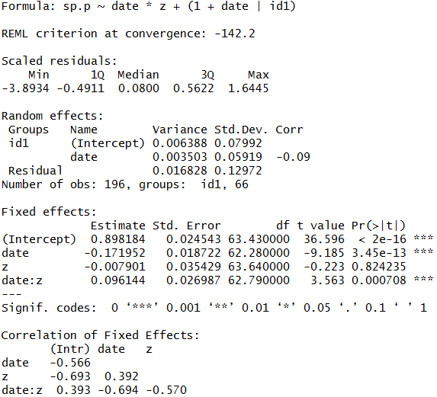

Analysis 1: control vs treatment (Pests)
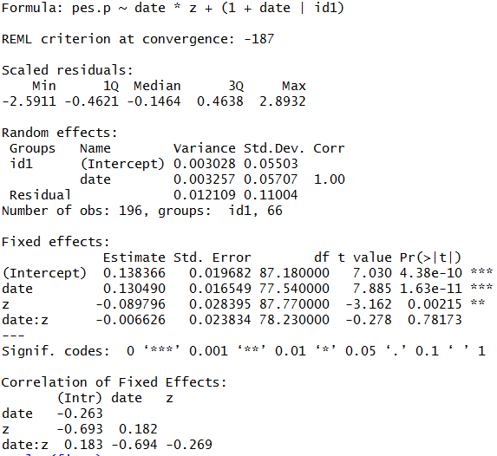

Results for Analysis 2
