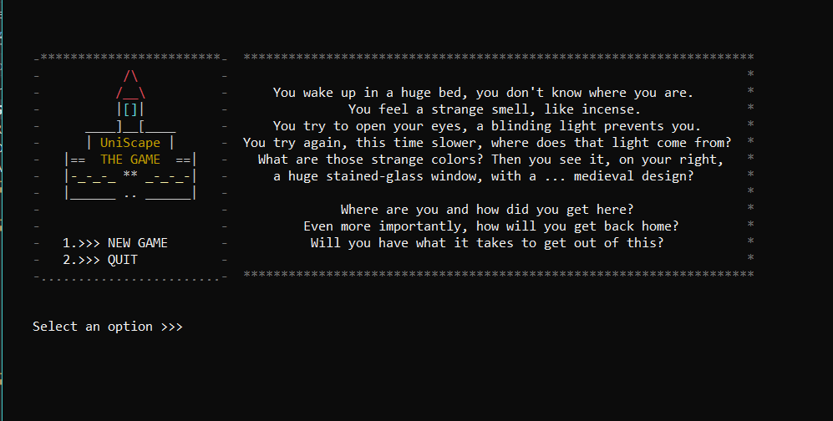

FIRST TASK REPORT

UNISCape: THE GAME

Alvaro Rosa Gonzalez | Games Development | 09-11-2018

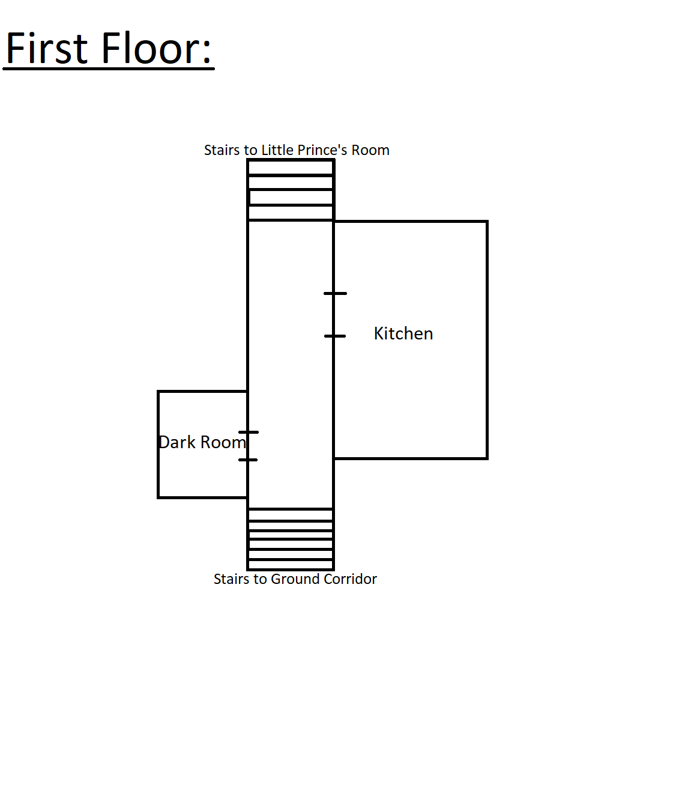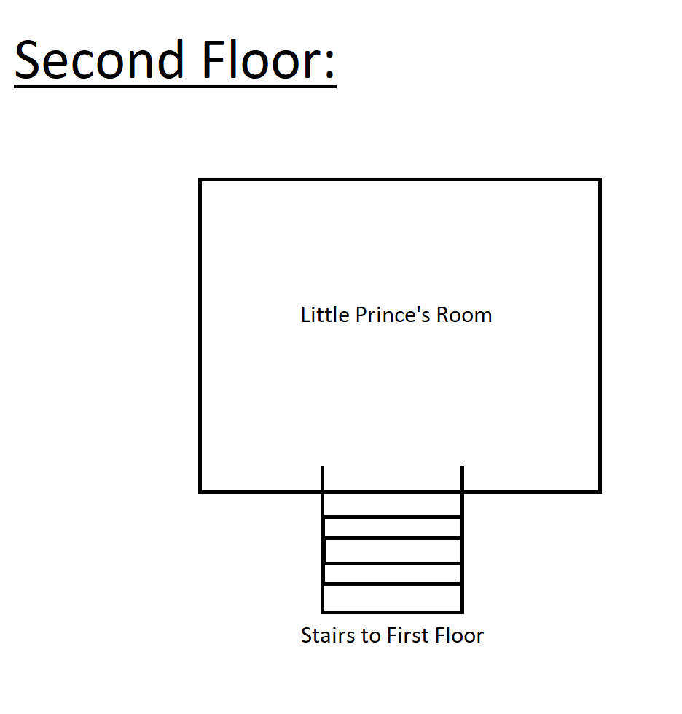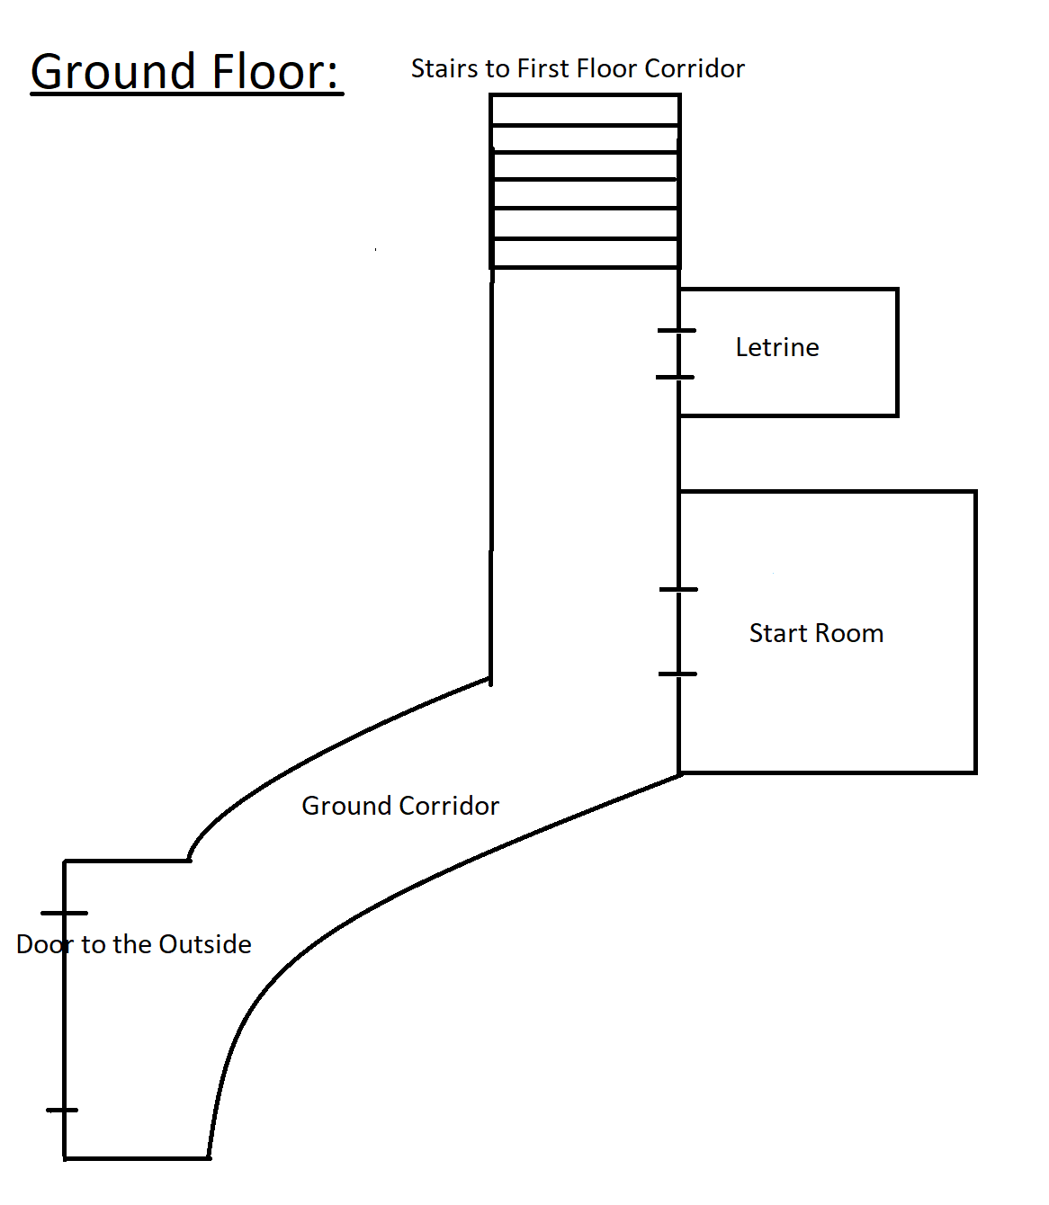**Building plan:**

**About it:**

UniScape is a text-based game developed on Visual Studio C++. In the game you are locked inside a castle and you have to find your way out of it by interacting with the enviroment and NPCs.

**Commands:**

* + Go to <ROOM NAME>:
    - Takes you to the room if it exists and is connected with the room you are at. If the door is locked you have to find the right key and unlock it.
  + Examine <OBJECT NAME>:

* + - Displays the description of the object, container or character on the argument.
  + Pick up <OBJECT NAME>:
    - Adds an object from the roo mor the container to your inventory.
  + Open <OBJECT NAME>:
    - Open a container and gets you to a new scren where you can see the content and interact with it. In order to open a container it has to be examined first.
  + Close <OBJECT NAME>:
    - Closes the container you are in and returns you to the room where the container is.
  + Use <OBJECT NAME> with <OBJECT/DOOR NAME>:
    - Triggers the interaction between an object from your inventory and other object or door.
  + Talk to <CHARACTER NAME>:
    - Starts a dialogue with a character. The dialogue depends on the actual stage of the NPC.
  + List inventory:
    - Display what you have in your inventory.
  + Give up:
    - Ends the game by loosing.