**Final Project Proposal – 206A Introduction to Robotics**

*Patrick Scheffe and Nikolas Alberti*

For our final project we are planning to construct a robot which you can challenge to play a game of tic tac toe. We want to combine elements of robotics as well as embedded systems in this project.

The basic idea is that there is a robotic manipulator which is mounted in a fixed position next to a whiteboard. It can draw a circle or a cross in a field of nine tiles. The setup keeps track of the user’s moves with camera vision or light sensors and decides its next move based on the current state of the field. The basic functionality is that the robot draws the field of play, so it automatically knows the position of the nine tiles. The user tells the robot with a button press, when their turn is over and it is the robots turn. The robot might then detect player’s move and make its own move.

The pen will be set up in a construction which has a shoulder and an elbow joint, so it can change its radial and angular position. In order to make space for the human player’s moves, the whole construction should be able to move away from the field, which could be realized by another rotational joint which lifts the construction up from the field. The pen will be mounted at the end effector.

The image processing and/or movement of the joints will be controlled by an embedded processor (e.g. Raspberry Pi, Arduino). Since we build this machine from scratch we have to take care about the interfacing with the sensors and actuators.

When the basic functionality has been implemented and there is still time left, there are countless possible refinements for this project. Especially the flexibility of the robot can be improved significantly. It may be possible to let the user draw a playing field and have the robot detect the tiles and calculate the end effector movement to draw the signs in the right space and of the right size accordingly. The robot could also detect which sign its opponent uses and decide to use a different one. It’s also imaginable that the robot detects when the user made a move and reacts after a delay when the user’s hand is out of the way. It’s possible that one should consider safety concerns, so that the robot does never move back onto the field while the users hand is still there. Basically it also is conceivable to implement another mode to let the robot draw or write.

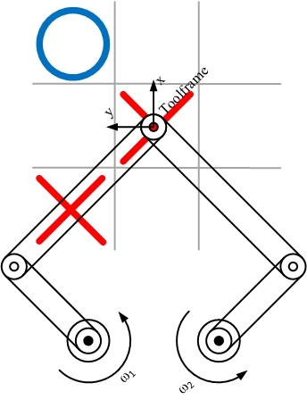We imagine building the hardware for this project will be very challenging.  
The picture below displays a sketch of a possible manipulator setup from above.