**COMPTE RENDU AP4A GIT**

Nom : Muna Ayuni BINTI MAHATHIR

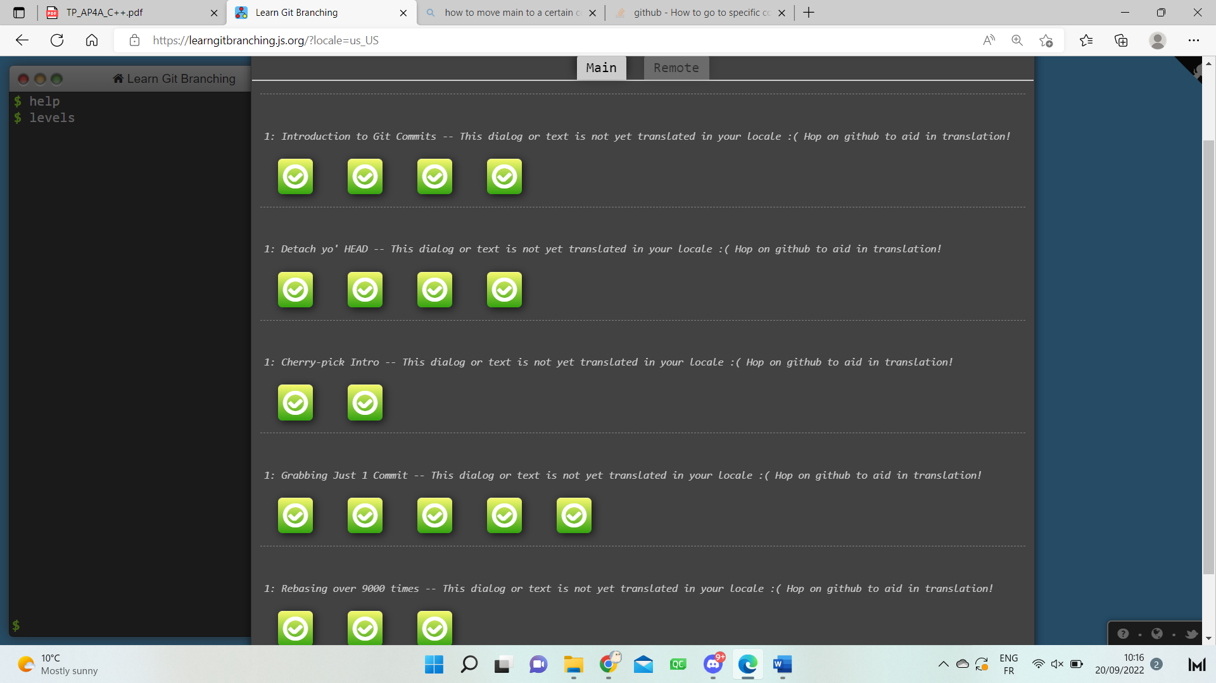

EXPLANATION

• Git config 🡪 This command is used to configure the setting.

• Git init 🡪 This is used to create new empty git repository.

• Git status 🡪 This displays the current status of a repository. For example, if a change is being staged, or if there are any untracked files, etc.

• Git add 🡪 This is used to add a change from our repository that has not been added yet. For example, we can add a file using this command.

• Git push 🡪 This is used to update or upload the changes from our local repository to our remote repository.

• Git merge 🡪 This is used to combine two branches into one same commit.

• Git diff 🡪 This command is used to compare the elements in git in order to observe and understand the changes that has been made. We can use this command to compare branch, commit, files, etc.

• Git blame 🡪 This is used to determine the author of the line code and when it is last modified.