Dokumentasi BEFORE - Level Materi
Fitur: penilaian tingkat kesulitan materi otomatis dari SET DIAGNOSTIK (netral, tidak terpengaruh mesin adaptif).
Status: BELUM diimplementasikan - gambar adalah kondisi saat ini (before).
Akun: guru1@ebiox.com (guru) - murid1@ebiox.com (siswa) - Tanggal: 15 Oktober 2026
1. Dashboard Guru
Route: /teacher - 1410x805 px
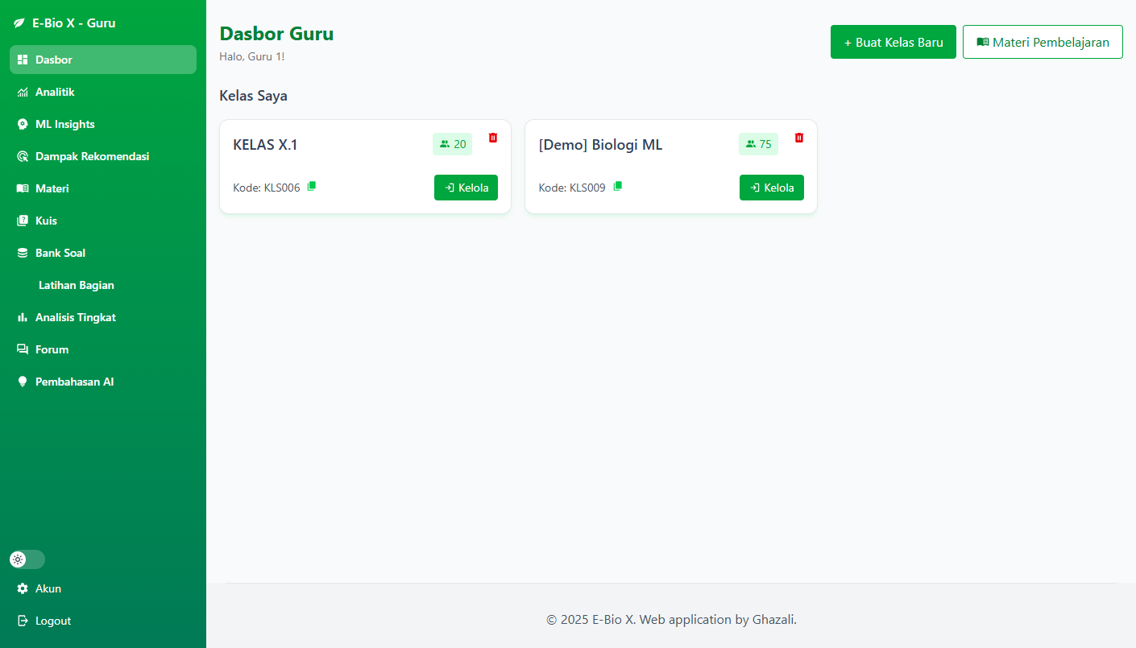

2. Daftar Materi (Guru)
Route: /teacher/materials - 1410x805 px
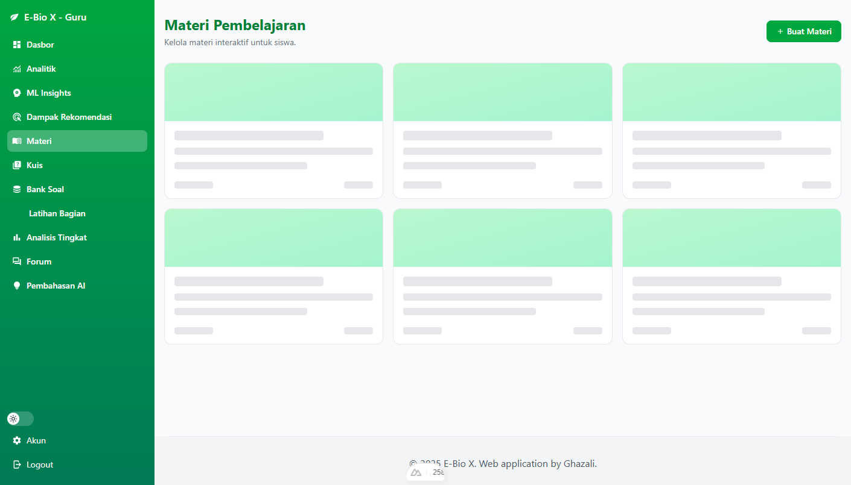

3. Form Materi Baru (Guru)
Route: /teacher/materials/create - 1410x1054 px
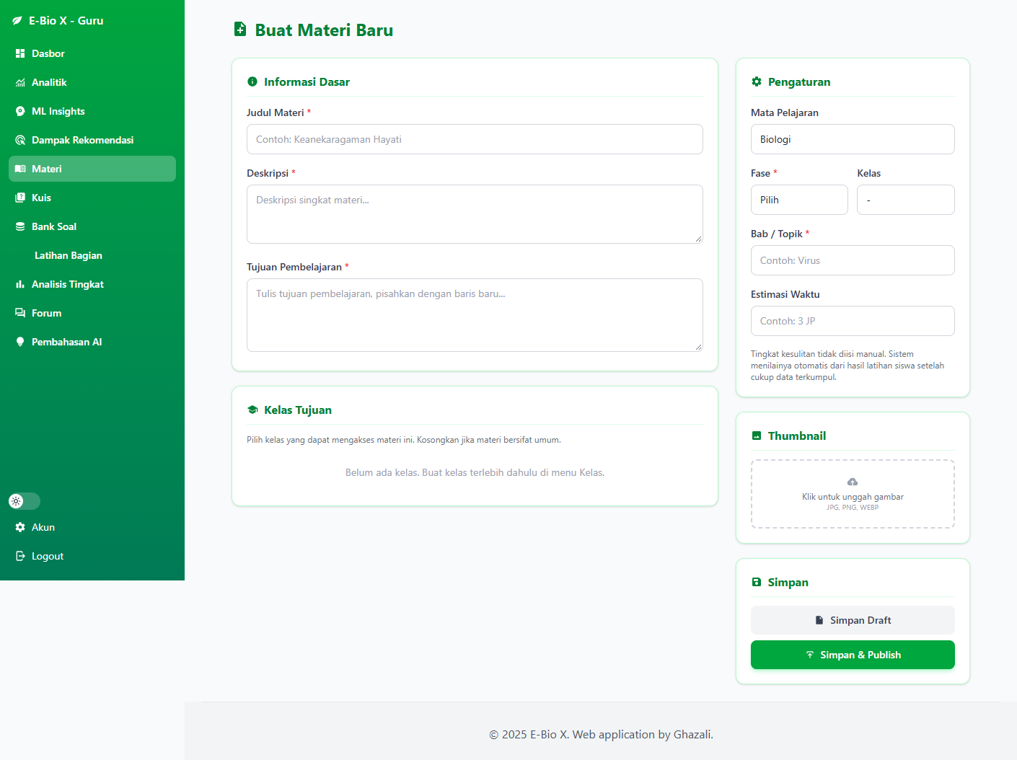

4. Form Edit Materi (Guru)
Route: /teacher/materials/edit/107 - 1410x1054 px
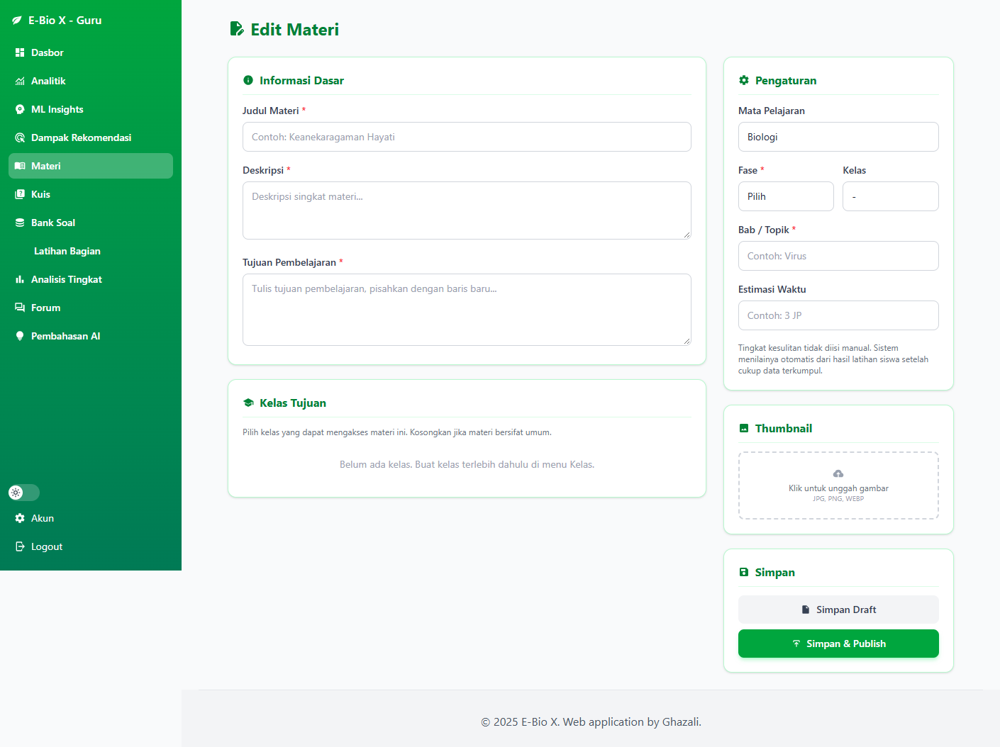

5. Analitik Materi (Guru)
Route: /teacher/materials/analytics/107 - 1410x2080 px
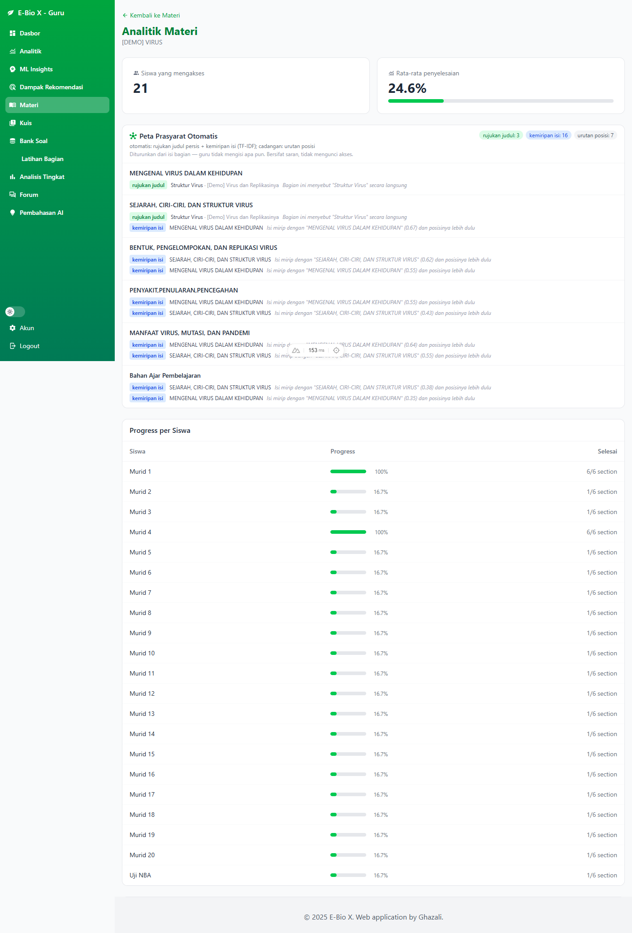

6. Latihan per Bagian (Guru)
Route: /teacher/practice - 1410x2971 px
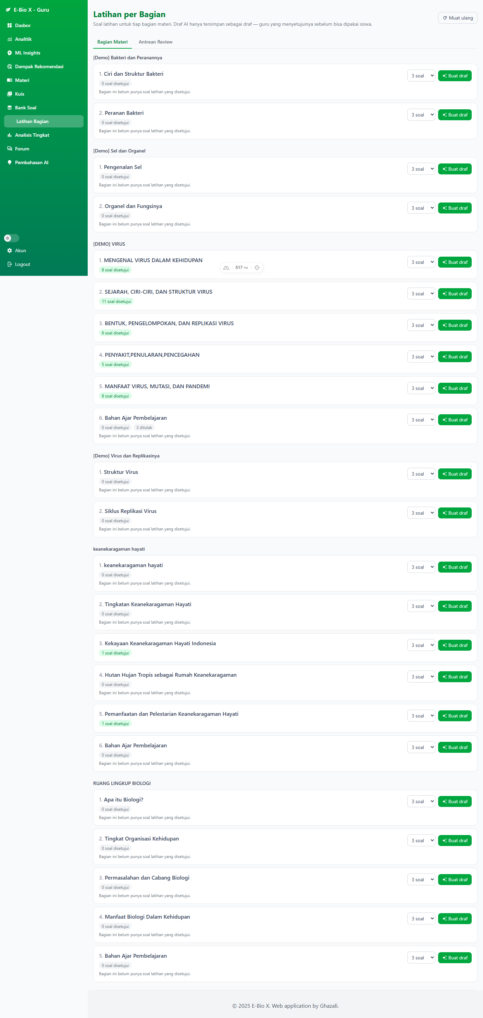

7. Bank Soal (Guru)
Route: /teacher/question-bank - 1410x2621 px
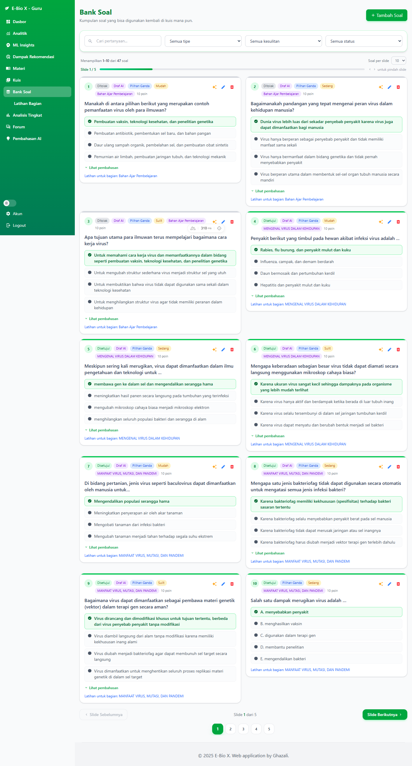

8. Analitik Penguasaan (Guru)
Route: /teacher/analytics - 1410x2324 px
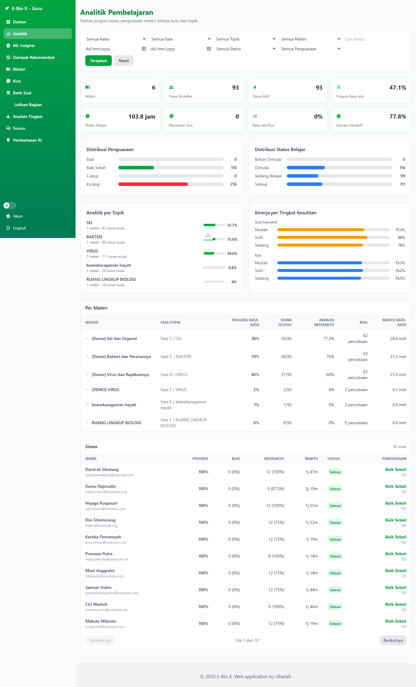

9. ML Insights (Guru)
Route: /teacher/analytics/ml - 1410x1749 px
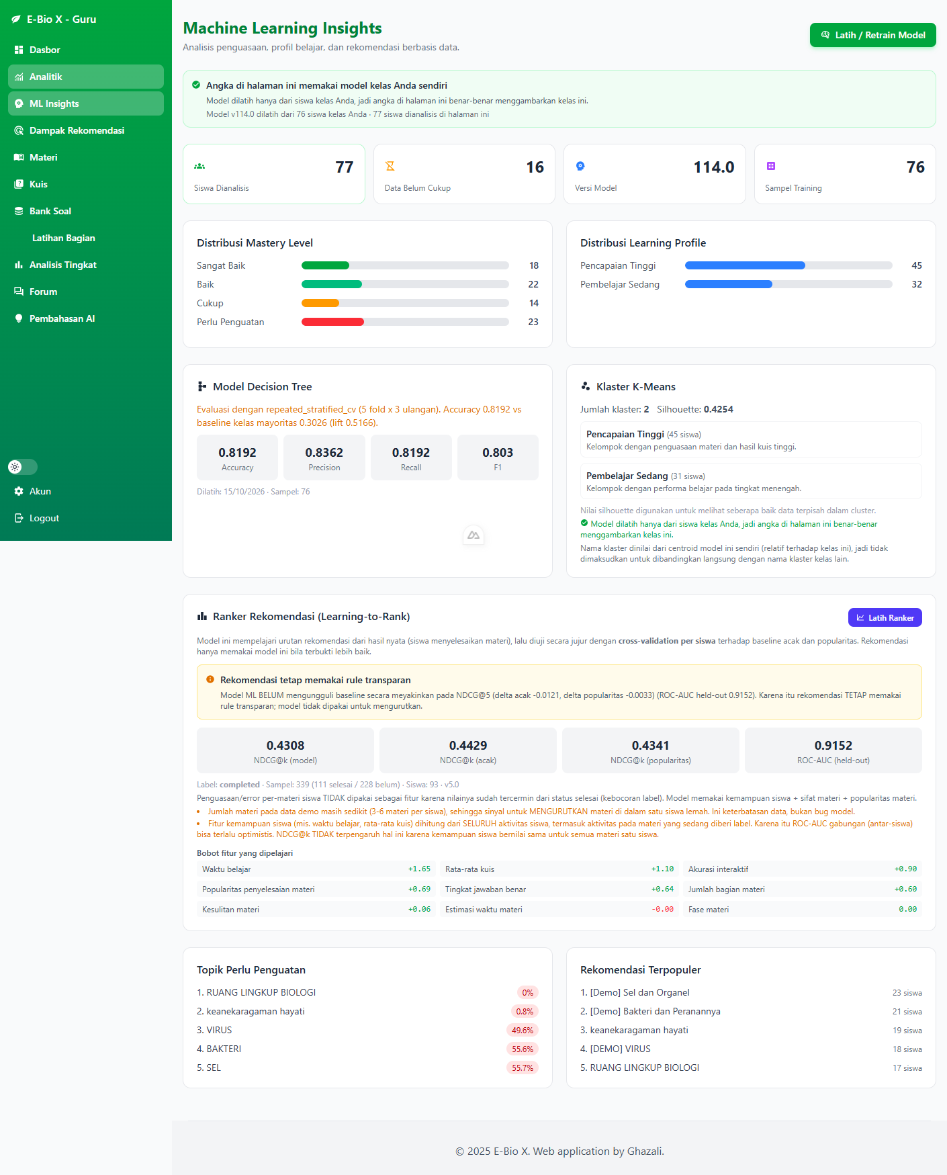

10. Analitik Siswa (Guru)
Route: /teacher/analytics/students/72 - 1410x1071 px
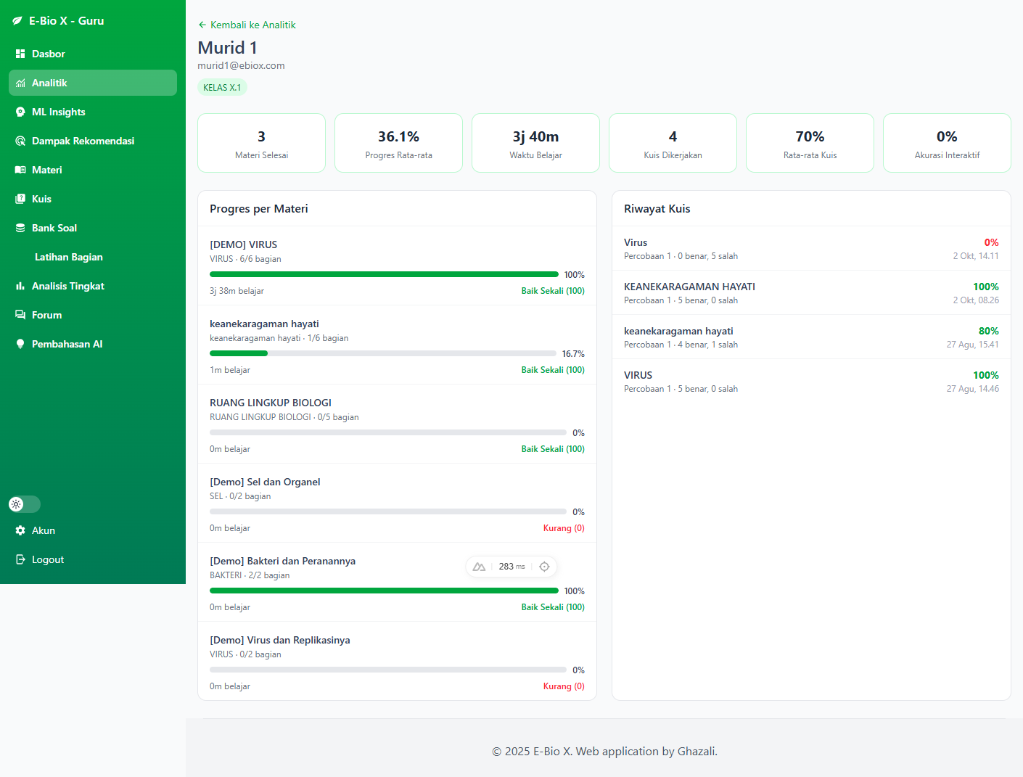

11. Daftar Materi (Siswa)
Route: /student/materials - 1410x880 px
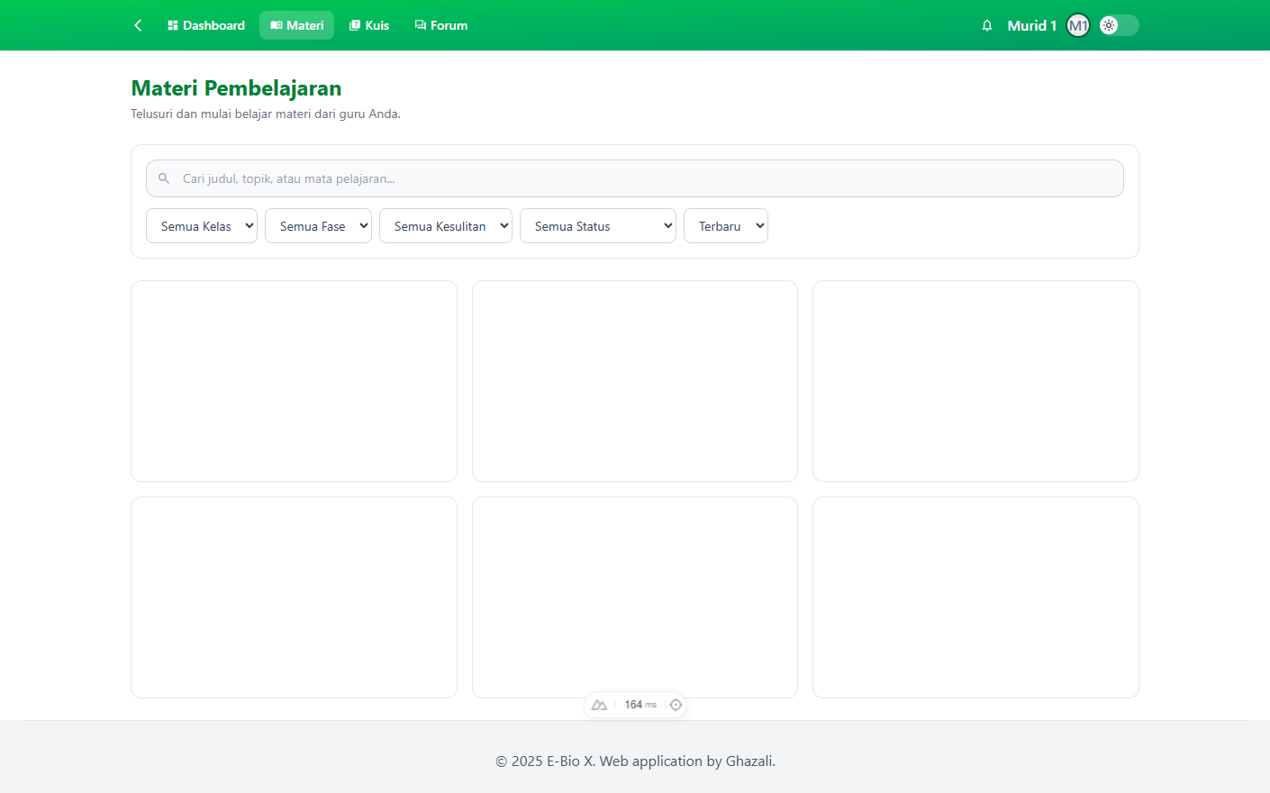

12. Detail Materi (Siswa)
Route: /student/materials/107 - 1410x3415 px
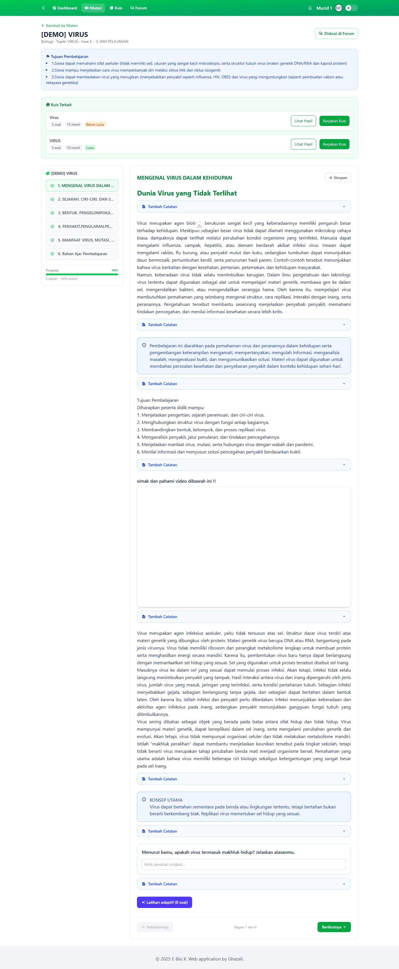

13. Dashboard Siswa
Route: /student/dashboard - 1410x2608 px
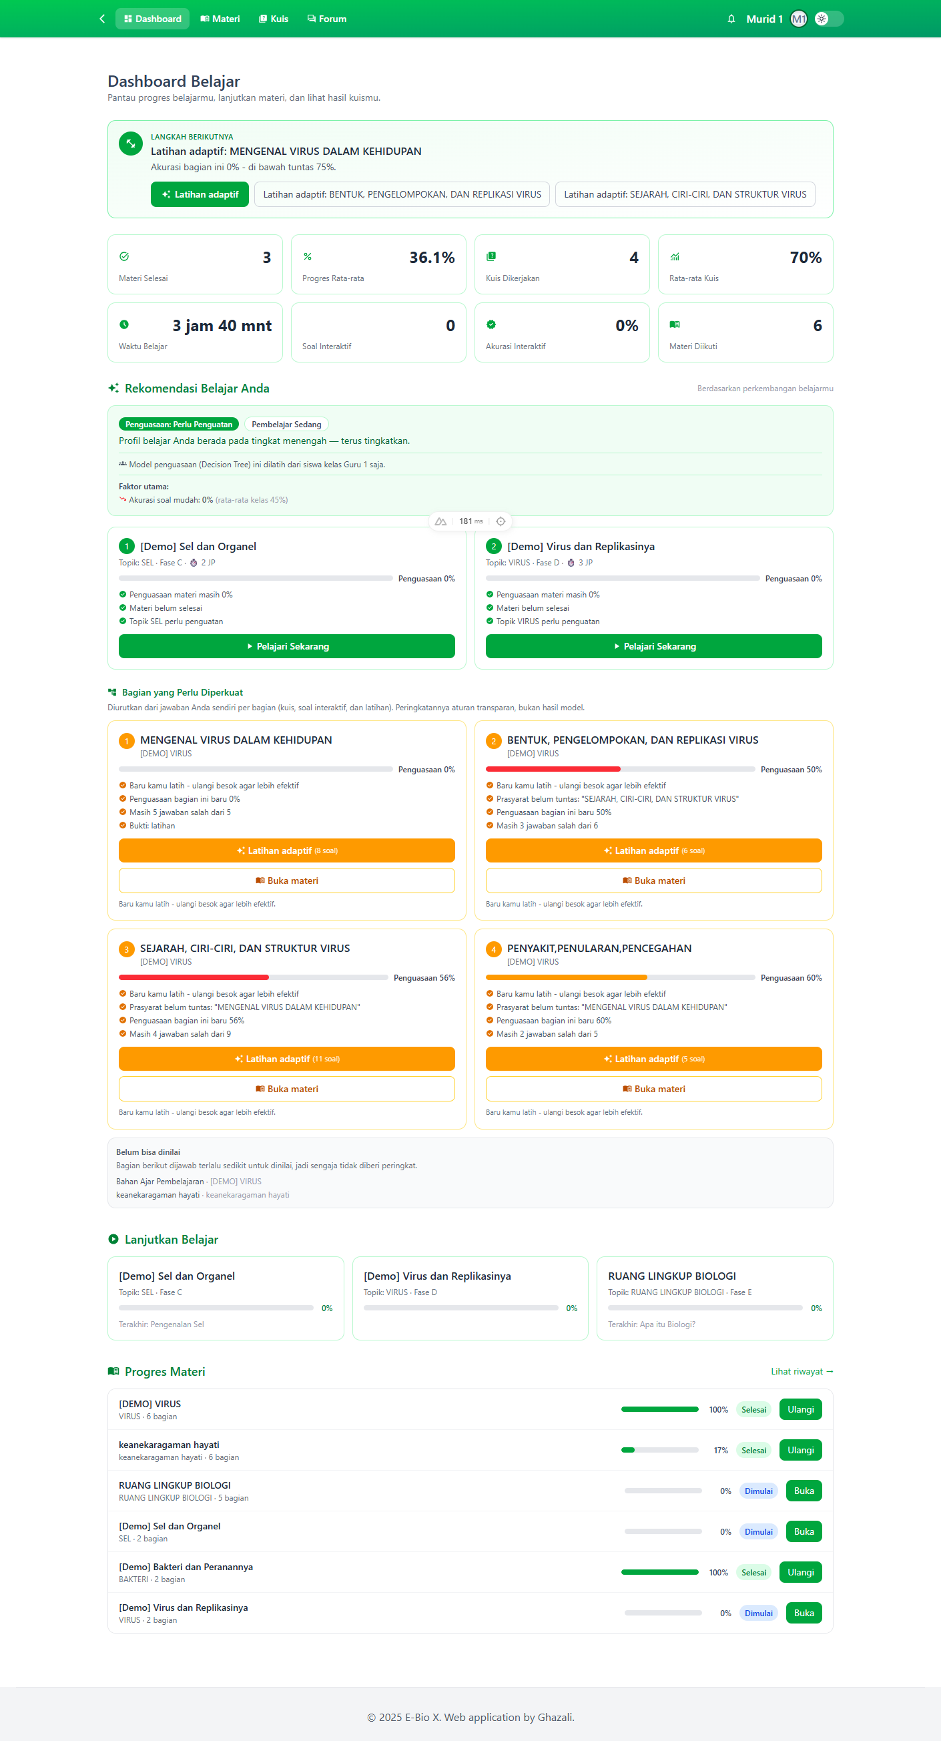

14. Riwayat Belajar (Siswa)
Route: /student/progress - 1410x851 px
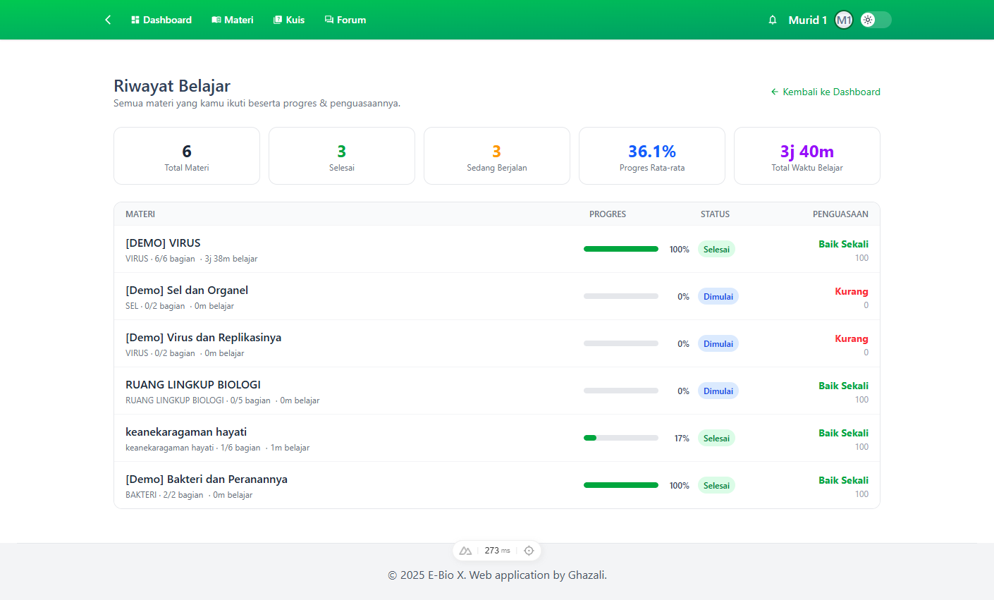

15. Progress Materi (Siswa)
Route: /student/progress/107 - 1410x805 px
