

**JMJ MARIST BROTHERS** **MIT 261 - Project**

Notre Dame of Marbel University 1st Semester SY 2025-2026

City of Koronadal Mrs. Brenda M. Balala, MIT

**MIT 261– Parallel and Distributed Systems**

**Project Title**

**Parallel and Distributed Student Performance Analytics Platform with MongoDB**

**Group members: Assigned Tasked**

1. **_________________________ ________________________**
2. **_________________________ ________________________**
3. **_________________________ ________________________**

Contents

Registrar’s Office Dashboard Reports 4

1. Student Academic Standing Report 4

2. Subject Pass/Fail Distribution 5

3. Enrollment Trend Analysis 5

4. Incomplete Grades Report 5

5. Retention and Dropout Rates 5

6. Top Performers per Program 6

7. Curriculum Progress and Advising 6

Faculty Dashboard Reports 9

1. Class Grade Distribution 9

2. Student Progress Tracker 9

3. Subject Difficulty Heatmap 9

4. Intervention Candidates List 9

5. Grade Submission Status 10

6. Custom Query Builder 10

7. Students Grade Analytics (Per Teacher) 10

Students Dashboard Reports 13

1. Academic Transcript Viewer 13

2. Performance Trend Over Time 13

3. Subject Difficulty Ratings 14

4. Comparison with Class Average 14

5. Passed vs Failed Summary 14

6.Curriculum and Subject Viewer 15

Source code for each dashboard and reports 17

Registrar’s Office Dashboard Reports 17

1. Student Academic Standing Report 17

2. Subject Pass/Fail Distribution 17

3. Enrollment Trend Analysis 17

4. Incomplete Grades Report 17

5. Retention and Dropout Rates 17

6. Top Performers per Program 17

7. Curriculum Progress and Advising 17

Faculty Dashboard Reports 17

1. Class Grade Distribution 17

2. Student Progress Tracker 17

3. Subject Difficulty Heatmap 17

4. Intervention Candidates List 17

5. Grade Submission Status 17

6. Custom Query Builder 17

7. Students Grade Analytics (Per Teacher) 17

Students Dashboard Reports 17

1. Academic Transcript Viewer 17

2. Performance Trend Over Time 17

3. Subject Difficulty Ratings 17

4. Comparison with Class Average 17

5. Passed vs Failed Summary 17

6. Curriculum and Subject Viewer 17

Recommendations for Dashboard Enhancements 17

MongoDB Database Model for Dashboard Enhancements 18

# Registrar’s Office Dashboard Reports

## 1. Student Academic Standing Report

|  |  |  |  |  |  |  |
| --- | --- | --- | --- | --- | --- | --- |
|  |  |  |  |  |  |  |
|  |  |  |  |  |  |  |
|  |  |  |  |  |  |  |

**Insight**: Enables quick identification of high achievers, students needing support, and overall academic distribution.

## 2. Subject Pass/Fail Distribution

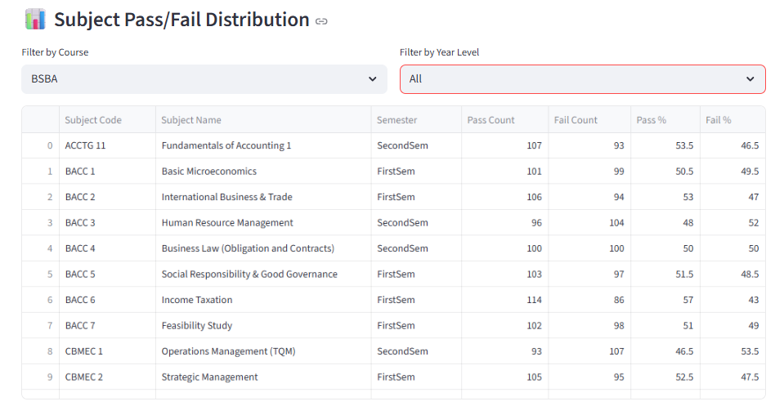

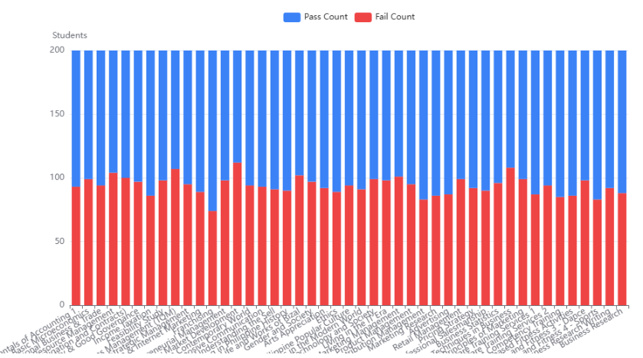

**Insight**: Clear visibility into subject-level performance by term—supports targeted interventions.

## 3. Enrollment Trend Analysis

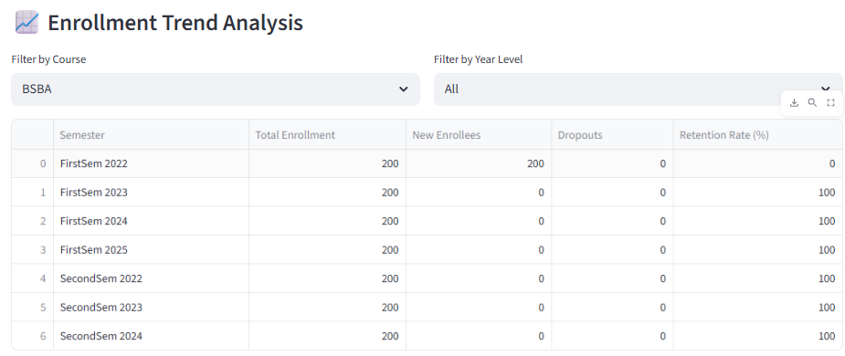

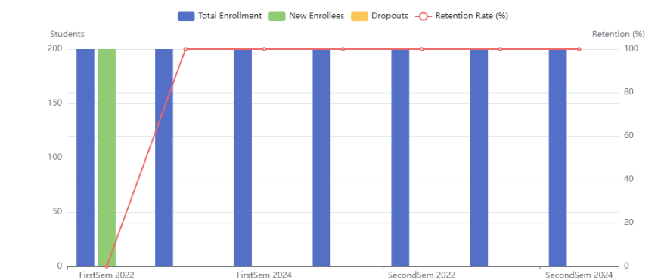

**Insight**: Plotting these values as line or area charts reveals enrollment dynamics—semester over semester or year over year.

## 4. Incomplete Grades Report

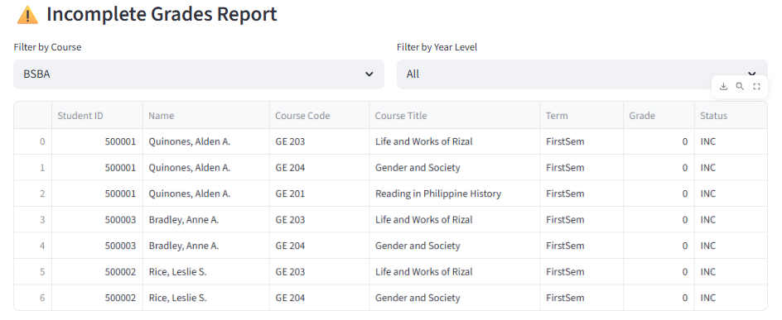

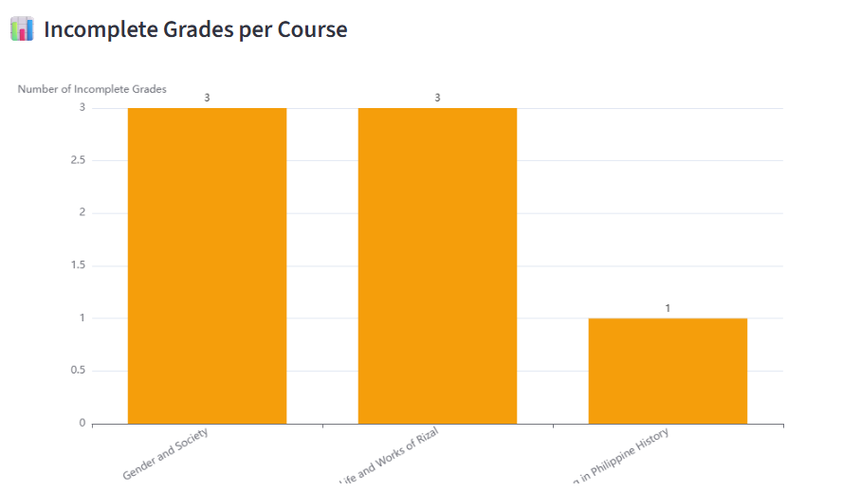

**Insight**: Helps Registrar’s Office identify and follow up with students and instructors regarding incomplete or missing grade submissions.

## 5. Retention and Dropout Rates

|  | **Semester to Semester** | **Retained** | **Dropped Out** | **Retention Rate (%)** |
| --- | --- | --- | --- | --- |
|  | Fall 2023 → Spring 2024 | 450 | 50 | 90% |
|  | Fall 2022 → Spring 2023 | 430 | 70 | 86% |
|  | … | … | … | … |

**Insight**: Measures student persistence and identifies retention issues early—critical for institutional planning.

## 6. Top Performers per Program

| **Program** | **Semester** | **Student ID** | **Student Name** | **GPA** | **Rank** |
| --- | --- | --- | --- | --- | --- |
| Computer Science | Spring 2025 | S025 | Maria Cruz | 99 | 1 |
| Biology | Spring 2025 | S038 | Ahmed Khan | 99 | 1 |
| … | … | … | … | … | … |

**Insight**: Highlights top academic performers by discipline—great for awards, recognitions, and program-level analysis.

## 7. Curriculum Progress and Advising

Filter by course and student name:

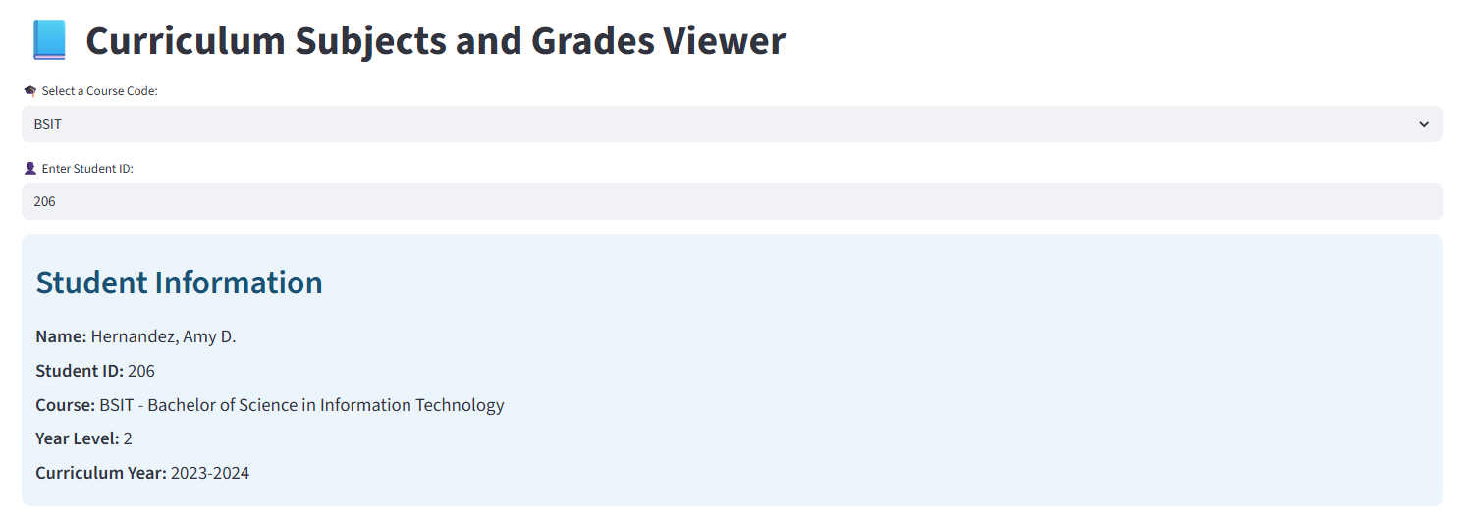

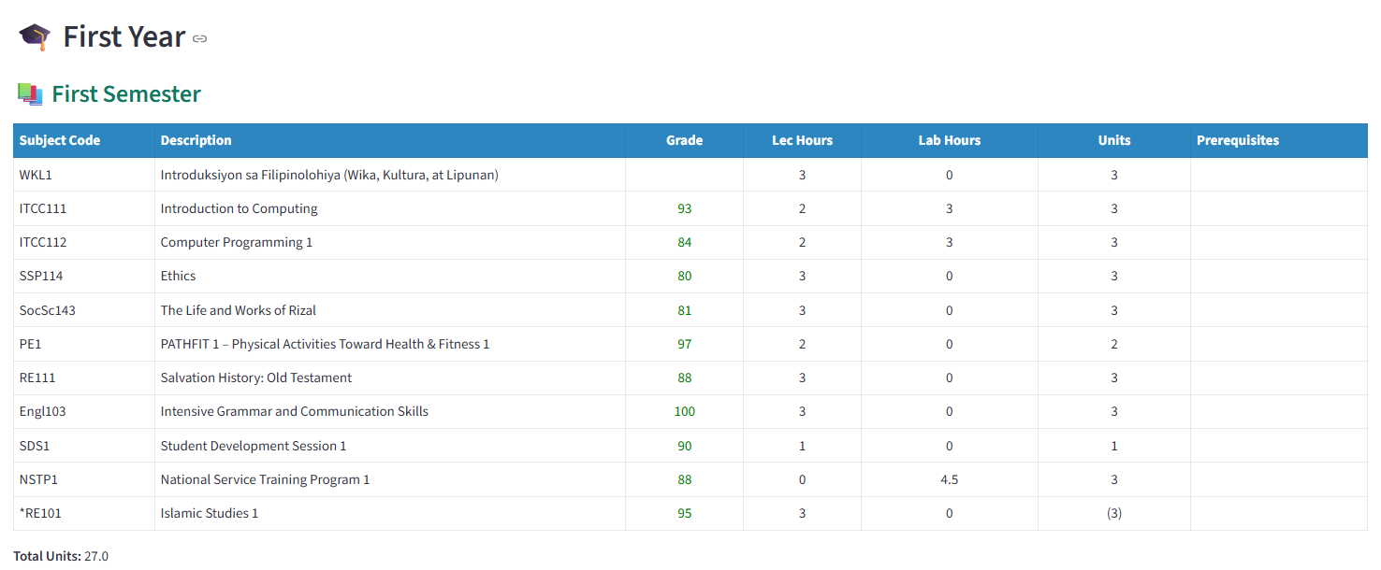

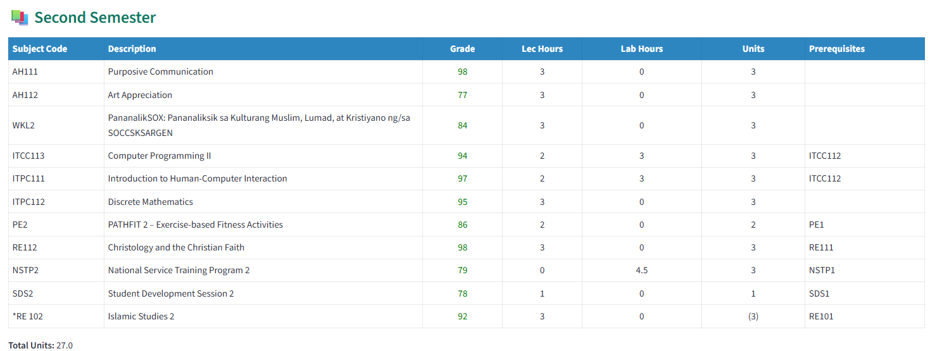

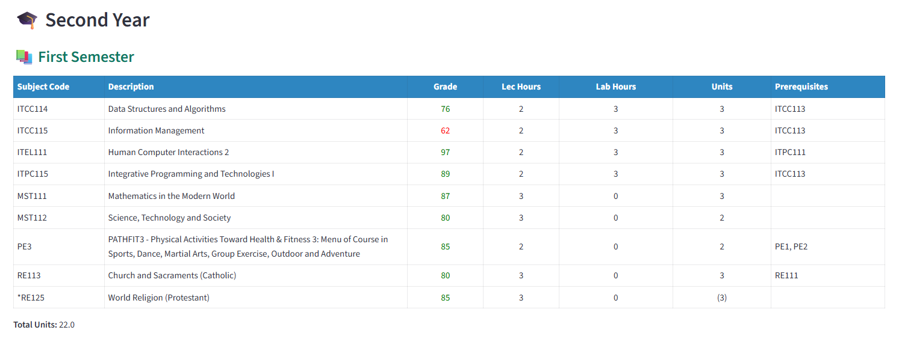

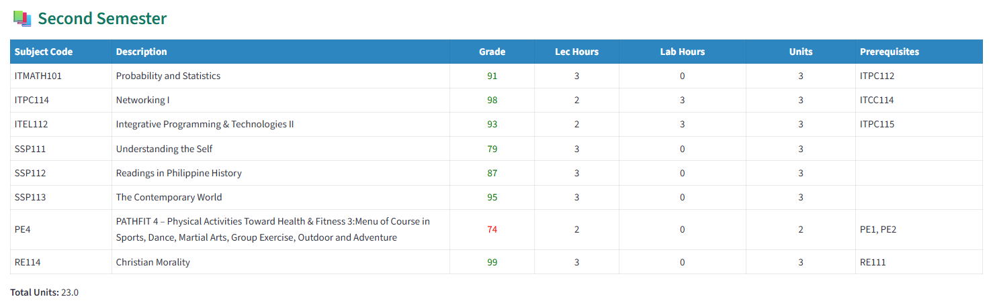

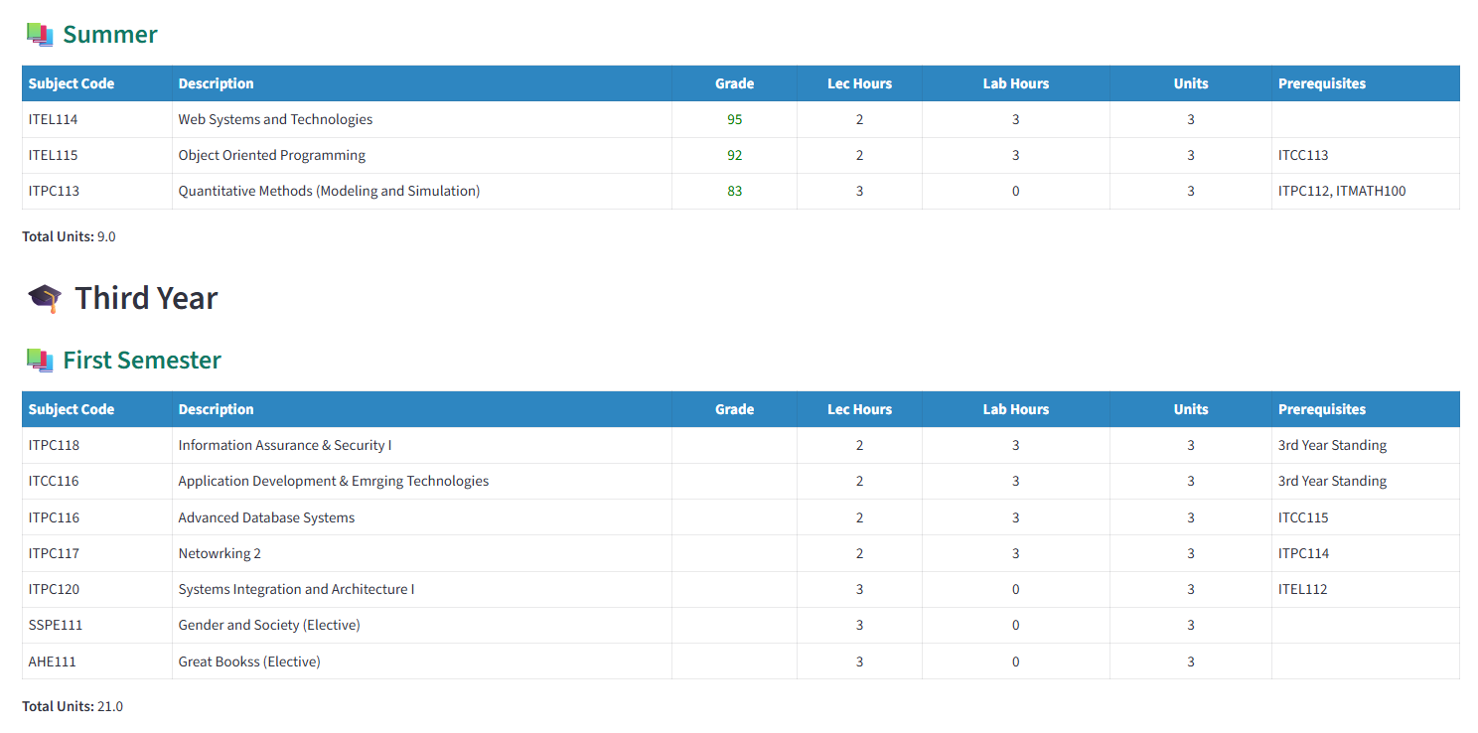

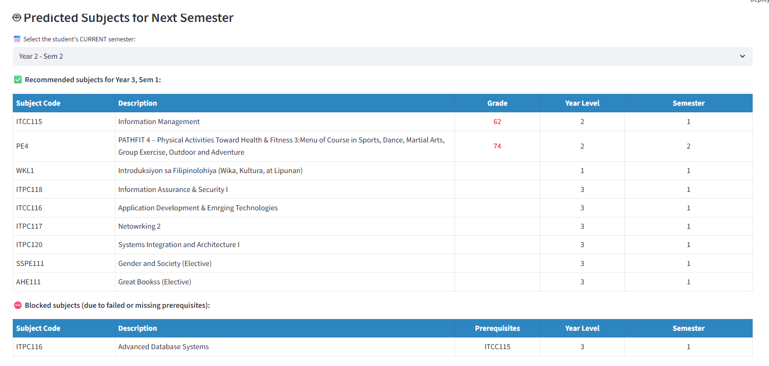

# Faculty Dashboard Reports

## Class Grade Distribution

* Displays a histogram of student grade distribution per subject.

Faculty Name: _______________________________

Semester and School Year: _____________________

|  |  |  |  |  |  |  |  |
| --- | --- | --- | --- | --- | --- | --- | --- |
| Followed by histogram. |  |  |  |  |  |  |  |

**Insight:** Quick view of overall performance—identifies courses with skewed grade distributions or those with high failure rates.

## Student Progress Tracker

Shows longitudinal performance for individual students.

Filtered by Subject or course or YearLevel

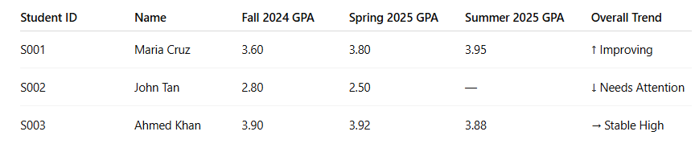

Followed by line graph/scatter chart.

## Subject Difficulty Heatmap

* Visualizes subjects with high failure or dropouts
* Subjects handled by the faculty

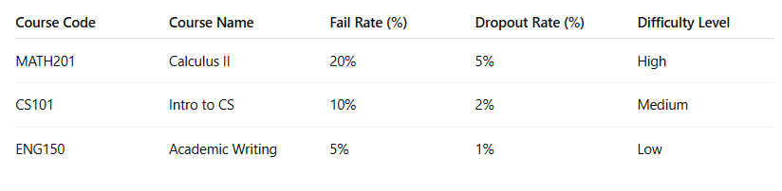

## Intervention Candidates List

* Lists students at academic risk based on current semester data (e.g. low grades, missing grades)

Faculty Name:

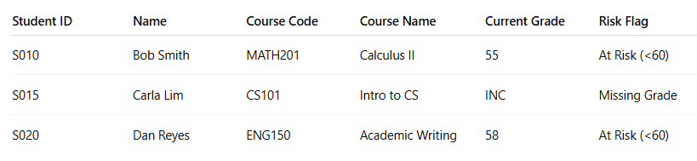

## Grade Submission Status

* Tracks the status of grade submissions by faculty for each class. (e.g. complete grades, with blank grades)

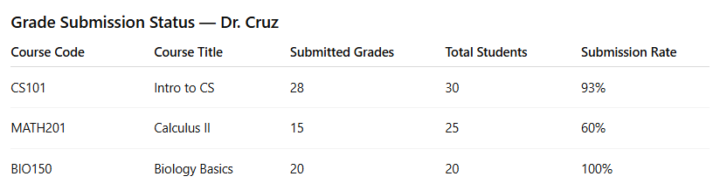

## Custom Query Builder

* Allows users to build filtered queries (e.g., “Show all students with <75 in CS101”).

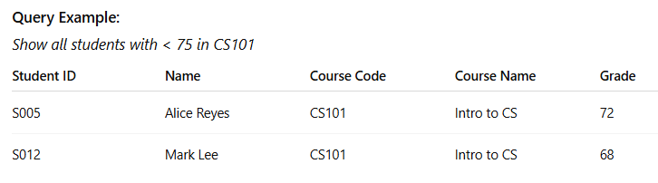

## Students Grade Analytics (Per Teacher)

Select Teacher

Natalie Moyer



Select Subject:



SDS1 - Student Development Session 1 (First Year, First Semester)



CSELEC4 - Intelligent Systems (Fourth Year, First Semester)

📊 Grades Summary of Faculty: Natalie Moyer

|  | Mean | **Median** | **Highest** | **Lowest** |
| --- | --- | --- | --- | --- |
| **0** | 86.21 | 88.00 | 100.00 | 61.00 |

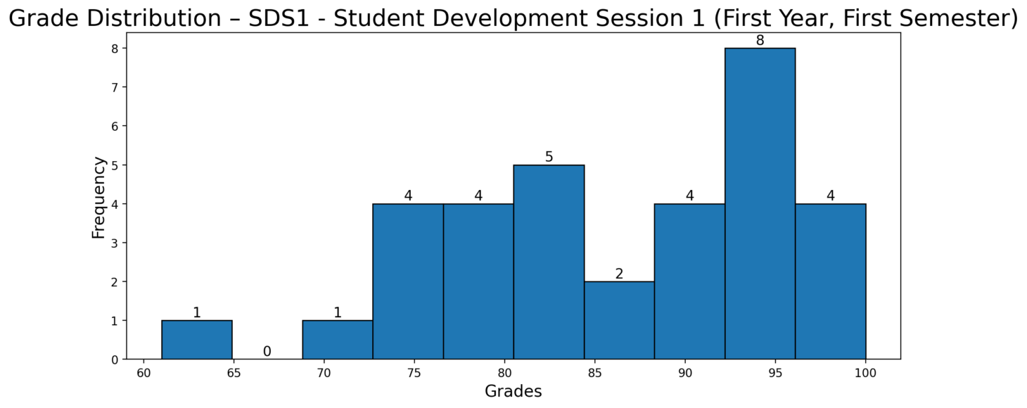

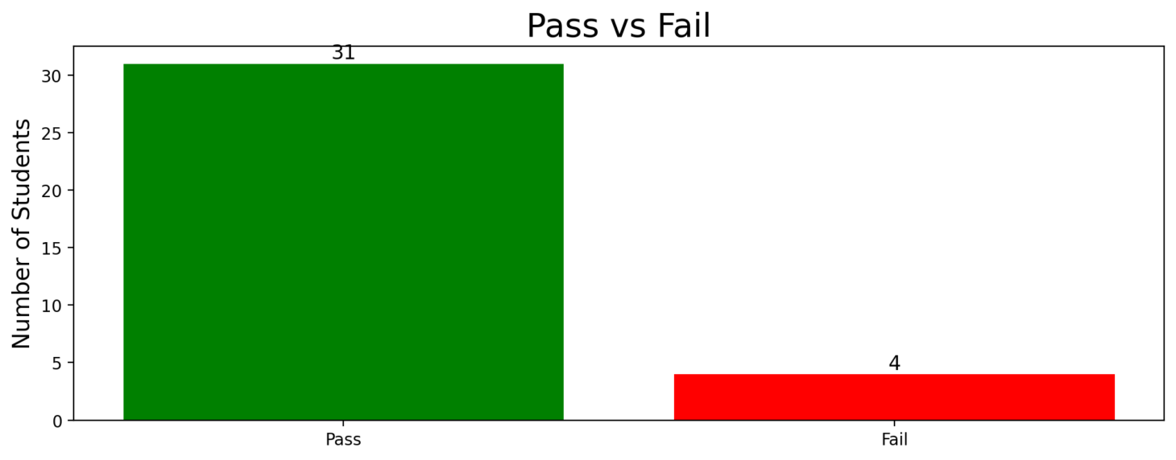

Student Grades

|  | **Student ID** | **Student Name** | **Course** | **YearLevel** | **Grade** | **Pass/Fail** |
| --- | --- | --- | --- | --- | --- | --- |
| **0** | 1359 | Adams, Susan J. | BSEE | 1 | ⭐ 83 | Pass |
| **1** | 1905 | Benson, Charles B. | BSEE | 1 | ⭐ 75 | Pass |
| **2** | 1821 | Benson, Laura M. | BSEE | 1 | ⭐ 93 | Pass |
| **3** | 1743 | Black, April P. | BSEE | 1 | ⭐ 89 | Pass |
| **4** | 1530 | Brown, Janice A. | BSEE | 1 | ⭐ 87 | Pass |
| **5** | 1394 | Chandler, Virginia J. | BSEE | 1 | ⭐ 99 | Pass |
| **6** | 1732 | Coleman, Lisa M. | BSEE | 1 | ⭐ 75 | Pass |
| **7** | 1938 | Cooper, Kristen S. | BSEE | 1 | ⭐ 81 | Pass |
| **8** | 1800 | Davis, Tammy A. | BSEE | 1 | ⭐ 82 | Pass |
| **9** | 1777 | Gallegos, Tyler S. | BSEE | 1 | ⭐ 94 | Pass |
| **10** | 1690 | Haley, Glenn C. | BSEE | 1 | ⭐ 88 | Pass |
| **11** | 1806 | Harris, John K. | BSEE | 1 | ⭐ 98 | Pass |
| **12** | 1868 | Henry, Michelle M. | BSEE | 1 | ⭐ 97 | Pass |
| **13** | 1972 | Jacobs, James P. | BSEE | 1 | ⭐ 90 | Pass |
| **14** | 1634 | Johnson, Lauren L. | BSEE | 1 | ⭐ 94 | Pass |
| **15** | 1494 | Jones, Richard P. | BSEE | 1 | ⭐ 83 | Pass |
| **16** | 1846 | Maynard, Anthony E. | BSEE | 1 | ⭐ 78 | Pass |
| **17** | 1847 | Mccarthy, Donna S. | BSEE | 1 | ⭐ 89 | Pass |
| **18** | 1362 | Mcintyre, Alexis L. | BSEE | 1 | ❌ | Fail |
| **19** | 1560 | Mendoza, Andre S. | BSEE | 1 | ⭐ 80 | Pass |
| **20** | 1463 | Mercado, Tracy B. | BSEE | 1 | ⭐ 93 | Pass |
| **21** | 1673 | Miller, Diane R. | BSEE | 1 | ⭐ 95 | Pass |
| **22** | 1428 | Padilla, Nicole D. | BSEE | 1 | 72 | Fail |
| **23** | 1945 | Patel, Patricia G. | BSEE | 1 | ⭐ 100 | Pass |
| **24** | 1562 | Phillips, Jocelyn E. | BSEE | 1 | ⭐ 76 | Pass |
| **25** | 1922 | Price, Patrick B. | BSEE | 1 | ⭐ 80 | Pass |
| **26** | 1674 | Reed, Keith J. | BSEE | 1 | 61 | Fail |
| **27** | 1523 | Romero, Ronald L. | BSEE | 1 | ⭐ 93 | Pass |
| **28** | 1621 | Ryan, Amanda E. | BSEE | 1 | ⭐ 95 | Pass |
| **29** | 1966 | Schmidt, Tony J. | BSEE | 1 | ⭐ 90 | Pass |
| **30** | 1737 | Simpson, Amy J. | BSEE | 1 | ❌ | Fail |
| **31** | 1446 | Stevens, Rebecca W. | BSEE | 1 | ⭐ 76 | Pass |
| **32** | 1466 | Torres, John J. | BSEE | 1 | ⭐ 84 | Pass |
| **33** | 1454 | Wade, Diana J. | BSEE | 1 | ⭐ 80 | Pass |
| **34** | 1813 | Young, Brenda K. | BSEE | 1 | ⭐ 95 | Pass |

# Students Dashboard Reports

## 1. Academic Transcript Viewer

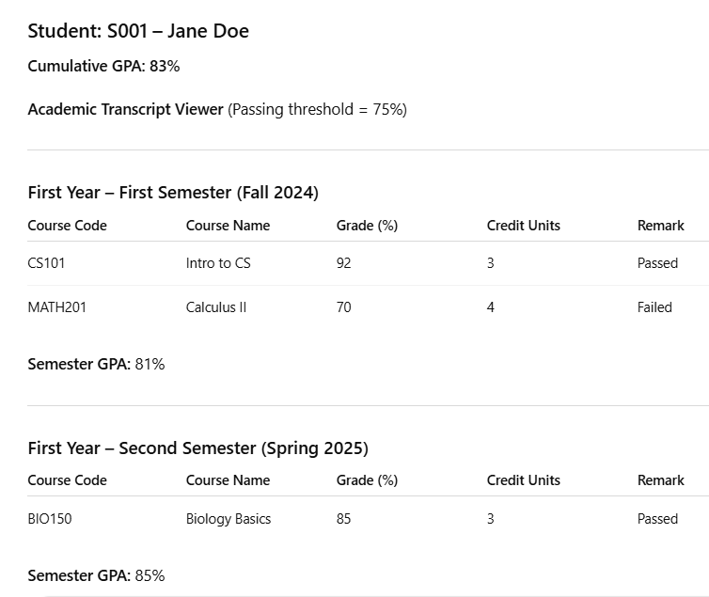

## 2. Performance Trend Over Time

| Semester | Semester GPA |
| --- | --- |
| Fall 2023 | 89.17 |
| Spring 2024 | 90.15 |
| Fall 2024 | 85.57 |
| Spring 2025 | 89.79 |

**Description:** Represents GPA progression across semesters, ideal for a line chart visual.

## 3. Subject Difficulty Ratings

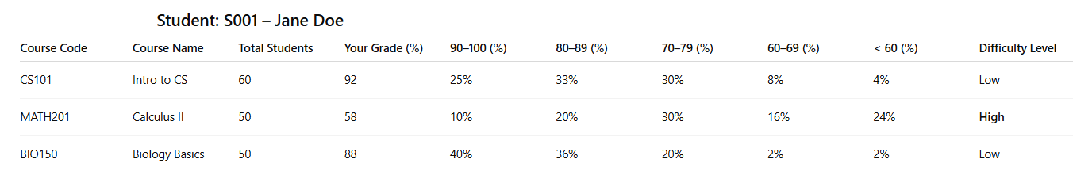

## 4. Comparison with Class Average

|  |  |  |  |
| --- | --- | --- | --- |

**Description:** Highlights how the student’s performance stacks up against peers.

## 5. Passed vs Failed Summary

|  |  |  |
| --- | --- | --- |
|  |  |  |
|  |  |  |

**Description:** A simple summary of academic outcomes—ideal for pie or bar chart depiction.

Followed by pie chart.

## 6.Curriculum and Subject Viewer

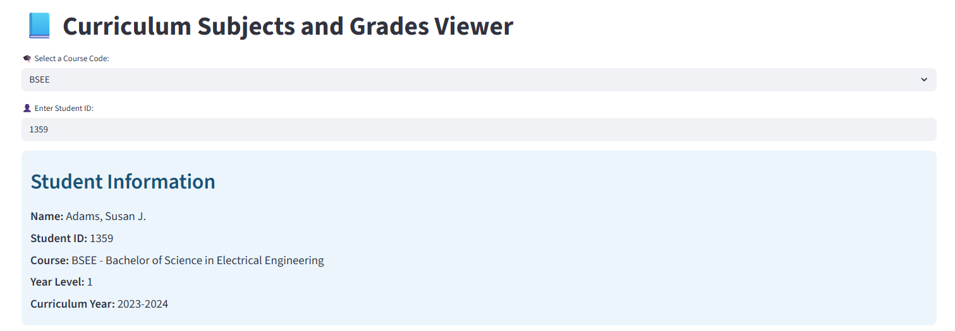

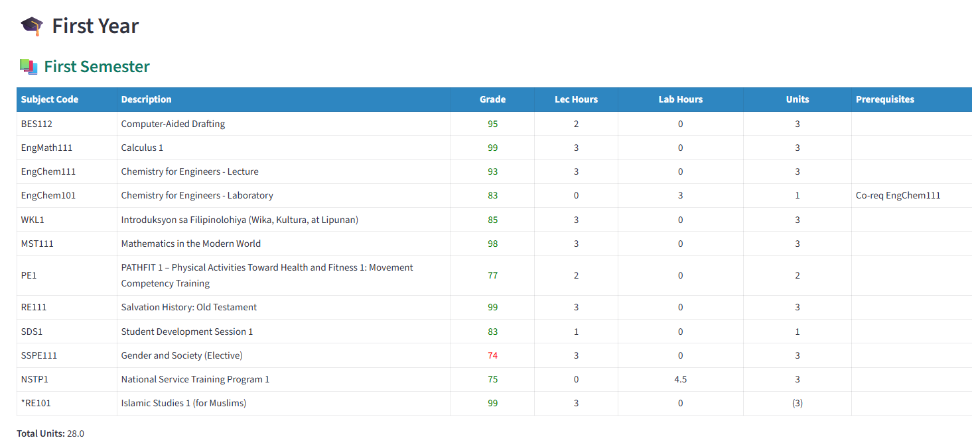

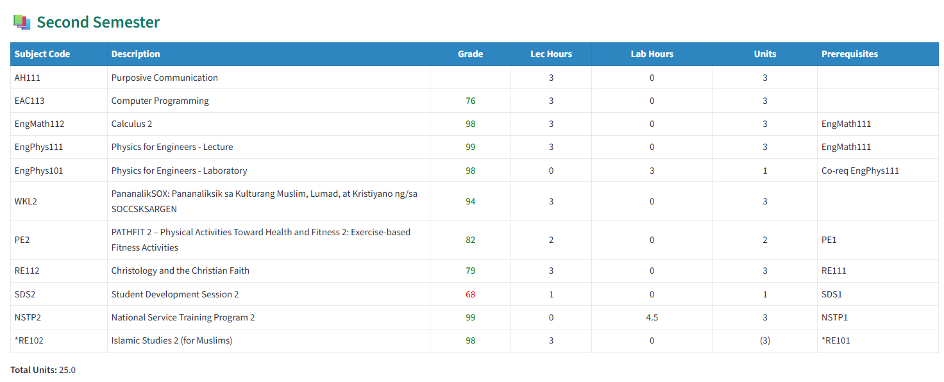

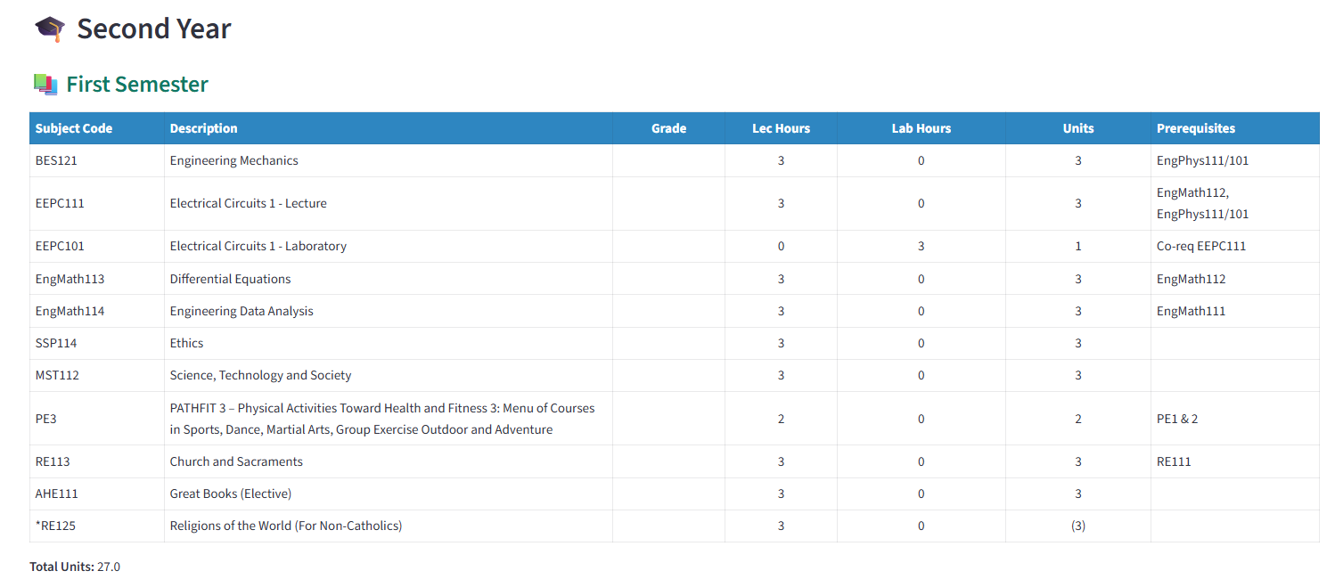

**Print this portion after checking, for documentation…**

# Source code for each dashboard and reports

# Registrar’s Office Dashboard Reports

## 1. Student Academic Standing Report

## 2. Subject Pass/Fail Distribution

## 3. Enrollment Trend Analysis

## 4. Incomplete Grades Report

## 5. Retention and Dropout Rates

## 6. Top Performers per Program

## 7. Curriculum Progress and Advising

# Faculty Dashboard Reports

## 1. Class Grade Distribution

## 2. Student Progress Tracker

## 3. Subject Difficulty Heatmap

## 4. Intervention Candidates List

## 5. Grade Submission Status

## 6. Custom Query Builder

## 7. Students Grade Analytics (Per Teacher)

# Students Dashboard Reports

## 1. Academic Transcript Viewer

## 2. Performance Trend Over Time

## 3. Subject Difficulty Ratings

## 4. Comparison with Class Average

## 5. Passed vs Failed Summary

## 6. Curriculum and Subject Viewer

# Recommendations for Dashboard Enhancements

To strengthen the **Distributed Academic Performance Analytics System** and expand its capability beyond descriptive analytics toward **predictive** and **prescriptive analytics**, provide your recommendations for each type of dashboard.

Your recommendations should:

1. Be **specific to the role** (Registrar, Faculty, Student).
2. Include both **predictive features** (e.g., forecasting grades, enrollment trends, student risk) and **prescriptive features** (e.g., recommended actions, course adjustments, support strategies).
3. Suggest **analytics-driven improvements** that will support better decision-making, early interventions, and long-term academic planning.
4. Please organize your recommendations under the following categories:
   1. **Registrar Dashboard**
   2. **Faculty Dashboard**
   3. **Student Dashboard**

# MongoDB Database Model for Dashboard Enhancements

Design a new MongoDB database model that defines collections and relationships capable of supporting descriptive, predictive, and prescriptive analytics. The model must ensure that the system can generate accurate reports and insights for the Registrar, Faculty, and Student dashboards.