User guide

how to MANAGE plans



Diamond Memorial Care Plans Inc.

http://dmcpi.com

1. Login with your user credentials
2. Navigate to “FILE MAINTENANCE MODULE” then select “PLANS”.

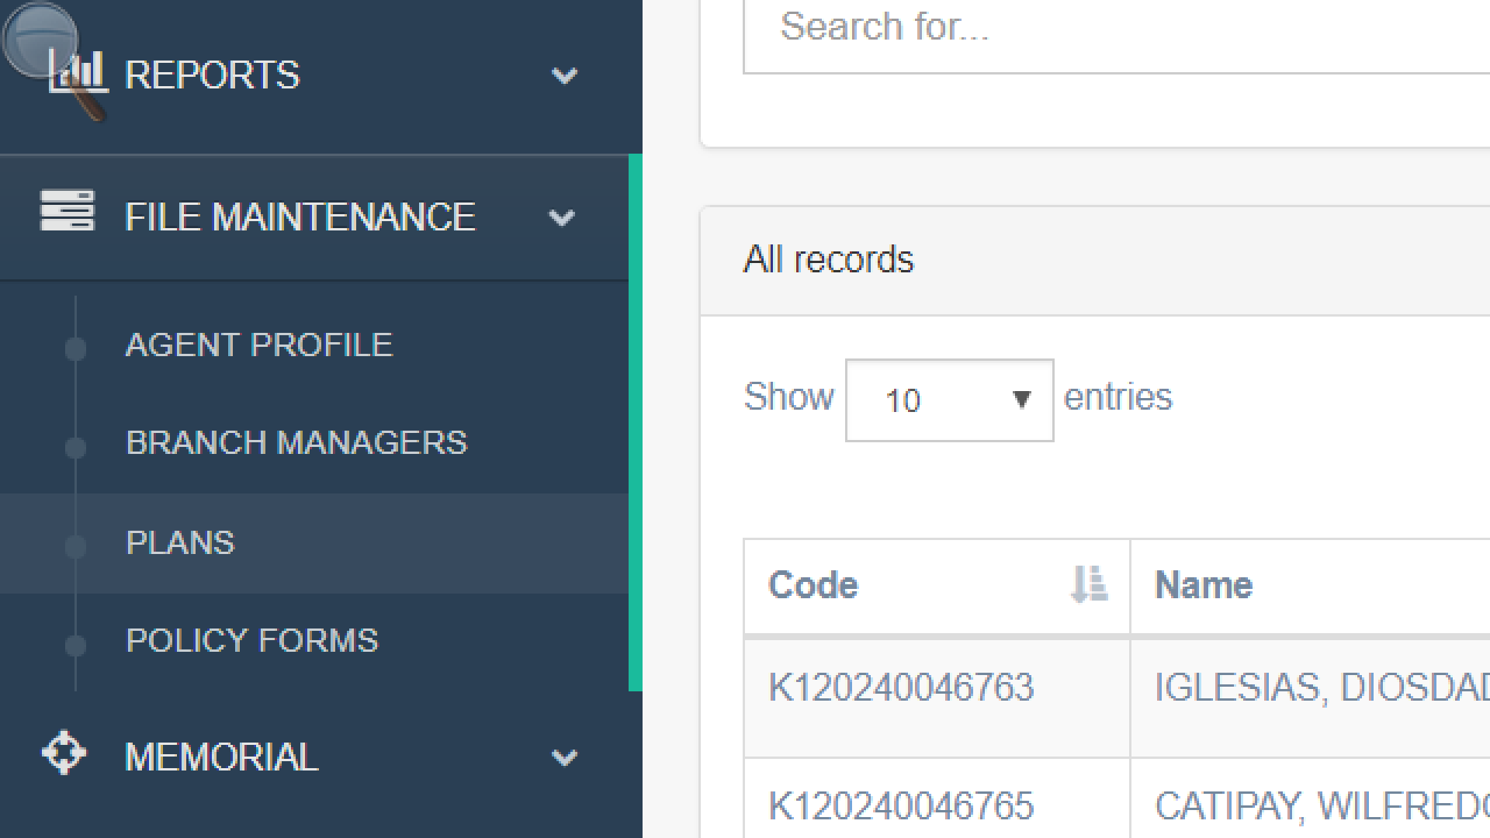

1. To “Add” new PLAN. Select the new plan button located at the upper right corner of the screen.

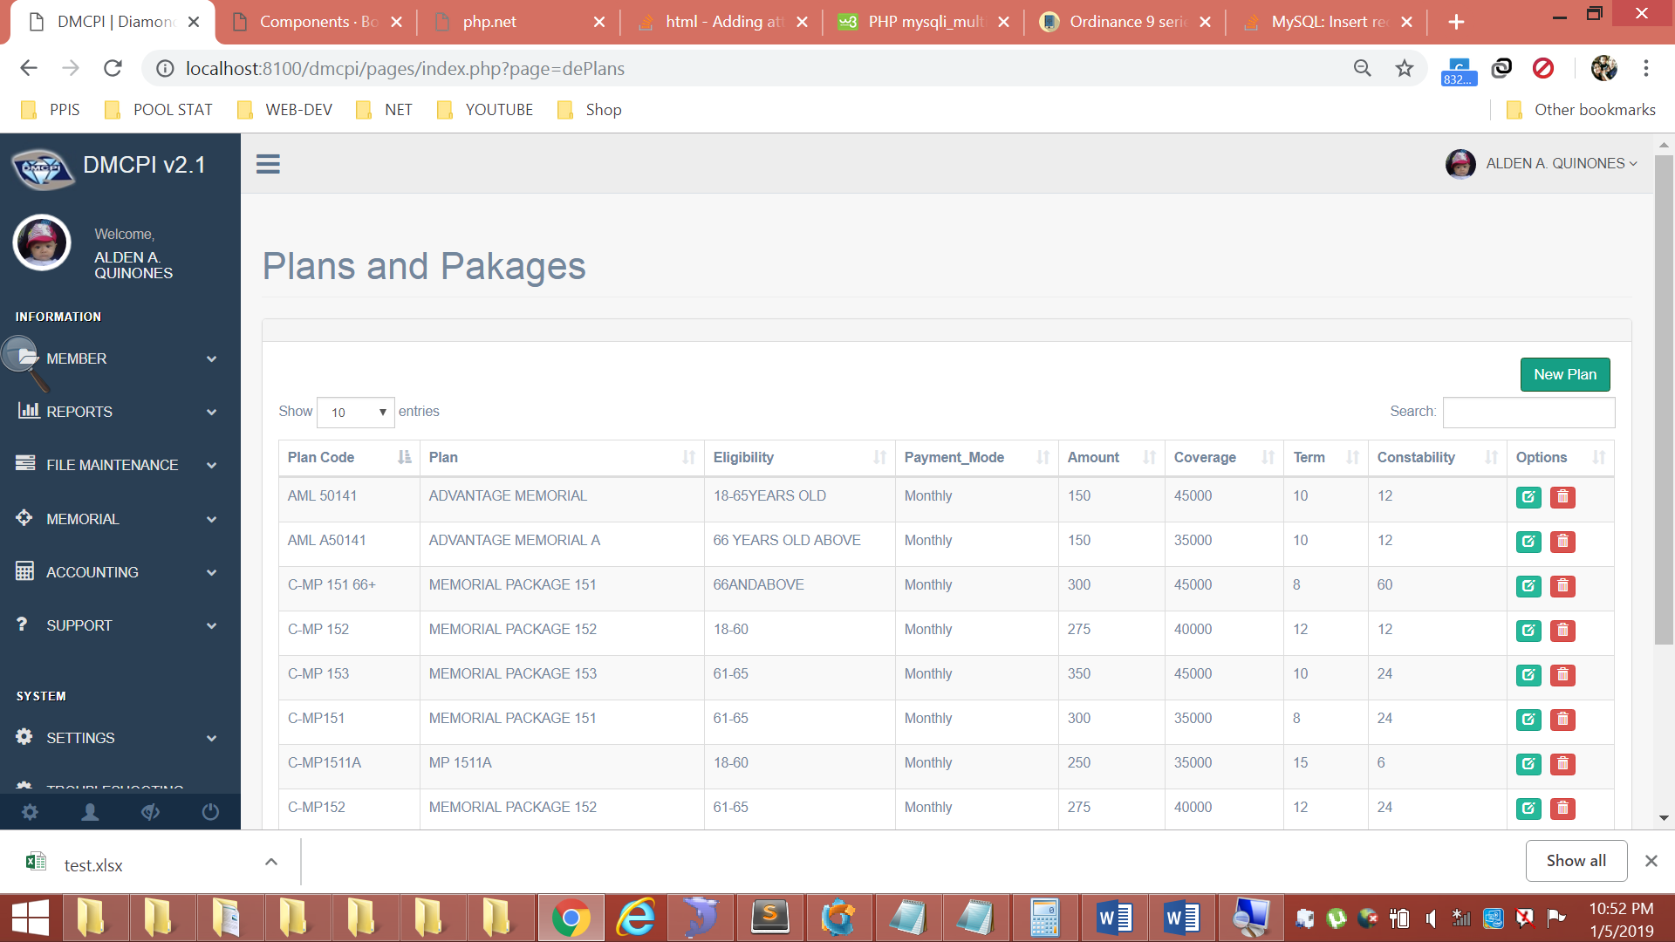

1. To Edit Plans, Search the name of the PLAN in a search box in the search box. Then select the Green Button at the far right of the table.

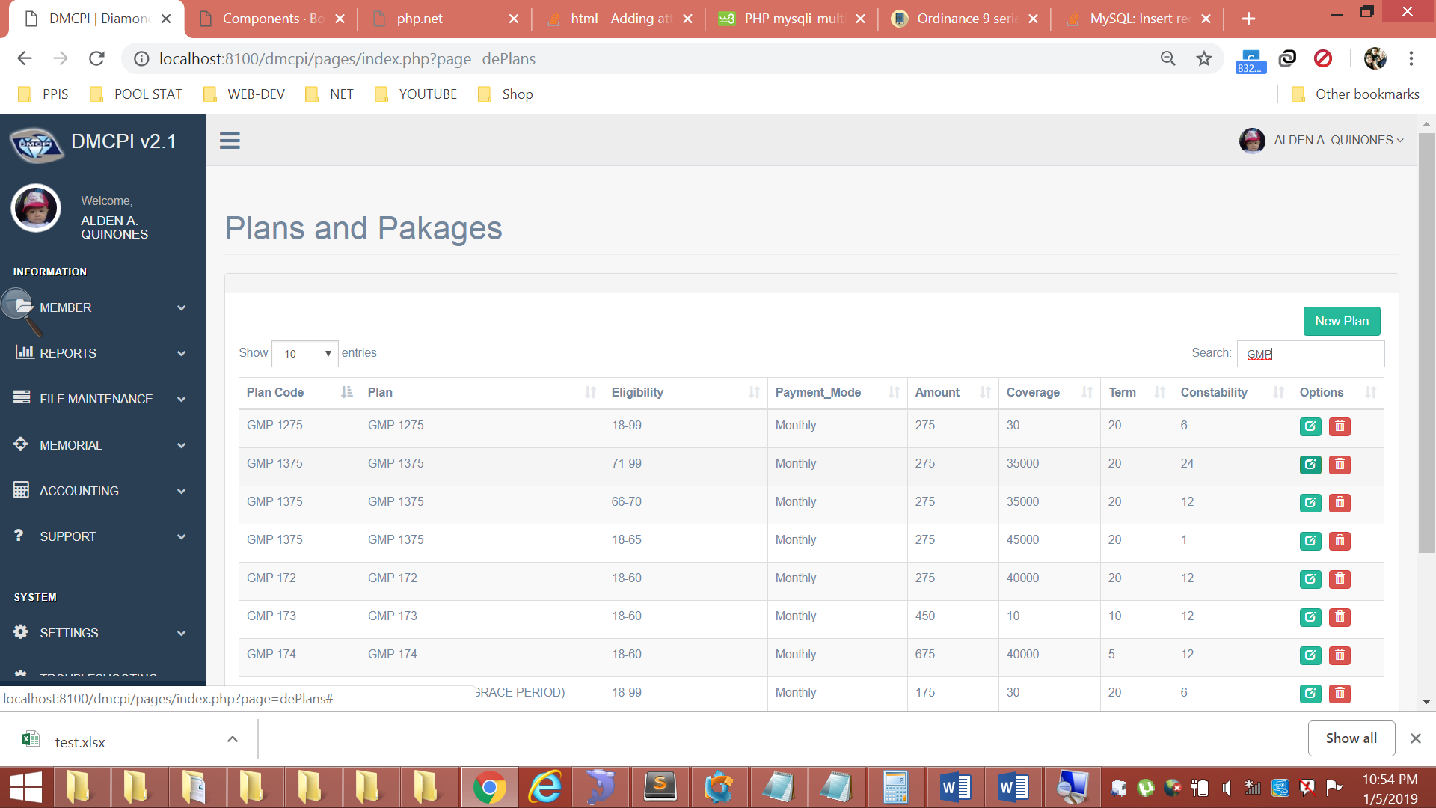

1. Then input all required information inside the box.

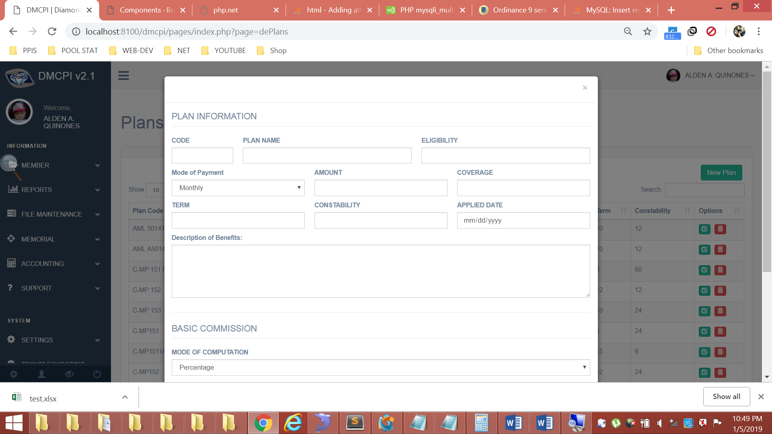

1. To setup basic commission, scroll down and find “BASIC COMMISION” section.

*(Leave blank if not applicable)*

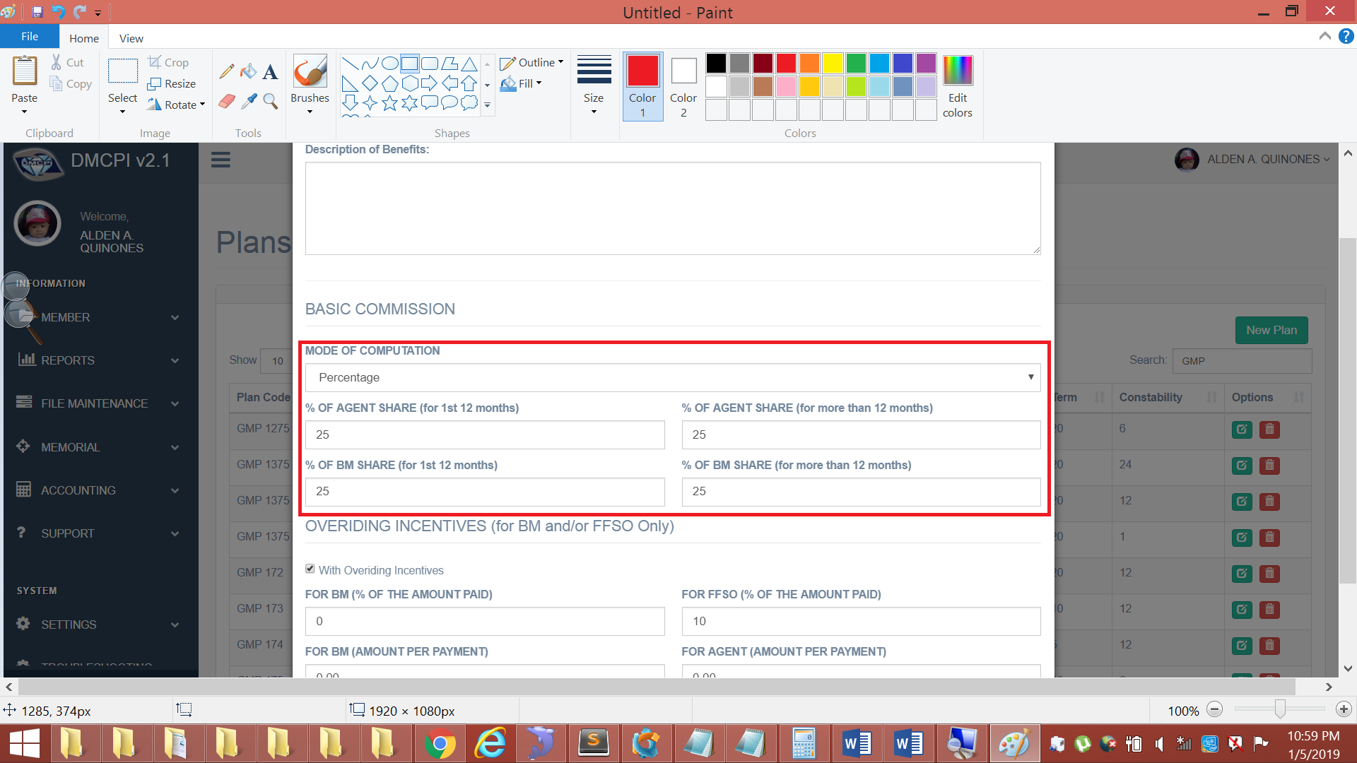

1. To setup “Overriding Incentives”. Scroll down and find it just below the “Basic Commission” Section *(Leave blank if not applicable)*

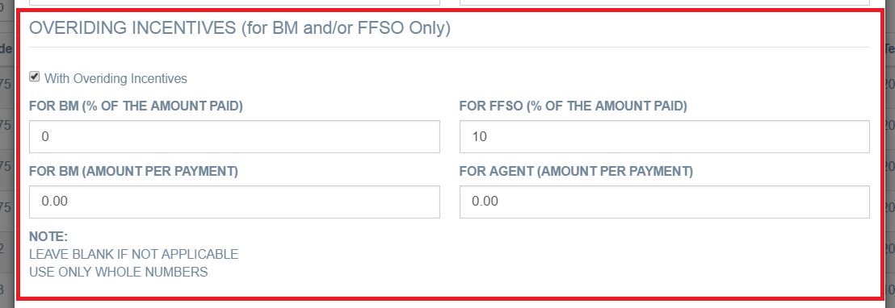

1. Click Save button.