User guide

HOW TO GENERATE AND DOWNLOAD MCPR

Diamond Memorial Care Plans Inc.

http://dmcpi.com

1. Login with your user credentials
2. Navigate to “REPORTS” MODULE then select “MCPR REPORTS”.

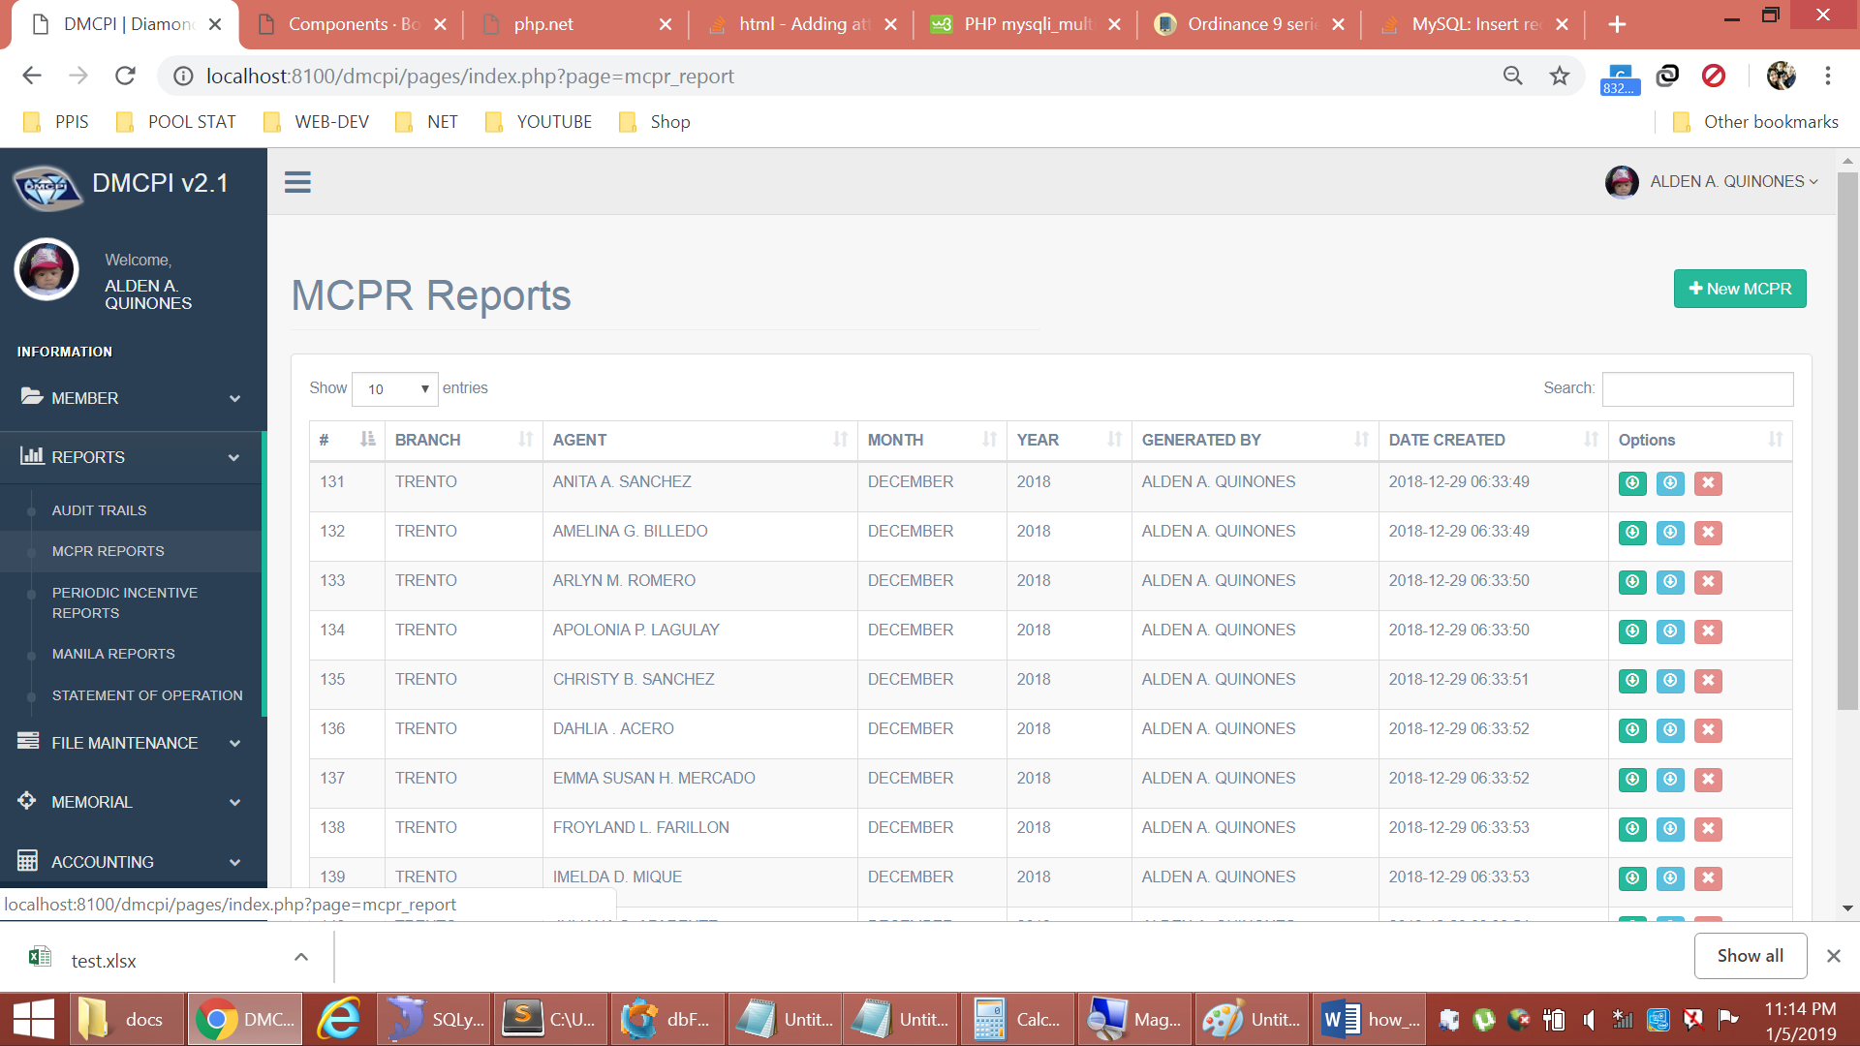

1. To generate MCPR, select the “New MCPR” button located at the upper right corner of the screen. Then fill all required information inside the box then generate.

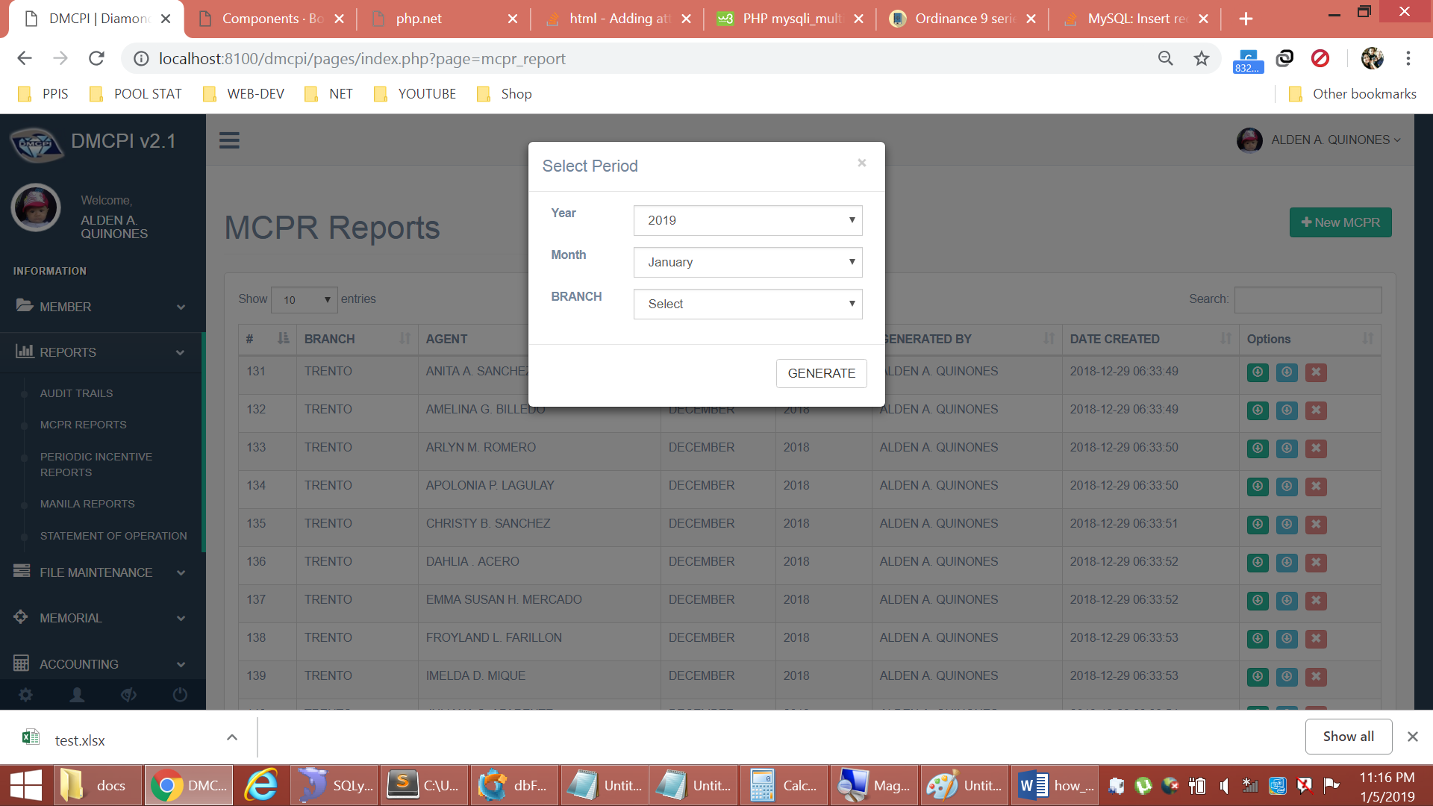

1. To Download MCPR, Search the MCPR entry in the search box. Then select the Green Button at the far right of the table.

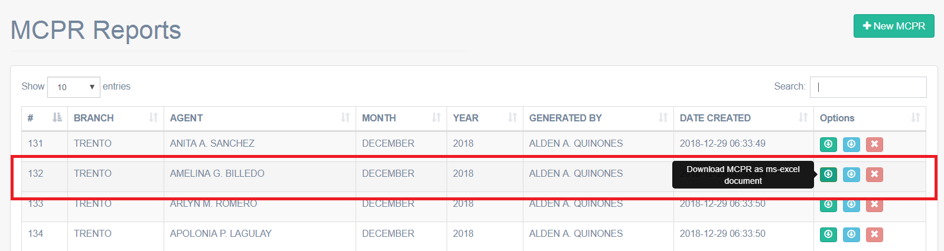

1. To download MCPR for OFFLINE encoding (for encoders only), click the BLUE button

