User guide

HOW TO upload offline encoded MCPR data

Diamond Memorial Care Plans Inc.

http://dmcpi.com

1. Login with your user credentials
2. Navigate to “MEMBER” MODULE then select “UPLOAD MCPR DATA”.

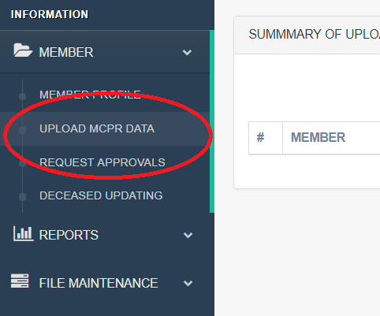

1. Find the “UPLOAD EXCEL” button located at the upper right corner of the screen then click browse button. Select the excel file the click submit. (*wait for the system to finish uploading*)

Note: the document must be in excel format (\*.xlsx)

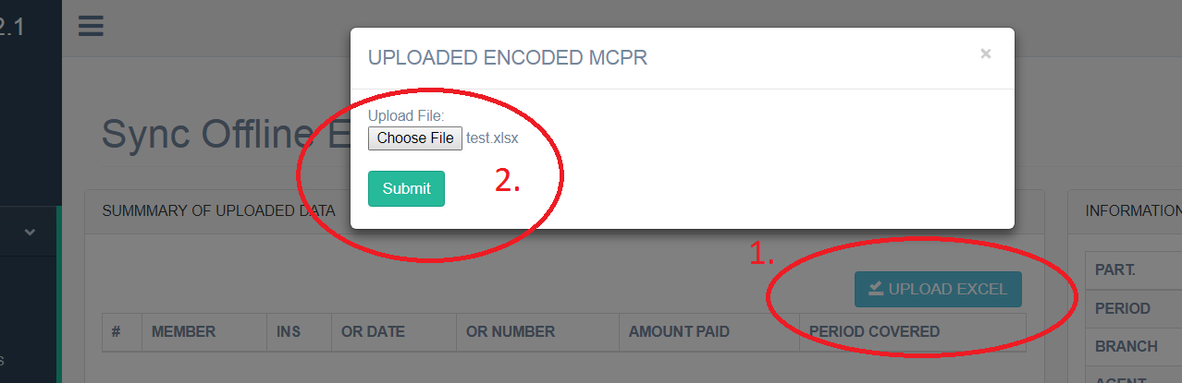

1. The system will display information of the uploaded document for review. (you can reupload your excel if you got a revision)

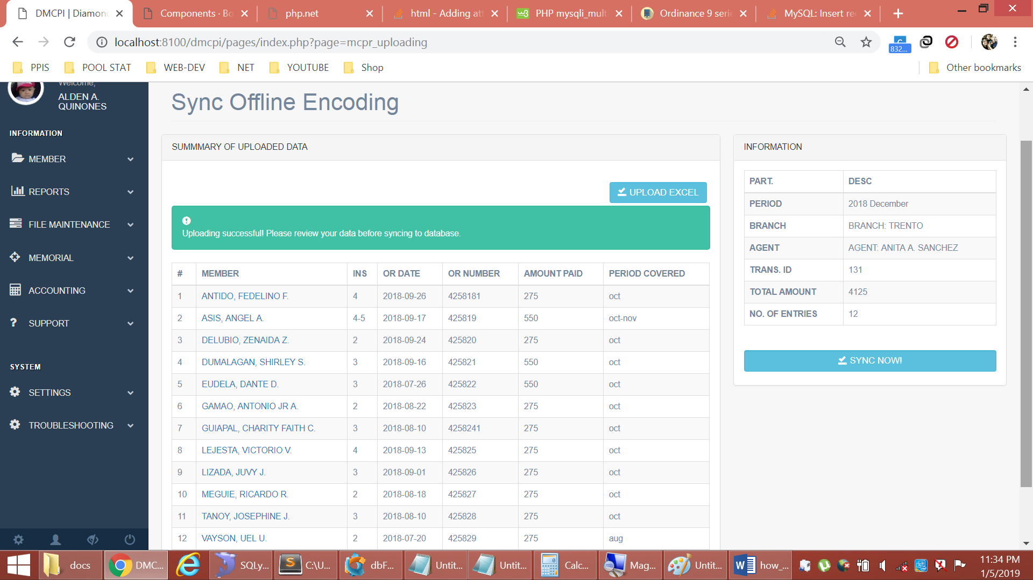

1. Finally, Click “SYNC NOW!” button – this will synchronized the information in your excel and the database.

Note: the system will prompt if then OR/PR already used.

