|  |
| --- |
|  |
| Crab Pulsar Polarimeter and Pulse Timer |
| Group 3 |

|  |
| --- |
| Vincent Miller (PSE), David Patenaude (PSE & CpE), Ethan Tomczak (EE), David Urrego (CpE)  6-14-2024  Sponsor: Dr. Stephen Eikenberry  Reviewers: Dr. Mark Maddox, Dr. Sonali Das, Dr. Stephen Eikenberry |

# – Executive Summary

[Executive summary is a work in progress as project documentation develops]

Pulsars are rare astronomical objects with uniquely extreme properties, the study of which has revolutionized our understanding of the universe in the past and may well continue to do so in the future. To further the field of astronomy, we have built a polarimeter to record precise polarization data of the light from optical pulsars.

# – Project Description

## 2.1 Project Background and Motivation

### 2.1.1 Background

Our project is about making an instrument that can measure the polarization and pulse timing of pulsars, which are neutron stars that emit pulses. We plan to accomplish this by attaching our instrument to a pre-existing telescope. To measure the polarization, we intend to make a linear Stokes polarimeter. By attaching this instrument onto the telescope, we can analyze intensity of light after it passes through the polarizers and waveplates, which allows for the polarimeter to calculate the Stokes parameters. These parameters include light intensity, circular polarization, as well as linear polarization. This data reveals the degree and angle of polarization. Light from the Crab Pulsar will also be processed to determine how the light is polarized. Overall, our tool can be used to determine the orientation and degree of the pulsar's magnetic field and analyze the interactions between the pulsar's emitted light and its surrounding environment.

### 2.1.2 Primary Motivation

The motivation for this project comes from Dr. Stephen Eikenberry, who is a professor at the University of Central Florida, College of Optics and Photonics. His research focuses on astrophysics and the development of instrumentation for Astrophotonics research.

At Dr. Eikenberry’s request we are building an instrument to measure the pulse timing and polarization of light from the Crab Pulsar, an optical pulsar approximately 7000 light years from earth. Pulsars are a type of neutron star that emit bright, directed beams of radiation while simultaneously spinning at high speeds. This leads to a pulsing effect where the brightness of the star increases and decreases periodically, as the beam points towards and then away from astronomers on Earth. Among astronomical objects, this regular pulsing behavior is unique to pulsars, and could provide valuable data needed to explain how they operate.

All neutron stars, pulsars included, are a highly unusual type of star with extremely fast rotational velocities, strong magnetic fields, and extreme densities. The polarization and pulse timing data provide astrophysicists with vital information needed to study the structure and dynamics of pulsars. Polarization data discloses details about the pulsar’s magnetic field such as its structure and strength, this can help explain how the pulsar emits radiation and interacts with particles. Measuring pulse timing can provide the distance of a pulsar from Earth, it can give information on the pulsar’s rotation and stability, and measuring changes in a pulsar’s timing can indicate internal processes like starquakes and/or interactions with nearby objects. The combination of these two data points can serve astronomers by helping scientists understand the pulsar’s behavior, structure, and the space around it. The extreme rotating magnetic fields near the surface of these types of stars interact with outgoing particles and produce linearly polarized light, which is what our project will be detecting. When synchronized with pulse timing measurements, our instrument will provide novel scientific data that will help scientists study these extreme and complex objects. Since pulses from the Crab Pulsar are detectable at visible wavelengths, our project will be built using visual spectrum optical components. It will be mounted onto the existing 20-inch telescope at the University of Central Florida’s Robinson Observatory. It is uncommon for pulsars to emit visible light, as there are only a handful of such pulsars known. The Crab Pulsar, being one of these rare exceptions, provides a unique opportunity to study its properties in detail. By focusing on visible light, our project aims to capture high resolution data that can reveal new insight about its emission mechanisms and magnetic field structure, which are characteristics that would be difficult to obtain at other wavelengths. Having a better understanding of this pulsar could greatly contribute to the field of astrophysics in a variety of ways.

### 2.1.3 Further Applications

The module we will be constructing can be used for many additional measurements by astronomers. This device will have a sufficient sampling rate to be able to measure all kinds of visible stars and exoplanets within our galaxy, helping astronomers gain a more thorough understanding of our universe. For example, using this device on other stars we can use the polarization and pulse timing data gathered to geometrically map the magnetic field of the observed star. In the case of exoplanets, astronomers will be able to map out the orbital path of the observed exoplanet. This can be done because the starlight reflected off the exoplanet will be of a particular polarization. Overall, we would like to see many observatories use this device for a wide range of data collection.

## **2.2. Existing Projects and Products Comparison**

### 2.2.1 Mini-HIPPI (Miniature High Precision Polarimetric Instrument)

This telescope polarimeter developed by Jeremy Bailey, Daniel V. Cotton, and Lucyna Kedziora-Chudczer displays very similar functionality to the product we would like to develop. The Mini–HIPPI is a telescope mountable stellar polarimeter which has the following design properties: high precision measurements (0.1% error), compact footprint (weight of 650g), large wavelength coverage (nanometer range), and lastly sophisticated optical design coupled with sensitive detectors. The optics section of the module comprises a ferroelectric liquid crystal (FLC) modulator, a Glan Taylor Prism, and a collection of photomultiplier tube modules [1]. The use of a FLC modulator rather than a wave plate retarder is important to note. FLC modulators allow for fast, real-time application, whereas a half wave plate retarder may want to be selected for higher precision and reliability. Furthermore, for this polarimeter design, the team chose a Glan Taylor prism which limits the measurements to linear polarization states of the input signal. This prism was primarily chosen for simplicity and cost-effectiveness. In summary, the Mini-HIPPI is an excellent project to reference for our project design considering the optics design.

### 2.2.2 Thorlabs High-Dynamic Polarimeter

An existing product on the market is a pre-built polarimeter. These polarimeters come with different wavelength ranges and an accuracy of ±0.25°. They operate on the principle of using a rotating quarter-wave plate and a linear polarizer hooked up to a photodiode. The use of a quarter-wave plate allows for the instrument to detect circularly polarized light. This particular polarimeter from Thorlabs has a max sampling rate of 400 samples/s [2]. In our case, we would require a higher sampling rate to achieve the temporal resolution to see the pulse features. We are also dealing with incoherent light, which this polarimeter cannot handle.

### 2.2.3 Radio Astronomy Polarimetry

Polarimetric measurements of various pulsars have been taken before and are most commonly done using radio frequencies. This is simply because, of the over 3000 known pulsars, the overwhelming majority pulse at radio frequencies. Additionally, radio polarimetry in astronomy can often be done without specialized measurement devices, since radio antennas are inherently susceptible to the polarization of the received signal. Specifically, this is the case with the ALMA radio telescope [3]. Unfortunately, radio frequency polarimetry cannot be used to replace visible spectrum polarization data. Visible spectrum light and higher energy light provide unique information about the high energy interactions and mechanisms taking place within pulsar magnetic fields.

### 2.2.4 Summary

Overall, it is critical that we do research on existing products and projects related to our project to compare design measures and locate potential obstacles that may slow developmental and prototyping processes. Through the work of others, we can also see if certain methods should or should not be considered regarding our design specifications. Additionally, the research opens the avenue into new technologies that may suffice a requirement we desire. Using this approach will aid our development timeline and will improve the overall quality of our final product.

## **2.3 Goals and Objectives**

### 2.3.1 Goals

Our goal is to enable further study of visible-spectrum pulsars (specifically the Crab Pulsar) by creating an instrument to measure the polarization and pulse timing concurrently of the incident light. This instrument would then be attached to a telescope to gather light from the pulsar. Our overall objectives (or sub-goals) to meet this goal are:

* Design a Stokes polarimeter that can sample at a minimum of 1MHz.
* Design a pupil imaging system for alignment of the instrument to a telescope.
* Provide an image for a telescope’s built-in tracking system.
* Design a software package which computes pulse timing for each measured polarization.

These overall objectives can be broken down into basic, advanced and stretch goals. Our basic goals are:

* Optics: High efficiency optical coupling out of telescope to initially collect 100% of telescope output, no more than 10% power loss through the system. Approximately zero off-axis aberrations in imaging subsystems. Measure pulse timing at 1μs and 1% polarization measurement accuracy.
* Hardware: Design a power supply unit with rechargeable battery. Design a PCB contains data path from peripherals, oscillator, physical control panel containing LCD, sampling start/stop button, and oscillator control. Implement a MCU to direct control flow and data flow. Include on-board memory and USB I/O for data processing.
* Software: Control flow for hardware; sampling start/stop and wave plate oscillation adjustment.

Then some advanced goals:

* Optics: design of a system for imaging the telescope’s aperture (exit pupil) for best alignment; designing optical paths to have minimized power loss; increasing sensitivity for higher polarization resolution (to 0.1% accuracy).
* Hardware: Allow for adjustable sampling rate and duration, variable frequency oscillator for waveplate. Include physical controls (buttons, dials, LCD, etc.) on physical instrument.
* Software: Effective and logical data management and precision processing of pulse timing and polarization intensity; program UART/I2C for external (PC) control.

Our stretch goals:

* Optics: To achieve significantly higher (0.01%) measurement accuracy; designing the system to not lose more than 5% of optical power throughout.
* Hardware: 1 hour battery run time without connection to outlet source; Remote sampling and oscillator controls; Low power mode.
* Software: Full GUI program. Utilize Wi-Fi/Bluetooth hardware for more interactivity options.

Our objectives for the above goals are:

Optics:

* To not lose any light from coupling by gathering the full aperture of telescope output.
* Create a separate light path for defocusing to the telescope’s aperture (imaging the pupil).
* Use AR coatings for optical surfaces on all light paths to reduce power loss.
* Include a Wedged Double Wollaston Prism for separating light based on polarization state.
* Implement single photon avalanche photodetectors with high temporal resolution. These will be sensitive enough to measure optical signals on the order of femtowatts.
* Use low chromatic dispersion half-waveplates with precise polarization control to ensure polarization accuracy.

Hardware:

* + Use AC to DC converter to charge battery. Distribute power throughout module using the necessary voltage regulators and op-amps schemes.
  + Create BNC I/O for oscillator output signal and photoreceiver data input.
  + Use a 1 MSPS ADC built into a MCU to convert photoreceiver signal into digital data which can be stored in on board memory.
  + Use filtering and amplification techniques to take MCU output clock and transform into a sine wave. We can use the MCU to read a potentiometer reading that will set the output frequency value of the clock.
  + Include sufficient flash memory to store sampled data, around 4GB is a good target.
  + Include an LCD display to allow user to see and set sample start, oscillator frequency, and sample rate.
  + Control panel will include a button, switch, and dial which will be read by the MCU to perform control actions.

Software:

* Use GPIO pins to read instrument parameters from hardware interface.
* Adjust hardware configuration (MCU) to match user parameters.
* Implement “.FITS” data formatting for the data coming in.
* Implement serial communication with connected PC.
* Implement pulse time calculation algorithm.
* Implement polarization angle algorithm.
* Make a user-interface for interacting with the data collected, including data plots.

### 2.3.2 Demonstration and Testing Plan

To demonstrate and test our project we will utilize a super continuum laser from one of the CREOL labs. This laser will have similar optical characteristics to that of a star, by being a broadband white light source, which will help test our instrument under suitable conditions for its use. By having a means to demonstrate in a controlled laboratory environment, we can work better on the prototype. We will also test the instrument at the Robinson Observatory at UCF when a more complete prototype is ready, and the night sky is clear. The telescope at the observatory is a 20” f/8.2 Ritchey-Chrétien reflector telescope.

Since we are interested in measuring fast pulse timing and polarization, we will modulate our light source. By using a super continuum laser, we can modulate at a frequency to test the speed of our instrument. For finding polarization, we can use a simple wire grid polarizer to change the source’s polarization and measure it with our instrument. By knowing the polarization of the light, we can then compare and measure the error of our instrument.

### 2.3.3 Illustrations

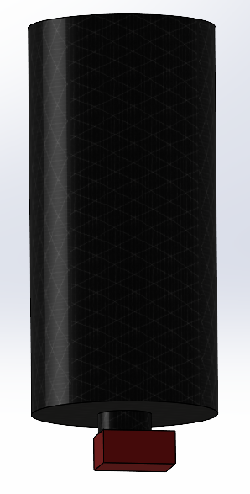 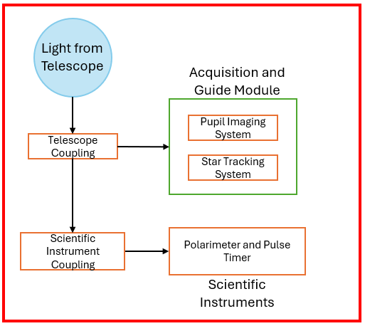

Figure 2.1 - (Left) Illustration of prototype (red) mounted onto a model of the Robinson Observatory telescope (black). (Right) Preliminary layout of individual optical system blocks within the prototype

### 2.3.4 Hardware Features and Specification

The physical structure of this device is separated into three components: power supply unit (PSU), printed circuit board (PCB), and the optics coupling and detection module. Within the power supply unit, we will house a battery which will supply power to printed circuit board and its peripherals. The design must meet our specification of supplementing the module with enough power for at least one hour before shutdown. In cases in which the module is low on battery, we will also include a 120V AC adapter within our design to charge the module. The module is intended to operate with the power from the adapter but can be disconnected if desired.

The printed circuit board will consist of the following components: Controls for adjusting sampling rate and start/stop of data collection. A separate potentiometer control for the half wave plate oscillation frequency will also be included allowing for the user to adjust the quality of the collected signal. MCU must have an ADC module which can sample at a rate of 1MSPS for our desired resolution. A Control board will host the necessary peripherals such as: buttons, knobs, and LCD needed for the previously mentioned functionalities. These control features will help us to collect an accurate sampling of data and allow for resolution adjustment if needed. We will have four distinct plane wave detectors in the optics module which would require approximately 780KB of data for all sensors to read for 50ms. The PCB will contain on-board memory storage of 4GB which will allow for approx. 5377.3, 50ms samples before needing to be cleared. A USB 3.0 port will be installed for first programing the MCU for proper functionality, and secondly allowing for data collection from an outside computer. The MCU will have input from the detectors which will be processed by the internal ADC to sample then save the incoming signal from each plane wave detector. Lasty, also in conjunction with the optics section we must include an oscillator which will send a signal to the half wave plate retarder. Our target output for the oscillator is 100 Hz sinewave anywhere from 5V to 25V depending on wave plate selected.

Attaching to the telescope mount itself will be the star tracking equipment, polarimeter and pulse timer, and the necessary coupling optics. Due to the rotation of the Earth, the telescope will need to be constantly adjusted to stay pointing at the target star. We will accomplish this by building a separate optical path from the scientific instruments, where the starlight is instead imaged onto a CCD. The image detected by this CCD will then be sent to the established telescope tracking and control software, which will make all necessary adjustments. This will be sufficient for the telescope to stay on target during our observations. The scientific instrumentation that we will be building is a linear stokes polarimeter that will simultaneously be used to measure pulse timing. This consists of a double wedged Wollaston prism, which will split the incoming light into two pairs of beams, where each pair has orthogonal polarizations. Each path will have its own linear polarizer at a unique angle. By using 0, 45, 90, and 135 angles for the four polarizers, we can determine the signal’s stokes parameters by comparing the intensity readings from each detector. Changes in the total detected intensity will be used to find pulse timing. The variable half-wave plate is continuously cycled to filter out variations in polarization created by the instrumentation itself that would otherwise overwhelm the signal. Coupling optics will be needed to ensure that all light collected by the telescope can be received by the scientific instruments. The telescope in question is a 20” f/8.2 Ritchey-Chretien telescope, and our coupling optics will need to fit this system such that all light enters the system, while also not being overly large to allow extraneous signals in.

Figure 2.2 - Initial Optical Design for Coupling, Imaging, Collimation and Beam Expansion.

Figure 2.3 - Initial Optical Design for the Polarimeter.

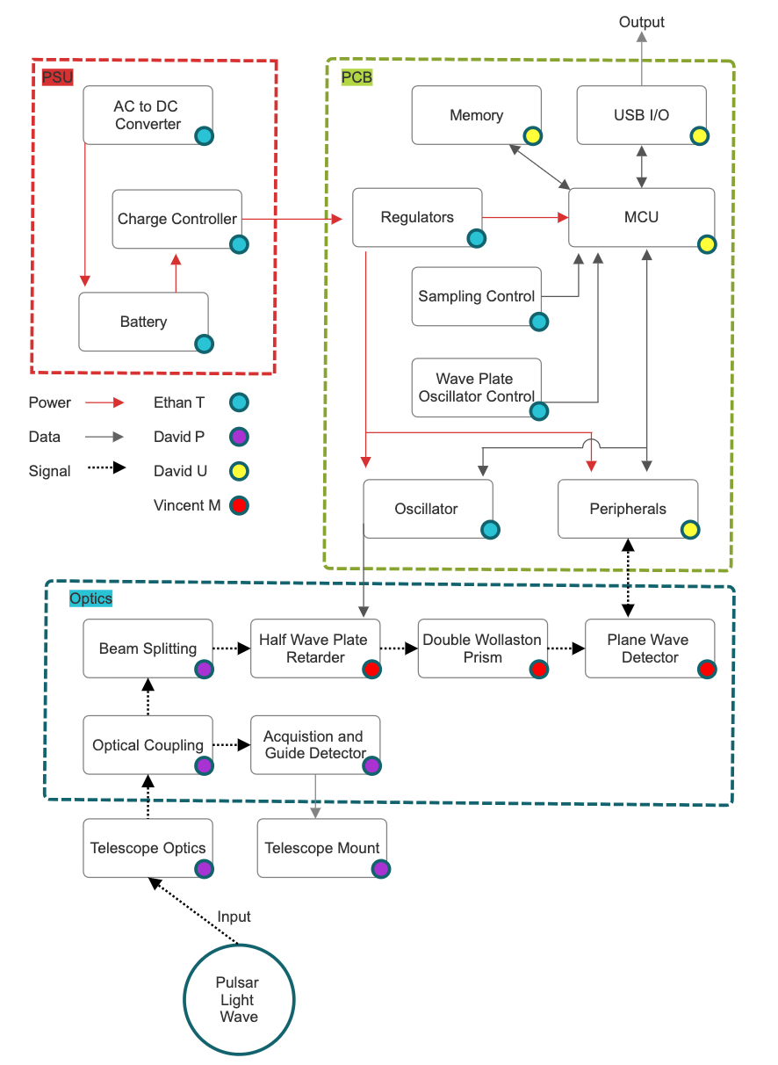

Figure 2.4 - HW diagram, broken down into 3 components: power supply (PSU), PCB, and Optics.

### 2.3.5 Software Features and Specification

On the software side, we will be acquiring the sensor data and processing it. The acquisition will be from 4 detectors, which require conversion from an analog signal to a digital signal. The digital signal can then be stored in a cache until sampling is complete, where it can be formatted and stored more permanently. We plan on formatting the data as a ‘.FITS,’ which stands for Flexible Image Transport System, which is a common file type used by astronomers.

To get the pulse time, we first find the intensity of the light by combining the intensities from two orthogonal detectors, such as the ones at 0° and 90°. This finds the 1st Stokes’ parameter and is used to scale the other parameters. With the intensity, the signal should be oscillating sinusoidally, and so we find the pulse time by measuring the difference between two maxima. The maxima can be found either by enumeration through the data, or by using calculus (derivatives) to find them. The general flow is shown in figure 2.5 (left).

For finding the polarization, we find the other two Stokes’ parameters. The 1st parameter *I* is the intensity and is used to scale the *Q* and *U* parameters. The *Q* parameter is found by taking the difference of the squares between 0° and 90°. To account for unpolarized light, the 3rd parameter *U* is found by taking the difference of squares between 45° and 135°. The general flow chart is shown in figure 2.5 (right) below.

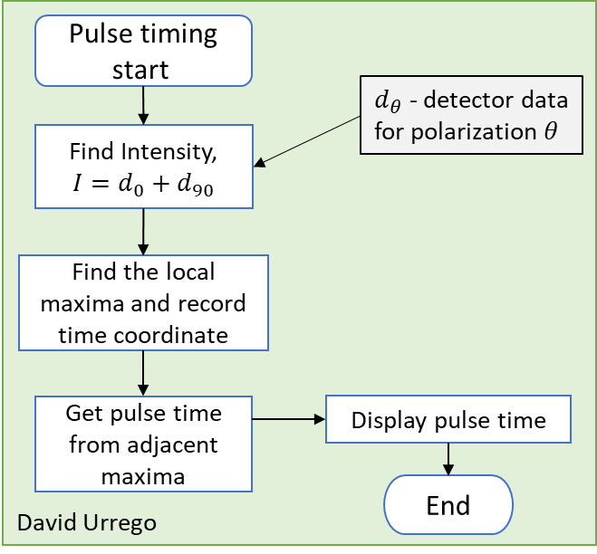 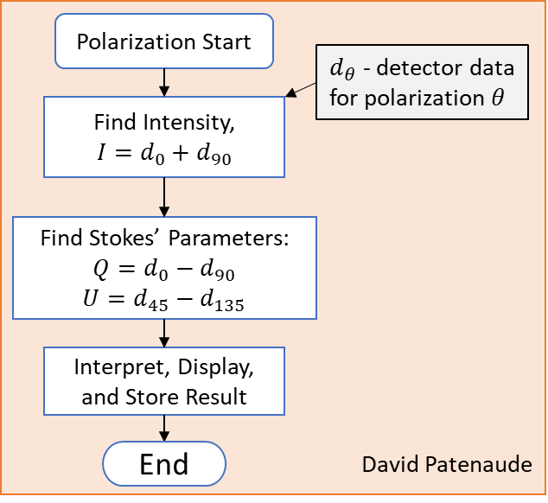

Figure 2.5 – (left) Flowchart for finding pulse time. (right) Flowchart for finding the polarization.

Additional programming of the microcontroller is also required. This is mainly for control flow. The control flow section of the flow chart below shows a design that displays systematic data processing and user interaction. It begins with the user pressing a yes/no button that will trigger a reaction of events, the system’s first response is to catch the voltage level from the potentiometer. Each voltage range will have a respective frequency it corresponds to, a start message will be displayed alongside the frequency on the LCD screen. This way the user is always aware of the system’s status. The system then generates a signal frequency directed at the wave plate which is crucial for data collection and polarization quality. Once the signal is output a 50ms runtime sample is collected. During this period, the system samples and holds buffer data, then saves it to the main memory, efficiently capturing and storing data to maintain integrity and accuracy. From here, the control flow branches into two parallel paths: one where the system ensures sufficient memory space and organization for incoming data through memory allocation, and another where it stops sampling and displays a session termination message on the LCD, informing the user. This structured approach optimizes data handling and memory management while enhancing user experience by providing real-time updates.

In the data management portion of the flowchart, the process begins with memory allocation, a critical step ensuring that sufficient space is set aside for subsequent operations. From memory allocation, the flow branches into two paths. The first path involves assigning address space for detectors 1 through 4, with each detector receiving 1 GB of memory. The second path involves tagging the sampling session, which requires 200 KB of memory. These two branches converge into a single step: USB transfer out. This final step involves transferring the allocated data, both the detector address spaces and the sampling session tag, out via USB. This structured flow ensures efficient memory use and smooth data transfer, keeping the system organized and making it easier to analyze and store data later.

The USB transfer leads to the data processing section of the flowchart. The first block in this section is the software package, which splits into two paths. The first path combines the intensity data from single plane wave detectors with its pair, locates data maxima and timestamps, and then calculates the delta between two maxima to determine pulse time. The second path calculates the Stokes parameters from the plane wave detector and uses these parameters to display a graph along with the corresponding polarization. Both paths converge at the final block, which displays the processed data on the monitor, ensuring comprehensive data processing and visualization.

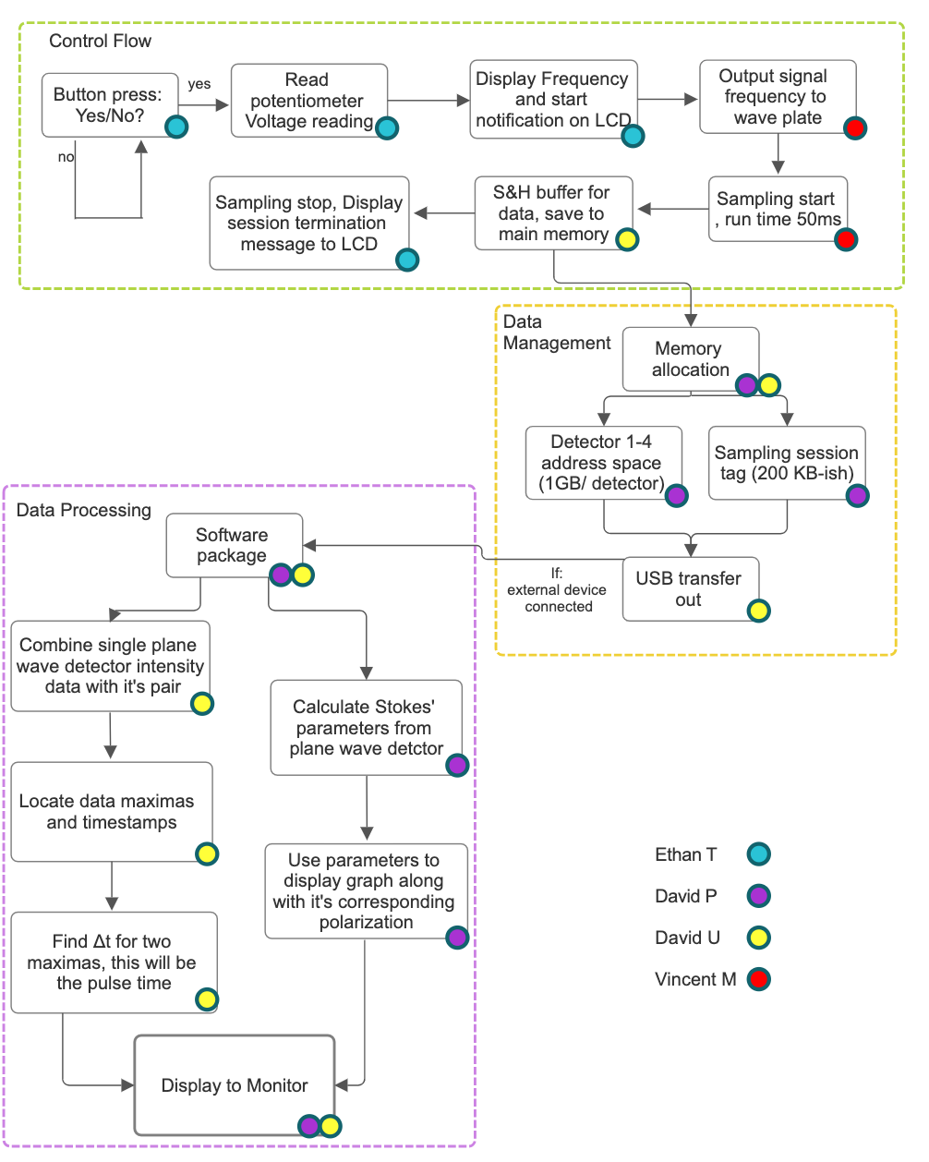

Figure 2.6 - Overall Software flow, including control flow, data management, and data processing.

### 2.3.6 Summary of Features and Objectives

The expected pulses from pulsars will be on the order of 30ms, but in order to see the features of the pulse, we will sample every 1µs. The detectors will therefore have to be fast and sensitive due to the faintness of the incident light. To measure polarization, the design will feature a modulated waveplate and Wollaston prisms to separate the light into 4 beams, which go through a polarizer before the detector. This set up describes a linear Stokes polarimeter. Sampling at a high frequency and oscillating the half-wave plate will eliminate the polarization effects from the telescope system.

To track the pulsar in the night sky, an image is captured and sent to the telescope’s built-in tracking software. The input light is split upon entering the instrument using a beamsplitter, allowing an image to be taken on one path, while the other path continues into the instrument. As an optional feature, we will also save the camera’s image to our internal storage. This makes it more convenient for the astronomer to retrieve the image for viewing.

Some other features we will implement are the ability to adjust the sampling frequency and the sample duration. By default, we will design for a 1MHz sampling rate, and 50ms duration. We will allow the sampling rate to increase to 2MHz and decrease to 100kHz while allowing the sample duration to increase to 1s and decrease to 25ms. The sampling rate will dictate how fast of an analog-to-digital converter we will need. The sample duration dictates how much storage is needed, although this isn’t a huge issue as memory chips are cheap. The main issue is ensuring that the memory is fast enough to not bottleneck the data acquisition. This feature will be implemented by adding some buttons or dials with a basic LCD character display, which allows direct control on the actual instrument. We may also consider making it software controlled via a program on a plugged-in computer. This gives more choice to the astronomer for how much continuous data they may want.

We also want to ensure minimal optical power loss from reflections and absorption when the light is coupled and manipulated by the instrument. This is an important consideration given the low incident light intensity from astronomical sources. This can be accomplished by minimizing the amount of glass material that the light must travel through, such as lenses and beamsplitters. When a lens is used, an anti-reflective (AR) coating can be used to virtually eliminate Fresnel reflection losses. To ensure minimal losses, the optical power loss will be calculated for the optical design to ensure that sufficient power reaches the detectors.

## 2.4 Required Specifications

On account of the previous objectives and constraints, Table 2.1 provides the functional specifications.

|  |  |  |
| --- | --- | --- |
| Table 2.1 – Specifications for Design | | |
| Description | Specification | Justification |
| 1. Polarization Measurement Accuracy | 0.1% | Customer specified minimum polarization accuracy & mitigate telescope effects on polarization |
| 1. Sample Rate, ADC Module | 1 MHz, 1 MSPS | Enables us to detect signals at 1µs temporal resolution |
| 1. Sample Duration/Time | 50ms | Allows for capture of full pulsar pulse |
| 1. Optical Power Sensitivity | 10fW | The signals we intend to measure are weak |
| 1. On-board memory | 4GB | Allows for storing significant amounts of data |
| 1. Instrument Size | 6”x9”x11” | Instrumentation must fit onto the available telescope slot. |
| 1. Half Wave Plate Retarder Oscillation | 0 –100 Hz | Determines quality of input signal |
| 1. Internal Data rate capacity | At least 16 MB/s | Sampling at 1µs for 4 sensors generates close to 16MB/s |

## 2.5 House of Quality

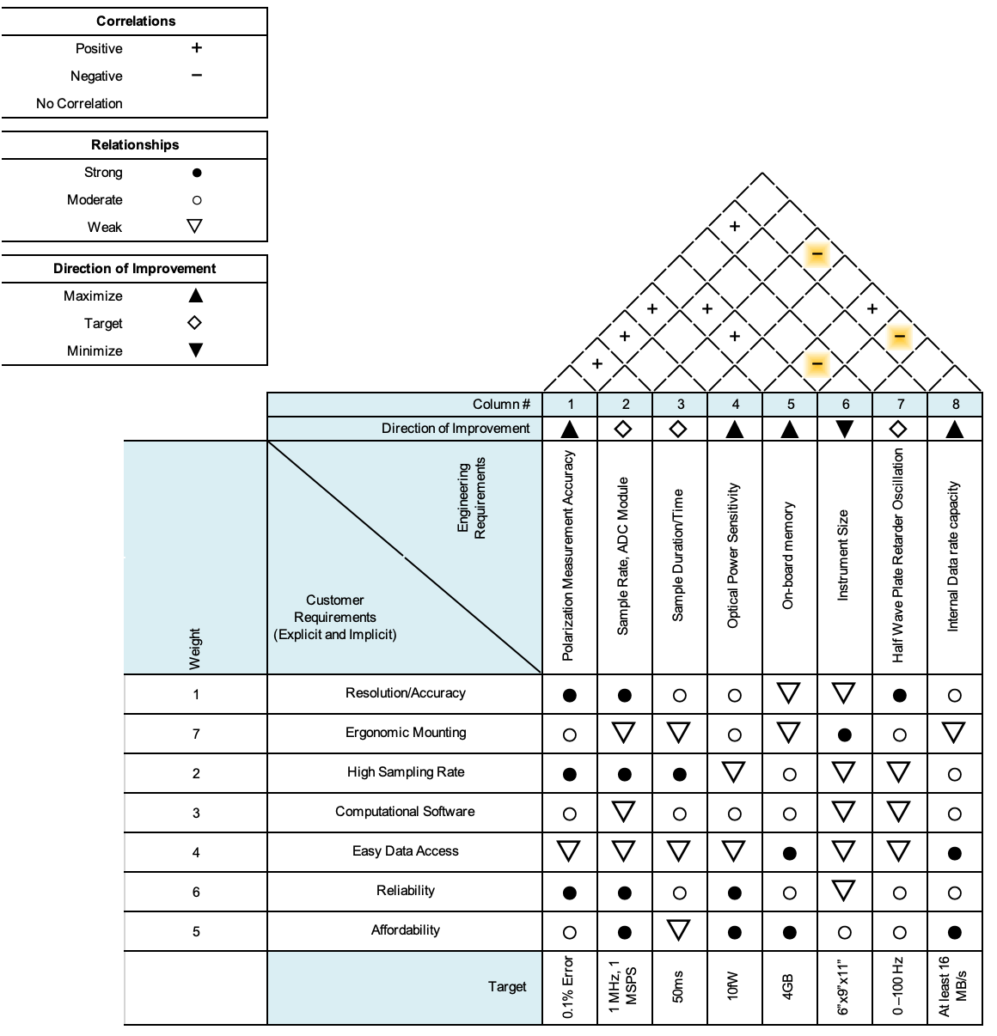

Figure 2.7 - House of quality, showing customer requirements and engineering specifications.

# Research and Investigation*

In this chapter, we report the findings of our research on the different technologies that we can use for completing our project. We then discuss products that we will use for the project.

## 3.1 FPGA vs. MCU

We begin by looking at the difference between a Field-Programmable Gate Array (FPGA) versus a Microcontroller (MCU). These are the two main technologies that can be used for embedded systems. Each has its own strengths and weaknesses. Deciding whether to use an FPGA or an MCU for a project like the Crab Pulsar Polarimeter and Pulse Timer involves looking at factors like performance, flexibility, power use, cost, and how hard they are to develop with.

Field-Programmable Gate Arrays (FPGAs) are semiconductor devices that have a bunch of programmable logic blocks connected through programmable links. Unlike fixed-function chips, FPGAs can be reconfigured after they are made, allowing designers to create custom hardware functions. FPGAs are great for performance because they can do many things at once, making them highly efficient for tasks that can be done in parallel. This is particularly useful for real-time signal processing where multiple operations need to happen at the same time. Additionally, FPGAs are very flexible because their hardware functions can be updated or changed without altering the physical device, which is helpful during development and testing. FPGAs can integrate custom peripherals tailored to specific application needs, allowing for highly specialized hardware setups. Moreover, because of their parallel architecture, FPGAs offer low latency for certain types of computations, which is important in real-time applications.

However, FPGAs have some downsides. Designing for FPGAs requires knowledge of hardware description languages (HDLs) like VHDL or Verilog, which can increase development time and costs due to the complexity of hardware design. FPGAs generally use more power compared to MCUs, which can be a problem in battery-operated applications. The initial cost of FPGAs and their development tools can be higher than those for MCUs, making them less attractive for budget-sensitive projects. Additionally, the design cycle for FPGAs can be longer because of the complexity of hardware design and the need for thorough testing and validation.

On the other hand, Microcontrollers (MCUs) are integrated circuits designed to perform specific control functions. They typically consist of a processor core, memory, and peripherals all in one chip. MCUs are widely used in embedded systems for their simplicity and cost-effectiveness. MCUs are easier to program and use compared to FPGAs, as they often use high-level programming languages like C or C++, which are more accessible to a broader range of developers. MCUs are designed to be power-efficient, making them ideal for battery-powered applications where energy use is a key factor. They are generally less expensive than FPGAs, both in terms of the initial hardware cost and the development tools required. MCUs come with a variety of built-in peripherals such as ADCs, DACs, timers, and communication interfaces, which simplify the design process. The development cycle for MCUs is typically shorter due to their simpler architecture and the availability of extensive libraries and development tools.

However, MCUs also have their limitations. They operate sequentially and may not handle tasks that need to be done in parallel as efficiently as FPGAs, which can be a drawback in applications requiring high-speed processing. Unlike FPGAs, MCUs have fixed hardware functionality, which means they cannot be reconfigured to change their fundamental hardware architecture. MCUs may have higher latency for certain types of operations due to their sequential processing nature, which can be a limitation in real-time applications requiring rapid response times. Additionally, while MCUs have a range of built-in peripherals, they lack the ability to implement completely custom hardware configurations as FPGAs do.

Given the specific needs of the Crab Pulsar Polarimeter and Pulse Timer project, we have decided to use an MCU for several reasons. The polarimeter is intended to operate for extended periods, potentially in remote locations where battery life is crucial. The lower power consumption of MCUs makes them ideal for such applications, ensuring longer operational times without frequent recharging or battery replacements. Budget constraints are always a factor in project development, and MCUs offer a cost-effective solution without compromising the necessary performance for our application. The lower initial cost and affordable development tools make MCUs a practical choice.

Utilizing an MCU allows the team to leverage existing skills and resources, reducing the learning curve associated with FPGA development. This leads to a shorter development cycle and faster time to completion, test, and prototype. MCUs come with built-in peripherals such as ADCs for signal conversion, timers for precise event handling, and communication interfaces for data transfer. These features align well with the requirements of our polarimeter, simplifying the hardware design and integration process. While FPGAs offer superior parallel processing capabilities, the performance of modern MCUs is sufficient for our data processing needs. By carefully optimizing the code and leveraging the MCU’s capabilities, we can achieve the required real-time data acquisition and processing.

In practical terms, the Crab Pulsar Polarimeter and Pulse Timer require precise, real-time data processing capabilities to measure the polarization and pulse timing of light from the Crab Pulsar. The instrument needs to handle high-frequency data sampling and processing while maintaining low power consumption for extended use. MCUs are particularly well-suited for this task because they can efficiently manage the high-frequency data sampling needed to capture the pulsar's light variations. With integrated peripherals, MCUs can directly interface with sensors and other components, streamlining the data acquisition and processing pipeline.

Moreover, the cost-effectiveness of MCUs is a significant advantage. Given that our project operates under budget constraints, the lower cost of MCUs compared to FPGAs allows us to allocate resources to other critical areas of the project, such as high-quality sensors and optics. This financial flexibility can enhance the overall performance and accuracy of our instrument. The lower initial investment in MCU hardware and development tools is also beneficial, enabling us to quickly prototype and test our designs without incurring prohibitive costs.

Another critical factor is the development simplicity offered by MCUs. Our team’s proficiency in high-level programming languages like C and C++ aligns perfectly with the development environment for MCUs. This alignment reduces the time and effort required to develop and debug the software, allowing us to focus more on optimizing performance and ensuring the robustness of our system. The availability of extensive libraries and community support for MCUs further accelerates the development process, providing access to pre-built functions and solutions that can be integrated into our project.

The built-in peripherals of MCUs play a crucial role in simplifying our design. For instance, the ADCs in MCUs allow us to convert the analog signals from our detectors into digital data for processing. Timers can be used to precisely control the sampling intervals, ensuring accurate time measurements of the pulsar’s pulses. Communication interfaces like UART, SPI, or I2C facilitate data transfer between different components of our system and external devices, such as a computer for data logging and analysis. These integrated peripherals eliminate the need for additional external components, reducing complexity and potential points of failure.

While FPGAs offer unparalleled performance for parallel processing tasks, the nature of our project does not demand such capabilities. The real-time data processing requirements can be effectively met by modern MCUs, especially when the software is carefully optimized to leverage the available processing power. By focusing on efficient code design and leveraging the MCU’s features, we can achieve the necessary performance without the added complexity and cost of FPGA development.

In conclusion, while both FPGAs and MCUs offer distinct advantages, the specific needs of the Crab Pulsar Polarimeter and Pulse Timer project make an MCU the more suitable choice. The MCU's power efficiency, cost-effectiveness, development simplicity, and integrated peripherals align well with our project requirements, ensuring a practical and efficient solution. By selecting an MCU, we can achieve our goals of precise polarization and pulse timing measurements while maintaining the flexibility and efficiency needed for extended use in an astronomical research setting. This choice allows us to deliver a high-quality instrument that meets our objectives while adhering to budget constraints and leveraging our team’s strengths in software development.

3.1.1 MCU Part Comparison

For our Crab Pulsar Polarimeter and Pulse Timer project, we need a microcontroller that can handle an ADC sample rate of 1MSPS, manage control inputs from potentiometers, buttons, and switches, support flash memory, and interface with USB for data transfer, all while being compatible with a 32 kHz crystal. Here we evaluate four microcontroller boards, each with different capabilities and limitations.

3.1.1.1 MSP430F6989

The **MSP430F6989** is a low-power microcontroller designed by Texas Instruments. It is known for its energy efficiency and is often used in battery-powered applications. It features a 12-bit ADC with 16 channels and a maximum sampling rate of 200 kSPS, which is significantly lower than the required 1MSPS. The MSP430F6989 runs at up to 16 MHz and offers 128 KB of flash memory and 2 KB of SRAM. Although it supports a 32 kHz crystal for precise timing and low-power modes, it lacks native USB connectivity and would require an external USB interface. While it has adequate GPIO pins for handling control inputs, the limited ADC sample rate is a drawback. However, we plan to use a separate ADC module to achieve the required sample rate. Additionally, the familiarity we have with this board is a significant advantage, simplifying development and debugging.

3.1.1.2 Arduino Nano

The **Arduino Nano**, based on the ATmega328P, is a popular compact microcontroller board commonly used in educational and DIY projects. It has a 10-bit ADC with 8 channels, operating at a clock speed of 16 MHz. The Arduino Nano provides 32 KB of flash memory, 2 KB of SRAM, and 1 KB of EEPROM. It relies on a USB-to-serial converter for USB connectivity and supports a 16 MHz crystal with an optional 32 kHz crystal. Despite its ease of use and sufficient GPIO pins for control inputs, the Arduino Nano does not meet the 1MSPS ADC requirement, lacks native USB connectivity, and has limited flash memory for extensive data logging.

3.1.1.3 ESP8266

The **ESP8266** is a low-cost Wi-Fi microcontroller known for its built-in wireless connectivity and versatility. It features a 10-bit ADC with only one channel and operates at clock speeds of 80 MHz or 160 MHz. The ESP8266 typically comes with 512 KB to 4 MB of flash memory and 80 KB of SRAM, with EEPROM emulated in flash. Although it provides good processing power for various tasks, it lacks native USB connectivity, requiring an external USB-to-serial converter, and does not natively support a 32 kHz crystal. The ADC capabilities and flash memory are insufficient for our project’s data logging needs.

3.1.1.4 PIC16F877A

The **PIC16F877A** from Microchip is a versatile microcontroller often used in embedded systems. It features a 10-bit ADC with 8 channels and runs at a clock speed of 20 MHz. The PIC16F877A has 14 KB of flash memory, 368 Bytes of SRAM, and 256 Bytes of EEPROM. It does not have native USB connectivity and supports crystals up to 20 MHz but not specifically a 32 kHz crystal. While it can handle control inputs from potentiometers, buttons, and switches, its ADC sample rate and resolution do not meet the 1MSPS requirement, and the limited flash memory and lack of USB support are significant limitations.

3.1.2 Summary

In conclusion, each microcontroller board presents a mix of advantages and limitations relative to the project requirements. The MSP430F6989 stands out for its low power consumption and adequate control input handling but requires external components to meet the high-speed ADC and USB connectivity requirements. The Arduino Nano is user-friendly but lacks sufficient ADC performance and native USB. The ESP8266 offers excellent wireless capabilities but has inadequate ADC and flash memory and lacks 32 kHz crystal support. The PIC16F877A is versatile for basic tasks but fails in ADC performance, memory capacity, USB connectivity, and crystal support. Despite the MSP430F6989's limited ADC sample rate, using a separate ADC module will address this issue, and our familiarity with this board provides a significant advantage in terms of development and debugging, making it a strong contender for our project.

## 3.2 Beamsplitter Technologies

Here we look at the different ways in which a beam can be split onto multiple paths. Some preliminary options are block beamsplitters, plate beamsplitters, and lithographic mirrors. Of these types of splitters, they can be either polarizing or non-polarizing, meaning they can split the light based on polarization state or not. First, we will look at plate beamsplitters.

### 3.2.1 Plate Beamsplitters

A plate beamsplitter is a piece of flat glass that has a special dielectric coating on it that reflects some fraction of the incident light. The exact ratio of reflected to transmitted (R/T) light can be designed through the design of the coating. Typically, these beamsplitters are used at a 45° angle of incidence (AOI) to give a 90° difference in the output optical paths. When the transmitted light goes through the glass, the light will refract and end up shifted or offset from the incident light [4]. Since the glass will have two boundaries with air, Fresnel reflections will occur on the back surface create a ‘ghosting’ effect. This effect diminishes the efficiency. To eliminate this effect, an anti-reflective (AR) coating may be applied to the back side of the beamsplitter, which will increase the efficiency of the beam splitter [4]. Another means of eliminating the ghosting is to use a 30 arcmin wedge, or some combination of the two [5]. The wedge makes it so that any amount that is reflected will diverge away.

While plate beamsplitters can be made for both polarizing and non-polarizing applications, the dependence on angle of incidence for polarized light makes it so that the reflection or transmission differs between *s*-polarized and *p*-polarized light [6]. The Fresnel reflection equations describe this effect, and it is plotted in figure 3.2 for uncoated N-BK7 glass (*n*=1.5168). Therefore, a non-polarizing plate beamsplitter will end up reflecting different intensities of parallel and perpendicular components of the incident light’s polarization. This is seen in some of the product datasheets from the different Thorlabs products.

From Thorlabs, they have 10:90 (R:T) plate beamsplitters with an AR coating for 400-700nm (visible light) operation. They have a couple of different sizes available, including a rectangular plate. Part number **BSN04** has a half-inch diameter and 3mm thickness. It also features the 30 arcmin wedge to further reduce the ghosting effect. The difference in transmitted and reflected *p*-polarized and *s*-polarized light is <35% [5]. The BSN products all share the transmission profile shown in figure 3.1 below, which shows how they differ. These are the specs that help populate the comparison table.

Figure 3.1 - Plot of transmission for a 10:90 plate beamsplitter, showing both the p- and s-polarized light. Taken from Thorlabs product website for BSN splitters: [www.thorlabs.com/newgrouppage9.cfm?objectgroup_id=4807](http://www.thorlabs.com/newgrouppage9.cfm?objectgroup_id=4807)

Figure 3.2 - Plot of Fresnel reflection/transmission of parallel (p) and perpendicular (s) polarized light for n=1.5168. This is for uncoated glass and is provided as an illustration of how the reflections of orthogonal polarizations differ with angle of incidence.

### 3.2.2 Cube Beamsplitters

Now we look at cube beamsplitters, which are two 90° prisms cemented together with a coating along the prisms’ hypotenuse. These are designed for a 0° AOI, and typically have AR coatings to prevent reflection losses. Since a 0° AOI is used, the polarizations do not deviate from each other very much, as shown in figure 3.3. Furthermore, the transmitted beam is not displaced from the incident beam as much as the plate beamsplitter deviates them [5] [6].

Cube beamsplitters are susceptible to high optical power (such as a pulsed laser) when cemented together, but optical contacting allows for the higher power [5]. In our use case, high power won’t be an issue, as we are dealing with faint incoherent light from a star.

Figure 3.3 - Reflection and Transmission of a beamsplitter cube. Retrieved from Thorlabs product page: [www.thorlabs.com/newgrouppage9.cfm?objectgroup_id=754](http://www.thorlabs.com/newgrouppage9.cfm?objectgroup_id=754)

Reflected and transmitted beam deviation is listed as ±5 arcmin, which is better than the displacement of a plate beamsplitter. The overall power transmitted and reflected is >85%, but the difference in *p*- and *s*-polarized light transmitted or reflected is <10% [5]. We visually see this difference is minimal from figure 3.3 above.

### 3.2.3 Pellicle Beamsplitters

Pellicle beamsplitters are made from a nitrocellulose membrane stretched to be only a few microns thick. This effectively eliminates the ghosting problem of plate beamsplitters. The downside is that the membrane is delicate and flammable, and therefore is only suitable for low-power applications [5].

The thin film nature of the nitrocellulose material makes it so that the transmission and reflection oscillate from multiple-beam interference. The classic example of this is a Fabry-Perot Etalon which uses the same mechanisms as that of a laser cavity. In all of these cases there is a 100% transmission (0% reflection) resonance at certain frequencies of light, which repeats based on the free-spectral range (FSR). Since we are operating over the visible spectrum (400-700nm), these variances would unevenly transmit/reflect the different wavelengths.

### 3.2.4 Lithographic Mirror

The lithographic mirror is a mirror with a very precise ~50µm ellipse in the center of it. The ellipse is made through a photolithographic process, where the ellipse is etched through a chemical process. Based on where the light hits the ellipse, some will be transmitted, while the rest is reflected. This would allow it to act as a beamsplitter with a variable R/T ratio based on alignment.

(to be expanded)

### 3.2.5 Comparisons between Beamsplitter types

Below is a table (3.4) that compares the different beamsplitter types mentioned in the previous sections. The data is taken from general product families for 10:90 beamsplitters. ChatGPT was used to start the research and included a pro/con of some of these different types [GPTA]. Its response is detailed in Appendix C for [GPTA].

|  |  |  |  |  |
| --- | --- | --- | --- | --- |
| Table 3.4 – Comparison of Beamsplitter Types | | | | |
| Specification | **Type of Beamsplitter** | | | |
| Plate | Cube | Pellicle | Lithographic Mirror |
| AOI | 45° | 0° | 45° | 45° |
| Relative Size | Compact | Bigger | Compact | Compact |
| Performance | <1% Power loss | <15% loss! | Variable | ? |
| Polarization Performance | No more than 35% R or T difference | <10% difference | Variable | ? |
| Beam Displacement | Yes | No | Minimal | No |
| Durability | Normal | Robust | Fragile | Normal |
| Cost | $100-200 | $175-250 | $100-150 | ? |

Of the specs compared, the polarization performance one of high importance since we will be measuring the polarization. If the beamsplitter affects the polarization too much, then the polarimeter will not accurately reflect the polarization of the pulsar’s light. Although any deviation could be accounted for in the data processing, minimizing the deviation of the polarizations would be ideal. In this case, a cube non-polarizing beamsplitter accomplishes this, at the downside of losing at most 15% of the total power. While this is concerning for a low light application, by minimizing losses elsewhere, and using sensitive detectors, it should still accomplish what we desire.

### 3.2.6 Beamsplitter Product Comparisons à move to product comps.

We now look at some of the specific products available for purchase that can be used for beamsplitting. We are mainly looking for a 10/90 beamsplitter, as we want most of the light to go to the polarimeter instrumentation.

|  |  |  |  |
| --- | --- | --- | --- |
| Table 3.5 – Comparison of Beamsplitter Products | | | |
| Specification | **BS025 ­– Cube B.S.** | **BSN10 -­­ Plate B.S.** |  |
| R/T ratio | 10:90 | 10:90 |  |
| Size | 1” (25.4mm) side length | Ø1" |  |
| Thickness (useful?) | 1” | 5mm |  |
| AOI | 0° | 45° |  |
| Performance |  |  |  |
| Polarization Performance |  |  |  |
| Power Loss |  |  |  |
| Durability |  |  |  |
| Cost | $205.50 | $140.17 |  |

## 3.3 Switchable Mirrors

As part of the exit pupil imaging system, there are two paths that the light can take, the alignment path for pupil imaging, and the default path for taking an image for tracking. To toggle the optional path a form of switchable mirror is required. Our options are to find a mirror that has a togglable reflective coating, or to mechanically move the mirror with a stepper motor (or something similar).

### 3.3.1 Transreflective Mirrors

Transreflective mirrors are mirrors that can toggle their reflectivity based on an electrical signal. These mirrors utilize thin film solid-state devices, allowing them to toggle their reflectivity. One product from Kent Optronics has >87% reflectance in the mirror state, and with an AR coating, 95% transmittance in the clear state [7]. The mirror works well in the visible light spectrum (400-700nm), which is what we are dealing with for this project.

### 3.3.2 Motorized Mirrors

A mirror that has a motorized mount typically allows for the angle of the mirror to be adjusted. These adjustments allow for a few degrees of rotation, with very high precision. Such mounts are expensive and are better used for beam-steering applications. However, there are motorized flip mounts that flip a mounted optical component from a 0° state to a 90° state. This would suit our needs to allow for two optical paths, one path where a mirror redirects the light by 90°, and the other path where the light continues unabated. Again, these come at a premium. Fortunately, they do make unmotorized mounts at a much-reduced cost [8].

Using an unmotorized mount comes with the downside that a mechanical means of flipping them must be devised. A simple lever-based approach may be a possible design. Alternatively, we can make a 3D printed mount and use a stepper motor to move the mirror into or out of the optical path.

D

### 3.3.3 Comparisons of Switchable Mirrors

Since this part of the design is not as critical as other parts, we want to minimize the costs of getting switchable mirrors. As such, our main criteria is cost.

### 3.3.4 Product Comparisons of Switchable Mirrors

## 3.4 Battery Technologies

### 3.4.1 Lithium-ion (Li-ion)

Lithium Battery technology is widely used in many electronic products, especially applications which require stable voltages and reliable lifespan. Li-ion batteries are materials like LiCoO2, LiMn2O4, LiFePO4, NMC, or NCA in the cathode, and silicon, graphite, or lithium titrate for the anode. Furthermore, the current collectors in the cathode and anode are aluminum and copper, respectively. These batteries use lithium salt as an electrolyte between the cathode and anode. Lasty, Li-ion batteries require a separator material typically a thickness of 20 μm and contain tiny pores that allow the ions to pass through during charging and discharging processes. The most common separator is called a “shutdown” separator and allows for the pores to seal shut if the battery wanders outside of the operating temperature or in the event of a short, effectively preventing damage [9]. Additives are often added to these batteries to prevent malfunction, deuteriation, or increase performance of the battery itself. These additives may include fire retardant, SEI-forming (Solid Electrolyte Interphase), and stabilizing chemicals. Overall, Li-ion batteries offer a high energy capability within a small footprint, are great for maintaining stable voltages which are essential for keeping sensitive components stable, and lastly Li-ion batteries have an excellent charge retention capacity ensuring a long lifespan of charge.

### 3.4.2 Lithium Polymer (Li-Po)

Lithium polymer batteries are a subcategory of lithium-ion batteries that offer many advantages over a typical Li-ion cell. Li-Po batteries are assembled virtually the same as Li-ion. However, rather than a liquid electrolyte a Li-Po battery utilizes a solid or gel polymer as the electrolyte component of the battery. To create these types of electrolyte materials, lithium salts are dissolved into high molecular density polymer host materials, resulting in the final product becoming a dual ionic conductor. These batteries however are susceptible to faster degradation due to a concentration polarization formed by movement of anions and cations [10]. Li-po Batteries allow for a thinner and more compact footprint on devices making this battery a great choice in many microelectronics and portable devices. Along with a decreased size, many Li-Po batteries can be manufactured n many shapes also allowing for more ergonomic use in products. The main disadvantages with Li-Po batteries are that the cost of manufacturing is more expensive as compared to a typical Li-ion battery. When compared to a liquid electrolyte lithium battery, Li-Po's performance is largely failing when it comes to charge density and cycle number. Overall, Li-Po although very versatile for small devices, really does not meet any standard we need with our project [11].

### 3.4.3 Nickel-Metal Hydride (NiMH)

Nickel Metal Hydride batteries are a precursor battery technology compared to lithium-ion batteries and have been in use since the early 1970s. Typical NiMH batteries are made using a metal hydride anode, a KOH electrolyte, and a separator material like a Li-ion. NiMH batteries offer great energy density and specific energy outputs as compared to NiCd batteries [12]; however, it is important to note the energy density of a Li-ion battery is greater than a NIMH cell. Furthermore, NiMH batteries often cost almost half the price to manufacture over Li-ion batteries [13]. In addition, NiMH batteries have been shown to allow for hundreds of reuse and recharge cycles which makes it a very reliable source of power. Lastly, NiHM batteries are susceptible to many operating malfunctions at low temperature [12] [1st link]. Overall, NiMH batteries may suffice our project requirements in terms of cost; however, we might want a battery in which as greater energy density for a longer cycle life.

### 3.4.4 Nickel-Cadmium (NiCd)

Similar in composition to NiMH batteries, NiCd batteries are composed of a nickel cathode and a cadmium anode, in which the cadmium electrode has a higher charge capacity. NiCd batteries are great in performance when it comes to durability, lifespan, charge retention, and flat discharge rate. However, these forms of batteries are expensive to manufacture and if the battery is disposed of improperly it can lead to extreme environmental damage. This is due to the properties of cadmium which is a highly toxic metal and can cause many issues [12] [last prgph 1st link]. In summary, for our project there is no real use to having this form of battery technology, heavily considering

### Summary

After researching and reviewing many battery technologies, Li-ion batteries seem to fit the best with our project’s application. This battery technology will ensure a steady and stable power supply that can be recharged and maintained effectively. In addition, Li-ion battery cost is inexpensive, and these batteries are offered in various energy and power specifications which meet our design criteria.

|  |  |  |
| --- | --- | --- |
| Battery Technology | Pros | Cons |
| Li-Ion | * High Energy Density * Robust component | * Lower voltage output when load draws high current |
| Li-Po | * Available in higher voltages than Li-ion * Low discharge temperature * Can be manufactured in many footprints | * If damaged is susceptible to thermal runaway |
| NiMH | * Low manufacture cost |  |
| NiCd | * Flat discharge rate | * Manufactured with highly toxic materials |

## 3.5 Polarimeter Technologies

Polarimeters are devices used in determining the polarization state of incident light beams. Measuring the polarization of light is crucial for many fields of optics far beyond the focus of this product. This interest means that the problem of measuring polarization has a wide variety of solutions.

### 3.5.1 The Simplest Polarimeter

Since a polarimeter is simply any device that can measure the polarization of light, there are a large variety of devices and techniques that can all be considered polarimeters. The simplest such device is a rotating, or otherwise variable, polarizer placed between a light source and a detector. Since the output optical power through a polarizer is dependent on the incident light’s polarization angle relative to the polarizer’s, rotating the polarizer will produce an easily detectable change in measured intensity. Output intensity can then be considered with respect to the known polarizer angle to determine the original polarization of the light.

This design benefits from having a very high theoretical maximum resolution. Polarization resolution is limited by the resolution of the detector and the precision to which the polarizer angle is known, both of which are dependent on the chosen equipment and could theoretically be very high. Additionally, this would also work for very weak signals, as a detector with high sensitivity could be used without issue.

This configuration would not be viable for use with a light source variable in intensity and polarization. Changes in optical power could not be attributed solely to rotating the polarizer. For the Crab Pulsar, a source whose intensity and polarization are constantly changing, this device would not be usable.

### 3.5.2 Integrated Polarimeters

Integrated polarimeter devices operate on similar principles to the polarimeter as discussed. Instead of rotating the polarizer, a rotating wave plate is added to the optical path that constantly modulates the light’s polarization state. Then, a detector records the variations in intensity relative to the wave plate angle to determine polarization state.

This design benefits strongly from its simplicity. On the user’s end, the device needs to be placed to detect signals and then plugged in to function properly. Problematically, this design is not applicable to a wide variety of circumstances. Products such as this come with the requirement that input light must be monochromatic and coherent. Monochromaticity and coherence are useful properties to have in a light source that is being measured, but their presence is rare outside of circumstances specially engineered to produce them. Naturally occurring light sources, such as a star, will be neither monochromatic nor coherent. Monochromaticity could theoretically be achieved by spectral filtering, but doing so would also eliminate most of the signal we are trying to measure.

Similarly, these integrated polarimeters are not designed with low light applications, such as astronomy, in mind. The detectors in these devices will not be sensitive enough to detect weak signals as needed, and since they are built as a singular device the sensitivity cannot be tweaked to fit our needs. Ultimately, an integrated polarimeter would make for a poor choice considering our technical requirements.

### 3.5.3 Stokes Polarimetry

Stokes parameters are a set of values that describe the polarization state of light. They consist of four parameters: I, Q, U, and V. The parameter I represents the total intensity of the light, while Q and U describe the linear polarization. The V parameter represents the circular polarization. Together, these parameters provide a complete description of the light’s polarization state.

The Intensity term I describes the total optical intensity measured by the polarimeter, irrespective of its polarization. This is determined by measuring the intensity of two orthogonal polarization states, then taking the sum. This is generally done with the two orthogonal polarizations being 0° and 90°. This parameter is then normalized to 1, and the other three Stokes Parameters are adjusted accordingly.

The first linear polarization term Q describes the linear polarization, with respect to the vertical and horizontal axes. This is calculated using the difference of the intensities of the 0° and 90° polarization states. As such, it has a possible range of values -1 ≤ Q ≤ 1.

The second linear polarization term U describes the linear polarization as well, but with respect to the ±45° axis. This accounts for ambiguity that may exist in determining the Q parameter. Take unpolarized light for example. The optical power measured coming out of both polarizers would be equal and the Q parameter would then be zero. However, this is the exact same result that you would see if the incident light was instead polarized to 45°. The U parameter solves this issue, since it is measured by taking the difference of intensities for two polarization states oriented at 45° from horizontal. In this case, +45° polarized light would give a U value of 1, while Q would be 0. Unpolarized light would result in both Q and U parameters being 0, removing any ambiguity.

The final parameter V describes the ellipticity. This is the degree to which the light circularly polarized, where values of 1 or -1 correspond to being perfectly left or right-handed circular polarization, with values in between being elliptical.

Alternative formulas for calculating each parameter do exist, however the provided technique is well suited for our polarimeter design as planned.

### 3.5.5 Stokes Polarimeters

A Stokes polarimeter is any device that is used to measure these Stokes parameters. This generally involves measuring the intensity of light after it passes through polarizers oriented at different angles, such as 0°, 45°, 90°, and 135°, although the absolute angles do not matter so much as their values relative to each other.

One specific design involves using a Wedged Double Wollaston Prism to split light into four distinct beams, The Wedged Double Wollaston Prism simply consists of two Wollaston Prisms placed next to each other, where each prism individually split incident light into two orthogonally polarized beams. Each beam path has its own polarizer at a unique angle, and a photodetector. The intensities measured by each of the four detectors are used to calculate the stokes parameters.

A major downside of the Stokes Polarimeter is the associated cost from needing to build four separate optical paths, each with their own set of lenses, polarizers, and detectors. This necessarily increases costs by a factor of four.

### 3.5.6 Polarimeter Comparison and Summary

While it would be ideal from a development perspective to be able to use an existing integrated polarimeter product, this will not be viable. These devices are not built with our relevant specifications in mind, so we cannot use them. Overall, the Stokes Polarimeter is the best option available, as it allows us to measure very faint signals with high accuracy. The variability in sensitivity and accuracy/precision enables us to use our own components as necessary to reach the required targets. The only downsides are its cost and increased design complexity, but these problems can certainly be solved.

|  |  |  |  |
| --- | --- | --- | --- |
| Table 3.5 – Comparison of Polarimeter Types | | | |
| Specification | Type of Polarizer | | |
| **Stokes Polarimeter** | **Simple Polarimeter** | **Integrated Polarimeter** |
| Sensitivity | Variable | Variable | Detector Limited |
| Data Accuracy | Variable | Low | Detector Limited |
| Installation | Requires Construction | Requires Construction | Simple Installation |
| Cost | High | Low | High |

## 3.6 Wollaston Prisms

Wollaston prisms are a type of beamsplitter that split light into the orthogonal components of its polarization, rather than by fractions of intensity. Wollaston prisms have an ordinary an extraordinary axis

## 3.7 Photodetectors

## 3.8 Half Wave Plates

Wave plates are optical devices that can change the polarization state of light. They make use of the fact that orthogonal polarizations have different refractive indices in some materials such as quartz and certain polymers. Wave plates have a fast and a slow axis, where light polarized along the fast axis has a lower refractive index than along the slow axis, slow axis has a higher refractive index. When light propagates through a material with these properties, it introduces a phase delay since light aligned to the slow axis will propagate more slowly. The total phase delay is described by the following equation:

Where d is waveplate thickness, ns and nf are the refractive indices along the slow and fast axes, respectively, and λ is the wavelength. is the total introduced phase delay. In a half wave plate the thickness is engineered such that the phase delay is equal to π/2, which converts incident light to a linearly polarized state along the fast axis.

### Multiple Order Waveplates

A multiple order half waveplate is a waveplate where the phase delay is not exactly equal to π/2, but rather a higher multiple of π/2. Any integer multiple of this phase delay will produce the same effect as any other. The specific value depends on the thickness, and it is significantly easier to manufacture components with larger thicknesses. This means that multiple order waveplates are significantly cheaper and easier to handle than the zero order alternative.

Since refractive index and by extension phase delay are wavelength specific, different wavelengths experience different retardations. The primary downside of multiple order waveplates is that the increased thickness leads to a larger retardation error when used at wavelengths beyond what it is specifically designed around, due to the increased space for error to accumulate. Retardation error is a measure that describes the change in retardation for a shift in wavelength, and should be minimized for a quality waveplate. For the same reasons, multiple order waveplates are more susceptible to temperature dependent retardation error as well.

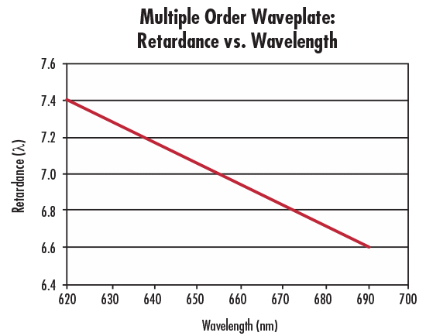  
  
Figure 3.4 - Plot of wave retardance with respect to wavelength for a 7.25λ multiple order waveplate with center wavelength 632nm.

### Zero Order Waveplates

Zero order waveplates are built to have the minimum possible thickness needed to achieve the necessary phase delay. This means that the thickness is such that is exactly equal to π/2 at the center wavelength. Since they are as thin as possible the retardation error at other wavelengths is similarly minimized.

Zero order waveplates are extremely thin, on the order of 25μm, but the exact thickness is dependent on product specifics. As a result, these components are both more difficult to manufacture and handle, which leads to dramatically increased cost. However, they have much better performance over a range with respect to both temperature and wavelength dependent retardation error. This significantly improved performance can justify the added cost in situations where it is needed.

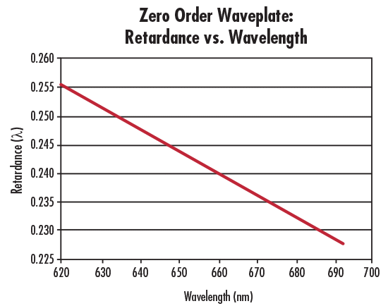

Figure 3.5 - Plot of wave retardance with respect to wavelength for a 0.25λ zero order waveplate with center wavelength 632nm.

### Achromatic and Superachromatic Waveplates

Achromatic waveplates are designed to polarization state of light across a wide range of wavelengths. Unlike traditional waveplates, which are typically effective only at a specific wavelength, achromatic waveplates maintain consistent performance over a broad spectrum, eliminating or otherwise minimizing wavelength dependent retardation error. This is done by layering multiple materials, typically quartz and magnesium fluoride, with distinct birefringent properties such that the error from one material is cancelled out by another’s.

A subtype of this component is the Superachromatic waveplate, which operates on the same basic principles, but is designed to minimize error over an extremely broadband range. superachromats are often designed to maintain precision in both the visible and near infrared spectrum simultaneously.

This makes them particularly useful in applications requiring precise control of polarization across multiple wavelengths. Since our product is meant for use with stars, which are broadband light sources, achromatic waveplates may prove crucial to providing the polarization accuracy we require. The price of achromatic and especially superachromatic waveplates is higher than their non-wavelength corrected counterparts, as achromats are often twice as expensive, and superachromats may more than six times the price.

Figure 3.6 – Plot of wave retardance vs. wavelength for an achromatic and a Superachromatic half waveplate. Sourced from [Mounted Superachromatic Wave Plates (thorlabs.com)](https://www.thorlabs.com/newgrouppage9.cfm?objectgroup_id=2193)

### Waveplate Comparison and Summary

## 3.9 Oscillators

Concerning our design, which includes a half wave plate retarder, we must consider how we will supply the correct signal to the wave plate for the correct switching time. This will ensure a quality signal to the photodetectors. The wave plate requires an oscillating signal for proper functionality, so we must look at what methods can be used to make an oscillator. An oscillator can be thought of as an amplifier in which positive feedback is used to create an output signal with desired frequency without the use of an additional AC input signal. Primarily we will focus on LC and crystal oscillators and discuss which may be better for our application.

### LC Oscillators

This design of an oscillator circuit offers many advantages regarding low cost, compatibility, and power consumption. This device utilizes a DC voltage input and outputs an AC signal that can be tuned to achieve an output with a desired frequency. The oscillation frequency relies on the inductance and capacitance reactance values. The output frequency can be computed by the following equation:

(eq. 3.1)

Although cheap to manufacture and easy to tune the output frequency, LC oscillators are susceptible to output variation across temperature ranges. This effect is primarily caused by the materials that compose the capacitors; inductors are still affected however a capacitor’s value will vary dramatically as temperature sweeps. Furthermore, LC oscillators have a slower start-up response time as compared to a crystal oscillator, this may affect the performance of any components that require the oscillator. The output signal produced by a small DC voltage i.e. 5V, 12V will require an op-amp to produce the necessary amplitude required for the half wave plate to operate. In summary, LC oscillators, although cheap and easily tunable, are most likely not the best option for our application as we want the start-up response to be rapid so that the half wave plate retarder is operating as intended as the sampling begins.

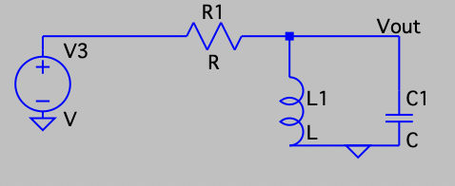

### Crystal Oscillators (Quartz)

Crystal Oscillators, although more expensive to implement, offer great advantages over LC oscillators. Both oscillator's working principles are virtually the same, if you apply a DC voltage input into the crystal device it will output an AC signal. This occurs because of the piezo-electric effect. Due to the material properties, crystals maintain fixed output frequencies. This limitation can be counteracted though frequency division allowing the output signal to be lowered. Typically, crystal oscillators are made with quartz, allowing them to be more robust and stable across various temperatures. Crystals also allow for a fast response time upon start up, making them very good for fast process applications. A popular configuration of the crystal oscillator is to use it in conjunction with an MCU, and used for a clock and will control the flow of instructions processed by the MCU [14]. Overall, a crystal oscillator is going to be a better fit for our design and application. Using this oscillator will ensure that all systems within the module are running swiftly for the sampling process, mainly starting up the half wave plate retarder. We will use a crystal oscillator with the MCU we plan to include on the PCB.

|  |  |  |
| --- | --- | --- |
| **Oscillator**  **Technology** | **Pros** | **Cons** |
| LC | * Tunable frequency * Low cost to manufacture * Simple design scheme * Capable of high frequency outputs * Robust component | * Temperature/Environment sensitive * High phase noise and distortion * Component tolerance may affect output frequency * Slow response time |
| Crystal (Quartz) | * Low Phase noise * Accurate and stable output frequency * Small component footprint * Fast response time | * Higher cost to manufacture * Fragile component * Fixed frequency * Complex design scheme |

## 3.10 Voltage Regulators

Voltage regulators are primarily used within the power supply unit of many electronic devices. This component aids in stabilizing power supplies (e.g. battery cells), preventing unstable voltage levels, and allow for ease of power management across very sophisticated circuits. This component is essential in our design to maintain a stable power delivery across the entire module. The main types of voltage regulators consist of switching, linear, and low dropout regulators.

### Switching Regulators

Switching regulators are a power efficient component which uses a periodic on/off series component to allow for selecting the operating function of the device. This type of regulator can take a wide range of input voltages from 2V minimum to +100V [<https://www.analog.com/en/product-category/switching-regulators.html#:~:text=These%20switching%20voltage%20regulators%20offer,efficiency%20operation%20up%20to%2096%25.>] and either increase or decrease the output voltage and/or alter the phase 180 degrees. The common configurations of this regulator consist of buck, boost, or boost-buck. When used as a buck converter the output is attenuated to a lower voltage than the input. Boost converters are just the opposite where the output voltage is greater than the input. Lastly, while used in a boost-buck configuration the regulator allows for both of previous cases to be selected, this is the most complex design for a switching regulator￼￼. Switching regulators tend to be offered in small package sizes allowing for a more condensed footprint on a PCB. Disadvantages of this type of regulator include having a significant addition of noise to the output signal. In addition, switching regulators tend to be more expensive than a linear regulator; this is due to the component’s design complexity.

### Linear Regulators

Linear regulators operate differently than switching regulators in that the device's internal resistance alters depending on the load connected to the output. Within this device there is no internal mechanism to control between fully conducting and off. Linear regulators take an input voltage which needs to be adjusted to be larger than the desired output signal. The output to input voltage ratio is extremely minute making a linear regulator a great option for reducing Electromagnetic Interference (EMI) in a regulator scheme. This characteristic is great for powering devices with low power consumption and allows the system to operate effectively [16]. The main disadvantage of this type of regulator is that whatever power has been lost between the input and output is given off in the form of heat dissipation which may cause complication to the integrity of the PCB and the components around it.

### Low Dropout Regulators

Low dropout regulators operate under very similar conditions to a linear regulator but differ by attempting to compensate for the output to input voltage loss. Typically, a linear regulator can have a 1 to 2 V drop between input and output. Whilst LDO regulators try to have only a drop of about a volt. For example, if a power supply was at 2.7 V the regulator could still manage to supply 2.5 V to the load [17]. Often LDO is used within many portable devices to ensure effective power distribution and management. Lastly, it is important to note that the better quality of output to input loss increases the price of this regulator device.

|  |  |  |
| --- | --- | --- |
| Voltage Regular Technology | Pros | Cons |
| Switching Regulator | * Configuration allows for Buck, Boost, or Buck-Boost * Wider range of input voltages (2V to +100V) | * Susceptible to high EMI from input to output * Complex design scheme * High power loss |
| Linear Regulator | * Low EMI from input to output * Simple design scheme * Medium-low power loss | * Configuration only Bucks |
| Low Dropout Regulator (LDO) | * Reduced power loss * Reduced dropout voltage | * More costly to manufacture over a typical linear regulator |

## Op-Amp

High gain bandwidth op-amps

Supply voltage and output swing

High PSSR and CMRR

Noise performance

Total Harmonic Distortion (THD)

## 3.11 Lens Material

In this section we look at some of the common glasses used to make lenses. Since the lens material is the medium in which light will travel in, it is important to pick a good material with low absorption and dispersion. Refractive index changes with wavelength, and so for light with multiple wavelengths (like white light), the different wavelengths will experience different light bending. This effect is called dispersion. Glass comes in a few varieties based on the index of refraction, dispersion properties and wavelength spectrums (UV, visible, IR). The two more common types are crowns and flints which are used together to eliminate/reduce chromatic aberrations. A popular supplier of optical glass is Schott.

Crown glass is a very popular variant due to its low dispersion, and relatively cheap cost. The optical clarity is also great. The most common variant is N-BK7 from Schott. It features a low index of refraction and high Abbe number (low dispersion). It is the go-to material for an initial optical design. The N- prefix denotes that it is made without environmentally harmful compounds, like lead or arsenic. The B is for boron while the K is for crown.

Flint glass often has a low Abbe number, meaning that it has higher dispersion. The most common use case is in the design of an achromatic doublet lens, which is a lens with little dispersion effects. Achromats use the combination of a crown and flint glass so that dispersion from the crown is cancelled by the flint. An example Schott flint is N-SF11, with an Abbe of 25.68 at the d-line (587nm).

There are also high-index materials that use Lanthanum (La) to increase the index of refraction. Crown and flint varieties exist that have a higher index of refraction. The reason a higher index may be desired is the reduced curvature that a lens would require for the same optical power. For a single surface, the power (*K*) is: where is the index of the material, and *n* is for the prior material. A greater difference in index and the less curvature there will be. Since curvature is tied with aberrations, a lower curvature results in less aberrations overall. An example material would be N-LAK34.

A useful way to compare glasses is to use a glass map or Abbe diagram. An Abbe diagram would have the index of refraction on one axis, and the Abbe number on the other axis. An abbe diagram is shown in figure 3.4 below.

Figure 3.4 - Schott's Interactive Abbe Diagram showing their different glass materials available. Take from <https://www.schott.com/en-us/special-selection-tools/interactive-abbe-diagram>

|  |  |  |
| --- | --- | --- |
| Table 3.10 – Comparison of Material Types/Classes | | |
| Material Class | Pros | Cons |
| Crown | Low dispersion, great clarity, low cost | More specialized glass may outperform it |
| Flint | Good clarity, low cost | High dispersion, |
| High-Index | Reduces curvatures and aberrations; good clarity | Higher cost |

*cost of materials not researched fully.

|  |  |  |  |  |
| --- | --- | --- | --- | --- |
| Table 3.10 – Comparison of Different Optical Materials | | | | |
| Glass | N-BK7 | N-SF11 | N-LAK34 | N-LASF55 |
|  | 1.5168 | 1.78472 | 1.72916 | 1.95380 |
|  | 64.17 | 25.68 | 54.50 | 30.56 |
| Cost |  |  |  |  |
|  |  |  |  |  |
|  |  |  |  |  |

Overall, the performance of N-BK7 is good, at a very reasonable price point, even with anti-reflective coatings. N-SF11 is generally used for making achromatic lenses, which is less of a concern as our camera will be monochrome (black and white).

## 3.11 Software Technologies

In this section, we look at some of the programs and programming languages that are available for us to use during the designing and implementation of the project.

### 3.11.1 Languages

As in the real world, there are many languages that can be used to program (communicate) with a computer. These vary in their capabilities based on how primitive (low-level) or fluent (high-level) their syntax is. For example, *C* is very primitive, with only basic keywords, requiring the programmer to develop their own data structures, and handle their own memory allocation (with *malloc*). *Python* on the other hand is very high-level, having lots of data structures built-in, and syntax similar to English: “for *x* in *range(0,5)*:” will loop values of *x* from 0 to 4.

#### 3.11.1.A - C Programming Language

Write about the *C* language and its pros/cons

Due to the simplicity of *C* it is the language of choice for most microcontrollers.

#### 3.11.1.B - Java Programming Language

*Java* is a language developed by Oracle and is designed for portability. Portability in this case is defined as being transferrable to other operating systems or machines without having to develop code that is specific to those operating systems. *Java* is an object-oriented programming (OOP) language, which means that variables are objects. Objects belong to a class, and a class can be thought of as a blueprint or schematic for objects. Classes define data members and methods (functions) for objects, and inheritance allows for relationships between classes (like parent and child). *Java* follows a strict structure in the sense that variables are type-checked during compilation, as opposed to during runtime like *Python*.

*Java* is a high-level language and is good for programming across multiple platforms (operating systems). By taking advantage of good OOP practices, like abstraction and ?, *Java* can be used for many programming purposes. It has a lot of packages that have many classes that can be used out-of-the-box, like a HashMap or a StreamReader. These packages offer versatility and additional resources for programming. Unfortunately, since *Java* is high-level, it is far abstracted from the hardware level, and so does not do good as an embedded system language. The data structures in *Java* would require more memory and processing power than *C*.

#### 3.11.1.C - Python Programming Language

Write about why *Python* is great! It is a scripting language that includes support for OOP and has many libraries of additional functionality.

*Python* is a scripting language, and so it is not compiled like most other languages. *Python* is compiled at runtime by the python interpreter. This means runtime errors are more common as type checking does not occur until runtime. *Python* also has support for object-oriented programming (OOP), just like *Java*. *Python* has lots of functionality built-in and can be expanded with packages that can be installed. Packages like *NumPy* and *matplotlib* allow for easy programming of arrays and numerical computations, as well as plotting of functions and data.

Despite the benefits, *Python* is more intensive to run on a machine, requiring a reasonable processor and memory (RAM). As such it is less useful for microcontrollers and microprocessors.

#### 3.11.1.D – JavaScript Programming???

*JavaScript* is primarily a language used for web applications. Since web

### 3.11.2 Language Comparison

For the languages looked at, we will be using *C/C++* for embedded (microcontroller) programming. These languages are the best for this kind of application due to their low system requirements.

Since we will also be developing a software package for processing of our data, we will use *Python* for its ease of use and powerful packages that can help us program faster.

### 3.11.3 Software Applications

For software that will be used for the project, we will use Code Composer Studio (CCS) from Texas Instruments (TI) for embedded software programming. CCS is chosen as we have familiar with it, and it has useful debugging functionality for MSP development boards. For other programming tasks, like building our website and our software package, we will use Visual Studio (VS) Code from Microsoft

For logistics, we will use Discord for team communication and VoIP calling. We will also be using GitHub as our code repository, which also solves the problem of source control with many authors contributing.

## 3.12 Memory Technologies

For our Crab Pulsar Polarimeter and Pulse Timer project, selecting the appropriate memory technology is essential due to the high-resolution data capturing requirements and the need for reliable long-term storage. We will evaluate four types of memory technologies: SRAM (Static Random-Access Memory), Flash Memory, DRAM (Dynamic Random-Access Memory), and FRAM (Ferroelectric Random-Access Memory). Each of these memory technologies has its own strengths and weaknesses that must be carefully considered to ensure optimal performance for our instrument.

SRAM is known for its extremely high speed and low latency, making it ideal for applications that require quick data access and processing. It consumes very little power when idle, which is advantageous for operations that do not need constant access. Furthermore, SRAM's reliability is high due to its static nature, allowing it to withstand numerous read and write cycles over time. However, SRAM is quite expensive per gigabyte compared to Flash and DRAM, making it less cost-effective for applications requiring large storage capacities. Additionally, SRAM has a lower storage density, meaning it occupies more physical space for the same amount of data compared to other memory types. This limitation makes it impractical for our project, which needs to store extensive amounts of data from pulsar observations, despite its high speed and low latency benefits.

DRAM, in contrast, offers faster read and write operations than Flash, which is beneficial for real-time data processing. Its higher storage density compared to SRAM allows for more compact storage solutions, enabling the storage of larger amounts of data in a smaller physical footprint. However, DRAM's volatility is a major drawback for our project. Since data stored in DRAM is lost when power is turned off, it is unsuitable for long-term data storage unless continuous power is assured or additional backup mechanisms are implemented. Furthermore, DRAM requires constant refreshing to maintain data integrity, resulting in higher power consumption, which is disadvantageous for our project, especially considering the remote and potentially battery-powered nature of the instrumentation. The volatility and high-power consumption of DRAM make it less suitable for our project, given the need for reliable long-term data storage in remote locations.

Flash Memory is the most suitable option for our project due to its balanced features. Flash memory is non-volatile, meaning it retains data even when the power is turned off, which is crucial for our data logging needs where data integrity over extended periods is essential. It offers high storage density, providing ample storage capacity within a reasonable physical space, which is vital for storing the extensive data collected during our pulsar observations. Moreover, Flash is more cost-effective per gigabyte compared to SRAM and DRAM, aligning well with our project budget and making it a practical choice for extensive data storage. However, Flash does have its challenges. It has slower write speeds compared to SRAM and DRAM, which could be problematic for real-time data capture. To mitigate this, we can use a buffering strategy with faster memory like SRAM or DRAM to handle real-time data capture, with periodic writes to Flash to ensure data integrity and efficiently manage write operations. Additionally, Flash has a limited number of write/erase cycles, which could impact its durability over the long term. Proper management of write operations and balanced wear leveling can help extend the lifespan of Flash in our application.

FRAM (Ferroelectric Random-Access Memory) offers several benefits that make it a contender for our project. FRAM is non-volatile, meaning it retains data without power, similar to Flash. It also offers fast write and read speeds, making it suitable for real-time applications, and its high endurance means it can handle many read and write cycles, making it highly durable. However, FRAM is more expensive per gigabyte compared to Flash and typically has lower storage density. While FRAM’s non-volatility and durability are advantageous, its higher cost and lower storage density compared to Flash limit its practicality for extensive data storage needs in our project.

In summary, each memory technology has its own set of advantages and limitations relative to our project requirements. SRAM provides high speed and low latency but is costly and occupies more space. DRAM offers very high speed and storage density but is volatile and consumes a lot of power. FRAM provides non-volatility, fast speeds, and high endurance but comes with a higher cost and lower storage density. Flash Memory, on the other hand, balances capacity, cost, and non-volatility, making it the optimal choice for our Crab Pulsar Polarimeter and Pulse Timer project. Its ability to store large amounts of data reliably over long periods, despite slower write speeds, fits well with our project’s requirements. By implementing data buffering and managing write/erase cycles effectively, we can ensure efficient and durable data storage. This choice lets us meet our performance, cost, and reliability goals, ultimately contributing to our project's success.

3.12.1 Memory Part Comparison

Selecting the appropriate memory technology for the Crab Pulsar Polarimeter and Pulse Timer project is crucial given the high-resolution data capturing requirements and the need for reliable long-term storage. We will evaluate four types of memory technologies: NOR Flash Memory, UFS (Universal Flash Storage), and NAND Flash Memory (including its various types: SLC, MLC, TLC, QLC). Each type has distinct advantages and disadvantages that must be carefully considered to ensure the optimal performance of our instrument.

3.12.1.1 NOR Flash Memory

NOR Flash Memory offers several advantages, including fast read speeds and better random access capabilities, allowing for efficient code execution directly from the memory. It is also highly reliable for read-intensive operations, which is beneficial for applications requiring frequent data access without modification. However, NOR flash is more expensive per gigabyte compared to NAND flash, making it less cost-effective for large storage capacities. Additionally, NOR flash has a lower storage density, meaning it occupies more physical space for the same amount of data compared to NAND flash. Furthermore, its write and erase operations are slower, which can be a limitation for data logging applications requiring frequent updates. While NOR flash's fast read speeds and random access capabilities are advantageous, its high cost and lower storage density make it impractical for storing the extensive amounts of data generated by our pulsar observations. Additionally, the slower write and erase speeds are not suitable for our real-time data logging needs.

3.12.1.2 UFS (Universal Flash Storage)

UFS (Universal Flash Storage) is another high-performance memory technology that offers significant benefits, including high data transfer rates and low latency, making it suitable for high-performance applications. It is designed for efficient power consumption, which is beneficial for battery-powered devices, and provides scalability in terms of storage capacity, accommodating various data storage needs. However, UFS is generally more expensive compared to traditional NAND flash solutions, and its integration may be more complex, requiring specific controllers and interfaces. As a relatively newer technology, UFS may also have less long-term reliability data compared to more established technologies like NAND flash. While UFS’s high performance and efficient power consumption are beneficial, the higher cost and complexity of integration may not justify its use for our project. The primary need for large, reliable storage at a reasonable cost is better served by other technologies.

3.12.1.3 NAND Flash Memory

NAND Flash Memory is available in several types, each with different characteristics. SLC (Single-Level Cell) NAND flash offers the highest endurance, best performance, and most reliability. However, it is the most expensive per gigabyte and has a lower storage density compared to MLC, TLC, and QLC. SLC NAND flash provides superior performance and reliability but is prohibitively expensive for the large storage requirements of our project. Its lower storage density also means it is not as space-efficient. MLC (Multi-Level Cell) NAND flash, on the other hand, offers a good balance between performance, cost, and endurance. It has higher storage density than SLC, making it more suitable for our project’s needs. MLC NAND flash provides a suitable balance of cost, performance, and endurance, making it an ideal choice for our project. It offers enough storage capacity at a reasonable cost, and its endurance is adequate for our data logging needs.

TLC (Triple-Level Cell) NAND flash provides higher storage density and lower cost per gigabyte. However, it has lower performance and endurance compared to SLC and MLC, with slower write speeds that could impact real-time data capture. While TLC NAND flash is more cost-effective and offers higher storage density, its lower performance and endurance may not meet the demands of our high-resolution data capturing requirements. QLC (Quad-Level Cell) NAND flash offers the highest storage density and lowest cost per gigabyte, but it has the lowest performance and endurance. Its slower write speeds and lower durability make it unsuitable for our project’s needs. QLC NAND flash is very affordable and offers high storage density, but its low performance and endurance make it unsuitable for our project’s needs.

3.12.2 Summary

After evaluating the different types of memory technologies, MLC NAND flash emerges as the best choice for our Crab Pulsar Polarimeter and Pulse Timer project. MLC NAND flash offers a good compromise between cost, performance, and endurance. It is more affordable than SLC and provides better performance and endurance than TLC and QLC, making it a cost-effective solution for our project. The moderate write/erase cycles of MLC NAND flash are adequate for our data logging needs. MLC NAND flash offers higher storage density compared to SLC, allowing us to store extensive data within a reasonable physical footprint and budget. This is crucial for capturing and storing the large volumes of data generated by our pulsar observations. Additionally, MLC NAND flash is non-volatile, retaining data even when power is turned off, ensuring data integrity over extended periods, which is essential for our project’s long-term data storage needs.

To ensure optimal performance and durability, we can implement strategies such as buffering, wear leveling, and error correction. Using faster memory (such as SRAM) to buffer real-time data before writing it to the MLC NAND flash can mitigate the slower write speeds and ensure efficient data capture. Employing wear leveling algorithms to distribute write and erase cycles evenly across the NAND flash memory can extend its lifespan. In summary, each memory technology has its own set of advantages and limitations relative to our project requirements. SRAM provides high speed and low latency but is costly and occupies more space. DRAM offers very high speed and storage density but is volatile and consumes a lot of power. FRAM provides non-volatility, fast speeds, and high endurance but comes with a higher cost and lower storage density. Flash Memory, specifically MLC NAND flash, balances capacity, cost, and non-volatility, making it the optimal choice for our Crab Pulsar Polarimeter and Pulse Timer project. Its capability to store large amounts of data reliably over long periods, despite slower write speeds, fits well with our project’s requirements. This choice lets us meet our performance, cost, and reliability goals, ultimately contributing to our project's success.

## Product Comparisons

Now we look at some of the products that we need for the design based on the technologies we’ve chosen. => is it more organized to have comparisons below the technology comparisons above it?

## Voltage Regulators

### Texas Instruments LDO Regulators

TPS7A49 [https://www.ti.com/product/TPS7A49?keyMatch=TPS7A49&tisearch=search-everything&usecase=GPN-ALT]

TPS7A02 [https://www.ti.com/product/TPS7A05?keyMatch=TPS7A05&tisearch=search-everything&usecase=GPN-ALT]

## Analog Devices LDO Regulators

LT3080 [https://www.analog.com/en/products/lt3080.html]

ADP150 [https://www.analog.com/en/products/adp150.html]

ADP7142

|  |  |  |  |  |  |
| --- | --- | --- | --- | --- | --- |
| Specification | TI TSP7A49 | TI TSP7A05 | Analog Devices LT3080 | Analog Devices  ADP150 | Analog Devices  ADP7142 |
| Input Voltage Range (V) | 3 - 36 | 1.4 - 5.5 | 1.2 - 36 | 2.5 - 5.5 | 2.7 - 40 |
| Output Voltage Range (V) | 1.194 - 33  (Adjustable) | 0.8 - 3.3 (Fixed) | 0 – 36  (Adjustable) | 1.8 - 3.3  (Fixed) | 1.8 - 5 (Fixed) |
| Output Current | 150 mA | 200 mA | 1.1 A | 150 mA | 200 mA |
| Quiescent current (µA) | 60 | 1 | 500 | 10 | 50 |
| Noise (µVrms) | 15 | 180 | 40 | 9 | 11 |
| Accuracy | 2% | 2% | 1% | 1% | 0.8% |
| Dropout Voltage (mV) | 260 | 204 | 350 | 105 | 200 |
| PSSR | 54 dB at 1kHz | 15.4 dB at 1kHz | 75dB at 120Hz, 55dB at 55kHz, and 20 at 1MHz | 70 dB at 10kHz | 88 dB at 10 kHz, 68 dB at 100 kHz, 50 dB at 1 MHz |
| Additional Features | Enable and Soft start | Enable, foldback overcurrent protection, and output discharge | Output can be parallel for higher current and heat spreading. Current limit with foldback and overtemperature protection | Current limit and overtemperature protection | Enable |
| Size |  |  |  |  |  |
| Cost |  |  |  |  |  |

# Standards and Design Constraints*

10pgs or more

# Comparison of ChatGPT with other Similar Platforms*

Pro/con analysis of using LLMs as well as their limitations; 3-4 examples of their benefit/harm to our experience in Senior Design. 5-8pgs.

# Optical Design

Details of the optical design

# Hardware Design

Block diagrams, schematics diagram, the architecture, etc.

# Software Design

Flowchart, case, state, and class diagrams. UI, data transfer and structure. Etc.

# System Fabrication / Prototype Construction

PCB layout, etc.

# System Testing and Evaluation

Testing of SW and HW; perf. Eval. Overall integration and plan for SDII;

Write about our method for testing the prototype without directly attempting to view the Crab pulsar

# Administrative Content*

Budget, financing, BOM, project milestones. Work distribution table.

### Declaration

Declaration: We hereby declare that we have not copied or used a Large Language Model (LLM) for the purposes of writing this proposal.

## 11.1 Budget and Financing

Our funding for this project is provided by Dr. Stephen Eikenberry through his Astrophotonics Laboratory. Dr. Eikenberry is a professor at the University of Central Florida, College of Optics and Photonics. Dr. Eikenberry is funding this project in order to further his astrophysics research. The instrument we are going to build will allow him and any other interested scientists access to useful astronomical data.

Dr. Eikenberry is also providing our group with access to laboratory and observatory facilities for testing purposes. Prototype testing will be done in-lab using existing equipment as needed. The telescope at the University of Central Florida’s Robinson Observatory is where we will do much of our later stage testing and ultimately the final product integration for our project.

|  |  |  |  |
| --- | --- | --- | --- |
| Table 2.2 – Preliminary Budget | | | |
| Part | Quantity | Unit Cost | Total Estimated Cost |
| Single Photon Avalanche Photodetectors | 4 | $1000 | $4000 |
| Variable Half Wave Retarder | 1 | $100 | $100 |
| Guide Camera | 1 | $400 | $400 |
| Wedged Double Wollaston Prism | 1 | $1200 | $1200 |
| Polarizers | 4 | $300 | $1200 |
| Mirror/Lens Optics | 10 | $40 | $400 |
| Housing | 1 | $100 | $100 |
| PCB Printing | 1 | $100 | $100 |
| Power Supply | 1 | $100 | $100 |
| RP2040 | 1 | $1 | $1 |
| **TOTAL** | **-** | **-** | **$8000** |

## 11.2 Bill of Materials (BOM)

[in progress]

## 11.3 Project Milestones

To make sure we are able to come up with a quality project and be able to deliver it in a timely manner, we have come up with key goals and milestones. Our main goals include defining clear objectives and requirements. Dr. Eikenberry is funding this project to further his astrophysics research. The significant PCB design and implementation, along with the 120-page documentation that will accompany our product. At the start of the project, we'll focus on setting clear goals, figuring out what we need, and understanding any limitations. We'll create a detailed plan that outlines when tasks should be completed by creating a Gantt chart with weekly deliverables that we discuss in biweekly meetings. Coming up with a budget given the specifications of our components needed will be essential. Additionally, we'll conduct initial studies to ensure our ideas are realistic and aligned with our desired outcomes.

Next, we will select and acquire the major components, ensuring we have most, if not all, of the essential materials early in the project. During this period, we will test each major part using breadboards or development boards to verify their functionality and compatibility. This will lead to creating a detailed overall schematic design, which will be the basis for our PCB layout design.

Throughout the project, we will demonstrate our progress weekly during our twice-a-week meetings. These meetings will serve as checkpoints to ensure we are on track and to address any issues promptly so problems throughout our semester don’t get a chance to build up. Additionally, we must produce a certain number of pages per week as deliverables to keep the project documentation on track and meet the 120-page final report requirement.

After the design phase, we will move on to the fabrication phase, where custom parts, optical components, and mechanical assemblies will be made according to our specifications. Following this, we will assemble all components into a working prototype. This phase will include careful alignment and calibration procedures to ensure our tool works correctly.

Midway through the project, we will conduct a midterm demonstration to get feedback and make necessary adjustments. This step is crucial for identifying any issues early and ensuring we stay on track. As we approach the final stages, we will focus on thorough testing to ensure all parts of the project meet our design specifications and performance criteria.

The final phase will involve completing all required documentation, including the final report, which must follow specific formatting and content guidelines. We will prepare for the final review and live demonstration by thoroughly rehearsing and ensuring all team members are ready to present their contributions effectively. Finally, we will participate in the Senior Design Showcase presentation, where we will demonstrate our fully functional prototype to faculty reviewers and other stakeholders. By following these goals and milestones, we aim to ensure the project's success and alignment with desired outcomes, ultimately leading to a successful demonstration of our prototype.

# Conclusion

2-3 pages

*’ed Chapters = minimum for 60pg Draft.

# **Appendices**

## Appendix A - References

|  |  |
| --- | --- |
| [1] | J. Baily, D. V. Cotton and L. Kedziora-Chudczer, "A high-precision polarimeter for small telescopes," *Royal Astronomical Society,* vol. 465, no. 2, pp. 1601-1607, Feb 2017. |
| [2] | "Polarimeter Systems with High Dynamic Range," ThorLabs, [Online]. Available: www.thorlabs.com/newgrouppage9.cfm?objectgroup_id=1564. [Accessed 28 May 2024]. |
| [3] | P. C. Cortes and et al., "Interferometric Mapping of Magnetic Fields: The ALMA View of the Massive Star-Forming Clump W43-MM1," *IOPscience,* vol. 825, no. 1, 2016. |
| [4] | "What are Beamsplitters?," ThorLabs, 4 Jun 2024. [Online]. Available: www.edmundoptics.com/knowledge-center/application-notes/optics/what-are-beamsplitters/. [Accessed 4 Jun 2024]. |
| [5] | ThorLabs, "Beamsplitter Guide," ThorLabs, [Online]. Available: www.thorlabs.com/newgrouppage9.cfm?objectgroup_id=9028. [Accessed 4 Jun 2024]. |
| [6] | D. R. Paschotta, "Beam Splitters," RP Photonics, [Online]. Available: https://doi.org/10.61835/mjw. [Accessed 4 Jun 2024]. |
| [7] | "Switchable Mirror / Switchable Glass," Ketn Optronics, 2014. [Online]. Available: www.kentoptronics.com/mirror.html. [Accessed 8 Jun 2024]. |
| [8] | "90[deg] Flip Mounts," ThorLabs, [Online]. Available: www.thorlabs.com/newgrouppage9.cfm?objectgroup_id=1447. [Accessed 9 Jun 2024]. |
| [9] | "Intro to Lithium-ion," FluxPower, 2023. [Online]. Available: www.fluxpower.com/lithium-ion-battery-technology-v2. [Accessed 13 Jun 2024]. |
| [10] | J. Chattopadhyay, T. S. Pathak and D. M. Santos, "Applications of Polymer Electrolytes in Lithium-Ion Batteries: A Review," *Polymers(Basel),* vol. 15, no. 3907, 27 Sep 2023. doi: 10.3390/polym15193907 |
| [11] | "The advantages and disadvantages of lithium polymer batttery," A&S Power, 02 07 2021. [Online]. Available: www.szaspower.com/industry-news/The-advantages-and-disadvantag.html. [Accessed 13 June 2024]. |
| [12] | A. R. Dehghani-Sanij, E. Tharumalingam, M. B. Dusseault and R. Fraser, "Study of energy storage systems and environmental challenges of batteries," *Renewable and Sustainable Energy Reviews,* vol. 104, pp. 192-208, 2019. |
| [13] | "Lithium vs NiMH Battery Packs," epec Engineered Technologies, 2024. [Online]. Available: www.epectec.com/batteries/lithium-vs-nimh-battery-packs.html. [Accessed 13 June 2024]. |
| [14] | "Quartz Crystal Oscillators," Electronics Tutorials, 2024. [Online]. Available: https://www.electronics-tutorials.ws/oscillator/crystal.html. [Accessed 13 June 2024]. |
| [15] | "What are buck, boost, and buck-boost DC-DC converters?," TDK-Lambda Americas, 31 July 2020. [Online]. Available: www.us.lambda.tdk.com/resources/blogs/20200731.html. [Accessed 13 June 2024]. |
| [16] | "Linear vs. Switching Regulators," Renesas, 2024. [Online]. Available: www.renesas.com/us/en/products/power-power-management/linear-vs-switching-regulators. [Accessed 13 June 2024]. |
| [17] | J. Patoux, "Ask The Applications Engineer-37: Low-Dropout Regulators," ADI Analog Dialogue, 2024. [Online]. Available: www.analog.com/en/resources/analog-dialogue/articles/low-dropout-regulators.html. [Accessed 13 June 2024]. |

## Appendix B – Copyright Permissions (if applicable)

Are product specification charts under fair use? Or is permission required?

## Appendix C – ChatGPT Prompts & Response

[GPTA]: Prompt: What are some different types of beamsplitters? I need both polarizing and non-polarizing beam splitter options.

Response: Beam splitters are optical devices used to split a beam of light into two or more separate beams. They are commonly used in various optical applications, including laser systems, interferometers, and imaging systems. There are two main categories of beam splitters: polarizing and non-polarizing. Here are some common types from each category:

### Non-Polarizing Beam Splitters (NPBS)

1. **Plate Beam Splitters**:

- **Description**: A thin, flat piece of glass or other transparent material with a partially reflective coating.

- **Usage**: Suitable for applications where minimal polarization dependence is required.

- **Pros**: Simple design, easy to manufacture, can handle a wide range of wavelengths.

- **Cons**: Can introduce beam displacement and unwanted reflections.

2. **Cube Beam Splitters**:

- **Description**: Consists of two right-angle prisms cemented together with a partially reflective coating on the hypotenuse of one prism.

- **Usage**: Commonly used in laser applications and optical systems where beam alignment and stability are crucial.

- **Pros**: Robust, minimal beam displacement, compact.

- **Cons**: Typically more expensive than plate beam splitters.

3. **Pellicle Beam Splitters**:

- **Description**: A very thin, transparent membrane stretched over a frame.

- **Usage**: Used in applications requiring minimal beam displacement and low absorption.

- **Pros**: Extremely thin, very low absorption, minimal beam displacement.

- **Cons**: Fragile, sensitive to environmental conditions, limited power handling.

4. **Variable Beam Splitters**:

- **Description**: Beam splitters with adjustable splitting ratios, often implemented using motorized or manual mechanisms.

- **Usage**: Used in experimental setups where flexibility in the beam splitting ratio is needed.

- **Pros**: Adjustable splitting ratio, versatile.

- **Cons**: Can be complex and expensive.

### Polarizing Beam Splitters (PBS)

1. **Polarizing Plate Beam Splitters**:

- **Description**: Similar to non-polarizing plate beam splitters but with a coating that separates light based on polarization.

- **Usage**: Used in applications where polarization control is required.

- **Pros**: Can achieve high polarization extinction ratios.

- **Cons**: Can introduce beam displacement, coating sensitivity.

2. **Polarizing Cube Beam Splitters**:

- **Description**: Made from two prisms with a dielectric coating that reflects one polarization while transmitting the other.

- **Usage**: Common in laser systems and optical setups where precise polarization separation is needed.

- **Pros**: High extinction ratio, compact, robust.

- **Cons**: Typically more expensive than polarizing plate beam splitters.

3. **Wollaston and Nomarski Beam Splitters**:

- **Description**: Consist of two birefringent prisms cemented together, used to separate polarizations with a large angular separation.

- **Usage**: Common in microscopy and interferometry.

- **Pros**: High polarization separation, large angular separation.

- **Cons**: Can be bulky, more complex to align.

4. **Glan-Thompson and Glan-Taylor Prisms**:

- **Description**: High-quality birefringent prisms that provide very high polarization extinction ratios.

- **Usage**: Used in applications requiring extremely pure polarized light.

- **Pros**: Extremely high extinction ratio, excellent optical quality.

- **Cons**: Expensive, limited wavelength range.

Each type of beam splitter has its own advantages and disadvantages, making them suitable for different applications depending on the specific requirements for wavelength range, polarization, beam displacement, and environmental conditions.