P3_DOC

Team Macrohard: Brandon Barnes, Carl Schneider, Jack Walsh, Saurabh Shah

1. Design pattern used
   1. Proxy Pattern – the book objects are never directly accessed by users, instead they are interacted with through BookButtonActivity.java
   2. BookButtonActivity class location: 3354-Macrohard\BookshelfTop\app\src\main\java\com\example\bookshelftop\BookButtonActivity.java
   3. 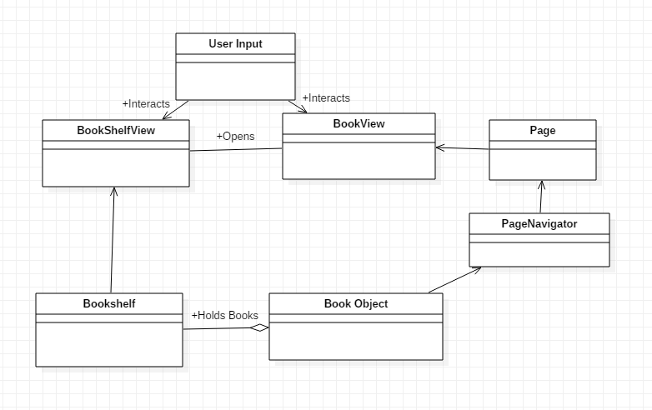
2. Test Classes
   1. Javadoc files are located in the Javadoc folder under com\example\BookshelfTop
   2. Saurabh Shah test class for NoteFile class
      1. Test class location: 3354-Macrohard\BookshelfTop\app\src\test\java\com\example\bookshelftop\NotesUnitTest.java
      2. NoteFile class location: 3354-Macrohard\BookshelfTop\app\src\main\java\com\example\bookshelftop\NoteFile.java
   3. Brandon Barnes test class for TagFile class and DocGrabber class
      1. Test class location: 3354-Macrohard\BookshelfTop\app\src\test\java\com\example\bookshelftop\TagFileTest.java
      2. TagFile class location: 3354-Macrohard\BookshelfTop\app\src\main\java\com\example\bookshelftop\TagFile.java
   4. John Walsh test class for BookShelf
      1. Test class location: 3354-Macrohard\BookshelfTop\app\src\test\java\com\example\bookshelftop\BookShelfTest.java
      2. BookShelf class location: 3354-Macrohard\BookshelfTop\app\src\main\java\com\example\bookshelftop\BookShelf.java
   5. Carl Schneider test class for PageNavigator
      1. Test class location: 3354-Macrohard\BookshelfTop\app\src\test\java\com\example\bookshelftop\PageNavigatortest.java
         1. The file that this test reads is at- …\3354-Macrohard\BookshelfTop\app\src\test\java\com\example\bookshelftop\TestFile.txt
         2. The … needs to be changed in the test class for the test to work
      2. PageNavigator class Location: 3354-Macrohard\BookshelfTop\app\src\main\java\com\example\bookshelftop\PageNavigator.java
3. Instructions to build and run software
   1. On startup, some lines referring to the package might have to be changed. Android studio will usually automatically fix this.
      1. Ex: package com.example.bookshelftop;
   2. There is also a chance of a “blank not resolved” error, where “app” and other imports are red. To fix this, click File -> invalidate caches / restart
   3. Make sure that the “app” is being run and not a test case or other executable
      1. Make sure that the API level is 28 or higher
      2. App was tested on an emulated Google Pixel
   4. After app has been placed on the phone or emulator
      1. ***These steps are for getting a sample .txt file. Any .txt can be used***
      2. Go to google chrome to download the .txt file we used for testing
         1. The url to the site that hosts our text file is
            1. https://www.sample-videos.com/download-sample-text-file.php
         2. Copy past the link into the search bar and find the download link for the 50kb text file

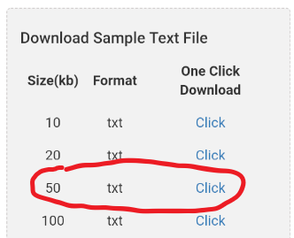

* + - 1. Additional test files can be downloaded from this google drive folder
         1. <https://drive.google.com/open?id=1Z9Lr7PcuCc1r4_FfK4KQot7VOiPRUs-W>
      2. Must use desktop view to download from drive
    1. Go into the phone settings (app with gear symbol)
       1. ***Must do this in options, cannot give permissions in app***
       2. Click “Apps and Notifications”
       3. Click “BookshelfTop”
       4. Click “Permissions”
       5. Turn the storage option to “on” (slider turns green)
    2. SampleTextFile_50kb.txt is now in the downloads folder
  1. Return to the app
     1. Click “import book”
     2. Enter the name of the file being imported, followed by .txt
        1. In this case, enter “SampleTextFile_50kb.txt”
        2. Make sure the filler text is deleted
     3. Click the back button (triangle on bottom left of phone screen)
     4. Click “Bookshelf”
        1. Select the book that was imported (config.txt)
  2. The book will appear
     1. Click on the book text to move forward a page
     2. Click on the back button at the bottom to move back a page