Hand Gesture Recognition with Synthetic Video Data and an Explainable Demo
Computer Vision – Assignment 2 (continuation of Assignment 1)
Tagishev Aldiyar, Zharylkassyn Aldiyar, Bitore Begimzhan
SE-2402 · Instructor: Baimukanova Zhanerke
Abstract
We extend the Assignment 1 hand-gesture classifier (fist, peace, stop, thumbs_up) with a text-to-video generator (Wan2.1 T2V 1.3B) for synthetic training data, three new real test sets recorded under unseen conditions, Grad-CAM explanations and a working web demo. The generator produced a usable clip in only 2 of 10 attempts, so synthetic frames are just 2.4% of the training set (14 frames, effectively two distinct images). On the familiar test set all configurations score 98.7–99.4% and cannot be told apart, but under new conditions (a dark scene, a bright-lights background, a second person) accuracy ranges from 34% to 88% depending on the training recipe. Over three seeds, augmentation was the main driver of robustness, synthetic frames alone gave a smaller gain, and on top of augmentation their benefit is not statistically distinguishable. The demo classifies one frame in about 50 ms on a laptop CPU.
1. Introduction
Assignment 1 trained a MobileNetV2 classifier for four static hand gestures on a self-collected video dataset and reached 82.4% test accuracy. It showed that the main failure was a sideways thumbs-up that was rare in training, and that validation accuracy (100%) did not predict test accuracy. Assignment 2 upgrades the same topic in five ways: (1) a state-of-the-art text-to-video model synthesises extra training clips; (2) three new real test sets in conditions the training videos do not cover replace the single easy test set as the main yardstick; (3) Grad-CAM explains the predictions; (4) a browser demo shows prediction, explanation, latency and a stress-test panel; (5) ethics and limitations are discussed.
Comparability note. The 24 videos used here were recorded for A2 following the A1 protocol, and frame extraction was changed (Section 2). “A1 recipe” below therefore means the A1 training recipe (MobileNetV2, no augmentation, same hyper-parameters) retrained on the new data; its numbers must not be compared with the 82.4% reported in A1.
2. Dataset update
2.1 Real training, validation and test data
The dataset consists of 24 smartphone videos (4 gestures × 3 backgrounds × 2 videos; light wall, wooden table, beige surface), 12–15 s each, with one gesture per video and the hand slowly moving and rotating. As in A1, the split is by source video: per class, the first wall video is used for validation, the first beige video for testing and the remaining four videos for training, so near-duplicate frames never cross splits. From each video the first 2.0 s and the last 1.5 s are dropped and every 4th frame is considered. A frame is kept only if the hand is present (at least 10% of pixels differ by more than 30 intensity levels from the empty first frame of the video) and it is not a near-duplicate of the previously kept frame; the kept frames are cropped to a square (20% vertical offset, as in A1) and resized to 256×256. This filter was added after inspecting a first extraction that contained empty background frames labelled as gestures and frames in which the hand was only entering the picture. For five videos in which the filter removed almost all frames (the hand was already in view in the first frame), the presence test was switched off and only duplicates were removed.
Table 1. Real frames per class and split (videos per split: train 4, val 1, test 1 per class).
Class | Videos | Train | Val | Test | Total
fist | 6 | 134 | 50 | 42 | 226
peace | 6 | 114 | 32 | 39 | 185
stop | 6 | 127 | 40 | 50 | 217
thumbs_up | 6 | 198 | 50 | 50 | 298
Total | 24 | 573 | 172 | 181 | 926

The classes are reasonably balanced; in training the largest class (thumbs_up, 198) is 1.74× the smallest (peace, 114), so macro-averaged metrics are reported next to accuracy.
2.2 New real test sets (evaluation only)
Three further sets were recorded to measure robustness. They are never used for training or model selection.
Table 2. Evaluation sets. “A1-style test” is the test split of Table 1.
Set | Videos | Gestures | Frames | Condition
A1-style test | 4 | all four | 181 | backgrounds and person as in training
dark | 2 | fist, peace | 90 | dim light; only two of four gestures
outdoor | 4 | all four | 197 | evening city scene, bright point lights and reflections behind the hand
person2 | 4 | all four | 195 | plain wall, a second team member’s hand

The two dark videos for stop and thumbs_up were not recorded, so accuracy on dark is computed over two of four classes and is not comparable with the other sets. Every set contains only 2–4 videos, so its frames are strongly correlated and differences of a few points are not meaningful.
2.3 Synthetic data and its share
Ten clips, one per prompt (gesture × scene, e.g. “closed fist on a wooden table, warm light” or “peace sign outdoors with green trees”), were generated offline with Wan2.1 T2V 1.3B (Section 3). After visual inspection only two clips were usable: peace on a green outdoor background and thumbs_up on a white marble wall. The other eight were rejected (unrecognisable or deformed hands, wrong gesture, or almost black frames), including all three clips prompted for a sideways thumb. Frames were extracted as for real clips (first 8 frames skipped, every 4th frame kept), giving 14 frames (7 peace, 7 thumbs_up). This is 2.4% of the 587 training frames, and because the clips are almost static these frames are effectively two distinct pictures. Synthetic frames are used in training only; validation and all test sets are real. There are no synthetic frames for fist or stop.
3. SOTA method: text-to-video diffusion (Wan2.1)
3.1 How it works
A text-to-video diffusion model creates a clip by starting from random noise and removing it step by step, steered by the text prompt, until a coherent video remains. To make this affordable the model does not work on pixels but on a compressed latent video: a spatio-temporal VAE shrinks the clip (Wan-VAE: 4× in time and 8×8 in space), a diffusion transformer (DiT) denoises the latent with attention over space and time, conditioned on embeddings of the prompt from a text encoder (umT5), and the VAE decoder turns the final latent back into frames [1]. Step-Video-T2V, the model suggested in the assignment, follows the same recipe with 30B parameters and a still stronger video VAE (16×16 spatial and 8× temporal compression) [2]; the Neurohive article [6] explains it. Its size is far beyond a free 16 GB Colab GPU, so we used Wan2.1, an open model of the same class with a 1.3B-parameter variant that needs about 8 GB of video memory according to its authors [1, 5]. This is a deviation from the suggested model and is stated here on purpose.
3.2 Why it should help this topic
The A1 errors came from poses and conditions that are rare in a small hand-made dataset: a sideways thumb, a stop with a widely spread thumb, low light and new backgrounds. A text prompt can ask for exactly these variations at the price of GPU time instead of new recording sessions, and the clips come with a free label (the prompted gesture).
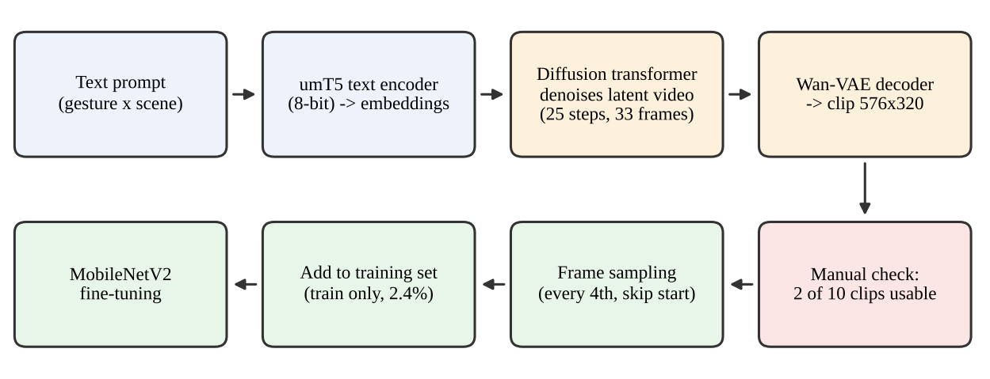
Figure 1. Synthetic-data pipeline: prompt → text encoder → latent denoising → decoding → manual check → frame sampling → training.
3.3 Settings and yield
We ran Wan2.1-T2V-1.3B through the diffusers library on a free Colab T4: 576×320 (portrait), 33 frames at 15 fps, 25 denoising steps, guidance scale 5, one seed per prompt and a negative prompt against extra or fused fingers and blur. Free-tier memory limits forced a two-stage run: the text encoder was loaded in 8-bit, the prompt embeddings were saved and the encoder was unloaded before the transformer was loaded. One clip took about 10 minutes (about 20 minutes in our first attempt with 50 steps and CPU offloading). Only 2 of 10 clips (20%) were usable. Hands are a known weak spot of video generators, and our low resolution, short clips and single seed per prompt probably did not help; we did not test other settings, so this is the yield of our configuration, not of the method in general. The method therefore delivered far less data than planned.
4. Experiments
4.1 Setup
All models are ImageNet-pretrained MobileNetV2 with a new 4-class head, trained in two stages exactly as in A1 (5 epochs head only at lr 1e-3, then 5 epochs with blocks 14–18 and the head at lr 1e-4), Adam, batch size 32, cross-entropy, restoring the weights of the epoch with the highest validation accuracy. When augmentation is used it consists of a random resized crop (75–100%), horizontal flip, rotation within ±15° and colour jitter (brightness and contrast ±30%, saturation ±20%, hue ±0.02). The four recipes {no augmentation, augmentation} × {real only, real + synthetic} form a 2×2 ablation; each was trained with seeds 0, 1 and 2.
4.2 Baseline vs. synthetic data on the familiar test set
Table 3. A1-style test set (181 frames), single run, seed 42; precision, recall and F1 are macro-averaged.
Training data (no augmentation) | Acc | Prec | Rec | F1 | thumbs_up recall | stop recall
Real only (A1 recipe) | 0.989 | 0.988 | 0.990 | 0.989 | 0.98 | 0.98
Real + synthetic | 0.994 | 0.994 | 0.995 | 0.995 | 0.98 | 1.00

The two models differ by one frame out of 181 (Figure 2), so this set shows no benefit of synthetic data; it also no longer discriminates between models, because its videos share background types and the person with the training videos. Both runs converge within the 10 epochs (Figure 3), and validation accuracy reaches about 1.0 early in stage 2, which repeats the A1 lesson that validation alone cannot rank models.
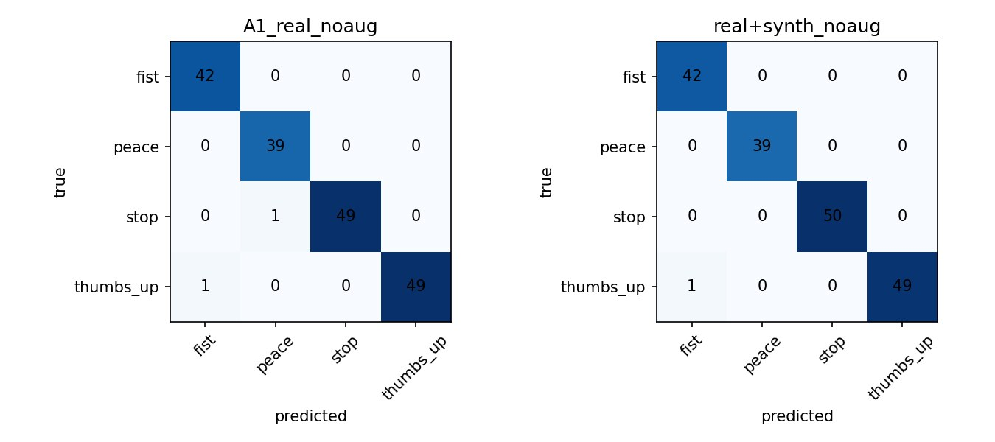
Figure 2. Test confusion matrices, real only (left) and real + synthetic (right), seed 42.
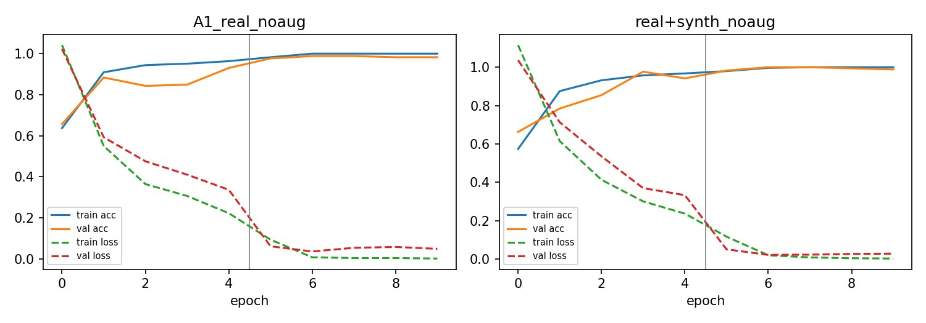
Figure 3. Loss and accuracy per epoch for both runs; the grey line marks the start of stage 2.
4.3 Ablation under new conditions (3 seeds)
Table 4. Accuracy, mean ± std over seeds 0, 1, 2 (sample std). Best value per column in bold.
Training recipe | A1-style test | dark* | outdoor | person2
Real, no aug (A1 recipe) | 0.989 ± 0.000 | 0.337 ± 0.167 | 0.374 ± 0.013 | 0.721 ± 0.018
Real + aug | 0.994 ± 0.010 | 0.874 ± 0.061 | 0.643 ± 0.147 | 0.882 ± 0.015
Real + synthetic, no aug | 0.991 ± 0.003 | 0.430 ± 0.017 | 0.540 ± 0.043 | 0.793 ± 0.030
Real + synthetic + aug | 0.987 ± 0.013 | 0.881 ± 0.064 | 0.799 ± 0.102 | 0.870 ± 0.060
dark contains only fist and peace (90 frames)
- Augmentation is the main driver. It raised accuracy from 0.337 to 0.874 (dark), 0.374 to 0.643 (outdoor) and 0.721 to 0.882 (person2). Brightness/contrast jitter and crops are the plausible cause, but we did not ablate individual transforms.
- Synthetic frames alone helped somewhat (+0.09, +0.17, +0.07). With only two distinct source pictures we cannot attribute this to the realism of synthetic data; any extra training images could shift the decision boundary. In the seed-42 run, outdoor peace went from 0/50 to 44/50 correct while outdoor fist stayed at 0/47 (no synthetic fist frames existed). The first single-seed comparison suggested +31 points on outdoor (0.386 → 0.695); the three-seed mean gives +17.
- On top of augmentation the benefit is not demonstrated. Outdoor improved by 0.155 (0.799 vs. 0.643), but the standard deviations (0.102 and 0.147) overlap, and dark (+0.007) and person2 (−0.012) show no difference.
- Variance is large (std up to 0.167), so single-seed comparisons on these small sets are unreliable. Each set holds only 2–4 videos.
The model shipped in the demo (real + synthetic + augmentation, seed 0) scores 0.994 accuracy and 0.995 macro F1 on the A1-style test, and 0.844 (dark, n = 90), 0.695 (outdoor, n = 197) and 0.882 (person2, n = 195) on the new sets.
5. Explainability: Grad-CAM
Grad-CAM is computed on the last convolutional block of MobileNetV2 (7×7 cells upsampled to 224×224); red marks regions that push the predicted class up. Figures 4–6 show a fixed random sample per case.
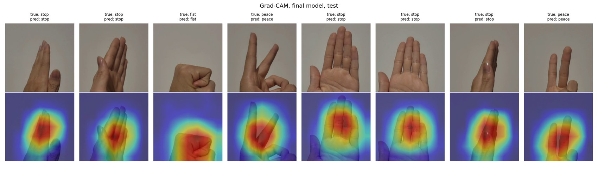
Figure 4. Final model on the A1-style test: all eight shown frames are correct and the attention lies on the hand.
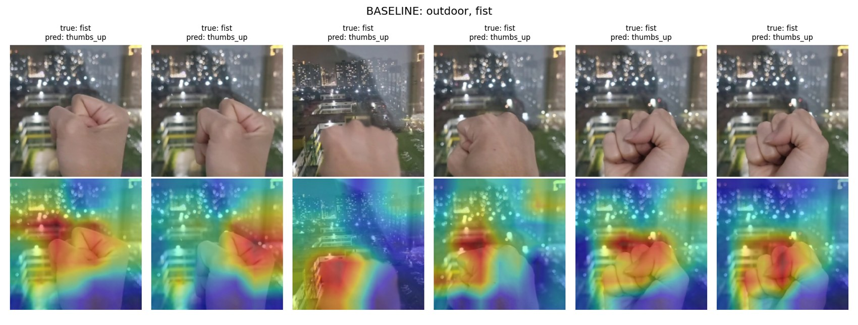
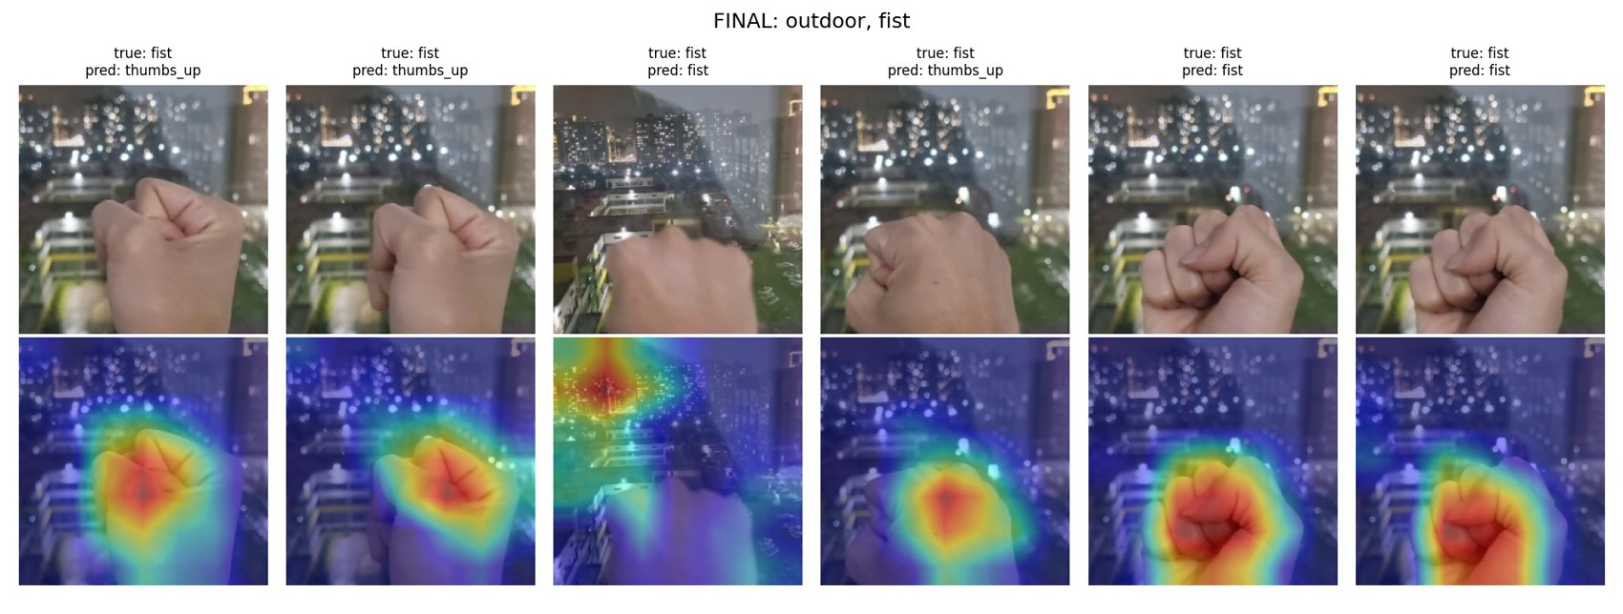
Figure 5. Outdoor, true class fist. Top: real-only baseline (thumbs_up predicted in all six frames), its heat spreads onto bright background lights and the building. Bottom: final model; the heat sits on the fist in five of six frames, yet three frames are still predicted thumbs_up.
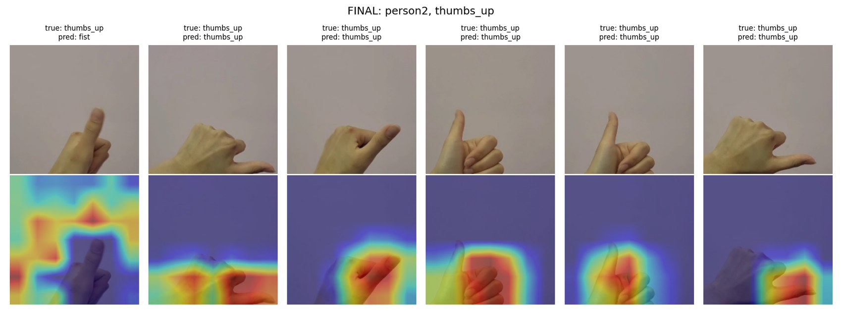
Figure 6. person2, true class thumbs_up (final model). The only error is frame 1, where just the thumb tip is visible and the attention is spread over the whole image.
Two cautious conclusions follow. The maps are consistent with the baseline relying partly on the background under unfamiliar lighting, and the final model attends to the hand much more often. But attending to the hand does not guarantee the right class (Figure 5, bottom): the appearance of the hand under these conditions is still out of distribution. With six frames per case and a 7×7 map, Grad-CAM here generates hypotheses rather than proof.
6. Demo application
The demo is a Gradio web app (app.py in the repository). The core flow is upload or webcam → predicted class with probabilities → Grad-CAM overlay (Figure 7, left). It also shows the latency of every request and the environment (device, torch version, OS and browser). A stress-test panel applies artificial brightness, blur, rotation and noise and shows the prediction before and after; these are simulated distortions, not real conditions. A separate tab shows the synthetic clips with a banner and a “SYNTHETIC (AI)” label on each (Figure 7, right). Generation itself runs offline in Colab, as allowed by the assignment. The app does not store uploaded images on purpose (Gradio may cache uploads temporarily).
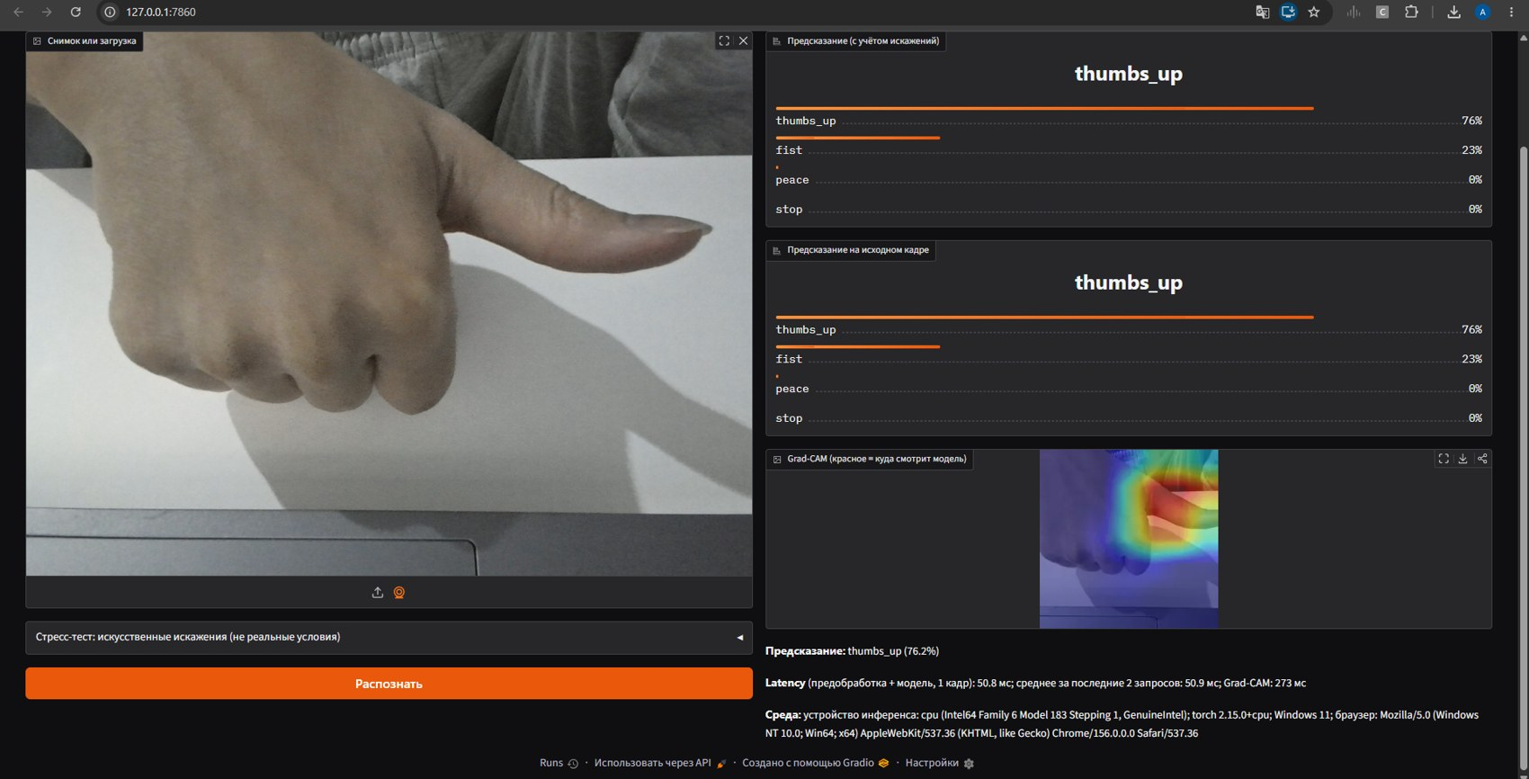 | 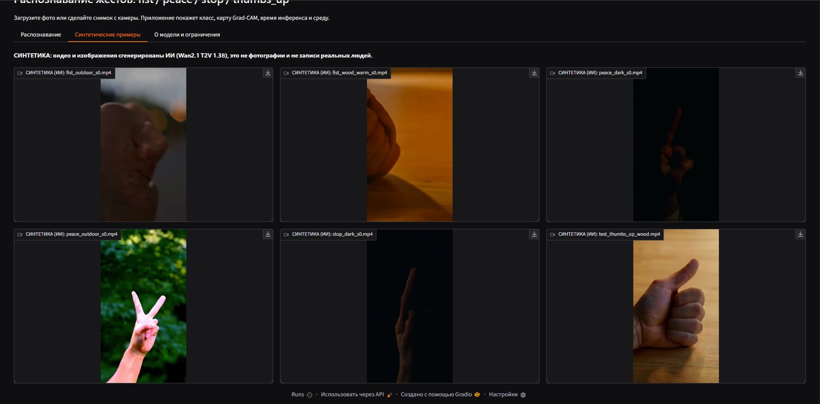
Figure 7. Left: prediction, Grad-CAM, latency and environment for a sideways thumbs-up. Right: tab with labelled synthetic clips (interface text is in Russian).
Table 5. Inference time for one 224×224 image.
Setting | Hardware | What is timed | Time
Colab, CPU | Colab CPU | model forward, mean of 100 runs | 25.7 ms
Colab, GPU | Tesla T4 | model forward, mean of 100 runs | 5.5 ms
Demo app | laptop CPU (Intel, family 6 model 183), Windows 11, Chrome | preprocessing + forward, mean of 6 requests | 50.0 ms
In the demo, Grad-CAM adds about 270 ms per request (it needs a backward pass) and is not included in the 50 ms. The app handles single snapshots, not a video stream, so no frame rate is claimed.
7. Ethics and limitations
Consent and privacy. The dataset contains hands only, no faces. The hands belong to members of the author team, who recorded them themselves. The app does not keep uploads, and webcam frames are processed locally when the app runs on the user’s machine.
Bias. All real data come from the hands of very few people, so skin tones, hand sizes and gesture styles are poorly covered; we did not measure accuracy across skin tones. The generator may carry the biases of its training data: the usable synthetic peace clip shows a pale pink hand that differs visibly from our real hands. A classifier trained on such data could work worse for people who are under-represented.
Misuse and disclosure. Gesture recognition itself is low-risk, but webcam-based analysis can be misused for surveillance, and video generators can produce realistic fake media of people. We generated only low-resolution clips of hands, never faces. All synthetic media are labelled as AI-generated in the app and in this report and are used in training only; test data are real.
Limitations.
- Small data: 24 training videos, hands of few people; test sets of 2–4 videos with strongly correlated frames; the dark set covers two gestures.
- Only three seeds and no hyper-parameter search; large standard deviations (Table 4).
- Synthetic yield of 20% and a 2.4% share; the synthetic “outdoor” clip (green daylight) looks nothing like the real outdoor set (night city lights), so the name overlap should not be read as a matched condition.
- Step-Video-T2V and ArtAug from the suggested list were not used; one generator at one setting was tested.
- Grad-CAM is coarse (7×7); latency was measured on one laptop for single snapshots.
8. Reproducibility
- Training and generation: Google Colab, Tesla T4 (16 GB), Python 3.13, PyTorch, torchvision, diffusers, transformers, bitsandbytes, OpenCV. Notebooks: generate_clips.ipynb (Wan2.1, prompts and settings of Section 3.3) and A2_train_eval.ipynb (frame extraction, training, ablation, latency, Grad-CAM).
- Seeds: 42 (Table 3), 0/1/2 (Table 4), 0 (demo model). Data layout on Drive: real/{train,val,test}/<class>/, real_env_test/<env>/<class>/, synthetic_clips/*.mp4; the eight rejected clips are listed in the EXCLUDE variable of the notebook.
- Demo: Python 3.14.3, torch 2.15.0 (CPU), gradio 6.31.0, Windows 11. Run pip install -r requirements.txt and python app.py, then open http://127.0.0.1:7860. Weights: model/final_real+synth_aug.pt.
- Repository: GitHub URL · Demo video: video URL
9. Conclusion
Adding text-to-video synthesis to the A1 pipeline worked technically but yielded little data: 2 of 10 clips were usable, 2.4% of training frames. The familiar test set is saturated (about 99%) and hides all differences, while three new real test sets reveal a large generalisation gap that augmentation closes substantially (e.g. dark 0.34 → 0.87). Synthetic frames gave a smaller gain on their own and no demonstrable gain on top of augmentation. Grad-CAM and the demo make failures visible, for example attention drifting to bright backgrounds. The next steps are more and better generated clips (more seeds, higher resolution, a hand-pose check to filter frames), recordings from more people and a per-transform augmentation ablation.
References
[1] Wan Team, Alibaba Group. Wan: Open and Advanced Large-Scale Video Generative Models. arXiv:2503.20314, 2025.
[2] Step-Video Team, StepFun. Step-Video-T2V Technical Report: The Practice, Challenges, and Future of Video Foundation Model. arXiv:2502.10248, 2025.
[3] M. Sandler et al. MobileNetV2: Inverted Residuals and Linear Bottlenecks. CVPR, 2018.
[4] R. R. Selvaraju et al. Grad-CAM: Visual Explanations from Deep Networks via Gradient-based Localization. ICCV, 2017.
[5] Wan2.1 repository and model card: https://github.com/Wan-Video/Wan2.1 ; https://huggingface.co/Wan-AI/Wan2.1-T2V-1.3B-Diffusers
[6] Neurohive article on Step-Video-T2V, as linked in the assignment handout: add URL

