**Data Analyst**

**Aldiyar Baiserik Project**

Bank Loan Query Document

Bank Loan Report

KPI’s:

**Total Loan Applications:**

Select Count(id) as Total_Loan_Applications

From dbo.bank_loan_data

**Total Loan Amount:**

Select Sum(loan_amount)

From dbo.bank_loan_data

**Total Payment Amount:**

Select Sum(total_payment) as Total_Payment_Amount

From dbo.bank_loan_data

**Month to Date Loan Applications:**

Select Count(id) as Mtd_Total_Loan_Applications

From dbo.bank_loan_data

Where Month(issue_date) =12 and Year(issue_date)=2021

Select Count(id) as PMTD_Total_Loan_Applications

From dbo.bank_loan_data

Where Month(issue_date)=11 and Year(issue_date)=2021

**Month to Date Total Loan Amount:**

Select Sum(loan_amount)as MTD_Total_Loan

From dbo.bank_loan_data

Where Month(issue_date)=12 and Year(issue_date)=2021



Select Sum(loan_amount)as PMTD_Total_Loan

From dbo.bank_loan_data

Where Month(issue_date)=11 and Year(issue_date)=2021



**Month to Date Total Payment Amount:**

Select Sum(total_payment)as MTD_Total_Payment

From dbo.bank_loan_data

Where Month(issue_date)=12 and Year(issue_date)=2021

Select Sum(total_payment)as PMTD_Total_Payment

From dbo.bank_loan_data

Where Month(issue_date)=11 and Year(issue_date)=2021



**Average Interest Rate:**

Select Round(AVG(int_rate)*100,2) AS Avg_Interest_rate

From dbo.bank_loan_data

**Good loan Applications:**

Select Count(loan_status) as Good_Loan_Applicants

FRom dbo.bank_loan_data

Where loan_status= 'Fully Paid' or loan_status='Current'

**Good loan Application Percentage:**

Select Cast(Round(Count(Case When loan_status= 'Fully Paid' or loan_status='Current' Then id End) *100

/

count(id),0) as nvarchar(5)) + '%' as Good_Loan_Percentage

From dbo.bank_loan_data

**Good Loan Funded Amount:**

Select Sum(loan_amount) as Good_Loan_Funded

From dbo.bank_loan_data

Where loan_status= 'Fully Paid' or loan_status='Current'



**Good Loan Total Received Amount:**

Select Sum(total_payment) as Good_Loan_Funded

From dbo.bank_loan_data

Where loan_status= 'Fully Paid' or loan_status='Current'

**Bad loan Applications:**

Select Count(loan_status) as Bad_Loan_Applicants

FRom dbo.bank_loan_data

Where loan_status= 'Charged Off'

**Bad loan Application Percentage:**

Select (Count(Case When loan_status = 'Charged off' Then id End)*100.0) /

Count(id) as Bad_Loan_Percentage

From dbo.bank_loan_data



**Bad Loan Funded Amount:** Select Sum(loan_amount) as Bad_Loan_Funded

From dbo.bank_loan_data

Where loan_status= 'Charged off'

**Bad Loan Total Received Amount:**

Select Sum(total_payment) as Bad_Loan_Funded

From dbo.bank_loan_data

Where loan_status= 'Charged off'

**Monthly Trend by Issue Date:**

Select Month(issue_date)as Month_Number,

DATENAME(Month,issue_date)as Month_Name,

Count(id) as Total_Loan_Applications,

Sum(loan_amount)as Total_Loan_Amount,

Sum(total_payment) as Total_Payment_Amount

from dbo.bank_loan_data

GROUP BY Month(issue_date), DATENAME(Month,issue_date)

order by 1

**Regional Analysis by State:**

Select address_state as Address_State,

Count(id) as Total_Loan_Applications,

Sum(loan_amount)as Total_Funded_Amount,

Sum(total_payment) as Total_Received_Amount

from dbo.bank_loan_data

GROUP BY address_state

order by Total_Loan_Applications desc

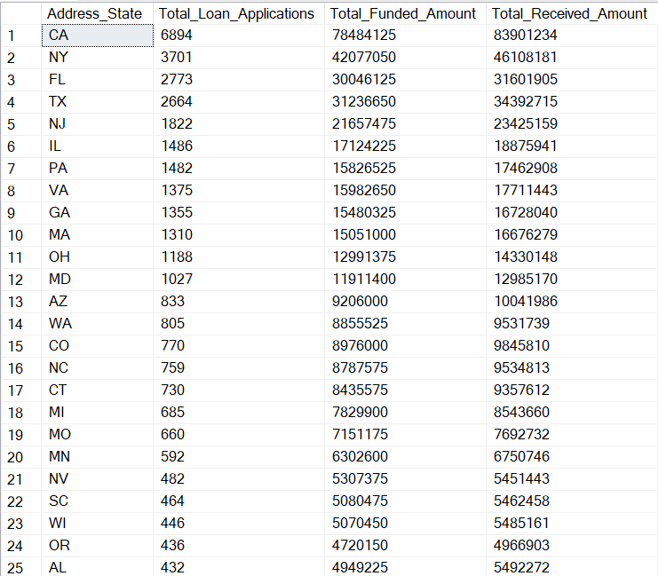**

**Loan Term Analysis:**

Select term as Term,

Count(id) as Total_Loan_Applications,

Sum(loan_amount)as Total_Funded_Amount,

Sum(total_payment) as Total_Received_Amount

from dbo.bank_loan_data

GROUP BY term

order by 1

**Employee Length Analysis:**

Select emp_length as Emp_Length,

Count(id) as Total_Loan_Applications,

Sum(loan_amount)as Total_Funded_Amount,

Sum(total_payment) as Total_Received_Amount

from dbo.bank_loan_data

GROUP BY emp_length

order by emp_length

**Loan Purpose Analysis:**

Select purpose as Purpose,

Count(id) as Total_Loan_Applications,

Sum(loan_amount)as Total_Funded_Amount,

Sum(total_payment) as Total_Received_Amount

from dbo.bank_loan_data

GROUP BY purpose

order by Total_Loan_Applications desc

**Home Ownership Analysis:**

Select home_ownership as Home_Ownership,

Count(id) as Total_Loan_Applications,

Sum(loan_amount)as Total_Funded_Amount,

Sum(total_payment) as Total_Received_Amount

from dbo.bank_loan_data

GROUP BY home_ownership

