
Università
degli Studi
di Catania

Dipartimento di Ingegneria Elettrica Elettronica Informatica
Corso di Laurea Magistrale in Ingegneria Informatica

Artificial Intelligence-Based Acoustic Models
Anno accademico 2023-2024

Candidato: Aldo Barca
Relatrice: Prof.ssa Daniela Giordano

ACKNOWLEDGEMENTS
SOMMARIO

INDEX
ACKNOWLEDGEMENTS 2
Introduction 1
1. Transformers and Few Shot Learning 2
1.1. The transformers 2
1.2. Transformer’s architecture 5
1.2.1. Input Embedding 6
1.2.2. Positional Encoding 7
1.2.3. Encoder layer 9
1.2.4. Decoder layer 10
1.2.5. Linear and softmax layers 11
1.3. Attention and Self Attention in transformers 11
1.3.1. Encoder Self-Attention 14
1.3.2. Decoder Self-Attention 14
1.3.3. Encoder-Decoder Attention 15
1.3.4. Attention hyperparameters 16
1.4. Few-Shot Learning 17
1.4.1. Transfer learning 18
2. Few-shot Bioacoustic Event Detection 22
2.1. Dataset of the challenge 22
2.1.1. 23
2.1.2. 23
2.2. rr 23
2.2.1. 23
2.2.2. 23
2.2.3. 23
3. Chapter 3 24
3.1. a. 24
3.1.1 24
3.1.2 24
3.1.3 24
3.1.4 24
3.2. r 25
3.2.1 25
3.2.2 25
3.2.2.1 25
3.2.2.2 25
3.2.2.3 25
3.3. Conclusions 25
BIBLIOGRAFY 26

Introduction
rrr

Transformers and Few Shot Learning

In this first chapter, the main focus is to address concisely the technologies used for this thesis project. A secondary objective of the chapter is to discuss the concept of few-shot learning and the state of the art in this regard.

The transformers
Transformers are a unique form of neural network architecture within deep learning models, specialize in converting input sequences into output sequences. The birth of the Transformer is in 2017 from the Google document “Attention is all you need”. The name Transformer itself is due to one of its most important features, the transformation of representations. The transformers accomplish this by understanding context and identifying connections between sequence elements. For instance, when given the input sequence "Which animal sound does a dog?", a transformer model analyzes the relationships between words like animal, sound, dog, and bark using internal mathematical representations. This understanding allows it to produce the output "The dog’s sound is a bark". The use cases for transformer vary in a great range of tasks, including speech recognition, automatic translation, and protein sequence analysis.
Early deep learning models which focused on natural language processing tasks tried to predict the next world based on the last word of a sequence. This is the same reasoning used in the automatic complete function of a phone keypad. In a larger scale they analyzed the frequency of connections between various word pairs or groupings within their training data and attempted to forecast the subsequent word. However, these initial methodologies struggled to retain context beyond a certain input length. For instance, a pioneering ML model failed to generate coherent paragraphs due to its inability to preserve context from the beginning to the end of a paragraph. To produce an outcome such as "I am from Italy. I like to ride horses. I speak Italian.", the model required the capacity to recall the correlation between Italy and Italian, a capability lacking in early neural networks. 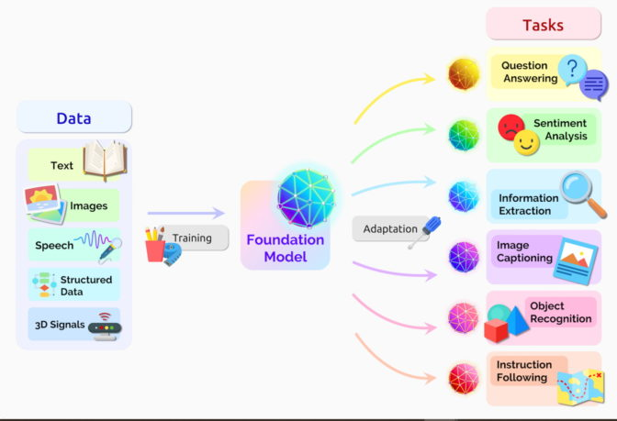
Transformer models have revolutionized NLP technologies by empowering models to navigate such extensive textual dependencies. Additionally, transformers offer further advantages:
- Facilitating the development of large-scale models
• Transformers process lengthy sequences comprehensively through parallel computation, substantially reducing both training and processing durations.

This advancement has facilitated the training of expansive language models (LLMs) like Generative Pretrained Transformer (GPT) and Bidirectional Encoder Representations from Transformers (BERT), equipped to grasp intricate linguistic structures. With billions of parameters encompassing diverse languages and human knowledge, transformers propel research towards more universally applicable AI systems.
Traditional neural networks, when dealing with sequential data, typically follow an encoder/decoder architecture pattern. In this pattern, the encoder processes the entire input sequence, like an English sentence, and transforms it into a concise mathematical representation, summarizing the input's essence. Subsequently, the decoder utilizes this summary to sequentially generate the output sequence, potentially translating the input sentence into French. This sequential processing approach, however, poses limitations. Each word or data segment is processed one after the other, leading to slow processing speeds and potential loss of important but little details, particularly over processing.
Considering the previous example about the automatic complete function of the keyword, the non-transformer model when are continuously selected the suggested words will make a no-sense phrase. In particular, looking at each set of 3 or 4 consecutive words, it may make sense, however these words don’t concatenate to anything with a meaning. This occurs due to the model implemented in the device not carrying the overall context of the message, only predicting which word is more likely to come up after the last ones. Transformers, on the other hand, keep track of the context of what is being written, and this is why the text they write makes sense.
Making another example, consider a scenario where the aim is to forecast the final word of the phrase: “I grew up in Italy… I speak fluent …”. Recent details indicate that the subsequent word likely pertains to a language. Yet, to pinpoint the specific language, we necessitate the context of Italy, situated further back within the text, and this is where transformers excel compared to, for instance, a recursive neural network.[3]
Transformer models revolutionize this process through the integration of the self-attention mechanism. Unlike traditional sequential processing, the self-attention mechanism enables the model to simultaneously examine various segments of the sequence, determining their relative importance, based on various information contained in the text. This mechanism not only enhances efficiency, enabling training on larger datasets, but also improves effectiveness, especially in scenarios involving lengthy textual inputs where distant context influences subsequent meanings.

Transformer’s architecture
The neural network framework inherent in a transformer encompasses multiple layers of software interplay aimed at producing the final output. Considering the picture below, we can distinguish the following main components:
- Input embeddings
- Positional encoding
- Transformer blocks (encoder and decoder layer)
- Linear and softmax layers
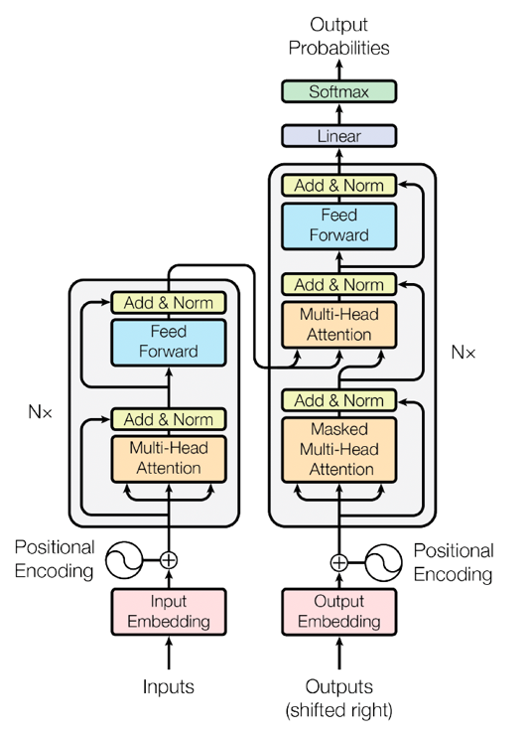
Image 1.1: Conceptual scheme of a Transformer. Nx in the image stands for N times, which means multiples encoders and decoders.

1.2.1. Input Embedding
The initial stage facilitates the conversion of the input sequence into a mathematical representation comprehensible to software algorithms. Initially, the input sequence is disassembled into a series of tokens or discrete sequence components. For instance, in the case of a sentence input, these tokens represent words. The embedding phase subsequently converts the token sequence into a mathematical sequence of vectors. These vectors encapsulate semantic and syntactic information in numerical form, with their attributes being acquired through the training process.
Conceptually, these vectors can be visualized as coordinates within an n-dimensional space. For example, in a simple two-dimensional graph, the x-axis denotes the alphanumeric value of the first letter of the word, while the y-axis signifies related semantic categories. For instance, the word "banana" might be represented as (2,2) due to commencing with the letter 'b' and being categorized as a fruit. Similarly, "mango" could be represented as (13,2) owing to its initial 'm' and fruit classification. Thus, the vector (x, y) informs the neural network of the semantic similarity between words sharing the same category.
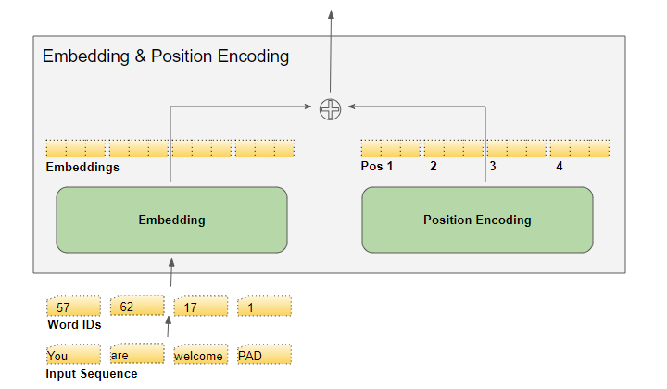

1.2.2. Positional Encoding
This layer supplements positional information to the input embeddings, crucial for imparting knowledge about the sequential order of tokens. Given the innate inability of neural networks to discern word order within a sequence, positional encoding rectifies this deficit. For instance, in the phrase "I play the guitar," the significance of "guitar" as the concluding word necessitates explicit positional encoding to elucidate its ordinal position within the sequence.
The first and more immediate solution could be utilizing a singular numerical value, such as an index, to denote an item's positional attribution within transformer models. However, the unmitigated growth of indices in magnitude for long sequences renders the employment of a solitary index impractical. Moreover, normalizing the index values to a range between 0 and 1 poses challenges,
. 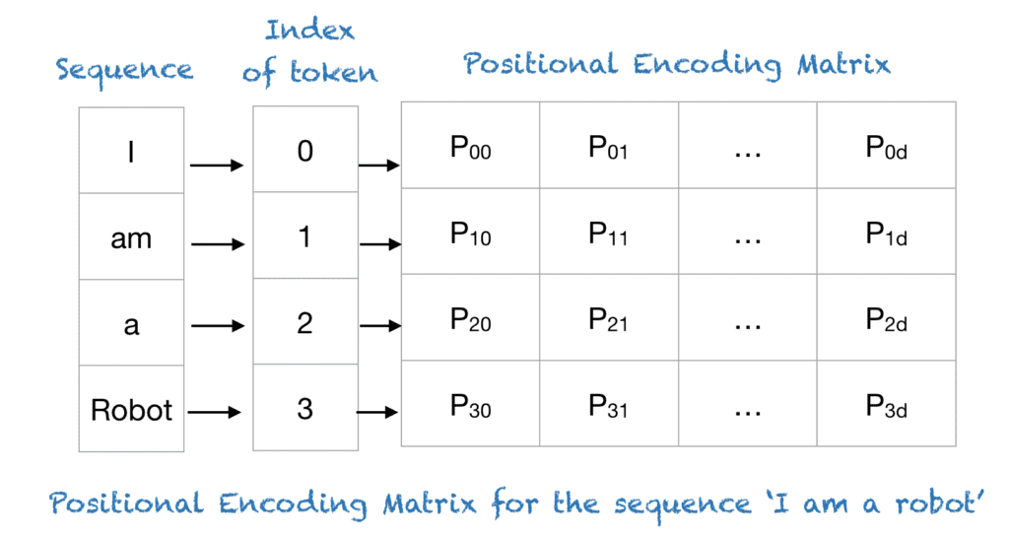

Supposing an input sequence of length L, if it’s required the encoding for a certain position pos then the encoding is given using sin and cos function with varying frequencies based on the position.
In particular, the classic positional encoder for transformers uses these formulas respectively for even and odd position of the token:

$${PE}_{(pos,2i)}=sin⁡(\frac{pos}{n^{ \frac{2i}{d_{model}}}})$$
$${PE}_{(pos,2i+1)}=cos⁡(\frac{pos}{n^{ \frac{2i}{d_{model}}}})$$
In these functions:
- pos: The position of an object in the input sequence, with 0 ≤ pos ≤ L/2
- d_model: Dimension of the output embedding space
- n: Scalar defined based on the specific case, in the classic literature the default value is 10000
- i: Used for mapping to column indices.

For instance, if the phrase to encode is “I am a Robot” and n=100 with d_model=4, then the resulting positional encoding is the one given in the following image:

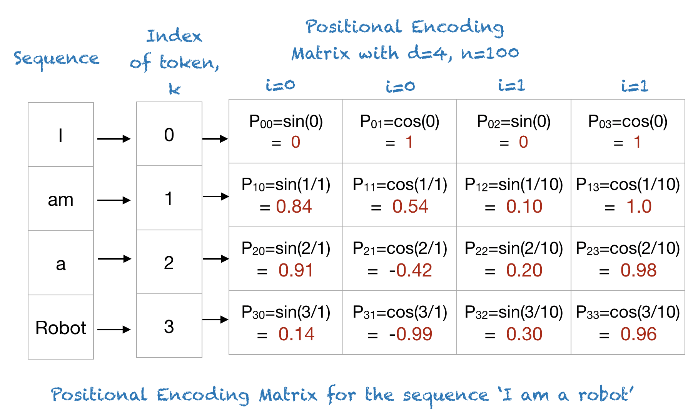

Using this approach for positional encoding for each position k corresponds a distinct sinusoid (or cosine wave) and so, we can ensure in conjunction with everything said before, three different major advantages:
- The sine and cosine functions, operating within the domain of [-1, 1], effectively constrain the values of the positional encoding matrix to a normalized range.
- Given the distinct sinusoidal patterns assigned to each position, a singular and unique encoding methodology is distinguished for each position.
- This characteristic facilitates the quantification of positional dissimilarity between different positions, hence enabling an empowered encoding of the relative positions of words.[4]

1.2.3. Encoder layer
The output of the positional encoding layer, also called embeddings, are then received as input of the encoder layer.
Constituting the foundational framework of a transformer, the input datas are processed sequentially across multiple layers of encoders (usually six), each comprising numerous attention heads. Each head executes distinct attention operations, including self-attention, which enables the model to selectively attend to various segments of the input sequence. By leveraging transformer blocks, the model adeptly captures intricate relationships and dependencies intrinsic to the input data, thereby enhancing predictive accuracy.[5]
Each encoder consists of two layers:
- Multi-Head Self-Attention Layer: This layer computes attention representations for each token in the sequence, allowing the model to consider relationships between tokens flexibly and efficiently. In fact, it implements the concept of input which pay attention to itself, also called self attention.
- Feedforward Neural Network: After self-attention, the results are passed through an additional feedforward neural network, adding a non-linear component.
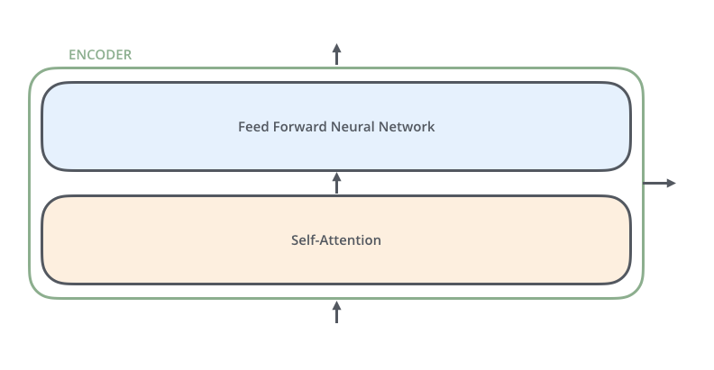

1.2.4. Decoder layer
The Decoder’s structure is very semiliar to the Encoder’s one but with some fundamental differences.
The first one is the way the output of the encoders are given as an input of the various decoders, in a parallel way similar to a broadcasting. 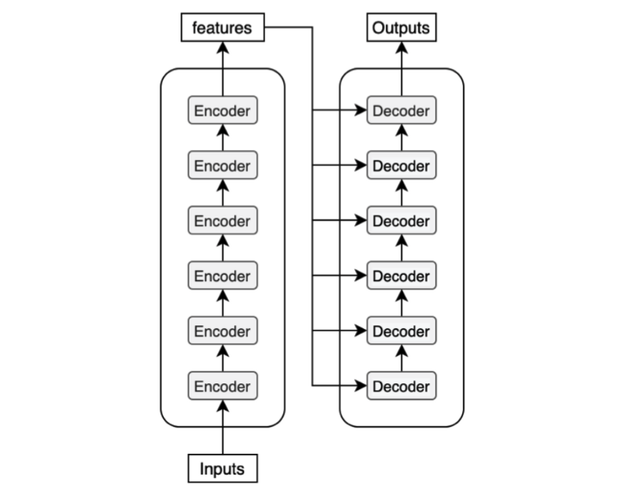
The second and crucial difference, is the precence of another additional layer in the decoder block called Encoder-Decoder Attention layer. This layer is the one which implements the fact that the target sequence pays attention to the input sequence, given as the output of the encoders.
As the Encoder layer there is a self attention mechanism but for the target instead of the input. This is why in the picture 1.1 the first decoder is given as an input the target (or output) embedded and then positional encoded as the input. [6]
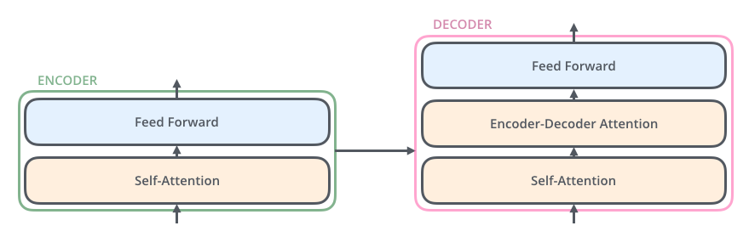

1.2.5. Linear and softmax layers
Following traversal through the transformer blocks, the resultant output undergoes processing via linear layers and softmax activation functions. These layers facilitate the transformation of input data into the desired output format, such as a probability distribution encompassing potential output tokens. The softmax function ensures the normalization of output values, thereby ensuring their adherence to valid probability constraints and rendering them amenable for subsequent model utilization.

Attention and Self Attention in transformers
After analyzing the architecture of the Transformer, it becomes necessary to delve into detail regarding the key mechanism of transformers, the Attention. This mechanism, indeed isn’t a concept exclusive of the transformer nonetheless is thanks to this new popular architecture that is well-known and used in neural networks.
Attention is a fundamental mechanism employed within the Transformer architecture, notably deployed in three distinct contexts:

- Self-Attention in the Encoder: Here, the input sequence pays attention to itself, facilitating the discernment of relevant features and relationships within the sequence.
- Self-Attention in the Decoder: In this phase, the target sequence undergoes a self-reflective process, allowing it to selectively emphasize pertinent elements and patterns inherent within its own structure.
- Encoder-Decoder Attention in the Decoder: Within this framework, the target sequence dynamically interacts with the input sequence, enabling it to draw upon contextual cues and correlations from the input to refine its own predictive capabilities.
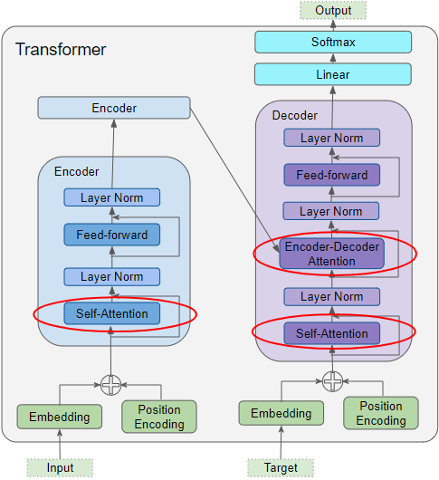
Image 1.2: Types of Attention highlighted in a Transformer architecture. [7]
A generic attention layer takes as input three parameters, known as Query, Key and Value.
- Query: This component represents the specific information that the model aims to retrieve or comprehend from the input sequence. Essentially, it acts as a reference point for discerning the significance of other elements within the sequence.
- Key: It servs as a mechanism for encoding contextual information associated with individual elements in the input sequence, the key encapsulates pertinent features and attributes crucial for understanding the interrelationships among different segments of the sequence.
- Value: The value represents the substantive information content attributed to each element in the input sequence, the value embodies the data that the model extracts and utilizes based on the attention mechanism's weighting, which is determined by the similarity between query and key.
Thanks to the combination of these three parameters a model can concentrate on pertinent segments of the input sequence and then generate coherent representations based on the specific task.
Transformer models in particular do not use just single self-attention. Instead, they use multi-head self-attention mechanisms, where attention is calculated multiple times in parallel with different learned linear projection. The projection into several subspaces creates multiple heads, each representing a different subspace of the input. Then the attention scores are calculated independently for each head, where each head has its own set of learnable parameters for calculating attention. The division in different heads allows the model to attend to different aspects of the input sequence simultaneously.

1.3.1. Encoder Self-Attention
The ouput of the positional encoding which encapsulates the position and meaning of every token is then fed at the same time as query, key and value for the first encoder. The encoder then produces an encoded representation of the input integrated with the attention scores as well. For each encoder an additional self-attention layer adds its own attention scores between all pair of tokens in the input sequence. These attention scores determine how much each token is correlated to other tokens, influencing the final representation of each token.

1.3.2. Decoder Self-Attention
The target sequence on the other hand is used to make the Output embedding. After an additional position encoding, the results are fed to all the three parameters in the first decoder. The resulting encoded representation for each token in the target sequence is fed as the query parameter in the encoder-decoder attention layer of the decoder.
An important difference is that’s also done an operation called masking. The masking operation basically block the decoder from using future tokens to obtain informations and therefore avoiding the decoder from cheating during training or the execution of a task [8].

1.3.3. Encoder-Decoder Attention
The output of the last encoder as discussed before is used as an input of decoder’s self attention mechanism even if a different way than in the encoder self-attention. Instead of being used as input of every three parameter of the attention layer, it’s used just as value and key for the decoder. In conjuction with the output of the decoder self-attention layer all three attention parameters of the encoder-decoder attention are ready to be computed.
The encoder-decoder attention is therefore getting a representation of both the target and the input. Thanks to both attention considered before, this layer can generate a representation which effectively encapsulates both the impact of attention scores derived from the input and the attention scores itself for each target sequence.
Thanks to the multiple distinct decoders, each Self-Attention and each Encoder-Decoder Attention also add their own attention scores into each token’s representation.
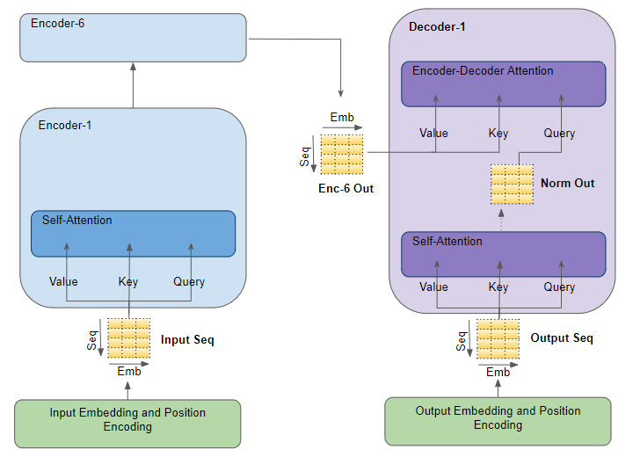
Image 1.3: The image visually describes how transformers process attention. [7]

1.3.4. Attention hyperparameters
A fundamental concept in transformer models refer to the attention parameters, which govern how attention mechanism operates within the model. Therefore, it’s crucial to analyze and decide carefully these parameters.
Among the various attention hyperparameters the most important are:
- Number of attention heads: Parameter which defines how many parallel attention mechanisms are parallelized during the multi-head attention layers. Increasing the number of heads increase the number of captured patterns and relationship in the data at the cost of an increased computational complexity,
- Query, key and value size: Parameter which defines the dimensionality of the parameters used in an attention mechanism. Increasing this hyperparameter increases the dimensionality of the weight matrix, therefore increasing the model’s capacity at cost of an increased requirement of computational resources and memory. Moreover, a high size of query, key and value can capture complex relationship between input. It’s important to be careful when deciding this parameter because increasing it causes a more likely chance of overfitting in the model. To prevent that it’s necessary to find a balance between model complexity and amount of training data.
- Attention Dropout: Dropout is often applied to the attention scores to prevent overfitting and improve generalization. Attention dropout randomly drops a certain proportion of attention weights during training

Few-Shot Learning
Few-shot learning is a machine learning paradigm where a model is trained to generalize from a small number of examples, typically much fewer than what is required by traditional learning algorithms. In traditional supervised learning, models are trained on large datasets with many labeled examples to learn the underlying patterns in the data. However, in real-world scenarios, collecting and annotating large amounts of data can be expensive or impractical, especially for specialized tasks.
Few-shot learning aims to address this challenge by enabling models to learn from a few examples or even a single example per class. This is particularly useful in scenarios where obtaining large amounts of labeled data is difficult, such as in medical imaging, robotics or natural language processing.
Moreover, by enabling models to generalize from limited examples, few-shot learning techniques have the potential to make machine learning more accessible and applicable to a wide range of real-world problems.
Parlare dell’approccio n-way k-shot
There are several approacbes to few-shot learning. The most significant ones are:
- Transfer learning
- Meta-Learning
- Data Augmentation

1.4.1. Transfer learning
Transfer learning is a machine learning method where an already developed model is used another time in a different task. This allows to train the “old” model with less datas compared to a new model created from scratch.
Thanks to transfer learning it’s possible to reduce greatly the amount of time and computational resources needed for the training. Moreover, transfer learning is a great technique in few-shot learning, where the amount of data which can be used during training is almost non existent.
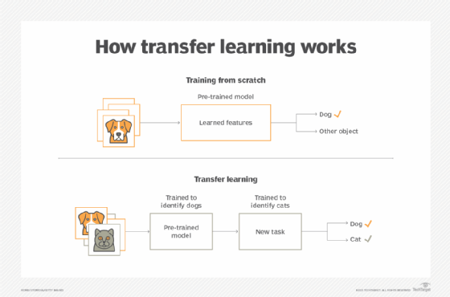
Transfer learning leverages knowledge gained from solving one problem and applies it to a different, but related problem. This process is done taking a pre-trained model (usually trained on a large dataset for a related task) and fine-tuning it on a smaller dataset for a specific task. By doing this, the model can learn to generalize better and perform well even with limited labeled data.
In transfer learning, knowledge from a source task is used to enhance learning in a new task. When the transfer method reduces the performance of the new task, it's called a negative transfer. A major challenge when developing transfer methods is ensuring positive transfer between related tasks while avoiding negative transfer between less related tasks. When knowledge is transfered from one task to another, the original task's characteristics are usually mapped onto those of the other task to specify correspondence. Traditionally, this alignment is provided by a human, but evolving methods are emerging that automate this mapping process.
Transfer learning can be executed through various methods. One approach involves identifying a related task, denoted as Task 2, that possesses ample labeled data transferable to the new task. The model is subsequently trained on Task 2, providing it with a foundation for addressing its primary task, Task 1.
Alternatively, transfer learning can leverage a pre-trained model, simplifying the process by utilizing an already trained model. The pre-trained model should have been trained on a large dataset for a similar task as Task 1. These models can be sourced from online repositories or other developers who have shared their work.
A third strategy, known as feature extraction or representation learning, employs deep learning techniques to discern the most significant features for Task 1, thereby establishing a representation of the task. While features are traditionally crafted manually, deep learning autonomously extracts features. Data scientists then select the pertinent features to inclide in the model. This learned representation can also be applied to other tasks.[9]
When using transfer learning, it is important to choose the most suitable strategy, and there are three key points to consider:
1. The first and most crucial question is the identification of which part of the knowledge should be transferred from the source to the target in order to address the target task’s problem.
2. Another important point is when the transfer should be made. There can be scenarios where the application of Transfer Learning methods may lead to a degradation of results. In reality, these performances depend on the similarity between the source and target domains and tasks
3. Lastly must be choose how is the transfer going to be done. Once the "what" and "when" questions have been addressed, the most appropriate Transfer Learning technique for the problem at hand can be rightly identified.[10]

1.4.2. Meta-Learning
Meta-learning, with its focus on acquiring the ability to adapt to new tasks, plays a pivotal role in tackling the obstacle presented by scarce labeled data in few-shot classification scenarios. This enables models to leverage previous knowledge garnered from different tasks to operate efficiently with minimal instances for unfamiliar tasks. [11]
Meta-learning in general means learning about learning. The focus of meta-learning is to create models and algorithm where the main objective is to adapt quickly to new tasks and environments, even with minimal amount of training data as given in few-shot learning. This approach can achieve new heights in learning new concept as fast as possible (as a human would do) even in more complex scenarious where the datasets aren’t huge or detailed. [12]
The key idea is to let meta learning agents to improve the learning ability over time, using two different level in learning: an inner and an outer level:
- The inner level refers to the learning of a new single task. The agent tries to learn the associated concepts from the dataset. This learning often involves only a small amount of data for each task, as the model leverages the knowledge gained from the outer level to quickly adapt.
- The outer level (also called meta-learning level) involves learning across tasks or domains. The model learns patterns or strategies from a distribution of tasks, which it can then use to adapt to new tasks more efficiently.
In regular supervised learning the key point is to obtain the globally optimal parameters ϑ, where the objective is to find the right ϑ which minimize:
ϑ= $\underset{ϑ}{\underbrace{\arg{min}}}{loss_function({ ϑ}_{0}){}}$
In general, finding ϑ is computationally hard or even unfeasible. It’s possible however to approximate ϑ using pre-defined knowledge ώ. This parameter includes the initial model parameters $ϑ_{0}$, the choice of an optimizer and the learning rate schedule.
In meta learning the main objective is to find the best ώ instead of assuming ώ as pre-given as in classical deep learning. Obtaining the best ώ is key to get the model to learn new tasks as quickly as possible. The right parameters are heavily influenced by the set of tasks the model must do and their frequencies in percentage.
Parlare degli algoritmi di meta-learning? MAML,matching networks,…?

1.4.2.1 Meta-Learning vs Transfer Learning
Considered the transfer learning discussed before, it’s entirely possible to transfer knowledge of previous tasks to new, unseen tasks. That’s why over time, the line between Transfer Learning and Meta-Learning has become increasingly blurred. A defining characteristic of meta-learning techniques, however, is their meta-objective, which explicitly targets performance optimization across a task distribution (as illustrated in earlier sections by computing the expected loss over a task distribution). This objective isn't necessarily a component of all transfer learning techniques.

1.4.3. Data Augmentation
In scenarious like few-shot learning the
1.4.4. Generative Models?

Few-shot Bioacoustic Event Detection
The focus of this thesis paper is to find a good solution for the challenge 5 of the DCASE Challenge 2024, Few-shot Bioacoustic Event Detection. As the name of the task suggests, the challenge main theme is sound event detection in a few-shot learning setting and in particular for animal (mammal and bird) vocalisations.
The main objective of the challenge is to create a model able to detect specific animal sounds in an audio. Furthermore, another fundamental criterion is the obligation to train the model with a few-shot supervised learning algorithm.
The reason for the technical committee to give a so hard constraint is explicit referred in the official documentation for the task: “Few-shot learning is a highly promising paradigm for sound event detection. It is also an extremely good fit to the needs of users in bioacoustics, in which increasingly large acoustic datasets commonly need to be labelled for events of an identified category (species or call-type in this case), even though this category might not be known in other datasets or have any yet-known label.”

Dataset of the challenge
The dataset of the challenge is split into training and validation sets. The training set consists of five sub-folders deriving from a different source each for different animals. Along with the audio files multi-class annotations are provided for each. The validation set consists of two sub-folders deriving from a different source each, with a single-class (class of interest) annotation file provided for each audio file. No informations are provided about the content of the validation set. This is done to ensure the partecipants can validate the model in a similar manner to the evaluation set.[13]
The evaluation set, provided later by the committee team, has a structure similar to the evaluation set. The outcome of the challenge, along with the associated score, will be determined based on the results obtained from the event detection on this set.
In the Few-shot Bioacoustic task, the training dataset is multi-labeled, as the annotations provided contain multiple classes of interest. However, both the validation and evaluation datasets are single-labeled, implying that each audio file is annotated for only one class of interest. Despite the presence of events from other classes, they remain unannotated and should not be predicted by the system. Furthermore, due to the few-shot setup of this task, each audio file in the evaluation set is solely accompanied by annotations for the initial 5 events of the class of interest. [14]

IDEE:
- Transfer learning classico, problema di differenza di dominio, in questo caso abbiamo task “simili” cioè riconoscere versi di animali ma con classi di animali diverse tra training, validation e evaluation set. Domanda, sono task abbastanza simili per riuscire a trasferire effetivamente knowledge o ci stiamo solo adattando ai dati e poi in evaluation va tutto male? Teoricamente c’è un domain gap assoluto o quasi, è molto probabile non ci siano intersezioni di classi tra training/validation e evaluation set.
- Meta learning classico con i vari task che creano il task set. Problema è che c’è il rischio che ci sia un negative migration del model e in più andrebbe fatto super ad hoc per questo caso. Domanda riconoscere ogni singola classe è considerabile un task a sè stante?
- GAN? Uso una adversarial per crearmi un dataset pieno, però domanda, riesco a creare dati utili e utilizzabili cosi. Inoltre l’evaluation set mi verrà dato in futuro e con classi totalmente nuove, ha senso fare una cosa del genere?
- Multimodal learning: training doppio, da un lato audio puri (se si può fare) e dall’altro audio trasformati in immagini tramite ad esempio un Audio Spectrogram Transformer. Domanda, questa forma di “data augmentation” è davvero tale ed è considerata multimodale? Porta a maggiori info e quindi aiuta il modello effettivamente?

IDEE DOCUMENTO UFFICIALE CHALLENGE 2023:
- Template matching: Si prendono i 5 esempi iniziali come templates e si fa la crosscorrelazione di ogni template con il rimanente file audio. Gli eventi vengono predetti selezionando i time frames dove la cross-correlazione supera una certa soglia (che va trovata)
- Prototypical networks: Prototypical networks, on the other hand are trained through episodic learning and employ a 5-way-2-shot classification model in our case. Each prototype represents a coordinate in vector space, calculated as a mean of the coordinates of the 5 samples. Training comprises a Support set of 5 labelled samples from each class, while the remaining samples form the Query set. A class prototype is computed via an embedding function with learning parameters. Distances are optimised, and the network training creates a general representation where similar sounds are closer. In this way, the future data points are labelled using nearest-neighbour algorithms.

IDEE VINCITRICI ANNO SCORSO:
- Multi-task frame-level embedding system ?
- Separation model?
- Usano un transformer encoder layer come modulo temporale
Data augmentation: Fanno un training augmentation e un fine-tuning augmentation in modo diverso.
- Nel training per aumentare la size del training set usano “Kaldi tools?” per perturbare gli audio a varie velocita (0,9x, 1x e 1,1x) per cambiare timbro e intonazione. Inoltre fanno un time-frequency masking e aggiungono un rumero gaussiano random per aumentare la generalizzazione del feature extractor.
- Nel fine-tuning per bilanciare la perdita di info data dal TF masking che causerebbe problemi nel transfering usano un “FilterAugment” per aumentare la Per channel energy normalization (?)
- Support set rebuilding: Visto che pensano che la predizione dell’evento nel frame level system non sia troppo dipendente dalle classi negative(quelle che non ci interessano nella predizione per il singolo audio) fanno una combinazione random delle posizioni tra eventi positivi e negativi.
https://dcase.community/documents/challenge2023/technical_reports/DCASE2023_Du_102_t5.pdf

2.1.1.

2.1.2.

rr

2.2.1.

2.2.2.

Tabella 2.2:

2.2.3.

Chapter 3

a.

3.1.1
§2.1

3.1.2

3.1.3

3.1.4
.

r

3.2.1

3.2.2

3.2.2.1

3.2.2.2
3.2.2.3

3.2.2.3

Conclusions

BIBLIOGRAFY
https://cohere.com/blog/what-are-transformer-models
https://aws.amazon.com/it/what-is/transformers-in-artificial-intelligence/

[3] https://towardsdatascience.com/transformers-141e32e69591

[4]https://machinelearningmastery.com/a-gentle-introduction-to-positional-encoding-in-transformer-models-part-1/
https://medium.com/machine-intelligence-and-deep-learning-lab/transformer-the-self-attention-mechanism-d7d853c2c621

[5]https://towardsdatascience.com/transformers-explained-visually-part-1-overview-of-functionality-95a6dd460452
[6] https://towardsdatascience.com/transformers-explained-visually-part-2-how-it-works-step-by-step-b49fa4a64f34
[7] https://towardsdatascience.com/transformers-explained-visually-part-3-multi-head-attention-deep-dive-1c1ff1024853
[8] https://medium.com/analytics-vidhya/masking-in-transformers-self-attention-mechanism-bad3c9ec235c
https://jalammar.github.io/illustrated-transformer/
[9]https://www.techtarget.com/searchcio/definition/transfer-learning#:~:text=Transfer%20learning%20is%20a%20machine,create%20a%20model%20from%20scratch.
[10]https://datascientest.com/en/transfer-learning-what-is-it

https://blog.roboflow.com/few-shot-learning/

[11]https://link.springer.com/article/10.1007/s10462-021-10004-4

[12]https://www.datacamp.com/tutorial/complete-guide-data-augmentation

[13]https://dcase.community/challenge2024/task-few-shot-bioacoustic-event-detection
[14] https://arxiv.org/pdf/2306.09223

