Installation notes

In recent years MATLAB undertook several important changes, which made difficult for us to keep FSDA aligned to the MATLAB system. For example, from R2012a a Toolstrip replaced menus and toolbars in the MATLAB Desktop, a gallery of apps was introduced in the desktop and the documentation system was redesigned, for the first time after years of stability; with R2014a third party software documentation was moved to a separate section without filtering and searching possibilities; with R2014b there was a major update of the MATLAB graphics system that forced us to revisit most of the FSDA plotting functions; with R2015a the third party documentation was changed again, and was partly reintegrated in the MATLAB documentation system. This is why you may find these installation notes rather intricate: we apologise if this is going to happen and we invite you to signal problems or bugs that you think are in contradiction with, or should be reported in, these notes. With your help, it will be easier for us to make these installation notes … superfluous.

1. FSDA works from the release R2009b of MATLAB and uses the Statistics toolbox.
2. FSDA can be installed :
   1. Automatically with our setup program for Windows platforms. The automatic installation updates your MATLAB search path and installs the FSDA documentation pages in the helpfiles folder, following the layout expected by your MATLAB release.
   2. Manually by unpacking the compressed tar file FSDA.tar.gz under a folder of your choice (say programs). The search path update and documentation setup can be done by running the MATLAB scripts addFSDA2path.m and setuphelp.m that are located respectively in the FSDA folder and the utilities subfolder. The same scripts can be used at any time to repeat, if necessary, these two steps.
3. If FSDA has been installed properly (in what follows without loss of generality we assume, for example, that FSDA has been installed in folder /Users/FSDA), after the installation the **“Set Path” window of MATLAB should include the following FSDA search paths** (the last three being introduced with FSDA V3.0 (i.e. with MATLAB R2015a).

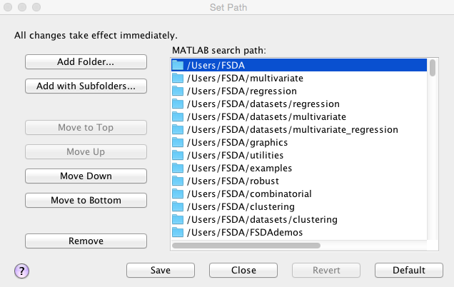

1. If there are multiple releases of MATLAB installed in your computer, our setup program will ask you to **choose to which release the FSDA Toolbox has to be associated and where** (under which folder) it has to be installed. The search path update and documentation setup are modified accordingly. However, if other MATLAB releases are present and the user intends to run FSDA also on them, the two steps should be completed manually by using the already mentioned addFSDA2path.m and setuphelp.m scripts (see 2b) as follows (now assuming a MS Windows platform installation under D:\programs\FSDA):

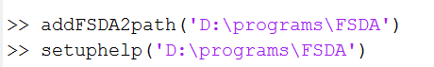

1. If FSDA is installed in MATLAB R2012b or subsequent releases, three APPS (brushRES, brushFAN and brushROB) are automatically installed:

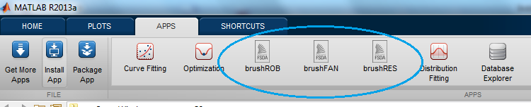

Remark: if the three APPS have not been automatically installed, you can easily install them manually by double clicking on the files brushFAN.mlappinstall, brushRES.mlappinstall and brushROB.mlappinstall contained in the root folder of FSDA.

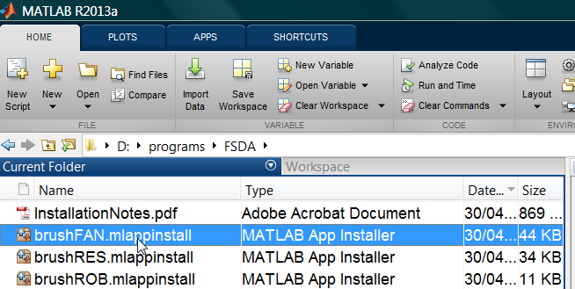

If FSDA is installed in MATLAB 2012a or earlier the three APPS appear inside MATLAB Start button|Toolboxes|FSDA.

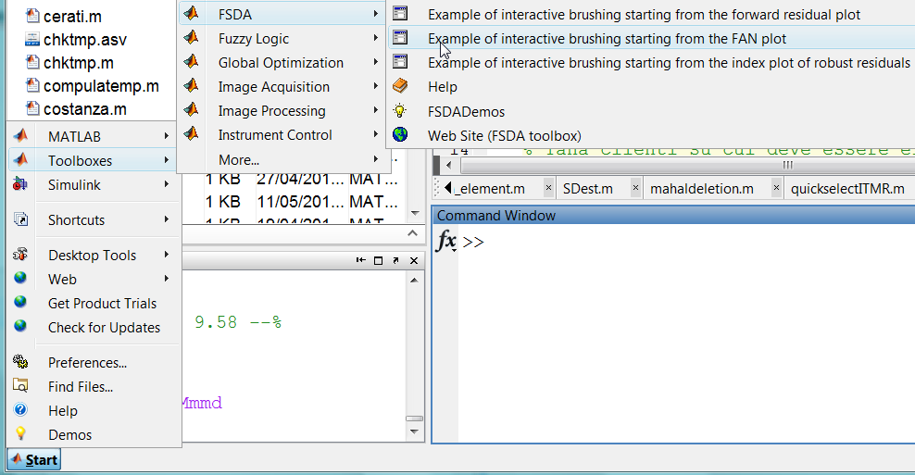

These APPS are graphical user interfaces conceived to demonstrate some functionalities of FSDA.

1. Our setup program, if successfully executed, adds to the “Program Files” Windows Menu the entry “FSDA toolbox for MATLAB”, includinga **FSDA uninstall program** that should be used by the user to remove an obsolete FSDA release, before an update:

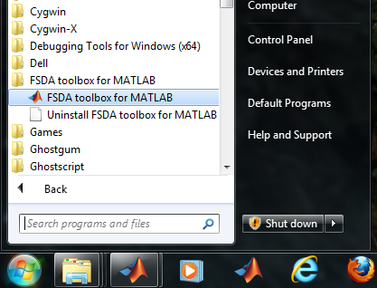

1. Nonetheless, to avoid problems that may occur if FSDA is installed with our setup program more than once, the setup program tries to locate and remove (with the agreement of the user) previous FSDA installations. Of course, your personal copies of FSDA folders not included in D:\programs\FSDA will not be affected.
2. If everything went well with an automatic or manual installation, when you open MATLAB:
   1. **The MATLAB “Help” pages should include FSDA with all its submenus**, as shown here:

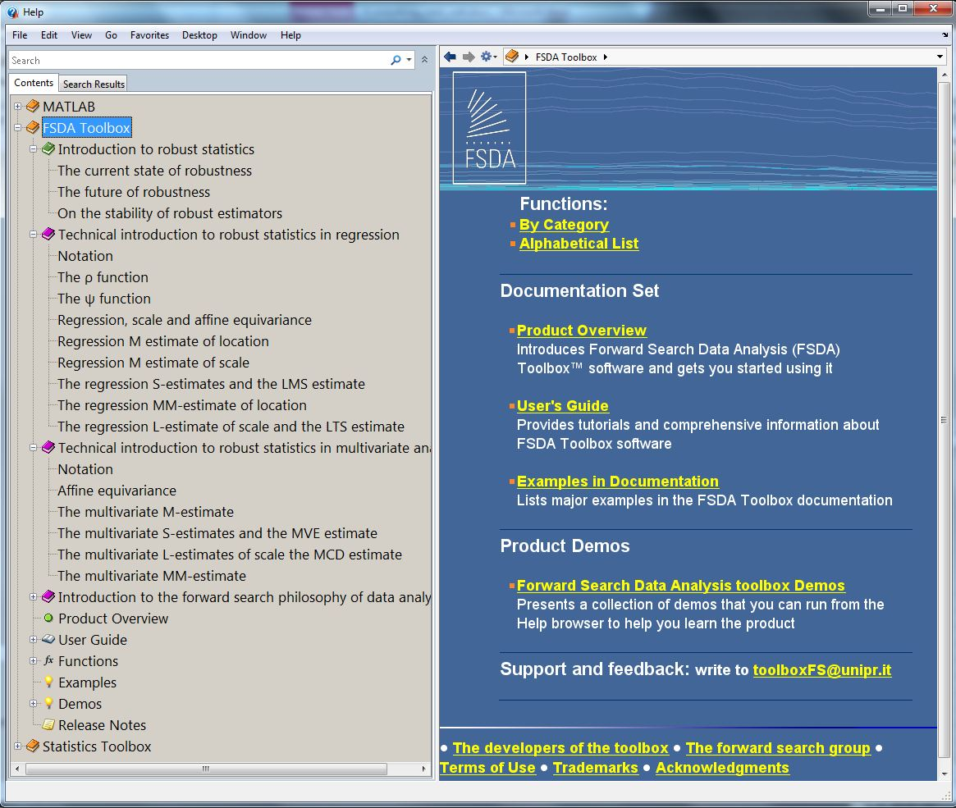

* 1. **or as shown here in the new R2015a MATLAB documentation style:**

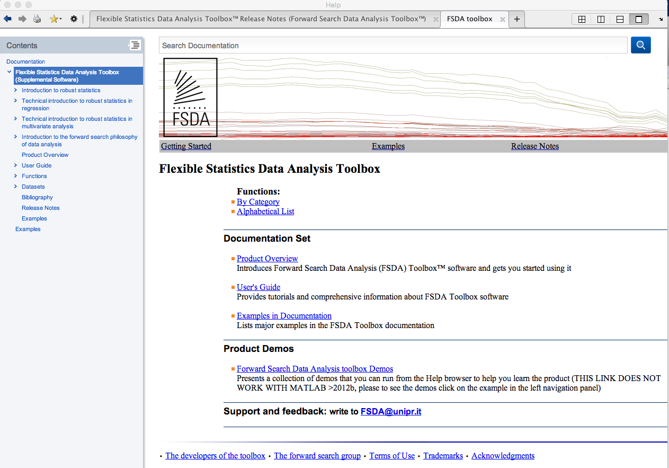

* 1. **With the setup installer, two example files named “examples_regression.m” and “examples_multivariate.m” should be opened automatically.** These files contain a series analysis of several well-known datasets in the literature of robust statistics and have the purpose to let the user familiarize with the toolbox**.**

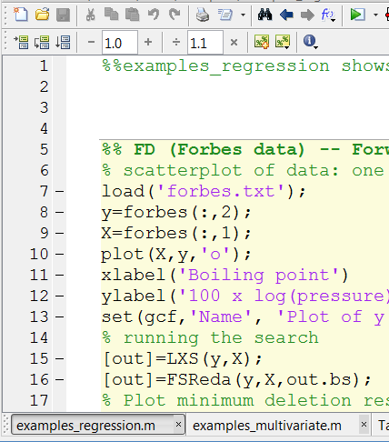

* 1. **FSDA should appear among the installed “Toolboxes” in the MATLAB “Start Menu” (only for MATLAB releases before R2012b)**

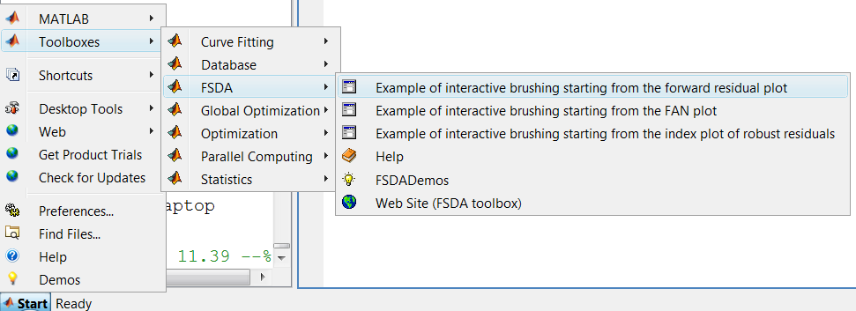

* 1. **For MATLAB R2012b+ installations, the html help files can be found in the Supplemental Software tab** which appears at the bottom of the Doc Center home page(see left panel of screenshot below)**. For MATLAB installations earlier than 2012b, the documentation is located in the same place as all the other official Mathworks toolboxes** (see right panel of screenshot below):

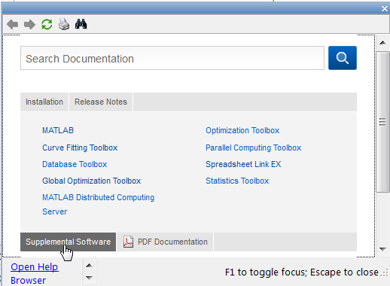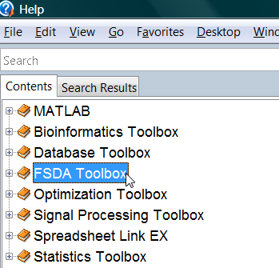

* 1. **If you search for a FSDA function in the MATLAB Help Browser, you should get results as in this example ” (all releases of MATLAB)**:

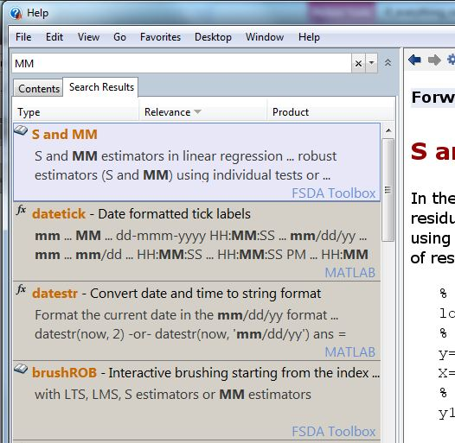

* 1. In the MATLAB function browser (SHIFT+F1), all FSDA functions can be immediately found (only for MATLAB releases lower than R2012b). For example if in the function browser you type FSMmmd, this is what you should get

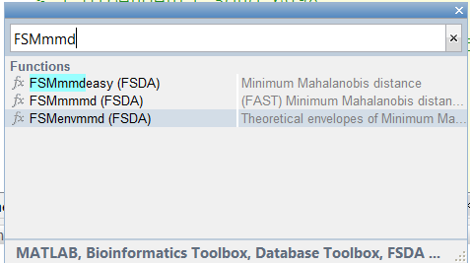

Similarly, using MATLAB releases lower than R2012b typing for example doc FSMmmd (or docsearch FSmmmd) you should automatically see the associated HTML documentation of the function.

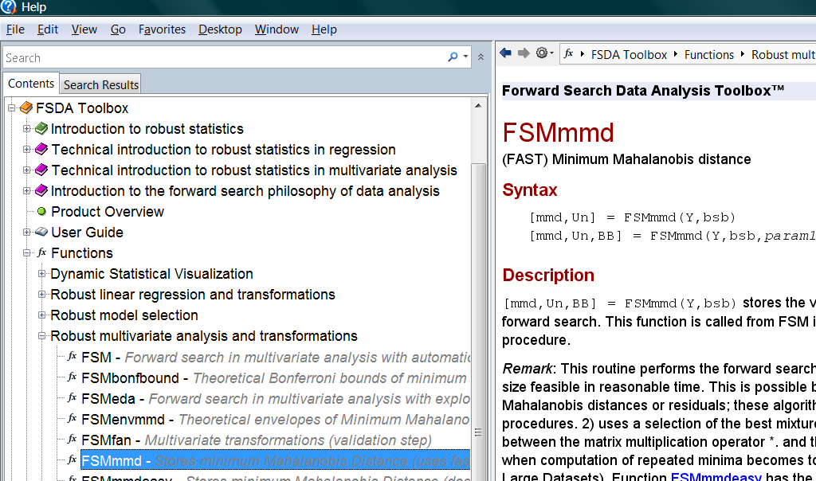

Unfortunately, from release R2012b docsearch does not search custom documentation. As far as we know the only possible way to go directly to the HTML documentation of third parties toolboxes is to use the undocumented option –classic as follows docsearch -classic

1. If you think that the MATLAB Help Browser is not producing proper search results for FSDA functions (like those in Figure 7.e and 7.f):
   1. Check first that in the MATLAB Help Preferences FSDA is selected, as here **(only for releases lower than R2012b):**

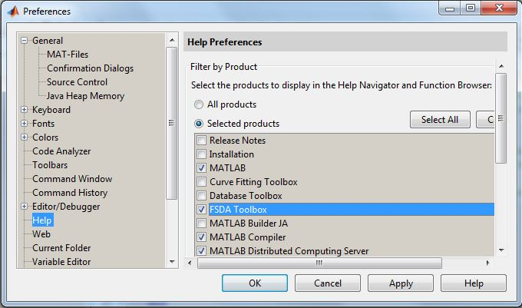

* 1. If it is selected but FSDA functions are never referenced in the search results, **it is likely that some internal index file is corrupted or its encoding is not appropriate for your operating system platform.** In this case, to rebuild the index file, it is sufficient to run the MATLAB builddocsearchdb command, as shown here:

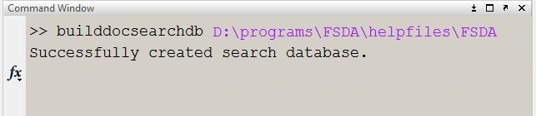

1. If in the help system you cannot find the FSDA toolbox, or you see two duplicate FSDA toolbox instances, it is possible that FSDA is installed in a position where you must have administrator privileges. If you find that inside …\FSDA\helpfiles, there are two subfolders named FSDAR8 and FSDAR8 as follows

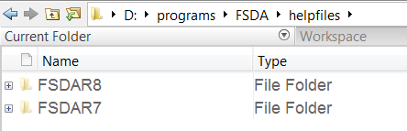

this means that the installation setup has not been able to rename/move these folders. In this case, if you use MATLAB 2012a or earlier rename FSDAR7, FSDA and delete folder FSDAR8. Alternatively, if you use MATLAB 2012b or later rename FSDAR8, FSDA and delete FSDAR7. Our routine setuphelp('D:\programs\FSDA') does in automatic way, what has just been described.

1. **From MATLAB R2015a,** **when you search for a given third party function** **for the first time**, the search results window will display a yellow message warning that a toolbox in the path does not have the proper documentation index file. The window and message produced when attempting to search for documentation about `FSR’ function, are shown here:

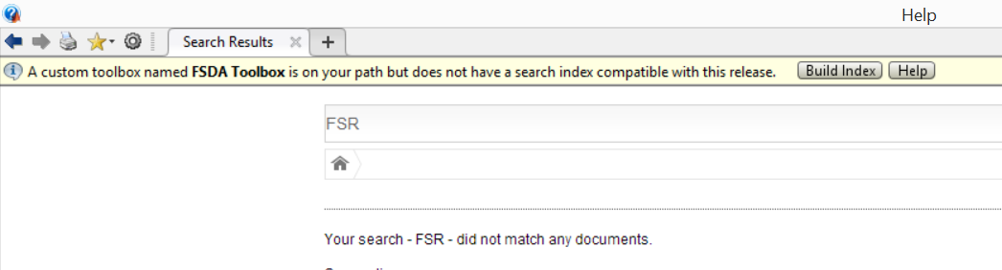

Only after clicking on the Build Index button you should start getting the desired documentation. You will be informed of the successful update of the search database with this message:



**If,** instead of this message and instead of receiving back the desired results, **you receive an error message** such as this one

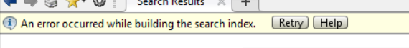

again it is likely that you have installed FSDA in a location without proper permissions and, thus, the index building operation (i.e. the builddocsearchdb command) could not update the search database. The only solution in this case is to obtain the writing permissions or to change location for FSDA. What you should get if the search is successful, is something like the following:

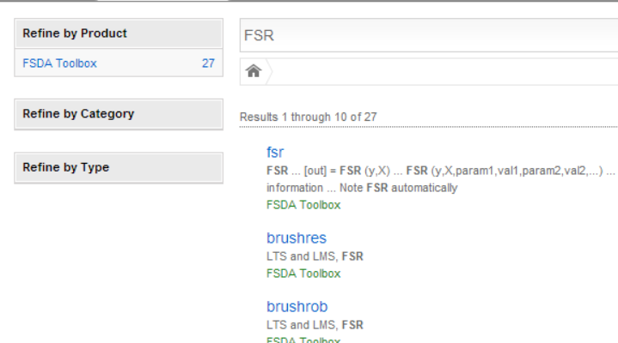

If you think that something not described in these notes went wrong

please do not hesitate to send an e-mail to

[toolboxFS@unipr.it](mailto:toolboxFS@unipr.it)[1]

1. The logo of the toolbox has been designed by Dr. Massimiliano Gusmini.