Training Tracked Final Project Documentation
Name: Aldo Cortez-Lucero
Project Title: Training Tracked
Course: SDEV 200
Date: May 10, 2026

Project Description
Training Tracked is a JavaFX workout tracking application. The purpose of the program is to let a user enter strength workout information, store the workout, search for saved workouts, and view a basic workout summary.
The user can enter the date, exercise name, workout duration, notes, muscle group, sets, reps, weight, and difficulty rating. The program then stores the workout using the non-GUI classes created earlier in the project.
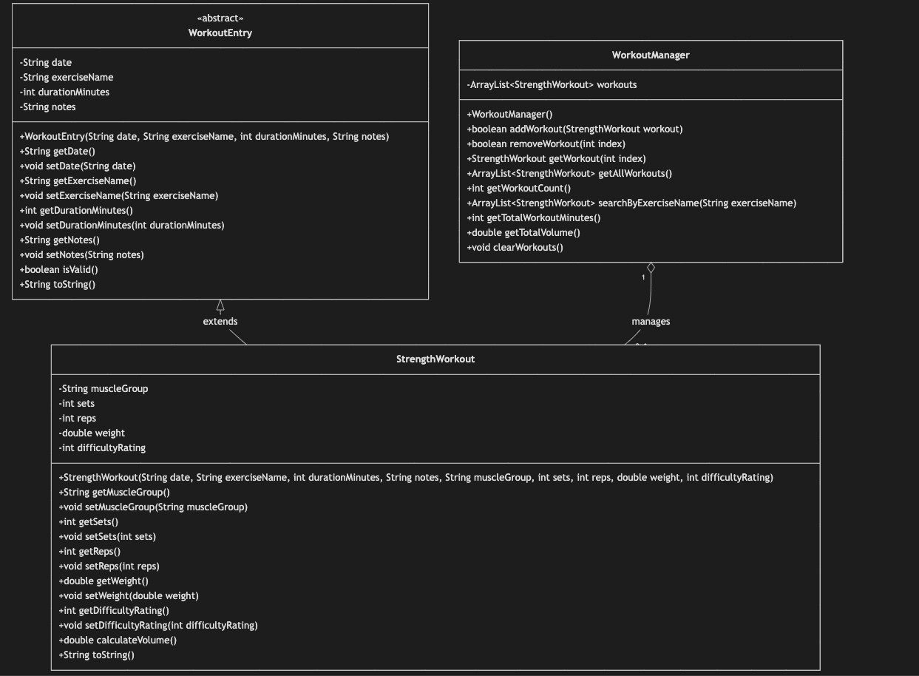
The JavaFX GUI is used only for the user interface. The workout data and logic are handled by separate classes, so the program keeps the interface separate from the main application logic.
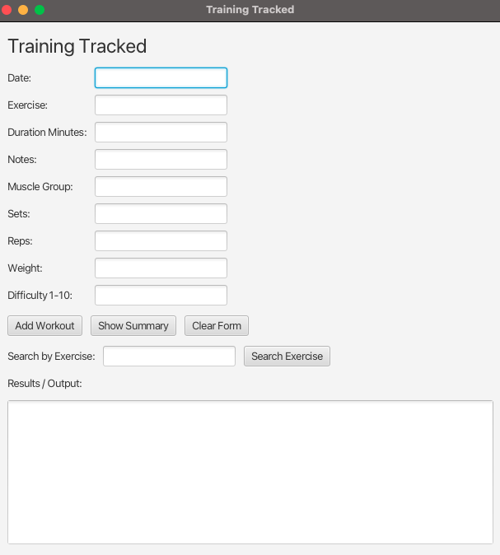
Startup/blank GUI

Filled input fields

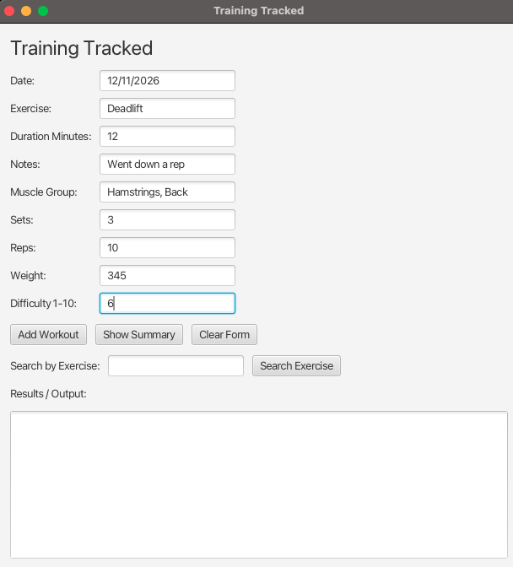

After clicking Add Workout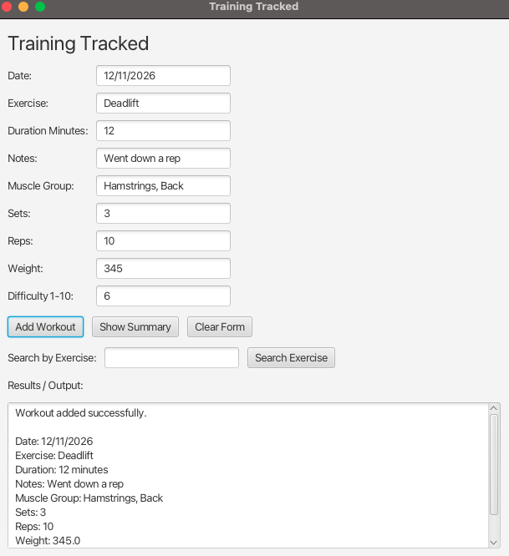

After clicking Show Summary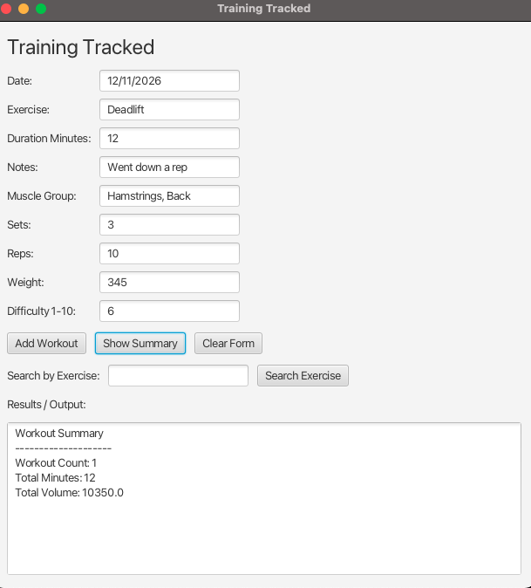

After clicking Search Exercise
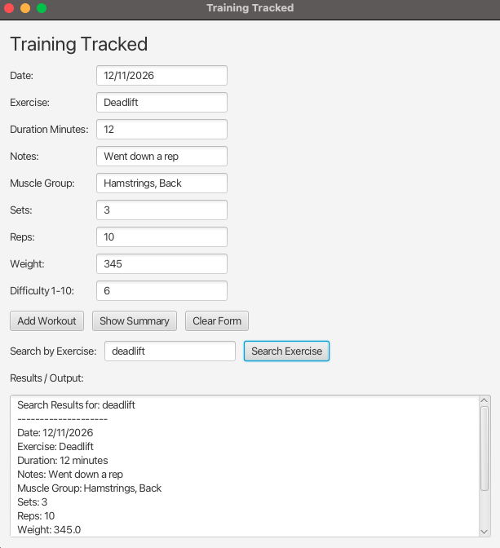

After clicking Clear Form