https://moontowermeta.com/

(12) Using Log Returns And Volatility To Normalize Strike Distances : options (reddit.com)

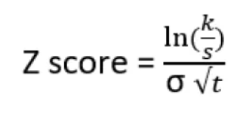

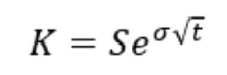

avec Zscore=1

