AAPL Diagonal Spread 1.04.2025

Trade idea is that volatility should converge
May should join Apr – and therefore May vol should go down between 230 and 240 or Apr should go up in the same range:

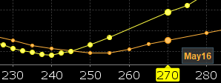
Multi-expiry skew AAPL, April 1st

This means selling May 240 vol and buying April 232.5 vol :
For 2.40$ credit.

The PnL is (assuming a 5 point vol increase) :
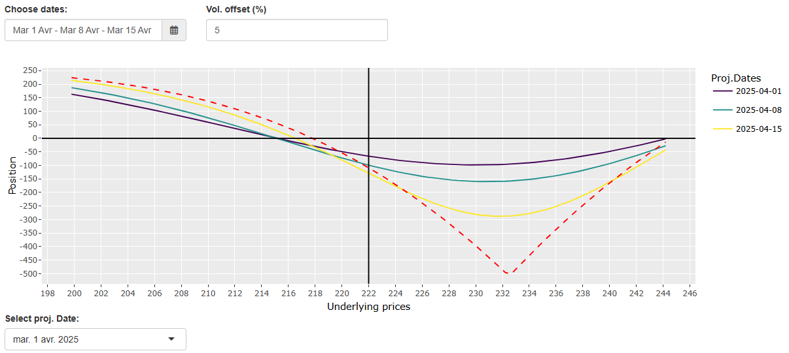
Strategy : Exit on Apr 15th in any case

