ESTX50 end of year Study

Looking for Dec/Jan disparity, i.e. buy Jan 2026, sell Dec 2025 :

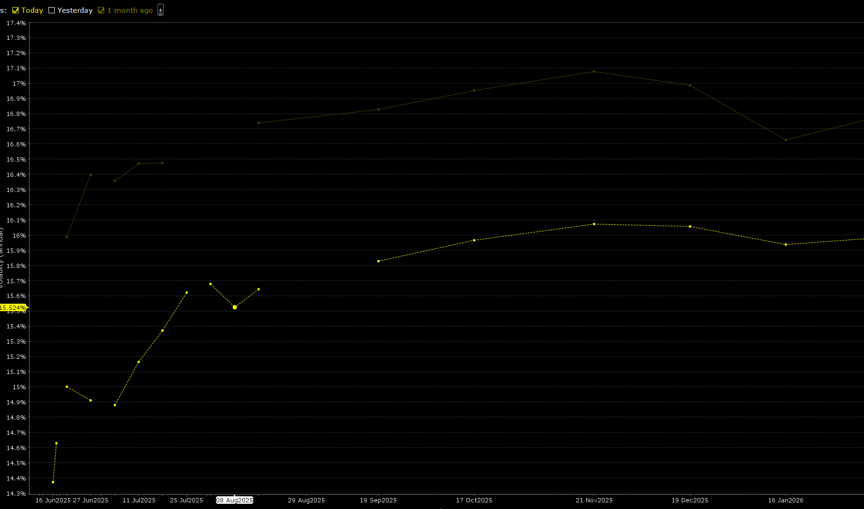
As of 13.06.2025 :

Notice that one month ago it was steeper and it was flat on Jan 13th. (6 months ago) :
