GOLD
1.10.2025

Initial : Bull Call 350/355
Price = 345$
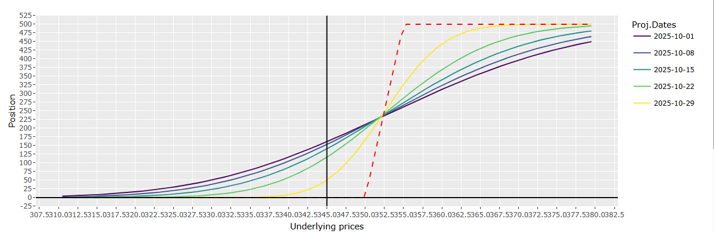
Scenario 1 :
Rachat Call 355, vente Call 360
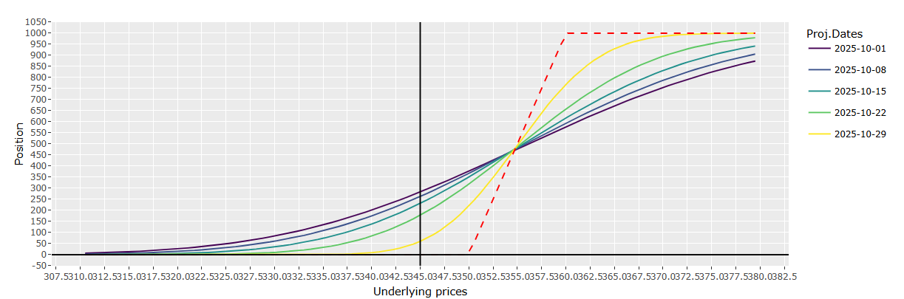
Scenario 2
Vente Bull Call 350/355, achat bull call 355/360

