UVIX Straddle 26.5, 7-Mar trade, Feb 20th – Mar 4th

DELTA RISK MANAGEMENT
On Feb 24th, straddle was already above 30, so straddle adjustment (let the call aside and buy back the 26.5 put and sell the put at 30) should have been made - alleviating some pain for the future. I did not do anything… 2 hours chart taken on March 6th – 12:01pm
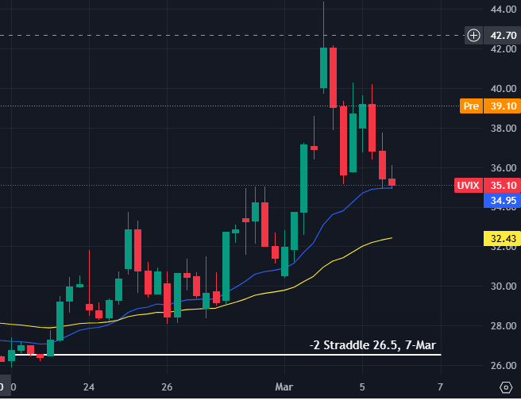

I sold the straddle at the very top of UVIX (worst possible time) – but I was relieved and did not want any exposure to UVIX any more.
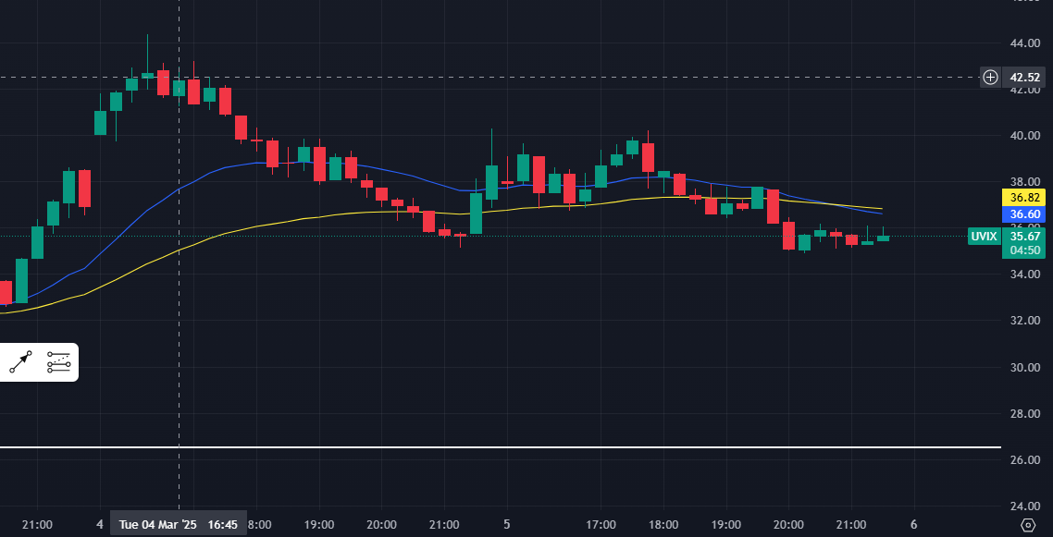

Stratégie d’ajustement des straddles
 | UVIX | IV | Call | Put | Realized Gain/Loss
20.02.2024 | 26.4 | 100 % | Call 26.5 : 2.15 | Put 26.5 : 2.05 | NA
24.02.2024 (Monday) | 30 | 125 % | Call 26.5 : 4.68 | Put 26.5 : 1.15  Put 30 : 2.67 | 0.90 → +180$
03.03.2024 (Monday 18h00) | 31.80 | 102 % | Call 26.5 : 5.35 | Put 30 : 0.76  Put 26.5 : 0.06 | 1.90 → +380$
03.03.2024 (Monday 21h00) | 34 | 150 % | Call 26.5 : 7.59 | Put 26.5 : 0.17  Put 30 : 0.76  Put 34 : 2.34 | 1.90 → +380$
04.03.2024 | 42 | 200 % | Call 26.5 : 15.75 | Put 34 : 0.61 | Put : 1.70 → +340$  Call : -13.6 →  -2720$

Free interest rate = 4.5 %
Trade result : -2720+340+380+180 = -1820$ au lieu de -2327$ - perte toujours élevée (20 % de perte évitée seulement)

Si stop au 2ème ajustement (March 3rd) perte de 520$ au lieu de 1090$ (50 % de perte évitée)

Si stop March 3rd 18h : Loss = 243$, loss=80$ with one adjustment to Put 30.

CONCLUSION : Ne faire qu’un seul ajustement et sortir sinon
Sizing minimal

Looking at BS simulation :

On March 3rd :

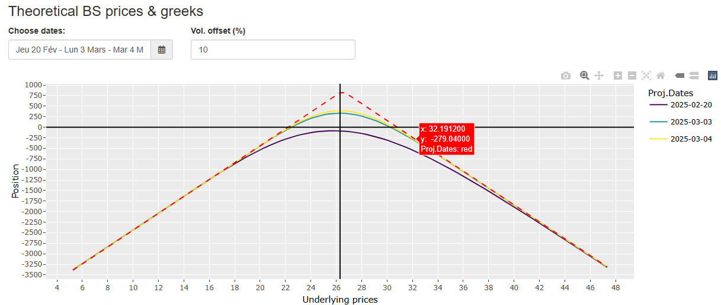

On March 4th :

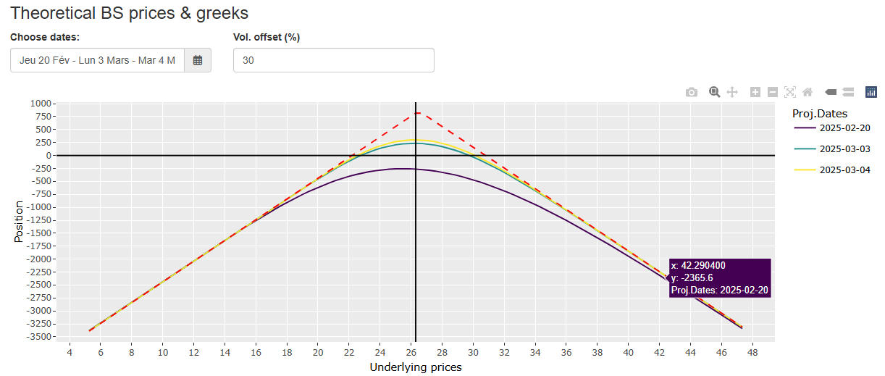

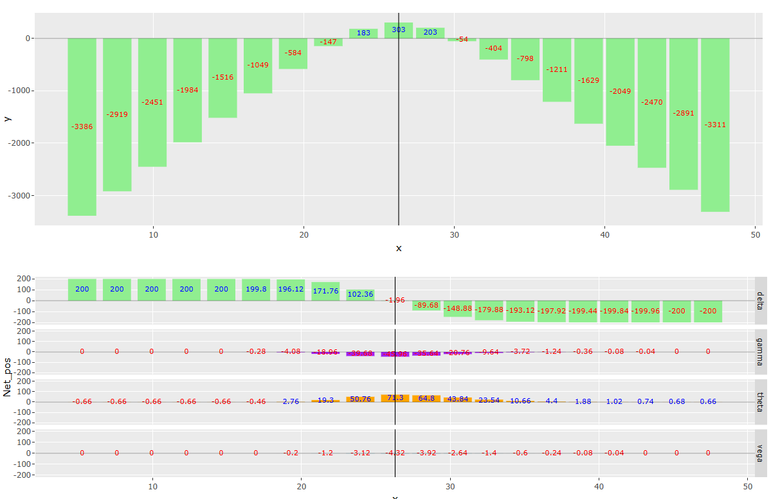

The real point is the gap in VIX (so UVIX change from 26 till 42 – this was a delta 1 trade (-200)) : At this point the loss is 2300 $ - exactly what I got.

VEGA RISK MANAGEMENT

None at this point – only one day left (vega was very small -0.0x...)

2 weeks ago 26.5 Straddle was trading at about 100 % vol.
1 week ago 110 % - not such a big difference.

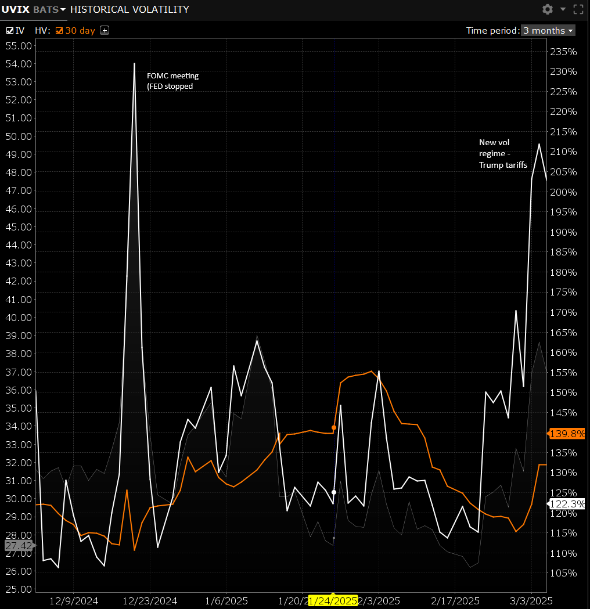

UVIX IV – March 7th expiration strikes IV – Feb 20th, 27th and March 4th

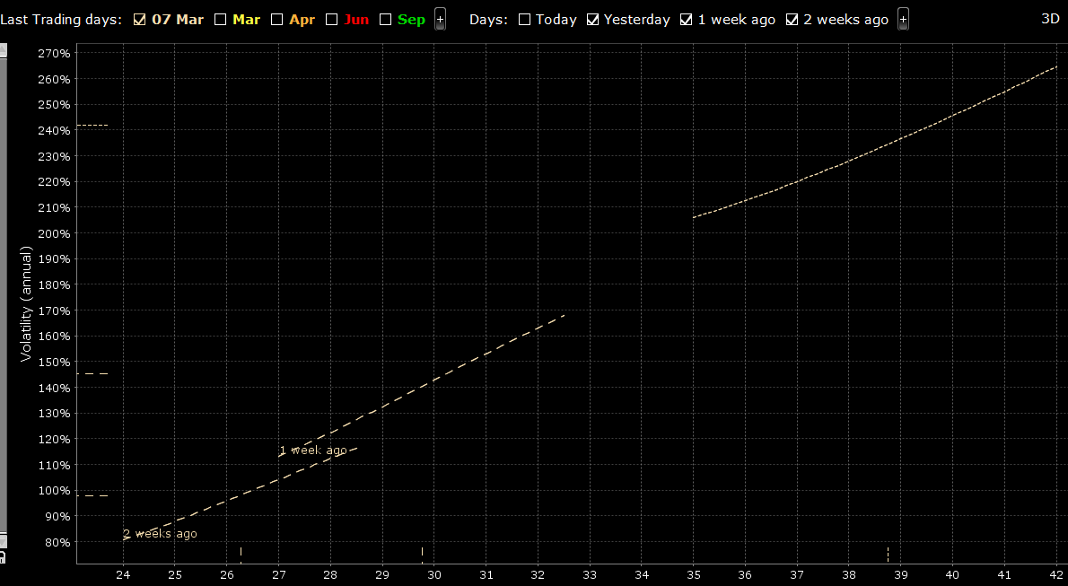

It is interesting to see how UVIX IV moved between Feb 28th (Friday) and Mar 3rd (Monday) :

