SIMPLE LIBRARY SYSTEM

MANAGEMENT

SUBMITTED BY:

CASIMSIMAN, CHRISTIAN
COSAIN, NAHID
COGONON, ALDRIAN
OCHEA, HYEZO SHYENE
SUARIO, GERO

COURSE/SECTION:

BSIT-2, SEC 03

SUBJECTS:
OBJECT-ORIENTED PROGRAMMING

SUBMITTED TO:
MS. BABATID, MARY CLARENCE

CEBU EASTERN COLLEGE, INC.
2026

1. Project Title
Simple Library System Management

2. Project Description
The Simple Library System Management is a desktop application developed using Java and JavaFX. It is designed to help users manage book records through a graphical user interface. The application allows users to enter book information, display records in a table, update existing information, and delete selected records.
Each book record contains an ID, title, author, ISBN, category, and quantity. The system checks required fields and validates the quantity entered by the user.
The application uses an organized structure consisting of model, view, controller, service, and repository classes. This structure demonstrates how object-oriented programming can be applied to develop a simple library management application.

3. Problem Statement
Managing book records manually can be time-consuming and may lead to inaccurate information, misplaced records, and difficulty updating book details. These problems can make it challenging to maintain an organized collection of library records.
The Simple Library System Management addresses these issues by providing a computer-based application for adding, viewing, updating, and deleting book records. It also validates user input to prevent incomplete book information and invalid quantity values.
However, the current application stores records temporarily in memory. Therefore, its records are not retained after the application is closed.

4. Objectives

General Objective
To develop a Java-based graphical application that simplifies the management of book records and demonstrates the practical application of object-oriented programming principles.

Specific Objectives
- To develop a graphical user interface using JavaFX.
- To provide functions for adding, displaying, updating, and deleting book records.
- To organize book information using attributes such as ID, title, author, ISBN, category, and quantity.
- To validate user input and prevent incomplete or invalid book information.
- To organize the program using separate classes for the model, view, controller, service, and repository.
- To apply object-oriented programming concepts in the development of the application.
- To identify and test the major functions of the system.

5. System Features

5.1 Add Book
Allows users to enter a book's title, author, ISBN, category, and quantity. The system assigns an ID and adds the new record to the table.

5.2 Display Book Records
Displays available book records in a table with columns for ID, title, author, ISBN, category, and quantity.

5.3 Update Selected Book
Allows users to select an existing book and modify its information. The system validates the new information before updating the record.

5.4 Delete Selected Book
Allows users to delete a selected book record from the table and the application's in-memory collection.

5.5 Clear Form
Clears the input fields and removes the current table selection.

5.6 Input Validation
Checks whether title, author, ISBN, and category are provided. It also requires quantity to be a whole number and prevents negative quantities.

5.7 Error Messages
Displays error dialogs when an operation cannot be completed, such as when required fields are missing, quantity is invalid, or no book is selected for updating or deleting.

5.8 Automatic ID Assignment
Assigns a sequential ID to each newly added book during the current application session.

System Limitations
The application does not currently include permanent database storage, book searching, or borrowing and returning transactions. Book records are stored in memory and are lost when the application closes.

6. OOP Implementation

6.1 Encapsulation
Encapsulation is demonstrated in the Book class, where its attributes, including id, title, author, isbn, category, and quantity, are declared private. Public getter and setter methods provide access to these attributes. This keeps the book's data and its related access methods organized within one class while preventing direct access to private fields from other classes. Other classes also use private fields to protect their internal data and references from direct external access.

6.2 Inheritance
Inheritance is demonstrated by the MainApp class, which extends JavaFX's Application class. MainApp receives application lifecycle functionality from JavaFX and implements the start(Stage stage) method to configure and display the library system's main window.

6.3 Polymorphism
Polymorphism is demonstrated through method overriding in MainApp. The class overrides the start(Stage stage) method inherited from JavaFX's Application class, providing the application's specific startup behavior.

6.4 Abstraction
Abstraction is demonstrated through the separation of the system into the view, controller, service, and repository layers. The BookView class handles the graphical interface, while BookController receives the user's requested actions and passes them to BookService. BookService contains the main rules for adding, updating, deleting, and validating book information, while BookRepository handles the in-memory collection of books. This structure hides lower-level details from the classes that do not need to manage them. For example, BookView can request an update through the controller without directly changing the repository's list. The application also uses JavaFX's Application class as an abstraction for application startup, allowing MainApp to provide its own start(Stage stage) implementation.

7. UML Class Diagram
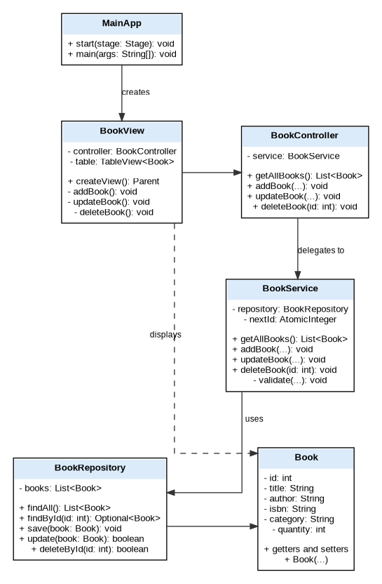
Figure 6. UML Class Diagram of the Simple Library System Management
The diagram shows the main classes and how they work together. MainApp initializes the application components. BookView presents the interface and communicates with BookController; the controller delegates operations to BookService; the service validates book information and uses BookRepository to manage records; and BookRepository stores and updates Book objects in memory.

8. GUI Screenshots

Figure 1. Main Application Interface
(EH BUTANG SS DRI BRO)
Figure 2. Adding a Book
(EH BUTANG SS DRI BRO)
Figure 3. Updating a Book
(EH BUTANG SS DRI BRO)
Figure 4. Deleting a Book
(EH BUTANG SS DRI BRO)
Figure 5. Input Validation
(EH BUTANG SS DRI BRO)

9. Testing

10. Conclusion
The Simple Library System Management was developed as a Java desktop application using JavaFX to make basic book-record management easier. The system allows users to add, view, update, and delete book records, clear the form, and receive error messages when required information is missing or invalid. The project also demonstrates the object-oriented programming principles of encapsulation, inheritance, polymorphism, and abstraction, together with a layered structure that separates the interface, controller, service, repository, and model responsibilities. Testing the main operations helps show that the application responds to common user actions and validates important input. At present, the records are stored only in memory, so they are lost when the application closes. Future improvements could include database storage, book searching, and borrowing and returning features. Overall, the project meets its main objective of providing a simple graphical tool for managing book records while demonstrating the practical use of Java and object-oriented programming.

