周会

# 一、主要资产类别回顾

表: 大类资产涨跌情况

| **资产类别** | **地区/板块** | **指数名称** | **最新点位** | **涨跌幅** | | |
| --- | --- | --- | --- | --- | --- | --- |
|  |  |  |  | **本周** | **本月** | **本年** |
| **Equity** | **MSCI EM** | **MXEF Index** | **1,353.5** | **4.78%** | **4.82%** | **4.82%** |
| **China** | **SHCOMP Index** | **3,570.1** | **2.79%** | **2.79%** | **2.79%** |
| **Europe** | **SX5E Index** | **3,645.1** | **2.60%** | **2.60%** | **2.60%** |
| **Japan** | **NKY Index** | **28,139.0** | **2.53%** | **2.53%** | **2.53%** |
| **Global** | **MXWO Index** | **2,753.3** | **2.35%** | **2.35%** | **2.35%** |
| **US** | **SPX Index** | **3,824.7** | **1.83%** | **1.83%** | **1.83%** |
| **Rates** | **China** | **I08272CN Index** | **197.6** | **0.17%** | **0.17%** | **0.17%** |
| **Europe** | **LEATTREU Index** | **286.0** | **-0.06%** | **-0.06%** | **-0.06%** |
| **Japan** | **SPBJPGOT Index** | **107.6** | **-0.08%** | **-0.08%** | **-0.08%** |
| **US** | **LUATTRUU Index** | **2,529.2** | **-1.18%** | **-1.18%** | **-1.18%** |
| **UK** | **BCEK1T Index** | **426.7** | **-1.54%** | **-1.54%** | **-1.54%** |
| **Credit** | **SSECB** | **000139.SH** | **333.3** | **1.38%** | **1.38%** | **1.38%** |
| **<EU> HY** | **LP01TREU Index** | **422.4** | **0.53%** | **0.53%** | **0.53%** |
| **Chinabond AAA Corporate** | **CBA04201.CS** | **187.0** | **0.25%** | **0.25%** | **0.25%** |
| **<US> HY** | **LF98TRUU Index** | **2,343.5** | **0.23%** | **0.23%** | **0.23%** |
| **Chinabond AA Corporate** | **CBA04001.CS** | **222.1** | **0.22%** | **0.22%** | **0.22%** |
| **Chinabond Composite** | **CBA00101.CS** | **202.6** | **0.21%** | **0.21%** | **0.21%** |
| **<EU> IG** | **LECPTREU Index** | **266.7** | **0.19%** | **0.19%** | **0.19%** |
| **<EM> HY Corp** | **BEBGTRUU Index** | **1,446.4** | **-0.40%** | **-0.40%** | **-0.40%** |
| **<Asia> HY** | **I29384US Index** | **263.6** | **-0.51%** | **-0.51%** | **-0.51%** |
| **<EM> Corp** | **BSEKTRUU Index** | **315.0** | **-0.52%** | **-0.52%** | **-0.52%** |
| **<CN> HY** | **I29381US Index** | **260.4** | **-0.62%** | **-0.62%** | **-0.62%** |
| **<Asia>** | **BEUCTRUU Index** | **208.1** | **-0.82%** | **-0.82%** | **-0.82%** |
| **<CN>** | **I29380US Index** | **206.6** | **-0.89%** | **-0.89%** | **-0.89%** |
| **<Asia> IG** | **I29385US Index** | **196.2** | **-0.95%** | **-0.95%** | **-0.95%** |
| **<CN> IG** | **I29382US Index** | **184.7** | **-1.01%** | **-1.01%** | **-1.01%** |
| **<EM> Sovereign** | **BSSUTRUU Index** | **419.1** | **-1.03%** | **-1.03%** | **-1.03%** |
| **<EM> IG Corp** | **BEHGTRUU Index** | **551.4** | **-1.04%** | **-1.04%** | **-1.04%** |
| **<US> IG** | **LUACTRUU Index** | **3,506.6** | **-1.52%** | **-1.52%** | **-1.52%** |
| **FX** | **JPY** | **JPY Curncy** | **103.9** | **0.72%** | **0.67%** | **0.67%** |
| **USD** | **DXY Index** | **90.1** | **0.18%** | **0.18%** | **0.18%** |
| **EUR** | **EUR Curncy** | **1.2** | **0.02%** | **0.02%** | **0.02%** |
| **CNH** | **USDCNH Curncy** | **6.5** | **-0.58%** | **-0.58%** | **-0.58%** |
| **GBP** | **GBP Curncy** | **1.4** | **-0.76%** | **-0.75%** | **-0.75%** |
| **CNY** | **USDCNY Curncy** | **6.5** | **-0.81%** | **-0.81%** | **-0.81%** |
| **CNH12M Forward** | **CNH12M Curncy** | **1,255.0** | **-14.77%** | **-14.33%** | **-14.33%** |
| **Commodity** | **Brent Oil** | **CO1 Comdty** | **56.0** | **8.09%** | **8.09%** | **8.09%** |
| **QHD Thermal Coal** | **COASQI55 Index** | **782.0** | **6.39%** | **6.39%** | **6.39%** |
| **Copper** | **LMCADY LME Comdty** | **8,118.0** | **4.76%** | **4.76%** | **4.76%** |
| **Aluminum** | **LMAHDY LME Comdty** | **2,024.0** | **2.55%** | **2.55%** | **2.55%** |
| **Rebar 25mm** | **CDSPDRAV Index** | **4,372.0** | **1.32%** | **1.32%** | **1.32%** |
| **Gold** | **XAU BGN Curncy** | **1,849.0** | **-2.62%** | **-2.60%** | **-2.60%** |
| **Volatility** | **VIX** | **VIX Index** | **21.6** | **-5.23%** | **-5.23%** | **-5.23%** |

# 二. 主要板块回顾

## 1. 全市场概览

### 1) 指数与估值

图: 收益与估值

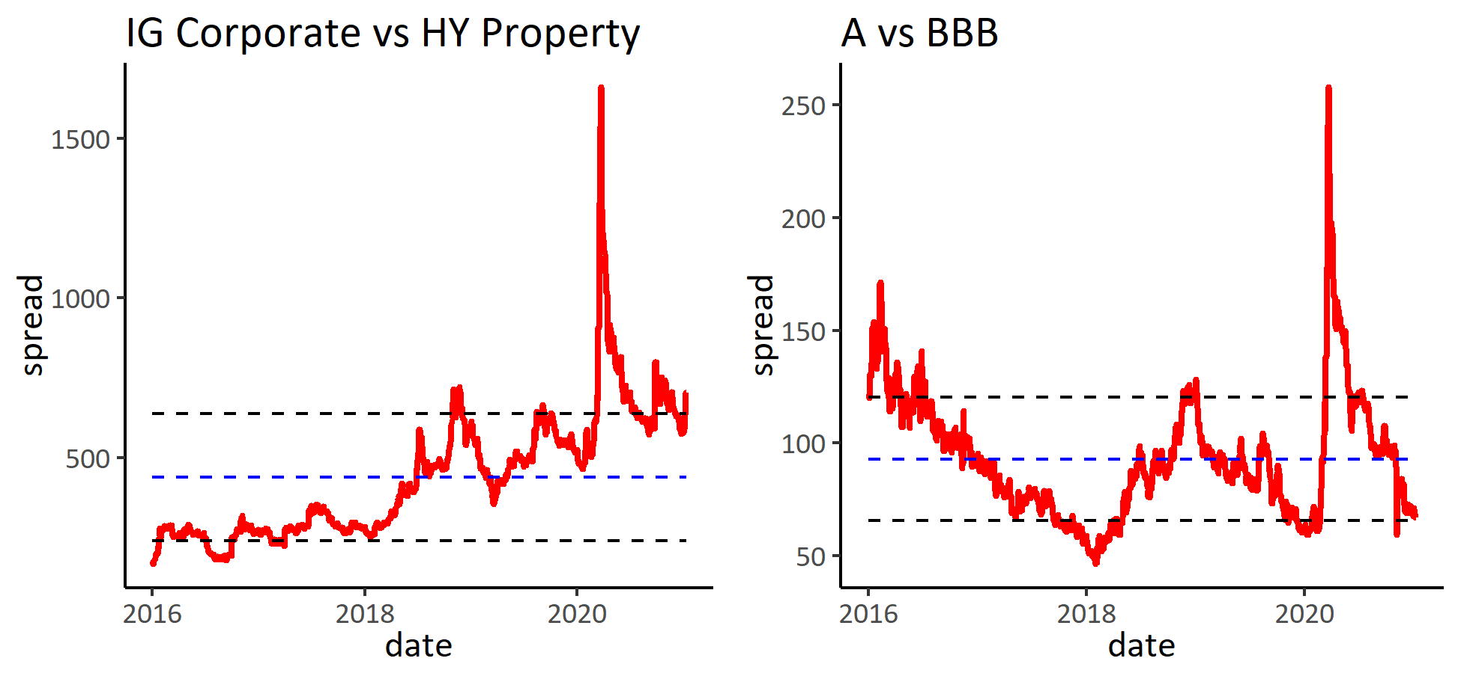

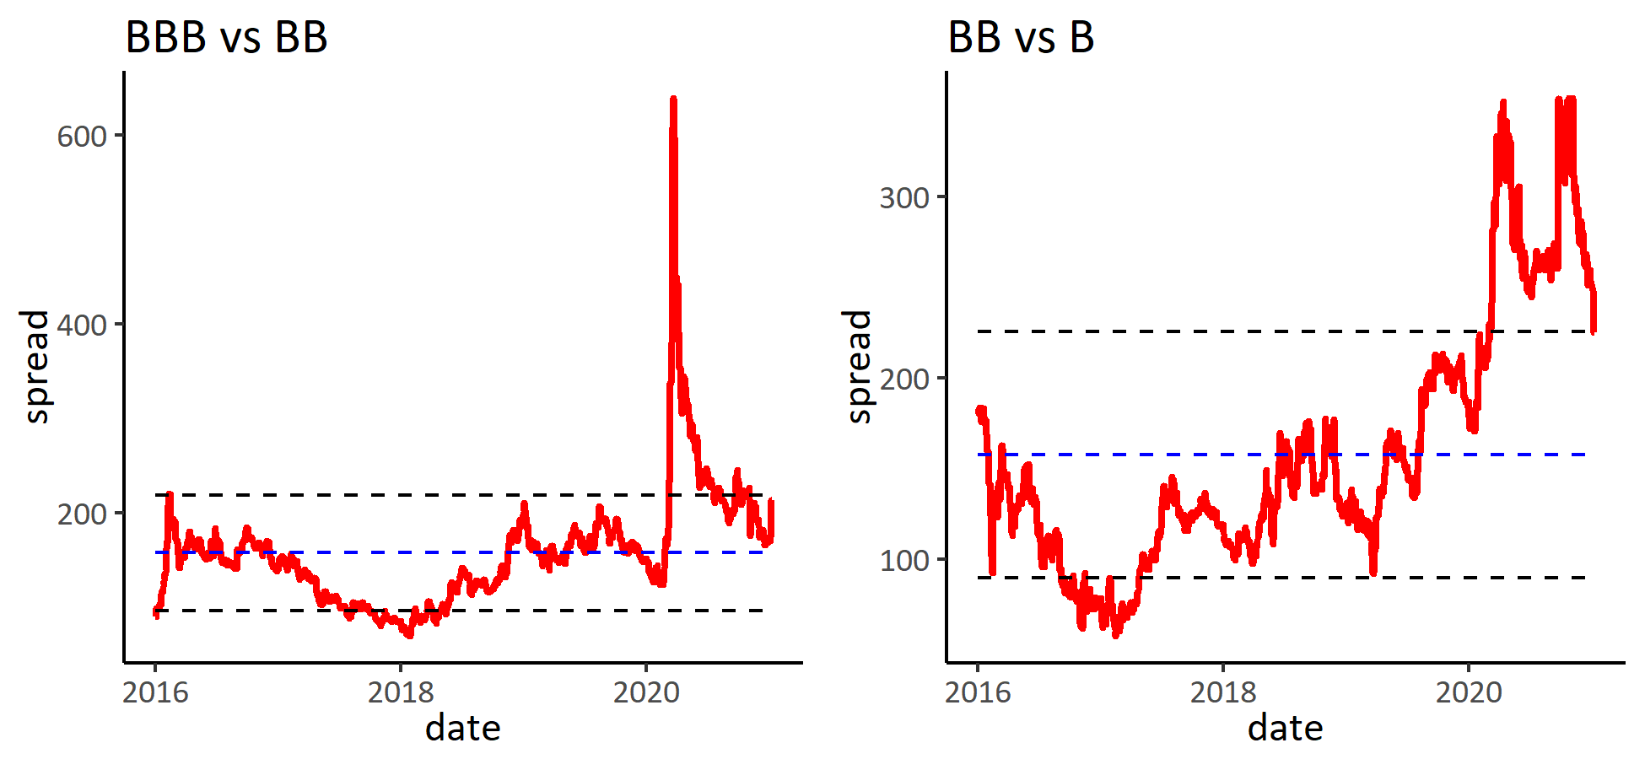

### 2) 板块涨跌幅

表: 按类别分组

|  | **涨跌幅** | | | **信用利差变动** | | |
| --- | --- | --- | --- | --- | --- | --- |
| **分组** | **本周** | **本月** | **本年** | **本周** | **本月** | **本年** |
| **AT1** | **0.3%** | **-0.1%** | **-0.1%** | **-13** | **-7** | **-7** |
| **Industry** | **0.1%** | **-0.4%** | **-0.4%** | **7** | **53** | **53** |
| **IG Corporate** | **-1.6%** | **-1.3%** | **-1.3%** | **14** | **14** | **14** |
| **HY Property** | **-1.5%** | **-3.0%** | **-3.0%** | **118** | **137** | **137** |
| **EM** | **-0.8%** | **-1.7%** | **-1.7%** | **-5** | **-2** | **-2** |
| **Tier 2** | **-0.8%** | **-1.3%** | **-1.3%** | **-5** | **-4** | **-4** |
| **Financials** | **-0.3%** | **-0.5%** | **-0.5%** | **3** | **4** | **4** |
| **LGFV** | **-0.1%** | **-0.1%** | **-0.1%** | **-1** | **0** | **0** |

表: 按综合评级分组

|  | **涨跌幅** | | | **信用利差变动** | | |
| --- | --- | --- | --- | --- | --- | --- |
| **分组** | **本周** | **本月** | **本年** | **本周** | **本月** | **本年** |
| **AA** | **-1.2%** | **-0.9%** | **-0.9%** | **-4** | **-2** | **-2** |
| **A** | **-1.4%** | **-1.3%** | **-1.3%** | **5** | **6** | **6** |
| **BBB** | **-0.8%** | **-1.1%** | **-1.1%** | **1** | **5** | **5** |
| **BB** | **-0.7%** | **-2.1%** | **-2.1%** | **41** | **48** | **48** |
| **B** | **-0.1%** | **-2.3%** | **-2.3%** | **16** | **20** | **20** |
| **CCC** | **1.2%** | **-2.0%** | **-2.0%** | **-31** | **-65** | **-65** |
| **NR** | **-0.0%** | **-0.2%** | **-0.2%** | **-3** | **-8** | **-8** |

表: 涨幅前十

| **债券简称** | **涨跌幅** | **信用利差变化** | **债券简称** | **涨跌幅** | **信用利差变化** | **债券简称** | **涨跌幅** | **信用利差变化** |
| --- | --- | --- | --- | --- | --- | --- | --- | --- |
|  | **本周** | |  | **本月** | |  | **本年** | |
| TSINGH 6.5 28 | **15.3%** | **-301** | TSINGH 6.5 28 | **12.2%** | **-301** | TSINGH 6.5 28 | **12.2%** | **-301** |
| DEGREE 7.25 21 | **10.6%** | **-2612** | DEGREE 7.25 21 | **10.6%** | **-2612** | DEGREE 7.25 21 | **10.6%** | **-2612** |
| ANGOL 9.125 49 | **4.4%** | **-64** | ANGOL 9.125 49 | **4.5%** | **-64** | ANGOL 9.125 49 | **4.5%** | **-64** |
| ANGOL 9.375 48 | **4.4%** | **-56** | ANGOL 9.375 48 | **4.5%** | **-56** | ANGOL 9.375 48 | **4.5%** | **-56** |
| TQLTHI 3.75 22 | **3.3%** | **-175** | TQLTHI 3.75 22 | **3.3%** | **-175** | TQLTHI 3.75 22 | **3.3%** | **-175** |
| ANGOL 8 29 | **3.0%** | **-64** | ZAMBIN 8.5 24 | **3.2%** | **-70** | ZAMBIN 8.5 24 | **3.2%** | **-70** |
| ANGOL 8.25 28 | **2.9%** | **-56** | ANGOL 8 29 | **3.0%** | **-64** | ANGOL 8 29 | **3.0%** | **-64** |
| ZAMBIN 8.5 24 | **2.8%** | **-70** | ANGOL 8.25 28 | **3.0%** | **-56** | ANGOL 8.25 28 | **3.0%** | **-56** |
| HONGQI 7.375 23 | **2.7%** | **-118** | HONGQI 7.375 23 | **2.8%** | **-118** | HONGQI 7.375 23 | **2.8%** | **-118** |
| NGERIA 8.747 31 | **2.6%** | **-55** | NGERIA 8.747 31 | **2.7%** | **-55** | NGERIA 8.747 31 | **2.7%** | **-55** |

表: 跌幅前十

| **债券简称** | **涨跌幅** | **信用利差变化** | **债券简称** | **涨跌幅** | **信用利差变化** | **债券简称** | **涨跌幅** | **信用利差变化** |
| --- | --- | --- | --- | --- | --- | --- | --- | --- |
|  | **本周** | |  | **本月** | |  | **本年** | |
| CHFOTN 8.6 24 | **-30.3%** | **1432** | CHFOTN 8.6 24 | **-30.2%** | **1432** | CHFOTN 8.6 24 | **-30.2%** | **1432** |
| CHFOTN 8.05 25 | **-28.9%** | **1105** | CHFOTN 8.05 25 | **-28.9%** | **1105** | CHFOTN 8.05 25 | **-28.9%** | **1105** |
| CHFOTN 6.9 23 | **-27.4%** | **1924** | CHFOTN 6.9 23 | **-27.4%** | **1924** | CHFOTN 6.9 23 | **-27.4%** | **1924** |
| BABA 4.4 57 | **-12.1%** | **43** | BABA 4.4 57 | **-12.1%** | **43** | BABA 4.4 57 | **-12.1%** | **43** |
| TENCNT 3.29 60 | **-11.7%** | **35** | TENCNT 3.29 60 | **-11.6%** | **35** | TENCNT 3.29 60 | **-11.6%** | **35** |
| BABA 4.2 47 | **-9.9%** | **42** | BABA 4.2 47 | **-9.9%** | **42** | BABA 4.2 47 | **-9.9%** | **42** |
| TENCNT 3.24 50 | **-8.6%** | **26** | TENCNT 3.24 50 | **-8.6%** | **26** | TENCNT 3.24 50 | **-8.6%** | **26** |
| TENCNT 4.525 49 | **-7.4%** | **28** | TENCNT 4.525 49 | **-7.4%** | **28** | TENCNT 4.525 49 | **-7.4%** | **28** |
| BABA 4 37 | **-7.2%** | **41** | BABA 4 37 | **-7.2%** | **41** | BABA 4 37 | **-7.2%** | **41** |
| PETMK 4.8 60 | **-7.2%** | **14** | PETMK 4.8 60 | **-7.2%** | **14** | PETMK 4.8 60 | **-7.2%** | **14** |

### 3) 估值分位

表: 分板块估值

|  |  | **到期收益率历史百分位** | | |  | **信用利差历史百分位** | | |
| --- | --- | --- | --- | --- | --- | --- | --- | --- |
| **分组** | **到期收益率** | **1年** | **3年** | **全部** | **信用利差** | **1年** | **3年** | **全部** |
| **AT1** | **4.9** | **18%** | **4%** | **4%** | **342** | **18%** | **4%** | **4%** |
| **EM** | **3.2** | **8%** | **2%** | **2%** | **220** | **8%** | **2%** | **2%** |
| **Financials** | **1.7** | **8%** | **2%** | **2%** | **140** | **8%** | **2%** | **2%** |
| **HY Property** | **8.9** | **60%** | **71%** | **77%** | **860** | **60%** | **71%** | **77%** |
| **IG Corporate** | **2.2** | **48%** | **10%** | **10%** | **157** | **48%** | **10%** | **10%** |
| **Industry** | **6.3** | **16%** | **8%** | **36%** | **623** | **16%** | **8%** | **36%** |
| **LGFV** | **3.5** | **6%** | **1%** | **9%** | **328** | **6%** | **1%** | **9%** |
| **Tier 2** | **2.2** | **8%** | **2%** | **2%** | **143** | **8%** | **2%** | **2%** |

表: 分评级估值

|  |  | **到期收益率历史百分位** | | |  | **信用利差历史百分位** | | |
| --- | --- | --- | --- | --- | --- | --- | --- | --- |
| **分组** | **到期收益率** | **1年** | **3年** | **全部** | **信用利差** | **1年** | **3年** | **全部** |
| **AA** | **1.8** | **28%** | **6%** | **6%** | **74** | **28%** | **6%** | **6%** |
| **A** | **2.0** | **42%** | **8%** | **8%** | **122** | **42%** | **8%** | **8%** |
| **BBB** | **2.8** | **12%** | **2%** | **2%** | **189** | **12%** | **2%** | **2%** |
| **BB** | **5.0** | **50%** | **19%** | **24%** | **403** | **50%** | **19%** | **24%** |
| **B** | **6.8** | **17%** | **10%** | **35%** | **628** | **17%** | **10%** | **35%** |
| **CCC** | **9.1** | **16%** | **70%** | **76%** | **822** | **16%** | **70%** | **76%** |
| **NR** | **4.0** | **2%** | **0%** | **0%** | **365** | **2%** | **0%** | **0%** |

### 4) 板块相关性

图: 板块相关性图

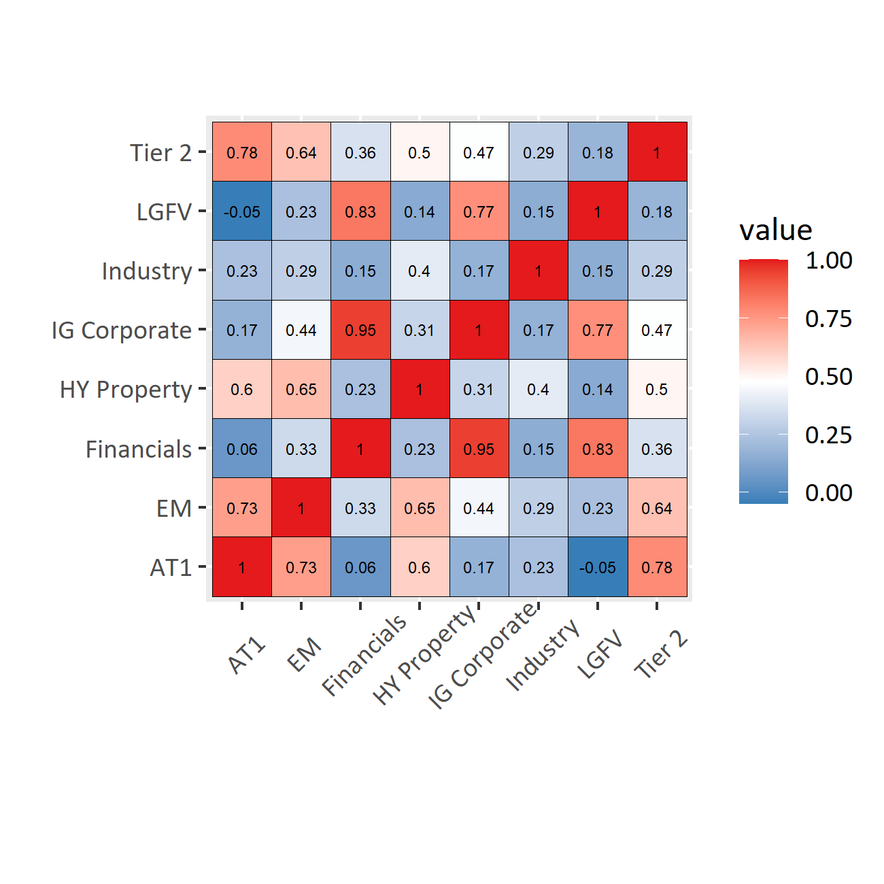

## 2. HY Property

### 1) 指数与估值

图: 收益与估值

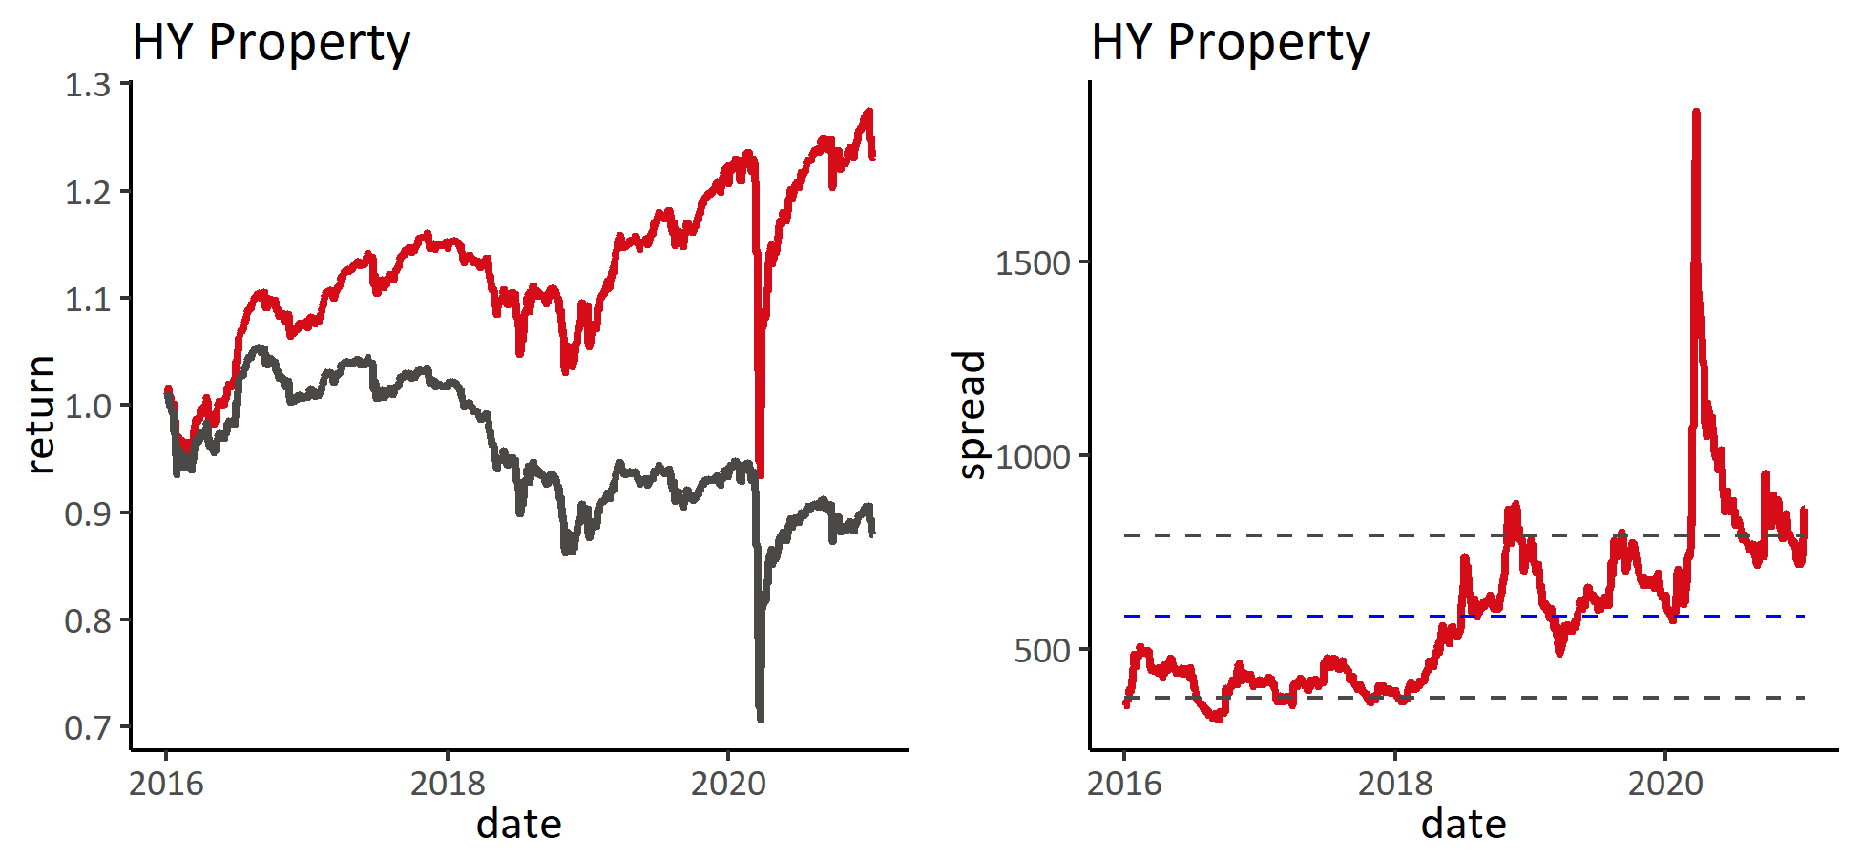

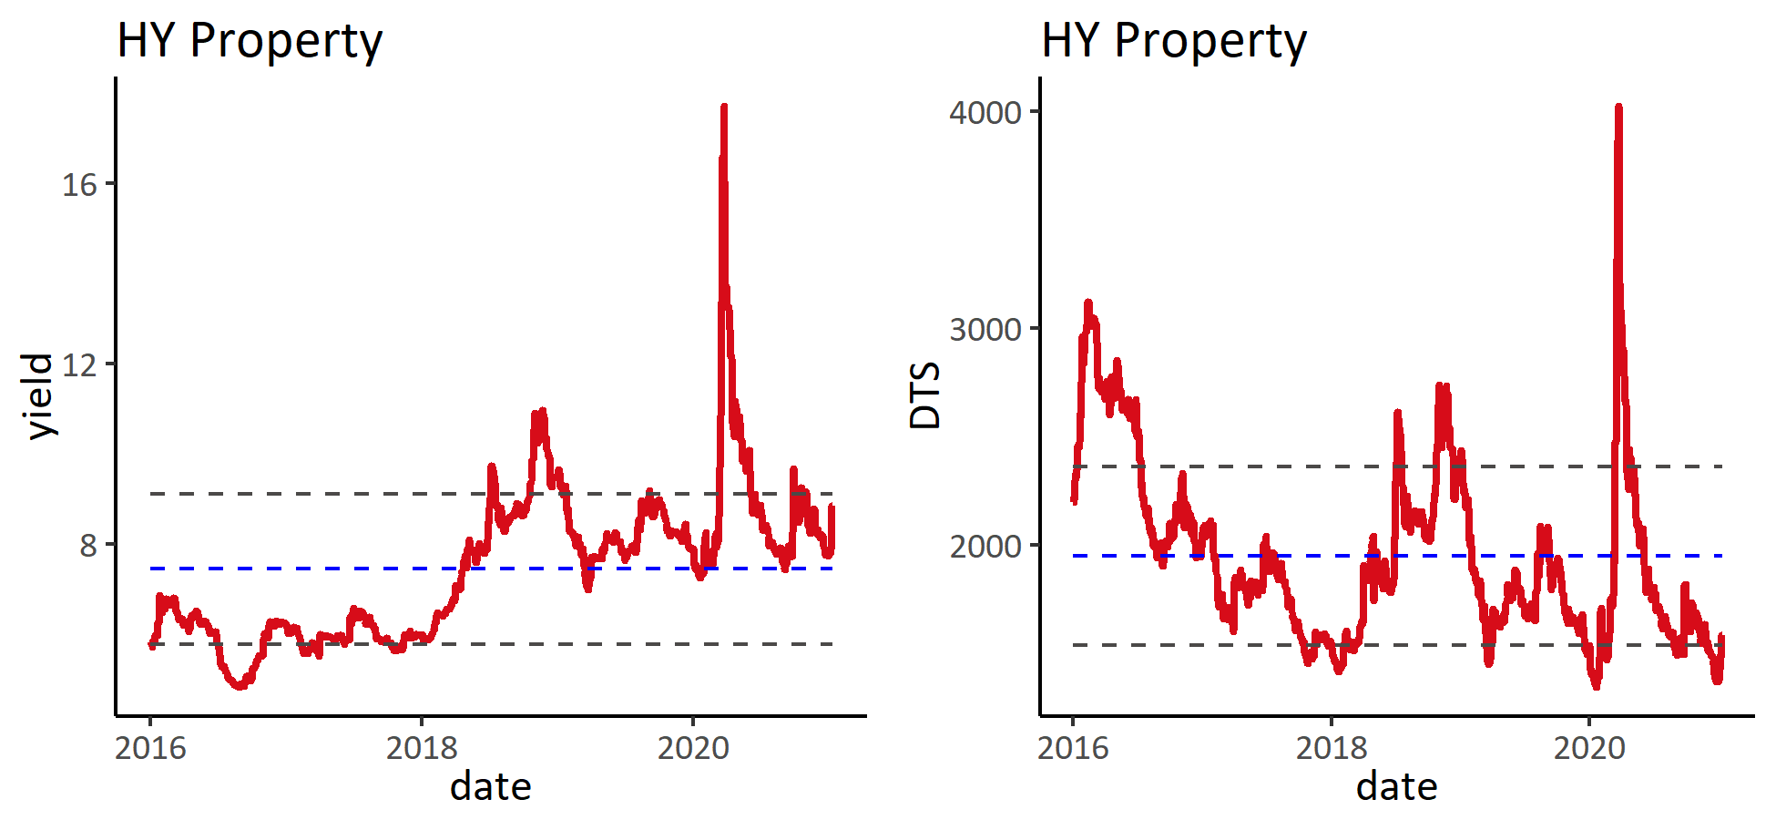

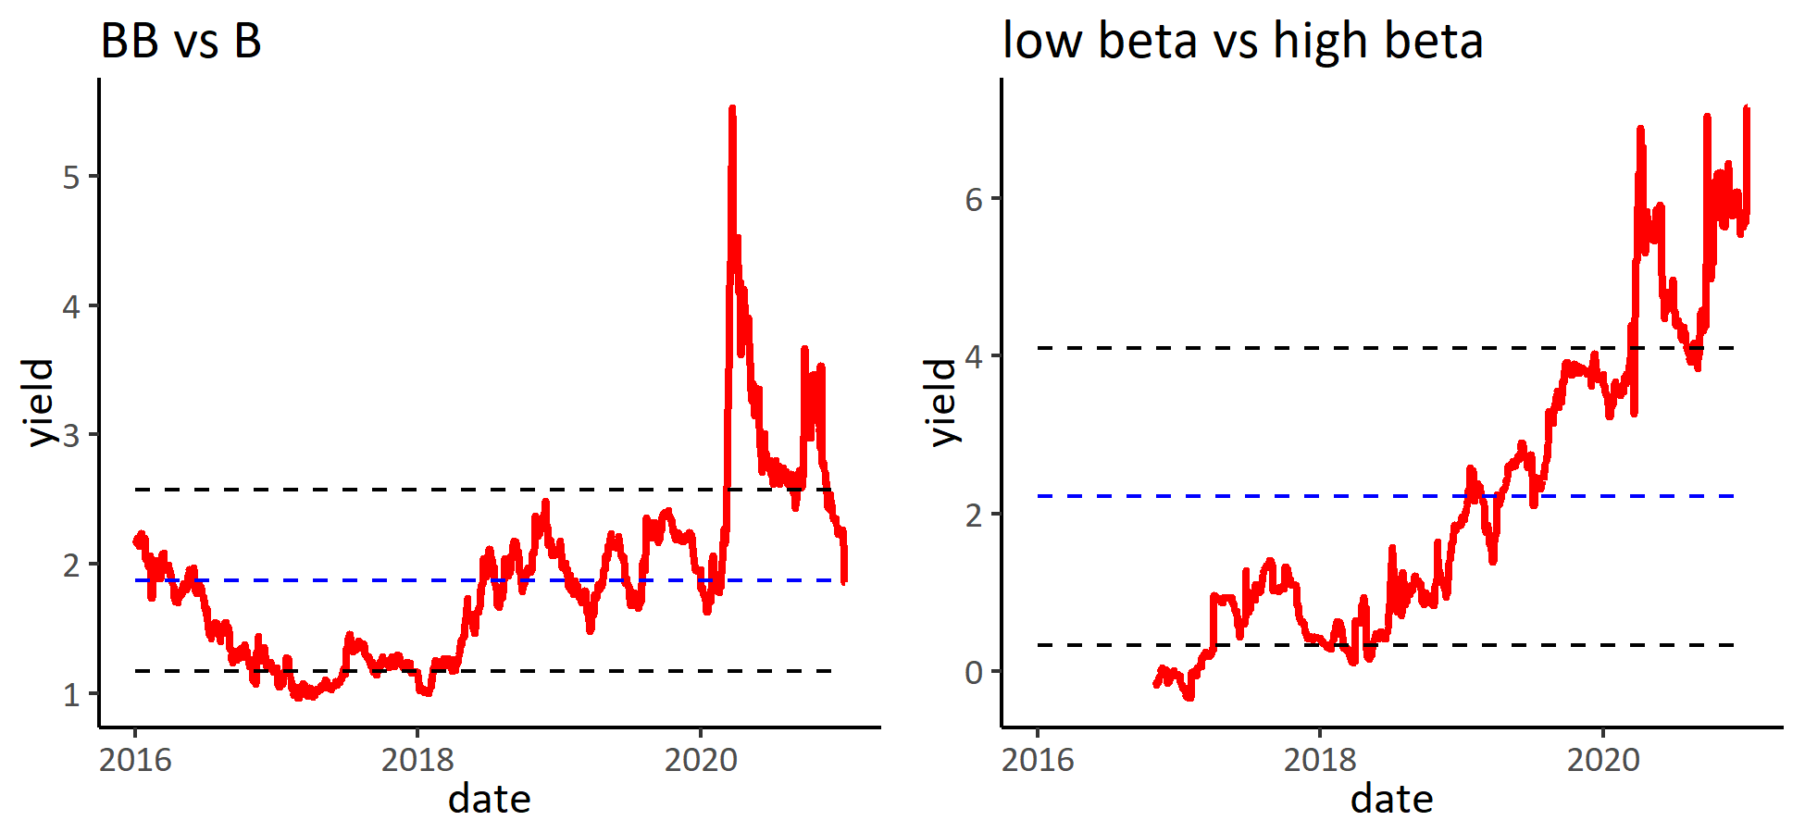

### 2) 板块涨跌幅

表: 按综合评级分组

|  | **涨跌幅** | | | **信用利差变动** | | |
| --- | --- | --- | --- | --- | --- | --- |
| **分组** | **本周** | **本月** | **本年** | **本周** | **本月** | **本年** |
| **BBB** | **-0.1%** | **-1.0%** | **-1.0%** | **9** | **36** | **36** |
| **BB** | **-4.2%** | **-5.3%** | **-5.3%** | **330** | **354** | **354** |
| **B** | **-0.5%** | **-3.1%** | **-3.1%** | **62** | **72** | **72** |
| **NR** | **0.2%** | **-0.7%** | **-0.7%** | **-4** | **-6** | **-6** |

表: 按类别分组

|  | **涨跌幅** | | | **信用利差变动** | | |
| --- | --- | --- | --- | --- | --- | --- |
| **分组** | **本周** | **本月** | **本年** | **本周** | **本月** | **本年** |
| **crossover** | **-0.1%** | **-1.1%** | **-1.1%** | **4** | **32** | **32** |
| **high beta** | **-3.7%** | **-8.2%** | **-8.2%** | **331** | **350** | **350** |
| **low beta** | **-0.3%** | **-1.6%** | **-1.6%** | **49** | **61** | **61** |

表: 涨幅前十

| **债券简称** | **涨跌幅** | **信用利差变化** | **债券简称** | **涨跌幅** | **信用利差变化** | **债券简称** | **涨跌幅** | **信用利差变化** |
| --- | --- | --- | --- | --- | --- | --- | --- | --- |
|  | **本周** | |  | **本月** | |  | **本年** | |
| XIN 14.2 21 | **2.5%** | **-290** | XIN 14.2 21 | **2.5%** | **-290** | XIN 14.2 21 | **2.5%** | **-290** |
| GZRFPR 8.125 24 | **2.2%** | **-53** | GZRFPR 8.125 24 | **2.3%** | **-53** | GZRFPR 8.125 24 | **2.3%** | **-53** |
| GZRFPR 8.625 24 | **2.0%** | **-69** | GZRFPR 8.625 24 | **2.0%** | **-69** | GZRFPR 8.625 24 | **2.0%** | **-69** |
| GZRFPR 8.625 24 | **1.9%** | **-50** | GZRFPR 8.625 24 | **2.0%** | **-50** | GZRFPR 8.625 24 | **2.0%** | **-50** |
| DEXICN 11.875 22 | **1.8%** | **-136** | DEXICN 11.875 22 | **1.9%** | **-136** | DEXICN 11.875 22 | **1.9%** | **-136** |
| GZRFPR 8.125 23 | **1.7%** | **-75** | GZRFPR 8.125 23 | **1.7%** | **-75** | GZRFPR 8.125 23 | **1.7%** | **-75** |
| ZENENT 12.5 22 | **1.4%** | **-69** | ZENENT 12.5 22 | **1.4%** | **-69** | ZENENT 12.5 22 | **1.4%** | **-69** |
| CSCHCN 7.25 22 | **1.3%** | **-63** | CSCHCN 7.25 22 | **1.3%** | **-63** | CSCHCN 7.25 22 | **1.3%** | **-63** |
| ZHLGHD 9.5 22 | **1.2%** | **-70** | TIANHL 13.75 23 | **1.3%** | **-33** | TIANHL 13.75 23 | **1.3%** | **-33** |
| TIANHL 13.75 23 | **1.2%** | **-33** | ZHLGHD 9.5 22 | **1.2%** | **-70** | ZHLGHD 9.5 22 | **1.2%** | **-70** |

表: 跌幅前十

| **债券简称** | **涨跌幅** | **信用利差变化** | **债券简称** | **涨跌幅** | **信用利差变化** | **债券简称** | **涨跌幅** | **信用利差变化** |
| --- | --- | --- | --- | --- | --- | --- | --- | --- |
|  | **本周** | |  | **本月** | |  | **本年** | |
| CHFOTN 8.6 24 | **-30.3%** | **1432** | CHFOTN 8.6 24 | **-30.2%** | **1432** | CHFOTN 8.6 24 | **-30.2%** | **1432** |
| CHFOTN 8.05 25 | **-28.9%** | **1105** | CHFOTN 8.05 25 | **-28.9%** | **1105** | CHFOTN 8.05 25 | **-28.9%** | **1105** |
| CHFOTN 8.75 22 | **-28.7%** | **2382** | CHFOTN 8.75 22 | **-28.6%** | **2382** | CHFOTN 8.75 22 | **-28.6%** | **2382** |
| CHFOTN 6.9 23 | **-27.4%** | **1924** | CHFOTN 6.9 23 | **-27.4%** | **1924** | CHFOTN 6.9 23 | **-27.4%** | **1924** |
| YUZHOU 7.375 26 | **-2.3%** | **57** | YUZHOU 7.375 26 | **-2.2%** | **57** | YUZHOU 7.375 26 | **-2.2%** | **57** |
| KAISAG 9.375 24 | **-2.2%** | **80** | KAISAG 9.375 24 | **-2.2%** | **80** | KAISAG 9.375 24 | **-2.2%** | **80** |
| SUNAC 7.5 24 | **-2.1%** | **147** | SUNAC 7.5 24 | **-2.1%** | **147** | SUNAC 7.5 24 | **-2.1%** | **147** |
| KAISAG 11.95 23 | **-1.8%** | **144** | KAISAG 10.875 23 | **-1.8%** | **97** | KAISAG 10.875 23 | **-1.8%** | **97** |
| KAISAG 10.875 23 | **-1.8%** | **97** | KAISAG 11.95 23 | **-1.8%** | **144** | KAISAG 11.95 23 | **-1.8%** | **144** |
| SUNAC 6.5 25 | **-1.8%** | **44** | SUNAC 6.5 25 | **-1.7%** | **44** | SUNAC 6.5 25 | **-1.7%** | **44** |

### 3) 估值分位

表: 分评级估值

|  |  | **到期收益率历史百分位** | | |  | **信用利差历史百分位** | | |
| --- | --- | --- | --- | --- | --- | --- | --- | --- |
| **分组** | **到期收益率** | **1年** | **3年** | **全部** | **信用利差** | **1年** | **3年** | **全部** |
| **BBB** | **3.9** | **7%** | **1%** | **1%** | **269** | **7%** | **1%** | **1%** |
| **BB** | **9.3** | **90%** | **96%** | **96%** | **881** | **90%** | **96%** | **96%** |
| **B** | **9.3** | **35%** | **47%** | **52%** | **921** | **35%** | **47%** | **52%** |
| **CCC** | **15.4** | **10%** | **2%** | **11%** | **1,565** | **10%** | **2%** | **11%** |
| **NR** | **6.8** | **17%** | **37%** | **39%** | **657** | **17%** | **37%** | **39%** |

## 3. IG Corporate

### 1) 指数与估值

图: 收益与估值

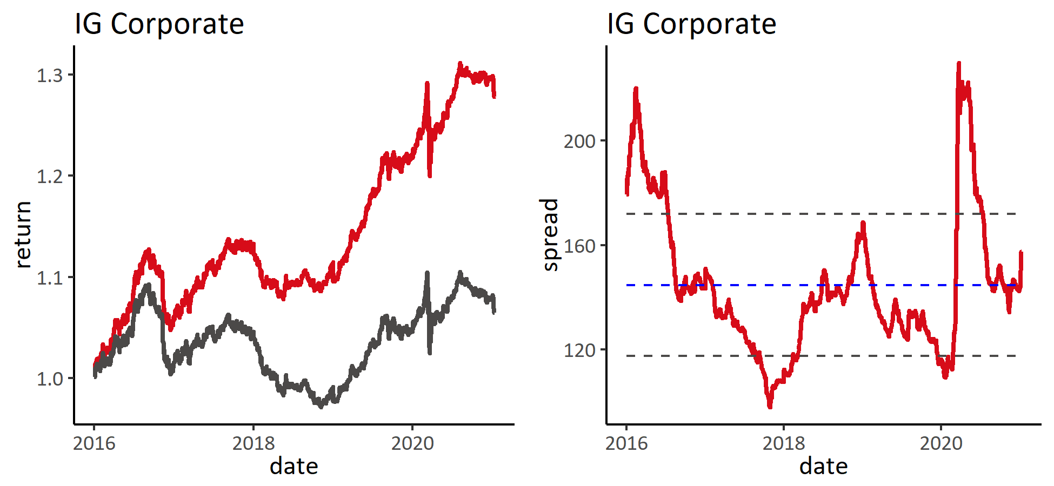

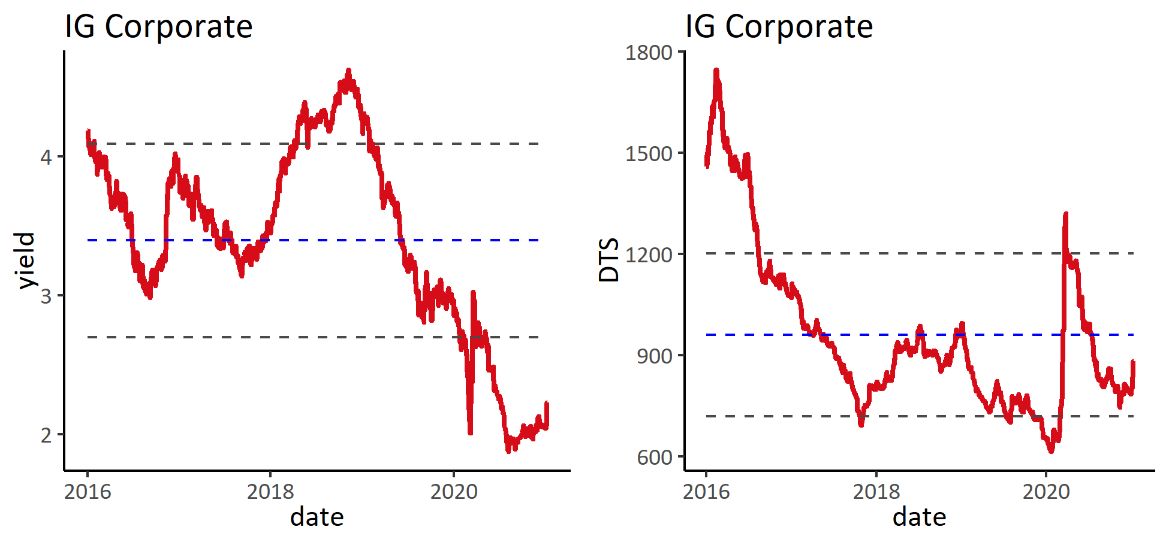

### 2) 板块涨跌幅

表: 按综合评级分组

|  | **涨跌幅** | | | **信用利差变动** | | |
| --- | --- | --- | --- | --- | --- | --- |
| **分组** | **本周** | **本月** | **本年** | **本周** | **本月** | **本年** |
| **A** | **-1.9%** | **-1.7%** | **-1.7%** | **14** | **14** | **14** |
| **BBB** | **-1.0%** | **-1.3%** | **-1.3%** | **15** | **16** | **16** |
| **BB** | **-0.1%** | **0.8%** | **0.8%** | **19** | **14** | **14** |
| **NR** | **-0.2%** | **-0.5%** | **-0.5%** | **0** | **4** | **4** |

表: 按类别分组

|  | **涨跌幅** | | | **信用利差变动** | | |
| --- | --- | --- | --- | --- | --- | --- |
| **分组** | **本周** | **本月** | **本年** | **本周** | **本月** | **本年** |
| **other** | **-0.0%** | **-0.4%** | **-0.4%** | **2** | **8** | **8** |
| **property** | **-0.4%** | **0.6%** | **0.6%** | **19** | **-1** | **-1** |
| **soe** | **-1.4%** | **-1.3%** | **-1.3%** | **15** | **17** | **17** |
| **tech** | **-1.4%** | **-1.7%** | **-1.7%** | **11** | **23** | **23** |

表: 涨幅前十

| **债券简称** | **涨跌幅** | **信用利差变化** | **债券简称** | **涨跌幅** | **信用利差变化** | **债券简称** | **涨跌幅** | **信用利差变化** |
| --- | --- | --- | --- | --- | --- | --- | --- | --- |
|  | **本周** | |  | **本月** | |  | **本年** | |
| CHPWCN 3 22 | **0.4%** | **-17** | SINOCE 6 24 | **0.4%** | **7** | SINOCE 6 24 | **0.4%** | **7** |
| SINOCE 6 24 | **0.4%** | **7** | CHPWCN 3 22 | **0.4%** | **-17** | CHPWCN 3 22 | **0.4%** | **-17** |
| POLHON 4 25 | **0.3%** | **-18** | POLHON 4 25 | **0.3%** | **-18** | POLHON 4 25 | **0.3%** | **-18** |
| VNKRLE 4.2 24 | **0.2%** | **7** | VNKRLE 4.2 24 | **0.3%** | **7** | VNKRLE 4.2 24 | **0.3%** | **7** |
| SHPORT 2.4 24 | **0.2%** | **-10** | SHPORT 2.4 24 | **0.2%** | **-10** | SHPORT 2.4 24 | **0.2%** | **-10** |
| GLPCHI 4.974 24 | **0.2%** | **9** | GLPCHI 4.974 24 | **0.2%** | **9** | GLPCHI 4.974 24 | **0.2%** | **9** |
| CGGCN 2.8 23 | **0.1%** | **-1** | CJIANT 4.5 21 | **0.2%** | **-14** | CJIANT 4.5 21 | **0.2%** | **-14** |
| CJIANT 4.5 21 | **0.1%** | **-14** | CGGCN 2.8 23 | **0.2%** | **-1** | CGGCN 2.8 23 | **0.2%** | **-1** |
| CHGRID 3.5 27 | **0.1%** | **42** | CHGRID 3.5 27 | **0.2%** | **42** | CHGRID 3.5 27 | **0.2%** | **42** |
| YUEXIU 4.5 23 | **0.1%** | **0** | YUEXIU 4.5 23 | **0.1%** | **0** | YUEXIU 4.5 23 | **0.1%** | **0** |

表: 跌幅前十

| **债券简称** | **涨跌幅** | **信用利差变化** | **债券简称** | **涨跌幅** | **信用利差变化** | **债券简称** | **涨跌幅** | **信用利差变化** |
| --- | --- | --- | --- | --- | --- | --- | --- | --- |
|  | **本周** | |  | **本月** | |  | **本年** | |
| BABA 4.4 57 | **-12.1%** | **43** | BABA 4.4 57 | **-12.1%** | **43** | BABA 4.4 57 | **-12.1%** | **43** |
| TENCNT 3.29 60 | **-11.7%** | **35** | TENCNT 3.29 60 | **-11.6%** | **35** | TENCNT 3.29 60 | **-11.6%** | **35** |
| BABA 4.2 47 | **-9.9%** | **42** | BABA 4.2 47 | **-9.9%** | **42** | BABA 4.2 47 | **-9.9%** | **42** |
| TENCNT 3.24 50 | **-8.6%** | **26** | TENCNT 3.24 50 | **-8.6%** | **26** | TENCNT 3.24 50 | **-8.6%** | **26** |
| TENCNT 4.525 49 | **-7.4%** | **28** | TENCNT 4.525 49 | **-7.4%** | **28** | TENCNT 4.525 49 | **-7.4%** | **28** |
| BABA 4 37 | **-7.2%** | **41** | BABA 4 37 | **-7.2%** | **41** | BABA 4 37 | **-7.2%** | **41** |
| CNOOC 3.3 49 | **-6.8%** | **18** | CNOOC 3.3 49 | **-6.8%** | **18** | CNOOC 3.3 49 | **-6.8%** | **18** |
| CNOOC 4.25 43 | **-6.5%** | **23** | CNOOC 4.25 43 | **-6.5%** | **23** | CNOOC 4.25 43 | **-6.5%** | **23** |
| HAOHUA 3 30 | **-6.3%** | **57** | HAOHUA 3 30 | **-6.3%** | **57** | HAOHUA 3 30 | **-6.3%** | **57** |
| CNOOC 4.2 45 | **-6.3%** | **20** | CNOOC 4.2 45 | **-6.2%** | **20** | CNOOC 4.2 45 | **-6.2%** | **20** |

### 3) 估值分位

表: 分评级估值

|  |  | **到期收益率历史百分位** | | |  | **信用利差历史百分位** | | |
| --- | --- | --- | --- | --- | --- | --- | --- | --- |
| **分组** | **到期收益率** | **1年** | **3年** | **全部** | **信用利差** | **1年** | **3年** | **全部** |
| **A** | **2.0** | **48%** | **10%** | **10%** | **128** | **48%** | **10%** | **10%** |
| **BBB** | **2.6** | **46%** | **9%** | **9%** | **206** | **46%** | **9%** | **9%** |
| **BB** | **7.0** | **96%** | **80%** | **80%** | **691** | **96%** | **80%** | **80%** |
| **NR** | **3.0** | **35%** | **7%** | **7%** | **262** | **35%** | **7%** | **7%** |

## 4. Financials

### 1) 指数与估值

图: 收益与估值

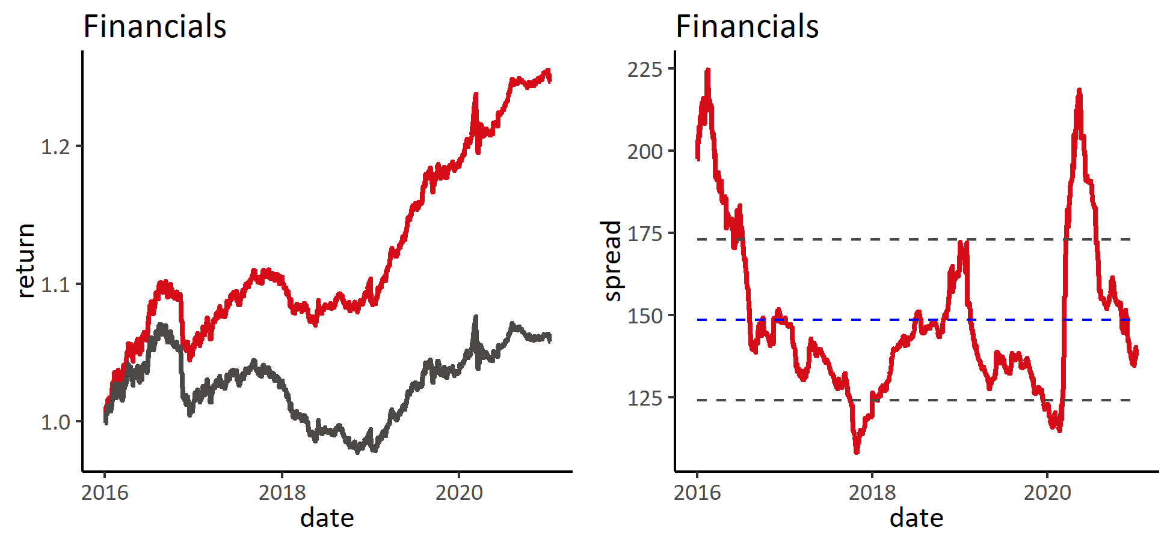

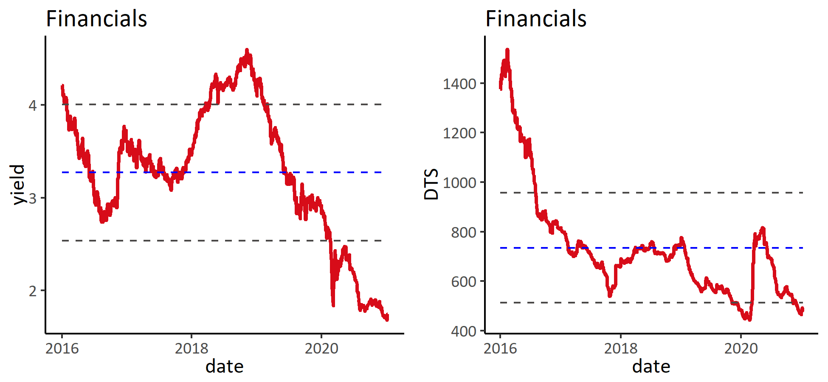

### 2) 板块涨跌幅

表: 按综合评级分组

|  | **涨跌幅** | | | **信用利差变动** | | |
| --- | --- | --- | --- | --- | --- | --- |
| **分组** | **本周** | **本月** | **本年** | **本周** | **本月** | **本年** |
| **A** | **-0.2%** | **-0.5%** | **-0.5%** | **2** | **2** | **2** |
| **BBB** | **-0.4%** | **-1.0%** | **-1.0%** | **5** | **5** | **5** |
| **BB** | **0.2%** | **-0.9%** | **-0.9%** | **6** | **7** | **7** |
| **NR** | **0.1%** | **-0.2%** | **-0.2%** | **-4** | **12** | **12** |

表: 按类别分组

|  | **涨跌幅** | | | **信用利差变动** | | |
| --- | --- | --- | --- | --- | --- | --- |
| **分组** | **本周** | **本月** | **本年** | **本周** | **本月** | **本年** |
| **AMC** | **-0.5%** | **-1.0%** | **-1.0%** | **6** | **10** | **10** |
| **big6** | **-0.0%** | **-0.1%** | **-0.1%** | **0** | **0** | **0** |
| **insurance** | **-0.0%** | **-0.4%** | **-0.4%** | **21** | **-34** | **-34** |
| **JCBC** | **0.0%** | **0.0%** | **0.0%** | **-3** | **21** | **21** |
| **leasing** | **-0.0%** | **-0.2%** | **-0.2%** | **0** | **1** | **1** |
| **other** | **0.2%** | **-0.9%** | **-0.9%** | **-14** | **-7** | **-7** |
| **policy** | **-0.1%** | **-0.1%** | **-0.1%** | **1** | **1** | **1** |
| **security** | **0.0%** | **-0.0%** | **-0.0%** | **-1** | **36** | **36** |

表: 涨幅前十

| **债券简称** | **涨跌幅** | **信用利差变化** | **债券简称** | **涨跌幅** | **信用利差变化** | **债券简称** | **涨跌幅** | **信用利差变化** |
| --- | --- | --- | --- | --- | --- | --- | --- | --- |
|  | **本周** | |  | **本月** | |  | **本年** | |
| EXIMCH 3.25 27 | **0.8%** | **50** | EXIMCH 3.25 27 | **0.8%** | **50** | EXIMCH 3.25 27 | **0.8%** | **50** |
| ORIEAS 2.875 24 | **0.7%** | **-23** | ORIEAS 2.875 24 | **0.7%** | **-23** | ORIEAS 2.875 24 | **0.7%** | **-23** |
| SDBC 3.375 27 | **0.6%** | **34** | SDBC 3.375 27 | **0.7%** | **34** | SDBC 3.375 27 | **0.7%** | **34** |
| BOCAVI 3.5 24 | **0.6%** | **-4** | BOCAVI 3.5 24 | **0.7%** | **-4** | BOCAVI 3.5 24 | **0.7%** | **-4** |
| BOCAVI 4 24 | **0.6%** | **-8** | BOCAVI 4 24 | **0.6%** | **-8** | BOCAVI 4 24 | **0.6%** | **-8** |
| HRINTH 3.25 24 | **0.5%** | **3** | HRINTH 3.25 24 | **0.5%** | **3** | HRINTH 3.25 24 | **0.5%** | **3** |
| ZHNBND 7.6 22 | **0.4%** | **-29** | ZHNBND 7.6 22 | **0.5%** | **-29** | ZHNBND 7.6 22 | **0.5%** | **-29** |
| TIANFS 4.3 22 | **0.4%** | **-18** | TIANFS 4.3 22 | **0.4%** | **-18** | TIANFS 4.3 22 | **0.4%** | **-18** |
| EXIMCH 3.375 27 | **0.4%** | **40** | EXIMCH 3.375 27 | **0.4%** | **40** | EXIMCH 3.375 27 | **0.4%** | **40** |
| BOCAVI 3.5 27 | **0.4%** | **38** | BOCAVI 3.5 27 | **0.4%** | **38** | BOCAVI 3.5 27 | **0.4%** | **38** |

表: 跌幅前十

| **债券简称** | **涨跌幅** | **信用利差变化** | **债券简称** | **涨跌幅** | **信用利差变化** | **债券简称** | **涨跌幅** | **信用利差变化** |
| --- | --- | --- | --- | --- | --- | --- | --- | --- |
|  | **本周** | |  | **本月** | |  | **本年** | |
| EXIMCH 4 47 | **-3.1%** | **-4** | EXIMCH 4 47 | **-3.1%** | **-4** | EXIMCH 4 47 | **-3.1%** | **-4** |
| HRINTH 3.625 30 | **-3.0%** | **19** | HRINTH 3.625 30 | **-3.0%** | **19** | HRINTH 3.625 30 | **-3.0%** | **19** |
| HRINTH 4.95 47 | **-3.0%** | **-2** | HRINTH 4.95 47 | **-2.9%** | **-2** | HRINTH 4.95 47 | **-2.9%** | **-2** |
| HRINTH 3.375 30 | **-3.0%** | **21** | HRINTH 3.375 30 | **-2.9%** | **21** | HRINTH 3.375 30 | **-2.9%** | **21** |
| HRINTH 3.875 29 | **-2.9%** | **26** | HRINTH 3.875 29 | **-2.9%** | **26** | HRINTH 3.875 29 | **-2.9%** | **26** |
| ORIEAS 2.75 30 | **-2.8%** | **15** | ORIEAS 2.75 30 | **-2.8%** | **15** | ORIEAS 2.75 30 | **-2.8%** | **15** |
| BOCAVI 2.625 30 | **-2.7%** | **14** | BOCAVI 2.625 30 | **-2.7%** | **14** | BOCAVI 2.625 30 | **-2.7%** | **14** |
| HRINTH 4.5 29 | **-2.7%** | **24** | HRINTH 4.5 29 | **-2.7%** | **24** | HRINTH 4.5 29 | **-2.7%** | **24** |
| CCAMCL 3.125 30 | **-2.3%** | **10** | CCAMCL 3.125 30 | **-2.2%** | **10** | CCAMCL 3.125 30 | **-2.2%** | **10** |
| CCAMCL 5.2 29 | **-2.1%** | **10** | CCAMCL 5.2 29 | **-2.0%** | **10** | CCAMCL 5.2 29 | **-2.0%** | **10** |

### 3) 估值分位

表: 分评级估值

|  |  | **到期收益率历史百分位** | | |  | **信用利差历史百分位** | | |
| --- | --- | --- | --- | --- | --- | --- | --- | --- |
| **分组** | **到期收益率** | **1年** | **3年** | **全部** | **信用利差** | **1年** | **3年** | **全部** |
| **A** | **2.0** | **48%** | **10%** | **10%** | **128** | **48%** | **10%** | **10%** |
| **BBB** | **2.6** | **46%** | **9%** | **9%** | **206** | **46%** | **9%** | **9%** |
| **BB** | **7.0** | **96%** | **80%** | **80%** | **691** | **96%** | **80%** | **80%** |
| **NR** | **3.0** | **35%** | **7%** | **7%** | **262** | **35%** | **7%** | **7%** |

## 5. LGFV

### 1) 指数与估值

图: 收益与估值

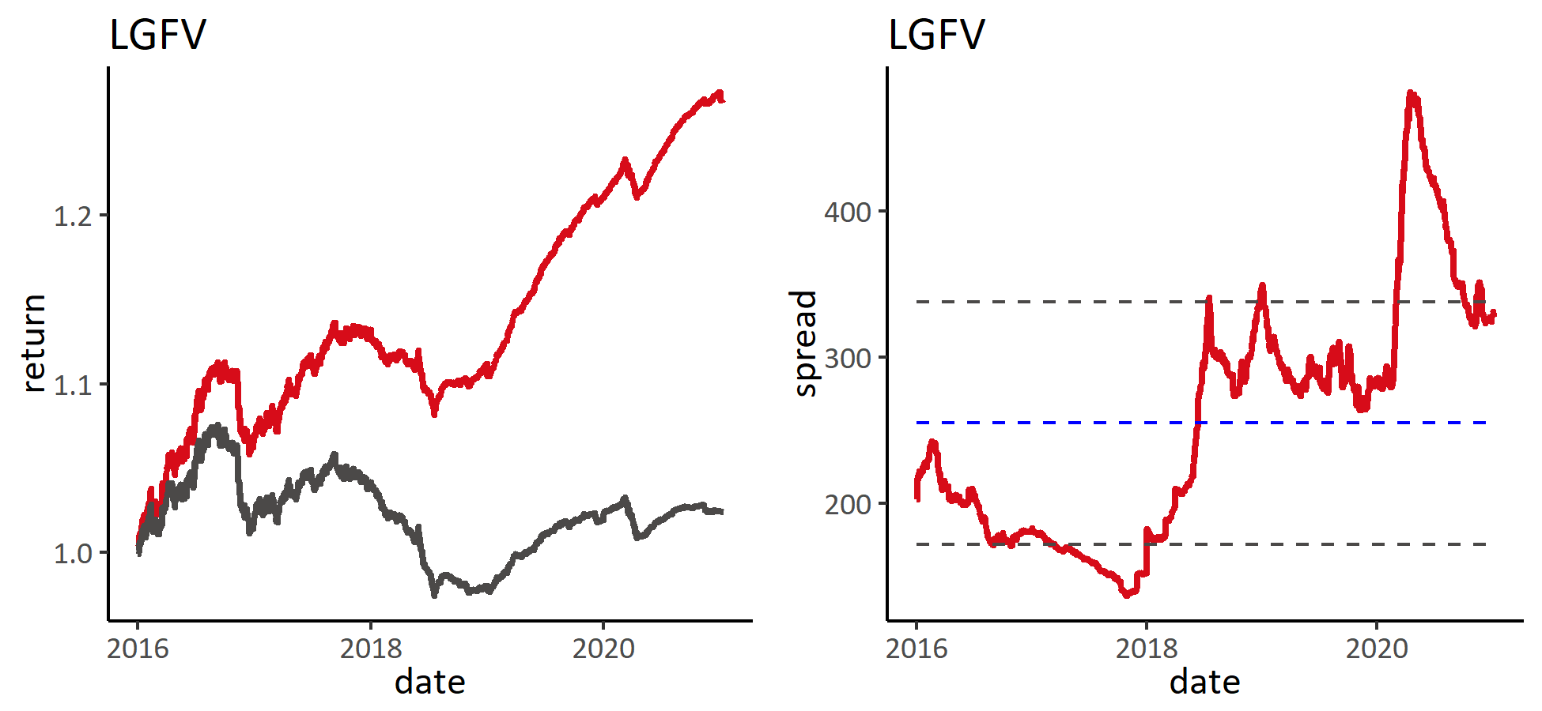

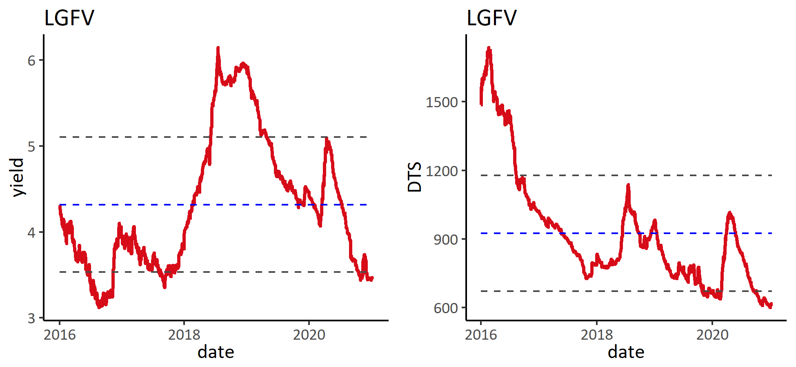

### 2) 板块涨跌幅

表: 按综合评级分组

|  | **涨跌幅** | | | **信用利差变动** | | |
| --- | --- | --- | --- | --- | --- | --- |
| **分组** | **本周** | **本月** | **本年** | **本周** | **本月** | **本年** |
| **A** | **-0.1%** | **-0.3%** | **-0.3%** | **1** | **5** | **5** |
| **BBB** | **0.0%** | **-0.4%** | **-0.4%** | **1** | **4** | **4** |
| **BB** | **0.1%** | **-0.4%** | **-0.4%** | **-1** | **-1** | **-1** |
| **NR** | **0.1%** | **-0.1%** | **-0.1%** | **-6** | **-8** | **-8** |

表: 涨幅前十

| **债券简称** | **涨跌幅** | **信用利差变化** | **债券简称** | **涨跌幅** | **信用利差变化** | **债券简称** | **涨跌幅** | **信用利差变化** |
| --- | --- | --- | --- | --- | --- | --- | --- | --- |
|  | **本周** | |  | **本月** | |  | **本年** | |
| WUECDE 5.8 21 | **1.7%** | **-173** | WUECDE 5.8 21 | **1.8%** | **-173** | WUECDE 5.8 21 | **1.8%** | **-173** |
| HKIQCL 5.95 25 | **1.6%** | **-55** | HKIQCL 5.95 25 | **1.6%** | **-55** | HKIQCL 5.95 25 | **1.6%** | **-55** |
| YWSOAO 3.15 23 | **0.6%** | **-17** | YWSOAO 3.15 23 | **0.6%** | **-17** | YWSOAO 3.15 23 | **0.6%** | **-17** |
| ZHJWCI 7.5 22 | **0.4%** | **-18** | ZHJWCI 7.5 22 | **0.5%** | **-18** | ZHJWCI 7.5 22 | **0.5%** | **-18** |
| ZGCHGI 6.5 22 | **0.4%** | **-17** | ZGCHGI 6.5 22 | **0.4%** | **-17** | ZGCHGI 6.5 22 | **0.4%** | **-17** |
| FANGYA 7.5 21 | **0.3%** | **-10** | FANGYA 7.5 21 | **0.4%** | **-10** | FANGYA 7.5 21 | **0.4%** | **-10** |
| CDECST 7.5 22 | **0.3%** | **-9** | CDECST 7.5 22 | **0.3%** | **-9** | CDECST 7.5 22 | **0.3%** | **-9** |
| NJYZSO 4.5 27 | **0.3%** | **41** | DIANCH 6.6 22 | **0.3%** | **-12** | DIANCH 6.6 22 | **0.3%** | **-12** |
| DIANCH 6.6 22 | **0.3%** | **-12** | NJYZSO 4.5 27 | **0.3%** | **41** | NJYZSO 4.5 27 | **0.3%** | **41** |
| GSELEC 6.25 21 | **0.3%** | **-22** | GSELEC 6.25 21 | **0.3%** | **-22** | GSELEC 6.25 21 | **0.3%** | **-22** |

表: 跌幅前十

| **债券简称** | **涨跌幅** | **信用利差变化** | **债券简称** | **涨跌幅** | **信用利差变化** | **债券简称** | **涨跌幅** | **信用利差变化** |
| --- | --- | --- | --- | --- | --- | --- | --- | --- |
|  | **本周** | |  | **本月** | |  | **本年** | |
| BEIENT 6.375 41 | **-2.7%** | **0** | BEIENT 6.375 41 | **-2.7%** | **0** | BEIENT 6.375 41 | **-2.7%** | **0** |
| BEIENT 4.99 40 | **-2.7%** | **-1** | BEIENT 4.99 40 | **-2.7%** | **-1** | BEIENT 4.99 40 | **-2.7%** | **-1** |
| YUNINV 6.25 22 | **-1.8%** | **184** | YUNINV 6.25 22 | **-1.8%** | **184** | YUNINV 6.25 22 | **-1.8%** | **184** |
| GUAMET 2.31 30 | **-1.6%** | **0** | GUAMET 2.31 30 | **-1.6%** | **0** | GUAMET 2.31 30 | **-1.6%** | **0** |
| GUAMET 1.507 25 | **-0.9%** | **7** | GUAMET 1.507 25 | **-0.9%** | **7** | GUAMET 1.507 25 | **-0.9%** | **7** |
| BJEHF 4.95 23 | **-0.4%** | **25** | BJEHF 4.95 23 | **-0.4%** | **25** | BJEHF 4.95 23 | **-0.4%** | **25** |
| UMQHTH 4.75 23 | **-0.2%** | **11** | UMQHTH 4.75 23 | **-0.2%** | **11** | UMQHTH 4.75 23 | **-0.2%** | **11** |
| PDSOAM 5.75 23 | **-0.2%** | **15** | PDSOAM 5.75 23 | **-0.2%** | **15** | PDSOAM 5.75 23 | **-0.2%** | **15** |
| PHCIIL 7 22 | **-0.2%** | **-17** | PHCIIL 7 22 | **-0.2%** | **-17** | PHCIIL 7 22 | **-0.2%** | **-17** |
| BJSTAT 4.125 25 | **-0.2%** | **-7** | GXCMIN 2.95 25 | **-0.2%** | **-8** | GXCMIN 2.95 25 | **-0.2%** | **-8** |

### 3) 估值分位

表: 分评级估值

|  |  | **到期收益率历史百分位** | | |  | **信用利差历史百分位** | | |
| --- | --- | --- | --- | --- | --- | --- | --- | --- |
| **分组** | **到期收益率** | **1年** | **3年** | **全部** | **信用利差** | **1年** | **3年** | **全部** |
| **A** | **1.9** | **12%** | **2%** | **2%** | **169** | **12%** | **2%** | **2%** |
| **BBB** | **3.3** | **8%** | **2%** | **7%** | **307** | **8%** | **2%** | **7%** |
| **BB** | **5.4** | **4%** | **1%** | **1%** | **532** | **4%** | **1%** | **1%** |
| **NR** | **4.1** | **8%** | **2%** | **2%** | **394** | **8%** | **2%** | **2%** |

## 6. Industry

### 1) 指数与估值

图: 收益与估值

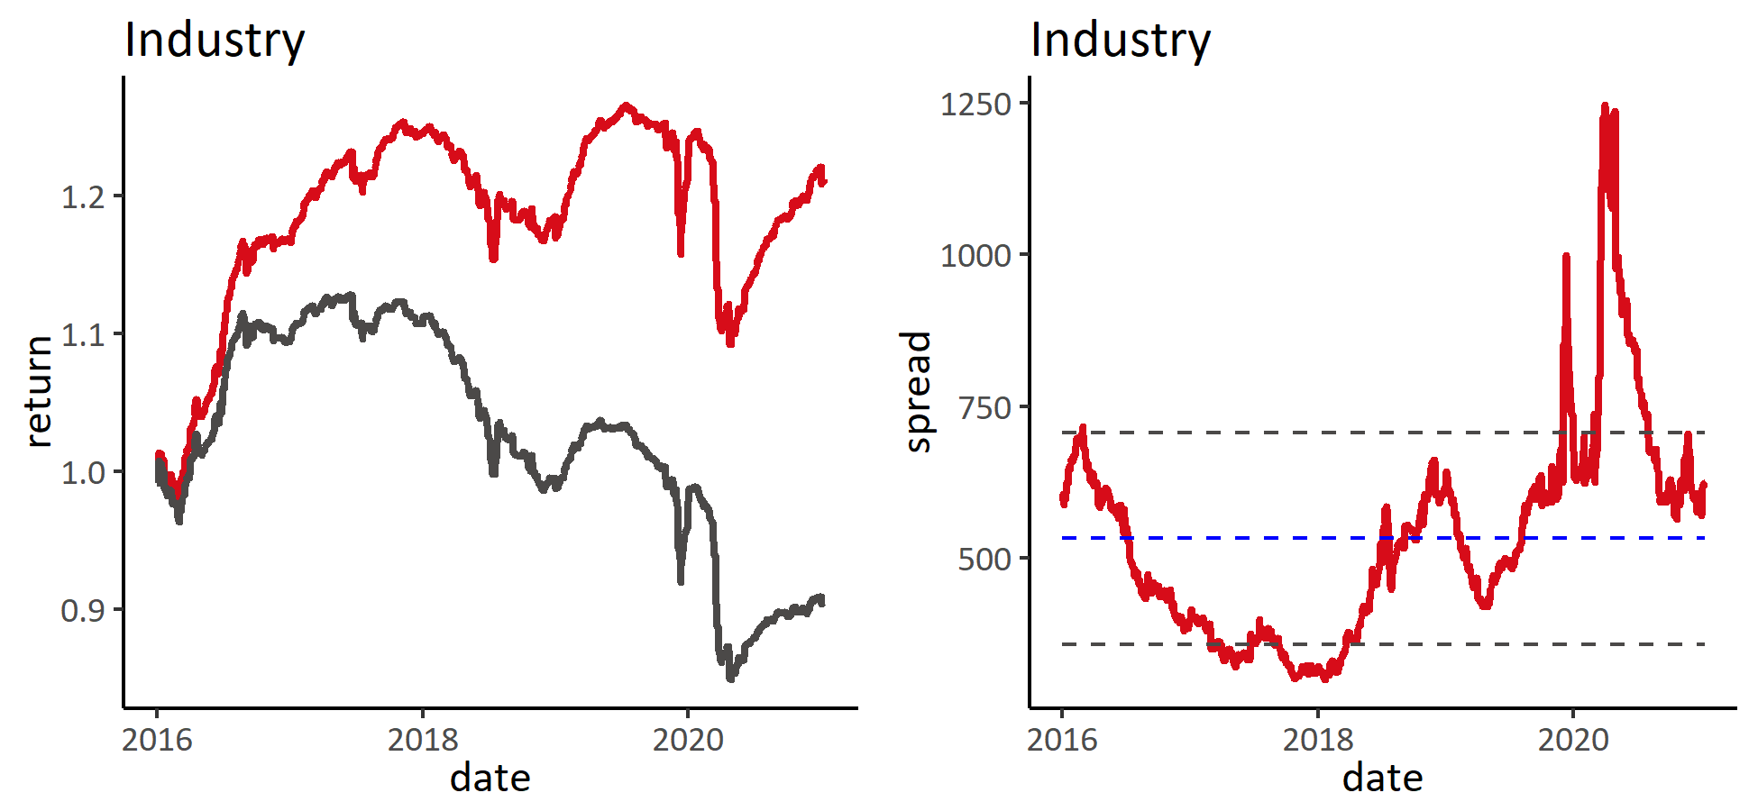

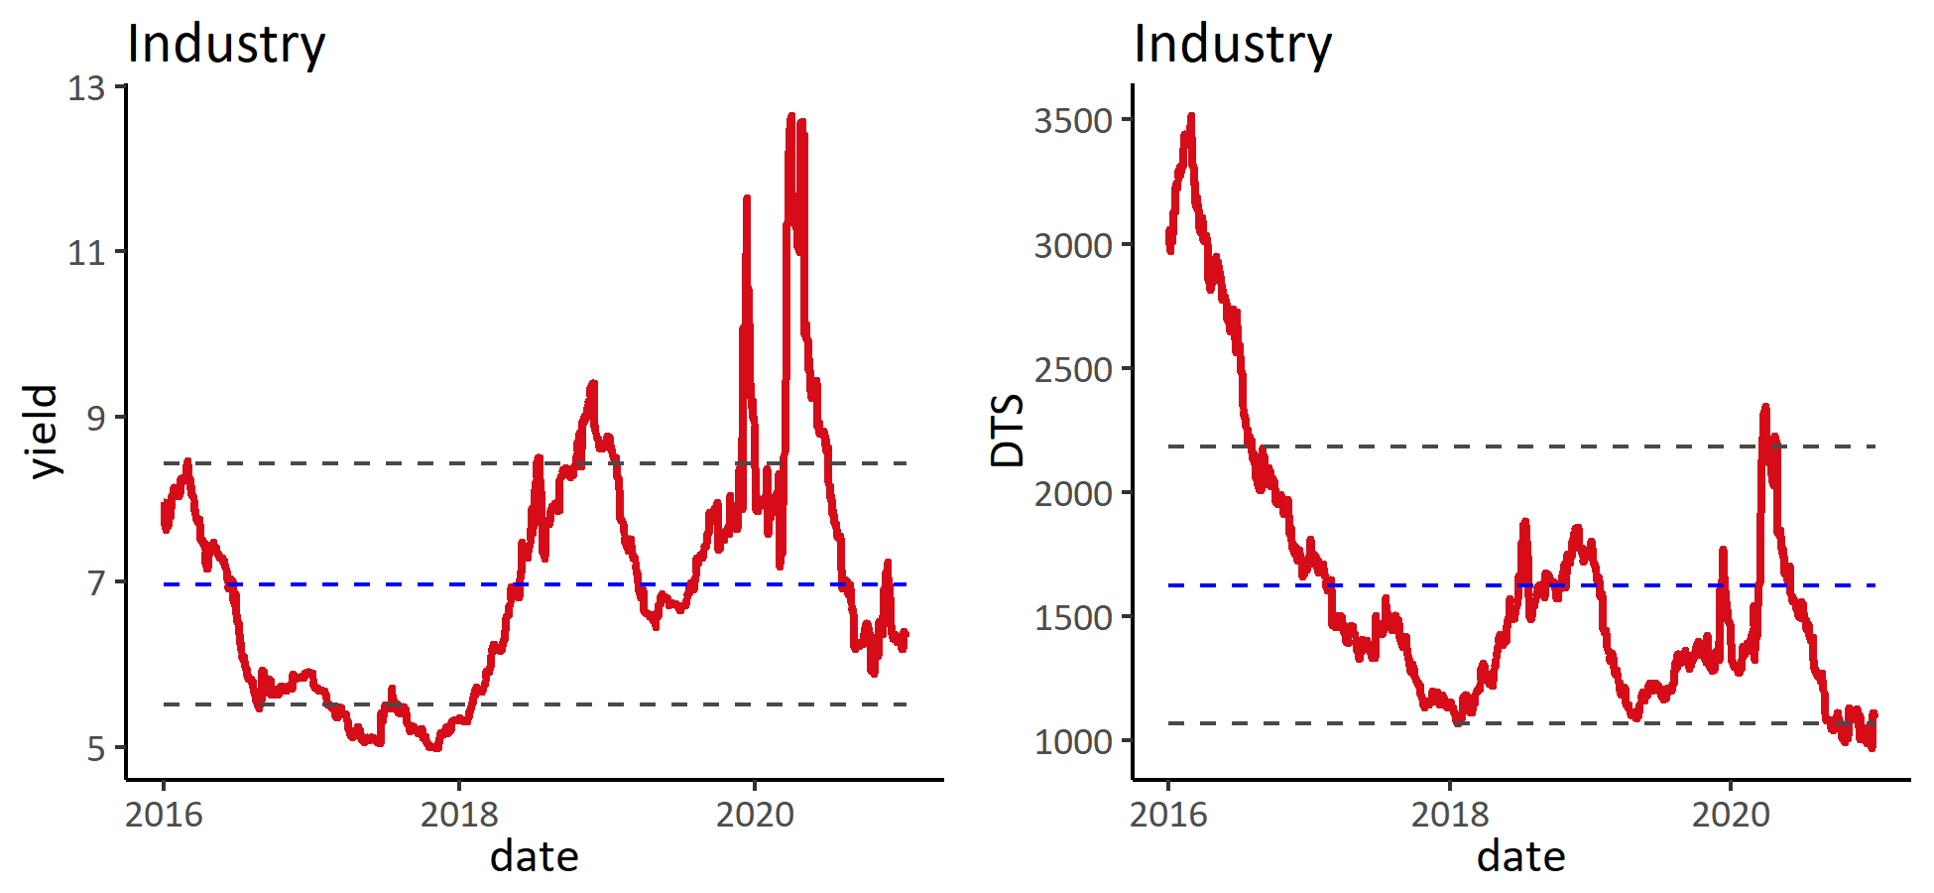

### 2) 板块涨跌幅

表: 按综合评级分组

|  | **涨跌幅** | | | **信用利差变动** | | |
| --- | --- | --- | --- | --- | --- | --- |
| **分组** | **本周** | **本月** | **本年** | **本周** | **本月** | **本年** |
| **BB** | **0.1%** | **-0.8%** | **-0.8%** | **24** | **65** | **65** |
| **B** | **0.7%** | **-1.0%** | **-1.0%** | **-33** | **45** | **45** |
| **CCC** | **0.9%** | **-1.4%** | **-1.4%** | **-37** | **89** | **89** |
| **NR** | **0.1%** | **-0.5%** | **-0.5%** | **5** | **-21** | **-21** |

表: 涨幅前十

| **债券简称** | **涨跌幅** | **信用利差变化** | **债券简称** | **涨跌幅** | **信用利差变化** | **债券简称** | **涨跌幅** | **信用利差变化** |
| --- | --- | --- | --- | --- | --- | --- | --- | --- |
|  | **本周** | |  | **本月** | |  | **本年** | |
| THSCPA 7.95 21 | **17.3%** | **-3382** | THSCPA 7.95 21 | **17.3%** | **-3382** | THSCPA 7.95 21 | **17.3%** | **-3382** |
| TSINGH 6.5 28 | **15.3%** | **-301** | THSCPA 6.95 22 | **12.8%** | **-784** | THSCPA 6.95 22 | **12.8%** | **-784** |
| THSCPA 6.95 22 | **12.7%** | **-784** | TSINGH 6.5 28 | **12.2%** | **-301** | TSINGH 6.5 28 | **12.2%** | **-301** |
| DEGREE 7.25 21 | **10.6%** | **-2612** | DEGREE 7.25 21 | **10.6%** | **-2612** | DEGREE 7.25 21 | **10.6%** | **-2612** |
| TSINGH 5.375 23 | **7.7%** | **-443** | TSINGH 5.375 23 | **8.4%** | **-443** | TSINGH 5.375 23 | **8.4%** | **-443** |
| SANYPH 6.25 21 | **3.7%** | **-395** | SANYPH 6.25 21 | **3.7%** | **-395** | SANYPH 6.25 21 | **3.7%** | **-395** |
| TQLTHI 3.75 22 | **3.3%** | **-175** | TQLTHI 3.75 22 | **3.3%** | **-175** | TQLTHI 3.75 22 | **3.3%** | **-175** |
| HONGQI 7.375 23 | **2.7%** | **-118** | HONGQI 7.375 23 | **2.8%** | **-118** | HONGQI 7.375 23 | **2.8%** | **-118** |
| HONGQI 7.125 22 | **1.6%** | **-96** | HONGQI 7.125 22 | **1.6%** | **-96** | HONGQI 7.125 22 | **1.6%** | **-96** |
| ANTOIL 7.5 22 | **1.3%** | **-62** | ANTOIL 7.5 22 | **1.4%** | **-62** | ANTOIL 7.5 22 | **1.4%** | **-62** |

表: 跌幅前十

| **债券简称** | **涨跌幅** | **信用利差变化** | **债券简称** | **涨跌幅** | **信用利差变化** | **债券简称** | **涨跌幅** | **信用利差变化** |
| --- | --- | --- | --- | --- | --- | --- | --- | --- |
|  | **本周** | |  | **本月** | |  | **本年** | |
| HILOHO 8.25 22 | **-0.8%** | **95** | HILOHO 8.25 22 | **-0.7%** | **95** | HILOHO 8.25 22 | **-0.7%** | **95** |
| HONHUA 6.375 22 | **-0.3%** | **26** | HONHUA 6.375 22 | **-0.2%** | **26** | HONHUA 6.375 22 | **-0.2%** | **26** |
| CHNAAR 5.5 24 | **-0.2%** | **28** | CHNAAR 5.5 24 | **-0.1%** | **28** | CHNAAR 5.5 24 | **-0.1%** | **28** |
| CARINC 8.875 22 | **-0.1%** | **28** | CARINC 8.875 22 | **-0.1%** | **28** | CARINC 8.875 22 | **-0.1%** | **28** |
| YINGDZ 6.25 23 | **-0.1%** | **320** | YINGDZ 6.25 23 | **-0.1%** | **320** | YINGDZ 6.25 23 | **-0.1%** | **320** |
| VNET 7.875 21 | **-0.0%** | **22** | GERGHK 4.625 23 | **0.0%** | **7** | GERGHK 4.625 23 | **0.0%** | **7** |
| GERGHK 4.625 23 | **-0.0%** | **7** | VNET 7.875 21 | **0.0%** | **22** | VNET 7.875 21 | **0.0%** | **22** |
| FOSUNI 5.25 22 | **0.0%** | **79** | FOSUNI 5.25 22 | **0.1%** | **79** | FOSUNI 5.25 22 | **0.1%** | **79** |
| CHMOLY 5.48 22 | **0.0%** | **6** | CHMOLY 5.48 22 | **0.1%** | **6** | CHMOLY 5.48 22 | **0.1%** | **6** |
| EHOUSE 7.6 23 | **0.1%** | **8** | YZCOAL 3.5 23 | **0.1%** | **3** | YZCOAL 3.5 23 | **0.1%** | **3** |

### 3) 估值分位

表: 分评级估值

|  |  | **到期收益率历史百分位** | | |  | **信用利差历史百分位** | | |
| --- | --- | --- | --- | --- | --- | --- | --- | --- |
| **分组** | **到期收益率** | **1年** | **3年** | **全部** | **信用利差** | **1年** | **3年** | **全部** |
| **BB** | **4.3** | **6%** | **1%** | **1%** | **420** | **6%** | **1%** | **1%** |
| **B** | **8.6** | **32%** | **53%** | **60%** | **849** | **32%** | **53%** | **60%** |
| **CCC** | **12.0** | **13%** | **64%** | **76%** | **1,173** | **13%** | **64%** | **76%** |
| **CC** | **14.2** | **16%** | **3%** | **3%** | **1,231** | **16%** | **3%** | **3%** |
| **NR** | **8.3** | **18%** | **46%** | **65%** | **818** | **18%** | **46%** | **65%** |

## 7. Bank Capital

### 1) 指数与估值

图: 收益与估值

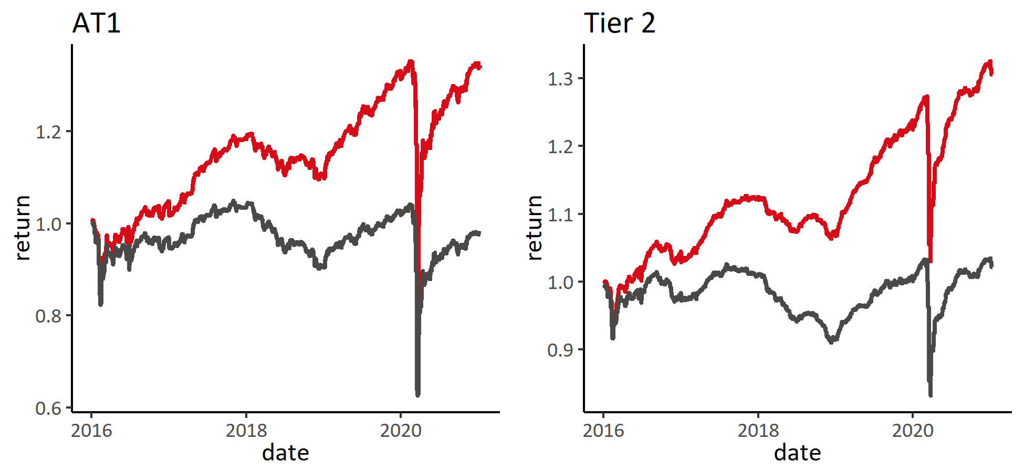

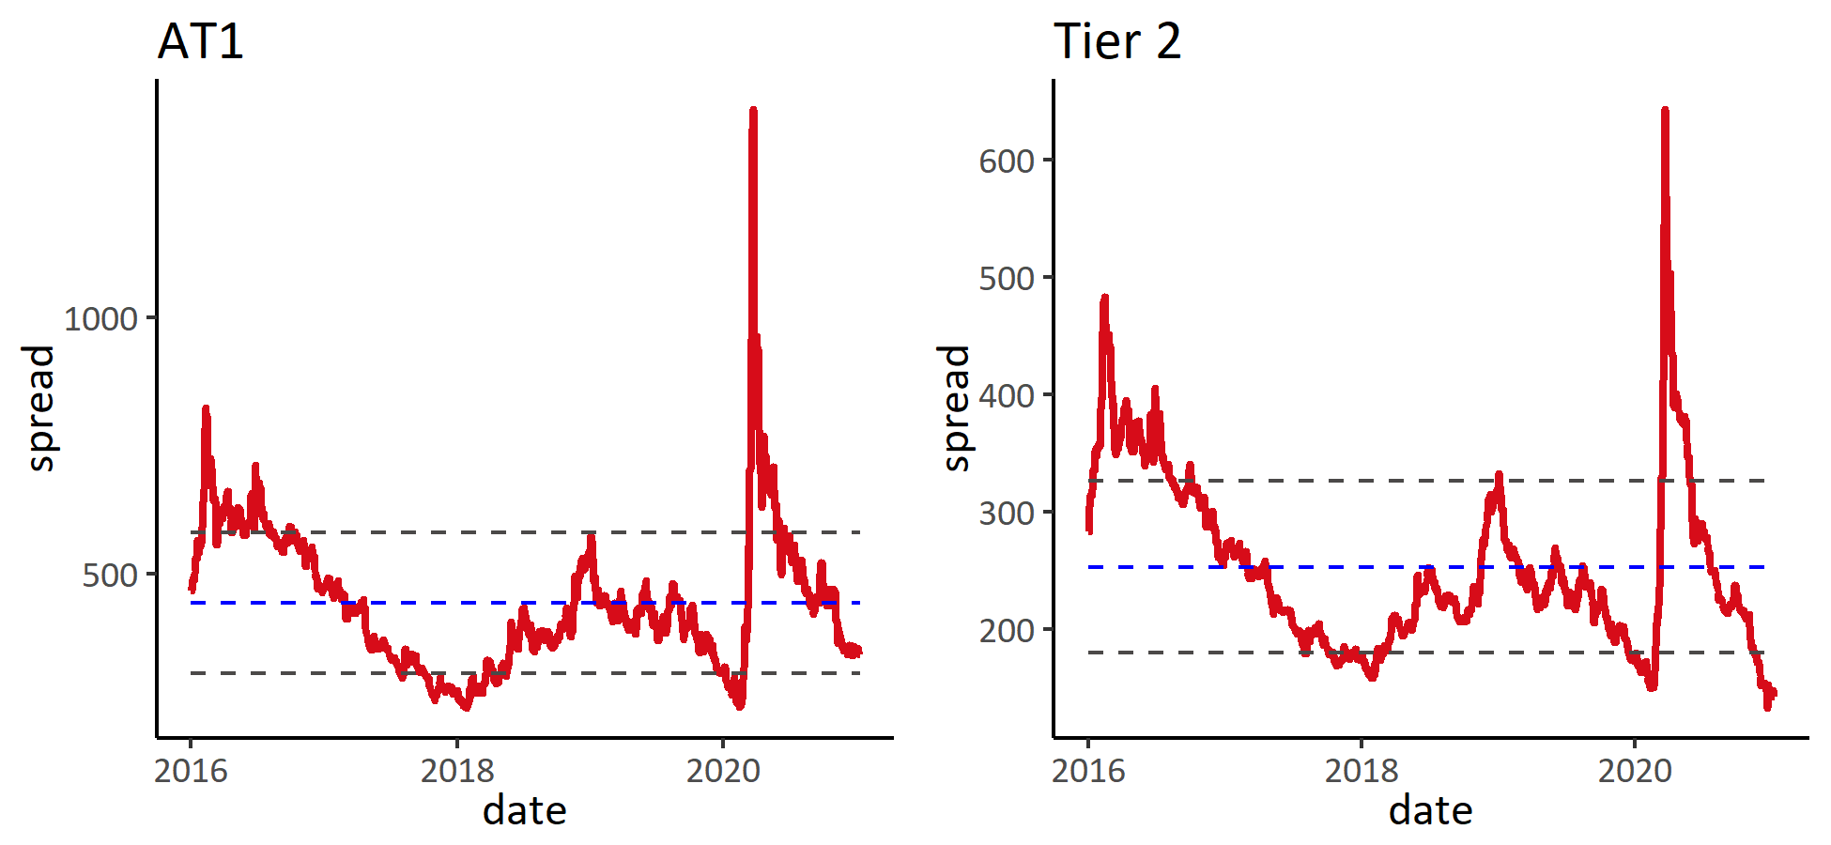

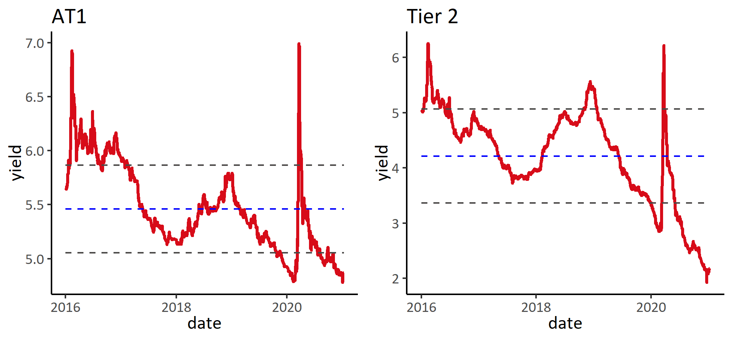

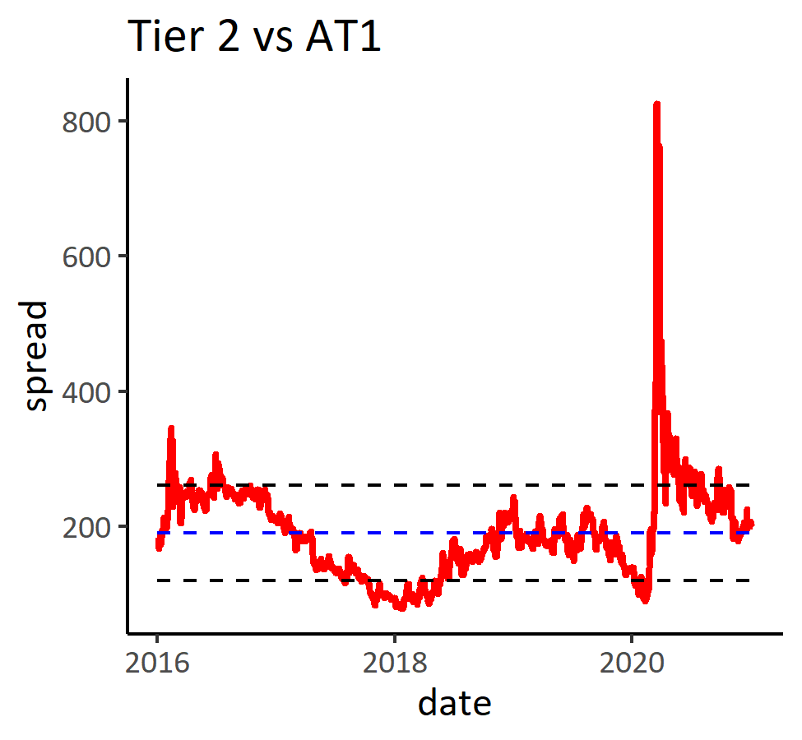

### 2) AT1板块涨跌幅

表: 按综合评级分组

|  | **涨跌幅** | | | **信用利差变动** | | |
| --- | --- | --- | --- | --- | --- | --- |
| **分组** | **本周** | **本月** | **本年** | **本周** | **本月** | **本年** |
| **BBB** | **0.3%** | **-0.7%** | **-0.7%** | **-9** | **-1** | **-1** |
| **BB** | **0.4%** | **-0.3%** | **-0.3%** | **-16** | **-10** | **-10** |
| **B** | **0.7%** | **0.3%** | **0.3%** | **-26** | **-26** | **-26** |

表: 涨幅前十

| **债券简称** | **涨跌幅** | **信用利差变化** | **债券简称** | **涨跌幅** | **信用利差变化** | **债券简称** | **涨跌幅** | **信用利差变化** |
| --- | --- | --- | --- | --- | --- | --- | --- | --- |
|  | **本周** | |  | **本月** | |  | **本年** | |
| STANLN 6 PERP | **1.5%** | **-48** | STANLN 6 PERP | **1.5%** | **-48** | STANLN 6 PERP | **1.5%** | **-48** |
| BACR 6.125 PERP | **1.0%** | **-31** | BACR 6.125 PERP | **1.0%** | **-31** | BACR 6.125 PERP | **1.0%** | **-31** |
| DB 4.789 PERP | **0.9%** | **-34** | DB 4.789 PERP | **0.9%** | **-34** | DB 4.789 PERP | **0.9%** | **-34** |
| BACR 7.75 PERP | **0.9%** | **-30** | BACR 7.75 PERP | **0.9%** | **-30** | BACR 7.75 PERP | **0.9%** | **-30** |
| WSTP 5 PERP | **0.8%** | **31** | WSTP 5 PERP | **0.8%** | **31** | WSTP 5 PERP | **0.8%** | **31** |
| HSBC 6.5 PERP | **0.8%** | **-30** | HSBC 6.5 PERP | **0.8%** | **-30** | HSBC 6.5 PERP | **0.8%** | **-30** |
| UCGIM 8 PERP | **0.7%** | **-26** | UCGIM 8 PERP | **0.8%** | **-26** | UCGIM 8 PERP | **0.8%** | **-26** |
| DANBNK 7 PERP | **0.7%** | **-28** | DANBNK 7 PERP | **0.7%** | **-28** | DANBNK 7 PERP | **0.7%** | **-28** |
| SEB 5.125 PERP | **0.6%** | **-28** | UBS 5 PERP | **0.7%** | **-24** | UBS 5 PERP | **0.7%** | **-24** |
| UBS 5 PERP | **0.6%** | **-24** | SEB 5.125 PERP | **0.7%** | **-28** | SEB 5.125 PERP | **0.7%** | **-28** |

表: 跌幅前十

| **债券简称** | **涨跌幅** | **信用利差变化** | **债券简称** | **涨跌幅** | **信用利差变化** | **债券简称** | **涨跌幅** | **信用利差变化** |
| --- | --- | --- | --- | --- | --- | --- | --- | --- |
|  | **本周** | |  | **本月** | |  | **本年** | |
| CS 4.5 PERP | **-0.5%** | **-12** | CS 4.5 PERP | **-0.5%** | **-12** | CS 4.5 PERP | **-0.5%** | **-12** |
| BNP 4.5 PERP | **-0.4%** | **-18** | BNP 4.5 PERP | **-0.4%** | **-18** | BNP 4.5 PERP | **-0.4%** | **-18** |
| SOCGEN 5.375 PERP | **-0.2%** | **-16** | SOCGEN 5.375 PERP | **-0.2%** | **-16** | SOCGEN 5.375 PERP | **-0.2%** | **-16** |
| SHBASS 6.25 PERP | **-0.1%** | **17** | SHBASS 6.25 PERP | **-0.1%** | **17** | SHBASS 6.25 PERP | **-0.1%** | **17** |
| INTNED 6.875 PERP | **-0.0%** | **7** | INTNED 6.875 PERP | **0.0%** | **7** | INTNED 6.875 PERP | **0.0%** | **7** |
| HSBC 4.6 PERP | **0.0%** | **-19** | HSBC 4.6 PERP | **0.1%** | **-19** | HSBC 4.6 PERP | **0.1%** | **-19** |
| ACAFP 7.875 PERP | **0.0%** | **11** | ACAFP 7.875 PERP | **0.1%** | **11** | ACAFP 7.875 PERP | **0.1%** | **11** |
| UBS 7.125 PERP | **0.1%** | **-9** | UBS 7.125 PERP | **0.2%** | **-9** | UBS 7.125 PERP | **0.2%** | **-9** |
| MQGAU 6.125 PERP | **0.2%** | **-15** | MQGAU 6.125 PERP | **0.2%** | **-15** | MQGAU 6.125 PERP | **0.2%** | **-15** |
| HSBC 6.375 PERP | **0.2%** | **-16** | HSBC 6.375 PERP | **0.2%** | **-16** | HSBC 6.375 PERP | **0.2%** | **-16** |

### 3) Tier2板块涨跌幅

表: 按综合评级分组

|  | **涨跌幅** | | | **信用利差变动** | | |
| --- | --- | --- | --- | --- | --- | --- |
| **分组** | **本周** | **本月** | **本年** | **本周** | **本月** | **本年** |
| **BBB** | **-1.3%** | **-1.7%** | **-1.7%** | **-2** | **-2** | **-2** |
| **BB** | **0.3%** | **-1.1%** | **-1.1%** | **-9** | **-3** | **-3** |

表: 涨幅前十

| **债券简称** | **涨跌幅** | **信用利差变化** | **债券简称** | **涨跌幅** | **信用利差变化** | **债券简称** | **涨跌幅** | **信用利差变化** |
| --- | --- | --- | --- | --- | --- | --- | --- | --- |
|  | **本周** | |  | **本月** | |  | **本年** | |
| BBVASM 5.125 33 | **1.0%** | **-34** | BBVASM 5.125 33 | **1.1%** | **-34** | BBVASM 5.125 33 | **1.1%** | **-34** |
| DB 4.875 32 | **0.6%** | **-23** | DB 4.875 32 | **0.6%** | **-23** | DB 4.875 32 | **0.6%** | **-23** |
| DB 4.296 28 | **0.5%** | **-15** | DB 4.296 28 | **0.5%** | **-15** | DB 4.296 28 | **0.5%** | **-15** |
| BACR 7.625 22 | **0.4%** | **-19** | BACR 7.625 22 | **0.5%** | **-19** | BACR 7.625 22 | **0.5%** | **-19** |
| UBS 5.125 24 | **0.3%** | **5** | UBS 5.125 24 | **0.3%** | **5** | UBS 5.125 24 | **0.3%** | **5** |
| CS 6.5 23 | **0.2%** | **-5** | CS 6.5 23 | **0.3%** | **-5** | CS 6.5 23 | **0.3%** | **-5** |
| ANZ 4.5 24 | **0.2%** | **8** | ANZ 4.5 24 | **0.2%** | **8** | ANZ 4.5 24 | **0.2%** | **8** |
| UBS 7.625 22 | **0.1%** | **-4** | UBS 7.625 22 | **0.1%** | **-4** | UBS 7.625 22 | **0.1%** | **-4** |
| BBVASM 5.35 29 | **0.1%** | **-5** | BBVASM 5.35 29 | **0.1%** | **-5** | BBVASM 5.35 29 | **0.1%** | **-5** |
| CBAAU 3.375 26 | **0.1%** | **-1** | CBAAU 3.375 26 | **0.1%** | **-1** | CBAAU 3.375 26 | **0.1%** | **-1** |

表: 跌幅前十

| **债券简称** | **涨跌幅** | **信用利差变化** | **债券简称** | **涨跌幅** | **信用利差变化** | **债券简称** | **涨跌幅** | **信用利差变化** |
| --- | --- | --- | --- | --- | --- | --- | --- | --- |
|  | **本周** | |  | **本月** | |  | **本年** | |
| WSTP 5 46 | **-4.5%** | **7** | WSTP 5 46 | **-4.5%** | **7** | WSTP 5 46 | **-4.5%** | **7** |
| CBAAU 4.316 48 | **-3.5%** | **-1** | CBAAU 4.316 48 | **-3.5%** | **-1** | CBAAU 4.316 48 | **-3.5%** | **-1** |
| WSTP 2.963 40 | **-3.4%** | **2** | WSTP 2.963 40 | **-3.4%** | **2** | WSTP 2.963 40 | **-3.4%** | **2** |
| WSTP 4.421 39 | **-2.8%** | **0** | WSTP 4.421 39 | **-2.8%** | **0** | WSTP 4.421 39 | **-2.8%** | **0** |
| CBAAU 3.743 39 | **-2.7%** | **-2** | CBAAU 3.743 39 | **-2.7%** | **-2** | CBAAU 3.743 39 | **-2.7%** | **-2** |
| ANZ 2.57 35 | **-1.5%** | **-1** | ANZ 2.57 35 | **-1.5%** | **-1** | ANZ 2.57 35 | **-1.5%** | **-1** |
| WSTP 2.668 35 | **-1.5%** | **-2** | WSTP 2.668 35 | **-1.5%** | **-2** | WSTP 2.668 35 | **-1.5%** | **-2** |
| CBAAU 3.61 34 | **-1.3%** | **-1** | CBAAU 3.61 34 | **-1.3%** | **-1** | CBAAU 3.61 34 | **-1.3%** | **-1** |
| MQGAU 3.624 30 | **-1.3%** | **-2** | MQGAU 3.624 30 | **-1.3%** | **-2** | MQGAU 3.624 30 | **-1.3%** | **-2** |
| WSTP 4.11 34 | **-1.2%** | **-2** | WSTP 4.11 34 | **-1.2%** | **-2** | WSTP 4.11 34 | **-1.2%** | **-2** |

### 4) 估值分位

表: AT1分评级估值

|  |  | **到期收益率历史百分位** | | |  | **信用利差历史百分位** | | |
| --- | --- | --- | --- | --- | --- | --- | --- | --- |
| **分组** | **到期收益率** | **1年** | **3年** | **全部** | **信用利差** | **1年** | **3年** | **全部** |
| **BBB** | **4.5** | **2%** | **0%** | **0%** | **318** | **2%** | **0%** | **0%** |
| **BB** | **5.1** | **22%** | **5%** | **5%** | **355** | **22%** | **5%** | **5%** |
| **B** | **5.6** | **36%** | **9%** | **9%** | **480** | **36%** | **9%** | **9%** |

## 8.EM

### 1) 指数与估值

图: 收益与估值

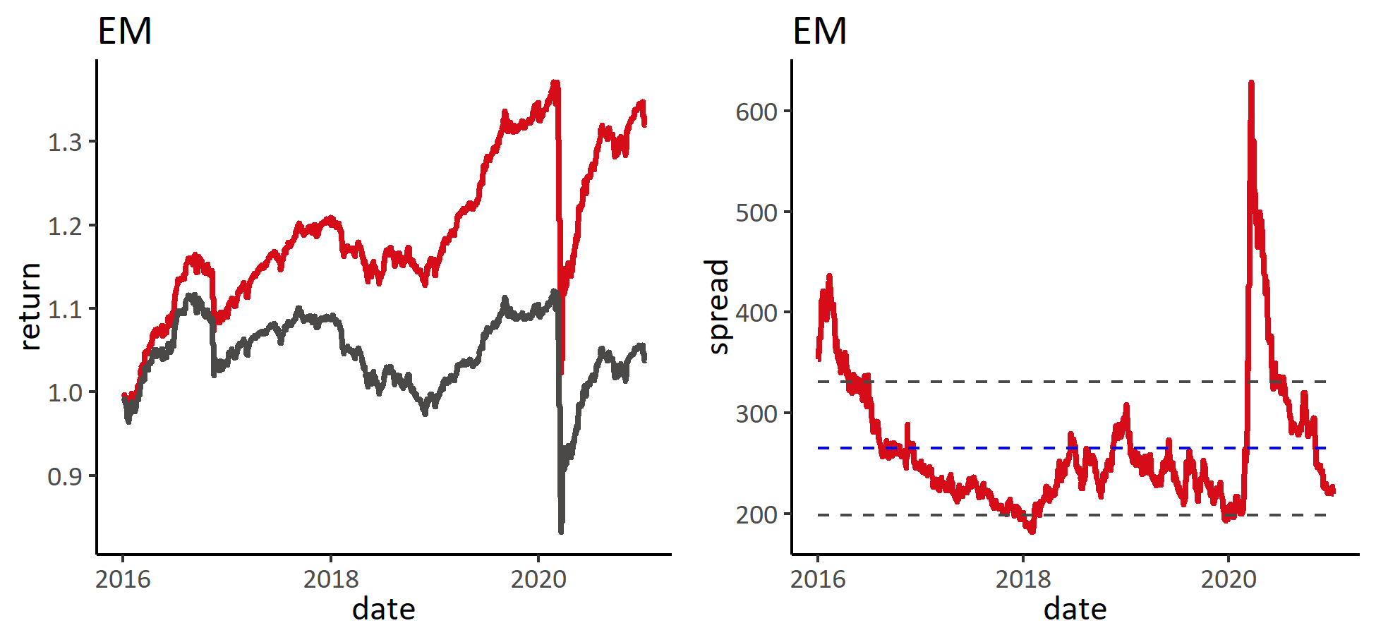

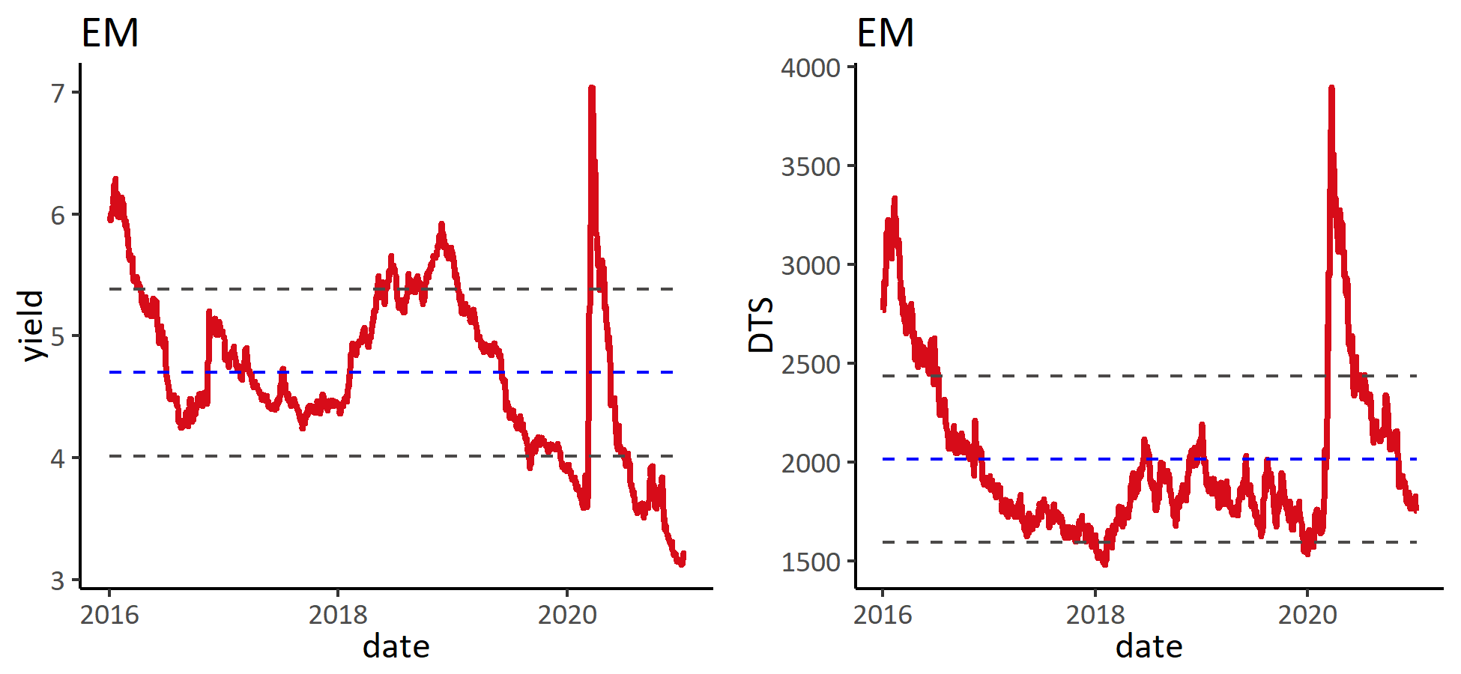

### 2) 板块涨跌幅

表: 按综合评级分组

|  | **涨跌幅** | | | **信用利差变动** | | |
| --- | --- | --- | --- | --- | --- | --- |
| **分组** | **本周** | **本月** | **本年** | **本周** | **本月** | **本年** |
| **AA** | **-1.1%** | **-1.1%** | **-1.1%** | **-4** | **-2** | **-2** |
| **A** | **-1.5%** | **-1.9%** | **-1.9%** | **-2** | **-1** | **-1** |
| **BBB** | **-1.0%** | **-1.7%** | **-1.7%** | **-2** | **3** | **3** |
| **BB** | **-0.3%** | **-3.6%** | **-3.6%** | **-7** | **-9** | **-9** |
| **B** | **0.4%** | **-2.4%** | **-2.4%** | **-11** | **-9** | **-9** |
| **CCC** | **1.4%** | **-2.5%** | **-2.5%** | **-31** | **-81** | **-81** |
| **NR** | **0.1%** | **-0.8%** | **-0.8%** | **-5** | **4** | **4** |

表: 涨幅前十

| **债券简称** | **涨跌幅** | **信用利差变化** | **债券简称** | **涨跌幅** | **信用利差变化** | **债券简称** | **涨跌幅** | **信用利差变化** |
| --- | --- | --- | --- | --- | --- | --- | --- | --- |
|  | **本周** | |  | **本月** | |  | **本年** | |
| ANGOL 9.125 49 | **4.4%** | **-64** | ANGOL 9.125 49 | **4.5%** | **-64** | ANGOL 9.125 49 | **4.5%** | **-64** |
| ANGOL 9.375 48 | **4.4%** | **-56** | ANGOL 9.375 48 | **4.5%** | **-56** | ANGOL 9.375 48 | **4.5%** | **-56** |
| ANGOL 8 29 | **3.0%** | **-64** | ANGOL 8 29 | **3.0%** | **-64** | ANGOL 8 29 | **3.0%** | **-64** |
| ANGOL 8.25 28 | **2.9%** | **-56** | ANGOL 8.25 28 | **3.0%** | **-56** | ANGOL 8.25 28 | **3.0%** | **-56** |
| NGERIA 8.747 31 | **2.6%** | **-55** | NGERIA 8.747 31 | **2.7%** | **-55** | NGERIA 8.747 31 | **2.7%** | **-55** |
| COSTAR 7.158 45 | **2.6%** | **-38** | COSTAR 7.158 45 | **2.7%** | **-38** | COSTAR 7.158 45 | **2.7%** | **-38** |
| ZAMBIN 8.97 27 | **2.5%** | **-14** | ZAMBIN 8.97 27 | **2.6%** | **-14** | ZAMBIN 8.97 27 | **2.6%** | **-14** |
| NGERIA 7.875 32 | **2.4%** | **-39** | NGERIA 7.875 32 | **2.4%** | **-39** | NGERIA 7.875 32 | **2.4%** | **-39** |
| NGERIA 7.625 47 | **2.3%** | **-40** | NGERIA 7.625 47 | **2.4%** | **-40** | NGERIA 7.625 47 | **2.4%** | **-40** |
| COSTAR 7 44 | **2.3%** | **-35** | COSTAR 7 44 | **2.4%** | **-35** | COSTAR 7 44 | **2.4%** | **-35** |

表: 跌幅前十

| **债券简称** | **涨跌幅** | **信用利差变化** | **债券简称** | **涨跌幅** | **信用利差变化** | **债券简称** | **涨跌幅** | **信用利差变化** |
| --- | --- | --- | --- | --- | --- | --- | --- | --- |
|  | **本周** | |  | **本月** | |  | **本年** | |
| PETMK 4.8 60 | **-7.2%** | **14** | PETMK 4.8 60 | **-7.2%** | **14** | PETMK 4.8 60 | **-7.2%** | **14** |
| PETMK 4.55 50 | **-6.6%** | **19** | PETMK 4.55 50 | **-6.6%** | **19** | PETMK 4.55 50 | **-6.6%** | **19** |
| PETMK 4.5 45 | **-4.3%** | **6** | PETMK 4.5 45 | **-4.3%** | **6** | PETMK 4.5 45 | **-4.3%** | **6** |
| MUBAUH 3.7 49 | **-3.8%** | **1** | MUBAUH 3.7 49 | **-3.8%** | **1** | MUBAUH 3.7 49 | **-3.8%** | **1** |
| KSA 3.75 55 | **-3.8%** | **-2** | KSA 3.75 55 | **-3.8%** | **-2** | KSA 3.75 55 | **-3.8%** | **-2** |
| PERTIJ 4.175 50 | **-3.5%** | **0** | PERTIJ 4.175 50 | **-3.5%** | **0** | PERTIJ 4.175 50 | **-3.5%** | **0** |
| MUBAUH 3.95 50 | **-3.4%** | **-5** | MUBAUH 3.95 50 | **-3.4%** | **-5** | MUBAUH 3.95 50 | **-3.4%** | **-5** |
| MALAYS 4.236 45 | **-3.4%** | **-1** | MALAYS 4.236 45 | **-3.4%** | **-1** | MALAYS 4.236 45 | **-3.4%** | **-1** |
| MALAYS 4.08 46 | **-3.4%** | **-3** | MALAYS 4.08 46 | **-3.3%** | **-3** | MALAYS 4.08 46 | **-3.3%** | **-3** |
| KSA 4.5 60 | **-3.2%** | **-1** | KSA 4.5 60 | **-3.1%** | **-1** | KSA 4.5 60 | **-3.1%** | **-1** |

### 3) 估值分位

表: 分评级估值

|  |  | **到期收益率历史百分位** | | |  | **信用利差历史百分位** | | |
| --- | --- | --- | --- | --- | --- | --- | --- | --- |
| **分组** | **到期收益率** | **1年** | **3年** | **全部** | **信用利差** | **1年** | **3年** | **全部** |
| **AA** | **1.8** | **28%** | **6%** | **6%** | **74** | **28%** | **6%** | **6%** |
| **A** | **2.3** | **40%** | **8%** | **8%** | **120** | **40%** | **8%** | **8%** |
| **BBB** | **2.5** | **14%** | **3%** | **3%** | **144** | **14%** | **3%** | **3%** |
| **BB** | **3.8** | **2%** | **0%** | **0%** | **283** | **2%** | **0%** | **0%** |
| **B** | **5.3** | **6%** | **1%** | **1%** | **443** | **6%** | **1%** | **1%** |
| **CCC** | **8.8** | **16%** | **70%** | **77%** | **783** | **16%** | **70%** | **77%** |
| **NR** | **3.2** | **8%** | **2%** | **2%** | **246** | **8%** | **2%** | **2%** |

# 三. 资金流向

## 1. EM资金流向

图: EM资金每周流入情况

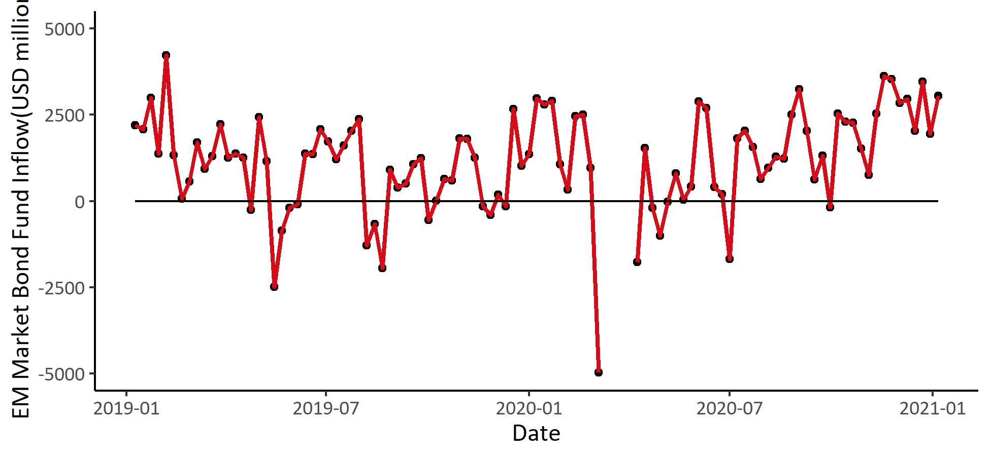

图: 上周EM资金分地区流入

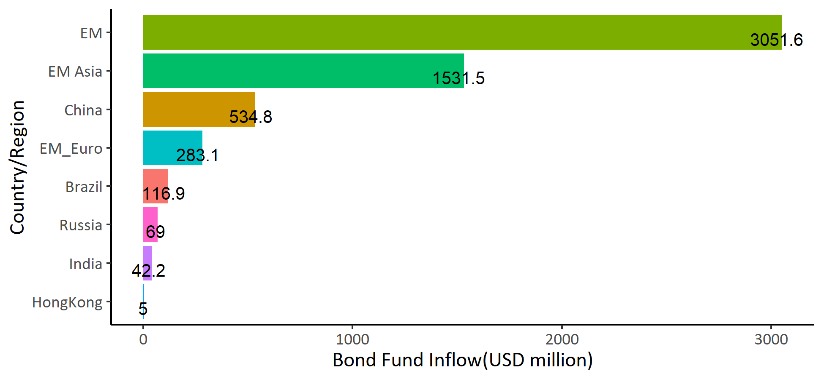

## 2. ETF资金流向

图: 美股ETF资金流向

