周会

目录

# 一、主要资产类别回顾

图: 主要资产近一周涨跌幅汇总

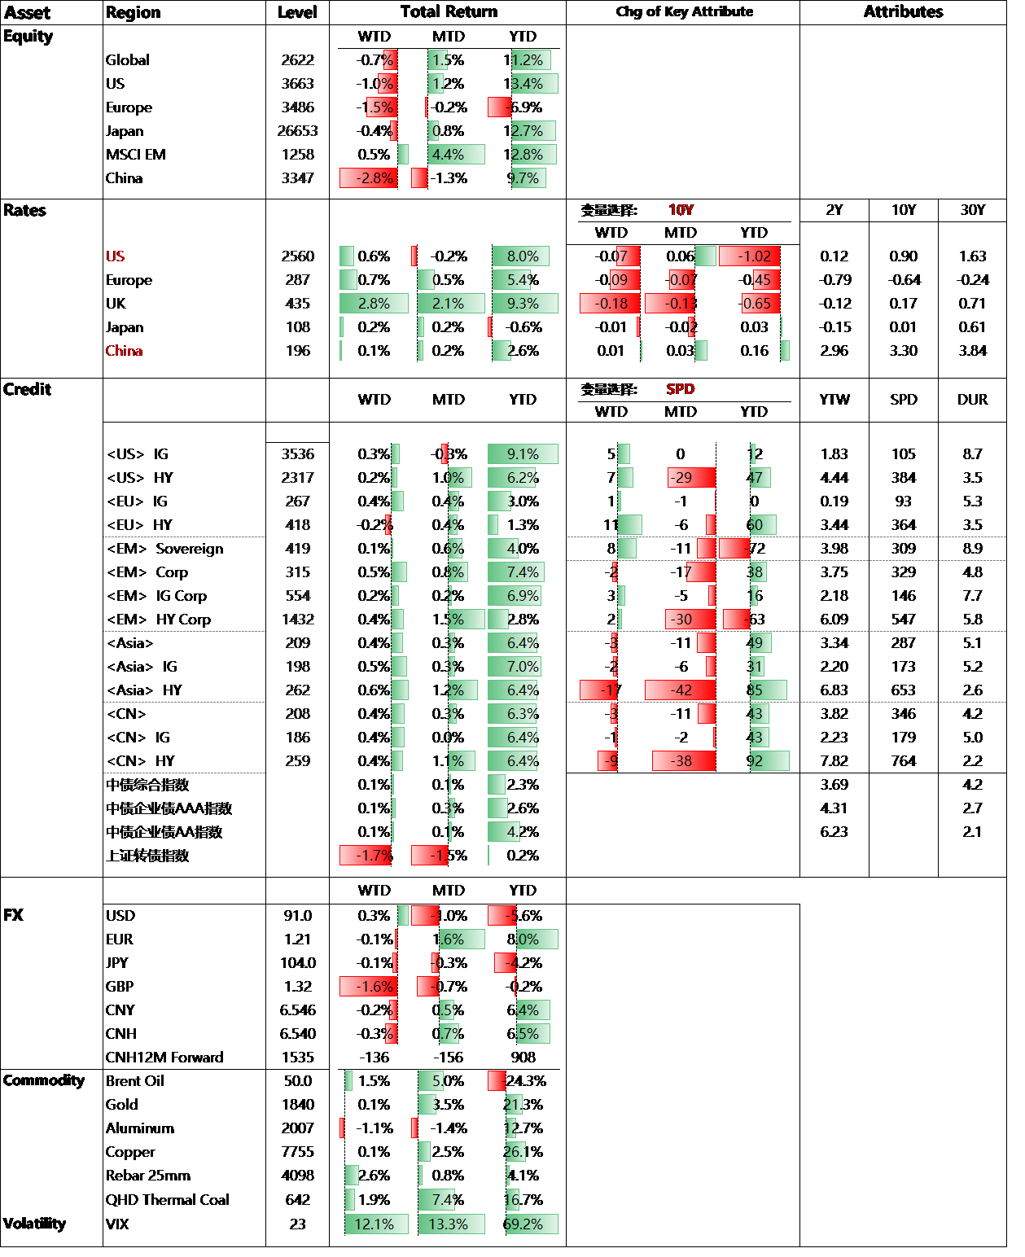

# 二. 主要板块回顾

## 1. 全市场概览

### 1) 指数回顾

图: 收益与估值

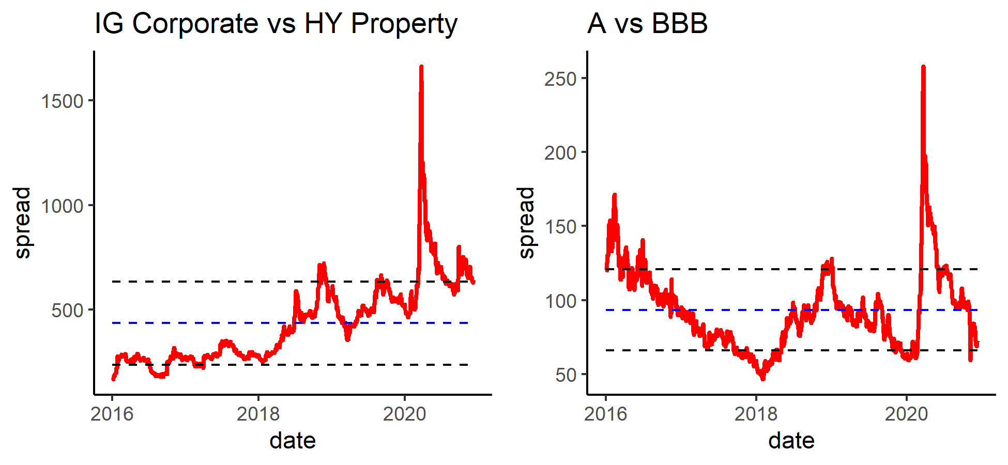

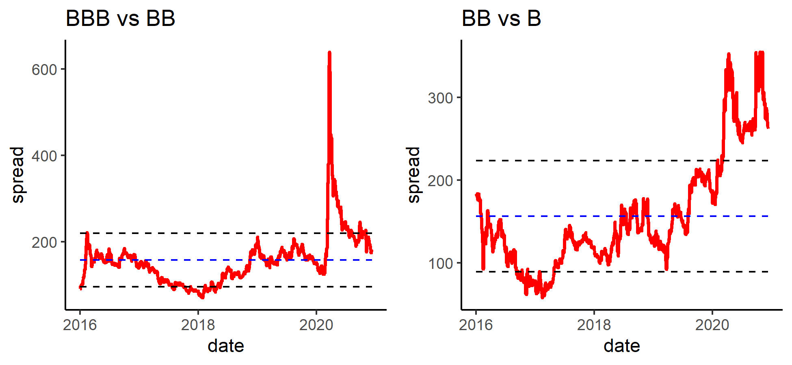

### 2) 分组数据概览

表: 按类别分组

|  | **涨跌幅** | | | **信用利差变动** | | |
| --- | --- | --- | --- | --- | --- | --- |
| **分组** | **本周** | **本月** | **本年** | **本周** | **本月** | **本年** |
| **AT1** | **-0.3%** | **0.1%** | **-4.2%** | **17** | **2** | **47** |
| **EM** | **-0.0%** | **0.6%** | **-3.7%** | **4** | **-12** | **29** |
| **Financials** | **0.3%** | **0.1%** | **2.4%** | **-4** | **-10** | **16** |
| **HY Property** | **0.1%** | **0.7%** | **-4.2%** | **-2** | **-15** | **155** |
| **IG Corporate** | **0.5%** | **-0.2%** | **2.7%** | **-1** | **-1** | **29** |
| **Industry** | **-0.0%** | **0.3%** | **-7.8%** | **-1** | **-49** | **-42** |
| **LGFV** | **0.1%** | **0.1%** | **0.2%** | **-3** | **-20** | **42** |
| **Tier 2** | **0.2%** | **0.4%** | **2.9%** | **2** | **-15** | **-23** |

表: 按综合评级分组

|  | **涨跌幅** | | | **信用利差变动** | | |
| --- | --- | --- | --- | --- | --- | --- |
| **分组** | **本周** | **本月** | **本年** | **本周** | **本月** | **本年** |
| **A** | **0.4%** | **-0.1%** | **4.1%** | **0** | **-2** | **17** |
| **AA** | **-0.1%** | **-0.2%** | **5.3%** | **7** | **-2** | **4** |
| **B** | **0.1%** | **1.6%** | **-6.8%** | **-6** | **-31** | **146** |
| **BB** | **-0.2%** | **0.8%** | **-3.6%** | **12** | **-20** | **62** |
| **BBB** | **0.1%** | **0.1%** | **1.1%** | **4** | **-9** | **28** |
| **CCC** | **-0.3%** | **2.3%** | **-72.8%** | **9** | **-75** | **396** |
| **NR** | **0.1%** | **0.2%** | **-2.0%** | **-4** | **-17** | **-50** |

表: 涨幅前十

| **债券简称** | **涨跌幅** | **信用利差变化** | **债券简称** | **涨跌幅** | **信用利差变化** | **债券简称** | **涨跌幅** | **信用利差变化** |
| --- | --- | --- | --- | --- | --- | --- | --- | --- |
|  | **本周** | |  | **本月** | |  | **本年** | |
| TQLTHI 3.75 22 | **45.8%** | **-2270** | TQLTHI 3.75 22 | **62.1%** | **-2918** | FANHAI 14.5 21 | **41.5%** | **-734** |
| ANTOIL 7.5 22 | **9.3%** | **-504** | ANTOIL 7.5 22 | **13.7%** | **-722** | XINHUZ 11 22 | **23.7%** | **-206** |
| SINOPE 3.35 50 | **3.0%** | **-12** | ZAMBIN 8.97 27 | **9.7%** | **-222** | XIN 14.2 21 | **22.7%** | **-25** |
| BABA 4.2 47 | **3.0%** | **-4** | COSTAR 7.158 45 | **8.4%** | **-79** | EAGRUY 7.5 25 | **21.8%** | **-108** |
| ELSALV 7.65 35 | **3.0%** | **-31** | COSTAR 7 44 | **8.3%** | **-75** | WSTP 5 46 | **21.8%** | **-36** |
| ELSALV 7.1246 50 | **2.9%** | **-12** | COSTAR 5.625 43 | **7.8%** | **-67** | CBAAU 3.743 39 | **20.7%** | **-46** |
| ELSALV 7.625 41 | **2.8%** | **-13** | COSTAR 6.125 31 | **6.8%** | **-108** | WSTP 4.421 39 | **19.9%** | **-44** |
| CFELEC 5.75 42 | **2.7%** | **-8** | ANGOL 9.125 49 | **6.4%** | **-68** | XINHUZ 11 21 | **19.8%** | **-261** |
| EXIMCH 4 47 | **2.7%** | **-3** | ANGOL 9.375 48 | **6.2%** | **-65** | BABA 4.4 57 | **19.7%** | **-5** |
| SINOPE 3.68 49 | **2.7%** | **-2** | ELSALV 7.1246 50 | **6.0%** | **-55** | CBAAU 4.316 48 | **19.2%** | **-16** |

表: 涨幅前十

| **债券简称** | **涨跌幅** | **信用利差变化** | **债券简称** | **涨跌幅** | **信用利差变化** | **债券简称** | **涨跌幅** | **信用利差变化** |
| --- | --- | --- | --- | --- | --- | --- | --- | --- |
|  | **本周** | |  | **本月** | |  | **本年** | |
| CFELEC 5.15 47 | **-8.0%** | **99** | CNOOC 3.3 49 | **-5.7%** | **28** | SRILAN 7.85 29 | **-35.5%** | **1104** |
| CHFOTN 6.9 23 | **-5.5%** | **325** | CFELEC 5.15 47 | **-5.0%** | **53** | SRILAN 7.55 30 | **-34.3%** | **984** |
| CHFOTN 8.6 24 | **-5.0%** | **192** | CNOOC 4.25 43 | **-4.2%** | **27** | SRILAN 6.825 26 | **-33.9%** | **1333** |
| CHFOTN 8.05 25 | **-4.1%** | **142** | CNOOC 7.5 39 | **-3.7%** | **28** | SRILAN 6.75 28 | **-33.2%** | **1054** |
| CHFOTN 9 21 | **-3.7%** | **641** | CNOOC 6.4 37 | **-3.7%** | **24** | SRILAN 6.85 25 | **-32.8%** | **1402** |
| CHFOTN 8.75 22 | **-3.6%** | **250** | CNOOC 5.875 35 | **-3.6%** | **33** | SRILAN 6.2 27 | **-32.5%** | **1114** |
| CHFOTN 6.92 22 | **-2.4%** | **203** | CNOOC 4.875 44 | **-3.6%** | **17** | SRILAN 6.85 24 | **-31.9%** | **1883** |
| HKIQCL 5.95 25 | **-1.9%** | **56** | SRILAN 6.825 26 | **-3.5%** | **102** | SRILAN 6.125 25 | **-31.0%** | **1402** |
| OMAN 6.75 48 | **-1.8%** | **28** | CNOOC 4.2 45 | **-3.2%** | **17** | SRILAN 6.35 24 | **-30.6%** | **1668** |
| EAGRUY 7.5 25 | **-1.8%** | **63** | CNOOC 5.75 41 | **-3.2%** | **20** | SRILAN 5.75 23 | **-27.3%** | **2087** |