3.17

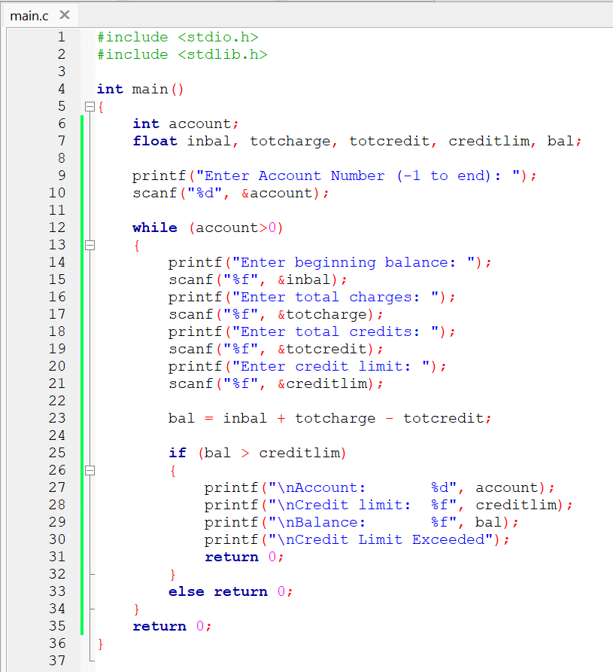

3.18

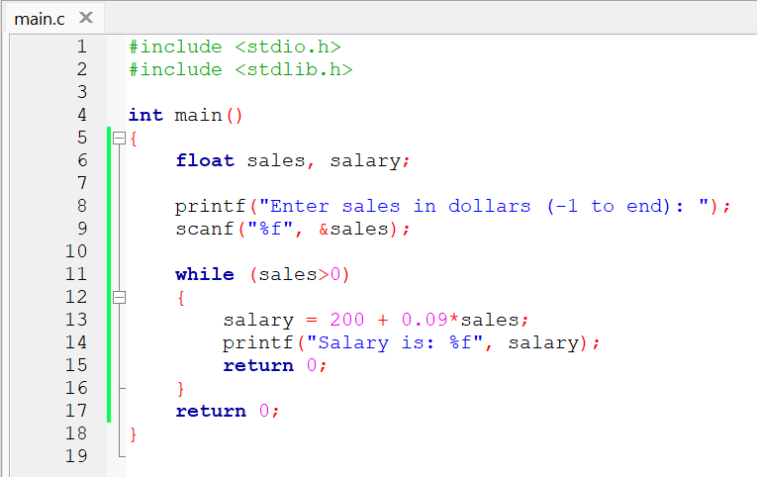

3.19

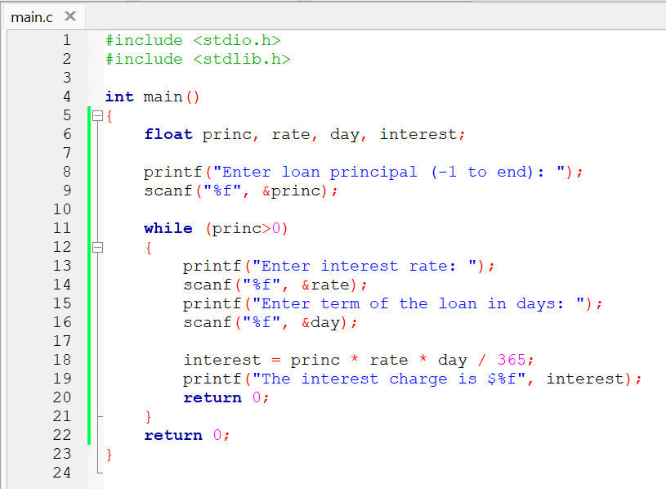

3.20

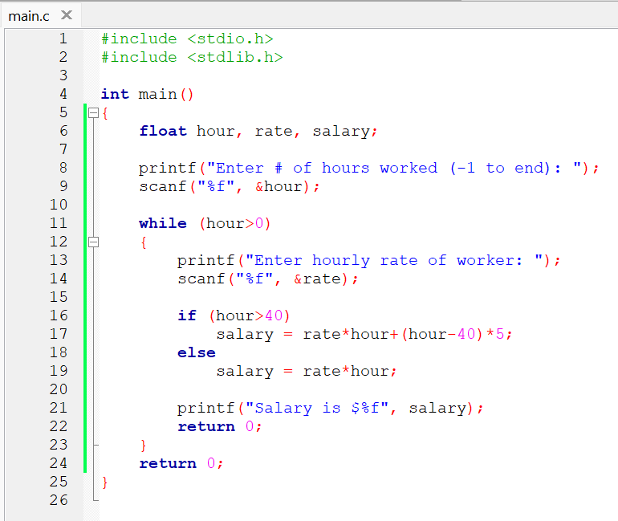

3.33

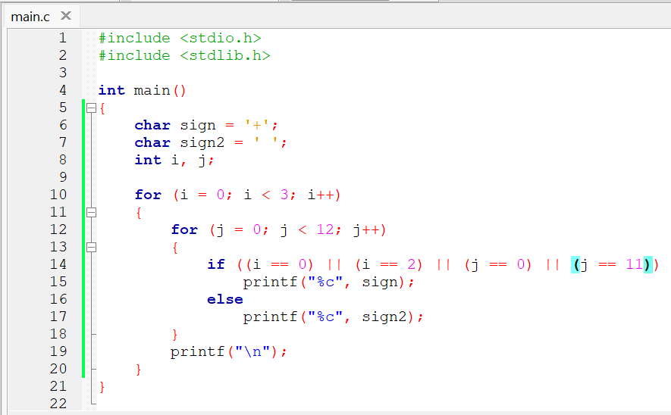

4.15

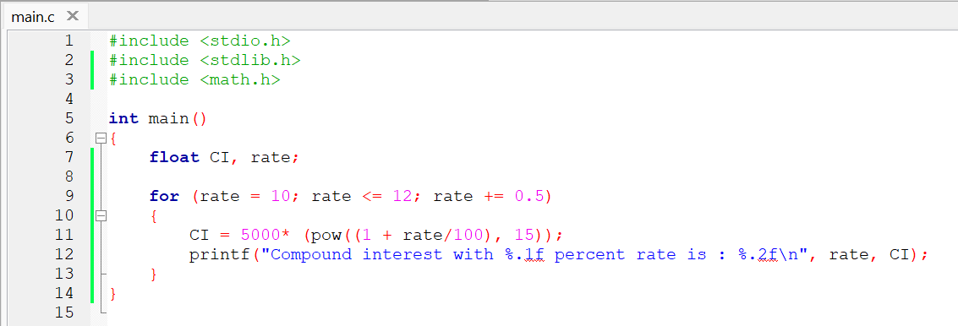

4.16

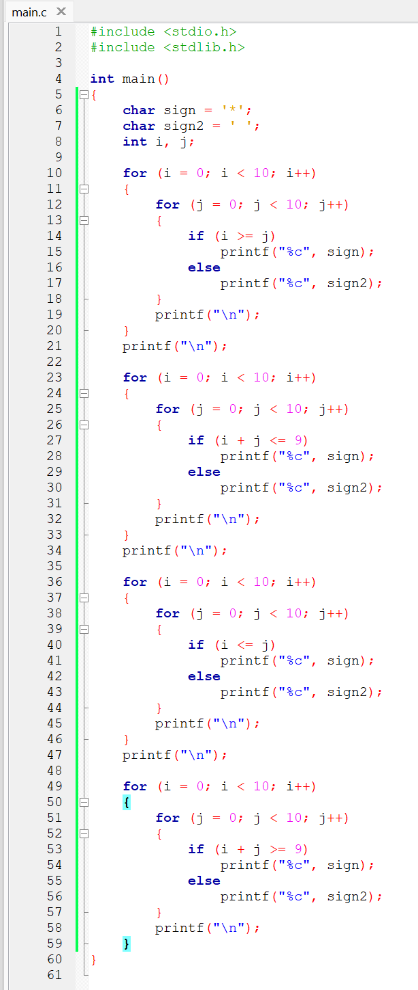

4.27

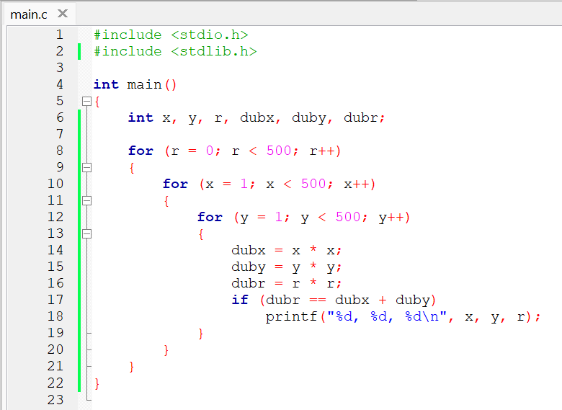

4.28

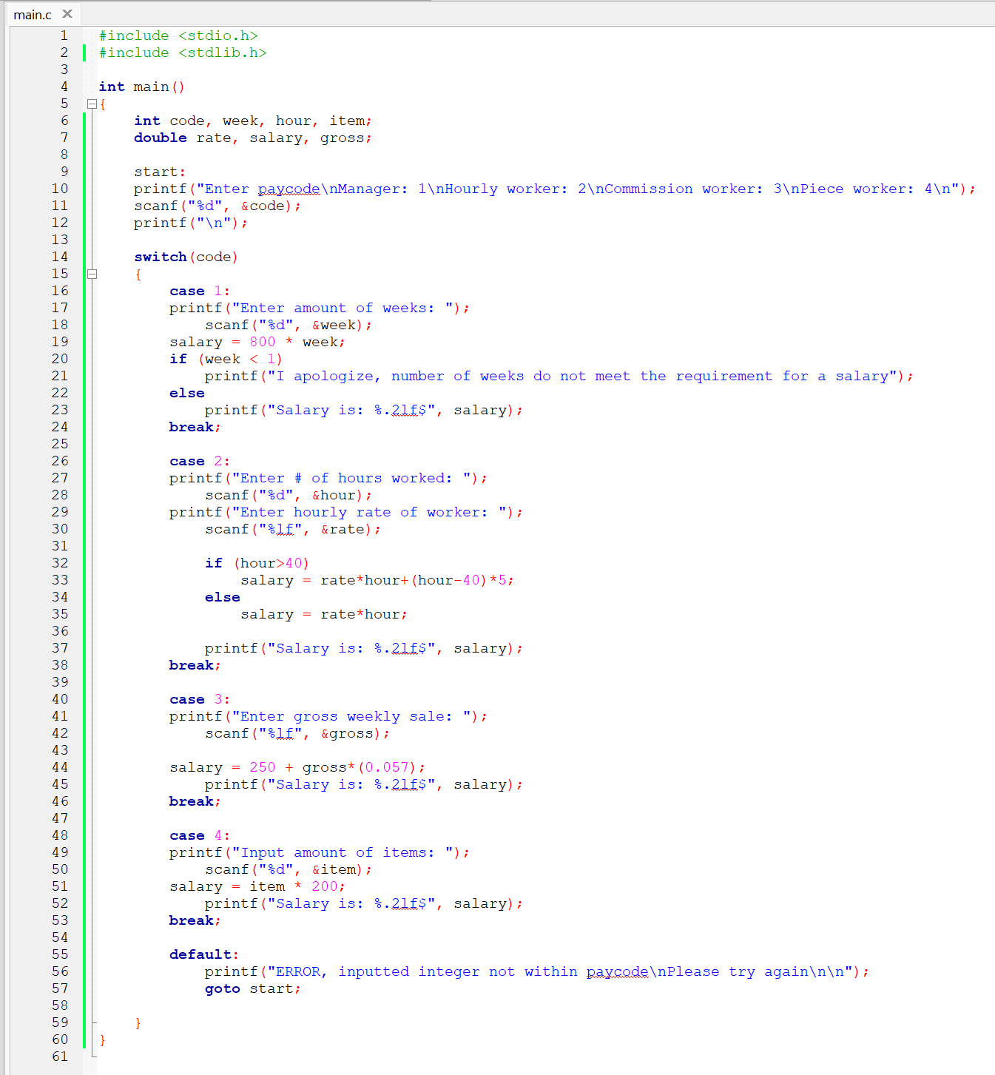

4.31

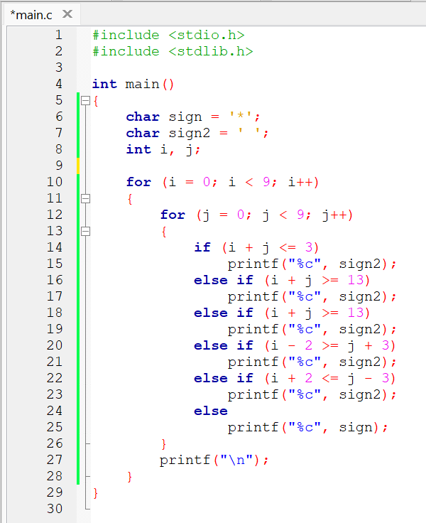

Conclusion:

The usage of for statements are very useful for loops. Loops are usually needed in printing multiple things or calculating something in a looping manner. Switch case statements are useful for making a function that runs according to the inputted data within switch. While statements are also useful in looping, the difference of while and for is that while contains a condition, for contains an, initialization, condition, and iteration.

Code:

https://github.com/AldrichWijaya/Homework