Discussion Time: 16th December, 2022, 20:56 - 22:01

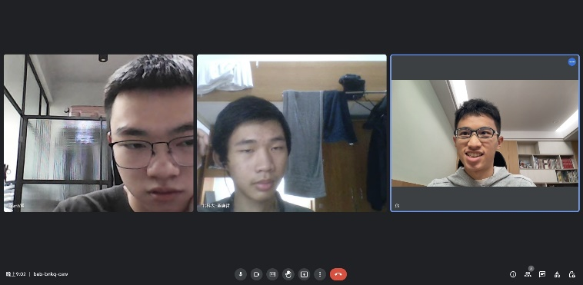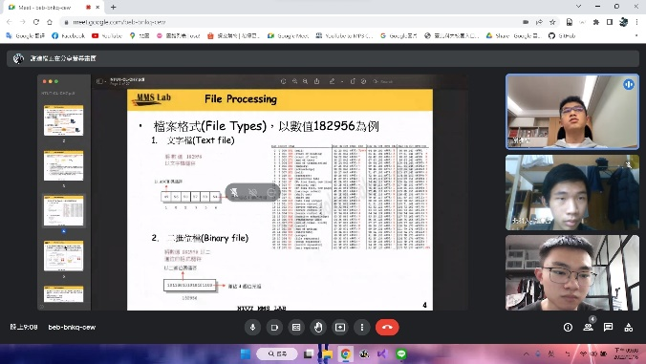

P14

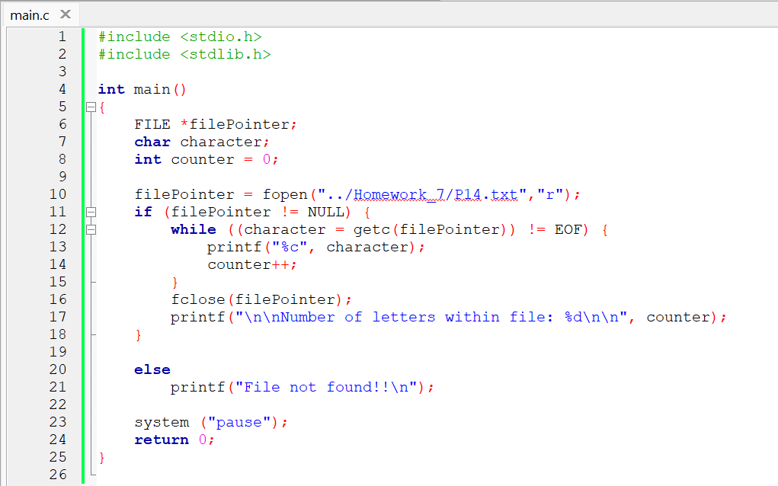

P15

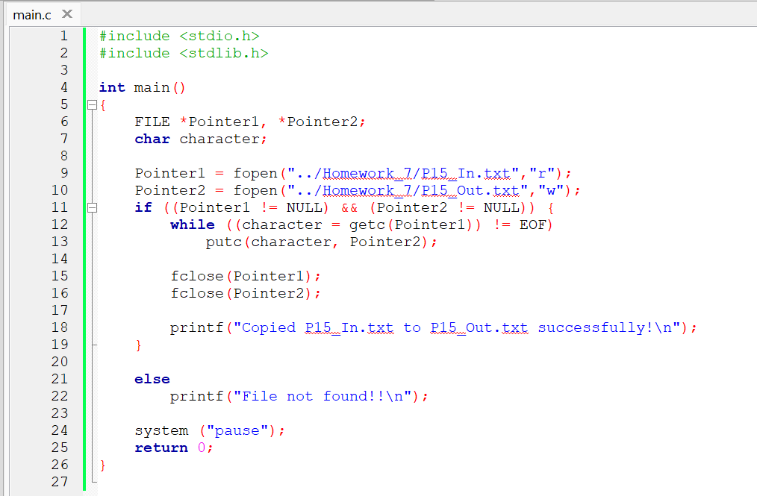

P16

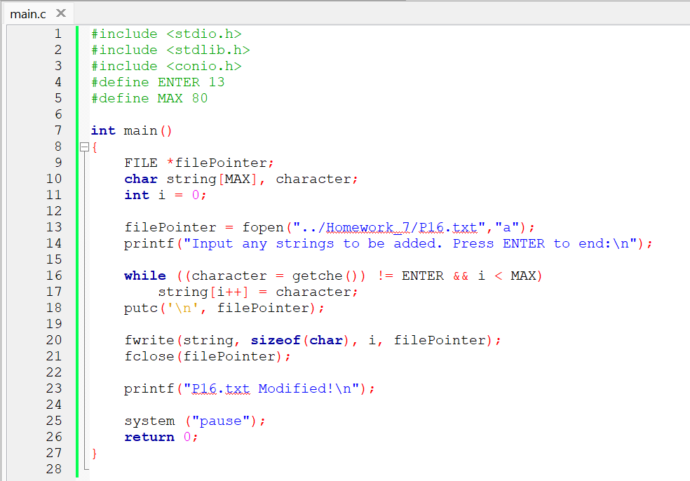

P17

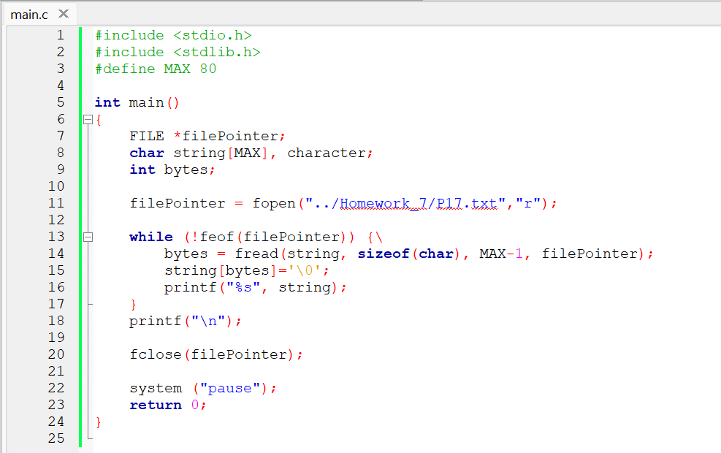

P18

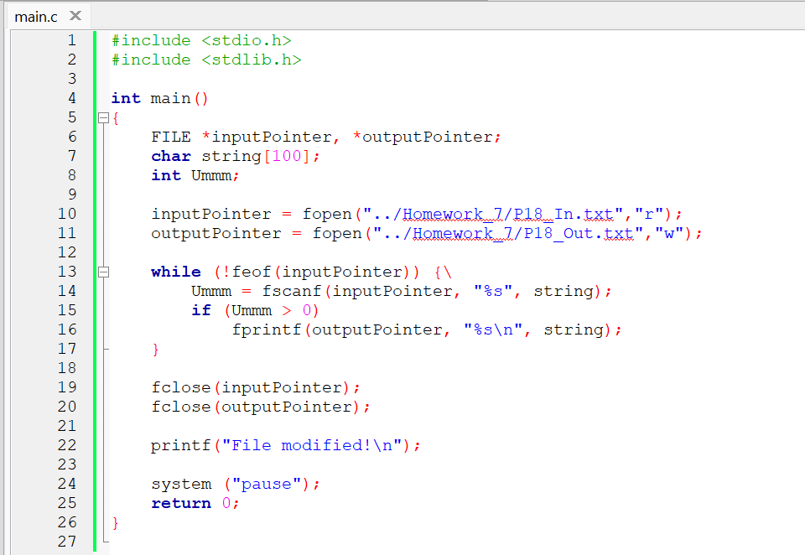

Conclusion:

Programs can be used to manipulate files within mass storage. From this homework, we only learn to modify a “.txt” file. It can be used

Code: <https://github.com/AldrichWijaya/Homework.git>