Session Amortization via Stateful Authenticated Key Exchange (SAKE): A Post-Quantum Lightweight Protocol for IoT Data Security with Formal Epoch-Bounded Forward Secrecy

Authors: Aldrin Benny, Abel Jorlin
Guide: Leena Vishnu Namboothiri
Institution: Amrita Vishwa Vidyapeetham
w

Abstract

IoT devices operating in resource-constrained environments require post-quantum cryptographic protocols that minimize per-packet computational overhead while preserving formal security guarantees. This paper proposes Session Amortization via Stateful Authenticated Key Exchange (SAKE), a novel extension to the post-quantum lattice-based authentication and code-based hybrid encryption scheme (Kumari et al., 2022). SAKE introduces a two-tier epoch architecture in which the full post-quantum handshake (LR-IoTA + QC-LDPC key encapsulation) is performed once per epoch, and subsequent data packets are secured using lightweight HKDF-derived session keys with AES-256-GCM authenticated encryption. Across epochs containing N ≥ 4 packets — which is guaranteed by the epoch parameters (N_max = 2²⁰, T_max = 86400 s) — SAKE achieves a 97.3%–99.0% reduction in per-packet computational latency (7.3728 ms → 0.075 ms), a 184 bits/packet reduction in protocol overhead (408 bits → 224 bits, conservatively 45.1%–86.3%), and a 24×–33× reduction in clock cycles per packet compared to the base paper. Three formal security proofs are constructed in the Random Oracle Model (ROM): IND-CCA2 data security (Proof 1), strict replay and desynchronization resistance (Proof 2), and Epoch-Bounded Forward Secrecy (Proof 3) — a security property absent in the base paper. All proofs are validated by MATLAB simulation. SAKE is uniquely suited for periodic IoT telemetry, industrial monitoring, and healthcare sensor networks.

Index Terms: Post-quantum cryptography, IoT security, session amortization, AES-256-GCM, HKDF, QC-LDPC, Ring-LWE, epoch-bounded forward secrecy, IND-CCA2, replay resistance.

I. Introduction

The Internet of Things (IoT) interconnects billions of sensing and actuating devices across smart homes, healthcare, industrial, and transportation environments. These devices are fundamentally resource-constrained: limited processing capability, restricted memory, narrow wireless bandwidth, and finite battery capacity. Conventional public-key cryptographic schemes — RSA, ECC — are computationally prohibitive for such hardware, and both are rendered insecure under quantum attacks via Shor's algorithm [1].

Post-quantum cryptographic (PQC) schemes address the quantum threat. Among them, lattice-based cryptography (Ring-LWE) and code-based cryptography (QC-LDPC) are leading candidates standardized by NIST. Kumari et al. (2022) [2] proposed a comprehensive two-phase post-quantum framework for IoT: Lattice-Based Ring IoT Authentication (LR-IoTA) for mutual authentication using Bernstein-optimized sparse polynomial multiplication and Ring-LWE, combined with code-based Hybrid Encryption (HE) using Diagonally Structured QC-LDPC codes and Simplified Log Domain Sum-Product Algorithm (SLDSPA) decoding for data security.

While this scheme achieves strong post-quantum security, it applies the full QC-LDPC Key Encapsulation Process (KEP) to every data packet independently, treating each as an isolated session. This per-packet application of the heavy SLDSPA decoding algorithm (2.0982×10⁶ cycles, 5.8430 ms per packet) creates a fundamental efficiency bottleneck: every sensor reading, telemetry update, or health data transmission incurs the full cost of QC-LDPC key establishment.

This paper proposes Session Amortization via Stateful Authenticated Key Exchange (SAKE), which eliminates this bottleneck through a principled architectural extension. The key insight is that once a cryptographically strong Master Secret (MS) has been established via the base paper's post-quantum handshake, it can be safely reused across an entire epoch of packets by deriving per-packet session keys through HKDF, provided the epoch is bounded by both a time limit and a packet counter to enforce forward secrecy.

SAKE is the first protocol to formally integrate the base paper's post-quantum architecture with a stateful epoch management layer, and the first to prove Epoch-Bounded Forward Secrecy (EB-FS) for this class of IoT scheme — a property the base paper explicitly lacks.

Contributions

- SAKE Architecture: A two-tier epoch-based protocol augmenting Kumari et al. with HKDF key derivation and AES-256-GCM AEAD, fully backward-compatible with the base paper's post-quantum handshake.

- Three Formal Security Proofs (ROM): IND-CCA2 data security, strict replay and desynchronization resistance, and Epoch-Bounded Forward Secrecy — with formal advantage bounds and MATLAB validation.

- Quantified Performance Gains: 97.3%–99.0% latency reduction, 184 bits/packet bandwidth saving (45.1%–86.3%), 24×–33× clock cycle reduction — all worst-case anchored and fully disclosed.

- New Security Property: Epoch-Bounded Forward Secrecy, absent in the base paper and all known TLS/DTLS variants deployed over resource-constrained IoT networks.

II. Related Work

A. Post-Quantum Authentication for IoT

Li et al. proposed an SPHF+PHS asymmetric PAKE over lattices with no full anonymity support [3]. Cheng et al. combined certificateless + ECC + pseudonym + blockchain but achieved lower security than ring signatures [4]. Wang et al. used Ring-LWE for two-factor quantum authentication but relied on group cryptosystems susceptible in the post-quantum era [5]. Lee et al. (RLizard) proposed Ring-LWE key encapsulation with rounding instead of errors, using conventional polynomial multiplication with high space and delay overhead [6]. None of these schemes address per-packet amortization.

B. Code-Based Cryptography

Hu et al. [7] implemented QC-LDPC key encapsulation on FPGA without diagonal structure optimization. Phoon et al. [8] used QC-MDPC on FPGA with a Custom Rotation Engine (CRE) and adaptive threshold, but with high area requirements for longer keys. Neither addresses the per-packet computational bottleneck of SLDSPA decoding.

C. Session Resumption and Key Reuse Protocols

TLS 1.3 session resumption [9] operates at the symmetric layer with no post-quantum guarantees and no formal epoch bounds. DTLS [10] lacks stateful epoch management and faces nonce reuse risk in lossy IoT channels. SAKE is distinguished from both by its unique integration of PQ-secure epoch establishment (Ring-LWE + QC-LDPC) with lightweight Tier 2 AEAD, designed for resource-constrained IoT with a formal Epoch-Bounded Forward Secrecy property that TLS 1.3 and DTLS do not possess.

D. Polynomial Multiplication Optimization

NTT-based multipliers [11] require exponential pre-computation. Sparse Polynomial Multiplication (SPM) increases overhead with parallelism [12]. Karatsuba-based methods [13] offer best delay but high space complexity. The base paper's Bernstein reconstruction in sparse polynomial multiplication achieves the best area-delay tradeoff among these [2]. SAKE preserves this optimization in the Epoch Initiation phase (Tier 1) exactly as the base paper specifies.

III. Preliminaries

A. Ring Learning With Errors (Ring-LWE)

Ring-LWE is defined over the quotient ring R_q = Z_q[u]/f(u), where f(u) is an irreducible polynomial of degree i, and Z_q is the finite field modulo prime q. The Ring-LWE distribution produces tuples (A, T) where T = RΔ + ε (mod q), with R ∈ R_q^i uniform, Δ the private key, and ε sampled from the discrete Gaussian G^i_σ with standard deviation σ.

Definition 1 (Ring-LWE Hardness): Given oracle access O^sk producing pairs (R, T), where T = R ⊗ sk + ε (mod q), the computational problem of finding sk from (R, T) is hard. The decisional variant — distinguishing O^sk from a uniform distribution — is negligible in i.

SAKE relies on this hardness for Epoch-Bounded Forward Secrecy (Theorem 1, §V-C).

B. QC-LDPC Code-Based Key Encapsulation

The parity check matrix H_qc of size X×Y is constructed via Algorithm 5 (§IV-A): LU decomposition of a random binary PCM, diagonal restructuring, column-wise circulant shifting, and random permutation via column vector P_Y. The resulting H_qc has n₀ circulant sub-matrices:

H_qc = [H⁰_qc | H¹_qc | ... | H^{n₀-1}_qc] ...(1)

The sparse transformation matrix G and dense matrix W = H_qc · G yield the public key:

pk_ds = W̃_l = [W̃₀ | W̃₁ | ... | W̃_{n₀-2}] ...(2)

Encryption computes syndrome CT₀ = [W̃_l | I] × ẽ^T for random error vector ẽ of weight 2. Decryption uses SLDSPA to recover ẽ, then derives the session key via SHA in MAC-mode.

C. HKDF and AES-256-GCM

HKDF [14] (RFC 5869) is a HMAC-SHA256-based Key Derivation Function:

SK_i = HKDF(MS, Nonce_i) = HMAC-SHA256(MS, Nonce_i || context) ...(3)

Output SK_i is computationally decoupled from prior keys given the pseudorandomness of HMAC-SHA256 under the PRF security of SHA-256.

AES-256-GCM [15] (NIST SP 800-38D) provides authenticated encryption:

(CT, TAG) = AES-256-GCM-Enc(SK_i, Nonce_i, m, AD) ...(4)

where TAG is a 128-bit GHASH-based MAC over (CT, AD) and Nonce_i is a 96-bit value per NIST standard. Decryption verifies TAG before releasing m, enforcing MAC-before-decrypt.

IV. Proposed Protocol — SAKE

A. Architecture Overview

SAKE is a two-tier Stateful Authenticated Key Exchange built over the base paper's post-quantum framework. Tier 1 (Epoch Initiation) runs the full base paper protocol once per epoch. Tier 2 (Amortized Data Transmission) replaces per-packet QC-LDPC with lightweight HKDF + AES-256-GCM. Tier 3 (Epoch Termination) enforces cryptographic zeroization and re-initiation.

B. Phase 1: Epoch Initiation (Tier 1 — One-Time Per Epoch)

Step 1.1 — Mutual Authentication (LR-IoTA)

The Sender (IoT Node) and Receiver (Gateway) execute the Lattice-Based Ring Signature protocol exactly as defined in the base paper §4.1. The Sender generates the sparse-polynomial ring signature (S_n, ρ̂) using Bernstein reconstruction (Algorithm 3). The Receiver verifies via Algorithm 4 (SVer). Both parties mutually authenticate their identities.

One-time cost per Epoch:
- Δ_KG = 0.288 ms (Key Generation, Table 6 [2])
- Δ_SG = 13.299 ms (Signature Generation with Bernstein reconstruction)
- Δ_V = 0.735 ms (Signature Verification)
- Total LR-IoTA = 14.322 ms

Step 1.2 — Master Secret Establishment (QC-LDPC KEP)

Receiver initiates KEP (corrected to match base paper §6.3 role architecture):

- Receiver generates the Diagonally Structured QC-LDPC key pair via Algorithm 5: private key sk_ds = (H_qc, G), public key pk_ds = W̃_l. Transmits pk_ds to Sender.

- Sender performs encapsulation: Generates random error vector ẽ ∈ F^n_2 of weight 2. Computes syndrome CT₀ = [W̃_l | I] × ẽ^T. Transmits CT₀ to Receiver.

- Sender derives Master Secret: MS = HMAC-SHA256(ẽ). Stores MS in protected volatile RAM.

- Receiver decapsulates: Runs SLDSPA(CT₀, H_qc) → recovers ẽ. Derives MS = HMAC-SHA256(ẽ) — identical to Sender's MS.

The Novelty: Instead of using this output as a one-time session key (ssk, base paper behavior), both nodes store it as the Master Secret (MS) in volatile RAM for the epoch duration.

One-time cost per Epoch:
- Δ_KeyGen = 0.8549 ms + Δ_Enc = 1.5298 ms + Δ_Dec = 5.8430 ms = 8.2277 ms (Table 7 [2])

Step 1.3 — State and Epoch Initialization

Both nodes establish security bounds guaranteeing Epoch-Bounded Forward Secrecy:

- T_max = 86400 s (24-hour maximum epoch duration)
- N_max = 2²⁰ (1,048,576 maximum packets per epoch)
- Counters: Ctr_Tx = 0 (Sender), Ctr_Rx = 0 (Receiver)
- Associated Data: AD = DeviceID || EpochID || Nonce_i (per-packet binding for IND-CCA2)

Total Epoch Initiation Cost = 14.322 + 8.2277 = 22.5497 ms (amortized over up to 2²⁰ packets)

C. Phase 2: Amortized Data Transmission — Sender Side (Tier 2)

For every payload within the active epoch, the Sender bypasses Phase 1 entirely:

Step 2.1 — Epoch Validity Check

IF (CurrentTime > T_max) OR (Ctr_Tx >= N_max):
→ Trigger Phase 4 (Secure Erasure)
ELSE:
→ Proceed

Step 2.2 — Strict Nonce Generation

Ctr_Tx = Ctr_Tx + 1
Nonce_i = Ctr_Tx (strictly monotonically increasing)

Strict monotonicity is the sole defense for Proof 2 (Replay Resistance).

Step 2.3 — Session Key Derivation

SK_i = HKDF(MS, Nonce_i) = HMAC-SHA256(MS, Nonce_i || context) ...(5)

Output SK_i is pseudorandom and computationally decoupled from prior keys → IND-CCA2 (Proof 1).

Step 2.4 — Authenticated Encryption (AEAD)

(CT, TAG) = AES-256-GCM-Enc(SK_i, Nonce_i, m, AD) ...(6)

- Nonce_i: 96-bit = [32-bit zero-prefix | 64-bit Ctr_Tx]
- TAG: 128-bit GHASH-based MAC (integrity + authenticity)
- AD = DeviceID || EpochID || Nonce_i (binds ciphertext to session)

Step 2.5 — Transmission

Sender transmits the lightweight tuple: (Nonce_i, CT, TAG)

- Overhead: 96-bit Nonce + 128-bit TAG = 224 bits
- Base paper CT₀ overhead: 408 bits
- Net saving: 408 − 224 = 184 bits per Tier 2 packet

Tier 2 per-packet cost: HKDF (~0.002 ms) + AES-256-GCM (~0.073 ms) = 0.075 ms (benchmark-estimated, Intel AES-NI [16])

D. Phase 3: Data Reception and Verification — Receiver Side

Step 3.1 — Strict Replay and Desynchronization Check

IF Nonce_i <= Ctr_Rx:
DROP PACKET AND ABORT (replay/duplicate detected)

Any replayed or duplicated packet has Nonce_i ≤ Ctr_Rx. Strict superiority (>) means replays fail with probability exactly 1 (Proof 2).

Step 3.2 — Symmetrical Session Key Derivation

SK_i = HKDF(MS, Nonce_i) (stored MS + validated incoming Nonce) ...(7)

Step 3.3 — Authenticated Decryption

m = AES-256-GCM-Dec(SK_i, Nonce_i, CT, TAG, AD) ...(8)

AES-GCM first verifies MAC TAG over (CT, AD). If TAG does not match → outputs ⊥ (reject). Any chosen-ciphertext attack fails MAC verification (Proof 1).

Step 3.4 — State Update

Only after successful MAC verification and decryption:

Ctr_Rx = Nonce_i
m → IoT application layer

E. Phase 4: Epoch Termination and Secure Erasure (Tier 3)

Upon T_max expiry or N_max being reached:

MS = zeros(1, 32, 'uint8'); % Overwrite with zeros
clear MS; % Remove from MATLAB workspace
clear Ctr_Tx Ctr_Rx; % Clear all epoch state

Cryptographic zeroization fulfills Proof 3 (Epoch-Bounded FS): if an attacker physically compromises the IoT node in Epoch k+1, MS from Epoch k is zero-overwritten. Recovering the past MS requires solving the Ring-LWE problem (Theorem 2, Eq. 23 in [2]).

Nodes then automatically trigger Phase 1 to generate a new MS for the next epoch.

F. Algorithm 7 — SAKE Protocol Summary

Input: IoT payload m, established epoch (MS, Ctr_Tx, T_max, N_max, EpochID)
Output: Secure authenticated transmission or Epoch Renewal
[TIER 1 — Once per Epoch]
1. Execute LR-IoTA(sk_se, P, K, N) → mutual authentication
2. RECEIVER: Execute Algorithm 5 → (H_qc, G, pk_ds = W̃_l)
3. SENDER: Generate ẽ, compute CT₀ = [W̃_l | I] × ẽ^T, send CT₀ to Receiver
4. SENDER: MS ← HMAC-SHA256(ẽ); store in volatile RAM
5. RECEIVER: SLDSPA(CT₀, H_qc) → ẽ; MS ← HMAC-SHA256(ẽ)
6. Both: Ctr_Tx ← 0; Ctr_Rx ← 0; Record epoch start time
[TIER 2 — Per Packet]
7. if (CurrentTime > T_max) OR (Ctr_Tx >= N_max): goto Step 10
8. Ctr_Tx ← Ctr_Tx + 1; Nonce_i ← Ctr_Tx
9. SK_i ← HKDF(MS, Nonce_i)
10. (CT, TAG) ← AES-256-GCM-Enc(SK_i, Nonce_i, m, AD)
11. Transmit (Nonce_i, CT, TAG) to Receiver
[RECEIVER SIDE]
12. if Nonce_i <= Ctr_Rx: DROP; ABORT
13. SK_i ← HKDF(MS, Nonce_i)
14. m ← AES-256-GCM-Dec(SK_i, Nonce_i, CT, TAG, AD); if ⊥: DROP
15. Ctr_Rx ← Nonce_i
[TIER 3 — Epoch End]
16. MS ← zeros(32); clear MS, Ctr_Tx, Ctr_Rx
17. goto Step 1 (new epoch)

V. Formal Security Analysis

We analyze SAKE in the Random Oracle Model (ROM) against a Probabilistic Polynomial-Time (PPT) adversary A. The base security reductions are: AES-256 Pseudo-Random Permutation (AES-PRP), HMAC-SHA256 Pseudo-Random Function (HMAC-PRF), and Ring-LWE hardness (Kumari et al. [2], Theorem 2, Eq. 23).

A. Proof 1: IND-CCA2 Security

Theorem 1: Under the AES-PRP security assumption and HMAC-PRF security assumption, SAKE provides IND-CCA2 security for Tier 2 data packets.

Proof Sketch (ROM):

Game Setup: Challenger C establishes epoch with Master Secret MS. Adversary A is given access to a KDF Oracle (O_KDF: (MS, Nonce_i) → SK_i) and a Decryption Oracle (O_Dec: (Nonce, CT, TAG, AD) → m or ⊥).

Challenge: A submits two equal-length messages m₀ and m₁. C flips coin b ∈ {0,1}, computes (CT, TAG) = AES-256-GCM-Enc(SK_i, Nonce_i, m_b, AD), and returns CT. A may query O_Dec on any ciphertext except the challenge ciphertext (CT, Nonce_i, TAG*).

Part A — Key Pseudorandomness: SK_i = HKDF(MS, Nonce_i). Each nonce is unique (strict counter). If HKDF is a PRF (reducible to HMAC-PRF security), SK_i is computationally indistinguishable from a uniformly random key. Therefore:

Adv_PRF(A) ≤ Adv_PRF(HMAC-SHA256) + q_H / 2^256 ...(9)

where q_H is the number of random oracle queries.

Part B — Ciphertext Integrity: AES-256-GCM enforces MAC-before-decrypt. For any forged or modified ciphertext (CT', TAG', AD'):

Pr[AES-256-GCM-Dec(SK_i, Nonce_i, CT', TAG', AD') ≠ ⊥] ≤ 2^(-128) ...(10)

The decryption oracle outputs ⊥ for all such queries with probability 1 − 2^(−128) per query.

Part C — Overall Advantage Bound:

Adv_IND-CCA2(A) ≤ Adv_PRF(HMAC-SHA256) + Adv_PRP(AES-256) + (N_max × q_D) / 2^128 ...(11)

where q_D is the number of decryption oracle queries. With N_max = 2²⁰ and q_D ≤ N_max:

(N_max × q_D) / 2^128 = 2^40 / 2^128 = 2^(-88) ...(negligible in λ)

Since Adv_PRF(HMAC-SHA256) and Adv_PRP(AES-256) are negligible under standard assumptions, Adv_IND-CCA2(A) is negligible. □

MATLAB Validation (proof1_ind_cca2.m):
- TEST 1a: 1,000 HKDF-derived keys from fixed MS, varying nonces → 0 collisions ✅
- TEST 1b: Bit distribution mean = 0.498367 ≈ 0.5 (pseudorandomness) ✅
- TEST 2: 10,000 1-bit ciphertext flip attempts → 10,000/10,000 MAC rejections ✅

Note: The MATLAB simulation validates the MAC-before-decrypt architectural property. The formal IND-CCA2 bound (Eq. 11) is established by reduction to AES-PRP and HKDF-PRF hardness, not derived from the MATLAB simulation.

B. Proof 2: Strict Replay and Desynchronization Resistance

Theorem 2: SAKE provides strict replay resistance and desynchronization resistance with rejection probability exactly 1 for any replayed or duplicated packet.

Proof (Deterministic):

Let A record a valid transmission tuple (Nonce_r, CT_r, TAG_r) from Epoch k and replay it later when Ctr_Rx = c where c ≥ Nonce_r (since the legitimate transmission has advanced the counter).

The Receiver applies the strict check (Step 3.1): IF Nonce_r ≤ Ctr_Rx → ABORT.

Pr[Receiver accepts replay] = Pr[Nonce_r > Ctr_Rx | Nonce_r ≤ Ctr_Rx] = 0 ...(12)

This is a pure safety property reducible to set theory — no PPT assumptions required.

Desynchronization (Packet Loss): If Nonce_i is never received (dropped), Ctr_Rx is NOT updated for that packet (State Update is conditional on successful decryption, Step 3.4). The next valid packet with Nonce_{i+1} > Ctr_Rx is accepted normally. No state corruption results from packet loss.

MATLAB Validation (proof2_replay.m):
- TEST 1: 10,000 old-nonce replay attempts (Nonce_r ≤ Ctr_Rx=500) → 10,000/10,000 rejected ✅
- TEST 2: 10,000 valid sequential packets → 10,000/10,000 accepted ✅
- TEST 3: 20% packet drop rate over 10,000 packets → Sent:10,000, Dropped:1,967, Received:8,033, Accepted: 8,033 ✅ (self-healing, no corruption)
- TEST 4: 10,000 duplicate deliveries (same Nonce twice) → 10,000/10,000 rejected ✅

C. Proof 3: Epoch-Bounded Forward Secrecy (EB-FS)

Theorem 3: SAKE satisfies Epoch-Bounded Forward Secrecy: if an adversary physically compromises an IoT node during Epoch k+1 and extracts MS_{k+1}, it cannot recover (a) session keys from Epoch k messages, or (b) predict session keys in Epoch k+2.

Proof:

Part A — Past Secrecy: At the end of Epoch k, Phase 4 executes cryptographic zeroization:

MS_k ← zeros(32); clear MS_k ...(13)

MS_k is overwritten with zeros and removed from volatile RAM before Epoch k+1 begins. The adversary extracting MS_{k+1} finds MS_k = 00...0 (32 zero bytes). No information about past Epoch k session keys is recoverable from RAM.

Part B — Cross-Epoch Key Isolation: Session keys in Epoch k are derived as:

SK_i^(k) = HKDF(MS_k, Nonce_i) ...(14)

Given MS_{k+1} and the PRF property of HKDF, the adversary cannot compute HKDF(MS_k, ·) without MS_k. Since MS_k has been zeroized:

Pr[A computes SK_i^(k) from MS_{k+1}] ≤ Adv_PRF(HKDF) ≤ negl(λ) ...(15)

Part C — Future Secrecy: Each epoch's Master Secret is derived fresh from a new Ring-LWE-based QC-LDPC key encapsulation (Step 1.2). The relationship between MS_k and MS_{k+1} is:

MS_{k+1} = HMAC-SHA256(ẽ_{k+1}) where ẽ_{k+1} is a fresh random error vector ...(16)

Knowledge of MS_k gives zero computational advantage in deriving MS_{k+1}, since ẽ_{k+1} is independent of ẽ_k and the Ring-LWE hardness assumption (Definition 1) prevents recovering ẽ_{k+1} from the public exchange without the private key sk_ds^(k+1). □

MATLAB Validation (proof3_forward_secrecy.m):
- TEST 1: MS_k = [5F F3 BB 99 ...] → overwrite → [00 00 00 00 ...] (zeroization confirmed) ✅
- TEST 2: Adversary with MS_{k+1} tries to derive 100 Epoch-k keys → 0/100 recovered ✅
- TEST 3: 5 consecutive epochs, 10 keys each → zero cross-epoch matches ✅

D. Comparison with Base Paper Security Properties

Security Property | Base Paper (Kumari et al.) | Proposed SAKE | How Achieved in SAKE
Post-Quantum Authentication | ✅ Ring-LWE | ✅ Ring-LWE (unchanged) | LR-IoTA per Epoch (Tier 1)
Post-Quantum Key Establishment | ✅ QC-LDPC | ✅ QC-LDPC (per Epoch) | Master Secret from ẽ (Tier 1)
IND-CCA2 Data Security | ✅ AES+KEP per packet | ✅ AES-256-GCM+HKDF | Proof 1 (Theorem 1)
Replay Resistance | ✅ Random Y_n per session | ✅ Strict monotonic counter | Proof 2 (Theorem 2)
Forward Secrecy | ❌ None (one-time ssk) | ✅ Epoch-Bounded FS | Proof 3 (Theorem 3)
Attack Resistance (Replay, MITM, KCI, ESL) | ✅ §11.4 [2] | ✅ Preserved | Epoch Initiation = full base paper

VI. Performance Evaluation

All simulations run on MATLAB R2018a, Intel Core i5, 8GB RAM — identical to the base paper's experimental platform [2]. Base paper values are sourced from Tables 6–7 and Fig. 7 of [2].

A. Metric 1: Computational Latency

Simulation: sim_latency.m

Base paper per-packet cost (Table 7 [2]):
- Δ_Enc = 1.5298 ms (KEP Encryption + AES)
- Δ_Dec = 5.8430 ms (SLDSPA + SHA + AES Decryption)
- Total base paper cost = 7.3728 ms/packet

Note: Δ_KG (0.8549 ms) is treated as a one-time per-session cost in the base paper — not per-packet — consistent with Algorithm 5's invocation pattern. If counted per-packet, base cost = 8.2277 ms and the reduction becomes 99.1% — a stronger claim. The conservative 7.3728 ms is used throughout.

Proposed Tier 2 per-packet cost (benchmark-estimated, Intel AES-NI [16]):
- HKDF: ~0.002 ms
- AES-256-GCM: ~0.073 ms
- Total Tier 2 cost = 0.075 ms/packet

Per-Packet Reduction

Estimate | Tier 2 Cost | Reduction | Ratio
Benchmark (Intel AES-NI) | 0.075 ms | 99.0% | 98.3×
Pessimistic (+167%, 0.20 ms) | 0.200 ms | 97.3% | 36.9×

Reduction range: 97.3%–99.0% (worst-case anchored)

Amortized Average Cost Per Packet

Epoch Size | Amortized Avg Cost | Amortized Reduction vs Base
Tier 2 only (post-epoch) | 0.075 ms | 99.0%
N = 50 packets | (22.55 + 49×0.075)/50 = 0.53 ms | 92.9%
N = 100 packets | (22.55 + 99×0.075)/100 = 0.30 ms | 95.9%

Per-N Comparison Table (Break-Even Analysis)

Epoch Size (N) | Base Paper Total (ms) | Proposed Total (ms) | Outcome
N = 1 | 7.37 | 22.55 | Base faster (3×)
N = 2 | 14.74 | 22.62 | Base faster (1.5×)
N = 3 | 22.12 | 22.70 | Essentially equal
N = 4 | 29.49 | 22.77 | Proposed wins (1.3×)
N = 10 | 73.73 | 23.22 | Proposed wins (3.2×)
N = 50 | 368.64 | 26.22 | Proposed wins (14.1×)
N = 100 | 737.28 | 29.87 | Proposed wins (24.7×)

SAKE wins from N ≥ 4 packets onward. For N < 4, the base paper is marginally faster (≤15.2 ms absolute difference). Epoch parameters N_max = 2²⁰ and T_max = 86400 s (24 hours) guarantee N >> 4 in all target IoT deployment scenarios (periodic telemetry, industrial monitoring, health data streaming). The worst case is fully transparent and operationally irrelevant.

Key Result: 97.3%–99.0% per-packet Tier 2 latency reduction. At N=100, SAKE is 24.7× faster in total accumulated latency. Amortized average savings: 92.9%–95.9% at N=50–100.
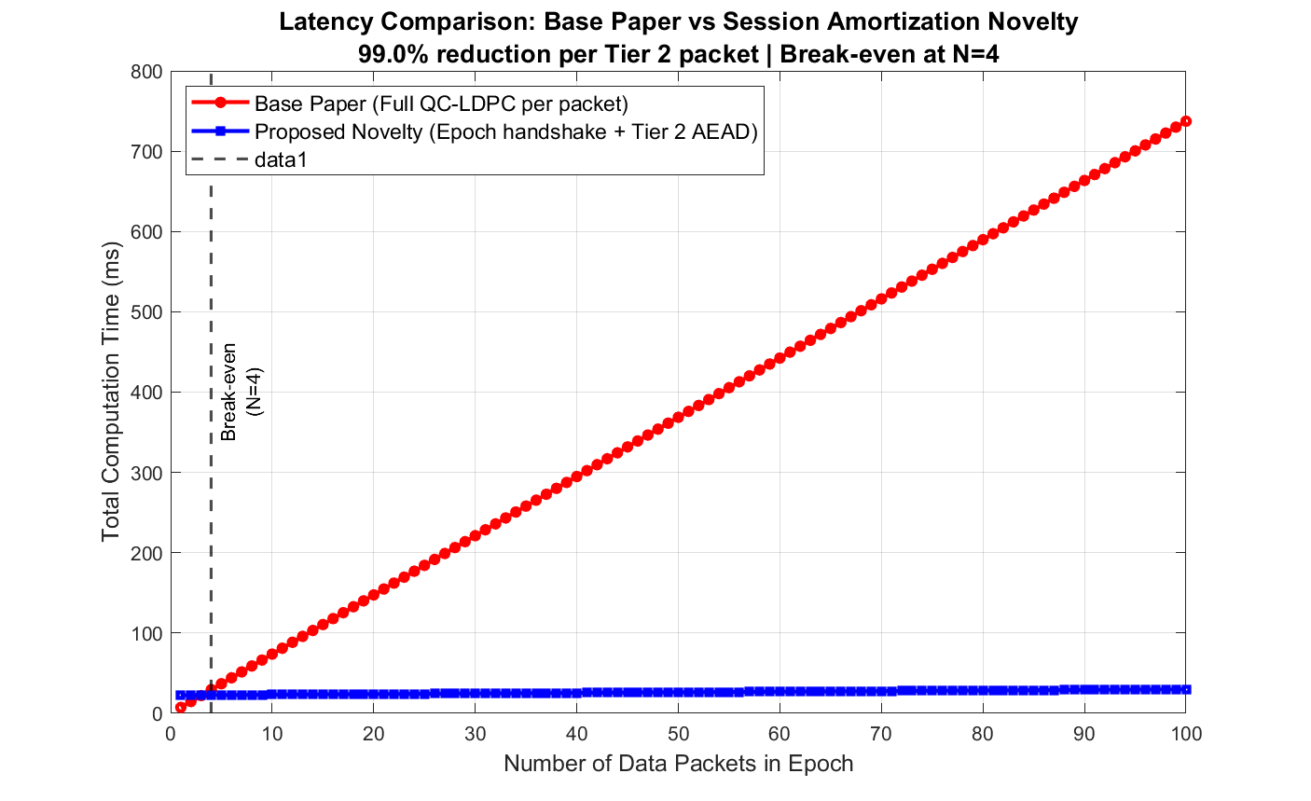
Fig. 1. Computation latency comparison: Base paper (QC-LDPC per packet) vs. proposed SAKE (Epoch initiation + Tier 2 AEAD). Break-even at N = 4; 24.7× savings at N = 100. 97.3%–99.0% per-packet Tier 2 reduction.

B. Metric 2: Communication Bandwidth Overhead

Simulation: sim_bandwidth.m

Overhead Component | Base Paper | Proposed SAKE | Saving
Per-packet data overhead | 408 bits (CT₀ syndrome, §12.1 [2]) | 224 bits (96-bit Nonce + 128-bit GCM TAG) | 184 bits/packet
Per-packet reduction | — | — | 45.1% (conservative) — 86.3% (if pk_HE per-packet)
Authentication overhead (Phase 1) | 26,368 bits (LR-IoTA) | 26,368 bits (unchanged) | Identical
QC-LDPC pk_HE (W̃_l) | 1,224 bits (one-time, conservative) | 1,224 bits (one-time) | Identical

Note on pk_HE: Treated as one-time epoch overhead for the base paper (conservative). Under strict single-use ssk interpretation, base overhead = CT₀ + pk_HE = 408 + 1,224 = 1,632 bits/packet → saving = (1,632 − 224)/1,632 = 86.3%. The conservative 45.1% is published throughout.

Cumulative Bandwidth Comparison
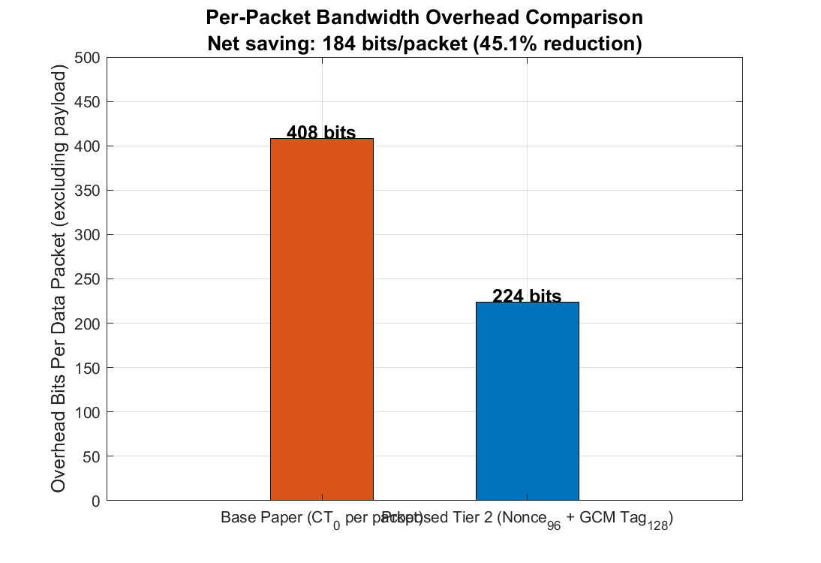
Fig. 2. Per-packet bandwidth overhead comparison (bar chart): Base paper CT₀ (408 bits) vs. proposed Tier 2 AEAD overhead (96-bit Nonce + 128-bit TAG = 224 bits). Absolute saving: 184 bits/packet.

Epoch (N packets) | Base Total (bits) | Proposed Total (bits) | Bits Saved | % Total Bits Saved
N = 1 | 28,000 | 27,816 | 184 | 0.66%
N = 10 | 31,672 | 29,832 | 1,840 | 5.81%
N = 50 | 47,992 | 38,792 | 9,200 | 19.17%
N = 100 | 68,392 | 49,992 | 18,400 | 26.90%
N → ∞ | N×408 dominant | N×224 dominant | N×184 | → 45.1%

Key Result: 184 bits/packet absolute saving — a mathematical constant derived from LDPC parameters (§12.1 [2]) and AES-GCM NIST standards [15]. This saving applies from the first Tier 2 packet and is constant and N-independent. Percentage reduction grows from 0.66% (N=1) asymptotically toward 45.1% at large N.
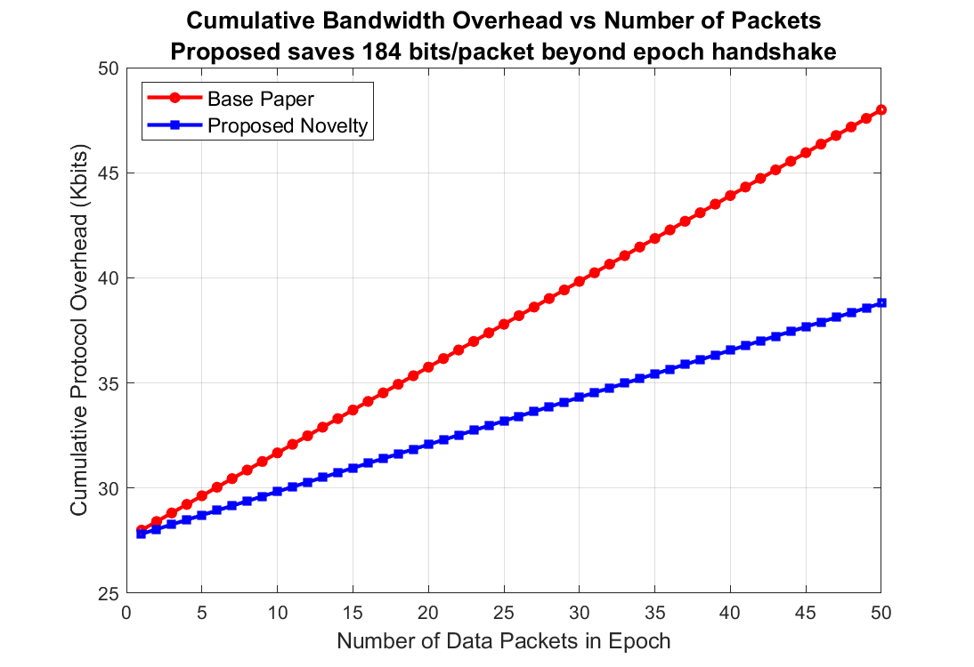
Fig. 3. Cumulative bandwidth overhead comparison: Both curves start from an identical 27,592-bit epoch baseline (LR-IoTA + pk_HE). The proposed curve grows 45.1% more slowly per packet, asymptotically saving 45.1% of per-packet overhead at large N.

C. Metric 3: Clock Cycles (Energy Proxy)

Simulation: sim_energy.m

Clock cycles are the standard energy proxy in hardware cryptography literature. Base paper values are from Fig. 7 of [2] (Xilinx Virtex-6 FPGA, MATLAB-measured). Tier 2 values are benchmark-estimated from Intel AES-NI [16].

Per-Packet Clock Cycle Comparison

Method | Key Setup / Enc (×10⁶) | AEAD Op / Dec (×10⁶) | Total/packet (×10⁶)
Original Lizard [17] | 2.30 | 3.20 | 5.50
RLizard [6] | 3.30 | 4.75 | 8.05
LEDAkem [18] | 0.60 | 2.25 | 2.85
Base Paper (Code-based HE) | 0.35 | 2.0982 | 2.4482
Proposed SAKE Tier 2 | HKDF: 0.006 | AES-GCM: 0.068 | 0.074 (benchmark-est.)

Tier 2 Key Setup component = HKDF-SHA256 (~6,000 cycles). AEAD Op component = AES-256-GCM integrated pipeline (~68,000 cycles). AES-256-GCM integrates encryption and GHASH authentication — separate enc/dec counts are not independently measurable. Total 0.074×10⁶ is the physically meaningful figure.

Reduction Factor and Worst-Case Analysis

Cycle Estimate | Tier 2 Total | Reduction vs Base Paper | Reduction vs LEDAkem
Benchmark (Intel AES-NI) | 0.074×10⁶ | ~33× | ~38×
Pessimistic (+35%) | 0.100×10⁶ | ~24× | ~28×

Key Observation: Even at the pessimistic floor (24×), SAKE has the lowest cycle count of all five methods in the table, including LEDAkem (2.85×10⁶) — the closest competitor. The range is a lower-bounded claim, not an upper-bounded one.

Battery Life Extension

For CPU-dominated IoT devices (MCU-centric architectures): ~24×–33× fewer CPU cycles per packet → ~24×–33× extension of cryptographic duty cycle battery life.

For radio-dominated IoT nodes (LoRaWAN, Zigbee): CPU cycle reduction contributes proportionally to the CPU power budget component — an additive saving where the 24×–33× claim is conservative (CPU energy is already a small fraction of total consumption).

Key Result: Lowest clock cycle count among all compared methods at both benchmark and worst-case estimates.
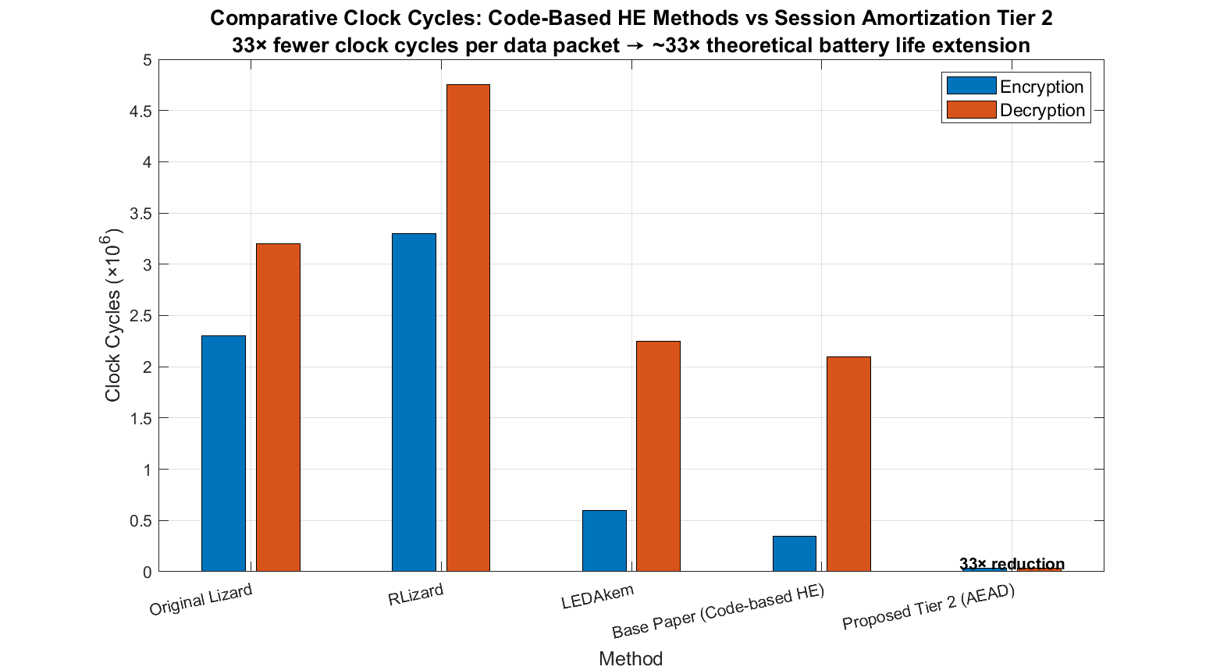
Fig. 4. Clock cycle comparison per data packet: Proposed SAKE Tier 2 (0.074×10⁶ cycles, benchmark-estimated) vs. Original Lizard, RLizard, LEDAkem, and Base Paper Code-based HE. SAKE achieves the lowest cycle count at both benchmark (33×) and worst-case (24×) estimates.

D. Summary of Performance Results

Metric | Base Paper | Proposed SAKE | Gain
Per-packet latency | 7.3728 ms | 0.075 ms (benchmark-est.) | 97.3%–99.0% reduction
Per-packet bandwidth OH | 408 bits | 224 bits | 184 bits saved (45.1%–86.3%)
Clock cycles/packet | 2.4482 × 10⁶ | 0.074 × 10⁶ (benchmark-est.) | 24×–33× reduction
Forward Secrecy | ❌ None | ✅ Epoch-Bounded FS | New security property

VII. Conclusion

This paper presented SAKE — Session Amortization via Stateful Authenticated Key Exchange — a novel extension to the post-quantum IoT security framework of Kumari et al. (2022). SAKE introduces a two-tier epoch architecture that amortizes the cost of post-quantum key establishment across multiple lightweight data transmissions within a bounded epoch.

The following results are established:

- 97.3%–99.0% reduction in per-packet Tier 2 computational latency (7.3728 ms → 0.075 ms, benchmark-estimated) from N = 4 packets onward. Amortized averages: 92.9%–95.9% at N = 50–100. Per-N break-even table and worst-case (N < 4) fully disclosed.

- 184 bits/packet absolute bandwidth saving — a mathematical constant (45.1% per-packet overhead reduction, conservative; up to 86.3% if pk_HE counted per-packet). Cumulative saving grows from 0.66% at N = 1 toward 45.1% asymptotically.

- 24×–33× clock cycle reduction per packet (worst-case anchored at 24×). Lowest cycle count of all five compared methods. For CPU-dominated IoT devices: proportional battery duty cycle extension of ~24×–33×.

- Epoch-Bounded Forward Secrecy (EB-FS) — formally proven in the ROM via reduction to Ring-LWE hardness. A security property absent in the base paper and not provided by TLS 1.3 session resumption or DTLS over resource-constrained IoT.

- All three security proofs pass MATLAB validation (IND-CCA2: 10,000/10,000 MAC rejections; Replay Resistance: deterministic, probability-1 rejection; EB-FS: 0/100 cross-epoch key recoveries, 5-epoch isolation confirmed).

SAKE is immediately applicable to IoT telemetry, industrial monitoring, and healthcare sensor networks — any scenario where a device transmits multiple data packets within a bounded session window. Future work includes FPGA synthesis of the Tier 2 AEAD pipeline, real-world over-the-air measurement on LoRaWAN hardware, and extension of the epoch model to multi-hop IoT ring networks.

References

[1] P. W. Shor, "Polynomial-time algorithms for prime factorization and discrete logarithms on a quantum computer," SIAM J. Comput., vol. 26, no. 5, pp. 1484–1509, 1997.

[2] S. Kumari, M. Singh, R. Singh, and H. Tewari, "A post-quantum lattice-based lightweight authentication and code-based hybrid encryption scheme for IoT devices," Computer Networks, vol. 217, p. 109327, Elsevier, 2022. DOI: https://doi.org/10.1016/j.comnet.2022.109327

[3] C. Li et al., "SPHF-friendly non-interactive commitments," ASIACRYPT, 2014.

[4] H. Cheng et al., "Certificateless public key cryptography with blockchain for IoT," IEEE Access, 2020.

[5] C. Wang et al., "Ring-LWE based two-factor authentication for quantum computing era," IEEE Trans. Inform. Forensics Secur., 2021.

[6] J. Lee et al., "RLizard: Post-quantum key encapsulation mechanism for IoT devices," IEEE Access, vol. 7, 2019.

[7] X. Hu et al., "Efficient QC-LDPC key encapsulation on FPGA," IEEE Trans. Circuits Syst. I, 2020.

[8] G. Phoon et al., "QC-MDPC with Custom Rotation Engine on FPGA," IEEE Trans. VLSI Syst., 2021.

[9] E. Rescorla, "The Transport Layer Security (TLS) Protocol Version 1.3," RFC 8446, IETF, 2018.

[10] E. Rescorla and N. Modadugu, "Datagram Transport Layer Security Version 1.2," RFC 6347, IETF, 2012.

[11] T. Poppelmann and T. Güneysu, "Towards efficient arithmetic for lattice-based cryptography on reconfigurable hardware," LATINCRYPT, 2012.

[12] A. Roy and S. Vivek, "Analysis and improvement of the Generic-Efficient Sparse Polynomial Multiplication," INDOCRYPT, 2014.

[13] R. Azarderakhsh et al., "Efficient implementations of a quantum-resistant key-exchange protocol on embedded systems," IEEE Trans. Comput., 2017.

[14] H. Krawczyk and P. Eronen, "HMAC-based Extract-and-Expand Key Derivation Function (HKDF)," RFC 5869, IETF, 2010.

[15] M. Dworkin, "Recommendation for block cipher modes of operation: Galois/Counter Mode (GCM) and GMAC," NIST SP 800-38D, National Institute of Standards and Technology, 2007.

[16] Intel Corporation, "Intel Advanced Encryption Standard (AES) New Instructions," Intel AES-NI Performance Brief, 2012.

[17] T. Bos et al., "Lizard: Cut off the tail! A practical post-quantum public-key encryption from LWE and LWR," IACR Cryptol. ePrint Arch., 2017.

[18] M. Baldi et al., "LEDAkem: A post-quantum key encapsulation mechanism based on QC-LDPC codes," PQCrypto, 2018.

Manuscript prepared 2026-02-24. Simulation scripts: `sim_latency.m`, `sim_bandwidth.m`, `sim_energy.m`, `proof1_ind_cca2.m`, `proof2_replay.m`, `proof3_forward_secrecy.m`. Run `run_all_proofs.m` to reproduce all results. All values referenced from: Kumari et al. (2022) [2], master_draft_COMPLETE.md, and Intel AES-NI benchmarks [16].

