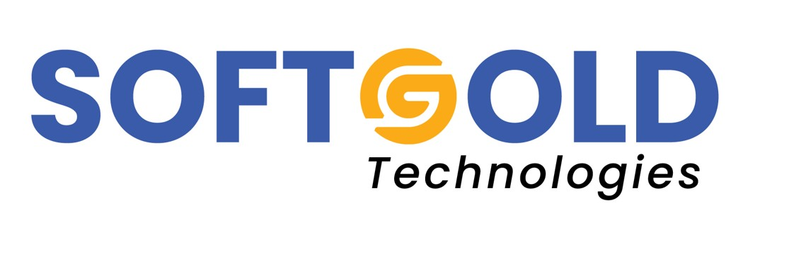
SOFTGOLD TECHNOLOGIES PRIVATE LIMITED
PROPOSAL
Business Website
Prepared For: James Tharakan Transport L.L.C
Address: Office F1-037, Dubai Investment Park, Dubai, UAE
Trade Licence / Register No.: 1308458 / 2220046
Date: 24 August 2026
Prepared By: Softgold Technologies Private Limited, Kerala, India

1. Understanding Your Business
James Tharakan Transport L.L.C is a Dubai-licensed road transport company operating under two active activities: Cargo Transport by Heavy Trucks and Raw Materials Transport by Road. The company's practical strength is in three areas:
1. The UAE-Oman corridor, with particular depth on the Muscat route.
2. Cross-border movement into the wider GCC.
3. Primarily Building and construction materials - a segment where deadlines, load handling and site access matter more than headline price.
The company was built from the ground up. The owner began as a driver and grew the venture into a licensed LLC. That history is a genuine commercial asset: it means the company understands border formalities, driver realities, load securing and site delivery from direct experience, not from a desk. Very few competitors can say that honestly. The website's main job is to make that credibility visible to buyers who have never met you.
2. The Problem We Are Solving
Today, a procurement officer at a contracting company in Sohar, a trader in Muscat, or a materials supplier in Dubai who hears your name has no way to verify you online. When they search, they find nothing. That creates two losses:
- Lost enquiries - buyers shortlist the transporters they can find and check.
- Weaker negotiating position - a company with no visible profile is treated as a small subcontractor, not a partner.
3. Proposed Solution
We propose a professional, mobile-first business website built specifically for a GCC road transport operator - not a generic template. The site will be fast, easy to update, and designed so that a buyer can understand what you do and contact you within thirty seconds.
3.1 Proposed Site Structure
1. Home
- Clear headline positioning: Cargo and building materials transport across UAE, Oman and the GCC.
- Immediate trust signals: years in operation, licensed Dubai LLC, fleet capability, Oman route specialisation.
- A prominent "Request a Quote" button on every screen.
2. About Us
- The founder's story - from driver to licensed operator. This is your strongest differentiator and deserves a full section, written properly.
- Company facts: legal form, licence number, Dubai Investment Park base, paid-up capital, DCCI membership.
3. Services
- Heavy truck cargo transport
- Raw materials and building materials transport (cement, aggregates, steel, blocks, tiles, sanitary ware, prefab units)
- Cross-border GCC transport with customs documentation support
- Project and site deliveries
- Each service gets its own short page - this is what search engines index and what buyers actually search for.
4. Routes & Coverage
- A dedicated page explaining the routes served today.
5. Fleet
- Truck types, trailer types, tonnage and load capacities, with photographs of your actual vehicles.
- Buyers choose transporters by whether the equipment matches the load. Making this explicit removes a round of back-and-forth on every enquiry.
6. Why Choose Us
- Ground experience, licensed operations, driver competence, load securing practice, on-time record, direct owner involvement.
7. Industries Served
- Construction and contracting, building materials suppliers, manufacturing, trading companies, project logistics etc.
8. Request a Quote
- A structured form capturing: cargo type, weight/volume, pickup location, delivery location, required date, contact details.
- Submissions arrive by email.
9. Contact
- Phone, office address, Google Map pin, and an enquiry form.
3.2 What Is Included in the Build
1. Custom design aligned to a clean, industrial transport identity - no stock template look.
2. Full mobile optimisation. The majority of GCC trade enquiries come from mobile.
3. Click-to-call on every page, connected to +971 56 916 1225.
4. Domain registration and one year of hosting, with SSL security certificate.
5. Contact and quote forms with spam protection.
6. Content writing - we will draft all page copy in professional English.
4. What We Need From You
1. Company logo, if one exists.
2. Photographs of your trucks, trailers and operations.
3. Confirmation of years in operation and approximate fleet size.
4. Names of key routes and any anchor clients you are permitted to mention.
5. Any permit or association memberships you would like displayed.

Softgold Technologies Private Limited
contact@softgoldtechnologies.com
www.softgoldtechnologies.com

