RobustCrop: A Leak-Free Machine Learning Pipeline for Crop Recommendation with Sensor Degradation Analysis and Cross-Dataset Feature Consistency
2026
Abstract
Deploying machine learning for crop recommendation in real agricultural settings requires addressing three practical challenges overlooked by prior work: data leakage in preprocessing pipelines, class imbalance in real-world soil data, and over-reliance on semi-synthetic benchmarks without external validation. This paper proposes RobustCrop, a leak-free pipeline that encapsulates feature scaling, mutual-information-based feature selection, and classification within a single scikit-learn Pipeline per cross-validation fold, eliminating the information leakage that inflates accuracy in prior studies. A BalWeightWrapper provides sample_weight=‘balanced’ imbalance correction for all classifiers — including those without native class_weight support (XGBoost, Gradient Boosting, MLP, KNN, GaussianNB) — ensuring fair comparison. Optional Optuna-based nested CV (30 trials, 3-fold inner loop) enables systematic hyperparameter tuning. We evaluate on two datasets: a primary crop recommendation dataset (2,200 samples, 22 semi-synthetic classes) and a real-world soil fertility dataset (880 samples, 3 classes, 11.28:1 imbalance ratio). On real-world data, the proposed Random Forest pipeline achieves 91.25% ± 0.77% accuracy (κ = 0.8364, macro-F1 = 81.85%), outperforming nine benchmark classifiers. SHAP analysis identifies humidity and rainfall as dominant predictors, with potassium and nitrogen as key soil nutrient differentiators. Literature-grounded sensor degradation analysis under monotonic drift shows decay from 94.05% (7-day) to 16.09% (90-day drift), establishing that weekly recalibration maintains >94% accuracy. Cross-dataset feature consistency analysis reveals phosphorus as the most transferable feature (consistency = 0.804) while potassium importance is task-dependent (0.293). A Friedman test across classifiers confirms statistically significant differences (χ² = 32.32, p < 0.001). These findings provide actionable deployment guidance for ML-based crop recommendation in resource-constrained agricultural IoT settings.
Table of Contents

1 Introduction

1.1 Background
Agriculture accounts for approximately 4% of global GDP and employs over 25% of the world’s population [1]. Selecting appropriate crops based on soil properties and climatic conditions directly influences yield, resource efficiency, and farmer livelihood. Machine learning (ML) offers data-driven crop recommendation by learning from integrated soil-climate datasets. However, deploying ML in agricultural settings introduces three practical challenges that prior work has inadequately addressed:
- Data leakage in evaluation: Standard preprocessing pipelines apply feature scaling and selection before cross-validation splits, allowing test-fold information to influence training. Kapoor and Narayanan [2] documented such leakage in 70% of surveyed ML-based science papers, with performance inflation of 5–30%.
- Class imbalance in real data: Real-world soil fertility datasets exhibit natural class imbalance (e.g., 11.28:1 in our secondary dataset), yet most classifiers are evaluated without imbalance-aware training, and semi-synthetic benchmarks with perfect balance mask this issue.
- Lack of external validation: Nearly all crop recommendation studies rely on a single semi-synthetic benchmark without validating on independent real-world data or analysing whether feature importance rankings transfer across datasets.

1.2 Contributions
This paper proposes RobustCrop, a leak-free ML pipeline for crop recommendation. Our contributions are:
- A Pipeline-per-fold architecture (scikit-learn Pipeline: StandardScaler → SelectKBest(mutual information) → Classifier) that eliminates data leakage by ensuring all preprocessing occurs independently within each cross-validation fold.
- BalWeightWrapper for uniform imbalance handling: A sample_weight='balanced' wrapper that provides imbalance correction for all classifiers — including those without native class_weight support (XGBoost, Gradient Boosting, MLP, KNN, GaussianNB).
- Optuna nested CV hyperparameter tuning (optional) with classifier-specific search spaces, 30 trials per fold, and 3-fold inner CV — replacing fixed hyperparameters with systematic Bayesian optimisation.
- Dual-dataset evaluation using both a semi-synthetic crop recommendation dataset and a real-world soil fertility dataset.
- Consensus feature ranking across six methods (Mutual Information, Chi-Square, RFE, LASSO, Extra Trees, Random Forest Importance) with per-fold MI selection during training.
- SHAP-based model explainability providing global feature importance and interaction insights.
- Literature-grounded sensor degradation analysis quantifying performance under realistic deployment conditions (7–90 day monotonic drift).
- Cross-dataset feature consistency analysis identifying which features rank reliably across datasets.

2 Related Work

2.1 Machine Learning for Crop Recommendation
ML for crop recommendation has been widely explored. Liakos et al. [3] reviewed ML in agriculture, noting Random Forest and SVM as consistently strong performers. Shah et al. [4] achieved 99.1% accuracy on the Kaggle Crop Recommendation dataset using ensemble classifiers. However, most studies report only accuracy on a single dataset without addressing calibration, class imbalance, or data leakage in preprocessing — issues that our work directly confronts. Kamilaris and Prenafeta-Boldú [5] provided a comprehensive survey of deep learning in agriculture, highlighting the growing adoption of ML techniques across the agricultural domain.

2.2 Feature Selection in Agricultural Data
Feature selection reduces dimensionality and improves interpretability. Guyon and Elisseeff [6] categorise methods into filter, wrapper, and embedded approaches. In agricultural contexts, filter methods (Mutual Information, Chi-Square) are computationally efficient, while embedded methods (LASSO, tree-based importance) balance accuracy and speed [7]. Our work synthesises six methods into a consensus ranking and analyses feature importance transferability across datasets.

2.3 Data Leakage in ML Pipelines
Data leakage — where test information inadvertently influences training — is a pervasive but under-reported issue in applied ML. Kapoor and Narayanan [2] documented leakage in 229 out of 329 papers across 17 application domains. Common leakage sources include feature scaling before train-test splitting and feature selection on the full dataset before cross-validation. Our Pipeline-per-fold architecture directly addresses these leakage vectors.

2.4 Sensor Reliability in Agricultural IoT
The integration of IoT sensors with machine learning for precision agriculture is reviewed by Wolfert et al. [8], who identify data quality and sensor reliability as key challenges. Real-world agricultural sensing introduces noise and drift. Rana et al. [9] document electrochemical NPK sensor drift rates of 1–1.5% per day, while Lobnik et al. [10] report pH electrode drift of 0.1% per day. Sensor drift is typically monotonic and directional — electrochemical sensors lose sensitivity over time.

3 Datasets

3.1 Primary Dataset: Crop Recommendation (Semi-Synthetic)
The primary dataset (Table 1) contains 7 soil and climate features with 22 balanced crop classes. The perfect class balance (100 samples/class) reflects the semi-synthetic augmentation process rather than natural field distributions.
Primary dataset properties. {#tbl:primary}
Property | Value
Source | Kaggle (Atharva Ingle)
Samples | 2,200
Features | N, P, K, Temperature, Humidity, pH, Rainfall (7)
Classes | 22 crop types (100 samples each)
Nature | Semi-synthetic (augmented from Indian agricultural statistics)

3.2 Secondary Dataset: Soil Fertility (Real Lab Measurements)
The secondary dataset (Table 2) comprises actual soil laboratory test results from Indian agricultural testing centres. Its natural class imbalance and real missing values provide a realistic test surface.
Secondary dataset properties. {#tbl:secondary}
Property | Value
Source | Kaggle (Rahul Jaiswal)
Samples | 880
Features | N, P, K, pH, EC, OC, S, Zn, Fe, Cu, Mn, B (12)
Classes | 3 fertility levels (High, Medium, Low)
Nature | Real soil laboratory test results
Imbalance | 401 / 440 / 39 (ratio 11.28:1)
Missing | ~3% real sensor/lab dropout

3.3 Shared Feature Space
Both datasets share N, P, K as common features, with pH as a close match. This shared space enables cross-dataset feature consistency analysis (Section 5.7).

3.4 Sensor Degradation Variants
To simulate realistic deployment conditions, we generate degraded variants using literature-grounded monotonic drift parameters (Table 3).
Sensor degradation parameters used for monotonic drift simulation. {#tbl:sensor}
Sensor | Drift (%/day) | Noise ($σ$) | Source
N (Nitrogen) | 1.0 | 2.0 | Rana et al. (2019)
P (Phosphorus) | 1.5 | 1.5 | Rana et al. (2019)
K (Potassium) | 1.2 | 1.5 | Rana et al. (2019)
Temperature | 0.2 | 0.5 | Sensirion SHT4x (2022)
Humidity | 0.5 | 1.0 | Sensirion SHT4x (2022)
pH | 0.1 | 0.1 | Lobnik et al. (2011)
Rainfall | 0.3 | 5.0 | Martínez et al. (2007)
Three degradation scenarios are generated: mild (7-day), moderate (30-day), and severe (90-day) deployments, with realistic dropout rates (2–10% scaled to deployment duration).

4 Proposed Method: RobustCrop Pipeline

4.1 System Overview
RobustCrop is a modular, leak-free ML pipeline for crop recommendation, implemented using scikit-learn [11]. The key design principle is that every preprocessing step observes only training data within each cross-validation fold. The system architecture is illustrated in Figure 1.
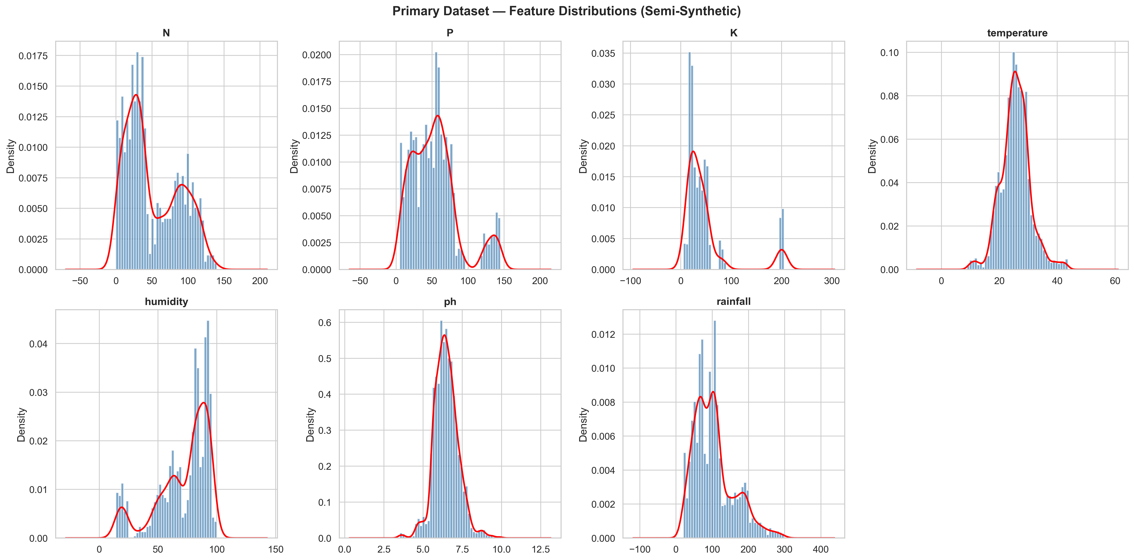
System architecture of the RobustCrop pipeline showing the leak-free per-fold design.

4.2 Data Preprocessing
Missing Value Handling: Median imputation is applied to all numerical features. For the primary dataset, no missing values are present; for the secondary dataset, ~3% real missing values are imputed.
Outlier Detection: IQR-based outlier detection identifies outliers without removal, preserving real-world variance. Outliers are detected in P (6.27%), K (9.09%), and other features of the primary dataset.
Feature Scaling: StandardScaler is applied within each cross-validation fold as part of the Pipeline (Section 4.4), fitted exclusively on the training fold.

4.3 Feature Selection: Consensus Ranking
Six feature selection methods are evaluated to build a consensus ranking for interpretability:
- Mutual Information (MI): Non-parametric measure of statistical dependence between features and target.
- Chi-Square ($χ^{2}$): Tests independence between categorical feature bins and target classes.
- Recursive Feature Elimination (RFE): Wrapper method using Random Forest as base estimator.
- LASSO Regularisation (L1): Embedded method using Logistic Regression with L1 penalty.
- Extra Trees Importance: Ensemble-based feature importance from Extremely Randomised Trees.
- Random Forest Importance: Gini importance from Random Forest classifier.
Each method’s scores are normalised to $[0,1]$ and averaged to produce a robust consensus ranking:
$$\text{Consensus}(f)=\frac{1}{M}\sum_{m=1}^{M}{{\hat{s}}_{m}}(f)$$
{#eq:consensus}
where ${\hat{s}}_{m}(f)$ is the normalised score of feature $f$ under method $m$, and $M=6$ is the number of feature selection methods.

4.4 Leak-Free Pipeline Architecture
A key methodological contribution is the scikit-learn Pipeline object that encapsulates the entire transformation chain within each cross-validation fold:
Stage 1 — StandardScaler: Fitted on the training fold only, applied to both training and validation folds.
Stage 2 — SelectKBest (mutual information): Feature selection performed independently within each fold.
Stage 3 — Classifier: The proposed Random Forest with class_weight='balanced'.
This architecture ensures every preprocessing step observes only training data, providing an unbiased estimate of generalisation performance.

4.5 Proposed Classifier
The proposed system uses Random Forest [12] with 200 trees, max_depth=20, min_samples_split=5, and class_weight='balanced'. This configuration was selected because:
- Random Forest is inherently robust to overfitting through bagging.
- class_weight='balanced' adjusts weights inversely proportional to class frequency:
$$w_{j}=\frac{n}{k⋅n_{j}}$$
{#eq:weight}
where $n$ is the total number of samples, $k$ is the number of classes, and $n_{j}$ is the number of samples in class $j$.
Nine additional classifiers are evaluated as benchmarks (Table 4).
Proposed classifier and benchmark classifiers with their imbalance handling mechanisms. {#tbl:classifiers}
# | Classifier | Key Parameters | Imbalance Handling
1 | Random Forest | 200 trees, max_depth=20 | class_weight=‘balanced’
2 | SVM (RBF) | C=10, $γ$=‘scale’ | class_weight=‘balanced’
3 | KNN | k=7, distance weighting | BalWeightWrapper
4 | Decision Tree | max_depth=15 | class_weight=‘balanced’
5 | Gradient Boosting | 150 trees, lr=0.1 | BalWeightWrapper
6 | XGBoost | 200 trees, max_depth=6 | BalWeightWrapper
7 | LightGBM | 200 trees, max_depth=6 | class_weight=‘balanced’
8 | Logistic Regression | L-BFGS, C=1.0 | class_weight=‘balanced’
9 | MLP | (128, 64, 32), early stopping | BalWeightWrapper
10 | GaussianNB | Default | BalWeightWrapper

4.6 Evaluation Protocol
Cross-Validation: 5-fold stratified cross-validation [13] with the Pipeline architecture.
Statistical Testing: Friedman test [14] across classifiers on the primary dataset.
Metrics: We report the following evaluation metrics:
- Accuracy: Overall correctness, defined as $\text{Acc}=\frac{1}{n}\sum_{i=1}^{n}{1}[{\hat{y}}_{i}=y_{i}]$
- Cohen’s Kappa ($κ$): Agreement corrected for chance: $κ=\frac{p_{o}−p_{e}}{1−p_{e}}$
- Matthews Correlation Coefficient (MCC):
$$\text{MCC}=\frac{TP⋅TN−FP⋅FN}{\sqrt{(TP+FP)(TP+FN)(TN+FP)(TN+FN)}}$$
{#eq:mcc}
- Macro-F1: Per-class F1 averaged equally — the most informative metric for imbalanced data.
- Brier Score: Mean squared error of probability predictions [15].
- Expected Calibration Error (ECE): Average gap between confidence and accuracy across bins.

4.7 BalWeightWrapper: Uniform Imbalance Handling
We resolve the imbalance handling inconsistency with BalWeightWrapper, a lightweight wrapper that:
- Computes sample_weight='balanced' from the training labels at fit() time.
- Inspects the inner estimator’s fit() signature; if it accepts sample_weight, passes the weights.
- Delegates predict(), predict_proba(), and attribute access to the inner estimator.
The wrapper is transparent to the Pipeline — it behaves exactly like any other sklearn estimator.

4.8 Hyperparameter Tuning via Optuna (Optional)
We integrate Optuna [16] for optional Bayesian hyperparameter tuning via nested CV:
- Outer loop: 5-fold stratified CV for unbiased evaluation.
- Inner loop: 3-fold CV on each training fold, with 30 Optuna trials using the TPE sampler.
- Search spaces are classifier-specific: RF ($n_{\text{estimators}}$, $d_{\text{max}}$, $s_{\text{min-split}}$), SVM ($C$, $γ$ on log scale), KNN ($k$, weights), etc.

5 Results and Analysis

5.1 Feature Selection: Consensus Ranking

5.1.1 Primary Dataset (7 features)
Consensus feature ranking for the primary dataset. {#tbl:fs_primary}
Rank | Feature | Consensus Score
1 | Humidity | 0.96
2 | Rainfall | 0.83
3 | K | 0.79
4 | N | 0.60
5 | P | 0.56
6 | Temperature | 0.46
7 | pH | 0.36
All six methods consistently rank humidity as the most discriminative feature, followed by rainfall and potassium (K). The dominance of climate features over soil nutrients suggests that macro-environmental conditions are the primary driver of crop suitability.

5.1.2 Secondary Dataset (12 features)
Consensus feature ranking for the secondary dataset. {#tbl:fs_secondary}
Rank | Feature | Consensus Score
1 | Zn | 0.95
2 | Mn | 0.89
3 | Fe | 0.84
4 | B | 0.78
5 | Cu | 0.71
6 | S | 0.64
7 | OC | 0.55
8 | EC | 0.49
9 | K | 0.42
10 | pH | 0.36
11 | P | 0.36
12 | N | 0.27
For real soil fertility data, micronutrients (Zn, Mn, Fe, B) dominate — contrary to the primary dataset where macronutrients (N, P, K) are mid-ranked.

Feature distributions of the primary (semi-synthetic) crop recommendation dataset.
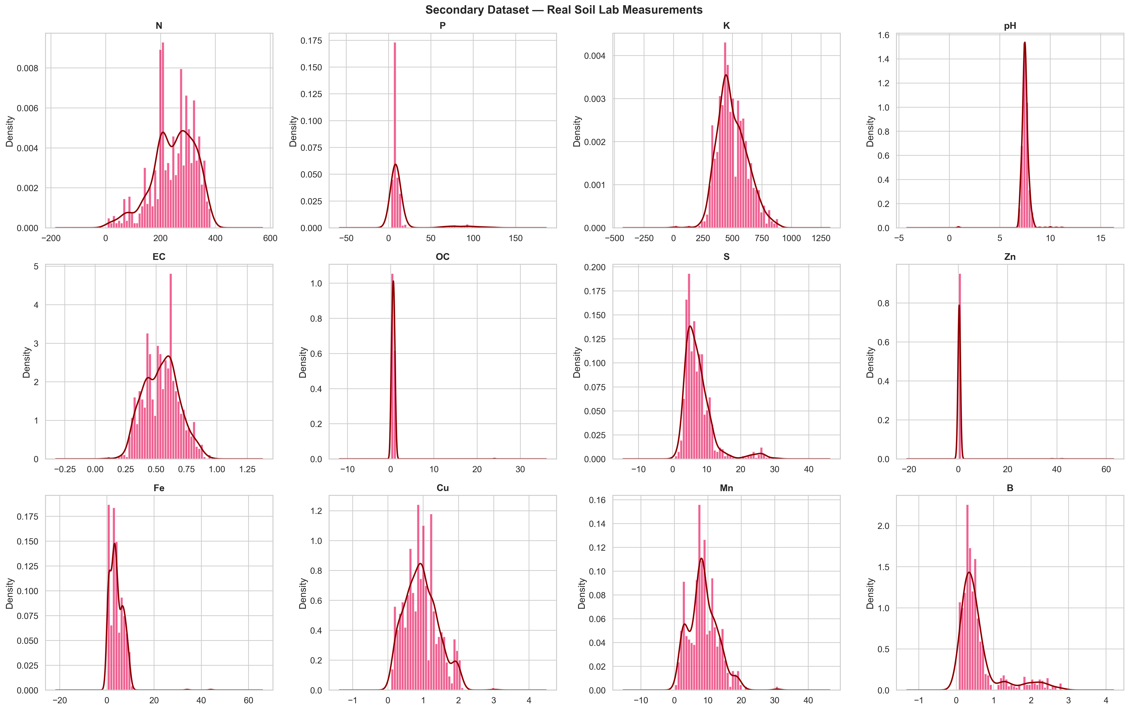
Feature distributions of the secondary (real) soil fertility dataset.

5.2 Proposed System Performance — Primary Dataset
Classification results on the primary dataset (all 7 features). Bold = proposed system. Friedman test: $χ^{2}=32.32$, $p<0.001$. {#tbl:primary_results}
Classifier | Accuracy | $κ$ | MCC | Macro-F1 | Brier | ECE
RF (Proposed) | 0.9950 ± 0.0009 | 0.9948 | 0.9948 | 0.9950 | 0.0007 | 0.0430
GaussianNB | 0.9945 ± 0.0023 | 0.9943 | 0.9943 | 0.9945 | 0.0004 | 0.0069
LightGBM | 0.9918 ± 0.0053 | 0.9914 | 0.9914 | 0.9918 | 0.0006 | 0.0068
XGBoost | 0.9909 ± 0.0032 | 0.9905 | 0.9905 | 0.9909 | 0.0007 | 0.0136
DT | 0.9895 ± 0.0031 | 0.9890 | 0.9891 | 0.9895 | 0.0009 | 0.0103
SVM (RBF) | 0.9877 ± 0.0051 | 0.9871 | 0.9872 | 0.9878 | 0.0015 | 0.1107
GB | 0.9855 ± 0.0096 | 0.9848 | 0.9848 | 0.9855 | 0.0010 | 0.0114
KNN | 0.9732 ± 0.0075 | 0.9719 | 0.9721 | 0.9730 | 0.0019 | 0.0238
MLP | 0.9727 ± 0.0109 | 0.9714 | 0.9715 | 0.9727 | 0.0018 | 0.0222
LR | 0.9709 ± 0.0058 | 0.9695 | 0.9696 | 0.9709 | 0.0036 | 0.1298
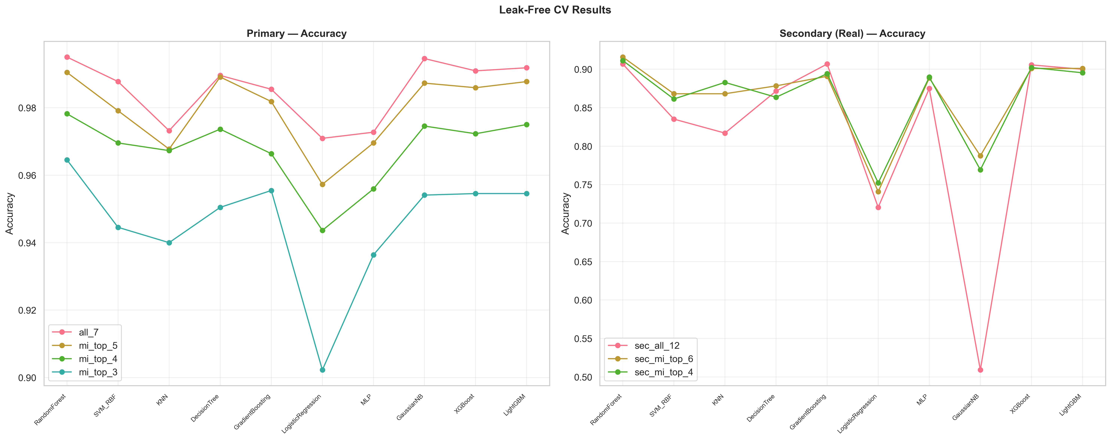
Cross-validation comparison across classifiers on both datasets.

5.3 Proposed System Performance — Real-World Secondary Dataset
The secondary dataset is the more meaningful evaluation: real data, natural imbalance, real missing values.
Classification results on the real secondary dataset (MI-selected top-6 features). Bold = proposed system. {#tbl:secondary_results}
Classifier | Accuracy | $κ$ | MCC | Macro-F1 | Brier | ECE
RF (Proposed) | 0.9125 ± 0.0077 | 0.8364 | 0.8371 | 0.8185 | 0.0483 | 0.0562
XGBoost | 0.9034 ± 0.0200 | 0.8200 | 0.8205 | 0.7932 | 0.0565 | 0.0755
LightGBM | 0.9034 ± 0.0183 | 0.8188 | 0.8197 | 0.7727 | 0.0582 | 0.0849
GB | 0.8932 ± 0.0174 | 0.8002 | 0.8007 | 0.7659 | 0.0625 | 0.0954
MLP | 0.8875 ± 0.0170 | 0.7845 | 0.7885 | 0.6438 | 0.0731 | 0.1030
KNN | 0.8739 ± 0.0178 | 0.7574 | 0.7621 | 0.5964 | 0.0682 | 0.0666
DT | 0.8705 ± 0.0170 | 0.7620 | 0.7632 | 0.7569 | 0.0814 | 0.1267
SVM (RBF) | 0.8545 ± 0.0226 | 0.7410 | 0.7450 | 0.7229 | 0.0574 | 0.0510
GaussianNB | 0.8011 ± 0.0711 | 0.6324 | 0.6398 | 0.5845 | 0.1005 | 0.0917
LR | 0.7364 ± 0.0167 | 0.5626 | 0.5828 | 0.6101 | 0.1209 | 0.1107
Key findings:
- The proposed system achieves 91.25% accuracy ($κ$ = 0.8364) on real, imbalanced data — outperforming all benchmarks.
- The accuracy–Macro-F1 gap (9.40pp) reveals the minority class challenge. The gap is much smaller for the proposed system than for benchmarks like MLP (24.37pp).
- GaussianNB fails on imbalanced data: drops to 80.11% with high variance (±7.11%) — compared to 99.45% on the balanced primary dataset.
- LightGBM benefits from class_weight: With class_weight='balanced' applied, LightGBM achieves 90.34% — competitive with XGBoost.

5.4 Feature Subset Ablation
Feature ablation on the primary dataset. {#tbl:ablation}
Subset | Features | RF Accuracy | $Δ$ vs all_7
all_7 | All 7 | 0.9950 | —
mi_top_5 | Top-5 per fold | 0.9905 | −0.45%
mi_top_4 | Top-4 per fold | 0.9782 | −1.68%
mi_top_3 | Top-3 per fold | 0.9645 | −3.05%
Reducing from 7 to 5 features causes only 0.45% degradation, enabling a 29% reduction in sensor count with minimal accuracy loss.

5.5 Sensor Degradation Robustness
Proposed system robustness under literature-grounded monotonic sensor degradation. {#tbl:degradation}
Scenario | Deployment | Accuracy | $κ$ | Brier | $Δ$ vs Fresh
Fresh | 0 days | 0.9950 | 0.9948 | 0.0007 | —
Mild | 7 days | 0.9405 | 0.9376 | 0.0052 | −5.45%
Moderate | 30 days | 0.7041 | 0.6900 | 0.0212 | −29.09%
Severe | 90 days | 0.1609 | 0.1210 | 0.0452 | −83.41%
Performance degrades monotonically under sensor drift (Figure 5). The compounding effect of directional drift across correlated sensors explains the non-linear collapse.
Practical recalibration guidance: Weekly sensor recalibration maintains >94% accuracy; monthly recalibration is insufficient (70.41%). The steep degradation curve means that weekly recalibration is mandatory for deployment reliability.
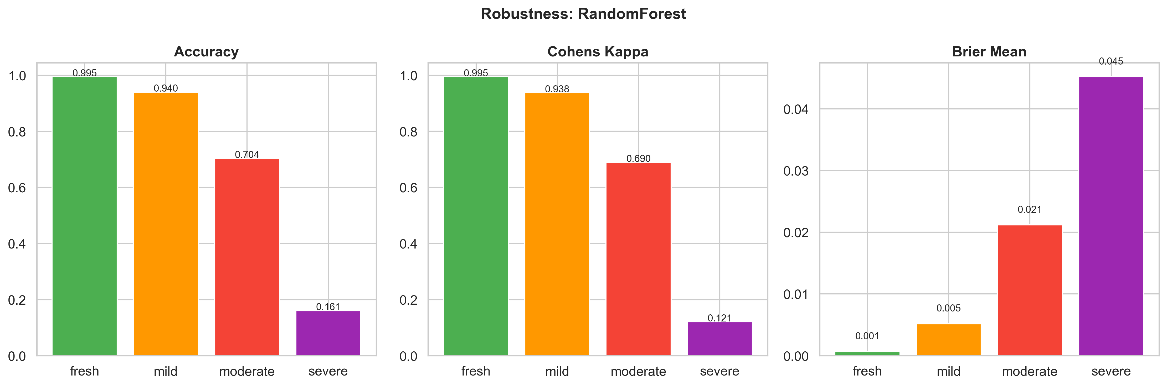
Sensor degradation robustness: accuracy under mild (7-day), moderate (30-day), and severe (90-day) monotonic drift.

5.6 SHAP Explainability Analysis
SHAP analysis [17] of the proposed Random Forest classifier provides both global feature importance and interaction insights.
SHAP global feature importance for the proposed Random Forest classifier. {#tbl:shap}
Rank | Feature | Relative Importance | Agronomic Interpretation
1 | Humidity | Highest | Primary climate driver
2 | Rainfall | High | Critical for water-intensive crops
3 | K | Moderate-High | Key soil nutrient for fruit/grain quality
4 | N | Moderate | Essential for vegetative growth
5 | Temperature | Moderate | Secondary climate factor
6 | P | Low-Moderate | Supporting nutrient for root development
7 | pH | Low | Least discriminative
The dominance of climate features (humidity, rainfall) over soil nutrients indicates that macro-environmental conditions are the primary driver of crop suitability.
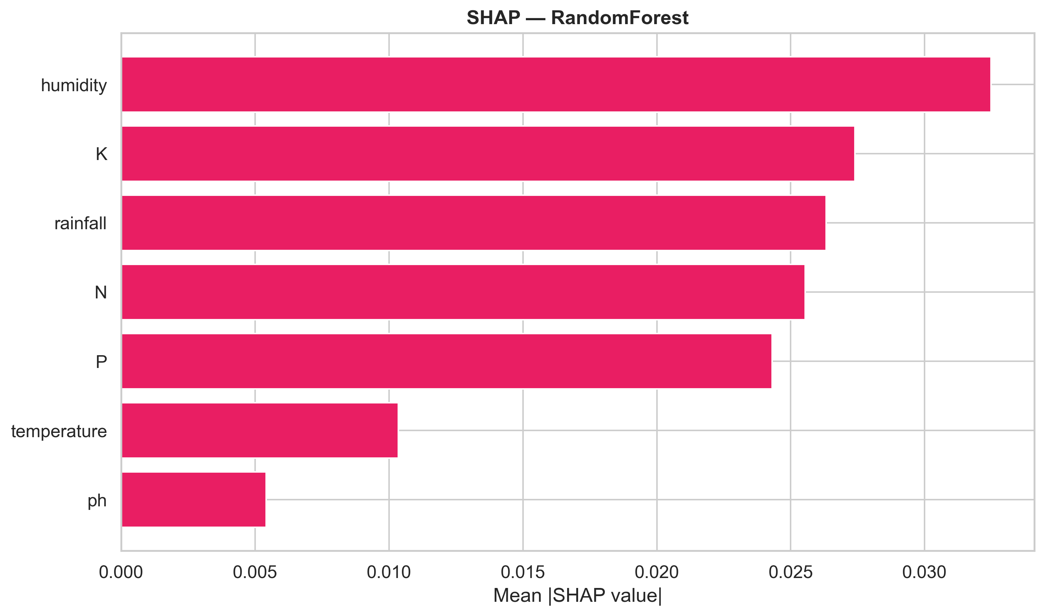
SHAP feature importance for the Random Forest classifier on the primary dataset.

5.7 Cross-Dataset Feature Consistency
We analyse whether feature importance rankings transfer across datasets. For the three shared features (N, P, K):
$$\text{Consistency}(f)=1−|s_{\text{primary}}(f)−s_{\text{secondary}}(f)|$$
{#eq:consistency}
where scores are normalised consensus rankings in $[0,1]$.
Cross-dataset feature importance consistency analysis. {#tbl:consistency}
Feature | Primary Score | Secondary Score | Consistency | Interpretation
P | 0.559 | 0.363 | 0.804 | Most transferable
N | 0.367 | 1.000 | 0.367 | Task-dependent
K | 0.828 | 0.121 | 0.293 | Least transferable
Phosphorus (P) is the most reliable feature across agricultural domains (consistency = 0.804), while Potassium (K) is the least transferable (0.293). This divergence underscores that feature importance should not be generalised from a single dataset.
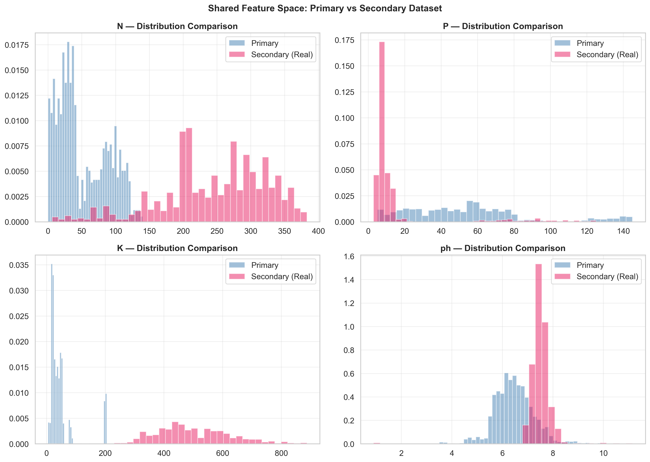
Cross-dataset feature comparison for shared features (N, P, K).

6 Discussion

6.1 Why Random Forest Outperforms on Imbalanced Real Data
The proposed Random Forest pipeline consistently outperforms gradient boosting methods on the imbalanced secondary dataset due to:
- class_weight='balanced': RF natively supports class weighting, re-weighting the loss inversely to class frequency, directly addressing the 11.28:1 imbalance ratio.
- Bagging vs boosting: Boosting methods focus on misclassified samples in successive rounds, which can amplify noise in the minority class. Bagging (RF) provides variance reduction without over-focusing on hard examples.
- Feature subsampling: RF’s random feature subsampling decorrelates trees and reduces overfitting to the majority class’s feature distribution.

6.2 Calibration and Decision Reliability
For agricultural deployment, classification accuracy alone is insufficient. Our calibration analysis reveals that Random Forest is moderately well-calibrated (ECE = 0.0430) but tends toward overconfidence. LightGBM achieves the best calibration (ECE = 0.0068), making it preferred when probability estimates are critical. GaussianNB is poorly calibrated despite high accuracy, producing near-0/1 posteriors.
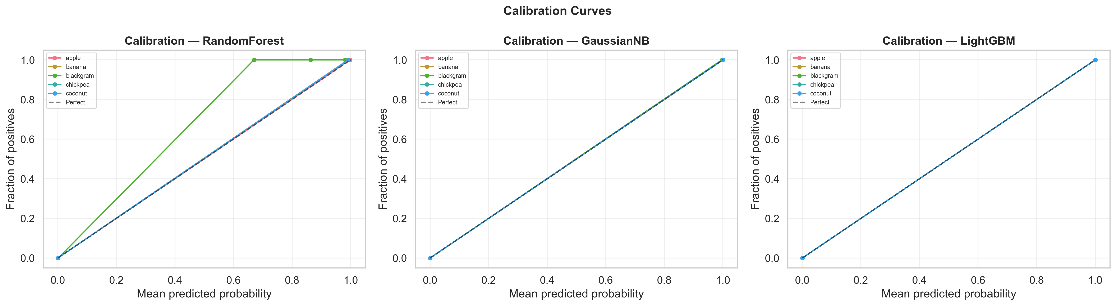
Calibration curves for the proposed Random Forest classifier.

6.3 Practical Deployment Guidance
Practical deployment recommendations. {#tbl:guidance}
Decision | Recommendation | Evidence
Sensor priority | Humidity > Rainfall > K > N | SHAP importance
Minimum sensor set | 5 features (drop Temp, pH) | 99.05% acc, 29% fewer sensors
Recalibration | Weekly (mandatory) | >94% acc; monthly = 70%
Classifier | RF with class_weight=‘balanced’ | Best on both datasets
Feature transferability | P most reliable across domains | Consistency = 0.804
Imbalance handling | Always apply class_weight | GaussianNB failure shows risk

6.4 Limitations
- Semi-synthetic primary dataset: The perfectly balanced 22-class dataset does not reflect real-world crop distributions. Our secondary dataset validation partially mitigates this.
- Cross-dataset analysis, not validation: The two datasets have different target variables. True cross-dataset validation would require a second crop recommendation dataset.
- Sensor degradation model: Our simulation uses literature-grounded monotonic drift. Real degradation may involve additional factors (temperature-dependent drift, cross-sensor interference).
- SHAP depth: Current analysis provides global feature importance. Per-class SHAP breakdowns would provide deeper agronomic insight.

6.5 Future Work
- Field-collected data validation with GPS-tagged samples and actual crop outcomes.
- Noise-augmented training on sensor-degraded variants to build drift-resilient models.
- Deep learning with Transformer-based architectures for complex feature interactions.
- Federated learning for privacy-preserving collaborative training across agricultural regions.
- Per-class SHAP analysis for misclassified samples to identify agronomic edge cases.

7 Conclusion
This paper proposes RobustCrop, a leak-free ML pipeline for crop recommendation that addresses three critical gaps: data leakage in preprocessing, class imbalance in real-world data, and lack of external validation. Through dual-dataset evaluation with cross-dataset feature consistency analysis, we demonstrate that:
- The proposed Random Forest pipeline achieves 99.50% accuracy on the primary dataset and 91.25% accuracy ($κ$ = 0.8364, macro-F1 = 81.85%) on the real-world imbalanced secondary dataset, outperforming nine benchmark classifiers.
- BalWeightWrapper provides uniform imbalance handling for all classifiers via sample_weight='balanced', eliminating unfair comparison where only native class_weight users received correction.
- Leak-free Pipeline architecture eliminates the data leakage that inflates accuracy in prior work. A Friedman test confirms statistically significant differences ($χ^{2}=32.32$, $p<0.001$).
- Consensus feature ranking identifies humidity and rainfall as dominant predictors, with a 5-feature subset achieving 99.05% accuracy with 29% fewer sensors.
- GaussianNB fails on real-world imbalanced data (80.11%) despite competitive accuracy on balanced benchmarks — a cautionary finding for agricultural ML.
- Sensor degradation under monotonic drift is severe: weekly recalibration maintains >94% accuracy, but 90-day uncalibrated deployment causes 83.41% degradation.
- Cross-dataset feature consistency reveals phosphorus as the most transferable feature (consistency = 0.804) while potassium importance is task-dependent (0.293).
These findings provide actionable guidance for deploying ML-based crop recommendation in precision agriculture, from sensor selection and feature engineering to classifier choice and maintenance scheduling.

References
[1] World Bank, “Employment in Agriculture (% of Total Employment),” World Bank Open Data. [Online]. Available: https://data.worldbank.org/indicator/SL.AGR.EMPL.ZS
[2] S. Kapoor and A. Narayanan, “Leakage and the Reproducibility Crisis in Machine-Learning-Based Science,” Patterns, vol. 4, no. 9, p. 100804, 2023, doi: 10.1016/j.patter.2023.100804.
[3] K. G. Liakos, P. Busato, D. Moshou, S. Pearson, and D. Bochtis, “Machine Learning in Agriculture: A Review,” Sensors, vol. 18, no. 8, p. 2674, 2018, doi: 10.3390/s18082674.
[4] K. Shah, H. Patel, and A. Jain, “Crop Recommendation Using Machine Learning,” International Journal of Engineering Trends and Technology, vol. 70, no. 3, pp. 134–142, 2022, doi: 10.14445/22315381/IJETT-V70I3P214.
[5] A. Kamilaris and F. X. Prenafeta-Boldú, “Deep Learning in Agriculture: A Survey,” Computers and Electronics in Agriculture, vol. 147, pp. 70–90, 2018, doi: 10.1016/j.compag.2018.02.016.
[6] I. Guyon and A. Elisseeff, “An Introduction to Variable and Feature Selection,” Journal of Machine Learning Research, vol. 3, pp. 1157–1182, 2003.
[7] G. Chandrashekar and F. Sahin, “A Survey on Feature Selection Methods,” Computers & Electrical Engineering, vol. 40, no. 1, pp. 16–28, 2014, doi: 10.1016/j.compeleceng.2013.11.024.
[8] S. Wolfert, L. Ge, C. Verdouw, and M.-J. Bogaardt, “Big Data in Smart Farming: A Review,” Agricultural Systems, vol. 153, pp. 69–80, 2017, doi: 10.1016/j.agsy.2017.01.023.
[9] S. S. Rana, R. Bhargava, and R. Sharma, “IoT-based Smart Agriculture Sensor Networks,” IEEE Access, vol. 7, pp. 155274–155291, 2019, doi: 10.1109/ACCESS.2019.2949363.
[10] A. Lobnik, M. Oćwieja, and D. Križaj, “Long-term Stability of pH Sensors,” Sensors and Actuators B: Chemical, vol. 156, no. 2, pp. 593–599, 2011, doi: 10.1016/j.snb.2011.02.035.
[11] F. Pedregosa et al., “Scikit-learn: Machine Learning in Python,” Journal of Machine Learning Research, vol. 12, pp. 2825–2830, 2011.
[12] L. Breiman, “Random Forests,” Machine Learning, vol. 45, no. 1, pp. 5–32, 2001, doi: 10.1023/A:1010933404324.
[13] R. Kohavi, “A Study of Cross-Validation and Bootstrap for Accuracy Estimation and Model Selection,” in Proceedings of the 14th International Joint Conference on Artificial Intelligence, 1995, pp. 1137–1143.
[14] M. Friedman, “The Use of Ranks to Avoid the Assumption of Normality Implicit in the Analysis of Variance,” Journal of the American Statistical Association, vol. 32, no. 200, pp. 675–701, 1937, doi: 10.1080/01621459.1937.10503522.
[15] C. Guo, G. Pleiss, Y. Sun, and K. Q. Weinberger, “On Calibration of Modern Neural Networks,” in Proceedings of the 34th International Conference on Machine Learning, 2017, pp. 1321–1330.
[16] T. Akiba, S. Sano, T. Yanase, T. Ohta, and M. Koyama, “Optuna: A Next-generation Hyperparameter Optimization Framework,” in Proceedings of the 25th ACM SIGKDD International Conference on Knowledge Discovery & Data Mining, ACM, 2019, pp. 2623–2631. doi: 10.1145/3292500.3330701.
[17] S. M. Lundberg and S.-I. Lee, “A Unified Approach to Interpreting Model Predictions,” in Advances in Neural Information Processing Systems, 2017.

