What the Audits Change: An Interpretable and Fairness-Aware Screening Framework for Diabetes from Population Health Surveys
Anonymous Submission
Author details withheld for double-blind review
Abstract—Machine learning models fitted to public health survey data carry failure modes that headline accuracy hides. This paper audits an interpretable screening framework for diabetes on the 2015 Behavioral Risk Factor Surveillance System (BRFSS; n = 253,680, 21 features) and reports what the audits change. Logistic regression, random forest, and histogram gradient boosting are compared over five seeds, and three held-out protocols bound duplicate-profile leakage: the deduplicated test protocol lowers boosting AUC from 0.8269 to 0.8177, and 1,963 rows share a covariate vector with a contradicting label. Class-balancing weights cost 60× in calibration (ECE 0.2367 versus 0.0038 unweighted) while buying no discrimination (AUC 0.8265 versus 0.8267). Fairness gaps are quantified with bootstrap intervals and group supports: the sex true-positive-rate (TPR) gap is 0.0171, whereas the age gap of 0.5111 persists at every operating point tested and rises to 0.79 out of time. Attribute-specific thresholds equalize their target attribute in sample but do not transfer: the income gap moves from 0.0899 to 0.8647 by 2021. We report a global sensitivity-targeted threshold, document the mitigation that fails, and state where the data cannot support population-level claims.
Keywords—diabetes screening, machine learning, calibration, fairness auditing, SHAP, BRFSS, health equity, ethical AI

Introduction
Context and requirements. Diabetes is among the most prevalent chronic diseases globally, and a substantial fraction of cases are undiagnosed. Population screening can surface at-risk individuals, but any such tool must be reproducible on open data, transparent, and bounded against individual clinical diagnosis. This paper audits a survey-based screening tool against these requirements.
Why audits change the conclusions. Prior work has applied logistic regression and machine learning classifiers to the BRFSS, with AUC values roughly between 0.72 and 0.80, and has extended to NHANES dysglycemia screening with decision-curve analysis, to external validation of NHANES-trained models on BRFSS with a 9.7% relative AUC drop, and to feature selection on BRFSS at AUC 0.823 [1]-[4]. Widely used claims about survey-based diabetes models are not reproducible under a leakage-audited protocol: on this same 253,680-row dataset, published pipelines report AUC near 0.99, whereas we measure 0.827. We therefore audit rather than chase AUC, and three findings are negative results that change practice: class-balancing weights are unnecessary and costly, attribute-specific thresholds do not transfer out of time, and the age disparity is not a threshold artifact.
Questions and contributions. We ask: (1) Drivers: which features most strongly associate with diabetes status, and how stable are these attributions across seeds and waves? (2) Fairness: how do performance and error rates differ across sex, age, income, and education groups, how much of each gap is support starvation, and does any mitigation survive validation? (3) Deployment: what training recipe, operating point, and calibration does a screening program actually need? We contribute a three-protocol leakage audit with a reconciled duplicate definition and label-noise sensitivity analysis; a calibration audit across four calibrators with per-wave transport; fairness quantification with supports, bootstrap inference, design-effect sensitivity and a support-restricted age estimate; an honest evaluation of attribute-specific thresholds in sample and out of time; SHAP explanations with stability metrics and alternative selectors; out-of-time validation on 2017–2021 waves; and decision-curve net benefit. The tool is screening-level and complementing, not replacing, clinical assessment.

Materials and Methods

Data source, variables, and sample flow
We use the CDC Diabetes Health Indicators dataset [5], derived from the 2015 BRFSS, a telephone survey conducted annually by the CDC since 1984. The cleaned release contains 253,680 listwise-complete respondents and 21 features, under CC0. The target is Diabetes_binary (0 = no diabetes, 1 = prediabetes or diabetes; prevalence 13.93%). Three features of the release constrain our claims. Race/ethnicity is absent, so fairness analysis is limited to sex, age, income, and education. The release carries no survey design variables (weights, strata, PSUs), so population-level claims are not supported and we quantify only the sensitivity of our uncertainty to assumed design effects. Finally, it collapses prediabetes and diabetes, addressed here with severity-stratified analysis. The 21 features span five groups: clinical, lifestyle, access, mental and physical status, and demographic (the full list is in the released code). Several are proxies—general health stands in for clinical status, income and education for socioeconomic position—and we treat them as such. No row was removed: a stratified 80/20 split (seed 42) yields 202,944 train and 50,736 test cases, with a further 64/16/20 train/calibration/test split for calibration work, and all preprocessing is fit on the training portion only.

Models and training protocol
Three models: (M0) logistic regression with L2 penalty (interpretable baseline), (M1) random forest (50–100 trees, max depth 20), (M2) scikit-learn's histogram-based gradient boosting (150 iterations, 31 leaves). The humble-baseline move: logistic regression is included deliberately and reported honestly. Because class-balancing weights distort the probability scale, we also train an unweighted gradient-boosting variant. Features are used as provided; continuous-valued fields are standardized for logistic regression only, and no derived features are added, keeping the questionnaire short. Model development uses stratified 5-fold cross-validation on the training portion and a held-out test set, with variance over five independent seeds (full re-split and re-train) as mean ± std. Baseline settings are fixed and light; to verify that these do not disadvantage any baseline we run a randomized search (20 iterations for gradient boosting, 6 for random forest, 10 for logistic regression; 3-fold CV on the training portion only) and tune XGBoost [6] (12 iterations, 3-fold CV).

Evaluation, explainability, and reproducibility
We keep the threshold convention explicit, because fairness at a conventional cutoff and at a deployed operating point differ\. Unless stated otherwise, subgroup fairness (Table 3) and the support-restricted age analysis use the conventional 0.5 cutoff on raw scores; all operating-point results (Table 4) use recalibrated scores at a sensitivity-targeted threshold; and the per-wave thresholds are chosen on raw scores to hold 85% sensitivity, with ECE reported on calibrated scores. Discrimination is measured by ROC-AUC, average precision (AUPRC), F1, and accuracy; calibration by Brier score, expected calibration error (ECE), and maximum calibration error (MCE), overall and per group, before and after recalibration with isotonic, Platt, Beta, and Venn–Abers calibrators, with ECE under five binning schemes. Leakage control uses three held-out protocols—a plain stratified split, a deduplicated test set, and grouped held-out assignment with identical covariate vectors confined to one fold—plus a deduplicated refit and a label-noise refit. Fairness uses TPR gap, FPR gap, equalized-odds difference [7], and selection-rate gap, each with per-group supports, 300-resample bootstrap confidence intervals, design-effect sensitivity, and intersectional cells. Model comparison uses a paired bootstrap of the test-set AUC difference (2,000 resamples); utility uses decision-curve net benefit. TreeSHAP [8] is computed on a 2,000-row test sample, with mean absolute SHAP per feature, top-10 stability as mean pairwise Jaccard overlap across seeds and waves, and comparison with permutation importance; as a complementary view we count single-feature counterfactual flips near the decision threshold, since SHAP is an attribution method and not a causal explanation [9]. Bounded perturbation probes shift each modifiable feature to a specified value, clipped to its historical range, and report the induced change in predicted probability with a paired bootstrap interval; these characterise behaviour, not causal effects. Implementation is Python 3.11.8, scikit-learn 1.5.2, XGBoost 2.1.3, SHAP 0.46.0, pandas 2.2.3, NumPy 2.1.3, matplotlib 3.9.2; seeds are fixed (42, 7, 123, 2024, 99), and run manifests and a SHA-256 artifact manifest are released with the code (repository in the Data and Code Availability section).

Results

Predictive performance and model comparison
Table 1 reports test performance over five seeds, with AUPRC added since screening operates under class imbalance; accuracy ranges from 0.7308 to 0.7458. Gradient boosting leads on both metrics (ROC-AUC 0.8288 ± 0.0014, AUPRC 0.4229), and logistic regression trails by less than 0.008 AUC. A paired bootstrap of the test-set AUC difference (2,000 resamples) shows the separations are significant yet practically negligible: boosting exceeds random forest by ΔAUC 0.0034 (95% CI [0.0023, 0.0044]) and logistic regression by 0.0073 (CI [0.0058, 0.0088]), both at p<0.001. A randomized search returns best CV AUC 0.8303 (boosting), 0.8275 (forest), and 0.8233 (logistic), preserving the ordering; tuned XGBoost is indistinguishable (test AUC 0.8274, AUPRC 0.4234). The margin is therefore a property of the data, not of our configurations: the differences are far below the 0.02–0.03 margin that would change a screening decision, which is the quantitative basis for the humble-baseline position.
- Test performance (mean ± std over 5 seeds). Accuracy spans 0.7308–0.7458.
Model | F1 | ROC-AUC | AUPRC
Logistic Reg. | 0.4418 ± 0.0015 | 0.8212 ± 0.0014 | 0.3926
Random Forest | 0.4515 ± 0.0007 | 0.8261 ± 0.0015 | 0.4153
Hist. GB | 0.4426 ± 0.0023 | 0.8288 ± 0.0014 | 0.4229
XGBoost (tuned) | — | 0.8274 | 0.4234

Leakage audit and duplicate reconciliation
We reconcile two duplicate counts that are frequently conflated. Under a strict definition—rows identical in all columns, including the outcome—24,206 rows (9.54%) repeat an earlier row; under a covariate-only definition—rows whose 21-feature vector repeats an earlier row regardless of outcome—25,772 rows (10.16%) do so, leaving 227,908 distinct covariate vectors. The difference matters: 1,963 rows carry a covariate vector identical to an earlier row but a contradicting label, which reflects either duplicated records with inconsistent labels or distinct respondents who share every measured covariate yet differ in outcome, so the count bounds label inconsistency rather than measuring it. Three held-out protocols bound the resulting leakage. The deduplicated test protocol (test rows with no covariate-vector overlap with training, n = 43,900) lowers AUC by 0.009–0.010 for every model (boosting 0.8269 → 0.8177, with AUPRC 0.4231 rising to 0.4309); the grouped held-out protocol, which uses all 253,680 rows for evaluation out of fold with no covariate vector crossing a fold boundary, yields 0.8301 (AUPRC 0.4326) and differs from the plain 5-fold protocol by only 0.0001. These movements are not contradictory: the plain split scores 50,736 rows once, the grouped protocol scores every row once out of fold and so has a 5.8× larger evaluation set and a less noisy estimate—a more complete evaluation, not a better model—and the deduplicated protocol is the deployment-representative, most conservative case. We therefore regard 0.8177 as our leakage-free estimate, and note that duplicate profiles do not explain published AUCs near 0.99 on this dataset.

Class-balancing weights are an unnecessary burden
Class weights are conventionally used to counteract imbalance, and we used them throughout. Comparing a class-weighted and an unweighted gradient-boosting model on identical splits shows the weighting buys nothing in discrimination (AUC 0.8265 vs 0.8267; AUPRC 0.4229 vs 0.4234) while inflating mean predicted probability from 0.139 to 0.376 and ECE from 0.0038 to 0.2367—a factor of 62. After recalibration both are comparable, and at a common sensitivity target of 0.85 the unweighted model reaches slightly higher net benefit (0.0787 versus 0.0785) and specificity (0.637 versus 0.623) at the same threshold (0.115), with sensitivity 0.857 versus 0.865: class weighting is an avoidable source of calibration error, not a necessary cost-sensitive choice; cost-sensitive loss functions were not evaluated, so that alternative remains open.
Table 2 compares four calibrators fitted on a held-out calibration split. Beta calibration is best on all three metrics (Brier 0.0974, ECE 0.0026, MCE 0.0508), closely followed by isotonic (ECE 0.0031 but MCE 0.2500) and Platt (ECE 0.0083, MCE 0.0559). Venn–Abers performs worst here (ECE 0.1534, mean predicted probability 0.2815): we implement it in its isotonic-plus-prior form, an isotonic regression of the outcome on the base score plus a self-consistency correction reconciling predicted and observed positives in the calibration split. That correction assumes mildly and uniformly over-confident base scores; a class-weighted ensemble whose mean predicted probability is 2.7 times the true prevalence violates the assumption, so the map shifts probabilities only partially back. The discrepancy is informative rather than anomalous; on the unweighted base the same calibrator is unnecessary, since those scores are already calibrated at ECE 0.0038. All calibrators are monotone, so AUC is unchanged (0.8265). The unweighted base model—the one we recommend—is already calibrated (ECE 0.0038, mean predicted 0.139) and stays calibrated after isotonic (0.0034) or Beta (0.0042) recalibration, so it needs no recalibration step. Per-group maximum ECE falls by one to two orders of magnitude under isotonic recalibration of the weighted model, and the conclusion is robust to binning: the uncalibrated ECE is 0.2367 under equal-width and equal-mass binning and 0.2155 threshold-weighted, while the isotonic value stays within 0.0026–0.0054 (equal-width 15: 0.0049; equal-mass 10: 0.0044). Figure 1 shows why: the weighted ensemble is calibrated only in the low-risk bins, and recalibration moves the whole curve onto the diagonal.
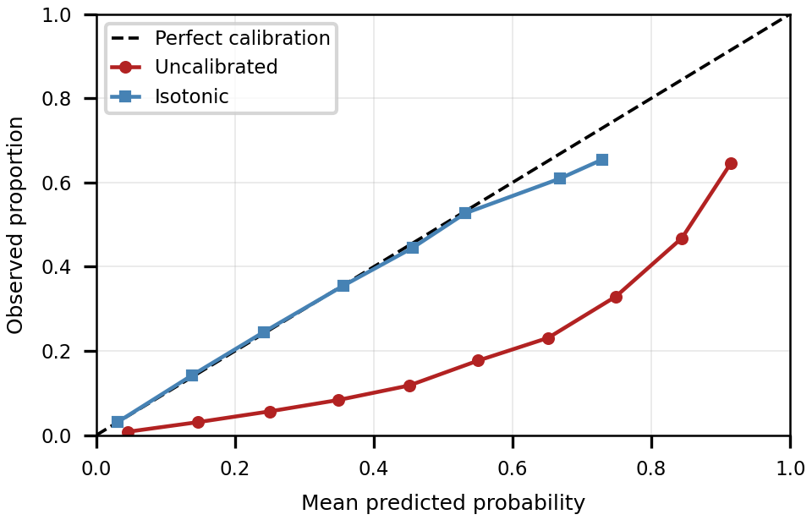
- Reliability of the class-weighted model before and after isotonic recalibration (HGB, 2015 test, 10 bins). The uncalibrated ensemble is badly over-confident at moderate predicted risks, which is the source of its ECE of 0.2367.
- Calibration before and after post-hoc recalibration (HGB, 2015 test, n=50,736). Upper block: class-weighted base. Lower block: the unweighted base recommended for deployment.
Calibrator | Brier | ECE | MCE | Mean pred.
Uncal. (weighted) | 0.1757 | 0.2367 | 0.4201 | 0.376
Isotonic | 0.0976 | 0.0031 | 0.2500 | 0.140
Platt (logistic) | 0.0977 | 0.0083 | 0.0559 | 0.139
Beta | 0.0974 | 0.0026 | 0.0508 | 0.139
Venn–Abers | 0.1266 | 0.1534 | 0.2420 | 0.282
Uncal. (unweighted) | 0.0976 | 0.0038 | — | 0.139
Isotonic | — | 0.0034 | — | —
Beta | — | 0.0042 | — | —
Observed prev. | — | — | — | 0.139

Out-of-time validation and calibration transport
Training on the 2015 wave and testing on later waves yields AUC 0.8338 (2017, n = 275,854), 0.8256 (2019, n = 243,317), and 0.8198 (2021, n = 236,378), against prevalences of 0.141, 0.145, and 0.142: a mild downward trend. The 2015 calibration map can also be transported rather than refit per wave, since refitting is impossible in a prospective deployment: the 2015-fitted isotonic map gives ECE 0.0064, 0.0062, and 0.0097 against raw values of 0.2240, 0.2326, and 0.2236; refitting on each wave improves ECE by only 0.0035, 0.0030, and 0.0056 (Brier penalties below 0.002), so the transport penalty is small. The threshold holding 85% sensitivity moves only from 0.420 to 0.395 across waves, so the operating point needs no per-wave re-estimation. The 0.014 AUC drop from 2017 to 2021 is milder than the 9.7% relative drop reported when an NHANES-trained model was validated on BRFSS [3].

Fairness, support starvation, and label noise
We quantify subgroup disparities with per-group supports and bootstrap confidence intervals (300 resamples) rather than point estimates alone, following recent audit practice for clinical risk models [10]. Table 3 reports the TPR gap, the equalized-odds FPR gap, and the smallest group count; we caution against over-interpreting gap metrics without base-rate context [11]. The sex TPR gap is small (0.0241, 95% CI [0.0066, 0.0417]); the age TPR gap is very large (0.7889, CI [0.6421, 0.8774]), but the smallest age band contains only 14 positives. Without design variables we cannot estimate the true design effect, so we report how the uncertainty would widen: the widest TPR-gap interval grows from 0.235 at DEFF =1 to 0.407 at DEFF =3, leaving conclusions unchanged but indicating that our intervals are optimistic. \1 Within age bands, discrimination is uneven rather than absent: over the seven support-retained bands, band-level AUC ranges from 0.7030 to 0.8245 in 2015 and 0.7065 to 0.8064 in 2021, while per-band ECE stays at most 0.0208 and 0.0246 (Fig. 2), so the age gap is not a calibration failure; net benefit at the recommended threshold stays positive in every band from 50–54 upward in 2021 (0.0692–0.1556).
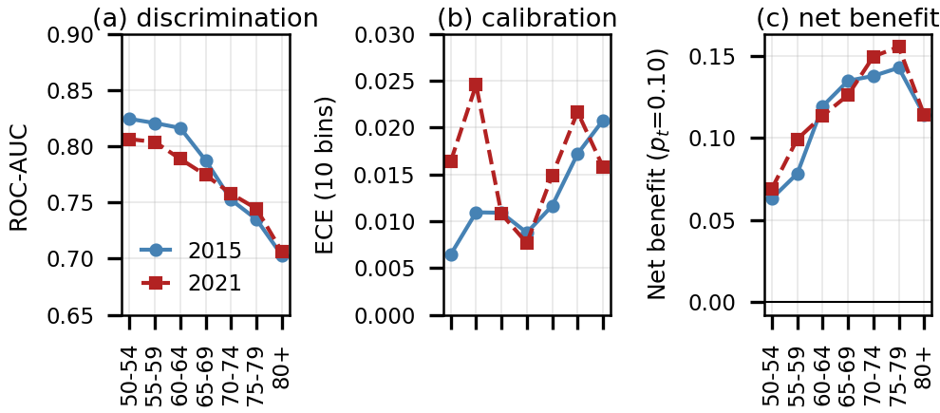
- Per-age-band diagnostics over the seven support-retained bands, at the recommended threshold: (a) ROC-AUC, (b) expected calibration error, (c) decision-curve net benefit at threshold probability 0.10. Discrimination falls with age while calibration stays flat, so the age TPR gap is a score-geometry effect rather than a calibration failure. The six lower-support bands are reported in the released logs.
- Subgroup disparities with support and bootstrap inference (HGB, global threshold 0.5 on raw scores). 95% TPR-gap CIs: sex (0.0066, 0.0417), age (0.6421, 0.8774).
Stratifier | TPR gap | FPR gap | Min n | Min npos
Sex | 0.0241 | 0.0643 | 22,205 | 3,384
Age (13) | 0.7889 | 0.5320 | 1,207 | 14
Income (8) | 0.2849 | 0.4229 | 1,941 | 475
Educ. (6) | 0.2436 | 0.4738 | 795 | 221
Sex × Age (21) | 0.5078 | 0.6045 | 1,200 | 39
Age × Income (64) | 0.7778 | 0.7622 | 113 | 31
Repeating the age computation under increasing minimum-support thresholds shows the gap falls from 0.7879 over all 13 bands to 0.1436 over the seven bands with at least 500 positives, while the widest within-group 95% CI for TPR narrows from 0.340 to 0.072. We report 0.1436 as the support-restricted estimate and treat the headline 0.7889 as support-starved; the residual gap is real and is not a threshold artifact. Because the release collapses prediabetes and diabetes, we test instead whether the model discriminates and calibrates within severity strata: within-stratum AUC ranges from 0.7199 to 0.8263 (GenHlth 1–2: 0.8145) and post-recalibration ECE from 0.0025 to 0.0134. Finally, refitting after removing the 5,218 rows involved in contradicting-label duplicates raises AUC from 0.8265 to 0.8397 (+0.0131). This is a diagnostic of label noise, not a proposed headline and not deployable practice: the refit uses a different, smaller sample (n = 248,462) whose train and test sets are themselves free of contradicting pairs, so its AUC is not comparable with the protocols above. It would also be optimistic for any deployed model, since a respondent whose covariates match another's but whose outcome differs cannot be labelled correctly. The contradicting rows actively degrade the fitted model—no deterministic function of the covariates can satisfy them—so our headline AUC of 0.8265 is conservative w.r.t. label noise. Their removal nonetheless widens the age TPR gap (0.5426 → 0.6671) and narrows the education gap (0.2400 → 0.1793), so fairness gaps and label noise are entangled in this release.

Operating points and the failure of attribute-specific thresholds
For screening, sensitivity matters more than overall accuracy. A single global threshold on recalibrated scores, selected to reach 0.85 sensitivity, is 0.115 and yields sensitivity 0.865, specificity 0.623, and net benefit 0.0785. We next implemented the mitigation fairness audits recommend: attribute-specific thresholds, each fitted on the calibration split to deliver 0.85 sensitivity within its own level (sex, age, income, education, or joint sex-by-age). In sample (Table 4), each policy does what it is designed to do—the income policy reduces the income TPR gap to 0.0899, the education policy to 0.0933, the sex policy to 0.0171—at overall sensitivity near 0.85; the sex policy reproduces the global row because the sex gap is already the smallest of the four attributes, not through a rounding artifact. Out of time, however, the fitted thresholds do not transfer (Fig. 3): by 2021 the income policy's own gap has grown to 0.8647 and the education policy's to 0.7128, and the age policy, which should equalize age, produces a TPR gap of 0.9087 in sample and 0.8937–0.8992 out of time—worse than the global threshold.
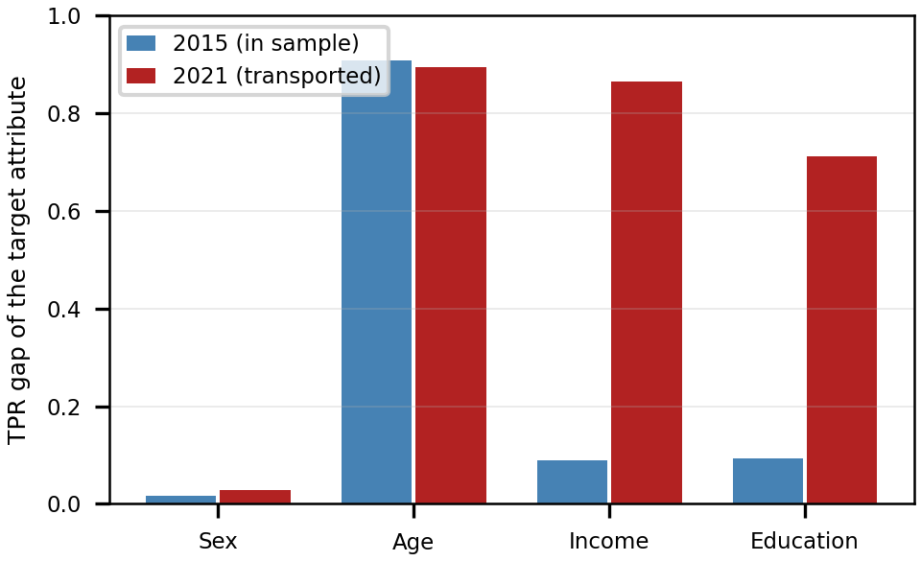
- Transfer of the attribute-specific thresholds. Each bar pair is the TPR gap of the policy's own target attribute, fitted in sample on 2015 and applied unchanged to 2021. The income and education policies equalize their attribute in sample and lose that property out of time; the age policy never held.
Diagnosing the failure shows the thresholds are not the problem: between 2015 and 2021 the per-level thresholds drift by at most 0.040, and most are unchanged. What moves is the prevalence within each level, which shifts by up to +0.029 (income level 8) and -0.059 (education level 2) and carries the mean predicted score with it, so the sensitivity each level receives drifts between 0.772 and 0.895 rather than the 0.85 targeted. The unevenness of those shifts—not threshold instability—widens the group gap, so attribute-specific thresholds fitted on one calibration split do not transfer out of time, and we report the failure rather than a mitigation. What does transfer is the global sensitivity-targeted threshold, which holds sensitivity at 0.84–0.86 and specificity at 0.62–0.64 across all three later waves; but it does not remove the age disparity, whose TPR gap is 0.5111 in 2015 and 0.7727, 0.7901, and 0.7646 in 2017, 2019, and 2021, while the sex gap stays small at 0.0171, 0.0201, 0.0229, and 0.0275. The age gap is a property of the model's score geometry at sensitivity-oriented operating points, not a threshold artifact. A single global threshold cannot substitute for a validated mitigation: selecting it to maximise specificity subject to overall sensitivity ≥ 0.85 and a bound on the worst-group TPR gap shows what a global fairness constraint costs—bounding the gap at 0.50 moves the threshold to 0.400 and specificity to 0.621, bounding it at 0.30 moves it to 0.140 and specificity to 0.344, and bounding it at 0.10 forces the threshold to 0.045 and specificity to 0.147.
- Threshold policies in sample and out of time, on recalibrated scores. Each level-specific threshold targets 0.85 sensitivity within its level, fitted on the 2015 calibration split. Last three columns are TPR gaps.
Policy | Sens. | Spec. | Sex | Income | Educ.
2015 test set (in sample)
Global, sens.-targeted | 0.865 | 0.623 | 0.0171 | 0.2158 | 0.1727
Sex-specific | 0.865 | 0.623 | 0.0171 | 0.2158 | 0.1727
Age-specific | 0.840 | 0.634 | 0.0340 | 0.2106 | 0.1876
Income-specific | 0.867 | 0.604 | 0.0476 | 0.0899 | 0.1141
Education-specific | 0.859 | 0.613 | 0.0288 | 0.1590 | 0.0933
Joint sex × age | 0.846 | 0.624 | 0.0144 | 0.2224 | 0.1962
2021 wave (thresholds fitted on 2015, transported)
Global, sens.-targeted | 0.842 | 0.639 | 0.0275 | 0.3079 | 0.1411
Sex-specific | 0.842 | 0.639 | 0.0275 | 0.3079 | 0.1411
Age-specific | 0.819 | 0.648 | 0.0368 | 0.2987 | 0.1567
Income-specific | 0.734 | 0.694 | 0.0461 | 0.8647 | 0.2927
Education-specific | 0.845 | 0.619 | 0.0274 | 0.2137 | 0.7128
Joint sex × age | 0.824 | 0.637 | 0.0122 | 0.3043 | 0.1566

Explainability, feature subsets, and utility
SHAP (Fig. 4) ranks general health status (0.638), high blood pressure (0.541), age (0.416), BMI (0.382), and high cholesterol (0.313) as the leading contributors, with the remaining features between income (0.136) and education (0.045). These align with established risk factors and support face validity, although several are consequences rather than antecedents of diabetes. The top-10 ordering is stable: mean pairwise Jaccard overlap is 0.964 across the five seeds (minimum 0.818, differing only in the tenth position) and 0.818 between 2015 and each later wave, where heavy alcohol use replaces difficulty walking; the ranking is a property of the data period, not the seed. As a complementary check on the known limitations of attribution methods, we compared the SHAP ranking with permutation importance (five repeats, ROC-AUC scoring): the two agree closely (Spearman rank correlation 0.955; 9 of the top 10 features in common), differing only in the order of BMI and age. Single-feature counterfactual flips among the 4,408 individuals within 0.05 of the threshold tell a different story: a one-point change in general health flips 67.5% of them, a ±5 change in BMI flips 88.2%, and a one-point change in age flips 48.0%, whereas changes in blood pressure or cholesterol flip none. SHAP magnitude is therefore not decision leverage.
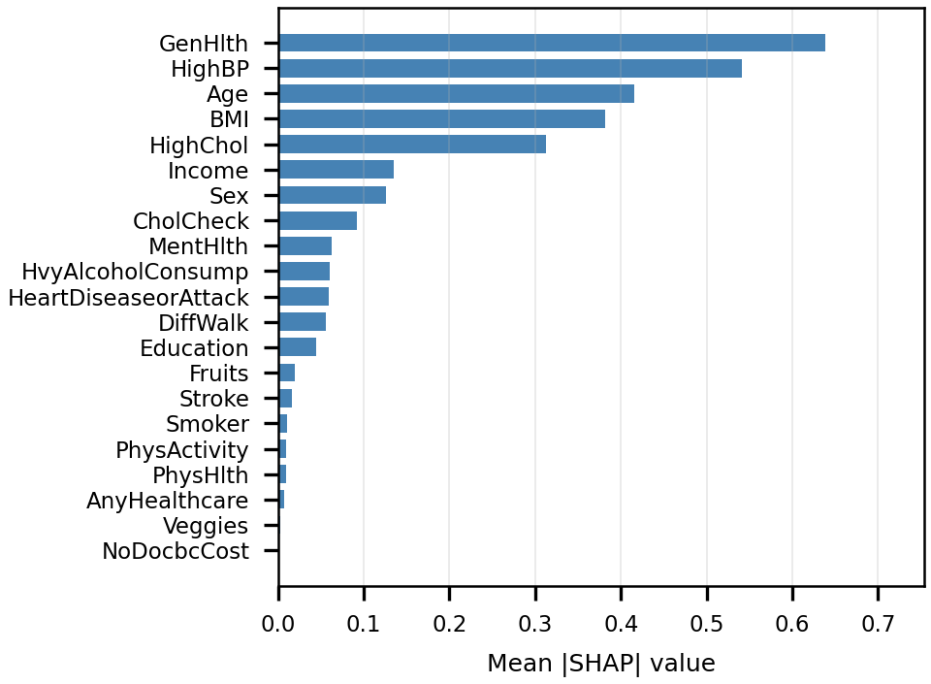
- Mean |SHAP| for all 21 features (HGB, 2,000-row test sample).
Feature-group ablations show that clinical-history features carry most of the signal (AUC 0.8241 versus 0.7104 for demographics alone), while lifestyle features alone are weaker (0.7475). Using training-only SHAP rankings, five features retain AUC 0.8186 against 0.8269 for all 21, and eleven reach 0.8257. At k=10, SHAP attains 0.8248, correlation filtering 0.8218, mutual information 0.8213, and ten random features 0.7784 ± 0.0108—SHAP is strongest but only marginally over the other filters, consistent with the 0.823 reported for a copula filter on this dataset [4]. Because several top features proxy the same constructs, we do not claim that a ten-item form is clinically validated.
For screening, the operating point must be justified by net benefit rather than a generic accuracy target. Decision-curve net benefit (Fig. 5) gives 0.068 against 0.044 for treat-all at a threshold of 0.10 and 0.009 against -0.076 at 0.20, with treat-all actively harmful beyond 0.10; the model dominates treat-all and treat-none across the clinically relevant range, supporting the operating points of Table 4.
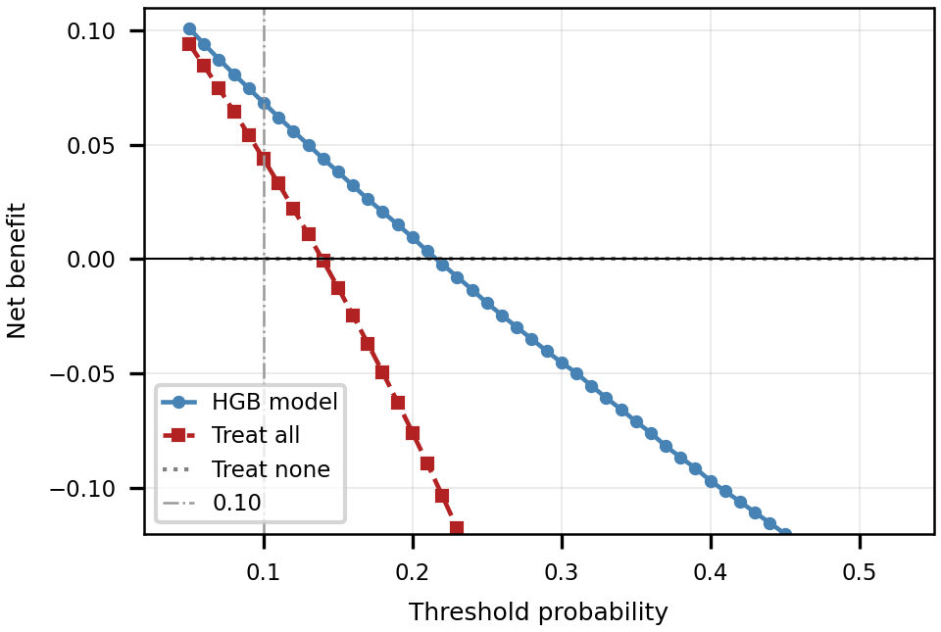
- Decision-curve net benefit against threshold probability (HGB, 2015 test). The model dominates treat-all and treat-none across the clinically relevant range, and treat-all becomes actively harmful beyond a threshold probability of 0.10, which supports the sensitivity-oriented operating points of Table 4.

Discussion
Our discrimination (AUC 0.8288, AUPRC 0.4229) exceeds earlier BRFSS studies reporting 0.72–0.80 and approaches NHANES dysglycemia screening at 0.820, but is markedly more conservative than BRFSS pipelines reporting AUC near 0.99 with stacked ensembles and resampling-based balancing [1]-[3]: our audit shows duplicate profiles and fold construction move AUC by at most 0.010 on this same 253,680-row dataset, so we regard those figures as unlikely to be reproducible, and the 0.794 to 0.717 drop reported for externally validated models is not reproduced by our in-domain transfer (0.8338 to 0.8198). A copula filter reports 0.823 with 10 features against our 0.8248 for SHAP at k=10, though differing years and splits preclude a decisive win; multi-task frameworks that pair leakage control with calibration reach comparable macro-AUROC on similar survey data [12], which this single-task audit complements by isolating the pitfalls. Our finding that class weighting dominates miscalibration is consistent with the wider literature, in which isotonic and Platt can themselves degrade proper scoring for strong tabular learners [13]; our calibrator ranking agrees with that benchmark except for Venn–Abers, whose prior correction assumes a mildly over-confident base model, which a class-weighted ensemble with mean predicted probability 2.7 times the true prevalence is not.
Three deployment scenarios are supported: (1) population-level risk stratification for outreach, with an unweighted model and a sensitivity-targeted threshold; (2) questionnaire triage in resource-limited settings, using the 8–10 item reduced form; (3) hypothesis generation for public-health research. Each requires corroboration with clinical measurements before any individual decision. Because our only validated operating point is a single global threshold, we do not recommend subgroup thresholds, and portable post-processing remains untested: equalized-odds post-processing fitted on one wave would inherit the non-transferability we documented, and drift-aware variants need design-based inference we lack.
The limitations are numbered: (1) self-reported cross-sectional data, no biomarkers (HbA1c, glucose), and several leading predictors are consequences rather than antecedents; (2) race/ethnicity absent, precluding race-stratified reliability; (3) no survey design weights, so population representativeness is not established and our intervals are optimistic by an unquantified design effect; (4) prediabetes and diabetes are collapsed, so the severity-stratified analysis is a proxy; (5) the leakage-free estimate uses a deduplicated test set of 43,900 rows, calibration was restored post hoc on a single 2015 split, and out-of-time validation remains within BRFSS, so no cross-survey external validation is attempted—a genuine gap, since prior work shows AUC falling from 0.794 to 0.717 under that shift; (6) the randomized search budget is small and single-split; (7) no fairness mitigation is validated, and intersectional cells are descriptive, with the smallest cell holding 31 positives; (8) SHAP is an attribution method, with no faithfulness guarantee. Throughout, association is not causation and screening is not diagnosis. Design-aware modelling and design-based inference are the established remedy for population-level claims [14], and survey-aware machine-learning guidelines now formalise the same requirement [15]: the CDC's own analysis of aggregated state weights documents a national-distribution error of 0.5 percentage points on a single demographic margin, with downstream distortion of diabetes prevalence estimates by group [16]. Our release carries none of those variables, so that route requires the raw BRFSS XPT files. Future work: design-weighted inference, race-stratified reliability, a fairness mitigation validated out of time, cross-survey validation against NHANES, and prospective evaluation with clinical biomarkers.

Conclusions
We audited an interpretable, fairness-aware screening framework for diabetes on 253,680 BRFSS respondents. (1) Gradient boosting and random forest outperform logistic regression by a significant but practically negligible margin (ΔAUC ≤ 0.0073). (2) The headline AUC is protocol-dependent: the leakage-free estimate is 0.8177, and 1,963 rows carry a covariate vector with a contradicting label, whose removal would raise AUC to 0.8397. (3) Class-balancing weights are unnecessary and costly (ECE 0.2367 versus 0.0038), and an unweighted model with a sensitivity-targeted threshold gives slightly higher net benefit. (4) The sex TPR gap is small (0.0171 at the deployed operating point), while the age gap persists at every operating point tested, is only partly support-starved, and rises out of time. (5) Attribute-specific thresholds—the mitigation fairness audits recommend—do not transfer out of time, and we report that failure rather than claim a remedy. (6) Decision-curve net benefit supports sensitivity-oriented operating points below 0.5. The tool is a screening-level, hypothesis-generating instrument, not a validated diagnostic, and does not yet support population-level prevalence claims.

Acknowledgments
Generative AI tools assisted with language editing and code; the authors reviewed and verified all content, and the AI tools are not listed as authors.

Data and Code Availability
The BRFSS-derived dataset is publicly available through the UCI repository (https://doi.org/10.24432/C53919). The analysis code, run manifests, logged results, and a SHA-256 hash manifest of every artifact are withheld during review and will be released on acceptance. This study analyses a publicly available, de-identified survey dataset under CC0; no identifiable human subject data were accessed, so no ethics approval was required.
- Z. Xie et al., “Building risk prediction models for type 2 diabetes using machine learning techniques,” Prev. Chronic Dis., vol. 16, p. e130, 2019.
- B. Sun et al., “Beyond the blood draw: Explainable machine learning for non-invasive dysglycemia risk screening,” arXiv:2606.16056, 2026.
- R. S. Pall et al., “Comprehensive evaluation of machine learning for type 2 diabetes risk prediction: Large-scale external validation and fairness analysis,” in Proc. IEEE CIPHER, 2026.
- A. Aich et al., “A copula based supervised filter for feature selection in machine learning driven diabetes risk prediction,” Sci. Rep., 2026.
- CDC Diabetes Health Indicators [Dataset]. (2017). UCI ML Repository. https://doi.org/10.24432/C53919 (accessed 17 Oct. 2026).
- T. Chen and C. Guestrin, “XGBoost: a scalable tree boosting system,” in Proc. ACM SIGKDD, pp. 785–794, 2016.
- M. Hardt, E. Price, and N. Srebro, “Equality of opportunity in supervised learning,” in Adv. Neural Inf. Process. Syst., vol. 29, pp. 3315–3323, 2016.
- S. M. Lundberg and S.-I. Lee, “A unified approach to interpreting model predictions,” in Adv. Neural Inf. Process. Syst., vol. 30, pp. 4768–4777, 2017.
- O. L\'etoff\'e et al., “Towards rigorous explainability by feature attribution,” arXiv:2604.15898, 2026.
- S. Roy et al., “KAISEN: Reproducible subgroup fairness auditing for clinical risk models,” arXiv:2607.28608, 2026.
- N. Mehrabi et al., “A survey on bias and fairness in machine learning,” ACM Comput. Surv., vol. 54, no. 6, art. 115, 2021.
- S. M. A. Hossain, R. K. Shayoni, M. F. Mridha, and J. Shin, “CardioMeta: Calibrated multi-task prediction of diabetes, hypertension, and cardiovascular disease across population and EHR data,” arXiv:2607.15721, 2026.
- V. Manokhin and D. Grnhaug, “When post-hoc calibration hurts: Platt scaling and isotonic regression on modern tabular models,” in Proc. Symp. Conformal and Probabilistic Prediction with Applications, ser. PMLR, vol. 329, pp. 378–381, 2026.
- M. Matabuena et al., “Screening for diabetes mellitus in the U.S. population using neural network models and complex survey designs,” arXiv:2403.19752, 2024.
- Y. K. Oh, H. W. Zheng, J. Feng, and A. A. T. Bui, “Survey-aware machine learning: A guideline for valid population health inference based on scoping review,” arXiv:2605.08963, 2026.
- CDC, “National weighting of data from the Behavioral Risk Factor Surveillance System (BRFSS),” 2016. https://stacks.cdc.gov/view/cdc/43284.

