**2022 SELEKDA ONLINE**

**Web Techologies Test Project**



# Introduction

The Indonesian Esports team needs a website to provide information about their team to all users in the world. In addition to providing information about the esports team, we also provide games that can be played and have a leaderboard, so users can measure their skills against other players.

The website needed to provide login and register features for the user. The target audience for this website is teen and young adults that is interested in playing games created using canvas in HTML5.

They need a working website that will be stored into the hosting so that it can be easily accessed, we recommend free hosting such as **000webhost.com** and others.

# Description of project and MODULE

Your task as a website developer is to create a design, front end and back end for the website and make it works.

You have been provided with some images that will help you to create the website and the games. You are not required to use all of the images; even you can add more text or images if necessary. You need to make a good website and working games, because the website will be accessed by users from around the country. The use of text and image will only be judged on design, not the meaning of the text.

1. **Design**

In design part, you should design about at least 3 pages of website. The new design should be developed to work on the defined devices and resolution: Desktop (1440 x 900px), Tablet (768 x 1024px) and Smartphone (320 x 480px). Just remember, you can add your own creativity on your design. Don’t be afraid to make something different rather than use a normal design or mainstream design.

And here are some description about design task:

1. Create Logo for **“Selekda Esport Indonesia”** that will be used for organization’s logo.
   1. The logo must be used as part of your design within the website concept
   2. Your logo must be consist of combination between shape and text **“SEI”**
2. Design 2 pages, consist:
   1. **Landing Page**
      1. Your logo
      2. Interactive banner section
      3. Images and video gallery thumbnail section
      4. Short text section about the website
      5. Fixed interactive menu on the top of website
      6. Team squad list & Team member
      7. Searching section to search for other users
      8. Social media icon (at least three social media icon)
      9. Acknowledgment or copyright **and** the text “Designed by : <You>” at the last section in the footer
   2. **Detail Team Squad Page**
      1. Your Logo
      2. Team Squad Information (logo, name squad, description, achievement)
      3. Team Member (name, role, email, date of birth, phone number, profile picture)
      4. Other Squad (logo, name squad)
3. You should place your work into 1 folder, which called **“design”**, you should only collect the photoshop files (*.psd) and screenshot files (*.jpg, *.png) for each design. The naming files should be like “Computer_Landing.psd”, “Computer_Landing.jpg”, “Tablet_Register.psd”, etc.
4. **Layout**

In this part you should slice your own design into the html. Bonus point will be given if you create the website **without** any css framework. But for javascript, you can use jquery or jquery ui.

The page should be a responsive website similar to the design you created before. You must add some animation or interactive interaction in your own page (the banner, the transition, hover animation, etc.).

You should collect your job into 1 folder, which called “**layout**”, you should only collect the html files (*.html), javascript files (*.js) and css (*.css) in the proper folder inside of “**layout**” folder.

**Provision:**

1. The website code must validate to HTML5
2. Your CSS code must validate CSS level 3
3. No error and warning found in js files
4. Place a comment in html, js and css files
5. You should collect the **fonts** if you use a new font, in the folder “**fonts**”
6. Some elements are only visible in wide screen layout, and the others can only appear in the narrow screen. You decide by your own decision, which one must be shown in the wide screen or which one must be hide
7. Your website will be marked in Google Chrome
8. **Game**

In this part you should create game to be played in the website. You are asked to develop an adventure game called “**Selekdash**” using HTML and CSS and develop client-side programming using JavaScript. Some media files are available to you in a zip file. You can create more media and modify anything in the media if you want. Your game needs to be developed in a tablet resolution (1000x600 pixels). In bigger resolution, the game must be centred in the screen both horizontally and vertically.

**Selekdash game screen should have meet these requirements below:**

1. Game Title
2. Gameboard
3. Character
4. Total Life Time
5. Total Score
6. Total Hearts
7. Player Name
8. Leaderboards

**Game mechanics:**

1. **Show game instruction** in the centre after page are loaded.
2. **Player can go to character select page** after fill username field and click “**Agree**” button at the bottom of game instruction.
3. **The “Agree” button should be disabled** if the user did not input username.
4. User can choose one from four characters, one of four stages, level (easy, medium, hard) and click “**Play**” button at the bottom of characters select page.
5. User can choose random character or stage with random button and show popup with wheels of characters or stage.
6. **The “Play” button should be disabled** if the user did not choose character, stage and level.
7. **Show countdown for three seconds in the center of screen** after user clicked the play button before the game started playing.
8. When the game starts, the player will get 3 hearts and get a life time of 20 seconds.
9. Life time will count down.
10. Game has a random **four** footholds.
11. **Meteor and boxes should move down** the border vertically at the exact given time.
12. **Meteor should show random** every 0,5 second.
    1. ‘2 meteors’ for easy level
    2. ‘3 meteors’ for medium level
    3. ‘4 meteors’ for hard level
13. **Drops one of these four boxes randomly** every 2 seconds.
    1. ‘blue box’ for add speed the character in 3 seconds
    2. ‘orange box’ for increase 1 heart
    3. ‘green box’ for increase life time 10 seconds
    4. ‘red box’ for decrease 1 heart
14. **To move the character**, player can use “WAD” and Space keys with the following :
    1. ‘W or Space’ for jumping (Double ‘W or Space’ for double jumping)
    2. ‘A’ for left move
    3. ‘D’ for right move
15. When the game starts, **there will be 3 random coin**.
16. The character will have a different pose when moving right, left and jumping using the provided character sprites image.
17. Running animation when the player is moving.
18. The player max get 5 hearts.
19. **The score will be increased** if player can collect coins.
20. An additional random coin will appear when the coin is obtained.
21. **Score** is served from total coins earned.
22. **The meteor, box and coin will be vanished** when player hit at the right timing or it passed the border without hit.
23. Characters will have animation effects when hit by meteors, boxes and coins.
24. When the character falls off the footing and touches the border, the character will return to the middle game board and display a death pose then disappear.
25. Player can **pause** the game.
26. Press **Esc** to open the **pause popup**. The game should be in paused state when opening the popup.
27. Press **Esc** again to **continue** or click the **continue** button.
28. **Game Over** if the heart and life time was 0 or the character falls from the footholds.
29. **Show popup after game over** to display the player username, life time, score, save high score button and restart button.
30. Highscore should be saved in database after player click **Save high score** button.
31. Players can see the leaderboard on the right of the game board and see details of players on the leaderboard by pressing the **details** button.
32. The leaderboard can be sorted by score and username.
33. **Show popup detail** to display the player username, life time and score after player click **Detail** button.
34. The game needs to work correctly in Google Chrome.

Please include comments in your JavaScript files to indicate the functionalities of the code. You should collect the **html files** (*.html), **javascript files** (*.js), and **media files** in a folder called “**game**”.

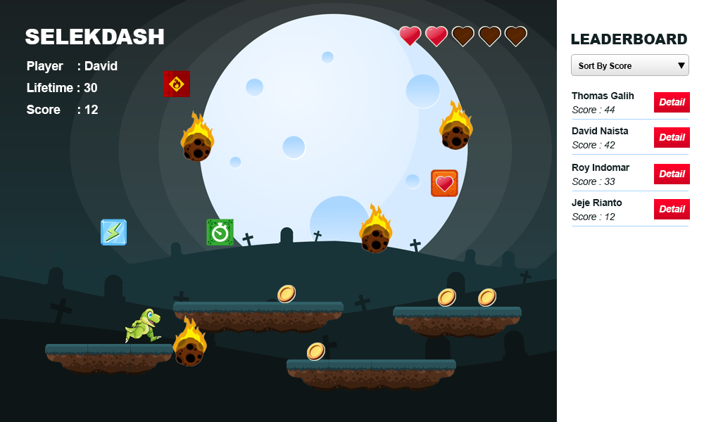

**Image 1** Example Gameboard

1. **Server Side**

In this part you should only use the framework **laravel**. For the database you can use **MySQL** or **mariadb** as the database. You should create **RESTful** API with several feature listed below using PHP framework. Please note that you need to follow [Google JSON Style Guide](https://google.github.io/styleguide/jsoncstyleguide.xml) in your JSON response.

**There are some function that should be able to be used:**

1. Web token to authorized user access to the website API
2. API for several feature listed below:
   1. User API
      1. User login (Admin and User)
      2. User registration, with fields:
         1. Name
         2. Username
         3. Email
         4. Password
         5. Date of Birth
         6. Phone Number
         7. Profile Picture
      3. User profile update
      4. Get user profile
   2. Captcha API
      1. Get captcha
      2. Validate captcha
   3. Data Management API (Admin Only)
      1. Banner (View, Insert, Update, Delete), with fields:
         1. Banner Title
         2. Banner Image
         3. Status (active, inactive)
      2. Team Squad (View, Insert, Update, Delete), with fields:
         1. Name Squad
         2. Description
         3. Achievement
      3. Team Member (View, Insert, Update, Delete), with fields:
         1. Name
         2. Role
         3. Email
         4. Date of Birth
         5. Phone Number
         6. Profile Picture
      4. User, with fields:
         1. Name
         2. Username
         3. Email
         4. Password
         5. Date of Birth
         6. Phone Number
         7. Profile Picture
   4. Selekdash game API
      1. Get leaderboard
      2. Save score to leaderboard

You should collect the **picture of database diagram** (*.png), **your zip project’s code** (*.zip), **database** (*.sql) and **API documentation** (*.doc) in folder, which called “**server**” folder.

1. **Implementation**

In this part you should combine all of the work you created before. You need to make the front end exactly like your designed, using your sliced html which is ported to be the website front end using one of JS Framework (AngularJS, VueJS, React), and implement the games also you need to connect your games and front end with the RESTful API you created.

There is several things that you should make in this section:

1. Login & logout for admin & user
2. Admin has several feature listed below:
   1. Data Management
      1. Banner (View, Insert, Update, Delete), with fields:
         1. Banner Title
         2. Banner Image
         3. Status (active, inactive)
      2. Team Squad (View, Insert, Update, Delete), with fields:
         1. Name Squad
         2. Game
         3. Description
      3. Team Member (View, Insert, Update, Delete), with fields:
         1. Name
         2. Role
         3. Email
         4. Date of Birth
         5. Phone Number
         6. Profile Picture
      4. User, with fields:
         1. Name
         2. Username
         3. Email
         4. Password
         5. Date of Birth
         6. Phone Number
         7. Profile Picture
   2. Update Profile
3. User has several feature listed below:
   1. Update Profile
   2. My Leaderboard
   3. Play Game
4. Save score to leaderboard
5. Make sure that only logged in user can play the game, if the guest click the Play button, show only Login & Register popup modal.
6. Everytime a user play the game, save the final score to the leaderboard so other user can see who got the top 10 highest score.
7. Leaderboard which displayed beside the game canvas.
8. When user wants to login and register, please add a simple captcha to prevent bruteforce attack. Note that you must create the captcha yourselves.

Collect the final result of your work in folder, which called “**front_end**” folder.

Please note that you must upload all of your work to the **hosting for the demo**, then upload all the source code & required files with the name **selekda.zip**

Please provide your website address when submitting your work.

**Example :**

Demo : **selekdaesport.com**

Source Code : **selekdaesport.com/selekda.zip**

Structure folder in **selekda.zip**

There is no limitation for the code, as long as you give an instruction (somekind of README) and it’s running well. You can add another page or function if it’s necessary.

1. **Wireframe**

There is a wireframe that visualize the general layout of the website. You can refer your design to this wireframe. But, it will be a plus if you add your own design that can improve your website.

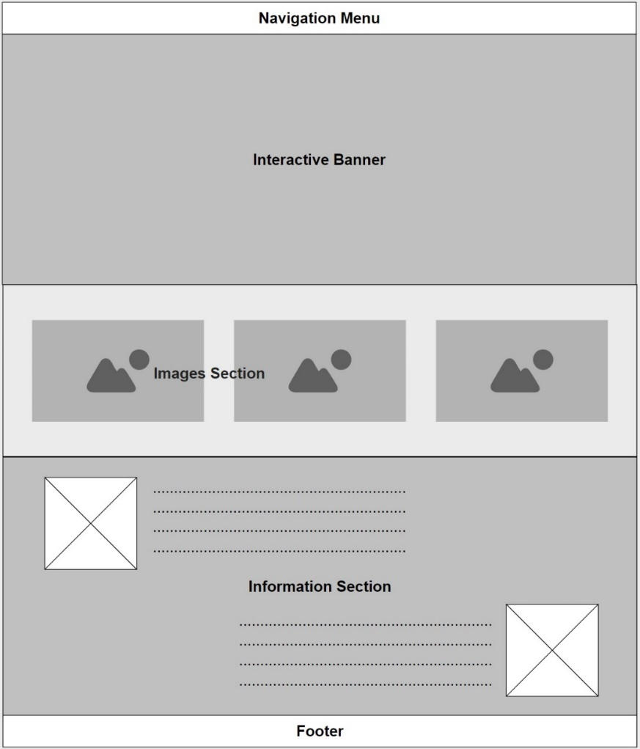

**Image 2** Wireframe

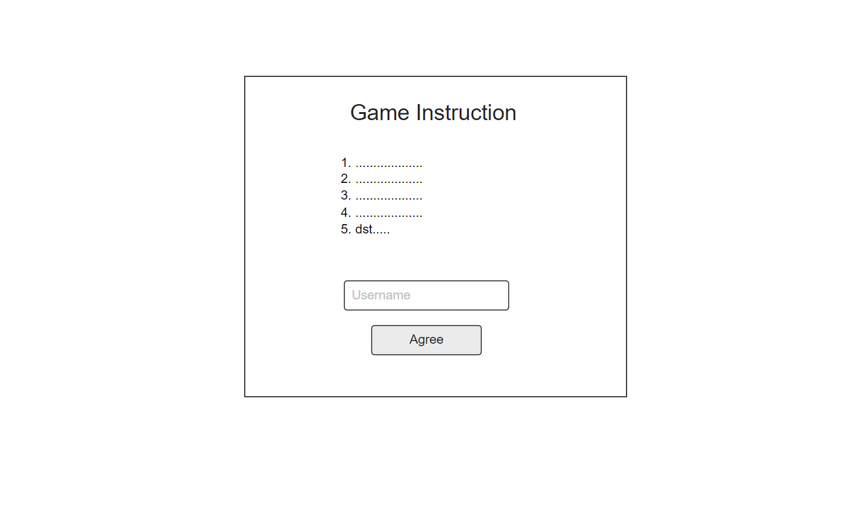

**Image 3** Game Instruction

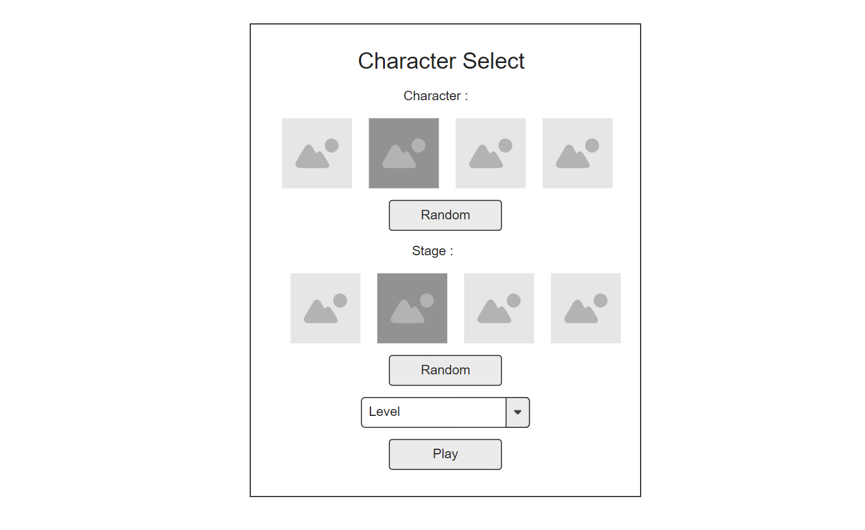

**Image 4** Character Select

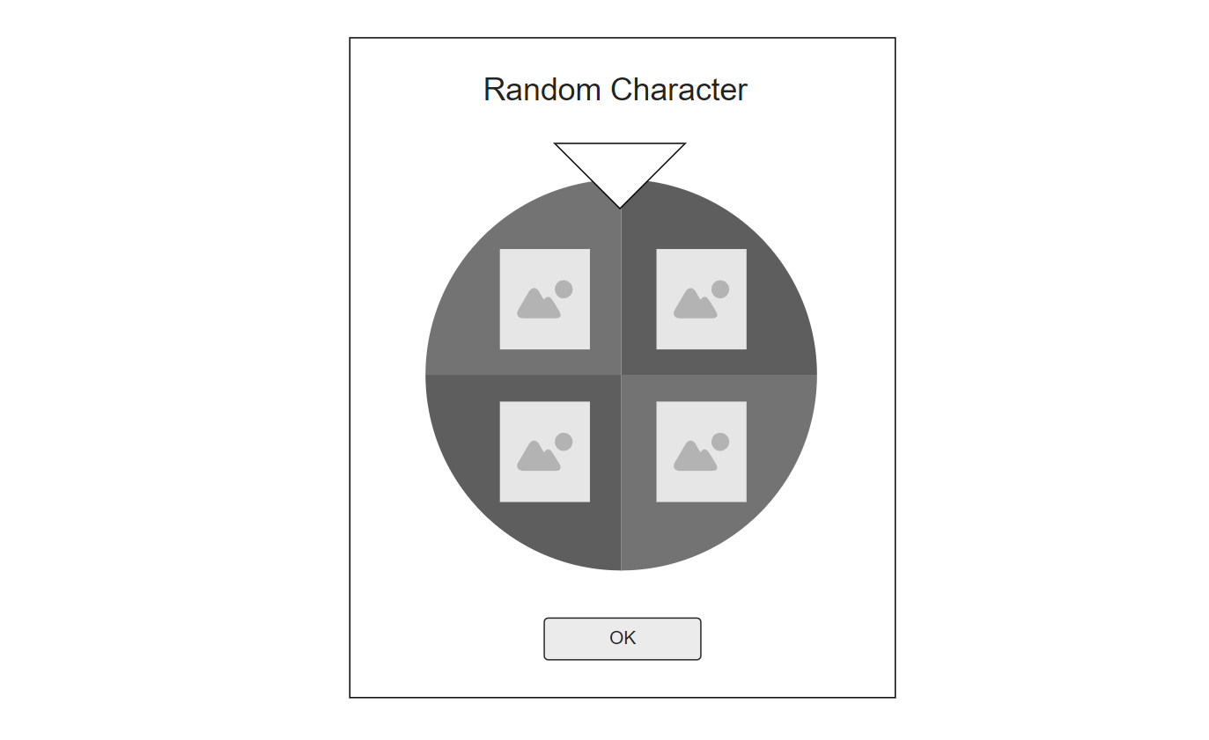

**Image 5** Random Character/Stage

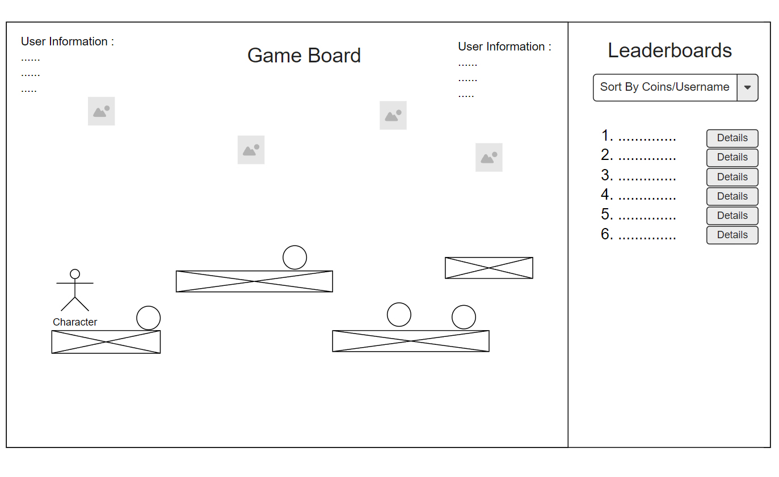

**Image 6** Gameboard

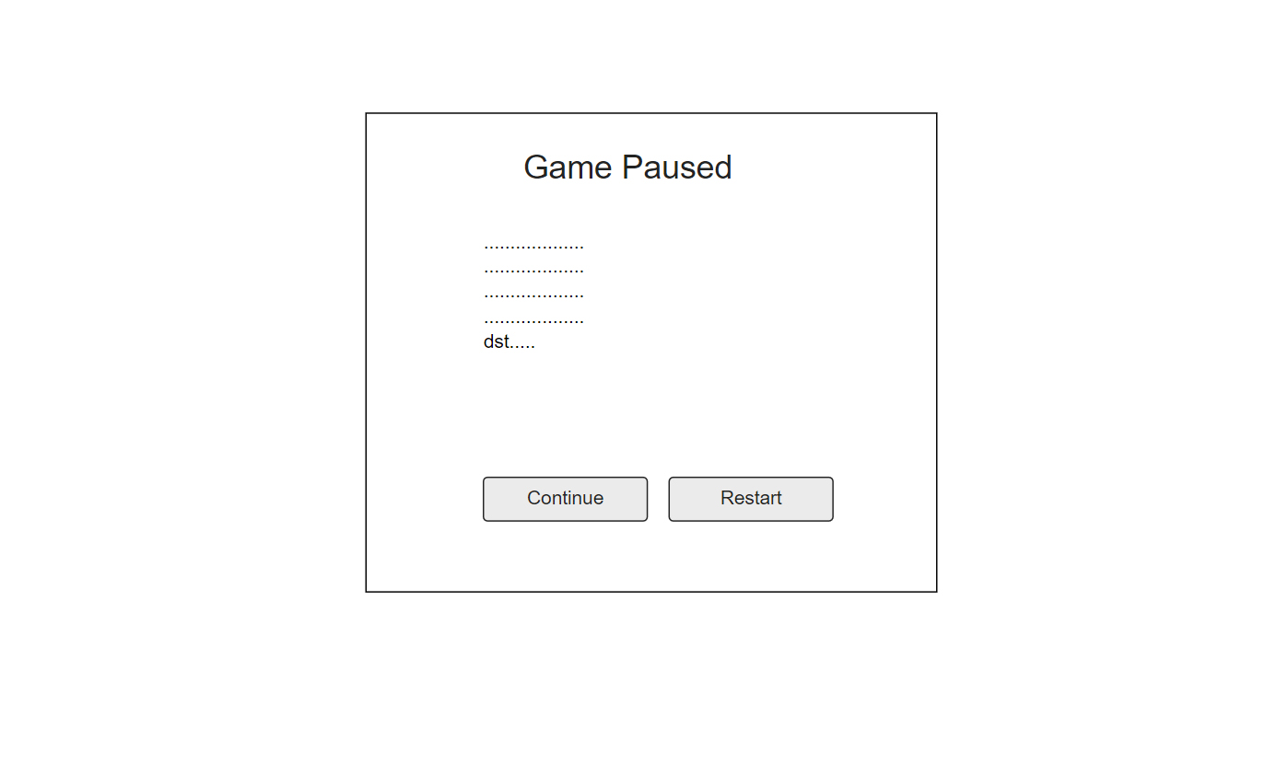

**Image 8** Game Paused

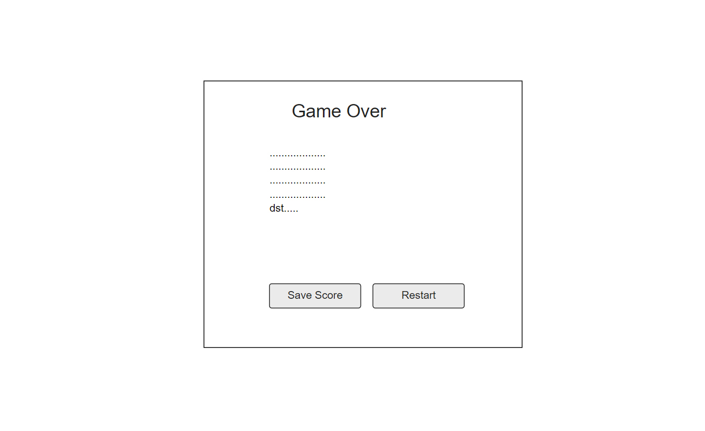

**Image 9** Game Over

**Notes**

All of your work must be uploaded on the hosting. All marking will use the demo url you provided. if the url you provided is not running, the points will automatically be zero, we recommend free hosting such as **000webhost.com** and others.

Media Files:

<https://drive.google.com/drive/folders/1ROL3x-_wIJ9PjoMStOSx34npDwtCYbLS?usp=sharing>

-- Good luck! --