


Activity | #2 | Writing an Itinerary Ingles para Negocios II
Ingeniería en Desarrollo de Software

TUTOR: Fátima Fernández de Lara Barrón

STUDENT: Alejandra Ibarra Carmona

DATE: February 1, 2026

Index

Development………………………………..3

Itinerary……………………………………..3

Grammarly…………………………………..7

Conclusions………………………………….7

References………………………………….8

- Itinerary

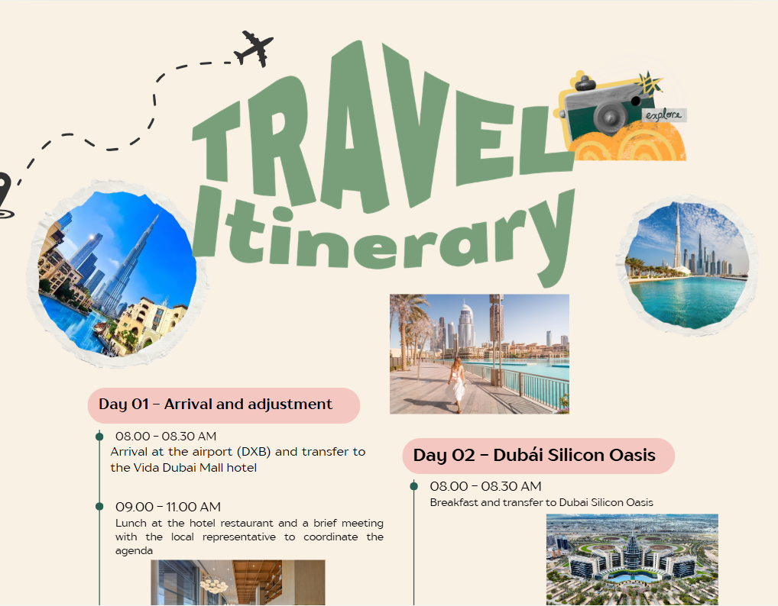

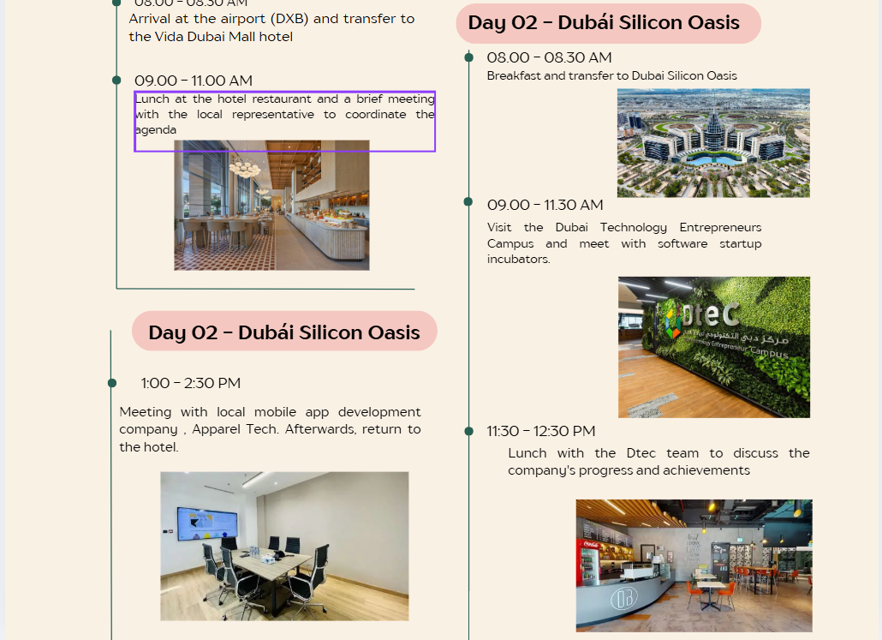

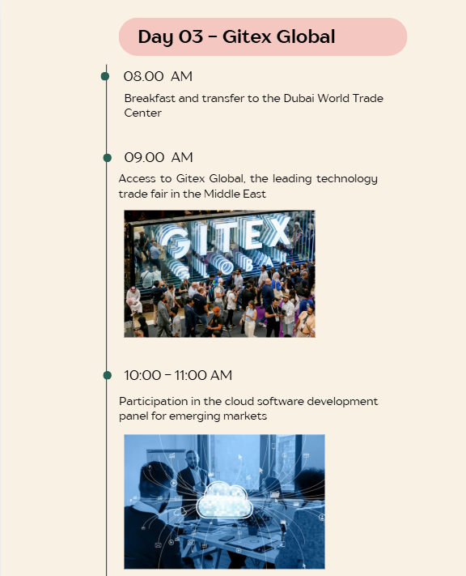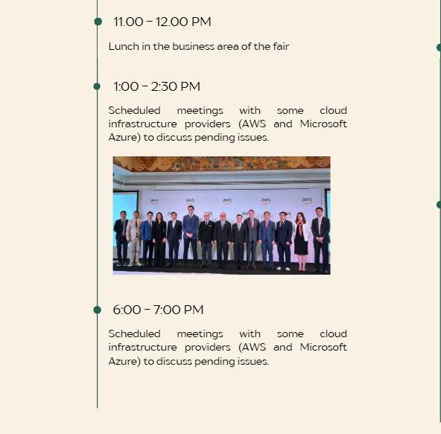
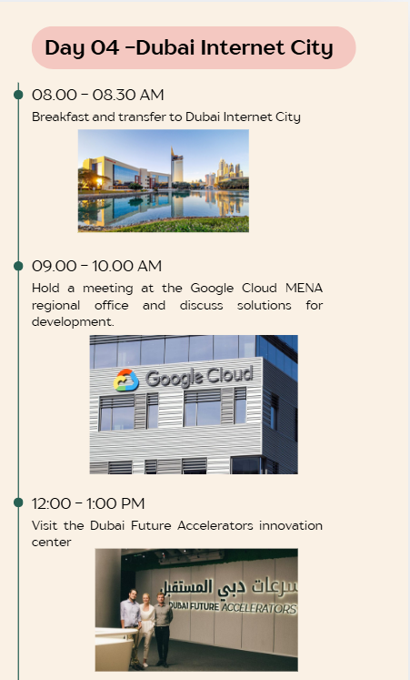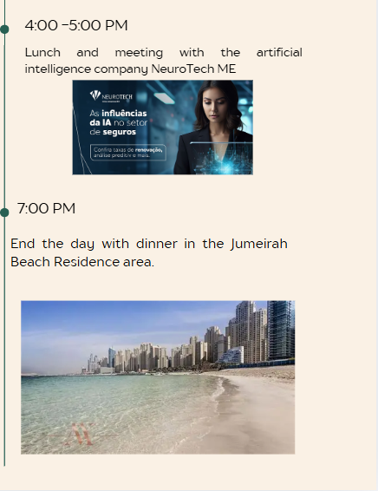

- Grammarly
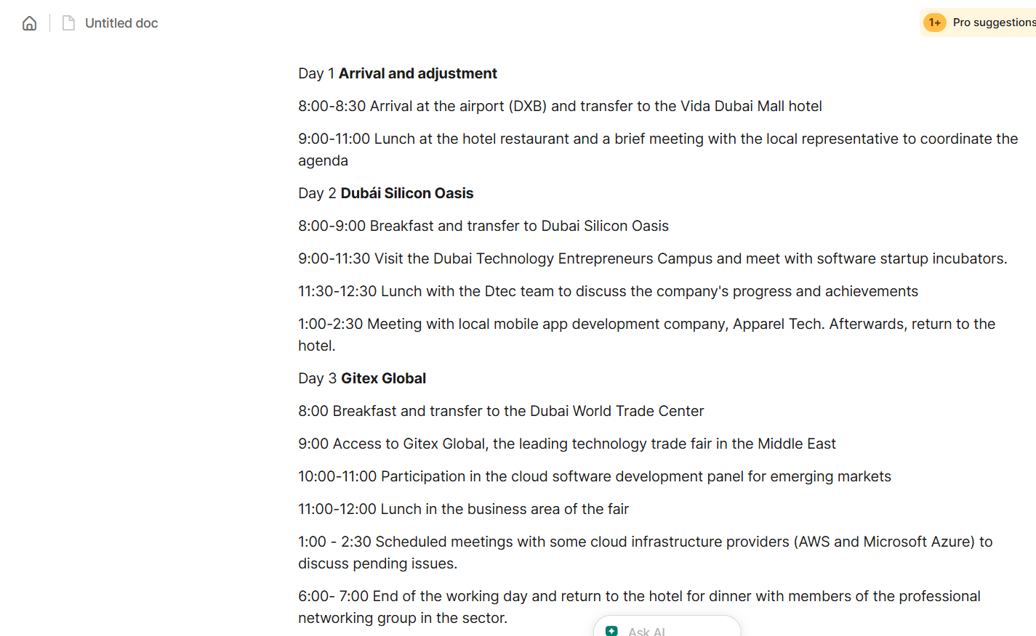
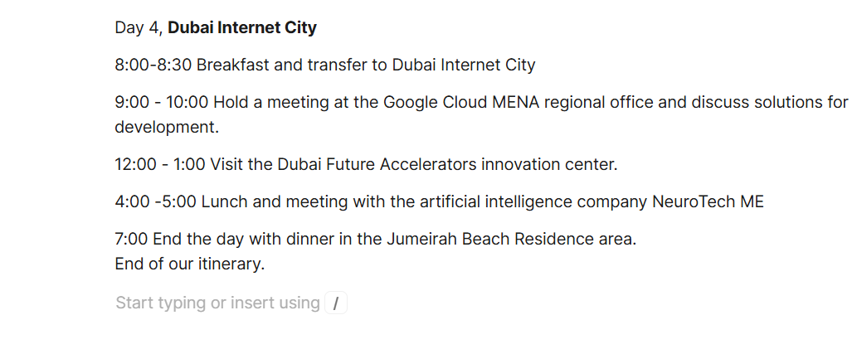

Conclusions

I learned a lot from this activity, as I not only learned about a new country, but also how to organize a business trip itinerary to that country, taking into account that I only had four days and visited important places with extensive knowledge in software development.

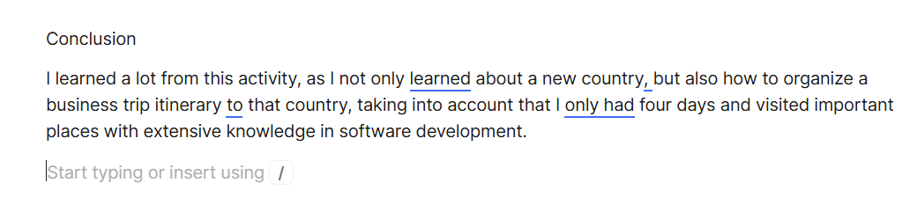

References

https://www.canva.com/design/DAHAG3RPBvQ/ODSlsG05ghWhnyvrsZLqxg/edit?utm_content=DAHAG3RPBvQ&utm_campaign=designshare&utm_medium=link2&utm_source=sharebutton

