


Activity | #3 | Creating a Business Trip Report

Inglés para Negocios II
Ingeniería en Desarrollo de Software

TUTOR: Fátima Fernández de Lara Barrón

STUDENT: Alejandra Ibarra Carmona

DATE: February 2th, 2026

Index

Introduction……………………………..3

Description……………………………..3

Justification.……………………………3

Development…………………………..4

Conclusions……………………………5

References……………………………5.

Introduction

By carrying out these three activities, I gained a lot of knowledge about organizing a business trip, from learning about the cuisine and government to discovering my particular interests in technology, especially in the potential for Mexico to establish a relationship and reach an agreement to gain more support, similar to Dubai.

Description

I also learned how to plan an itinerary so that I could organize my business trip better, taking into account the costs and showing the company that this trip is extremely important, as I can bring more knowledge back to Mexico.
An itinerary for a business trip is an essential tool that helps us organize and plan the trip efficiently. It must fulfill its main function, which is to provide a detailed guide to the activities to be carried out and the key meetings and appointments that will take place during the trip.

Justification

The business trip report is a document that allows a company to evaluate the effectiveness of the trips that were made. It must contain basic information such as the title, date, and names of the people involved in the trip, the purpose, the clients and prospects visited, the activities carried out, and the events attended. It is also extremely important to include the expenses so that the company can take all aspects into account.

- Summary

During this four-day business trip to Dubai, we visited important places where I learned more about software development. We also attended the Gitex Global festival and visited other places of great importance to technology in Dubai, as well as enjoying the cuisine and hotels. I had meetings with leading businesspeople, and we discussed how we can further promote technology in Mexico and ensure that engineers have extensive knowledge.

- Business Trip Report

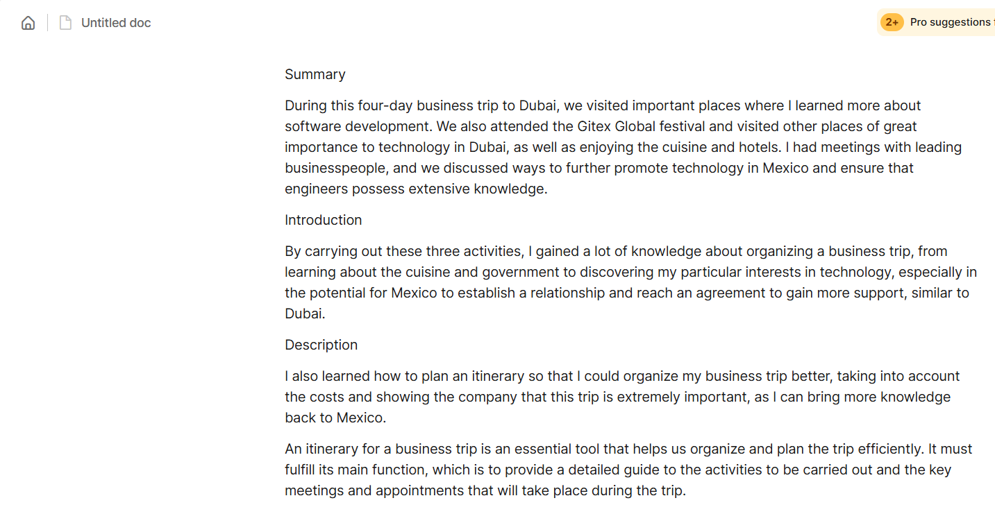

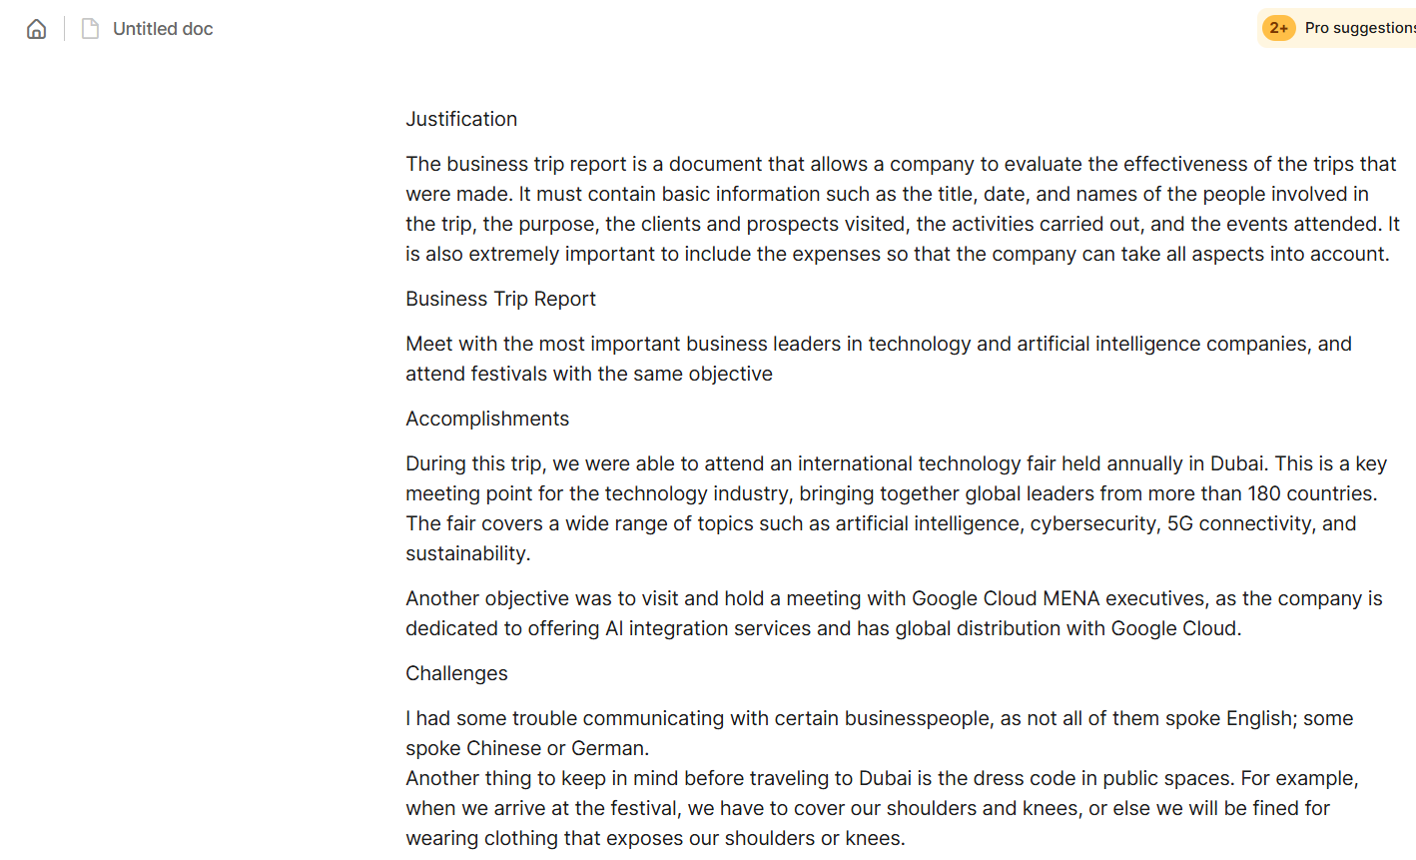
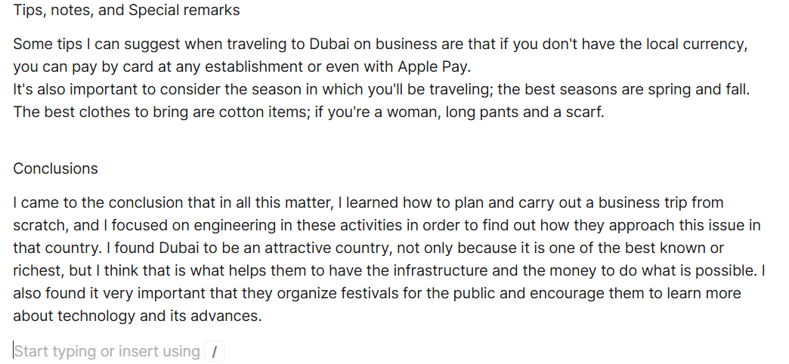
Conclusions

I came to the conclusion that in all this matter, I learned how to plan and carry out a business trip from scratch, and I focused on engineering in these activities in order to find out how they approach this issue in that country. I found Dubai to be an attractive country, not only because it is one of the best known or richest, but I think that is what helps them to have the infrastructure and the money to do what is possible. I also found it very important that they organize festivals for the public and encourage them to learn more about technology and its advances.
References

