Supplementary material

Fig. S1 SPM paired t-statistic parametric maps of relative [¹⁸F]FDG uptake vs. [¹¹C]UCB-J uptake differences
A) Young HC=11
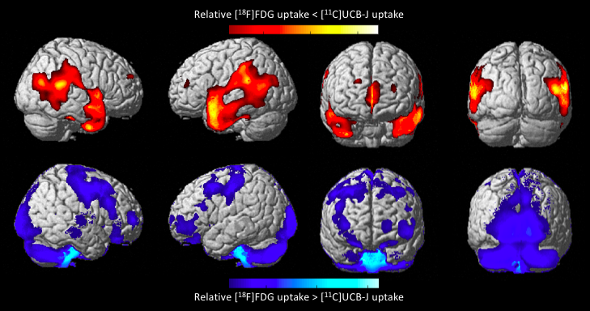
B) Old HC=15
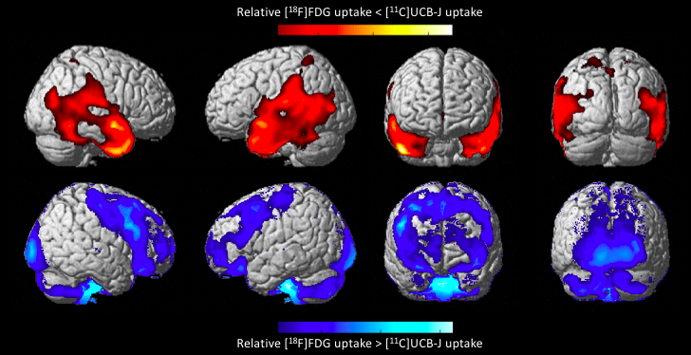
C) T-statistical map of significant clusters (P 0.001) in the voxel-based linear regression of relative [¹⁸F]FDG uptake vs. [¹¹C]UCB-J uptake differences and age
Fig S1. (a) SPM paired t-statistic parametric maps of relative [¹⁸F]FDG uptake vs. [¹¹C]UCB-J uptake differences (upper row) and [¹⁸F]FDG>[¹¹C]UCB-J (bottom row) in 11 young HC. (b) SPM paired t-statistic parametric maps of relative [¹⁸F]FDG uptake vs. [¹¹C]UCB-J uptake differences (upper row) and [¹⁸F]FDG>[¹¹C]UCB-J (bottom row) in 15 old HC. Only significant clusters with FWE<0.05 are shown. Colour bars above and below the Figure represent the t-value. (c) T-statistical map of significant clusters in the voxel-based linear regression of relative [¹⁸F] FDG uptake vs. [¹¹C]UCB-J uptake differences and age, overlaid on an averaged T1-weighted image of all subjects.

Fig. S2 Medial and axial projections (figure 3)
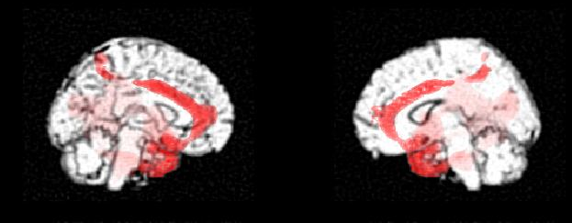
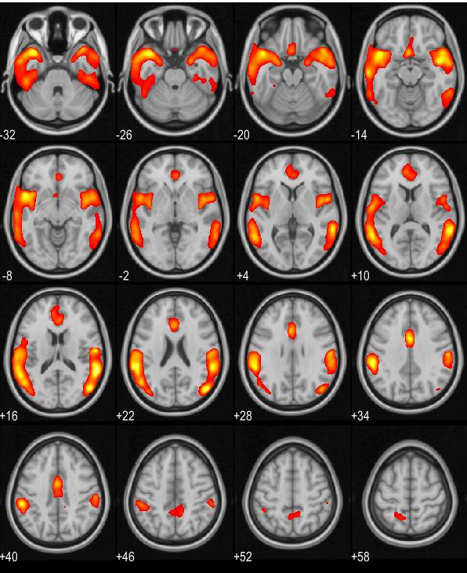

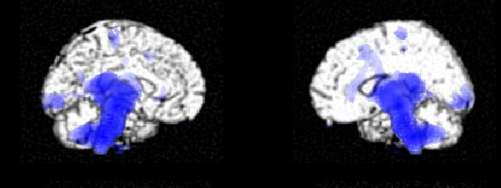

Figure S2. SPM paired t-statistic parametric maps of relative [18F]FDG uptake<[11C]UCB-J uptake (upper row) and [18F]FDG>[11C]UCB-J (bottom row). Only significant clusters with FWE<0.05 are shown. All HC subject (N=26).

Table S1. Relative [¹⁸F]FDG uptake vs. [¹¹C]UCB-J uptake differences (%)
HC old
Region (GM norm) | [¹⁸F]FDG | [¹¹C]UCB-J | Relative difference (%) | P-value (uncorrected)
FCX | 1.04 | 1.01 | 2.81 | 0.001
Amg | 0.73 | 0.86 | -18.11 | <0.001
MTCx | 0.89 | 1.01 | -12.71 | <0.001
LTCx | 0.85 | 0.99 | -16.77 | <0.001
PCX | 1.03 | 1.03 | 0.66 | 0.072
OCX | 1.10 | 1.00 | 8.92 | <0.001
STR | 1.07 | 0.95 | 11.02 | <0.001
SN | 0.78 | 0.39 | 49.08 | <0.001
ICX | 0.91 | 1.01 | -10.37 | <0.001
ACC | 0.98 | 1.14 | -15.79 | <0.001
PCCx | 1.21 | 1.15 | 4.58 | 0.053
CBL | 0.94 | 0.84 | 10.11 | 0.007
Thal | 0.99 | 0.62 | 35.02 | <0.001

HC young
Region (GM norm) | [¹⁸F]FDG | [¹¹C]UCB-J | Relative difference (%) | P-value (uncorrected)
FCX | 1.05 | 0.99 | 5.24 | 0.107
Amg | 0.63 | 0.78 | -23.54 | <0.001
MTCx | 0.86 | 0.96 | -12.49 | <0.001
LTCx | 0.82 | 0.96 | -17.40 | <0.001
PCX | 1.01 | 1.03 | -0.86 | 0.826
OCX | 1.09 | 1.00 | 8.26 | 0.005
STR | 0.96 | 0.86 | 12.07 | <0.001
SN | 0.66 | 0.40 | 39.49 | <0.001
ICX | 0.93 | 1.00 | - 8.38 | 0.001
ACC | 0.96 | 1.07 | -11.01 | <0.001
PCCx | 1.13 | 1.10 | 3.23 | 0.153
CBL | 0.84 | 0.84 | 5.24 | <0.001
Thal | 0.91 | 0.62 | 29.11 | <0.001

Region  (GM norm) | Relative difference (%) Young | Relative difference (%) Old | P-value (uncorrected)
FCX | 5.24 | 2.81 | 0.001
Amg | -23.54 | -18.11 | 0.129
MTCx | -12.49 | -12.71 | 0.889
LTCx | -17.40 | -16.77 | 0.790
PCX | -0.86 | 0.66 | 0.002
OCX | 8.26 | 8.92 | 0.702
STR | 12.07 | 11.02 | 0.548
SN | 39.49 | 49.08 | 0.002
ICX | - 8.38 | -10.37 | 0.302
ACC | -11.01 | -15.79 | 0.020
PCCx | 3.23 | 4.58 | 0.290
CBL | 5.24 | 10.11 | 0.011
Thal | 29.11 | 35.02 | 0.001

Table S1. Percentage difference of [¹⁸F]FDG over [¹¹C]UCB-J for the main VOIs. Relative differences calculated as the average of the relative difference in all old or young subjects. ACCx: anterior cingulate cortex; CBL: cerebellum; FCx: frontal cortex; ICx: insular cortex; LTCx: lateral temporal cortex; mTCx: medial temporal cortex; OCx: occipital cortex; PCCx: posterior cingulate cortex; PCx: parietal cortex; Str: striatum; Thal: thalamus

Table (S)2. Region of interest analysis of [¹¹C]UCB-J SUVR-1 and [¹⁸F]FDG SUVR values for young versus old HC
A) VOI region | Old versus young  [¹¹C]UCB-J CSO norm | Old versus young  [¹¹C]UCB-J CSO norm PVC | Old versus young  [¹⁸F]FDG CSO norm | Old versus young  [¹⁸F]FDG CSO norm PVC
FCx | 0.002 | 0.035 | 0.000 | 0.000
HIP | 0.014 | 0.057 | 0.000 | 0.000
Amg | 0.046 | 0.281 | 0.000 | 0.000
mTCx | 0.001 | 0.023 | 0.000 | 0.000
LTCx | 0.000 | 0.026 | 0.000 | 0.000
PCx | 0.000 | 0.011 | 0.000 | 0.000
OCx | 0.000 | 0.004 | 0.000 | 0.000
Str | 0.022 | 0.093 | 0.000 | 0.000
SN | 0.001 | 0.006 | 0.000 | 0.001
ICx | 0.000 | 0.005 | 0.000 | 0.000
ACC | 0.004 | 0.096 | 0.000 | 0.000
PCCx | 0.001 | 0.033 | 0.000 | 0.000
CBL | 0.001 | 0.033 | 0.000 | 0.000
THAL | 0.001 | 0.012 | 0.000 | 0.000
P designates the group test P-value (two-sample t test with equal variances). CSO: centrum semiovale, ACCx: anterior cingulate cortex, CBL: cerebellum, FCx: frontal cortex, ICx: insular cortex, LTCx: lateral temporal cortex, mTCx: medial temporal cortex, OCx: occipital cortex, PCCx: posterior cingulate cortex, PCx: parietal cortex, Str: striatum, Thal: thalamus.
B) VOI region | Old versus young  [¹¹C]UCB-J CSO norm | Old versus young  [¹¹C]UCB-J CSO norm PVC | Old versus young  [¹⁸F]FDG CSO norm | Old versus young  [¹⁸F]FDG CSO norm PVC
FCx | 0.028 | 0.496 | 0.000 | 0.000
HIP | 0.190 | 0.799 | 0.000 | 0.000
Amg | 0.641 | 1.0 | 0.000 | 0.000
mTCx | 0.008 | 0.323 | 0.000 | 0.000
LTCx | 0.006 | 0.357 | 0.000 | 0.000
PCx | 0.001 | 0.155 | 0.000 | 0.000
OCx | 0.001 | 0.053 | 0.000 | 0.000
Str | 0.314 | 1.0 | 0.000 | 0.000
SN | 0.008 | 0.081 | 0.003 | 0.017
ICx | 0.001 | 0.067 | 0.000 | 0.000
ACC | 0.059 | 1.0 | 0.000 | 0.000
PCCx | 0.018 | 0.456 | 0.000 | 0.000
CBL | 0.013 | 0.461 | 0.000 | 0.000
THAL | 0.011 | 0.16 | 0.000 | 0.000

P designates the group test P-value (Bonferroni corrected, two-sample t test with equal variances). CSO: centrum semiovale, ACCx: anterior cingulate cortex, CBL: cerebellum, FCx: frontal cortex, ICx: insular cortex, LTCx: lateral temporal cortex, mTCx: medial temporal cortex, OCx: occipital cortex, PCCx: posterior cingulate cortex, PCx: parietal cortex, Str: striatum, Thal: thalamus.

The following neuropsychologic tests were included:
Danish Adult Reading Test (DART): was included as a measure of premorbid IQ³⁸.
Executive functioning domain tests: Phonemic letter fluency: Participants had to name as many words starting with -s as possible within a 60-second time limit. Scoring: number of correctly named words. 64-card Wisconsin Card sorting Test³⁹ was included to assess executive function. WCST consists of 64 unambiguous cards to be organised according to four stimuli cards (differing in shape, number or colour). When 10 cards were sorted correctly, the sorting principle was changed. The task was discontinued when all 64 cards had been sorted. Scoring: total number of errors. Stroop interference⁴⁰: The test consisted of a sheet of paper with words printed in an incongruent colour. The participants had to ignore the words and name the colours within the 45-second timeframe. Scoring: number of correctly named colours.
Language domain tests: Boston Naming Test (BNT)⁴¹: was applied as a test of confrontational naming ability. BNT consisted of 30 line-drawings, which the participant had to name. Scoring: number of correctly named drawings. Semantic fluency: The participants had to name as many animals as possible within a 60-second time limit. Scoring: number of correctly named animals. Similarities⁴²: was included to assess linguistic concept formation and reasoning. The participant had to tell what two words had in common. Scoring: number of correct answers.
Attention domain test: Stroop colour word test⁴⁰: colour naming was included as a measure of attention (part two of the test). Scoring: number of correct answers. Digit span backwards⁴²: consisted of digit sequences that were read to the participant who had to repeat the sequence backwards. Scoring: number of correctly repeated sequences. Letter number sequencing⁴²: a series of letters and numbers were read to the participant who had to order them in numerical and alphabetical order. Scoring: number of correctly repeated sequences
Memory domain test: Location learning test (LLT)⁴³ is a test of visuospatial learning and memory. The participants had five 30-second trials to memorize the position of objects on a matrix with 25 grids. Each of the learning trials was followed by an immediate recall, where the participant had to place the line drawings of the objects on an empty matrix in the correct grid. Registration of total number of placement errors for immediate and delayed recall. Rey Auditory Verbal Learning List⁴⁴ ⁴⁵ assess verbal learning and memory. The test consisted of 5 presentations of a 15-item wordlist. Recall was administered after each presentation and a delayed recall after 30 minutes.
Visuospatial domain test. Clock drawing test: assess visuospatial ability. Benton judgement of line orientation⁴⁶ assess the ability of the participant to judge and match the orientation and angles of lines on simple line-drawings. Scoring: number of correct answers.

