Supplementary Figures
Less is more: Lemurs (Eulemur spp.) may benefit from loss of trichromatic vision
Behavioral Ecology and Sociobiology
Rachel L. Jacobs, Carrie C. Veilleux, Edward E. Louis, Jr., James P. Herrera, Chihiro Hiramatsu, David C. Frankel, Mitchell T. Irwin, Amanda D. Melin, Brenda J. Bradley

Corresponding author: Rachel L. Jacobs; Affiliation: Center for the Advanced Study of Human Paleobiology, Department of Anthropology, The George Washington University, Washington, DC 20052, USA; Present address: US Fish & Wildlife Service, National Fish & Wildlife Forensics Laboratory, 1490 East Main Street, Ashland, OR 97520, USA; Email: rlynjacobs@gmail.com

Fig. S1 Schematic representation of the two genetic mechanisms resulting in trichromatic color vision in primates: polymorphic trichromacy and routine trichromacy. M = medium-wavelength (green) sensitive, L = long-wavelength (red) sensitive.
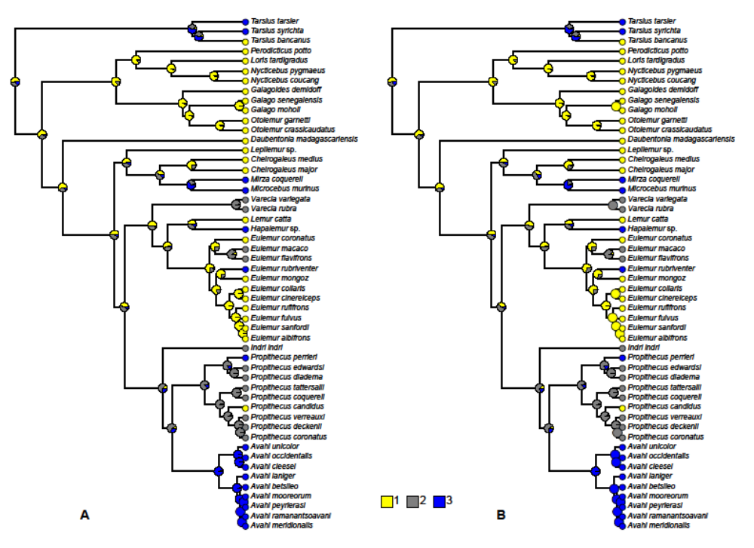

Fig. S2 Results of stochastic character mapping analyses. Pie charts at each node represent the posterior probabilities for ancestral states. 1 (yellow) = monomorphic for the M opsin, 2 (gray) = polymorphic (M and L opsins), 3 (blue) = monomorphic for the L opsin. The results of the analysis using symmetrical transition rates are shown in A, and the results of the analysis allowing the transition rates to differ are shown in B. Phylogeny from Herrera and Dávalos (2016). See reference in main text.

Fig. S3 Example reflectance spectra, representing mean reflectance for each plant part, for three plant species and six plant parts consumed by E. rubriventer in Ranomafana National Park.
Fig. S4 Chromaticity and luminance plots for trichromatic Eulemur under “day”, “dusk”, and “moonlit night” illuminations for 72 plant parts from 40 plant species consumed by E. rubriventer in RNP. Mean value is plotted for each plant part. Left: Red-green (L/(L+M)) chromaticity vs. blue-yellow (S/(L+M)) chromaticity plots; Right: Luminance (L+M) vs. blue-yellow (S/(L+M)) chromaticity plots.
Fig. S5 Chromaticity vs. luminance plots for dichromatic Eulemur under “day”, “dusk”, and “moonlit night” illuminations for 72 plant parts from 40 plant species consumed by E. rubriventer in RNP. Mean value is plotted for each plant part. Luminance (L or M) vs. blue-yellow (S/(L or M)) plots are given for each dichromatic phenotype.
Fig. S6 Box plots of chromatic JND values for trichromatic and dichromatic (M opsin and L opsin) Eulemur under “day”, “dusk”, and “moonlit night” illuminations. Horizontal lines within each box indicate the median of the distribution. Boxes envelop the interquartile range (50% of values) of the sample distribution, and whiskers encompass 1.5 times the interquartile range. Data represent 72 plant parts from 40 plant species consumed by E. rubriventer in RNP as viewed against upper and lower leaves.
Fig. S7 Box plots of luminance JND values for trichromatic and dichromatic (M opsin and L opsin) Eulemur under “day”, “dusk”, and “moonlit night” illuminations. Horizontal lines within each box indicate the median of the distribution. Boxes envelop the interquartile range (50% of values) of the sample distribution, and whiskers encompass 1.5 times the interquartile range. Data represent 72 plant parts from 40 plant species consumed by E. rubriventer in RNP as viewed against upper and lower leaves.

